Taylor Singleton

Dr. Lin

CSCI 332

17 October, 2019

Homework 3

1. The problem my friend is having is that in the evening, cable internet users experience 20%+ slowdowns due to cable internet bandwidth being shared between neighbors. The slowdowns are not due to my friend’s computer, but because of the bandwidth of their network. DSL users do not experience similar loses of speed since internet is piped in directly through their phone lines. To fix the problem, my friend could switch to DSL, upgrade their current connection to a faster speed, or save their internet activity for when peak time is over.

2.

a. -r (--route: display routing table), -i (--interfaces: display interface table),

-g (--groups: display multicast group memberships), -s (--statistics: display

networking statistics (like SNMP)), -M (--masquerade: display masqueraded connections), -v (--verbose: be verbose), -W (--wide: don’t truncate IP addresses), -n (--numeric: don’t resolve names), --numeric-hosts (don’t resolve host names), --numeric-ports (don’t resolve port names), --numeric-users (don’t resolve user names), -N (--symbolic: resolve hardware names), -e (--extend: display other/more information), -p (--programs: display PID/Program name for sockets), -o (--timers: display timers), -c (--continuous: continuous listening), -l (--listening: display listening server sockets), -a (--all: display all sockets (default: connected)), -F (--fib: display Forwarding Information Base (default)), -C (--cache: display routing cache instead of FIB), -Z (--context: display SELinux security context for sockets)

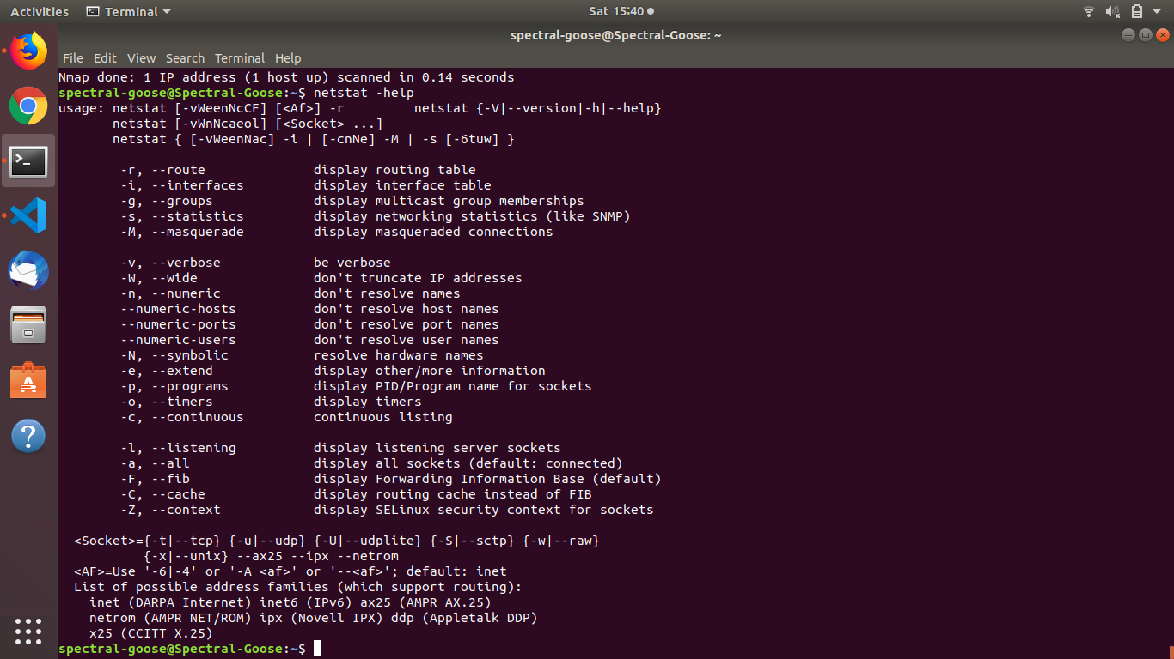

b. What ports are open in your system?

43522

50014

34566

60862

42013

51514

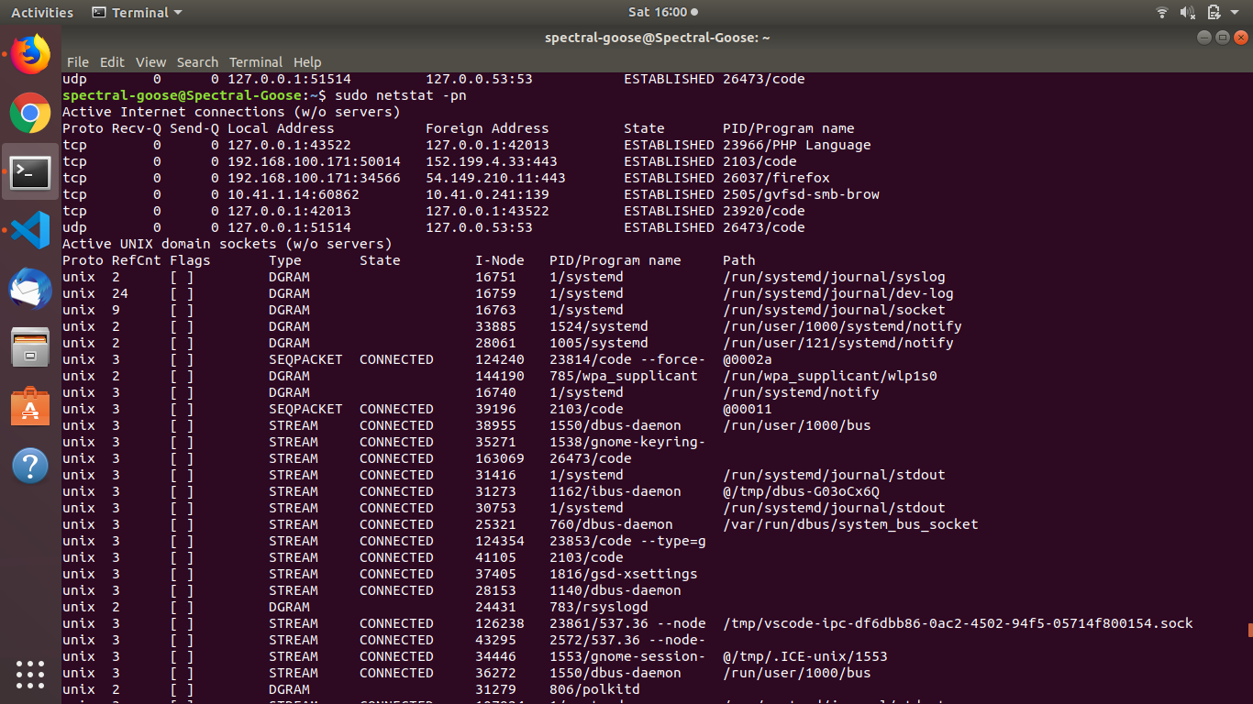

c. Research how to close a port with instructions and examples.

To close my local host, first locate the port’s PID by typing

$ sudo netstat -ap

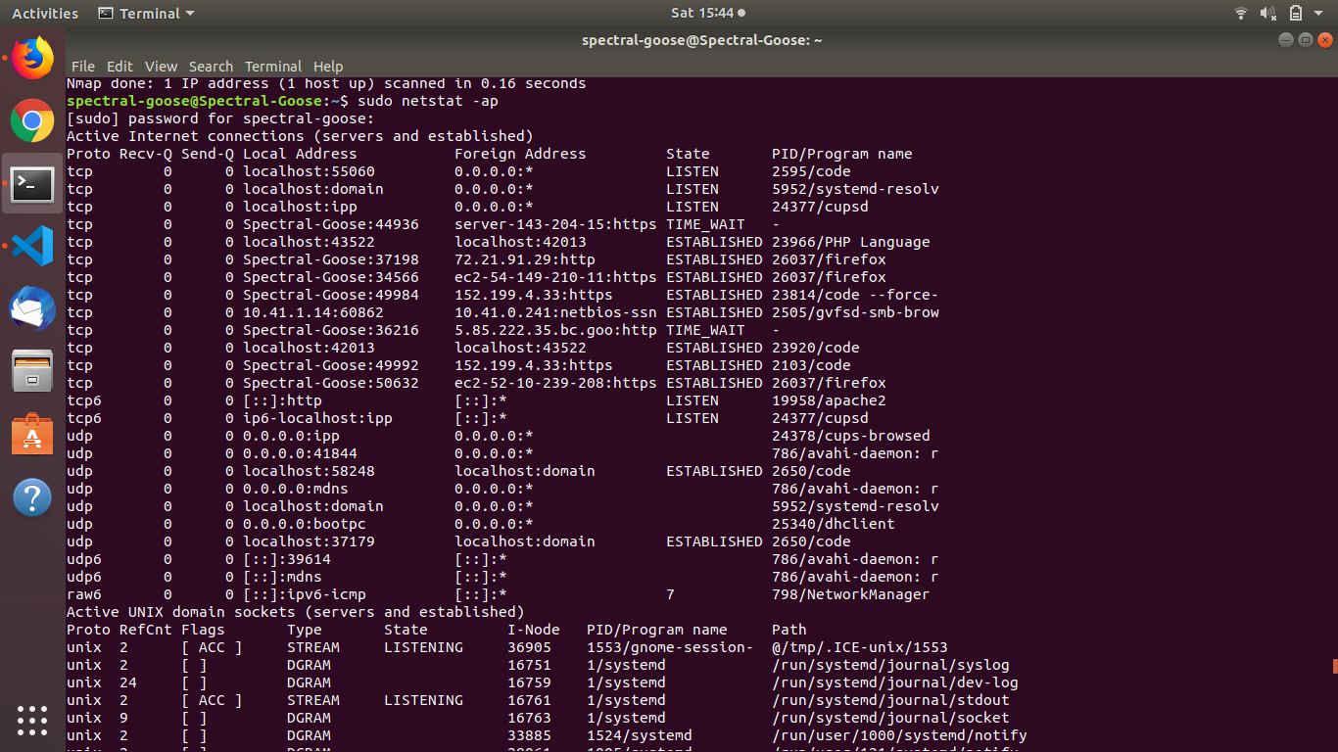

We need the PID which is the number after the status of the port. Next, type

$ sudo kill <pid>

Where <pid> is the PID of the open port. Test to see if it is still listening by typing

$ sudo netstat -ap | grep <pid>

If the port does not show up, then it is closed.

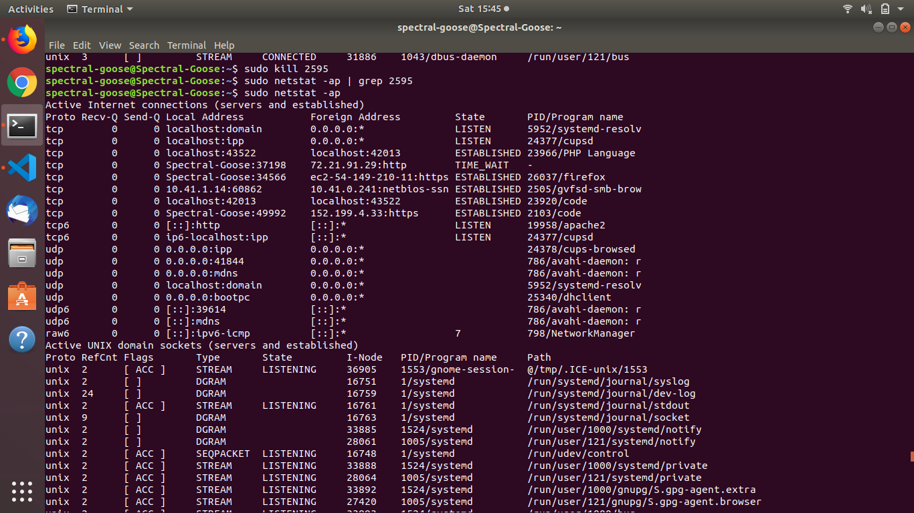

d. List at least five opened ports and their functionality. For example, port 21 for FTP, ....

43522 (tcp) – PHP Language

50014 (tcp) - code

34566 (tcp) - firefox

60862 (tcp) – gvfsd-smb-brow

42013 (tcp) - code

51514 (udp) – code



Take screen shots and paste them on your answer sheets.

3.

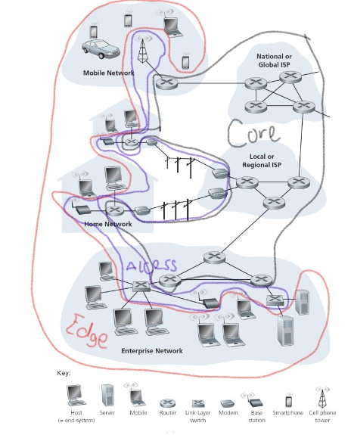

4.(10%) Please draw a Manchester encoded waveform of a stream of binary:0011101000



5. CLIENT -> SERVER: I am ready for communication.

SERVER -> CLIENT: I am also ready for communication.

(Communication established)

CLIENT -> SERVER: Please give me “Hay_Jude.mp3”.

SERVER -> CLIENT: Giving you “Hay_Jude.mp3”.

SERVER -> CLIENT: File transferred.

CLIENT -> SERVER: Thank you. Goodbye.

SERVER -> CLIENT: You’re welcome. Goodbye.

(Communication ended)

6.

DSLAM

Digital Subscriber Line Action Multiplexer – this is a device that receives input from multiple DSL sources and merges them using multiplexing.

CO

Central Office – this is an office located in a specific place to handle the network traffic of that specific location.

CMTS

Cable Modem Termination System – this is a piece of equipment at a company’s hubsite which provides internet service to cable subscribers.

FTTH

Fiber To The Home – this means a network, typically residential, is connected via fiber and therefore has the lightening fast internet speeds fiber provides

AON

Active Optical Network – an AON relies on powered network equipment to product a network signal.

PON

Passive Optical Network – a PON uses unpowered fiber optic splitters to divide bandwidth between access points.

IFTTT

If This, Then That – connects multiple devices and software from different companies in order to trigger automations in those devices and software.

OLT

Optical Line Terminal – serves as the service provider for a PON.

IXP

Internet eXchange Point – this is the delivery system through which internet providers and content providers exchange their information. Exchanges happen autonomously.

LEO

Low Earth Orbit – satellites in low earth orbit are used in telecommunication systems. Low earth orbit is defined as 400 to 1,000 miles above the surface of the earth.