In order to complete this lab, you must have your programming environment ready:

1. (50%) Follow Ubuntu Installation videos to complete all tasks.

a. Install Ubuntu on your machine. If you are an on-campus student, please use the university issued laptop. If you are an online student, please install a virtual machine(VMWare Player or VirtualBox) on your own computer.

Done!

b. Install all Ubuntu updates. You may want to install a few updates at a time.

Done!

c. Install Visual Studio Code

Done!

d. Install all Visual Studio Code Updates

Done!

e. Install Apache

Done!

2. (10%) Install browsers like Firefox or Chrome. Take a screen shot as a proof for this problem.

Done!

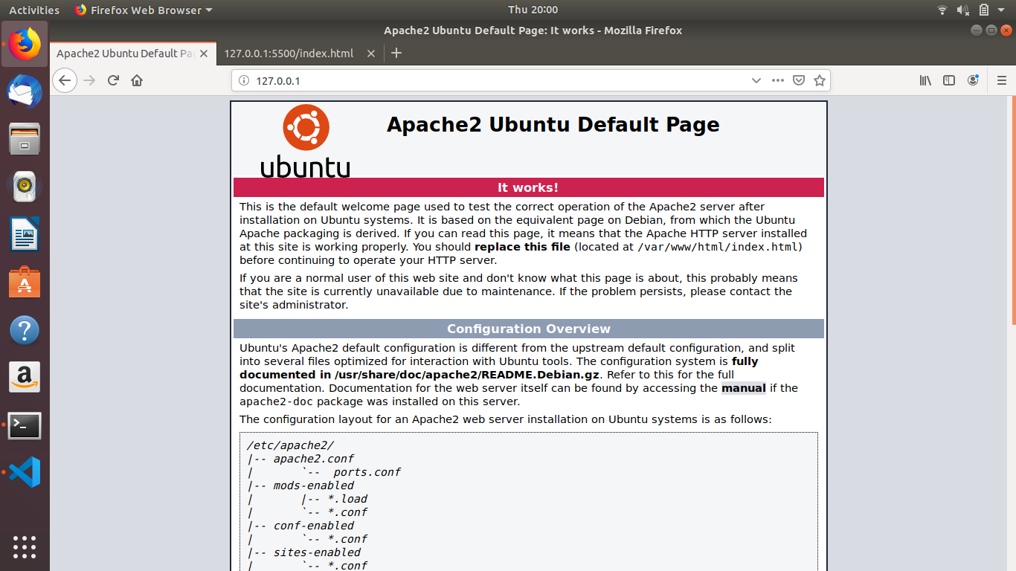

3. (20%) Run VS Code and take a screen shot.

Done!

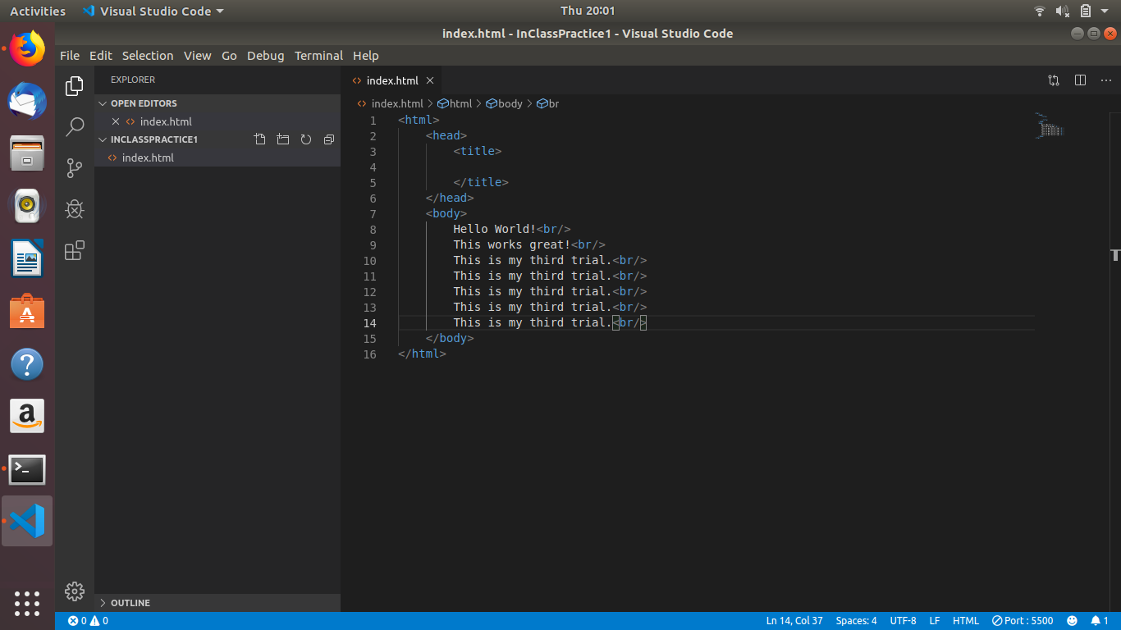

4. (20%) To verify you installed Apache correctly, open a browser and enter http://127.0.0.1 in the URL field.

Done!