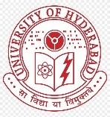 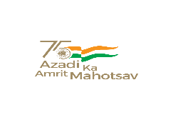 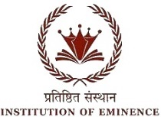

**BHARAT KA AMRIT MAHOTSAV**

UNIVERSITY OF HYDERABAD

SCHOOL OF COMPUTER AND INFORMATION SCIENCE

Collaboration with O/o Dean Student Welfare & O/o Chief Warden

Cordially invites you to Technical Sessions of Two days National Seminar on “BAM-2022“

Organized on 7th & 8th April 2022

Technical Session on “Social-economic and health applications of Sanatana Dharma through AI methods”

**7th****April 2:00pm to 3:45pm** **Venue:** **New Seminar, SCIS**

|  |  |  |
| --- | --- | --- |
| **Session Chair** |  |  |
| **Keynote speech by** |  | **2:00 – 2:15** |
| **Student paper presentation** | | |
| **Paper-1** |  | **2:30 – 2:45** |
| **Paper-2** |  | **2:45 – 3:00** |
| **Paper-3** |  | **3:00 – 3:15** |
| **Paper-4** |  | **3:15 – 3:30** |
| **Paper-5** |  | **3:30 – 3:45** |