1.Examine the routing table of the EAST router. What packets will be forwarded through the GRE tunnel?

To examine EAST router’s routing table should be used show ip route command to know that any packets reaching 172.16.1.0 and 172.16.12.0 network addresses will reach their destination through GRE tunnel.

2. Provide a figure/diagram of an IP packet forwarded from PC-A to PC-C through the GRE tunnel. The figure should show GRE header, inner and outerIP headers with specific source and destination addresses.

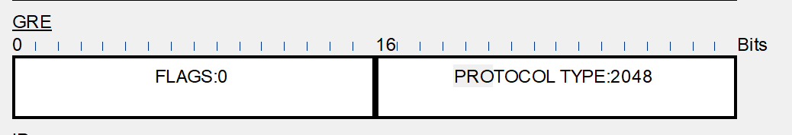

Pic.1, this shows the header of one of the packets sent from PC-A to PC-C

We should ping from PC-A PC-C in simulation this way :

C:\>ping 172.16.2.3

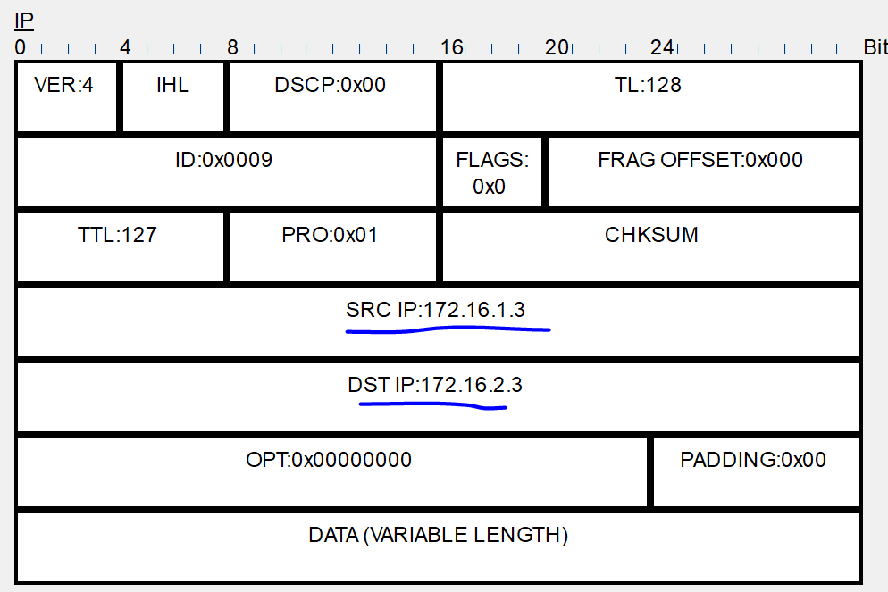

Pic.2, inner IP

SRC and DST are the IPs inside a packet came to the router WEST

So, we saw on the router WEST in tab “inbound” there was inner ip and GRE header didn’t appeared yet. That means there was no encapsulation yet.

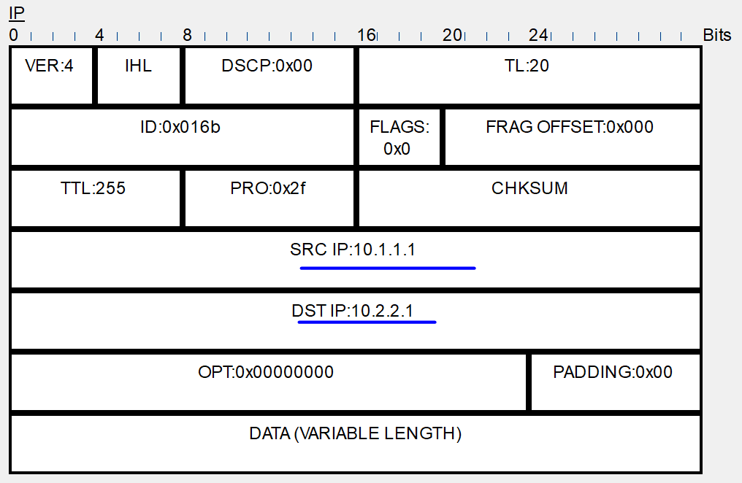

Pic.3, Outer IP

In tab “outbound” we can see both GRE header and outbound IPs(underlined). This means that encapsulation has been made.

3.Considerthe case when the ISP router does not support GRE protocol. How does this affect the functioning of the GRE tunnel?

The main goal of a router is a routing. This means an ISP router is only to check outbound IP and destination IP(to know that destination ip is not its own) and ISP router will not check GRE header. ISP will route a packet further. So if ISP router does not support GRE protocol it will not cause any troubles to a GRE tunnel.

4. Give an example of the case when IP addresses configured at Tunnel0 interfaces are used (the addresses present in inner or outerIP headers).

As an example case we chose WEST router in simulation mode. Let us use ping 172.16.12.2 command:

WEST#ping 172.16.12.2

It has generated a packet on this router and it was routed to the ISP router. Down below we can see insides of the packet on the ISP in innerbound.

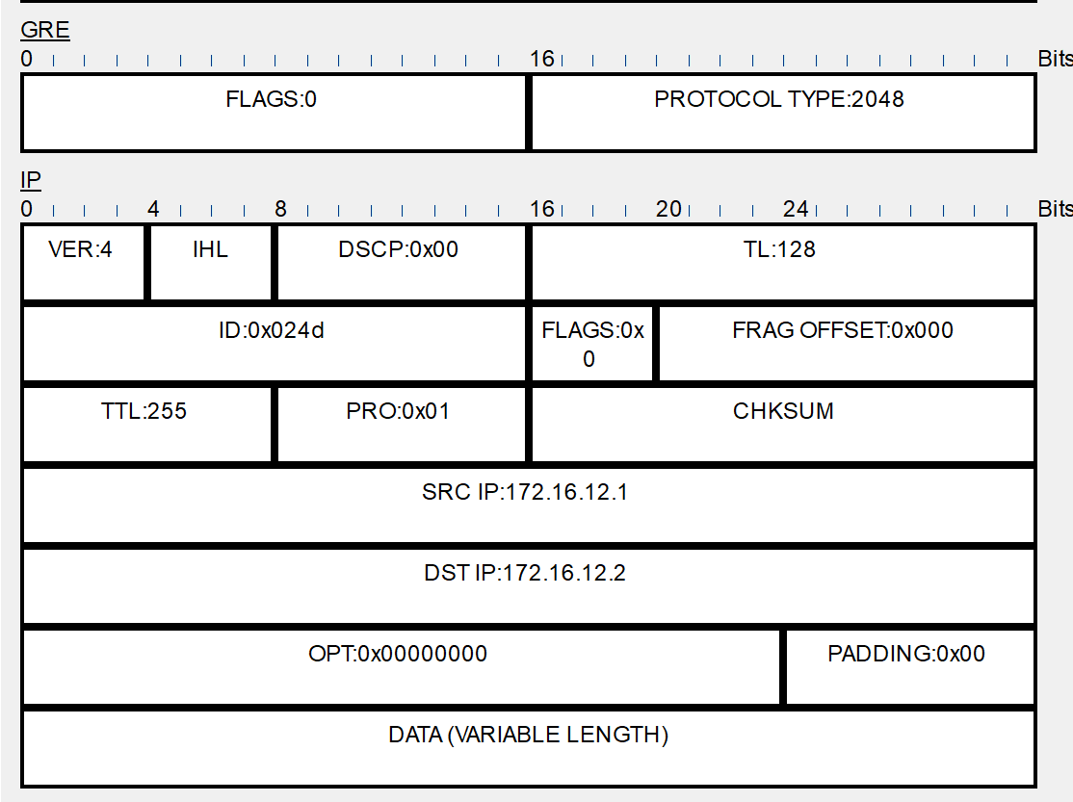

Pic.4, tunnel address - 172.16.12.1 & 172.16.12.2

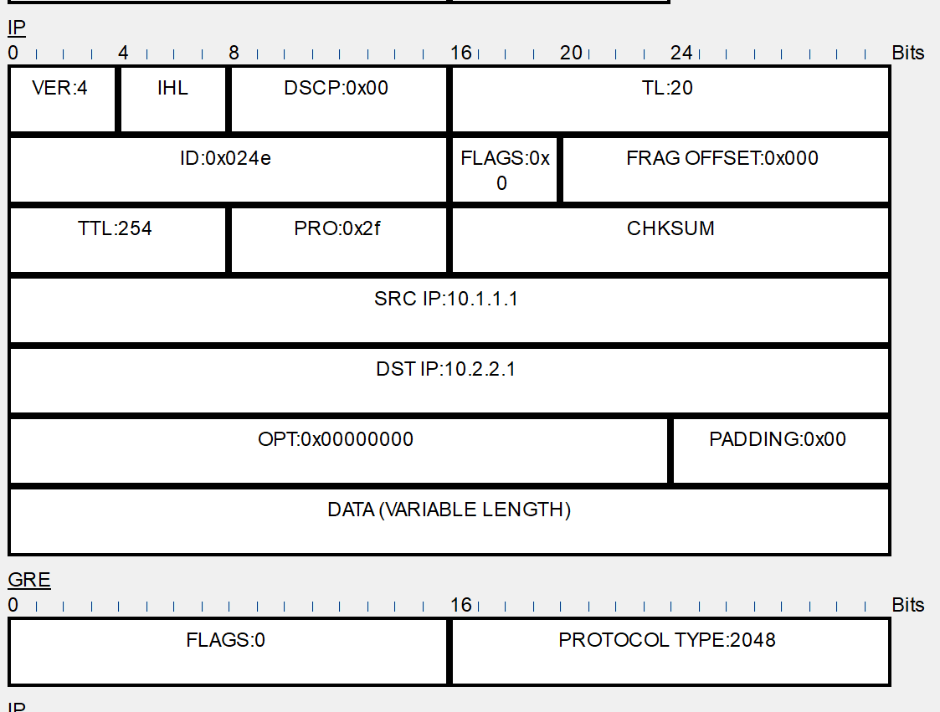

Pic.5, In outbound