Laboratory 1
Introduction to MARS and MIPS

NOTE: shaded sections of the exercises are questions which you will answer in a separate lab report.

In this lab, you will be introduced to the MARS programming environment in which you will develop MIPS assembly language programs

Basic MARS Use

Exercise 1: Launch MARS from the Start menu.

1. Download the lab1.asm attachment.

2. Launch MARS from the Start menu. You will see something like this screenshot:
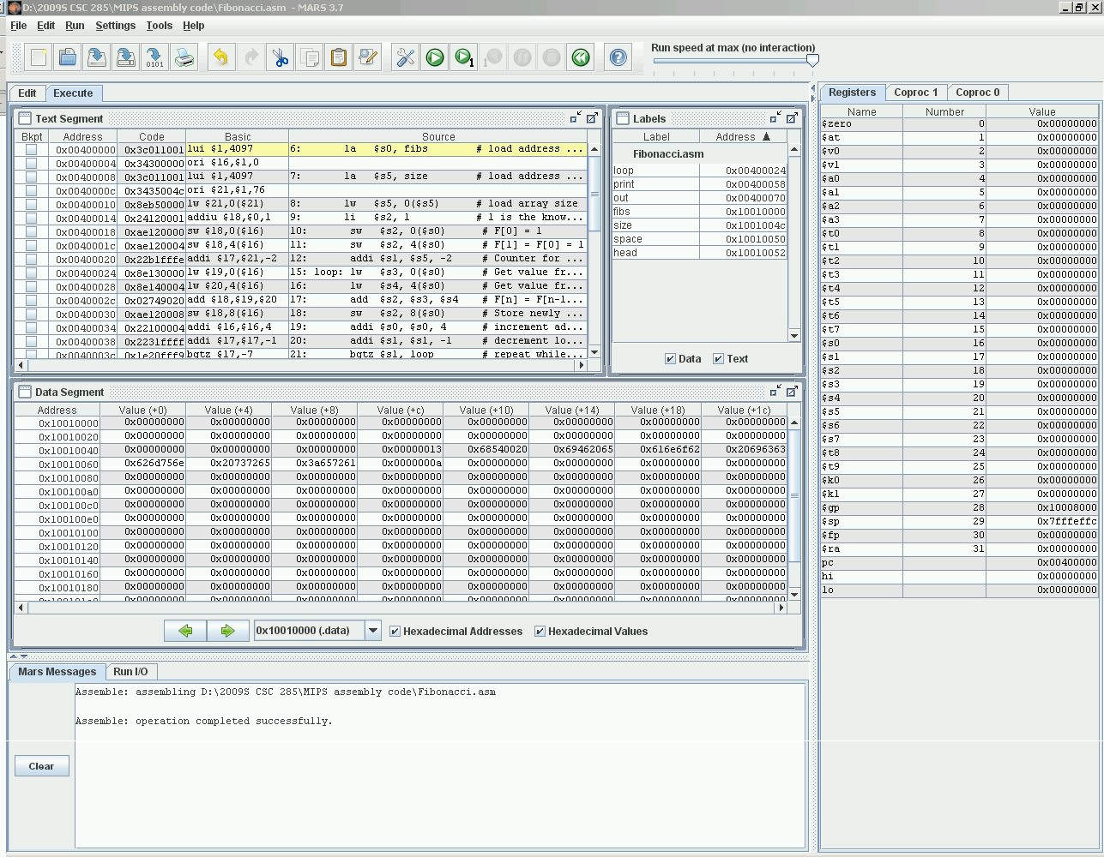
Notice the Edit/Execute tabs and the Mars Messages/Run I/O tabs. These are used to switch between the panels used for those purposes.

Also notice the Registers/Coproc 1/Coproc 2 panel along the right-hand side of the screen (in this class, we are mainly interested in the Registers tab). All 32 MIPS registers are labeled and numbered, in addition to 3 more listed at the bottom (the pc , or program counter, and hi and lo registers, which you will learn about later).

Which two registers have a non-zero value at this point?

Can you explain what the value of the pc indicates?

3. Use File…Open to open lab1.asm, which contains a MIPS program to add two numbers. You will see the file open in the Edit panel.

NOTE: (All icons have menubar equivalents; the remainder of these steps will use the icon whenever possible.)
4. Assemble the program using the icon  (also available from the Run menu).
Examine the Mars Messages panel, and notice that the message indicates the assembly was successful. Also notice that the tab automatically changes from Edit to Execute, and that the Text Segment and Data
Segment panels are now displayed (similar to the earlier screenshot).

What does the 0x notation mean which precedes the 8-digit numbers you see displayed in these panels?

5. The Text Segment contains the code from the .text section of the program (the program instructions). Explain what you think each column in this panel is used for:

Bkpt:

Address:

Code:

Basic:

Source:

What is the starting address of the program?
6. The Data Segment contains the code from the .data section of the program (the variables and constants defined in the program).

What is the starting address of the Data Segment?

Each row in the Data Segment lists the contents of 8 words in memory, each of which contains 32 bits, or 4 bytes, of data.

Notice that the first 7 words in the Data Segment contain non-zero values. Why are these non-zero for this program?

7. Use the Settings menu to configure the MARS displays. The settings will be retained for the next MARS
session.
• The Labels display contains the addresses of the assembly code statements with a label, but the default is to not show this display. Select the checkbox from the Settings menu.
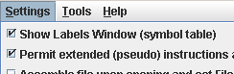
• Select the checkbox to allow pseudo-instructions (programmer-friendly instruction substitutions and shorthand).
• Select the startup display format of addresses and values to be hexadecimal.

8. Use the slider bar to change the run speed to 1 instructions per second. 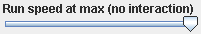 This allows us to “watch the action” instead of the assembly program finishing directly.

9. There are a number of ways to execute the program:

• The  icon runs the program to completion. Using this icon, you should observe the yellow highlight showing the program’s progress in the Text Segment, and green highlight showing the registers being modified in the Registers panel. When there are changes to the Data Segment, they are also highlighted.
• The  icon resets the program and simulator to initial values. Memory contents are those specified within the program, and register contents are generally zero.
• The  icon is “single-step.” Its complement is , “single-step backwards” (undoes each operation).

10. Run the program to completion, using the very slow 1 second per instruction speed. You will need to enter values twice in the Run I/O panel, to be used for the addition. Upon completion, the following will be displayed:
Enter a value:2
Enter a value:3
The sum is:5
program is finished running –

11. Reset and run the program one instruction at a time, using the single-step . Examine the registers after each instruction to verify that you understand any new values.
12. Set a breakpoint at address 0x400038 by clicking on the checkbox at the left of the instruction.

• Reset and run the program again, which stops at the breakpoint, before executing the instruction.
• Examine the value of $t2 at this point. What is it?
• Perform a single step is to execute the add instruction.
• Examine the value of $t2 again. What is it now?
• Click to continue from the breakpoint. Note that you could modify register or memory values directly at a breakpoint before continuing, if it was necessary to do so for testing purposes.

13. Open the Help  for information on MIPS instructions, pseudoinstructions, directives, and syscalls.

Exercise 2: Now that you have seen the basic operation of MARS, try and write your own program! Modify the add program so that it prompts you for your name and age, and outputs a message that greets you and tells you how old you will be in 4 years.

# to read in a string, do the following. The string will be stored in memory at location “answer”
li $v0,8 # system code for read string
la $a0,answer #put address of answer string in $a0 lw $a1,alength #put length of string in $a1
syscall

#you also need the following definitions in your .data section for this to work:
answer: .space 51 #will hold up to 50 characters, so the name must be 50 characters or less alength: .word 50

When you run your program, your console should look like the following:

What is your name? Wendy Wellesley
What is your age? 20
Hello, Wendy Wellesley
You will be 24 years old in four years

Format and comment your program appropriately, and print a copy to attach to your lab report.

Exercise 3: Begin editing a source file for a new MIPS program.

1. Type in the following program (you don’t have to type the #comments), and save as lab1-2.asm on the desktop:
.text
.globl main

main: li $v0,4 #load sys call code for print string to $v0 (contract for syscall)
la $a0,prompt #address of string to print syscall #print the string

li $v0,1 #sys call for print integer
lb $a0,val #load the integer to print to$a0 (contract for syscall)
syscall #print it
addi $t0,$t0,1 #increment the value of $t0 li $v0,10 #sys call for exit
syscall

.data
prompt: .asciiz “your code is: “
val: .byte 8

Assemble the program. If you have typed the program in with no syntax errors, the Mars Messages window should tell that your program loaded successfully. Run the program to observe its simple output.

2. Examine the Data Segment. Record the values shown for the first 16 bytes in data memory (write exactly as shown in the MARS data segment, where 4 bytes are grouped together in each entry):

Data Segment
Address Value (+0) Value (+4) Value (+8) Value (+C)
0x10010000

3. Record the address and data contents of each byte location in the Data Segment using the stack model of memory.

• Show one byte per row.
• Lowest address should be at bottom of stack.
• Label the address which corresponds to the start of the prompt string
• Label the address which corresponds to val (NOTE: the Labels panel lists the addresses).

Address Label Data

What is the meaning of the first byte that has a 00 value?

Where does the value of 08 come from in the byte with that value?

0x10010000
Exercise 4:
1. Create another source file containing the following program, and save it as lab1-3.asm:

.text
.globl main

main: | li $v0,10 syscall | #sys call for exit
nums: | .data  .byte 4,3,2,1  .half 8,7,6,5  .word 1,2,3,4  .space 1
letters:  neg1s: | .word 12  .asciiz “EFG”  .ascii “efg”  .byte -1,-1
.word 15

2. Before running the program, predict the contents of data memory (use hexadecimal values, but to save space, omit preceding the numbers with 0x):

Data Segment
Address Value (+0) Value (+4) Value (+8) Value (+C) Value (+10) Value (+14) Value (+18) Value (+1C)
0x10010000

0x10010020

3. Record the address and data contents of the Data Segment using the stack model of memory.
• This time, show one word (4 bytes) per row.
• Lowest address should be at bottom of stack.
• Label the addresses corresponding to nums, letters, and neg1s
Address Label  0x10010000 |  | D | Data

Assemble the program, and examine the Data Segment/verify that the data is stored in memory as you predicted.
Exercise 5: Consider the following program (you don’t need to create a new source file, just read the code and answer the questions):

.text

la $s0,neg1byte la $s1,oneword la $s2,twowords
la $s3,smallstring lb $t0,3($s1)
add $s1,$s1,$t0 lb $t1,0($s1) addi $s1,$s1,2 add $s2,$s1,$t1 sb $t0,0($s2) addi $s1,$s1,7 add $a0,$s1,$t0 li $v0,4
syscall
lw $t0,0($s3) sh $t0,-5($s2) li $v0,10 syscall

.data
neg1byte: .byte -1 oneword: .word 0x02030405 twowords: .word 02,03 smallstring: .asciiz “abc”
halfwords: .half 10,11,12,13,14,15

Assume that neg1byte represents address 0x10010000, and that all unspecified bytes in memory contain 00.

1. How many bytes are allocated in the data section, from the starting address neg1byte to the end of the data stored at halfwords (count any extra bytes allocated by the data directives)?

List your predicted values for the bytes stored in the Data Segment before the program executes:

Data Segment
Address Value (+0) Value (+4) Value (+8) Value (+C) Value (+10) Value (+14) Value (+18) Value (+1C)
0x10010000

0x10010020

2. Fill in the following table to show the contents of registers $s0-s3 and $t0-$t1 after each instruction is executed.

Only fill in the entries that change for each instruction. If a value stored in memory is modified by an instruction, also record that address and it’s new value on that line.

$s0 $s1 $s2 $s3 $t0 $t1 $a0 addr: val
00000000 00000000 00000000 00000000 00000000 00000000 00000000

la $s0,neg1byte

la $s1,oneword

la $s2,twowords

la $s3,smallstring

lb $t0,3($s1)

add $s1,$s1,$t0

lb $t1,0($s1)

addi $s1,$s1,2

add $s2,$s1,$t1

sb $t0,0($s2)

addi $s1,$s1,7

add $a0,$s1,$t0

li $v0,4 syscall

lw $t0,0($s3)

sh $t0,-5($s2)

What should be displayed in the Run I/O window at the end of the program?

Record your predicted values of the bytes stored in the data section after the program is done executing (just record the new values in memory, in the correct location; don’t rewrite your whole table):

Data Segment
Address Value (+0) Value (+4) Value (+8) Value (+C) Value (+10) Value (+14) Value (+18) Value (+1C)
0x10010000

0x10010020

