Running Report Contextual Spillage Questionnaire – Response V2
Iteration 2: Spillage Mechanisms, Contributing Conditions and Existing Controls
Focused follow-up questionnaire supporting the evolving contextual notes

Questionnaire Version | V2
Iteration | 2
Primary Context Source | Running_Report_Contextual_Spillage_NotesV2.1
Reference Questionnaire | Running_Report_Contextual_Spillage_Questionnaire_ResponseV1
Completed By
Date Completed

1. Purpose of This Questionnaire
Questionnaire V1 established the baseline of what type of spillage was observed and where it was found. This second iteration moves the investigation to the next level: how the spillage is generated, what conditions contribute to it, what controls are currently in place, why those controls may be ineffective, and what practical remedial concepts should be developed further.
The questionnaire is intentionally problem/mechanism focused rather than repeating the full asset-by-asset V1 format. It concentrates on the open items already identified in the contextual notes: carryback and belt-cleaner performance; sample-conveyor loading and side containment; belt tracking/alignment; screen-water containment and structural condition; L1 structural condition; housekeeping and spillage recovery; and trip/restart-generated spillage.

2. Completion Guidance
- Answer from the best information currently available. 'Unknown' is a valid response where the cause, history, or design detail is not yet known.
- Where several causes may apply, mark all applicable options. The report may ultimately identify a combination of causes rather than one single root cause.
- Distinguish between directly observed facts, information reported by operations/maintenance personnel, and engineering interpretation or inference.
- Add photo/video references wherever they help preserve the evidence chain.
- Do not force a final design solution at this stage. Working remedial concepts are sufficient and can be refined in later iterations.
- Where an answer applies globally to several conveyors, record it once in the system-wide section and then note only important exceptions in the asset-specific sections.

3. Cause-and-Effect Capture Framework
For this iteration, use the following sequence when describing a condition:
Observed Spillage → Immediate Mechanism → Contributing Condition(s) → Probable Root Cause → Existing Control → Control Deficiency → Practical Remedial Concept
The questionnaire does not require every link in this chain to be proven. Record what is known and leave unsupported links as Unknown or as a clearly stated working hypothesis.

4. Fines Carryback and Belt-Cleaner / Scraper Systems
The contextual notes identify dry fines and return-side carryback as a system-wide issue. CV06 provides a direct maintenance-failure example, while CV09 provides a direct design/arrangement example. This section is intended to determine how much of the wider carryback problem is caused by design, selection, adjustment, wear, missing components, maintenance, belt condition, or a combination of these factors.

4.1 System-Wide Carryback Mechanism
System-wide observation / question | Yes | No | Unknown | N/A
Carryback is a recurring condition across multiple conveyor sections. | X
Carryback is normally visible immediately downstream of the head / discharge pulley. | X
Carryback progressively drops from the return belt along the conveyor route. | X
Return rollers / idlers remove additional adhered material from the belt and redistribute it below the conveyor. | X
Wet fines produce more persistent carryback than dry fines. | X
Dry fines also remain on the belt after discharge and contribute to return-side deposits. |  |  | X
The amount of carryback varies materially between conveyor sections. | X
Carryback becomes worse when the belt-cleaner condition deteriorates. | X
Carryback continues even where a belt cleaner / scraper is installed and apparently intact.  NOTE This is a conditional YES, it also depends on if the scrapper rubber blades are intact and proper contact with the conveyor belt surface, what often happens id the rubber blades wear away and that leaves a gap for the fines to pass through that is one of the root causes that I identified. That why the proposal is to redesign the scrapper with a spring-loaded mechanism to always keep positive contract pressure on the belt. | x
Evidence basis for the responses in this subsection
Evidence basis |  | Yes | No | Unknown | N/A
Directly observed during inspection |  | X
Supported by photograph(s) |  | X
Supported by video evidence |  | X
Reported by operations / maintenance personnel |  | X
Engineering interpretation / inference from observed condition
General description of how carryback develops through the plant | well, if we look at the product’s life cycle. The material/product is blasted and then collected and transported to the primary crusher which is under ground the combined product already has fines in it as result from the blasting. Then from initial entry point into the conveyor eco system which is the primary crusher underground which further adds fines to the combined product that is introduced onto the conveyor system, namely the UC conveyor line Uc5,4,3,2,1 etc.… and from there the combined product is passed all the way through the different belt systems/sections until the surface plant screens where it is washed etc.
Where carryback appears to originate most often | if I understand the question correctly, I would say , the primary crushers. If you mean where do di notice fines appearing first in a given conveyor belt normal underneath the belt/return side, starting predominantly from the head side.
Where the worst redistribution / secondary deposits occur | on the conveyors frames/support structure and surrounding environment.
Any operating condition that makes carryback noticeably worse | when water is introduced into the transport system, the origins are from many possible sources and are normally non-fixed conditions, such as someone could be using water/hose to clean and the water is introduced into the combined product, other possible sources are the dust suppression system uses water sprayers to help control the dust generated from the combined product being transported from one conveyor to the next for example. Another example is high pressure water hoses are use to dislodge product that might be jammed in the under-ground storage silos to assist the product to make tit move/flow easier, this last example is not also the case but I have witness this practice being done when I was there to conduct the inspection.

4.2 Belt-Cleaner / Scraper Deficiency Types
Mark every deficiency that has been observed or is believed to contribute somewhere in the inspected conveyor system.
Possible deficiency / condition | Yes | No | Unknown | N/A
Cleaner / scraper blades missing. | X
Cleaner / scraper blades excessively worn. | X
Blade coverage across the belt width is incomplete. | X
Cleaner does not maintain adequate contact pressure with the belt. | X
Cleaner requires manual adjustment and is not kept correctly adjusted. | X
Spring / tensioning mechanism is absent.  NOTE: this is not possible as the current design(s) don not employe spring mechanisms. |  | x
Spring / tensioning mechanism is present but ineffective.  NOTE: this is not possible as the current design(s) don not employe spring mechanisms. |  | x
Support bush / mounting hardware is damaged or displaced. | x
Cleaner frame / mounting arrangement is mechanically damaged. |  |  | x
Cleaner is positioned outside the intended discharge containment envelope. | x
Material removed by the cleaner is not directed back into the chute / product stream. | x
Cleaner location is difficult to access for inspection or maintenance. | x
Cleaner selection / blade type appears unsuitable for the material condition. |  |  | x
Wet or sticky material overwhelms the cleaner arrangement. | x
Belt surface condition / damage reduces cleaning effectiveness. | x
Return-belt geometry or nearby rollers interfere with effective cleaning. |  |  | x
Maintenance frequency is insufficient for the service conditions.  NOTE: I don’t know what the mines service schedule and planning routine is. |  |  | x
Failure is mainly maintenance-related rather than design-related. |  | x
Failure is mainly design/arrangement-related rather than maintenance-related. | X
Both design and maintenance deficiencies contribute materially. | X

4.3 Current Cleaner Inspection and Maintenance Practice
Current control / maintenance practice |  | Yes | No | Unknown | N/A
Belt cleaners are included in a formal planned-maintenance inspection. |  |  |  | X
Cleaner blade wear is routinely checked. NOTE: considering the poor state that I found them in I would say no. |  |  |  | x
Cleaner contact pressure / adjustment is routinely checked. |  |  | x
Missing or damaged cleaner components are normally replaced promptly. |  |  | x
There is a defined replacement criterion for cleaner blades / wear elements. |  |  |  | x
Maintenance personnel have adequate access to clean, inspect and adjust the cleaner. |  | x
The cleaner can be safely inspected without major dismantling of the chute. |  | x
A common scraper design / standard is already used across multiple conveyors. |  |  | x
Maintenance records could be reviewed if required. |  |  |  | x
Known inspection / maintenance frequency | the mine operates on a Four day one and four day off cycle meaning the plant is in operation for four days and then the plant is on maintenance for four days.
Who normally owns / performs the maintenance | the designated section artisan and section supervisors.
Known recurring maintenance problem(s) | Unknown as I did not enquire as part of the inspection period.
Any existing standard / preferred cleaner design | I am un clear if the mine has a current standard, I believe the design is left to the OEM that installed the conveyor belt.

4.4 CV06 - Cleaner Maintenance Failure
Current evidence: CV06-REF-004 records a scraper support bushing displaced from its housing and CV06-REF-005 records the head scraper blades completely missing.
CV06 condition / question | Yes | No | Unknown | N/A
The cleaner / scraper was not fully functional at the time of inspection. | x
The displaced support bush would reduce or destabilise scraper contact with the belt. | X
The missing blades would allow carryback to pass the head-cleaning point. | X
The condition appears to result from wear / progressive deterioration. |  | X
The condition appears to result from a component failure. |  | X
The condition appears to result from inadequate maintenance / replacement. | X
The exact failure history is unknown. | X
The current scraper support design is prone to this type of failure. |  |  | X
A redesigned support / tensioning arrangement should be investigated for wider use.  YES, the proposed design should be implemented and tested preferably on CV9 and then once proven standardized and rolled out to all head discharge sections. | X
Evidence basis for the responses in this subsection
Evidence basis |  | Yes | No | Unknown | N/A
Directly observed during inspection |  | X
Supported by photograph(s) |  | X
Supported by video evidence |  | X
Reported by operations / maintenance personnel |  |  |  | X
Engineering interpretation / inference from observed condition |  | X
Probable reason the support bush displaced | poor housing design
Probable reason blades were missing | unknown, did not see any physical evidence of damage.
Known maintenance history / previous similar failures | unknown
Working remedial concept for CV06 | None, that I am aware of
Potential lessons applicable to other conveyors | the proposed scrapper design should be standardized if proven and then rolled out to all conveyor head sections.

4.5 CV09 - Cleaner Location / Chute Containment Design
Current evidence indicates that the existing CV09 scraper is outside the discharge-chute containment; some removed wet carryback falls directly into the surrounding area, while residual carryback continues downstream and is removed by return rollers.
CV09 design / mechanism question |  | Yes | No | Unknown | N/A
The cleaner is physically outside the effective chute containment envelope. |  | X
Material successfully removed by the cleaner can fall directly into the open environment. |  | X
Residual carryback remains on the return belt after the cleaner. |  | X
Downstream return rollers dislodge additional wet fines / carryback. |  | X
The resulting deposits extend beyond the immediate discharge point. |  | X
The current chute could be extended / modified to enclose the cleaner. |  | X
Adequate maintenance access can be retained if the chute is extended. |  | X
A spring-loaded / self-tensioning cleaner arrangement is physically feasible. |  | X
A mechanical travel / wear limiter is feasible to prevent over-travel toward the belt. |  | X
A secondary cleaner stage may be required in addition to the primary cleaner. |  | X
Drainage / wet-fines handling must be incorporated into any revised enclosure. |  |  | X
The same containment principle could be applied to other conveyor discharge points. |  | x
Physical constraint preventing current cleaner from being inside the chute | Unknown, would require some further investigation.
Space available for extending / revising the chute | Yes
Required maintenance-access provision | Yes
Preferred cleaner / tensioning concept | Yes
Need for primary + secondary cleaner arrangement | Yes
How removed wet fines should return to the product stream | They don’t they are collected and stock piled when discharge from the CV9 conveyor and into the cv9 chute.
Other design constraints | unknown

4.6 Carryback / Cleaner Review by Conveyor
Use short entries only. Suggested entries: Yes / No / Unknown, 'Same as CV09', 'Maintenance issue', 'Design issue', or a brief note.
NOTE: Though I Noted/answered Unknown For the column “Cleaner Present” that is only because I did not have access to verify. This reason I have defined unknown for design issue is cause I have not been able to visual verify certain ones in under the cleaner present I have inferred that there must be a design issue cause that is the conclusion that I came to on the ones that I could verify visually. Based on the evidence that all other conveyor section exhibits the fines issue of depositing carryback on the return section of the conveyor the same as the confirmed ones it is logical to conclude that there are similar or the same design flaws/factors in those areas to . base on the premise that if the proposed design for the cleaner/scrapper works and is effective at cleaning the CV09 location then implementing the same design would solve the same problem in the other locations where answered as inferred. Another supporting premise to consider is the all-discharge chutes use the same basic shape and manufacturing design it is logical to conclude that they would follow and employ the same identified design flaws, hence there problem of the fines spillage is common and universal across the entire conveyor eco system. The only exception is conveyor U4 as it uses a custom cleaner design where which is shown in [] as it discharges differently into the silos.
Asset | Cleaner present? | Cleaner effective? | Maintenance issue? | Design issue? | Standard redesign applicable? | Notes / evidence
W10 | Unknown | no | Unknown | Inferred | Yes
CV01 | Unknown | no | Unknown | Inferred | Yes
CV02 | Unknown | no | Unknown | Inferred | Yes
CV04 | Unknown | no | Unknown | Inferred | Yes
CV06 | No | no | Unknown | Inferred | Yes
CV09 | Yes | no | Unknown | Yes | Yes
CV14 | Unknown | no | Unknown | Inferred | Yes
CV15 | Yes | no | Unknown | Yes | Yes
L1 | Unknown | no | Unknown | Inferred | Yes
L3 | Unknown | no | Unknown | Inferred | Yes
Sample Conveyor 1 | Unknown | no | Unknown | Inferred | Yes
Sample Conveyor 2 | Unknown | no | Unknown | Inferred | Yes
Crusher | NA | NA | NA | NA | NA | NA
UC05-UC01 system | Unknown | no | Unknown | Inferred | Yes
U3 | Unknown | no | Unknown | Inferred | Yes
U4 Tripper Car | Yes | Yes | Unknown | No | No
U5A | Unknown | no | Unknown | Inferred | Yes
U5B | Unknown | no | Unknown | Inferred | Yes

5. Sample Conveyors 2 and 3 - Product Loading and Side Containment
Questionnaire V1 identified a mismatch between product size / volume and the practical containment capability of Sample Conveyors 2 and 3. The next step is to define how product is fed onto these belts, what can be controlled, and what secondary side-containment measure is practical.

5.1 Existing Feed / Throughput Control
What currently determines or controls the quantity of sample product placed onto the conveyor?
Possible condition / response |  | Yes | No | Unknown | N/A
Fixed chute geometry only |  | X
Adjustable gate / slide gate |  |  | X
Feeder speed |  |  |  | X
Upstream conveyor speed / throughput |  | X
Operator-controlled manual restriction |  |  |  | X
Process sampling device / sampler discharge cycle |  |  |  | X
No effective feed-rate control |  |  |  | X
Current control mechanism is unknown |  | X
Other / additional condition (describe below) |  |  |  | X
Feed / loading mechanism question |  | Yes | No | Unknown | N/A
The belt is periodically loaded with more product than it can practically contain. |  | X
Individual lump size contributes to product falling from the belt. |  | X
The volume of product, rather than lump size alone, is a major contributor. |  | X
Product enters the belt off-centre. |  |  | X
Product impact / bounce at the loading point contributes to loss. |  |  | X
Feed occurs in surges rather than as a steady controlled stream. |  |  | X
Reducing / metering the incoming quantity would materially reduce spillage. |  |  |  | x
The existing feed system can be adjusted without major redesign. |  |  | X
A mechanical redesign of the feed-control arrangement is likely required. |  | X
Describe the current feed arrangement | I will provide a picture that shows the arrangement.  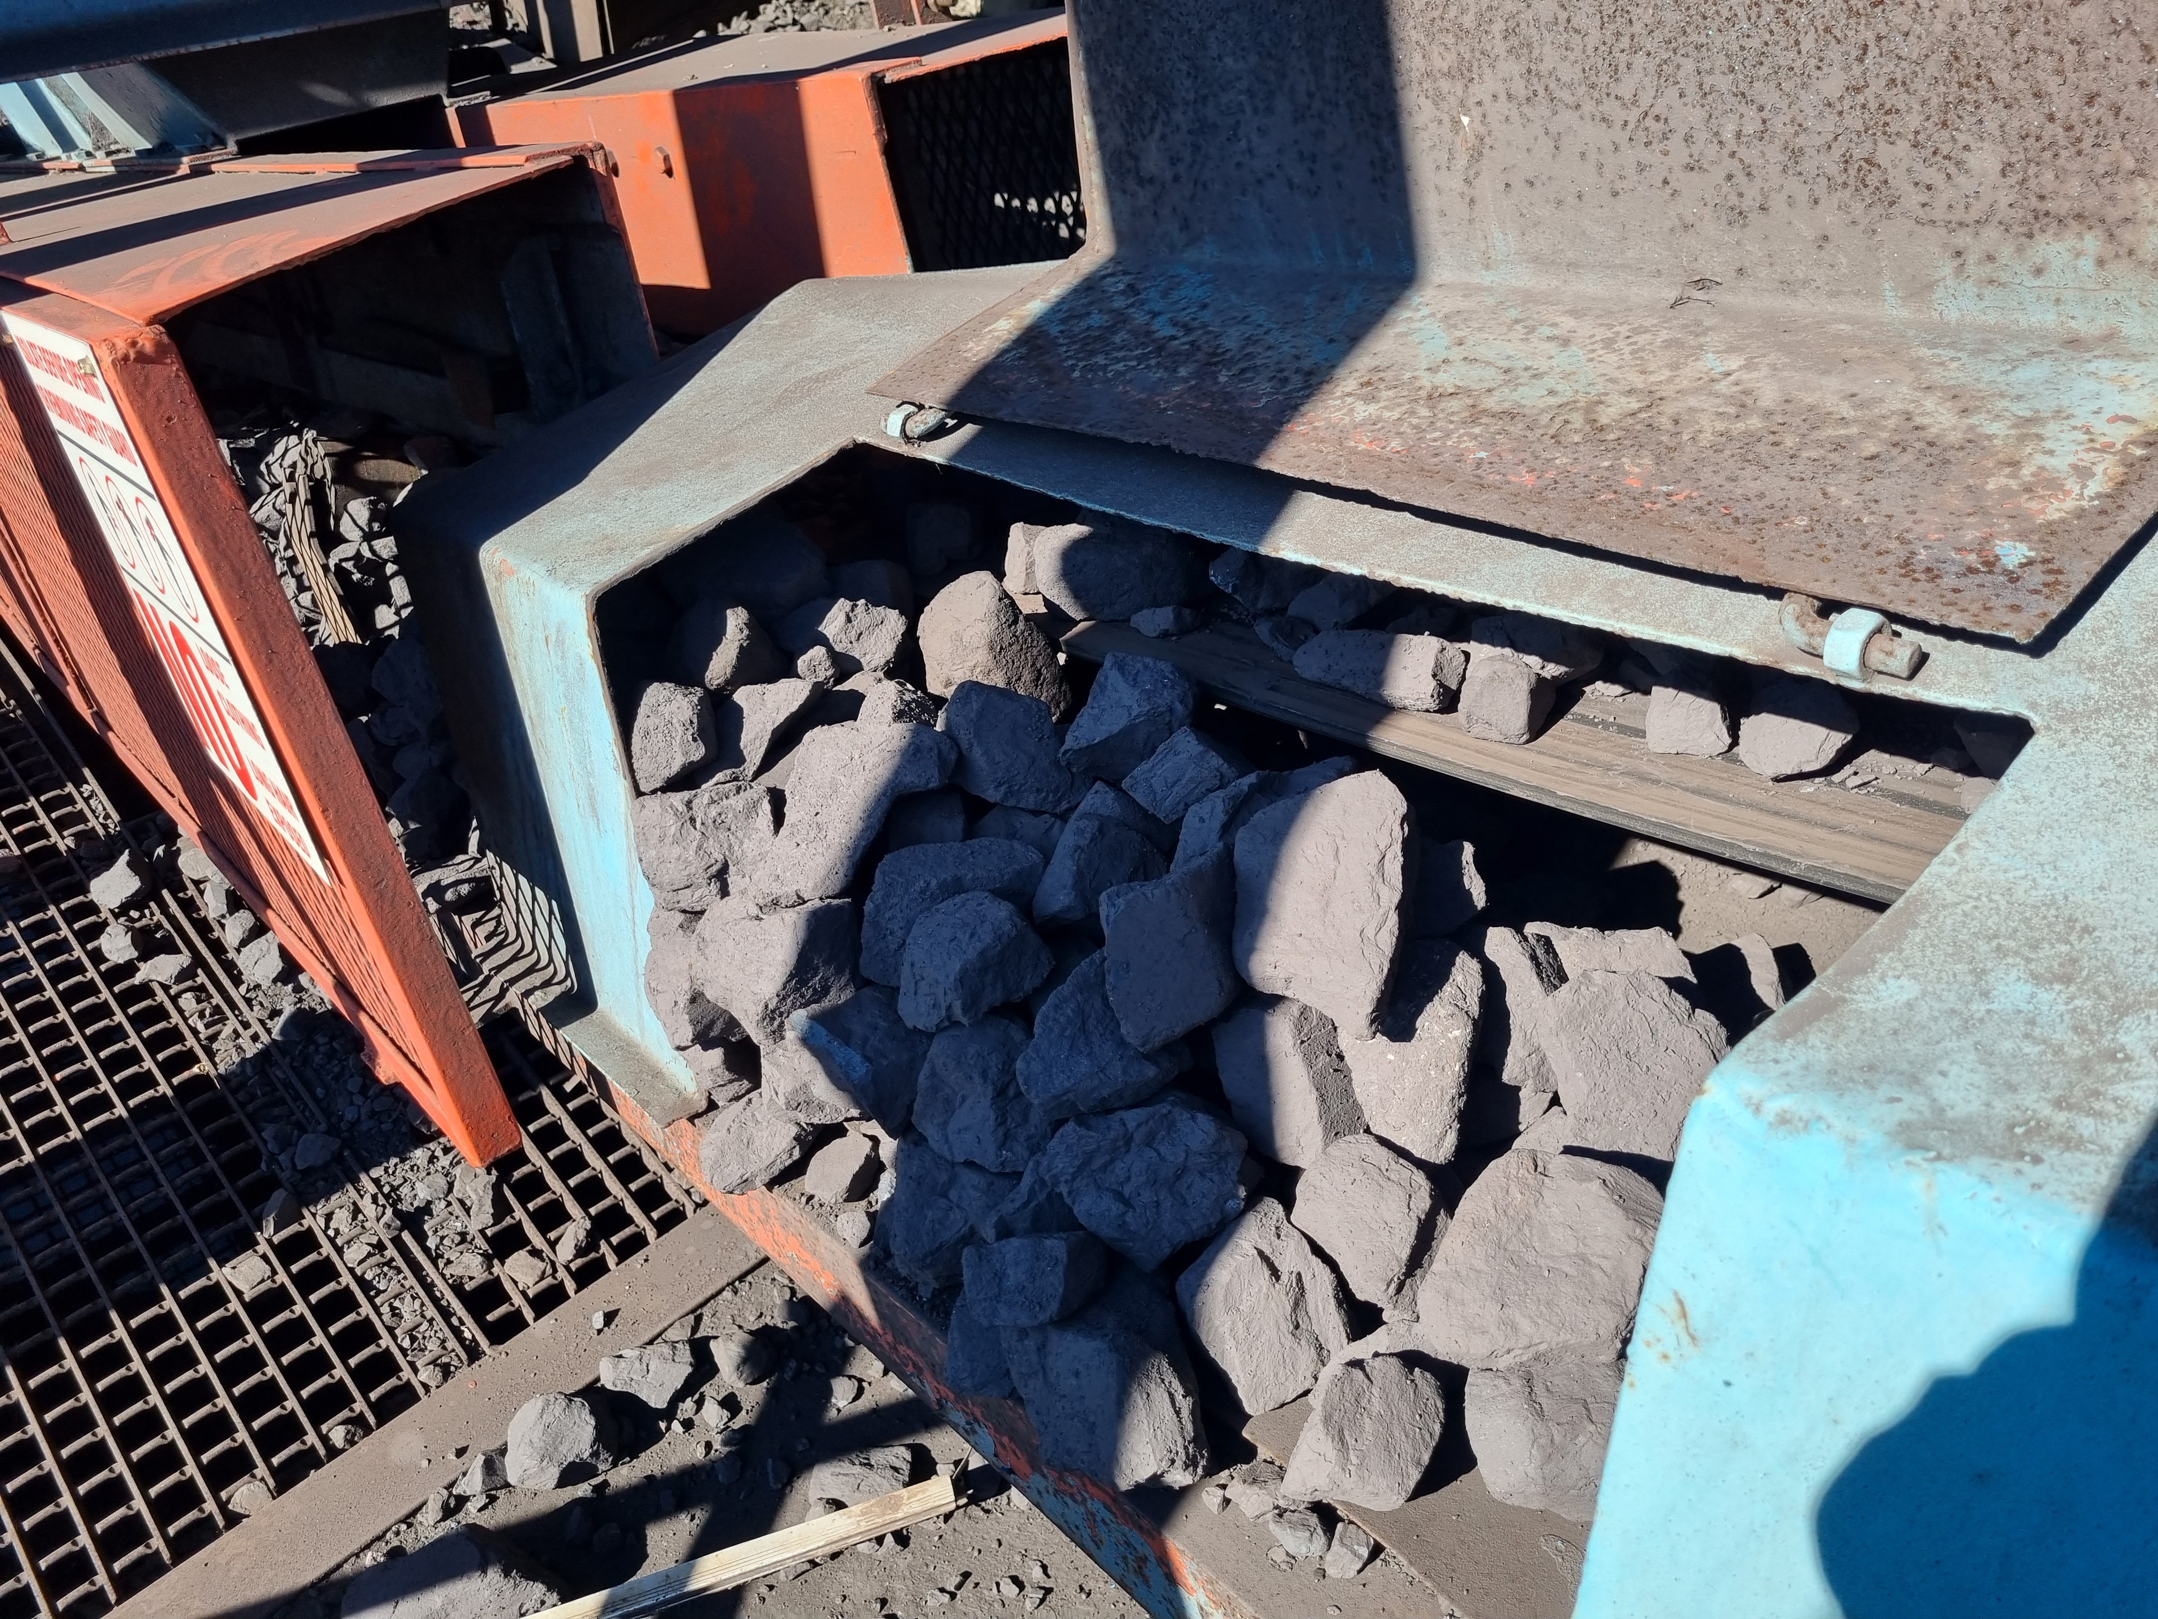  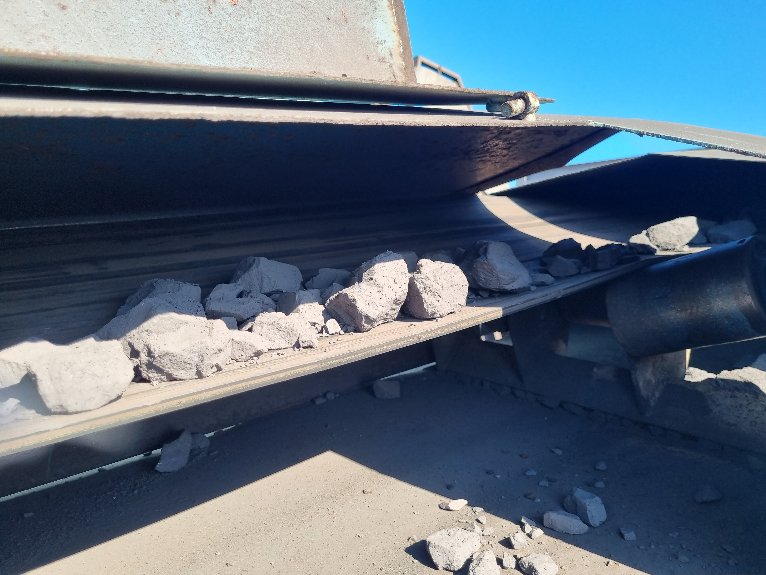  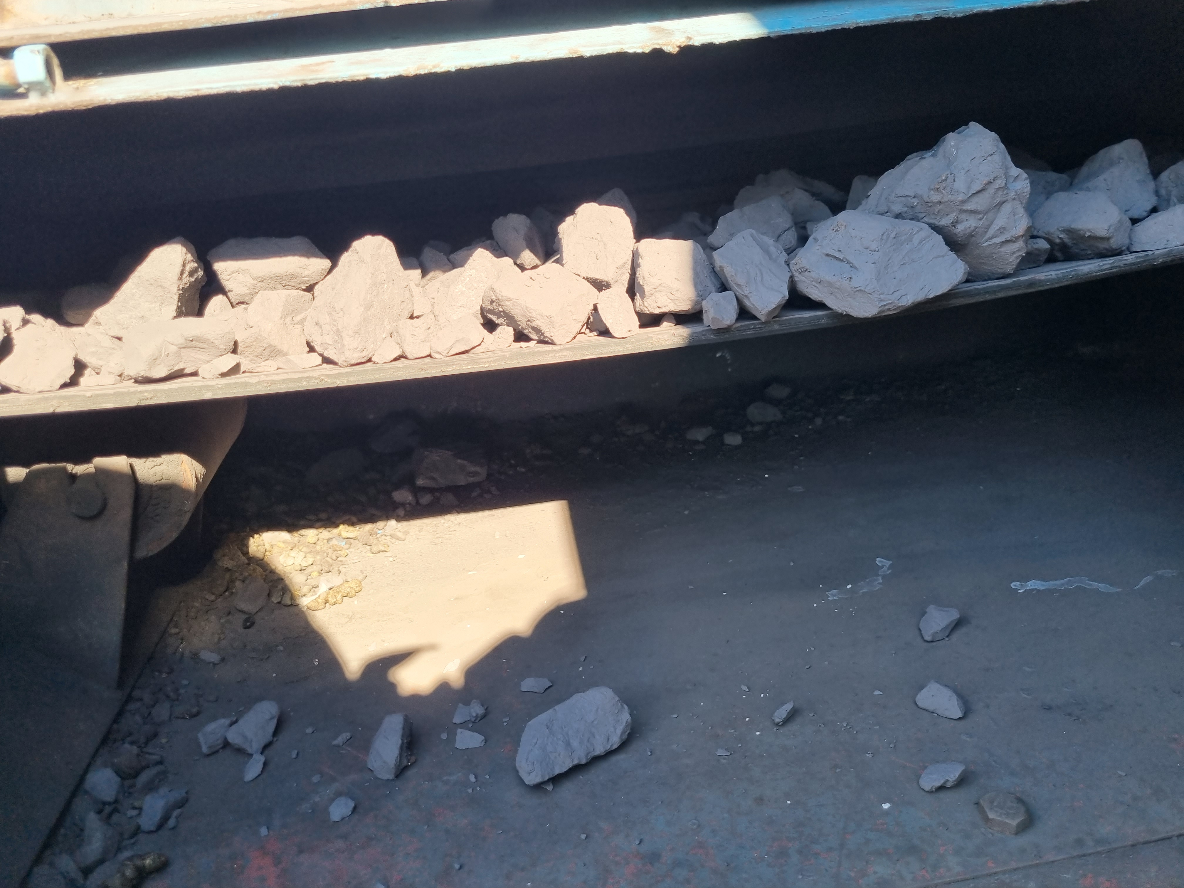
What variable can practically be adjusted to reduce throughput? | I would estimate the best answer would be to throttle the intake sections
What appears to be the main overload mechanism? | it’s a combination of factors; I suspect the belt being so small in relation the product leads to the product falling off the belt and then the product accumulates under the covers which intern pushes the belt off- center and to the one side and then that aggravates the situation even further and cause the spillage to happen even more. This is all a theory and no proof that is simply my own logical inference and observation theory.
How often does overloading / oversize loading occur? | continuously.

5.2 Proposed Side-Containment Function
The purpose of this section is to define what the proposed sideboards / containment rails are expected to do before final geometry is developed.
Containment function / requirement |  | Yes | No | Unknown | N/A
The primary purpose is to retain large lumps that move toward the edge of the belt. |  | X
The primary purpose is to keep the product stream centred on the belt. |  | X
The containment should act only in the loading / impact zone. |  |  | X
The containment should continue beyond the loading zone for a significant belt length. |  | X
The containment should be fixed and should not normally contact the belt. |  | X
Flexible skirting / sealing material should be used in addition to a rigid side structure. |  | X
The design must allow normal belt mistracking clearance without belt contact. |  | X
The design must prevent product becoming trapped between the belt and the containment. |  | X
The design must remain removable / accessible for maintenance. |  | X
Side containment should be treated as a secondary control after feed-rate correction, not as the primary solution. |  | X
Preferred engineering term for the proposed measure (if known) | Conveyor Side Skirt?
Approximate length required | the entire length of the conveyor.
Approximate height / product-retention requirement | +/- 250mm
Required belt / structure clearance | 5 to 10 mm
Loading-zone only or longer conveyor section? | Longer section
Preferred material / construction concept | rubber skirting
Maintenance / cleaning access requirement | Yes

5.3 Sample Conveyor 2 - Specific Follow-up
Sample Conveyor 2 question |  | Yes | No | Unknown | N/A
Spillage is primarily caused by excessive product quantity / belt loading. |  | x
Oversize lump dimensions are a material contributor. |  | x
Off-centre loading is a material contributor. |  | x
Belt mistracking is not a primary cause at Sample Conveyor 2. |  |  | x
Feed throttling / metering should be the first corrective action investigated. |  | x
Side containment should be investigated as an additional retention measure. |  | x
Photo reference(s) supporting the cause | LoadoutStationSample2-REF-001 through LoadoutStationSample2-REF-008 and LoadoutStationSample3-REF-001 through LoadoutStationSample3-REF-011 as the two conveyor systems are behavioral and dimensionally the same.
Preferred feed-control modification | unknown
Preferred side-containment concept | side support rails with rubber skirt that runs over the sides of the conveyor belt.
Any other contributing condition | Not verified but check the head and tail pully alignment and tensioning?

5.4 Sample Conveyor 3 - Specific Follow-up
Sample Conveyor 3 question |  | Yes | No | Unknown | N/A
The same loading / belt-capacity issue as Sample Conveyor 2 is present. |  | X
Belt mistracking independently contributes to product loss. |  | X
The mistracking makes the loading / containment problem worse. |  | X
Spillage can occur even when the belt is correctly tracked because the load itself is excessive. |  | X
Both feed control and belt-tracking correction are required. |  | X
Side containment should only be finalised after belt tracking is corrected. |  | X
Direction / nature of belt mistracking | 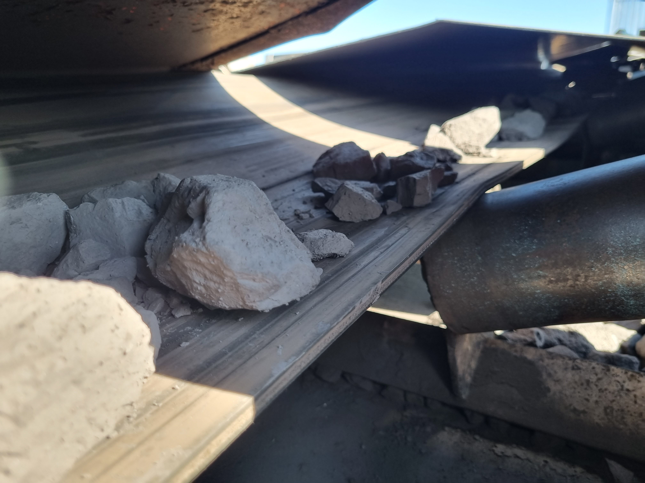  The image shows the mistracking offset to the one side showing that almost 50% of the required surface to carry the product is missing/offset making it very easy for most of the product to fall off the belt.
Is mistracking constant, intermittent, or load-dependent? | unknow as I have not observed it live operational conditionals to see if there are conditional changes, to determine if it is mistracking constant, intermittent, or load-dependent.
Probable mechanical source of mistracking | head and tail pully alignment and tensioning, another possible scenario is the belt is enclosed in a cover and when spillage occurs (product falls off the belt and since it has no where to escape to the buildup of spillage underneath pushes the belt to the side?
How mistracking changes, the observed spillage | drastically as the belt is so narrow the any mistracking will cause the belt to lave room for the product to fall off.
Working combined remedial approach | I don’t not fully understand what this question is asking?

6. Conveyor Belt Tracking / Alignment
This section focuses only on locations where the current contextual notes identify an actual or suspected alignment / tracking issue: L3, Sample Conveyor 3, and the U4 Tripper Car.

6.1 L3 Conveyor - Tail-End Offset
L3 tracking / alignment question |  | Yes | No | Unknown | N/A
The tail-end pulley / belt offset observed in LoadoutStationL3-REF-001 represents active belt mistracking. |  | x
The offset is present continuously during operation. |  | x
The offset changes with belt load. |  |  |  | x
The belt makes contact with structure / guarding because of the offset. |  |  |  | x
The offset contributes directly to current product spillage. |  | x
The offset contributes mainly to wear / mechanical risk rather than current product spillage. |  |  | x
Pulley alignment is suspected as the primary cause. |  |  |  | x
Idler / roller alignment is suspected as a contributing cause. |  |  | x
Structural alignment is suspected as a contributing cause. |  |  |  | x
The cause cannot yet be determined from the available evidence. |  |  |  | x
Observed direction / magnitude of offset | more than 50% of the lateral width of the conveyor
Known adjustment method at the tail end | Unknown, suspect adjustment bolts.
Probable cause | unknown
Evidence linking / not linking the offset to spillage | LoadoutStationSample3-REF-001 to LoadoutStationSample3-REF-012 photos
Working remedial action | none currently employed, that I know of.

6.2 U4 Conveyor - Tripper Car
U4 Tripper Car alignment question |  | Yes | No | Unknown | N/A
Tail-end pulley misalignment is fixed relative to the tripper-car structure. |  | X
The apparent misalignment changes with tripper-car position. |  |  |  | X
The tripper-car track / rail alignment may contribute. |  |  |  | X
Pulley bearing / mounting position may contribute. |  |  |  | X
Structural distortion / mounting geometry may contribute. |  |  |  | X
Belt tension / take-up behaviour may contribute. |  |  |  | X
Idler / training arrangement may contribute. |  |  |  | X
The mistracking becomes worse at specific positions along the travel path. |  |  |  | X
Product loss from one side of the belt is repeatable when the car reaches certain positions. |  | X
The pulley can be mechanically realigned using existing adjustment provisions. |  | X
A structural modification may be required to obtain correct alignment. |  |  |  | X
At what tripper-car position(s) is mistracking worst? | unknown
Does pulley alignment change as the car travels? | no
Suspected source of pulley misalignment | unknown
Existing pulley / bearing adjustment provisions | unknown
Track / rail condition relevant to alignment | unknown
Working corrective action | unknown
Verification required after correction | yes.

6.3 Tracking Verification Requirements
Verification requirement |  | Yes | No | Unknown | N/A
Belt position should be checked unloaded and under normal product load. |  | X
Alignment should be verified at the tail pulley. |  | X
Alignment should be verified through the carrying idlers. |  |  |  | X
Alignment should be verified through the return idlers. |  | X
Tripper-car belt tracking should be checked through its full travel range. |  | X
A fixed reference / centreline should be established for repeatable alignment checks. |  |  |  | X
Post-adjustment inspection should confirm that product remains centred and no longer escapes laterally. |  | X
Measurement / verification method proposed | Alignment should be verified through the carrying idlers.
Who should perform alignment verification | Section Supervisor
Any operating condition required during verification | the belt should be running and the tripper car moved back and forth to ensure the belt stays centered?

7. Screening Plant - Water Containment and Structural Condition

7.1 Screen / Chute Water Escape Mechanism
Water-containment question | Yes | No | Unknown | N/A
Water escapes during normal screening / washing operation. | X
Water escapes primarily from the side of the screen chute. | X
Water escapes through chute joints / seams. |  |  | X
Damaged or missing seals contribute. |  |  | X
Insufficient enclosure / cover height contributes. |  |  | X
Water spray direction / nozzle arrangement contributes. |  |  | X
Excessive water flow / volume contributes. |  |  | X
Screen vibration / movement contributes to water escape. |  |  | X
Product build-up / blockage causes water to overflow or divert. |  |  | X
Wear / corrosion has opened leakage paths. |  |  | X
The exact water escape path is visible and can be physically identified. | X
More than one escape mechanism is present. |  |  | X
Evidence basis for the responses in this subsection
Evidence basis |  | Yes | No | Unknown | N/A
Directly observed during inspection |  | X
Supported by photograph(s) |  | X
Supported by video evidence |  | X
Reported by operations / maintenance personnel |  | X
Engineering interpretation / inference from observed condition |  |  | X
Exact water escape location(s) | form inspection vantage/view point upper left side. The photos and video show the locations.
Normal vs abnormal operating condition when leakage occurs | The normal operating conditions the combined product is discharged into the screen which filters the product that already the correct size and the passes the product that is of correct size out to the conveyors that take the product out to the stick pile ready to be taken up by the load out station conveyor system. The fines pass through and is ultimately taking out via the cv09 conveyor to transport the fines to the fines stock pile for final handling. I am not aware of what the abnormal operating conditions would be.
Suspected primary cause | during the inspection the equipment was in operation and the water leakage was identified and observed, I was not able to get in close enough to the operating equipment while in operation to conclusively identify possible causes.
Current seals / covers / containment arrangement | unknown
Working modification to contain water and wet fines | none that I am aware of.
Drainage / clean-out requirement for any revised chute | the statement/question is unclear to mean what is required from me, not sure how to answer the question.

7.2 Consequence of Water / Wet-Fines Escape
Consequence / secondary effect |  | Yes | No | Unknown | N/A
Escaping water carries fines into surrounding plant areas. |  |  |  | X
Wet fines / slurry accumulate on floors or structural members. |  | X
Repeated wetting contributes to visible corrosion. |  | X
Water reaches load-bearing structural members. |  | X
Water reaches walkways / access areas. |  | X
Current drainage is inadequate. |  |  |  | X
Current housekeeping cannot prevent recurring wet-fines accumulation while leakage continues. |  | X
Main areas affected by water / slurry | structural environment around the screen on the side where the water escapes.
Most severe corrosion location(s) | floor support interface, as per photos.
Any known drainage problems | No none was identified or communicated to me during the inspection.

7.3 Damaged / Cut Screen Supports
Keep the distinction between observed fact and hypothesis. The supports being cut/damaged is an observed condition; the reason they were cut remains unconfirmed unless evidence is available.
Screen-support condition / status |  | Yes | No | Unknown | N/A
The affected members are load-bearing screen support members. |  | X
The cuts / damage were directly observed. |  | X
The reason for the cuts is confirmed. |  |  | X
The reason for the cuts is not confirmed. |  | X
It has been reported that the cuts were made to assist screen installation / replacement. |  |  | X
There is documentary / maintenance evidence supporting that explanation. |  |  | X
A formal structural assessment has already been completed. |  |  |  | X
Repair / replacement work has already been scheduled. |  |  |  | X
Temporary operational / access restrictions have been imposed because of the condition. |  |  | X
Replacement supports may need revised geometry to provide installation clearance. |  |  |  | X
Any revised support position / geometry requires structural calculation and approval. |  | X
Observed member(s) affected | surround the screen immediate area and supports.
Known reason for damage / cutting | not known, only deduced possible causes from past empierce.
Who provided the explanation (if reported) | I did.
Structural assessment status | unknown
Repair / replacement status | no imitated or started as far as I know,
Required installation-clearance change | unknown must still be quantified.
Qualified authority / discipline required for design approval | YES

8. L1 Conveyor / Tunnel - Structural Damage and Corrosion
Questionnaire V1 records structural damage around the L1 conveyor/tunnel and corrosion in the same general area. This section is intended to determine whether the damage is being caused by belt interaction, spillage/water exposure, another mechanism, or a combination of factors.
L1 structural question |  | Yes | No | Unknown | N/A
The conveyor belt has made physical contact with structural steel / tunnel components. |  | X
The contact is current / ongoing rather than historical only. NOTE Intermittent if the belt tracks off center. |  | x
Belt mistracking is suspected to cause the structural contact. |  | X
The structural damage could itself influence belt alignment / tracking. |  |  | X
Corrosion is present on the same structures. |  | X
Water / wet product exposure contributes to the corrosion. |  | X
Dry fines accumulation retains moisture and contributes to corrosion. |  | X
The structural damage and corrosion are separate issues with different causes. |  | X
A formal structural assessment has already been completed. |  |  |  | X
Repair work has already been scheduled. NOTEL Not Likely. |  |  |  | X
The damaged condition restricts maintenance or access. |  |  | X
Describe belt-to-structure contact location | 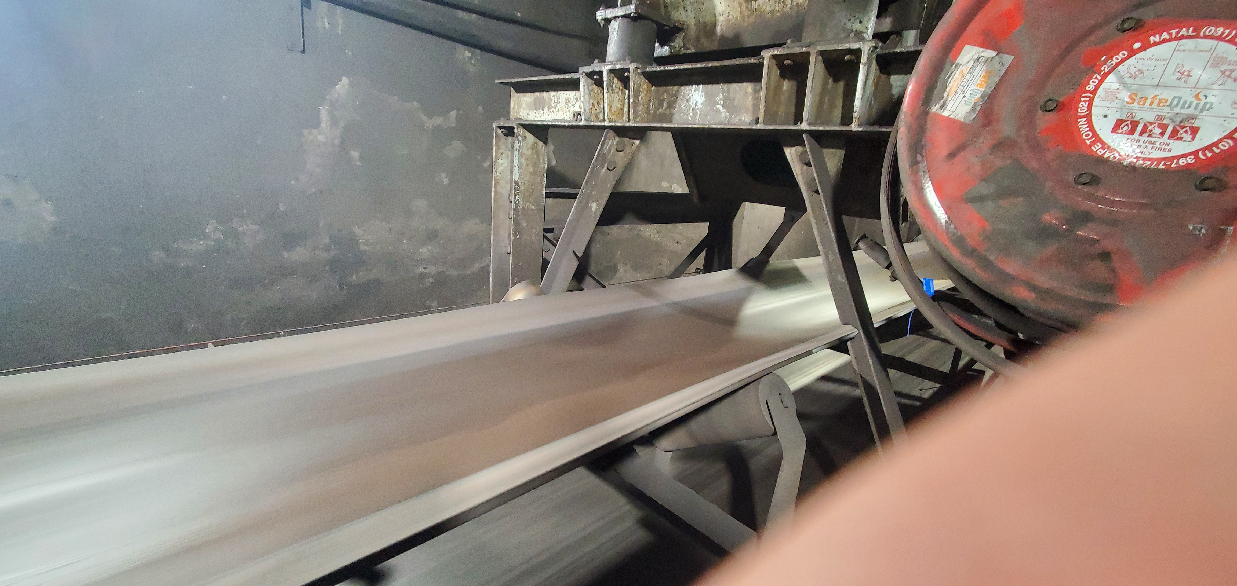  Belt rubbed up against the angular support to the left and the right of the belt, see the slots in the side supports.
Probable cause of structural damage | belt mis-tracking
Probable source of corrosion / moisture | accumulation of fines around the supports and that retain moisture.
Structural assessment status | requires repair as it is a main support structure.
Repair / maintenance status | unknown
Any required belt-alignment correction before structural repair | it currently not required as the belt is currently running centered as of last inspection.
Evidence references | The LoadoutStationL1-REF, Photo Series but specifically:  LoadoutStationL1-REF-007  LoadoutStationL1-REF-008  LoadoutStationL1-REF-009

9. Housekeeping, Spillage Recovery and Rehandling
Visible accumulation reflects both the rate at which material escapes the process and the way the plant currently removes / recovers that material. The purpose here is to document the current practice without confusing housekeeping with elimination of the source mechanism.
How is spilled material normally removed from the inspected areas?
Possible condition / response | Yes | No | Unknown | N/A
Manual shovelling | X
Brooms / manual sweeping |  |  | X
Wheelbarrow / hand trolley | X
Mobile loader / LHD / similar equipment |  |  | X
Vacuum / suction system |  | X
Water wash-down | X
Dedicated recovery conveyor / chute |  | X
Combination of methods |  |  | X
Method varies by area | X
Current method unknown |  |  |  | X
Other / additional condition (describe below) |  |  |  | X
How frequently is routine spillage / fines accumulation normally cleared?
Possible condition / response |  | Yes | No | Unknown | N/A
Continuous / during operation |  |  |  | x
Each shift |  |  |  | X
Daily |  |  |  | X
Several times per week |  |  |  | X
Weekly |  |  |  | X
Planned shutdown only |  |  |  | X
As required when accumulation becomes excessive |  | X
No fixed frequency / reactive only |  |  |  | X
Frequency unknown |  |  |  | X
Other / additional condition (describe below)
Housekeeping / recovery question |  | Yes | No | Unknown | N/A
Housekeeping removes the accumulation but the same spillage rapidly returns. |  | X
Cleaning is difficult because of restricted access below conveyors. |  |  |  | x
Confined-space controls materially complicate cleaning in some areas. |  | X
Wet fines / slurry require a different recovery method from dry fines. |  |  | X
Recovered product is normally reintroduced into the process. |  | X
Recovered material is sometimes discarded rather than reintroduced. |  | X
Rehandling of spilled material creates additional secondary spillage. |  |  | X
Current housekeeping resources are insufficient for the recurring spillage load. |  | X
Source-control improvements would materially reduce housekeeping demand. |  | X
Who is responsible for routine spillage removal? | Mine Personal
Typical cleaning frequency by major area | Unknown
Where recovered fines / product are placed | On the nearest belt section, but requires confirmation.
How recovered product is returned to the process | On the nearest belt section, but requires confirmation
Most difficult areas to clean | some under ground sections were the belt runs through very confined spaces.
Main access / confined-space restrictions | not sure what this statement/question is asking of me.
Any existing housekeeping standard / procedure | unknown but it does not look like it though.

10. Conveyor Trips, Restart Preparation and Event-Driven Spillage
This mechanism is episodic rather than continuously recurring. Product may be deliberately removed from a loaded conveyor to reduce restart load after a trip, blockage, or other operating event.
Trip / restart practice question |  | Yes | No | Unknown | N/A
There is a written procedure for clearing product from a loaded conveyor before restart. |  |  |  | X
The decision to remove product is controlled / authorised by a defined role. |  | X
Product is normally removed only when a loaded belt cannot restart safely / effectively. |  | X
Chute blockages are a common initiating event. |  | X
Mechanical / electrical belt trips are a common initiating event. |  | x
Overloading is a common initiating event. |  |  | X
Removed product is deposited directly alongside the conveyor. |  | X
A designated temporary containment / laydown area is used. |  |  | X
Removed material is later manually reintroduced into the process. |  | X
The rehandling process can itself create secondary spillage. |  |  | X
The event is infrequent compared with chronic carryback spillage. |  | X
Typical event that requires belt unloading | blockages in the chutes.
Where removed product is placed | along side the belt or nearest safe location
Method used to remove product | shovel and manual Labour.
Method used to reintroduce product | I have no communication on what the official method is but I would infer that it would be manual Labour with shovels.
Typical frequency of this type of event | unknown.
Existing written procedure / work instruction | unknown.
Potential improvement to temporary containment / rehandling | unknown.

11. Chronic vs Event-Driven Spillage Classification
For each condition, mark the description that best represents the normal behaviour. Use Unknown where there is insufficient operational history.
Condition | Continuous / Chronic | Recurring but Intermittent | Event-Driven Only | Unknown | Notes
System-wide dry-fines carryback | X
Wet carryback around CV09 | X
CV06 cleaner maintenance failure | X
CV15 wet/dry fines accumulation | X
Sample Conveyor 2 overloading / containment loss | X
Sample Conveyor 3 overloading / mistracking | X
L3 tail-end offset / mistracking |  |  |  | X
U4 Tripper Car mistracking / lateral product loss |  |  |  | X
Screen water / wet-fines leakage | X
L1 belt / structural interaction |  |  |  | X
Trip / restart product clearing |  |  |  | X

12. Cross-System Root-Cause Themes
This section is intended to test whether the evidence now supports several broader root-cause themes across the plant. These are not final report conclusions until the supporting responses and evidence are consolidated.
Potential cross-system root-cause theme |  | Yes | No | Unknown | N/A
Inadequate belt-cleaner / scraper design is a system-wide contributor. |  | X
Inadequate scraper maintenance is a system-wide contributor. |  | X
Poor containment of material at discharge / transfer points is a system-wide contributor. |  | X
Belt mistracking / alignment defects are a recurring contributor to solid-product loss. |  |  |  | X
Feed-rate / loading control is a contributor at the sample conveyors. |  |  |  | X
Water containment around the screens is a distinct process-design / maintenance issue. |  |  |  | X
Structural deterioration is both a consequence of spillage and an independent maintenance risk in some areas. |  | X
Housekeeping is mainly treating the result of recurring spillage rather than eliminating the source. |  | X
Event-driven trip/restart spillage requires a separate operational-control approach from chronic carryback. |  | X
A small number of standardised engineering controls could address similar failure mechanisms across multiple conveyor sections. |  | X
Three most important systemic causes currently identified | ineffective scrapper design that allows fines to pass the discharge side of the conveyor and return on the return side of the belt. Misaligned head or tail pully affecting belt tracking.
Three most important local / asset-specific causes | Unknown, I don not understand what this statement/question is wanting to know.
Controls that could be standardised across multiple conveyors | the proposed redesign of the scrapper implementation at the head/discharge section of the conveyor that ensures that fines/wet fines are efficiently transferred over to the
Issues requiring further inspection / measurement before a recommendation can be finalised | Sample Conveyor Head and tail pullies alignment and tension and the volume being feed into the sample conveyor systems and the ratio of the product size to the belt width/capacity for the sample conveyor systems.
Any new issue discovered while completing Questionnaire V2 | No

13. Questionnaire V2 Completion Summary
Sections fully answered | to the best of my ability and knowledge.
Sections still partly Unknown | that we can derive from the sections that I have answered. That can be reviewed, if need be,
Additional photos / videos that should be added | yes two namely UGU4-REF-011 and UGU4-REF-012 to the U4 Collection of photos/video reference collection. They show the different cleaner/ scrapper design.
People / departments whose input is still required | None
Technical measurements / drawings still required | Make Contextual drawings of the proposed scrapper design and side skirting rails.
Suggested focus for Questionnaire V3 / next iteration | none that I can think of

