ISS  INSPECTION &  SPECIFICATION  SERVICES CC. | CONTROLLED ENGINEERING INSPECTION REPORT  HEAD SHEAVE MASTER TEMPLATE  Professional reporting framework for technical review, defect traceability and maintenance action tracking.
MECHANICAL ASSET CONDITION ASSESSMENT
Head Sheave Inspection Report
Inspection report · engineering assessment · maintenance recommendations
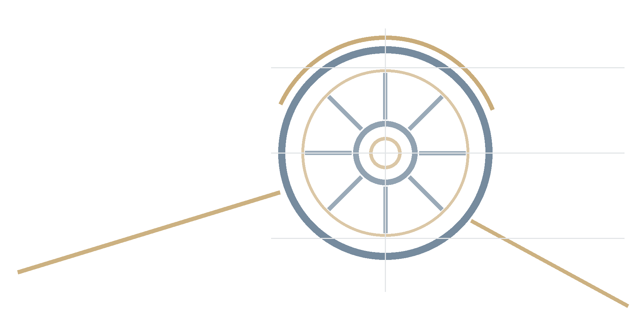 | PROJECT IMAGE / ARRANGEMENT  Replace this technical motif with a client-approved photograph, shaft arrangement or headgear image for an issued report.  Recommended crop: 16:9 landscape

Client | [Client Name] | Mine / site | [Mine / Site]
Area / system | [Area / System] | Asset / asset group | [Asset Name]
Report number | [Report Number] | Revision | [Revision]
Issue date | [Issue Date] | Inspection date | [Inspection Date]
Issue status | [Issue Status] | Prepared by | [Prepared By]
Reviewed by | [Reviewed By] | Approved by | [Approved By]
Client reference | [Client Reference] | ISS job number | [ISS Job Number]
CONFIDENTIALITY & RELIANCE
Prepared for the named client and stated purpose only. Reliance, distribution and operational decisions remain subject to the agreed scope, contractual requirements, stated limitations and responsible engineering review.

Inspection & Specification Services cc. · Reg. No. 1990/020258/23 · 24 Jonkershoek Street, Vaalpark, 1947
Office: +27 (016) 971-2259 · Cell: +27 (083) 442-7913 · iss@inspecserv.co.za

Controlled Document Notice
This master template provides a controlled, client-neutral structure for head sheave inspection reporting. It is intended to be populated with verified project data, inspection evidence, engineering assessment and recommendations before issue.
HOW TO USE THIS TEMPLATE
Complete the highlighted content controls on the cover, populate the project-specific tables, duplicate the repeatable asset and finding modules as required, remove unused instructional text, and update all fields using Ctrl+A then F9 before issue.

The report findings are limited to the agreed scope, access conditions, inspection methods, information supplied and evidence recorded. Visual inspection does not establish the internal condition of bearings, shafts, welds or other inaccessible components unless supporting examination or test evidence is recorded.
No external standard, acceptance criterion, measurement or NDT result may be included unless it has been verified for the specific project.
Document Control
Table 1 - Document control and report metadata
Report title | Head Sheave Inspection Report
Report number | [Report Number]
Revision | [Revision]
Issue status | [Issue Status]
Issue date | [Issue Date]
Client | [Client Name]
Mine / site | [Mine / Site]
Area / system | [Area / System]
Asset / asset group | [Asset Name]
Template version | 2.1

Document Authorization Record
Front-matter authorization identifies the document roles. Final technical issue sign-off remains at the end of the main report.
Table 2 - Document authorization record
Role | Name | Title / discipline | Email | Date | Initials
Prepared by | [Prepared By] | [Title / Discipline] | [Email] | [Date]
Reviewed by | [Reviewed By] | [Title / Discipline] | [Email] | [Date]
Approved by | [Approved By] | [Title / Discipline] | [Email] | [Date]

Revision History
Table 3 - Revision history
Revision | Date | Issue status | Description of change | Prepared by | Approved by
[Revision] | [Issue Date] | [Issue Status] | Initial issue / change description | [Prepared By] | [Approved By]

Distribution List
Table 4 - Controlled distribution list
Recipient | Role | Organisation | Email | Format | Distribution date
[Recipient] | [Role] | [Client Name] | [Email] | PDF / DOCX | [Date]
[Recipient] | ISS file copy | Inspection & Specification Services cc. | iss@inspecserv.co.za | PDF / DOCX | [Date]

Table of Contents
Word field: update before issue using Ctrl+A then F9. Main report headings and appendices are included; front-matter control pages are excluded.
1 Purpose 7
2 Executive Summary 7
2.1 Executive Dashboard 7
3 Introduction 7
4 Scope of Inspection 7
5 Inspection Limitations 8
6 Applicable Standards and References 8
7 Definitions and Abbreviations 8
8 Responsibilities 9
9 Asset Information 11
9.1 Repeatable Asset Data Sheet 11
10 Inspection Team and Equipment Used 11
10.1 Inspection Team 11
10.2 Inspection Equipment 11
11 Inspection Methodology 11
12 Inspection Criteria 12
13 Condition Rating, Defect Severity and Maintenance Priority 12
14 Engineering Sketches and Reference Arrangement 13
15 Asset Descriptions 15
15.1 Repeatable Asset Description 15
16 Inspection Findings 15
16.1 Repeatable Sheave Finding Module 15
17 Summary of Defects 16
18 Inspection Observation Log 17
19 Engineering Assessment 17
20 Recommendations 17
21 Conclusion 17
22 Technical Review and Report Issue Sign-off 17
Appendix A - Photographic Register 19
A.1 Photographic Evidence Page Template 19
Appendix B - Inspection Checklist 20
Appendix C - Measurements and Dimensional Records 21
Appendix D - NDT Results 22
Appendix E - Drawings, Schematics and Reference Information 23
Appendix F - Supporting Documentation 24

List of Figures
Generated from Word-native Figure captions.
Figure 1 - Head sheave arrangement and inspection orientation placeholder 13
Figure 2 - Photographic evidence sheet - PHOTO-001 / DEF-001 16
List of Tables
Generated from Word-native Table captions. All captions use continuous SEQ numbering.
Table 1 - Document control and report metadata 2
Table 2 - Document authorization record 2
Table 3 - Revision history 3
Table 4 - Controlled distribution list 3
Table 5 - Executive asset summary matrix 7
Table 6 - Executive recommendation register 7
Table 7 - Assets and activities included in scope 7
Table 8 - Scope exclusions 8
Table 9 - Inspection limitations register 8
Table 10 - Applicable standards and references register 8
Table 11 - Definitions and abbreviations 8
Table 12 - Responsibility and interface matrix 9
Table 13 - Head sheave asset data sheet 11
Table 14 - Inspection team register 11
Table 15 - Inspection equipment and calibration register 11
Table 16 - Inspection methodology matrix 12
Table 17 - Inspection criteria and evidence requirements 12
Table 18 - Condition rating 12
Table 19 - Defect severity classification 13
Table 20 - Maintenance priority guidance 13
Table 21 - Inspection orientation key 13
Table 22 - Asset description summary 15
Table 23 - Finding classification and action 16
Table 24 - Photographic evidence assessment 16
Table 25 - Consolidated defect register 16
Table 26 - Inspection observation and evidence log 17
Table 27 - Detailed recommendation and action register 17
Table 28 - Technical review and issue sign-off 17
Table 29 - Photographic register 19
Table 30 - Head sheave inspection checklist 20
Table 31 - Measurements and dimensional records 21
Table 32 - NDT results register 22
Table 33 - Drawings and schematics register 23
Table 34 - Supporting documentation register 24


Purpose
Confirm the stated purpose against the client request and agreed inspection scope.
This report documents the inspection of [Asset / asset group] at [Mine / site] for [Client]. It records the inspection scope, limitations, observations, engineering assessment, defect classification and recommendations arising from the inspection completed on [Inspection date].

Executive Summary
Complete this section last. Summarise only outcomes supported by the detailed findings and evidence.
Provide a concise management-level summary of the assets inspected, overall condition, material defects, risk implications, immediate actions and planned maintenance requirements.

Executive Dashboard
ASSETS INSPECTED  [Count] | OVERALL CONDITION  [Rating] | HIGHEST PRIORITY  [P1-P4] | OPEN ACTIONS  [Count]

Table 5 - Executive asset summary matrix
Asset | Asset tag / ID | Overall condition | Highest severity | Priority | Open findings | Executive comment
[Asset 1] | [ID] | [Rating] | [Level] | [P#] | [Count] | [Summary]
[Asset 2] | [ID] | [Rating] | [Level] | [P#] | [Count] | [Summary]
[Asset 3] | [ID] | [Rating] | [Level] | [P#] | [Count] | [Summary]

Table 6 - Executive recommendation register
Action ID | Asset | Recommended action | Priority | Responsible discipline | Target / shutdown | Status
REC-001 | [Asset] | [Recommended action] | [P#] | [Discipline] | [Target] | Open
REC-002 | [Asset] | [Recommended action] | [P#] | [Discipline] | [Target] | Open

Introduction
Inspection & Specification Services cc. was requested to inspect and document the condition of [Asset / asset group] at [Mine / site]. The report provides an evidence-based technical record for engineering review, maintenance planning and follow-up action tracking.
Describe the operational role of the head sheaves, the reason for the inspection, the inspection date or shutdown window, the client request and any relevant asset history supplied for review.

Scope of Inspection
List only assets and activities included in the agreed scope. Record all exclusions explicitly.
Table 7 - Assets and activities included in scope
Asset | Asset tag / ID | Location | Inspection activity | Access / operating state | Comment
[Asset] | [ID] | [Location] | Visual / measurement / alignment / NDT | Stopped / isolated / operating | [Comment]

Table 8 - Scope exclusions
Excluded item | Reason / access constraint | Assessment implication | Recommended follow-up
[Excluded item] | [Reason] | [Impact on confidence or completeness] | [Follow-up]

Inspection Limitations
The inspection was limited by the recorded access, operating condition, visibility, cleanliness, disassembly status, information supplied and inspection methods. Internal bearing condition must not be inferred from external visual inspection unless supporting evidence is available.
NDT results may be reported only where the method, scope, operator or report reference and result evidence are available.
Table 9 - Inspection limitations register
Limitation ID | Affected asset / area | Limitation | Impact on assessment | Follow-up requirement
LIM-001 | [Asset / area] | [Limitation] | [Impact on finding confidence] | [Follow-up]

Applicable Standards and References
Do not invent standards or acceptance limits. Include only verified procedures, drawings, OEM data and external references.
Table 10 - Applicable standards and references register
Ref. ID | Type | Title / description | Document number | Revision / date | Source | Status
REF-001 | Drawing / OEM / procedure / standard | [Title] | [Number] | [Revision] | [Source] | Verified / not supplied

Definitions and Abbreviations
Table 11 - Definitions and abbreviations
Term | Definition
IR | Inspection Report
ISS | Inspection & Specification Services cc.
NDT | Non-destructive testing
UT | Ultrasonic testing
MPI | Magnetic particle inspection
OEM | Original equipment manufacturer
P1-P4 | Maintenance priority classifications defined in this report

Responsibilities
Table 12 - Responsibility and interface matrix
Party / role | Responsibility | Report interface / deliverable
Client management / responsible site authority | Provide scope confirmation, access, isolation, asset information, operational context and formal site decisions. | Review findings, determine operational response and authorise corrective actions.
ISS inspector / project manager | Perform the agreed inspection, record evidence, compile findings and recommendations within the stated limitations. | Issue draft and final inspection report.
ISS reviewing engineer | Review technical content, evidence traceability, engineering assessment and recommendations. | Technical review and approval.
Maintenance contractor / specialist, where appointed | Verify repair scope, execute approved work and provide completion evidence. | Repair records, measurements, NDT and close-out evidence.

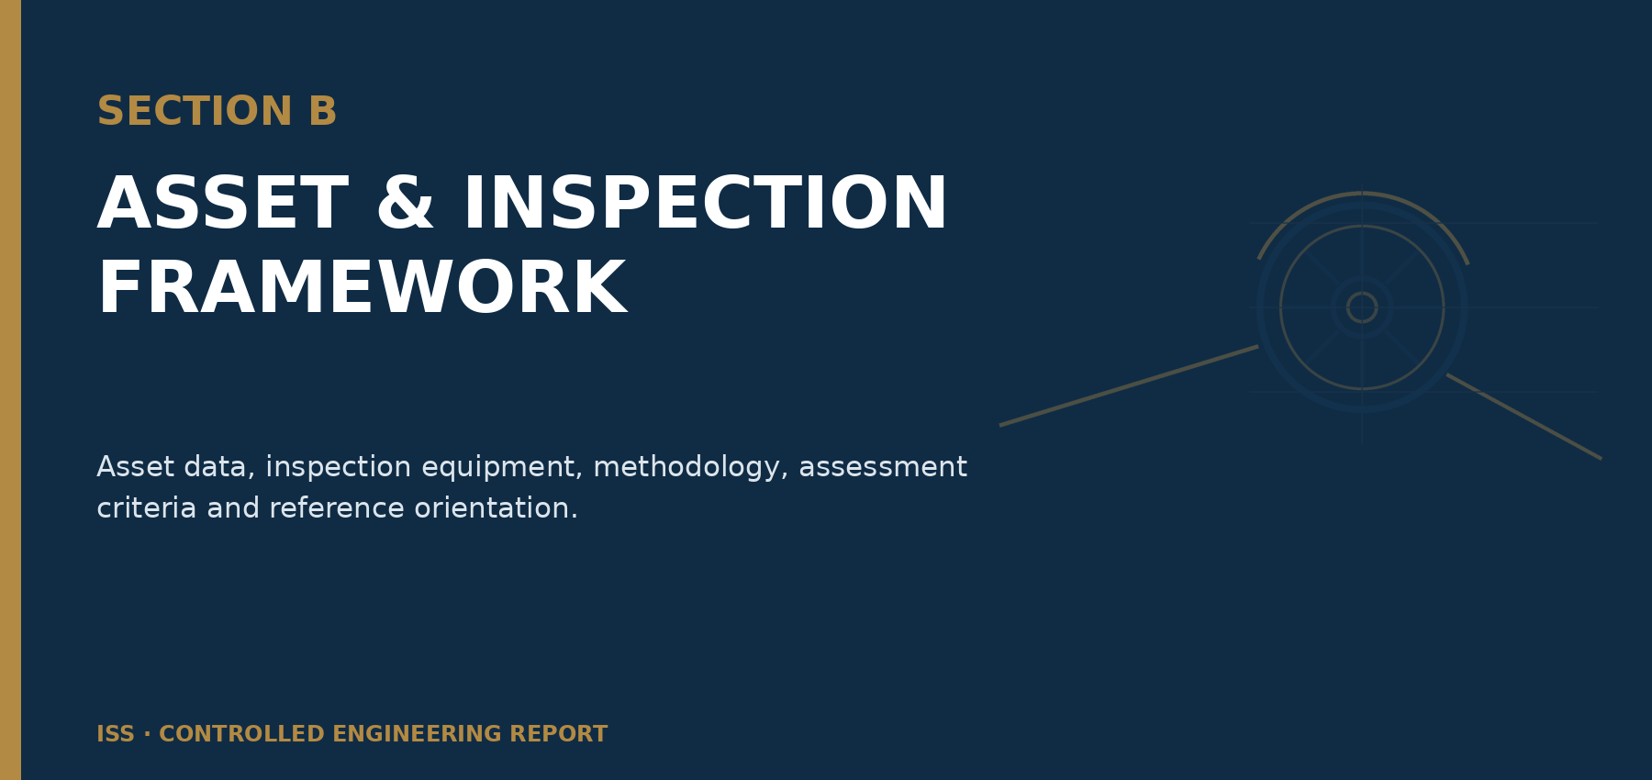

Asset Information
Duplicate the asset data sheet for each sheave. Use client asset-register and OEM information where available; mark unknown values as “Not supplied”.

Repeatable Asset Data Sheet
Table 13 - Head sheave asset data sheet
Asset name | [Asset name] | Asset tag / ID | [Tag / ID]
Location | [Location] | Service / duty | [Service]
Manufacturer / OEM | [OEM] | Model / serial number | [Model / serial]
Sheave diameter | [Diameter] | Number of grooves | [Count]
Rope diameter | [Rope diameter] | Groove profile / radius | [Profile / radius]
Bearing type | [Bearing type] | Shaft / axle reference | [Reference]
Design speed / duty | [Design data] | Commissioned / installation date | [Date]
Drawing / OEM reference | [Reference] | Inspection date | [Date]
Inspector(s) | [Name(s)] | Overall condition rating | [Rating]

Inspection Team and Equipment Used

Inspection Team
Table 14 - Inspection team register
Name | Role / discipline | Company | Competency / authorisation | Site induction / permit reference
[Name] | [Role] | ISS / Client / Contractor | [Competency] | [Reference]

Inspection Equipment
List only equipment actually used. Record calibration data where measurement accuracy or test validity depends on it.
Table 15 - Inspection equipment and calibration register
Equipment | Purpose | Manufacturer / model | Equipment ID | Calibration certificate | Calibration due | Accuracy / range | Comment
[Equipment] | [Purpose] | [Make / model] | [ID] | [Certificate] | [Due date] | [Accuracy / range] | [Comment]

Inspection Methodology
The inspection methodology may combine visual examination, photographic documentation, dimensional measurement, rope groove assessment, rope tracking and alignment observation, structural inspection, fastener inspection, corrosion and coating assessment, and NDT where included in the agreed scope.
Table 16 - Inspection methodology matrix
Method ID | Inspection activity | Purpose | Evidence captured | Acceptance / reference basis | Limitation / note
M-01 | Visual inspection | Record visible condition, damage, wear and anomalies | Observation notes and photographs | Verified reference or engineering assessment | [Limitation]
M-02 | Rope groove assessment | Assess visible groove profile, contact and wear indicators | Photographs / gauge / measurement | OEM / verified criterion / comparative evidence | [Limitation]
M-03 | Rope tracking and alignment observation | Record visible tracking indicators and abnormal contact evidence | Photographs / alignment readings | Verified drawing / measurement basis | [Limitation]

Inspection Criteria
Table 17 - Inspection criteria and evidence requirements
Attribute | Assessment basis | Evidence required | Typical record | Reference / note
Rope groove and rim condition | Visible wear, damage, profile concerns and abnormal contact evidence | Photographs and measurements where performed | Finding / defect ID | [Reference]
Rope tracking and alignment | Visible tracking evidence, contact pattern, rope approach and departure | Photographs, alignment observations and readings where performed | Finding / defect ID | [Reference]
Hub, shaft and bearing housing | Visible external condition, security, leakage and damage indicators | Photographs / notes / temperature or vibration data where included | Observation ID | [Reference]
Structural components and supports | Visible deformation, cracking indicators, corrosion, coating and fastener condition | Photographs / NDT / measurements where included | Finding / defect ID | [Reference]

Condition Rating, Defect Severity and Maintenance Priority
The following classifications support consistent reporting and maintenance planning. They do not replace the mine’s formal risk assessment, statutory obligations or decisions by the responsible site authority.
Table 18 - Condition rating
Rating | General meaning | Typical reporting response
Excellent | No material defect observed within the inspection scope. | Record condition and routine inspection interval.
Good | Minor condition observations only. | Monitor through routine maintenance and inspection.
Fair | Serviceable with deterioration requiring planned attention. | Plan maintenance, measurement or enhanced monitoring.
Poor | Significant deterioration requiring priority engineering or maintenance review. | Define corrective action and verification requirements.
Critical | Potentially unacceptable condition requiring immediate responsible-site review. | Escalate immediately and determine operational response.
Table 19 - Defect severity classification
Level | Classification | Definition | Default action
Level 1 | Minor | Low-significance observation requiring monitoring or routine correction. | Record and monitor.
Level 2 | Moderate | Defect requiring planned corrective action. | Schedule corrective work.
Level 3 | Significant | Defect requiring priority engineering review and corrective action. | Repair at the next suitable shutdown or earlier.
Level 4 | Critical | Potentially critical condition requiring immediate responsible-site review. | Immediate escalation and corrective action.

Table 20 - Maintenance priority guidance
Priority | Meaning | Typical timeframe guidance | Required response
P1 | Immediate | Before continued operation where required by responsible review. | Escalate and define immediate controls / corrective action.
P2 | Urgent | Earliest practicable maintenance opportunity. | Plan and execute short-term corrective action.
P3 | Planned | Next suitable scheduled shutdown or maintenance cycle. | Include in approved maintenance plan.
P4 | Monitor | Routine inspection and maintenance interval. | Trend and verify at future inspection.

Engineering Sketches and Reference Arrangement
Insert a verified shaft arrangement, rope path, inspection orientation, asset numbering key or annotated schematic. Clearly identify drawing status and source.

[INSERT VERIFIED ARRANGEMENT / ENGINEERING SKETCH]
Figure 1 - Head sheave arrangement and inspection orientation placeholder
Table 21 - Inspection orientation key
Reference | Description | Direction / datum | Source drawing / photograph
A | [Reference location] | [Direction / datum] | [Reference]
B | [Reference location] | [Direction / datum] | [Reference]

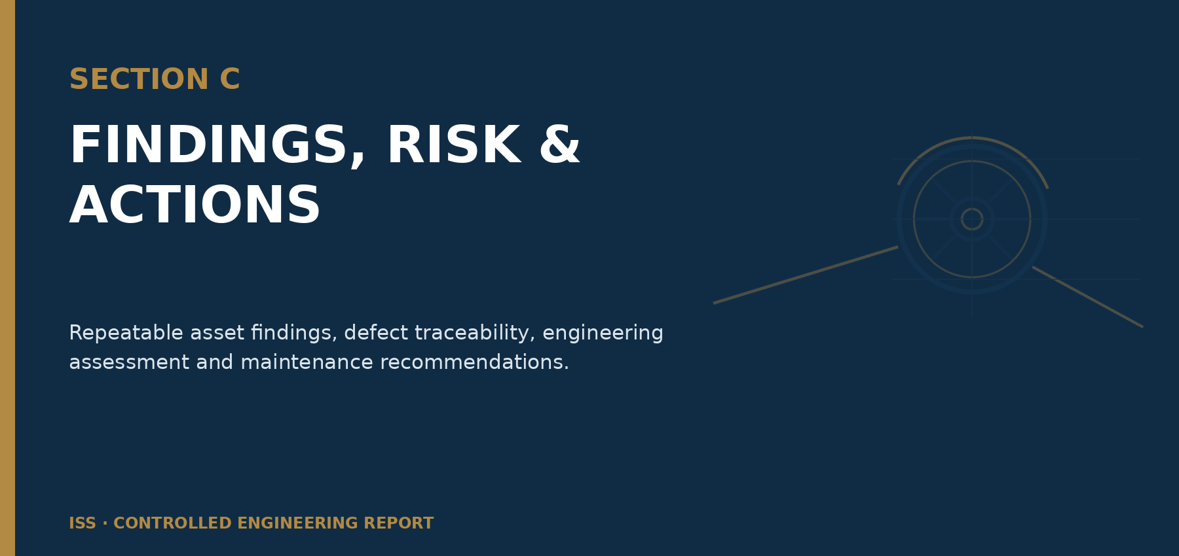

Asset Descriptions
Provide a concise operational and physical description for each sheave before presenting detailed findings.

Repeatable Asset Description
[Asset name] is located at [Location] and performs [Service / duty]. The asset comprises [principal components]. Relevant rope path, sheave arrangement and identification references are provided in [Drawing / Figure reference].
Table 22 - Asset description summary
Field | Entry
Asset | [Asset name / tag]
Operational duty | [Duty]
Location | [Location]
Principal components | [Description]
Reference drawing / figure | [Reference]
Inspection access state | [State]

Inspection Findings
Duplicate the following module for each sheave and each material defect. Assign unique defect IDs in the format DEF-001, DEF-002, etc. Observations and engineering assessment must remain separate.

Repeatable Sheave Finding Module
Defect ID | DEF-001 | Asset | [Asset name / tag]
Finding title | [Concise finding title] | Location | [Location / component]

Asset Overview and General Condition
[Asset name / tag] | [Location] | Overall condition: [Condition rating]. State the evidence supporting the rating.

Inspection Observation
OBSERVATION ONLY
[Record visible, measured or tested evidence. Do not include causal interpretation or unsupported conclusions in this subsection.]

Rope Groove and Rim Condition
[Observation] · [Measurement, if performed] · [Photo / evidence reference] · [Limitation]

Rope Tracking and Alignment
[Observation] · [Alignment / approach / departure evidence] · [Photo / evidence reference] · [Limitation]

Hub, Shaft and Bearing Housing
[External visible condition] · [Leakage / security / temperature / vibration evidence if included] · [Limitation]

Structural Components, Fasteners and Guards
[Observation] · [Photo / NDT / measurement reference] · [Limitation]

Corrosion, Coating and Housekeeping
[Observation] · [Extent / location] · [Impact on inspection visibility or maintenance]

Engineering Assessment
ENGINEERING INTERPRETATION
[Interpret the recorded evidence within the stated scope and limitations. Identify likely mechanisms and implications without declaring continued operation safe unless appropriately supported and approved.]

Defect Classification and Recommended Action
Table 23 - Finding classification and action
Defect ID | Condition rating | Severity | Priority | Recommended action | Responsible discipline | Verification requirement
DEF-001 | [Rating] | [Level] | [P#] | [Action] | [Discipline] | [Verification]

Photographic Evidence Sheet
[INSERT PHOTOGRAPH] | Photo ID  PHOTO-001  Defect ID  DEF-001  Asset  [Asset]  Component / location  [Location]  View direction  [Direction]  Date / time  [Date / time]
Caption
[Evidence-based photo caption]
Figure 2 - Photographic evidence sheet - PHOTO-001 / DEF-001
Table 24 - Photographic evidence assessment
Observation | Engineering assessment | Recommended action
[Observation supported by the photograph] | [Interpretation within scope and limitations] | [Action / priority / verification]

Summary of Defects
Table 25 - Consolidated defect register
Defect ID | Asset | Component / location | Defect / observation | Condition | Severity | Priority | Evidence | Responsible discipline | Status
DEF-001 | [Asset] | [Location] | [Observation] | [Rating] | [Level] | [P#] | PHOTO-001 | [Discipline] | Open

Inspection Observation Log
Table 26 - Inspection observation and evidence log
Observation ID | Asset | Location | Observation | Evidence reference | Condition rating | Related defect ID | Status
OBS-001 | [Asset] | [Location] | [Observation] | PHOTO-001 / measurement / NDT | [Rating] | DEF-001 | Open

Engineering Assessment
Consolidate the engineering interpretation of the individual findings. Address observed mechanisms, likely implications, data confidence, limitations and the need for specialist verification.
Interpret the recorded observations and evidence within the stated scope and limitations. Explain likely wear, alignment, fatigue, corrosion, fastening or operating mechanisms only where supported by evidence. Distinguish confirmed conditions from probable or possible mechanisms.
State where additional measurement, alignment survey, rope examination, bearing assessment, NDT, structural analysis or OEM review is required before a final maintenance or operational decision.

Recommendations
Every recommendation must link to an observation or defect ID and identify action, priority, responsible discipline, target, verification and close-out evidence.
Table 27 - Detailed recommendation and action register
Action ID | Related defect ID | Asset | Recommendation | Priority | Responsible discipline | Target / shutdown | Verification requirement | Close-out evidence | Status
REC-001 | DEF-001 | [Asset] | [Recommended action] | [P#] | [Discipline] | [Target] | [Verification] | [Required evidence] | Open

Conclusion
Complete after all findings, assessments and recommendations have been reviewed. Do not declare an asset safe for continued operation unless that conclusion is appropriately supported and approved.
Summarise the overall condition, principal findings, required actions and follow-up requirements within the inspection scope and limitations. Identify any condition requiring immediate responsible-site review and any information still required to close the assessment.

Technical Review and Report Issue Sign-off
This sign-off confirms technical review and issue of the report; it does not transfer the client’s responsibility for site risk assessment, operational decisions or implementation of corrective actions.
Table 28 - Technical review and issue sign-off
Role | Name | Title / discipline | Review status | Date | Signature
Prepared by | [Prepared By] | [Title / discipline] | Complete | [Date]
Technical reviewer | [Reviewed By] | [Title / discipline] | Accepted / comments closed | [Date]
Approved for issue | [Approved By] | [Title / discipline] | Approved | [Date]



Appendix A - Photographic Register
Every photograph must link to an asset, location, view direction, observation and defect ID where applicable. Unused appendix status: [NOT USED].
Table 29 - Photographic register
Photo ID | Asset | Component / location | View direction | Description / observation | Related defect ID | Date / time | File name / source | Report page
PHOTO-001 | [Asset] | [Location] | [Direction] | [Description / observation] | DEF-001 | [Date / time] | [File name] | [Page]

A.1 Photographic Evidence Page Template
Duplicate the photographic evidence sheet in Section 16 for each material image. Use one large image per page where annotations or detailed wear features must remain legible; use two images per page only where evidence remains clear.

Appendix B - Inspection Checklist
Table 30 - Head sheave inspection checklist
Item | Inspection check | Result | Observation / limitation | Evidence reference | Related defect ID
1 | Asset identification confirmed | Pass / Fail / N/A | [Observation] | [Reference] | [DEF ID]
2 | Rope groove and rim condition examined | Pass / Fail / N/A | [Observation] | [Reference] | [DEF ID]
3 | Rope tracking and alignment indicators examined | Pass / Fail / N/A | [Observation] | [Reference] | [DEF ID]
4 | Hub, shaft and bearing housing externally examined | Pass / Fail / N/A | [Observation] | [Reference] | [DEF ID]
5 | Structural supports, fasteners and guards examined | Pass / Fail / N/A | [Observation] | [Reference] | [DEF ID]
6 | Corrosion, coating and housekeeping assessed | Pass / Fail / N/A | [Observation] | [Reference] | [DEF ID]

Appendix C - Measurements and Dimensional Records
Table 31 - Measurements and dimensional records
Measurement ID | Asset | Location / feature | Instrument / equipment ID | Measured value | Unit | Reference / criterion | Deviation | Comment
MEAS-001 | [Asset] | [Location] | [Equipment ID] | [Value] | [Unit] | [Reference] | [Deviation] | [Comment]

Appendix D - NDT Results
Table 32 - NDT results register
NDT ID | Asset | Location | Method | Procedure / technique | Operator / certification | Result | Report reference | Comment
NDT-001 | [Asset] | [Location] | MPI / UT / other | [Procedure] | [Operator / level] | [Result] | [Report number] | [Comment]

Appendix E - Drawings, Schematics and Reference Information
Table 33 - Drawings and schematics register
Reference ID | Drawing / document number | Title | Revision | Source | Status | Comment
DRG-001 | [Number] | [Title] | [Revision] | [Source] | Verified / reference only | [Comment]

Appendix F - Supporting Documentation
Table 34 - Supporting documentation register
Document ID | Title / description | Document number | Revision / date | Source | Report relevance | Status
DOC-001 | [Title / description] | [Number] | [Revision / date] | [Source] | [Relevance] | Included / reference only

