G52ADS 2014-15. Coursework ONE: “Analysis of Scaling”

Part A. Counting.

Line |  | Increment:
1  2  3  4  5  6  7  8  9  10  11  12  13  14  15  16  17  18  19  20  21  22 | static int p(int[] A) {  int n = A.length; c += 2;  int[] B = new int[n]; c += n+1;  int sum = 0; c += 1;  for (int p=0; p < n; p++) { c += 6 ;  int k = A[p]; c += 3 ;  int m = 0; c += 1 ;  while ( k >= 2 ) { c += 2 ;  k /= 2; c += 3 ;  m++; c += 3 ;  }  c += 2;  B[p] = m; c += 3;  sum += m; c += 4;  }  c += 3;  A = B; c += 2;  c += 1;  return sum;  } | read, each array element set to 0  3 for comparison (read, read, compare), 3 for incrementing (read, increment write)  read, divide, write  while comparison fails  array lookup, read, write  read, read, arithmetic, write  for comparison fails  pointer read, pointer write

Part B. Main Graph
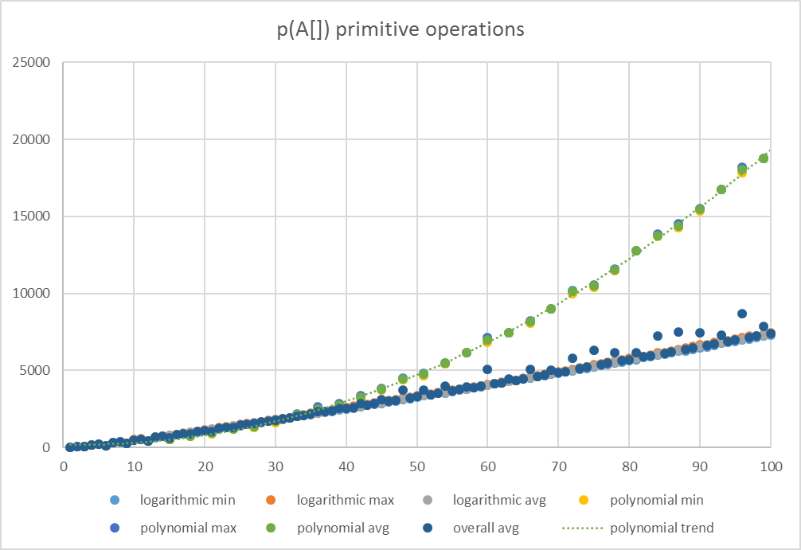
y = 2.0174x² - 10.649x + 202.81

Part C. Analysis and Interpretation

The function p() that we had to analyse takes an integer array and for every element in the array it divides the value of the element until it’s less than or equal to 2 and sums up the number of times it had to divide. The number of operations is highly dependent of the highest possible integer in the array, therefore the randInit() function has to be analysed too, which populates the array with elements. It does so in a semi-random manner. It has two cases: when the highest number in the array can only be as high as the number of elements in the array, the other case is when the maximum value can be as high as 2^{n/4} where n is the number of elements in the array. Which case happens is decided randomly but it is dependent on the number of elements. According to my calculations the function does 8n*log₂(k)+20n+10 primitive operations where n is the number of elements in the array and k is the highest possible value in the array.

<< Following are some suggested headings >>

Analysis of worst case behaviour

The worst case scenario is when randInit() sets the maximum value in the array to k = n/4 + 2^{n/4}. Therefore changing the number of operations to 8n*log₂(n/4 + 2^{n/4})+20n+10. If we drop the smaller terms (ie. factors that are relatively small on higher ns) we get n*log₂(2^{n}). And after arithmetic transformations this becomes n². Therefore the “big-O” of p() is O(n²) which corresponds to trendline.

Analysis of best case behaviour

The best case scenario is when randInit() sets the maximum value in the array to k = n. Therefore changing the number of operations to 8n*log₂(n)+20n+10. If we drop the smaller terms we get n*log(n). Therefore the “big-omega” of p() is Ω(n*log(n)).

Analysis of average case behaviour

