**Game Document Group Project:**

**G51FSE COURSEWORK 2014**

* Barnabás Forgó
* Oliver Gee

**Game concept:**

***1.1*** The goal for the project was to create an inventive 2D game at a professional standard of quality, for this we produced a game loosely based on the traditional sci-fi spaceship “shoot em up” style. Involving the player controlling the actions of an avatar being able to shoot and damage enemies in order to progress. The player’s ship has the ability to also be killed through collision with object such as asteroids. On collision the asteroid will disappear but the player loses a life; Loss of all life’s results in game over displaying their score and allowing the player to start from the beginning again however their score will become saved, allowing the player to compete against their self’s and friends.

**Requirements Definition and Speciﬁcation**

**Functional requirements**

**Menu priority order:**

***2.1.1*** The system must display a main menu for the user before the main game is played

***2.1.2*** The system's menu must display a selection for the user to quit the program, play the main game and move to a high score page

***2.1.3*** The system's menu must clearly show what the user is currently selected

***2.1.4*** The system's highscore page must display the highest top ten scores saved

***2.1.5*** The system's highscore page must display a clear way to return back to the menu page

***2.1.6*** On selection of the "Highscores" option on the menu the menu should be closed and the highscore page should be opened

***2.1.7*** On selection of the "Start Game" option the menu should close and start the main game sequence

**Main game priority order :**

***2.1.8*** The main game should display the controls before the game starts

***2.1.9*** The main game should display the level number before each round starts

***2.1.10*** The main game must have a space related background

***2.1.11*** The player's current score should be shown at all times

***2.1.12*** the players number of lives should be shown at all times

***2.1.12*** The system should be able to pause the game

***Avatar* priority order*:***

***2.1.12*** The system should allow the user's avatar to move up using the w key

***2.1.13*** The system should allow the user's avatar to move down using the s key

***2.1.14*** The system should allow the user's avatar to move left using the a key

***2.1.15*** The system should allow the user's avatar to move right using the d key

***2.1.16*** The system should allow the user's avatar to be rotated forward relevant to the position of the cursor on the screen

***2.1.17*** The system should allow the user's avatar fire a projectile on the left click of the mouse

***2.1.18*** The projectile from the ships avatar should follow a straight path from the direction if was "fired"

***2.1.19*** If the players avatar collides with an asteroid then the player should lose a life the collided object removed and classed as destroid producing no further asteroids in this case

***2.1.20*** If the projectile collides with an asteroid then the asteroid if removed, if it is a parent asteroids then child asteroids should be created

***2.1.21*** If the projectile collides with an asteroid the relevant score increase should be made

***2.1.22*** If all asteroids are removed from the game the next level should start after a brief warning

***2.1.23*** On the asteroids generation they should have a randomly generated path of direction and should not generate with a suitable radius of the players avatar

***2.1.24*** If an asteroid moves outside the screen, it should appear from another side of the screen retaining its direction of travel

***2.1.25*** If the player loses all their lives a game over screen should be displayed and their score saved

***2.1.26*** On firing of a projectile a firing sound should be played

***2.1.27*** On collision of asteroid and avatar a colliding sound should be played

***2.1.28*** On starting of the game a background theme should run in loop

***2.1.29*** Pressing R should restart the game

***2.1.30*** Pressing "Esc" should pause the game"

**2.1.31** When a level is finished the preceding level should contain 3 more fully sized asteroids than the last

**2.1.32** The player’s avatar should not be able to move outside of the screen

***2.1.33*** Pressing “q” while paused must return the player back to the main menu screen

**Non-functional requirements priority order**

***2.2.1*** Starting the program should take no longer than a second

***2.2.2*** Changing to either from the main menu to the leaderboard or back should be near instantaneous

***2.2.3*** Starting the main game should take no longer than a second

***2.2.4*** Main menu font should be of a consistent size and colour

***2.2.5*** All text throught should be clear and readable

***2.2.6*** The game's mechanics should be understood easily

***2.2.7*** The game's controls should be unambiguous and consistent with other games

***2.2.8*** The game's sound must be of "good" quality

***2.2.9*** The game's sprites and images must show basic detail and look presentable and clear throughout game play

***2.2.10*** The game's difficulty must increase as level get higher

***2.2.11*** The system should be responsive to the players actions with no noticeable lag time

***2.2.12*** The should be no delay time in pausing and unpausing the game

***2.2.13*** All game screens should not put the user under and cognitive stress and keep to a minimalistic style

***2.2.14*** All images, sprites, fonts and sounds should be representable of the space theme

**Requirements specification**

|  |  |
| --- | --- |
| **Requirements specification** | **Linked requirement definitions** |
| The system will loosely based on the traditional sci-fi spaceship “shoot em up” style | *2.2.14*  *2.1.10* |
| The system will have a main menu allowing users to move around options in the game such as highscore | *2.1.1 … 2.1.7*  *2.2.2* |
| The game will have a method of storing and presenting a high score’s to the user | 2.1.2 … 2.1.6 |
| The game should emit audio for relevant actions | *2.1.26*  *2.1.27*  *2.1.28*  *2.2.14*  *2.2.8* |
| The game should have a small tutorial outlining the controls of the game and what level the player is currently on | *2.1.8*  *2.1.9*  *2.2.7* |
| The game should have multiple levels | *2.1.9*  *2.2.10*  *2.1.22* |
| The game’s avatar should be able to move | *2.1.12 … 2.1.16*  2.1.32 |
| The game’s avatar should be able to fire a projectile | *2.1.17*  *2.1.18*  *2.1.20*  *2.1.21* |
| The game should be able to win or lose and indicate this | *2.1.12*  *2.1.19*  *2.1.20*  *2.1.22*  *2.1.25* |
| The game should run quickly; having fast loading times and no lag time | *2.2.1*  *2.2.2*  *2.2.3*  *2.2.11*  *2.2.12* |
| The system should be readable and clear at all times, avoiding cognitive stress | *2.2.4*  *2.2.5*  *2.2.9*  *2.2.13* |
| The game should be pauseable | *2.1.12*  *2.1.30*  *2.2.12* |
| The game should become harder as time progresses in one play through | *2.2.10*  *2.1.31* |
| The main menu should be to be returned to if the user wants/needs | 2.1.33 |

**Game Design:**

*Interaction design/structure:*

The game will open with a small menu option allowing for the user to select either to play the game, to see the high scores. From the highscore page the user should be able to either quit or return to the main menu. The main menu and the highscore page will have the same style retaining font, font size, background and sound to keep consistency throughout the game.

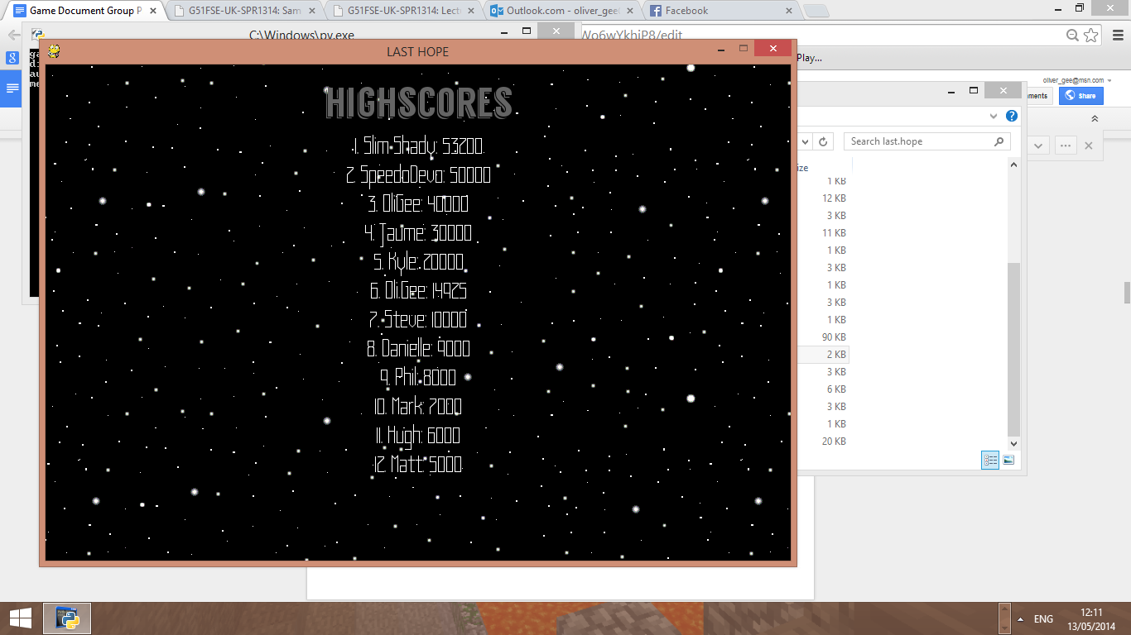

From selecting to play the game from the main menu, the menu would close only displaying the game to reduce the amount of information visible at

one time. A small tutorial will be displayed before anything else to reassure the user of the controls then the game will start.

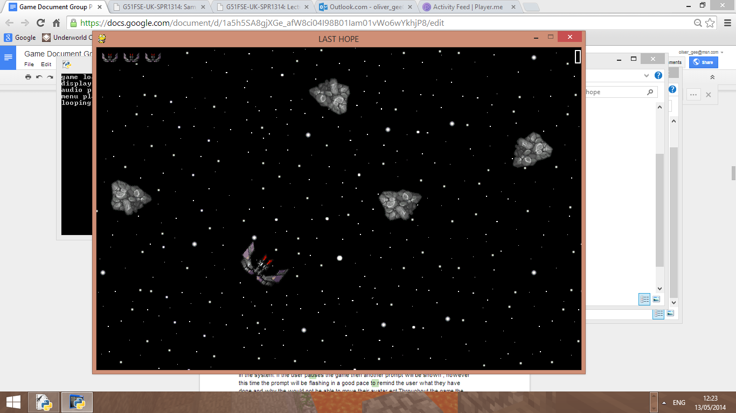This player’s avatar would start in the middle with the number of life clearly visible in the top left, this will decrease dynamically as the game progresses along with the score that will be shown in the top right. On loss the game will display a prompt, this will be the same for a victory however in a different colour to symbolise victory from defeat allowing the user to have a better understanding on what is occurring in the system. If the user pauses the game then another prompt will be shown; however this time the prompt will be flashing in a good pace to remind the user what they have done and why they would not be able to move their avatar etc. Throughout the game the same background will be visible, traditional of the archaic design whilst retaining a consistent image.

*Scoring system:*

On initial load up of the game the players score will be set to zero and given three lives. Hitting the largest asteroid with a projectile will earn the player 25 points, the rock will split producing two smaller ones. Hitting these will give the player 50 points, on collision again the rocks will split producing each two smaller rocks that will award 75 points but not produce further rocks. The scoring rewards the player for shooting the smaller asteroids due their size makes them harder to hit and avoid in large groups as each will have its own path of direction.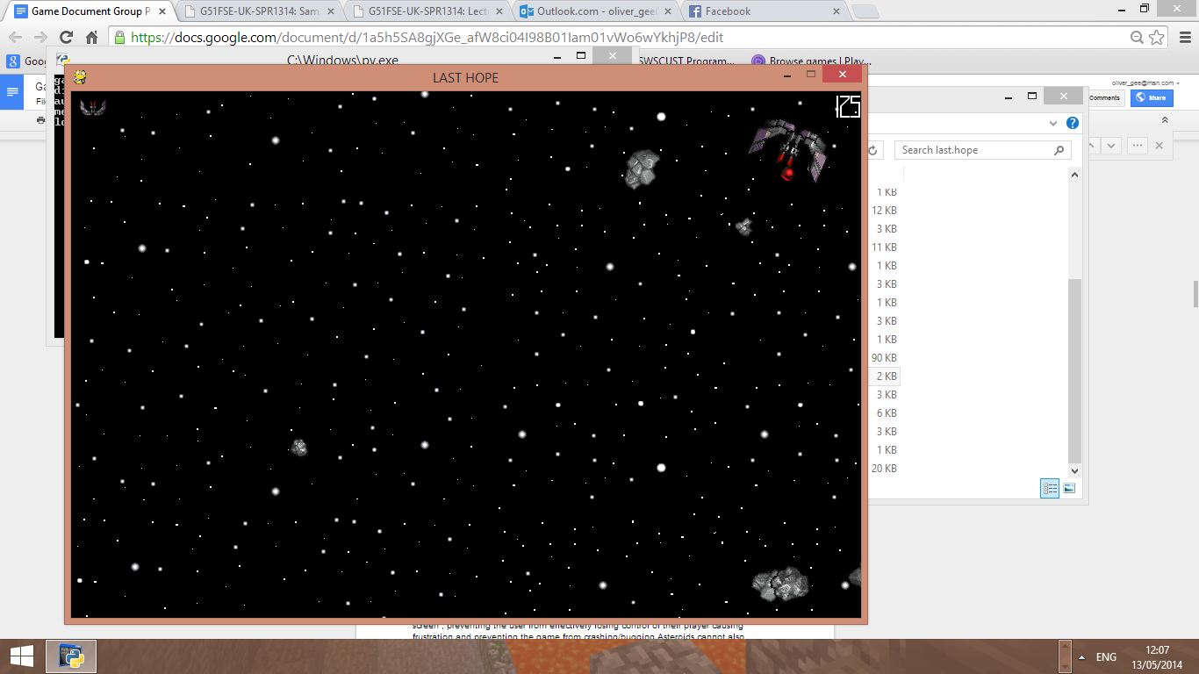

On completion of a level the score will be retained to the next round, this is repeated until the user has no lives left. In this eventual case since the game has no fixed ending the score is saved in which it is compared to the current standing scores. If the new score is greater than one of the ten that will be displayed in the display page then the new score is placed in the correct location and the lower score shuffled along.

*Rules and controller behaviour:*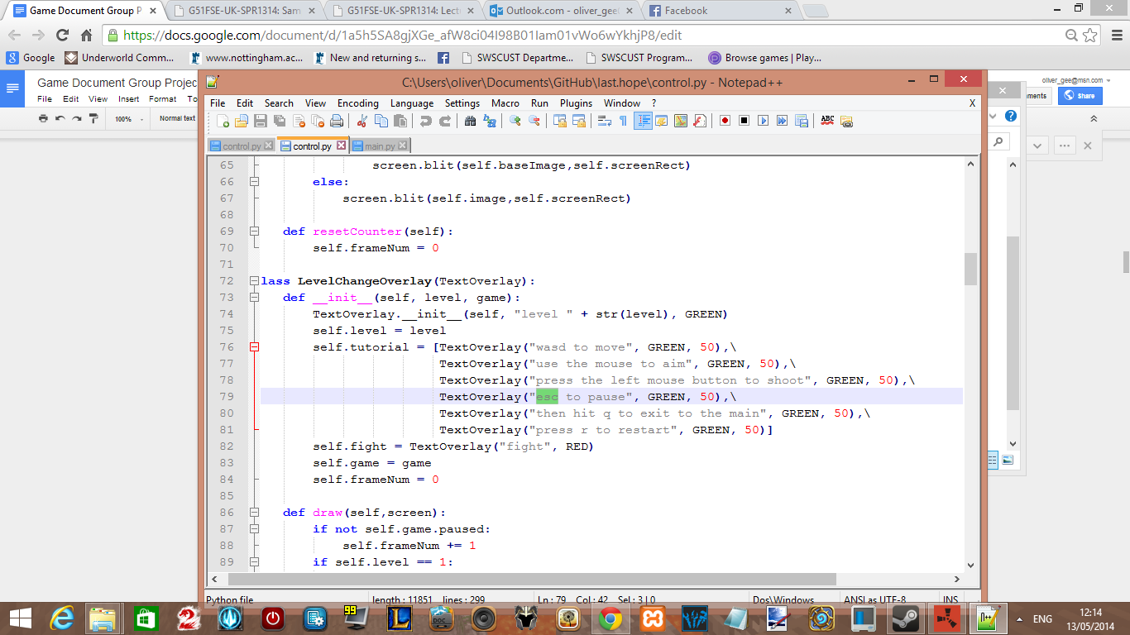

For the user to navigate through the menu they must use “w” to move upwards through the selection and “s” to move downwards. Using the left mouse click to register their selection.

For moving their avatar the controls have been made the same to give the user ease of life making them simple and easy to use. ”WASD” to move the avatar, mouse to aim and left click to fire. These control are common for this genre and will allow the user to pick up and understand the game quickly preventing stress from not understanding the controls.

As mentioned in the small tutorial “Esc” would pause the game and pressing “q” while paused will return the player to the main menu. The ship will not be able to leave the screen, preventing the user from effectively losing control of their player causing frustration and preventing the game from crashing/bugging. Asteroids cannot also generate on top of the ship at the start of a new level creating instant loss of life to the user and would be considered unfair, this is also the same in the case an asteroid collides with the player the asteroid will not create its subsequent smaller forms if possible as they would instantly also cause further loss of live to the user.

**Evaluation of prototype and design reﬁnements:**

Through spending allot of time getting a strong prototype together we presented the foundations of game with the promise for more features such as a shop, unlockables, skins and bosses. However under review it was decided that it just wasn't feasible given the time constraints to meet such targets opting over quality rather than quantity. Realising we had a bad case of feature lust for things that were just not needed for the finished product, we added to the display that was already partially set up and creating a smart easy to use UI. Despite producing a good prototype we did find issues such some of our original sounds were too loud and annoying to the player and that our hit detection and pathfinding of the asteroids was a bit off and some would become stuck or float around the edges. The skin of the players main avatar also had to be redone in order to make the projectiles fire more realistically as well as creating a moving background that made the game feel less static and more engaging to a user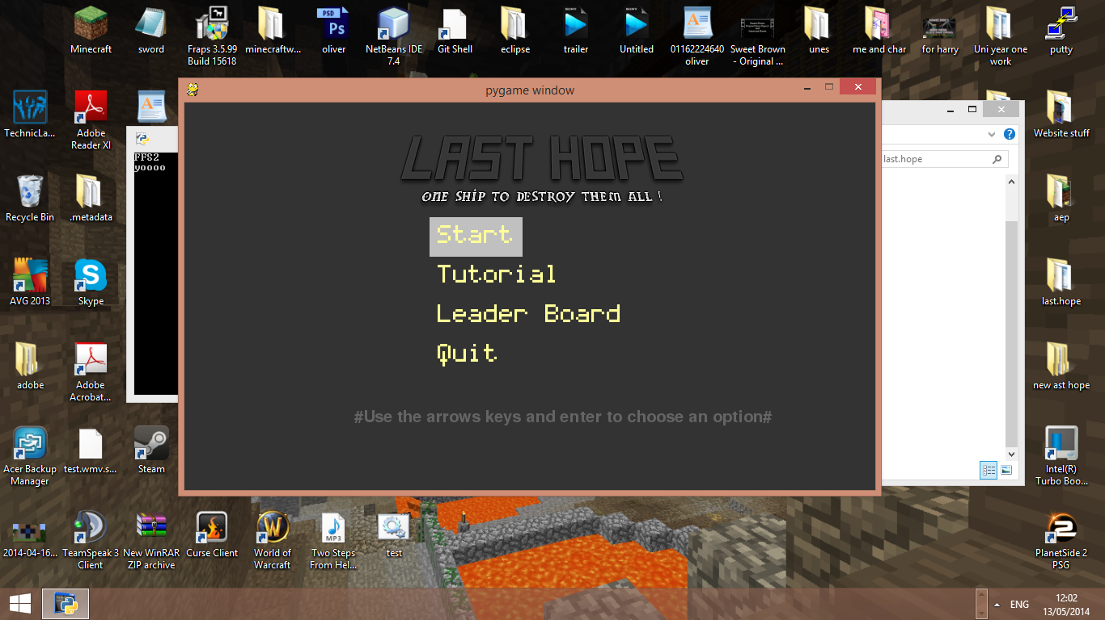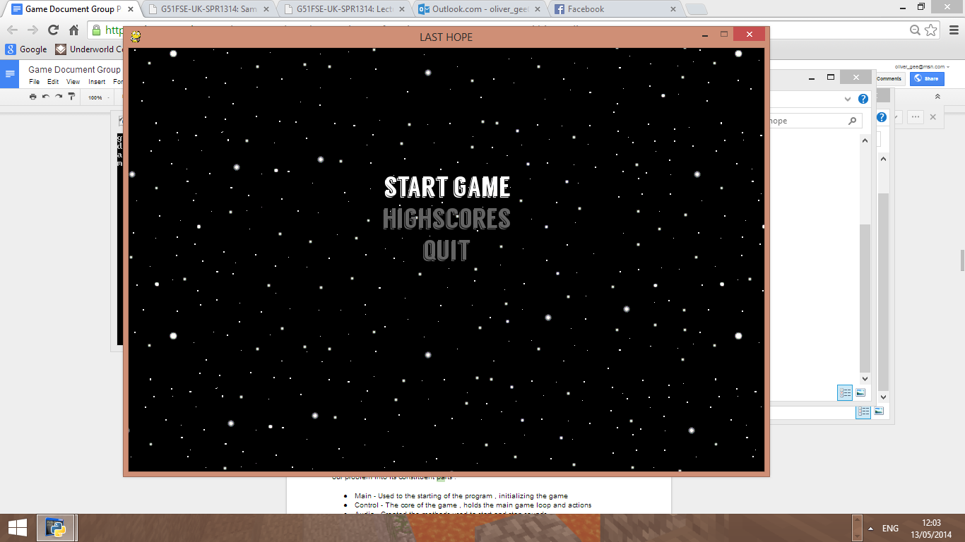

**Implementation notes and description of the development methodology:**

*Implementation:*

In our coding practise we ensured that we used an object oriented model, breaking down our problem into its constituent parts:

* Main - Used to the starting of the program, initializing the game
* Control - The core of the game, holds the main game loop and actions

*Classes*:

Background

- Loads the image for the background, and sets the container

- Updates the movement of the background image

TextOverlay

- Creates new instance of the text overlays

- Supports the flashing pausing

- Draws the overlays to the screen

LevelChangeOverlay

- Creates overlay for opening level details

- Draws overlays to the screen

ScoreDisplay

- Takes in the score value, creates font display

- Outputs score to screen

LivesDisplay

- Takes in the life value, display number of images relevant

Game

- Initializes the variable in the game e.g score

- Increments variables each level e.g Number of asteroids

- Processing events e.g shooting, moving

- Checking for collisions

- Updating the position of sprites

- Updates scoring

* Audio - Created the methods used to start and stop sounds
* Player & enemies- Holds information on the players character & enemies
* Constants - For colours etc
* Menu & Highscore - produces the menu and presenting the scores

From this we were able to specify what jobs were needed to be done, and how they would be implemented into the system, we used camelcase to present our variables and us lower case for methods and a capital letter for a class allowing for consistent code that code be read and understood throughout the program. Whilst commenting on changes and complex areas of the code to make it easier for someone else to see what was changed and how it works.

Using github we were able to control versions, rollback and ensure we both where working from the most up to date code so that there was no inconsistencies that would have slowed down progress having to merge code together. It also allowed us to see what needed to be done and what was left to be finished or improved. Storing our code over the internet allowed for fast accessibility increasing overall productivity from allowing lots of small continued updates whenever was easiest for us

*Debugging*

We found the easiest way to debug our program was through the use of the python IDE that on error would display the area the bug happened, this saved allot of time preventing the manual search through the recent entries from last test. Another method was to use breakpoints to step through code to line by line to identify where the issue was coming from.

*Methodology*

We found that our methodology was best compared to the spiral model. This was mainly because we would outline the requirements the user wanted, design how we would implement these needs into the system then create a new prototype displaying the change before finally reviewing the system again. Because of this we found that our work was constantly being altered from the changing requirements as we understood more about what the user would want. An exsample of this was identifying new issues such as an asteroid generation issue causing “unfair” deaths to the player that we were able to recognise from playing the prototypes and resolve early.

Despite this we did use some agile methods such as pairs programming in order to refactoring part that did not meet the mark often leading to an increase in the fps of the system from discussing face to face what areas could have been changed to become more efficient whilst reducing the number of errors in writing new code. However late into the project the effects of this became lessened as we came to a point where we knew what was needed to satisfy our requirements and the main concern was doing it efficiently

**Evidence of testing:**

***Test Suit document copy***

|  |  |  |
| --- | --- | --- |
| **Test case ID** | **Description** | **Pass/Fail** |
| **1.1.1** | **Pressing “w” moves players ships upwards** | **Pass** |
| **1.1.2** | **Pressing “s” moves players ships downwards** | **Pass** |
| **1.1.3** | **pressing “a“ moves players ships left** | **Pass** |
|  | **pressing “d” moves players ships right** | **Pass** |
| **1.2** | **Moving the mouse creates a rotation effect on the ship** | **Fail only moving in right angles** |
| **1.2.1** | **Moving the mouse creates a rotation effect on the ship** | **Fail spiralling out of the screen** |
| **1.2.2** | **Moving the mouse creates a rotation effect on the ship** | **Pass, used a bass center and rect to control rotation** |
| **1.3** | **Clicking the left mouse key fires projectiles** | **Fail image appearing , not moving** |
| **1.3.1** | **Clicking the left mouse key fires projectiles** | **Pass changed to the position the mouse was at one the screen** |
| **2.1** | **Generation of one asteroid** | **Pass, needs to spin only moving in2 liner paths** |
| **2.2** | **Generation of one asteroid moving and spinning** | **Pass however to fast** |
| **2.2.1** | **Generation of one asteroid moving and spinning** | **Pass, moves at a good pace that is fair** |
| **2.3** | **Ship cannot move outside of the screen, asteroids can** | **Pass** |
| **2.4** | **Collision with projectile causes asteroid to disappear** | **Fail, game crashes** |
| **2.4.1** | **Collision with projectile causes asteroid to disappear** | **Fail, passes through** |
| **2.4.2** | **Collision with projectile causes asteroid to disappear** | **Fail, only the projectile is being removed** |
| **2.4.3** | **Collision with projectile causes asteroid to disappear** | **Pass both are removed** |
| **2.5** | **Collision causes score to increase** | **Pass score updated** |
| **2.6** | **collision causes smaller asteroids to be made** | **Fail, Not generating in correct location, won't move either** |
| **2.6.1** | **collision causes smaller asteroids to be made** | **Pass, smaller asteroids getting stuck though** |
| **2.6.2** | **collision causes smaller asteroids to be made to move** | **Pass pathfinding improved** |
| **3.1** | **Collision between player and asteroid loses player a life** | **Pass** |
| **3.1.1** | **Collision between player and asteroid loses a life and the screen is updated to show this** | **Pass, life indicator moves down one** |
| **3.1** | **When player moves the background moves slightly** | **Pass, however causing a clipping issues when done too much** |
| **3.1.1** | **removed clipping issue** | **pass ,boundaries added** |
| **4.1** | **Moves to next level when asteroids are removed** | **Pass, score not being carried, lives get reset ?** |
| **4.1.1** | **Moves to next level when asteroids are removed** | **Pass, variables are passed over to next phase now** |
| **4.2** | **Display shows victory in case of level completion** | **Pass** |
| **4.3** | **Display shows loss in case of lives hitting 0** | **Pass** |
| **4.4** | **Restart allowing for player to start again** | **Fail, carries lives over causing crash** |
| **4.4.1** | **Restart allowing for player to start again** | **Pass** |
| **4.5** | **pressing Esc pauses game** | **Fail player can still fire ? but projectiles don't move** |
| **4.5.1** | **pressing Esc pauses game** | **Pass, added boolean to check the if paused** |
| **4.6** | **Will display flash on and off** | **Pass** |
| **4.7** | **Will Background theme play on start, is it good quality** | **Fail, path not found** |
| **4.7.1** | **Will Background theme play on start, is it good quality** | **Fail, file type issue** |
| **4.7.3** | **Will Background theme play on start, is it good quality** | **Pass !** |
| **4.8** | **Will sounds play for firing and death** | **Pass** |
| **5.1** | **Menu appears on start** | **pass** |
| **5.2** | **User can move their selection to all possible options** | **pass** |
| **5.3** | **Selecting quit will close the game** | **Pass** |
| **5.4** | **Selecting highscore option will close the menu, open high scores** | **Pass** |
| **5.5** | **Highscore menu displaying highscore** | **Pass, names not working correctly** |
| **5.6** | **Names display on highscore ?** | **Pass passed over correctly now** |
| **5.7** | **Can user return to menu from highscores page** | **Pass** |
| **5.8** | **Selecting main game option from the menu will start the game** | **Pass** |
| **5.9** | **Is there a way to return back to the menu ?** | **Fail ,”Esc” key not working** |
| **5.9.1** | **Is there a way to return back to the menu ?** | **Pass, user sent back to main menu** |
| **5.11** | **Beating highscore correctly updates** | **Fail, wrong order** |
| **5.11.1** | **Beating highscore correctly updates and sort scores correctly** | **Pass** |

*Evidence of testing*

**1.1** Github screen overview: Showing contributes and changes of the game 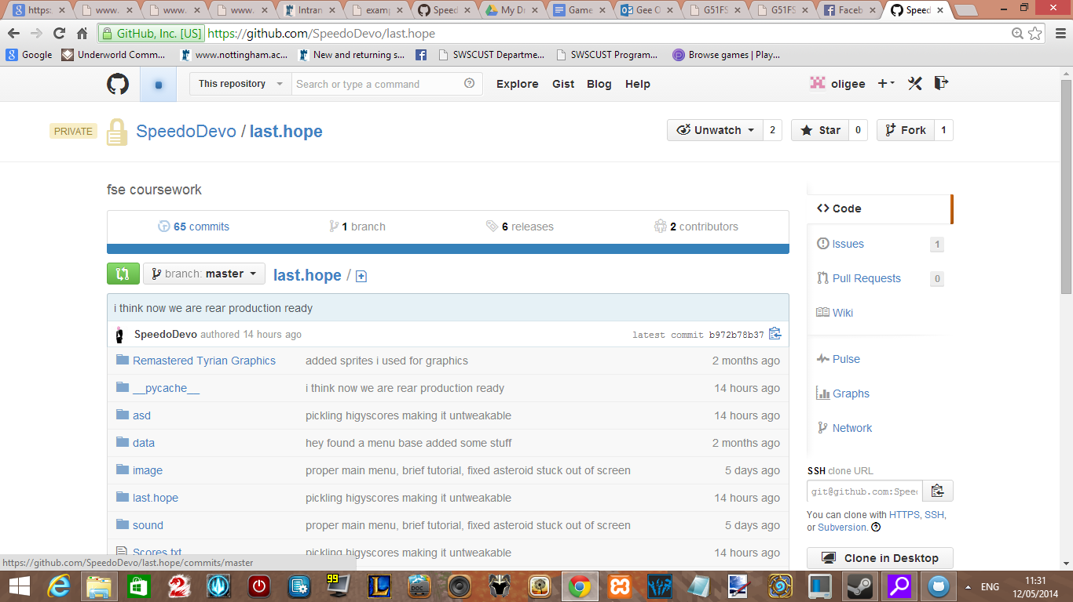

**1.2** Github post screen, showing bug reporting and changes

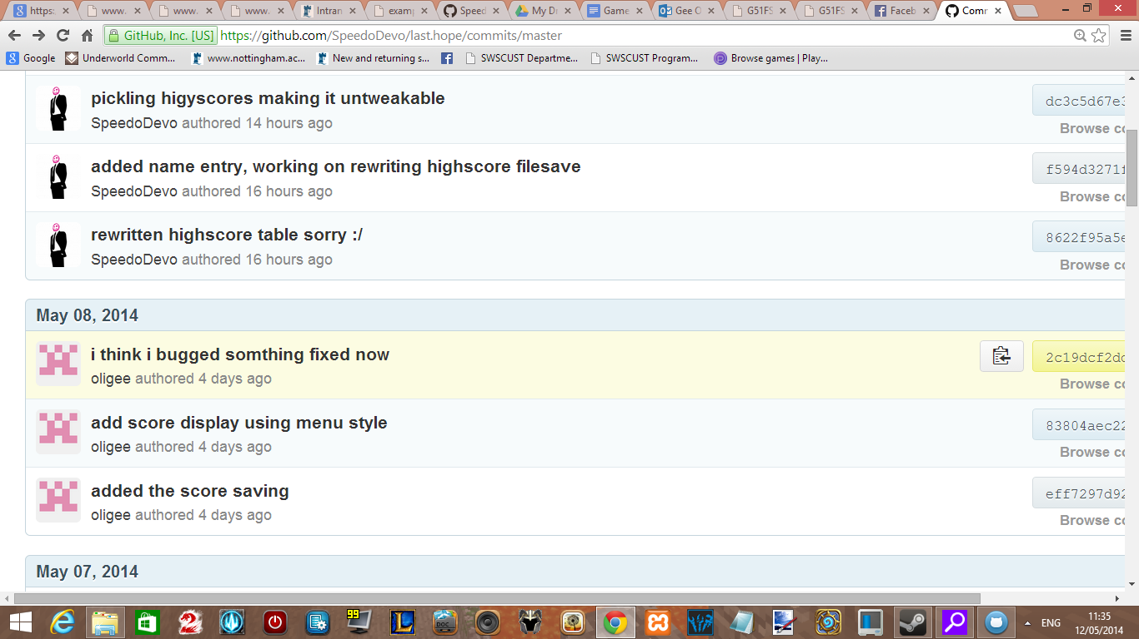

**1.3** Code changes

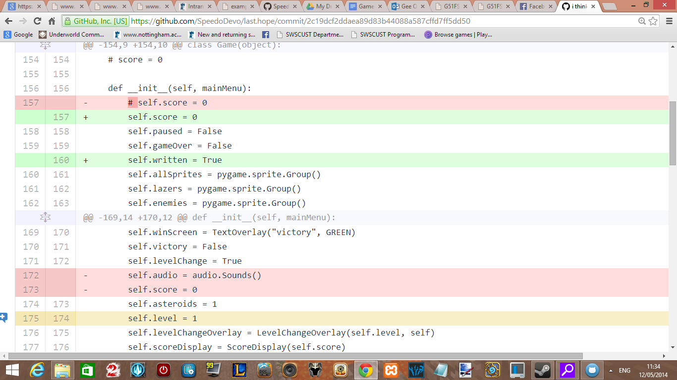

**1.4** Command line prints to show regions of completion

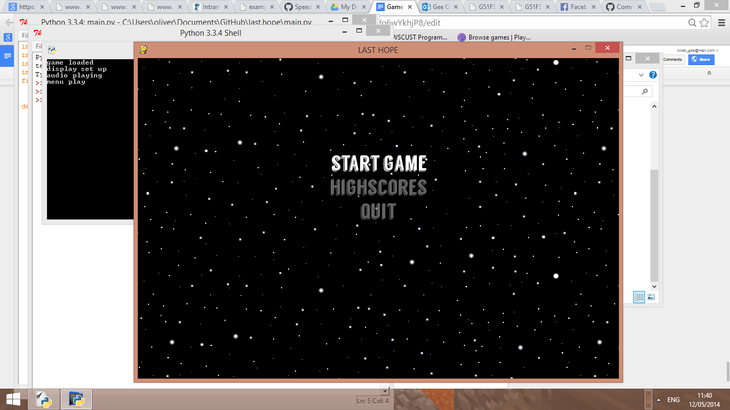

**1.5** Use of IDE fixing bugs

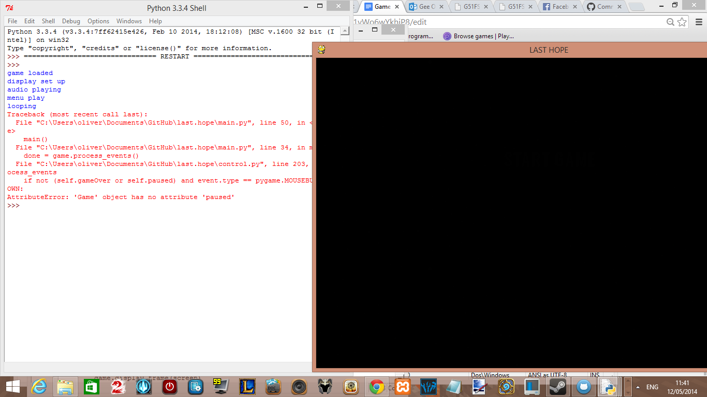

**Evaluation of the game through user evaluation:**

*Points of consideration:*

* One of our focuses was to create an original game, which we were on track for along as we could implement all of the features we had planned e.g. “power ups” and a shop, but due to deciding not due to time feeling we would be rushing on the quality of the game. This vastly reduces the amount of time a user could enjoy this game without becoming bored.
* Due to the leader board system this makes the game much more enjoyable when played with friends, however being a PC based game there is a high chance that the user will not happen to have a friend with them when they decide to play the game, mixed with the fact there is no online support the user will often be competing against their self
* Due to mathematical limitations on firing a projectile in certain angles the shots with drift off to another place because of rounding errors, this makes long range shots harder to take however becomes unnoticeable due to the large number of enemies
* As we felt that sound was a crucial part of the system we found it necessary to include it, however never adding a way to stop the background theme could annoy and frustrate some users, reducing replayability. Despite the soundtrack we found being interesting it is just the one soundtrack and as a developer becoming annoying to hear
* Initial menu issue, even though we displayed the controls of the game just before the first level of each round we neglected to note that the controls for the menu matched that of the main game, so a new player would have no understanding of how to use the menu because they cannot reach the tutorial

*Summary:*

Despite some of our failures to add extra features, i believe we made the correct decision to focus on producing a strong well coded aesthetically pleasing product rather than rushing to cut corners producing a game that would have likely been allot less refined and probably damaging N2 games reputation. Causing them to waste further time and money in the future handling complaints because we missed out validations and checks. However with more time we would love to continue working on the project to add the extra features we originally wanted.