May 18, 2026

MORETA SHIPPING LINES
MR. LEANDRO DONGOR

Dear Sir:
This is to bill you of the following:

HUSTLING
DR NO. | DATE | WAYBILL NO. | VAN NO. | VAN SIZE | CLIENT | AMOUNT (PHP)
35721 | 5/15/26 | MCA00826007  MCA00826150 | DRYU2903908  DRYU2903620 | 20 FTR | MORETA  (PIER - JACANA) | 2,820
35727 | 5/9/26 | MCA00726184 | MSLU9796071 | 40 FTR | MORETA  (PIER - JACANA) | 2,820
 |  |  |  |  | TOTAL | 5,640

Bank Details:
Bank Name | : | Chinabank – Puerto Princesa City
Account Name | : | F&E Divine Manna Corporation
Account Number | : | 118700006140

Prepared by: | 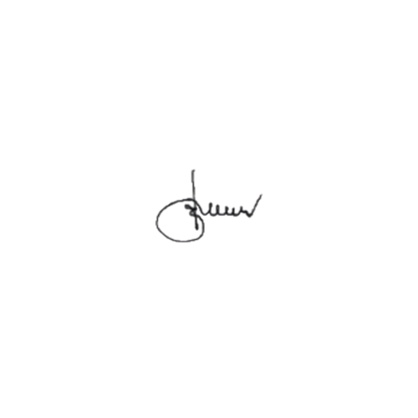  Approved by:
Amelita Jara | Evelyn N. Pua
Sales & Operation | General Manager

