BILLING TRANSMITTAL

May 18, 2026

MORETA SHIPPING LINES

DATE COVERED | SOA NO. | DETAILS | AMOUNT (Php)
May 9, 2026 – May 15, 2026 | 2026-045 | Hustling Trip | 5,640

Prepared by: | Approved by:
Amelita Jara | Evelyn N. Pua
Sales & Operation | 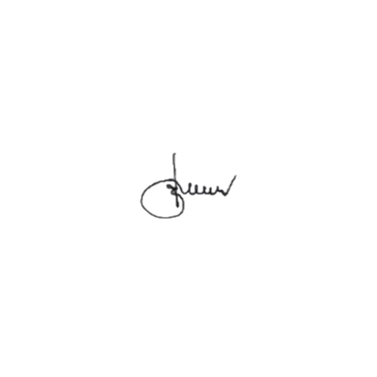  General Manager


