PRESENCE SCAN
Attendance Management System

Desktop QR Code-Based Attendance System
for Tertiary Institutions
Project Documentation

Prepared by:
Gad Mensah
2026

Table of Contents
1.1 Background to Study 4
1.2 Problem Statement 4
1.3 Research Questions 5
1.4 Research Aim and Objectives 5
Aim 5
Objectives 5
1.5 Scope of the Study 5
1.6 Significance of the Study 6
1.7 Limitations of the Study 6
1.8 Research Methodology Overview 7
Data Collection Methods 7
Development Stack 7
1.9 Key Terms and Definitions 8
1.10 Organization of the Report 8
2.1 Introduction 9
2.2 Traditional Attendance Systems 9
2.3 QR Code Technology 10
2.4 Automated Attendance Systems — Technology Comparison 11
2.5 Review of Similar Existing Systems 12
2.5.1 SmartTendance 12
2.5.2 Attenqo 13
2.5.3 UAMS (University Attendance Management System) 14
2.5.4 Comparative Summary and Research Gap 15
3.1 Development Methodology 17
3.2 Requirements Analysis 17
3.2.1 Functional Requirements 17
3.2.2 Non-Functional Requirements 18
3.3 System Architecture 18
3.4 Database Design 19
3.5 Input and Output Design 20
System Inputs 20
System Outputs 20
3.6 System Diagrams 20
3.7 Hardware and Software Requirements 24

List of Tables
1 Development Stack Table 7
2 Key Terms And Definitions 8
3Technology Comparison 11
4Comparative Summary 15
5 Functional Requirements 18
6 Non-functional Requirements 18
7 Database Design 19
8 Use Case Diagram 21
9 System Flowchart Diagram 22
10 Entity-Relationship (ER) Diagram 23
11 Module Diagram 24
12 Hardware And Software Requirements 25

CHAPTER ONE
Introduction

1.1 Background to Study
Attendance management is a critical administrative function in tertiary institutions, serving as a key indicator of student engagement, academic participation, and eligibility for assessments. Institutions have long depended on paper registers, manual roll calls, and circulated signature sheets — methods that are inefficient, susceptible to manipulation, and time-consuming, particularly in large cohorts where manual marking can consume a significant portion of lecture time.
The global expansion of higher education enrolment has compounded these inefficiencies. As class sizes grow and institutions manage more courses across multiple departments, the administrative overhead of manual attendance recording scales disproportionately. Lecturers are expected to track and maintain accurate records for dozens of students per session, often across multiple cohorts, while simultaneously managing lesson delivery and student engagement.
The proliferation of affordable digital tools has opened new pathways for automating attendance workflows in higher education. QR (Quick Response) code technology is especially attractive: codes can be generated at negligible cost, scanned in under a second, and deployed without specialist hardware. This project leverages these properties by generating individual QR codes for registered students and providing a webcam-based desktop interface for scanning.
Unlike many QR-based systems that require a dependable internet connection or full web deployment, Presence Scan operates as a standalone desktop application backed by a local PostgreSQL database and a live camera feed. The system validates each scanned student against the active timetable, checks that the scanning lecturer is assigned to the current course, applies a configurable grace period, and records attendance — all without external network dependency. This architecture makes the system particularly well-suited to institutions with limited or unreliable internet infrastructure, which remain prevalent across sub-Saharan Africa and other developing regions.

1.2 Problem Statement
Traditional attendance management systems in tertiary institutions are inefficient, time-consuming, and vulnerable to deliberate fraud. Manual recording frequently results in inaccurate records, administrative bottlenecks, and proxy attendance — where one student marks attendance on behalf of an absent peer. The consequences of inaccurate attendance records extend beyond administrative inconvenience: students may be incorrectly barred from examinations, institutional accreditation bodies may receive misleading data, and lecturers face additional workloads reconciling and correcting discrepant records.
Proxy attendance represents a particularly significant integrity risk. Because manual methods rely solely on physical signatures or verbal confirmation, they provide no reliable mechanism for verifying that the person signing is actually the enrolled student. This vulnerability is widely understood by students and, in the absence of deterrents, is routinely exploited.
Many existing digital attendance solutions compound these issues by assuming constant internet access or reliance on cloud infrastructure, creating practical barriers for institutions that need a simple, staff-managed desktop solution. This study addresses these gaps by designing and implementing Presence Scan: a desktop QR code-based system that improves recording accuracy, reduces attendance fraud, and simplifies administration in tertiary institutions.

1.3 Research Questions
The study is guided by the following research questions:
- How can QR code technology improve the accuracy and efficiency of attendance management in tertiary institutions?
- What are the principal weaknesses of traditional manual attendance systems?
- What desktop-based mechanisms can minimize proxy attendance in a QR attendance system?
- How can timetable validation and role-based access control improve attendance integrity?
- How does Presence Scan compare with manual methods in terms of speed, accuracy, and usability?

1.4 Research Aim and Objectives

Aim
To design and implement a secure desktop QR code-based attendance management system tailored to the operational realities of tertiary institutions.

Objectives
- To critically evaluate the limitations of traditional attendance systems in higher education.
- To design a desktop QR code workflow encompassing student registration, scanning, and record keeping.
- To implement role-based access control for lecturers, administrators, and developer access.
- To secure all user credentials using password hashing and controlled password reset flows.
- To bind lecturer and course creation to the department of the logged-in administrator or Head of Department.
- To automate attendance recording, reporting, analytics, CSV import, and timetable-aware navigation processes.
- To evaluate the performance, accuracy, and usability of the proposed system against defined benchmarks.

1.5 Scope of the Study
This study focuses on the design and implementation of a QR code-based attendance system for tertiary institutions, supporting two primary login roles — lecturers and administrators (including Heads of Department). Registered students are issued unique QR codes representing their identity within the system.
The following capabilities are within scope:
- Generation and management of QR codes for registered students.
- Webcam-based scanning of student QR codes on a desktop interface.
- Automatic attendance recording against the active timetable slot.
- Generation of per-course and institution-wide attendance reports and statistics.
- Role-based access control differentiating lecturer and administrator functions.
- Hashed authentication for lecturers, administrators, and developer access.
- Department-aware lecturer and course creation, tied to the logged-in administrator or Head of Department.
- Lecturer profile management, including create, update, password reset, and delete actions.
- CSV import for bulk student and course registration with validation feedback shown in the import dialog.
- Special-day and timetable validation for attendance recording and dashboard date navigation.
- Single-school deployment structure, where one database represents one institution.
The following areas are explicitly excluded from scope:
- Biometric authentication (fingerprint or facial recognition).
- Integration with national student or identity databases.
- Financial management or fee-tracking functionality.

1.6 Significance of the Study
This study makes both practical and academic contributions. Practically, Presence Scan reduces administrative burden on lecturers, improves the accuracy of institutional records, and deters attendance fraud without expensive specialist hardware. Academically, it contributes to the growing body of research on digital transformation in higher education and offers a replicable reference model for low-cost attendance automation in resource-constrained environments.
The system is particularly significant in the context of sub-Saharan African tertiary education, where rapid growth in student enrolment has not been matched by equivalent investment in administrative digital infrastructure. By providing an open-source, locally deployable alternative to expensive cloud-based platforms, Presence Scan offers a realistic and scalable pathway to attendance digitization for institutions that might otherwise be excluded from such improvements.

1.7 Limitations of the Study
The following limitations are acknowledged:
- The system was validated in a limited academic environment and may require further testing before full institutional deployment.
- Time constraints restricted the breadth of user acceptance testing during the project period.
- The system depends on a functioning webcam or camera device for scanning operations.
- Deployment is currently tied to the configured PostgreSQL database and local Windows environment.
- The use of static QR codes introduces a theoretical forwarding fraud risk that is mitigated but not fully eliminated by server-side duplicate rejection.

1.8 Research Methodology Overview
The project adopts Agile Software Development Methodology, chosen for its support of iterative delivery, continuous stakeholder feedback, and adaptive planning — attributes well-suited to a system that must simultaneously satisfy the needs of students, lecturers, and administrators. Agile's sprint-based structure allowed requirements to be refined progressively as early prototypes were demonstrated to prospective users, ensuring that the final system reflected real institutional workflows rather than assumed ones.
Each sprint concluded with a review session in which working software was demonstrated to at least one prospective end user, and feedback was incorporated into the backlog for the following sprint. This approach reduced the risk of late-stage requirement mismatches and ensured that design decisions — such as the grace-period mechanism and the duplicate-scan rejection behavior — were validated by actual lecturers before being finalized.

Data Collection Methods
- Semi-structured interviews with lecturers and students to identify pain points in existing attendance processes.
- Observational study of manual attendance workflows during live lectures.
- Systematic review of related literature and existing automated attendance systems.

Development Stack

1 Development Stack Table
Component | Technology / Tool
Frontend / Desktop UI | Python Tkinter
Camera and QR Scanning | OpenCV, pyzbar
QR Code Generation | qrcode, Pillow
Backend Logic | Python
Database | PostgreSQL via psycopg2
Development IDE | Visual Studio Code
Version Control | Git
Deployment OS | Windows

1.9 Key Terms and Definitions

2 Key Terms And Definitions
Term | Definition
QR Code | A two-dimensional barcode capable of encoding hundreds of characters, readable rapidly by a camera with no dedicated hardware.
Attendance Management System | A software application used to track, record, and manage attendance data electronically.
Proxy Attendance | The fraudulent practice of one student recording attendance on behalf of an absent peer.
Authentication | The process of verifying a user's identity before granting system access or recording attendance.
Timetable Slot | A scheduled lecture period used by the system to determine valid attendance windows.
Grace Period | A configurable time window after lecture start during which attendance can still be accepted.
RBAC | Role-Based Access Control — a security model assigning permissions based on user role (lecturer or administrator).

1.10 Organization of the Report
The remainder of this report is organized as follows:
- Chapter Two reviews existing literature on attendance management, QR code technology, and automated systems deployed in higher education.
- Chapter Three presents the system analysis and design, covering requirements, database design, architectural decisions, and system diagrams.
- Chapter Four details the implementation process, testing strategy, and system evaluation.
- Chapter Five presents conclusions, recommendations, and directions for future work.

CHAPTER TWO
Literature Review

2.1 Introduction
This chapter reviews existing literature on attendance management systems in tertiary institutions, the evolution and applications of QR code technology, and a selection of existing automated attendance solutions. The review covers traditional manual approaches, the technological landscape of automated attendance tools, and an in-depth examination of three comparable systems currently deployed in higher education contexts. For each existing system, both strengths and limitations are considered in detail. The review identifies key gaps in the current state of the art and establishes the theoretical foundation for the design decisions taken in Presence Scan.

2.2 Traditional Attendance Systems
Manual attendance systems have been the dominant mode of tracking student participation for decades. The three most prevalent methods — paper registers, oral roll calls, and circulated signature sheets — are straightforward to implement but carry significant operational disadvantages that have been extensively documented in the academic literature.
Paper registers and circulated signature sheets are particularly susceptible to falsification. Because they rely solely on handwritten signature, there is no mechanism to verify that the person signing is actually the enrolled student. A student who is absent can arrange for a classmate to sign on their behalf, and without close visual monitoring of every student as they sign — impractical in large cohort settings — this proxy attendance is effectively undetectable. The problem is not merely theoretical: a survey conducted by Kasim and Ramlan (2021) found that over 60% of students at a Malaysian polytechnic admitted to witnessing proxy attendance, and more than 20% admitted to participating in it directly.
Oral roll calls, while harder to falsify, introduce a different set of problems. Calling each student's name individually consumes between three and ten minutes of lecture time per session — an interval that scales poorly as class sizes grow (Kasim & Ramlan, 2021). In a course with three scheduled sessions per week over a fifteen-week semester, this equates to between 135 and 450 minutes of teaching time lost per course to attendance administration alone. In modular degree programmes where contact hours are tightly managed, this loss is educationally significant.
A further limitation of manual methods is the transcription burden they impose. Raw paper records must be manually entered into institutional management systems, adding administrative workload and creating a second opportunity for error. Research by Ohta et al. (2020) found that manual attendance records contained an average transcription error rate of approximately 4% — a figure that, while seemingly small, can materially affect examination eligibility determinations and student progression decisions at scale. An institution processing attendance data for five thousand students across hundreds of courses per semester cannot easily absorb a 4% error rate without systematic auditing processes that themselves consume additional administrative resources.
Beyond operational inefficiency, manual systems create significant data management challenges. Paper registers are physically vulnerable — they can be lost, damaged, or destroyed, resulting in permanent loss of the records they contain. They are also difficult to query: generating a summary of a student's attendance across multiple courses, or identifying all students below a minimum attendance threshold, requires either manual cross-referencing of multiple physical documents or full transcription before any analysis can begin.
Despite these well-documented shortcomings, many institutions in low- and middle-income countries continue to rely on manual systems, primarily due to limited ICT infrastructure, budget constraints, and resistance to organizational change. This persistence creates a clear and urgent opportunity for a low-cost digital alternative that does not require significant infrastructure investment or ongoing service subscriptions.

2.3 QR Code Technology
A QR (Quick Response) code is a two-dimensional matrix barcode developed by Denso Wave in 1994. Unlike one-dimensional barcodes, which encode data in a single horizontal axis, QR codes encode data across both horizontal and vertical axes, allowing them to store hundreds of characters — including alphanumeric strings, URLs, and binary payloads — in a compact, machine-readable format. Modern camera-equipped devices can decode a QR code in under a second, requiring no dedicated scanning hardware beyond the image sensor already present in smartphones, laptops, and desktop webcams.
The structural design of a QR code contributes significantly to its practical utility in field deployments. Each code incorporates Reed-Solomon error correction, which allows it to remain scannable even when up to 30% of its surface area is damaged, obscured, or soiled — a property that makes QR codes robust under real-world conditions such as worn student ID cards, low-quality printing, or partial obstruction. Four error correction levels are defined in the QR standard: Level L (7% recovery), Level M (15%), Level Q (25%), and Level H (30%), offering a configurable trade-off between data storage capacity and damage tolerance.
QR codes have achieved exceptionally broad adoption across diverse domains, including payment systems (e.g., WeChat Pay, GhanaQR), product authentication, event ticketing, restaurant menus, and healthcare records management. This ubiquity has made QR decoding a standard feature of device operating systems and camera applications, further reducing the barrier to deployment. For attendance automation specifically, their negligible generation cost, sub-second scan speed, and compatibility with commodity hardware represent a compelling combination.
A critical distinction for security-sensitive attendance applications is that between static and dynamic QR codes. A static code encodes a fixed, immutable value — such as a student identifier — and remains valid indefinitely. This permanence is operationally convenient but introduces a fraud vector: a student could photograph a peer's QR code and send it electronically to a confederate, who could then scan it from any location during the lecture window. In an era of instant messaging and image sharing, this form of forwarding fraud requires minimal effort and is difficult to detect without additional verification layers.
A dynamic QR code addresses this vulnerability by encoding a time-limited, session-specific token — a short-lived value generated fresh for each attendance session — that expires automatically after a predefined interval. Any forwarded image of a dynamic code becomes useless once the session closes, rendering remote fraud significantly more difficult (Singh et al., 2022). The trade-off is added system complexity: a token generation and validation service must run continuously, and students must have access to a device capable of displaying the current token at the moment of scanning.
Presence Scan uses static per-student QR codes, accepting the theoretical forwarding risk in exchange for implementation simplicity and hardware independence. This risk is mitigated at the server side through timetable-slot-level duplicate rejection: because each student's attendance for a given slot can only be recorded once, a forwarded code can at most produce a single fraudulent record — and only if it is scanned before the legitimate student arrives. The design represents a pragmatic balance appropriate to the operational context of many tertiary institutions.

2.4 Automated Attendance Systems — Technology Comparison
A range of technologies has been applied to automated attendance collection in higher education, each with distinct trade-offs across cost, accuracy, fraud resistance, and the infrastructure required to deploy and maintain the system at scale. The table below summarizes the principal alternatives.

3Technology Comparison
Technology | Cost | Accuracy | Fraud Resistance | Infrastructure Needed
QR Code (Dynamic) | Low | High | Medium–High | Webcam only
RFID | Medium | High | Medium | RFID readers & tags
Biometric (Fingerprint) | High | Very High | Very High | Dedicated readers
NFC | Medium | High | Medium | NFC-enabled devices
Facial Recognition | High | Very High | Very High | Camera & GPU server

RFID-based systems encode student identifiers on card-embedded chips and read them passively as students pass a reader. While accurate and fast for individual scans, RFID is susceptible to card-sharing fraud (a student can hand their card to another person) and requires the installation of fixed reader hardware at venue entry points — an ongoing capital and maintenance cost. NFC operates on similar principles but requires students to actively tap their device against a reader, introducing a minor additional action per student.
Biometric systems — fingerprint readers and facial recognition — offer the highest fraud resistance of any current technology, as the authenticating attribute (a fingerprint or facial geometry) cannot be transferred between individuals. However, their capital cost, the specialist hardware they require, and the significant data protection and privacy obligations associated with storing biometric templates make them disproportionate for many institutional contexts, particularly in jurisdictions with developing data-protection regulatory frameworks.
QR code systems occupy a favorable position in this landscape: they achieve high accuracy at low cost with minimal infrastructure requirements, while server-side controls — timetable validation, grace periods, and duplicate rejection — bring fraud resistance to a practically acceptable level for most tertiary institutions (Onyema et al., 2021).

2.5 Review of Similar Existing Systems
The following subsections examine three attendance management systems that have been deployed or documented in higher education contexts. Each system is evaluated for its core approach, key strengths, and — with particular attention — the limitations and issues that have been identified through use, published evaluations, or structural analysis. The subsection concludes with a comparative summary and an identification of the research gap that motivates Presence Scan.

2.5.1 SmartTendance
SmartTendance is a cloud-hosted attendance management platform aimed at universities and colleges. Its core mechanism is dynamic QR code scanning: the system generates a fresh session token at the start of each lecture, displays it on a projector screen or lecturer device, and students scan it using their smartphones to register their presence. An optional facial recognition layer can be activated to verify that the face of the scanning student matches the enrolled photograph on file, adding a second biometric confirmation of identity.
The platform provides real-time analytics dashboards accessible to both lecturers and administrators, enabling immediate identification of attendance trends, at-risk students, and anomalies within and across courses. Automated alerts can be configured to notify students and academic advisors when attendance falls below a defined threshold. Integration with institutional student information systems (SIS) is also supported, allowing attendance data to flow directly into existing academic management workflows.
SmartTendance's primary strengths are its strong security posture and its operational depth. The combination of dynamic session tokens and optional facial verification makes proxy attendance exceptionally difficult: a student would need to be physically present with their smartphone at the moment the token is displayed in the lecture hall, and facial recognition adds a further layer that cannot be defeated by card or code sharing. The real-time dashboards give administrators genuinely actionable insight without requiring manual report generation.
However, SmartTendance has several significant limitations that restrict its suitability for many institutional contexts. First and most critically, the system requires stable internet connectivity for every operation — QR tokens are generated server-side and attendance records are submitted via the cloud. Any interruption in connectivity can prevent attendance from being recorded. In contexts where network infrastructure is unreliable or bandwidth is shared across a large campus population, this dependency creates a systemic operational risk that is difficult to mitigate.
Second, SmartTendance's cloud infrastructure model entails ongoing subscription costs that may be prohibitive for smaller or under-resourced institutions. Unlike a locally deployed system that incurs primarily one-time setup costs, cloud-based attendance platforms typically charge on a per-user or per-institution basis, creating a recurring financial commitment. For institutions in low- and middle-income countries, these costs can represent a significant barrier to adoption.
Third, cloud hosting raises data sovereignty and privacy concerns that are increasingly salient under modern data protection frameworks. Student attendance records are sensitive personal data; their storage and processing by a third-party cloud provider introduces questions about jurisdiction, data access, and the handling of breaches that may conflict with institutional data governance policies or national regulations.
Fourth, the requirement that all students carry smartphones capable of scanning QR codes represents a hardware dependency on the student side. While smartphone penetration is high in many populations, it is not universal — students without smartphones may disproportionately come from lower-income backgrounds, creating an equity issue at the heart of the system's core mechanism.

2.5.2 Attenqo
Attenqo takes a layered approach to attendance verification, combining QR code scanning with GPS location verification and compulsory selfie capture. When a student scans the session QR code, the application simultaneously records their GPS coordinates and captures a photograph of their face using the front-facing camera. All three data points — QR code validity, physical location, and facial image — are validated before attendance is accepted. The intention is to make remote or proxy attendance practically impossible, since defeating the system would require simultaneously spoofing GPS coordinates, presenting a valid QR code, and producing a matching photograph.
Despite these security advantages, Attenqo has attracted significant criticism in its deployment evaluations. The most fundamental limitation is its hardware dependency: the system requires that every student possess a smartphone with GPS, a front-facing camera, and an active mobile data connection. In student populations where device ownership is heterogeneous, this assumption cannot be safely made.
GPS accuracy introduces further technical limitations. GPS signals are notoriously unreliable inside buildings — particularly in large concrete lecture theatres — where signal attenuation and multipath reflections can produce location estimates that are tens or hundreds of metres from the device's true position. Attenqo's geofencing logic must therefore be calibrated with wide tolerances to avoid incorrectly rejecting legitimate attendance submissions, partially undermining the fraud-resistance value of location verification.
The selfie requirement has generated privacy objections from students and institutions alike. Collecting real-time facial photographs at every attendance event produces a substantial ongoing store of biometric-adjacent data. This data must be stored, secured, and eventually deleted in accordance with data protection legislation — obligations that add compliance complexity and cost.
User experience evaluations of Attenqo have consistently highlighted the interface's complexity as a barrier at session start. Requiring students to open an application, scan a code, wait for GPS lock, and complete a selfie capture introduces a multi-step flow that generates queuing and confusion — particularly among students unfamiliar with the application or those whose devices are slow. Additionally, continuous GPS polling and camera activation impose a non-trivial battery drain on student devices.

2.5.3 UAMS (University Attendance Management System)
UAMS is a research-oriented attendance management system that employs Bluetooth Low Energy (BLE) proximity detection in combination with geofencing to verify that a student is physically within the lecture venue before their attendance is recorded. Small BLE beacon devices installed in each lecture room broadcast a unique identifier signal; students' smartphones detect this signal through the UAMS mobile application and use it, in conjunction with GPS coordinates, to confirm venue presence. The system also implements an offline synchronization capability, allowing attendance records captured during periods without internet connectivity to be queued locally on the device and uploaded automatically once a connection is re-established.
BLE proximity detection is technically sophisticated. Unlike GPS — which suffers from severe signal degradation indoors — BLE signals are transmitted at short range and are specifically intended for indoor proximity sensing. A correctly calibrated BLE beacon can reliably detect devices within a specific room while excluding devices in adjacent rooms or corridors, providing a degree of spatial precision that GPS cannot match in enclosed environments.
The offline synchronization feature is UAMS's most significant practical advantage over purely cloud-dependent systems. Because attendance data is held locally on the student device until connectivity is available, sessions can proceed normally even when the campus network is unavailable or overloaded. The queued records are uploaded and reconciled with the central database as soon as connectivity is restored.
Despite these technical merits, UAMS carries a substantial set of limitations. The most significant is infrastructure cost. BLE beacons must be physically installed in every lecture venue — a requirement that scales directly with the number of rooms an institution manages. Each beacon requires initial procurement, physical installation, periodic battery replacement, and eventual replacement, representing considerable ongoing capital expenditure.
Beacon calibration is a further operational challenge. BLE signal strength is affected by physical obstructions, interference from other wireless devices, and room layout. A beacon calibrated correctly in an empty room may behave differently during a lecture, requiring iterative and time-consuming recalibration. On the student side, UAMS shares Attenqo's dependency on student-owned smartphones with Bluetooth enabled — a permission that many users deny for privacy or battery reasons.

2.5.4 Comparative Summary and Research Gap
The three systems reviewed above illustrate the range of technical approaches currently applied to automated attendance management in higher education. Taken together, however, they share a common set of structural limitations that collectively define a research gap this study aims to address.

4Comparative Summary
System | Key Strengths | Key Limitations
SmartTendance | Dynamic QR + facial recognition; real-time dashboards; strong fraud resistance. | Requires stable internet at all times; expensive cloud infrastructure; data sovereignty concerns; high subscription cost.
Attenqo | Multi-layer verification (QR + GPS + selfie); strong physical presence confirmation. | Smartphone dependency; GPS spoofing risk; interface complexity; high data consumption; privacy concerns with selfie capture.
UAMS | BLE proximity detection; offline sync capability; geofencing accuracy. | BLE beacon hardware cost per venue; complex mobile permissions; high maintenance overhead; single-platform dependency.
Presence Scan (Proposed) | Local deployment; no internet dependency; webcam-based scanning; timetable validation; low cost. | Static QR codes less fraud-resistant than dynamic tokens; webcam lighting sensitivity; no mobile companion.

The first and most pervasive limitation across all three reviewed systems is the dependency on student-owned smartphones. All three systems require students to install and actively use a mobile application, placing a hardware and software burden on the student side that cannot be universally guaranteed.
The second structural limitation is network dependency. SmartTendance and Attenqo both require active internet connectivity for core operations. A system that operates entirely locally, with no external network requirement for day-to-day attendance recording, is more resilient and appropriate for institutions with limited or inconsistent connectivity.
The third limitation is infrastructure cost. SmartTendance's cloud subscription, Attenqo's per-seat mobile licensing, and UAMS's BLE beacon installation all introduce costs that may be prohibitive for smaller or less well-resourced institutions. A system deployable on hardware the institution already owns — a desktop computer and a webcam — occupies a substantially more accessible cost point.
Presence Scan is designed to address this gap directly. By placing a webcam-based scanner under the lecturer's control on a standard desktop machine, and by operating against a local PostgreSQL database that requires no external connectivity, the system eliminates student device dependencies and network requirements simultaneously. Timetable validation and duplicate-entry rejection provide fraud resistance appropriate to the institutional context without requiring the privacy-sensitive data collection of biometric systems.
CHAPTER THREE
System Analysis and Design

3.1 Development Methodology
The Agile Software Development Methodology was adopted for this project. Agile supports incremental delivery through short development cycles (sprints), continuous stakeholder feedback, and the flexibility to adapt to evolving requirements — attributes particularly valuable when building a system that must satisfy the diverse needs of students, lecturers, and administrators simultaneously.
Agile was preferred over traditional waterfall-based methodologies for several practical reasons. First, the requirements for an attendance system of this type are partially emergent: edge cases such as the behavior when a lecturer scans outside a timetable window, or the exact form of report output expected by administrators, are most reliably defined through feedback on working software rather than upfront specification. Second, the project timeline was fixed, and Agile's iterative structure ensured that a working, testable core system was available well before the final deadline, leaving time for refinement and evaluation. Third, involving real lecturers and administrators in sprint reviews produced requirement insights — such as the importance of a clear on-screen rejection message when a duplicate scan is detected — that would not have surfaced through interviews alone.
The project was structured into four two-week sprints: (1) requirements gathering and system design; (2) user authentication and QR code generation; (3) QR scanning, attendance recording, and reporting; and (4) testing, evaluation, and documentation.

3.2 Requirements Analysis

3.2.1 Functional Requirements

ID | Requirement | Priority
FR-01 | The system shall allow administrators and lecturers to authenticate securely. | Must Have
FR-02 | The system shall allow administrators to register and manage students, courses, lecturers, and timetable entries. | Must Have
FR-03 | The system shall generate a unique QR code for each registered student. | Must Have
FR-04 | Lecturers shall be able to scan student QR codes using a webcam-based interface to record attendance. | Must Have
FR-05 | The system shall reject duplicate attendance submissions within the same timetable slot. | Must Have
FR-06 | The system shall validate attendance only when the course is active on the timetable. | Must Have
FR-07 | Lecturers shall be able to view attendance records for their assigned courses. | Must Have
FR-08 | Administrators shall access institution-wide attendance analytics and reports. | Should Have
FR-09 | The system shall support CSV export of attendance data. | Could Have
5 Functional Requirements

3.2.2 Non-Functional Requirements

ID | Requirement | Category
NFR-01 | The system shall respond to QR scan and attendance recording requests within 2 seconds under normal load. | Performance
NFR-02 | All user passwords shall be stored as salted cryptographic hashes (bcrypt or equivalent). | Security
NFR-03 | Attendance scans shall be validated against registered student records and timetable rules. | Security
NFR-04 | The system shall support concurrent use by administrative staff without performance degradation. | Scalability
NFR-05 | The user interface shall be operable on standard Windows desktop environments. | Usability
NFR-06 | The system shall maintain stable operation during all scheduled lecture hours. | Reliability
6 Non-functional Requirements

3.3 System Architecture
Presence Scan follows a desktop client architecture built with Python Tkinter and a PostgreSQL database layer. The user interface, business logic, and database operations are implemented in modular Python files to promote maintainability and extensibility. This separation of concerns means that individual modules — for example, the scanning engine or the reporting layer — can be updated or replaced without cascading changes across the entire codebase.
The choice of a local PostgreSQL database rather than a cloud-hosted data store was deliberate. It eliminates the latency and reliability risks associated with network-dependent data access, ensures that attendance sessions can proceed uninterrupted regardless of internet connectivity, and gives institutions direct control over their student data without dependency on third-party service providers.
Three primary application areas interact with the system:
- Login Screen — allows administrators and lecturers to authenticate and initialize a session.
- Lecturer Dashboard — provides access to QR scanning, attendance reports, student management, and settings.
- Admin Dashboard — provides institution-wide analytics, course management, lecturer management, reports, and settings.
The scanner module uses OpenCV to capture live camera frames, pyzbar to decode QR codes, and the database layer to validate students, courses, and timetable entries before attendance is committed. The validation pipeline is intentionally sequential: a scan that fails any check — unrecognized student, wrong course, outside time window, or duplicate — is rejected at the earliest failing stage, minimizing unnecessary database operations and providing clear, specific feedback to the scanning lecturer.

3.4 Database Design
The database is normalized to third normal form (3NF) and organized around the following primary entities. Normalization ensures that data redundancy is minimized, updates propagate correctly, and the schema can accommodate future extensions — such as additional institution types or new reporting dimensions — without structural redesign.

Entity | Description
Universities | Stores university records including institution name, address, and configuration.
Departments | Stores departmental records linked to universities.
HODs | Stores Head of Department accounts used for administrator access.
Lecturers | Stores lecturer accounts, names, department associations, and roles.
Students | Stores student identifiers, names, programme details, and QR code values.
Courses | Stores course codes, titles, department links, lecturer assignments, credit hours, and grace-period settings.
Course Registrations | Links students to the courses in which they are enrolled.
Timetable | Stores day-of-week and time-slot data for each course.
Attendance | Records whether a student is present for a specific timetable slot.
7 Database Design

Referential integrity is enforced throughout via foreign key constraints. For example, an attendance record cannot reference a timetable slot or student that does not exist in the corresponding tables, ensuring that orphaned records cannot accumulate through partial data entry. The attendance table applies a unique composite constraint on the timetable slot and student identifier, preventing duplicate entries at the database level and providing a second layer of protection independent of application-side validation.
The grace minutes field on the Courses entity is stored at the course level rather than the timetable level, reflecting the practical reality that different courses may have different policies — a large lecture with hundreds of students may require a longer grace period than a small seminar group. Administrators can configure this value per course through the admin dashboard without requiring any database changes.

3.5 Input and Output Design

System Inputs
- Student registration details — student ID, full name, programme, and year of study.
- Lecturer credentials and course assignments.
- Course details, timetable entries, and configurable grace-period durations.
- QR scan data captured from student identity cards via the webcam feed.

System Outputs
- Per-course attendance lists, filterable by date and timetable slot.
- Attendance summary reports for lecturers and administrators.
- Attendance statistics and trend summaries on the admin dashboard.
- Exportable CSV attendance files for offline analysis or institutional reporting.

3.6 System Diagrams
The following diagrams are included to fully specify the system design. All diagrams should be inserted as labelled figures in the final printed or submitted version of this document.
- 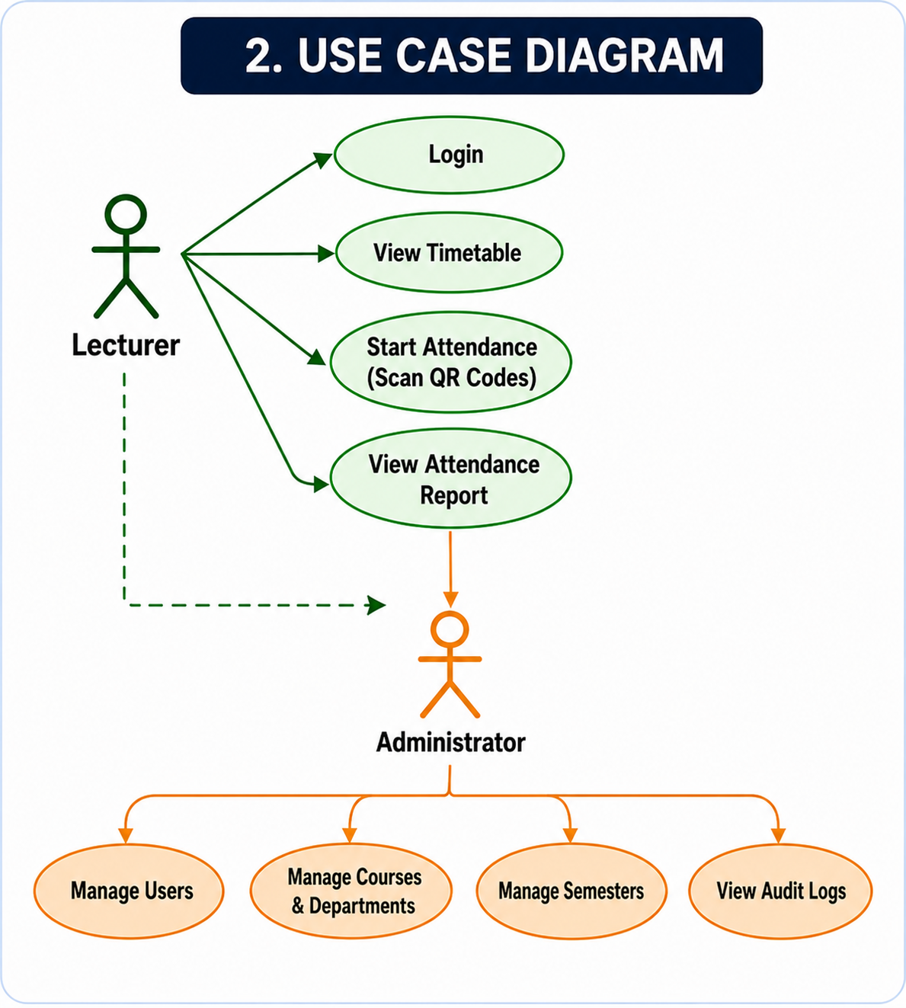
8 Use Case Diagram
Use Case Diagram — illustrating interactions of lecturers, administrators, and students with the system.
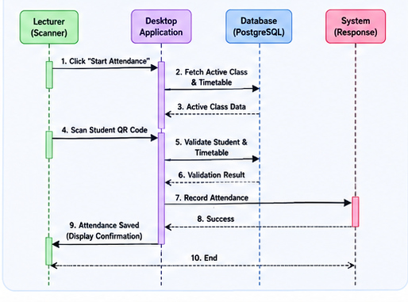
9 System Flowchart Diagram
System Flowchart — depicting the end-to-end attendance recording process from login to report generation.

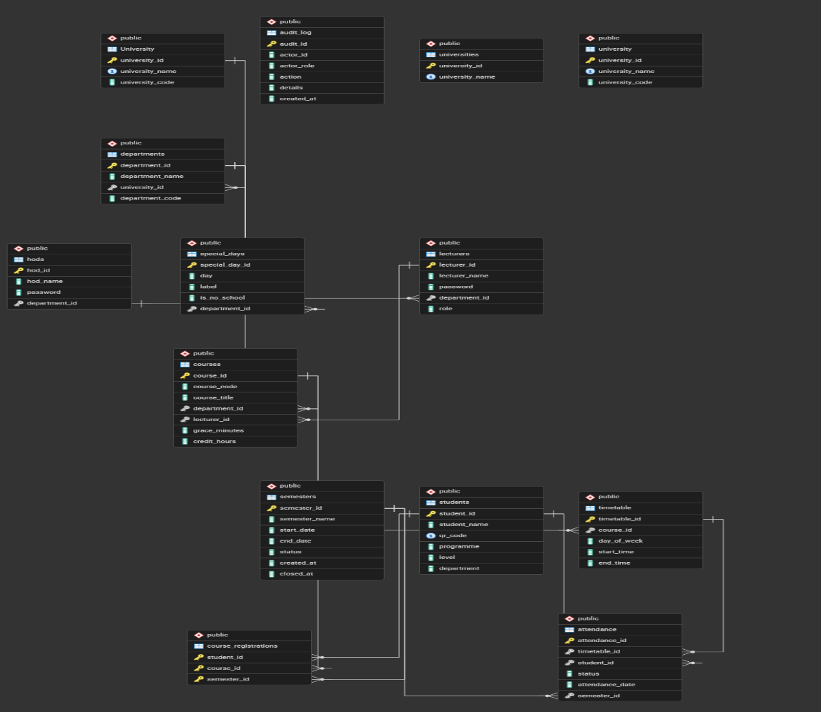
10 Entity-Relationship (ER) Diagram

Entity-Relationship (ER) Diagram — defining the database schema and entity relationships.

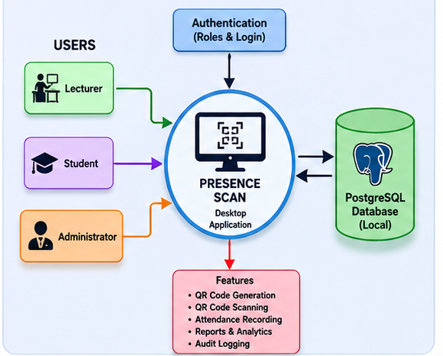
11 Module Diagram
Module Diagram — describing the modular structure of the desktop application.

3.7 Hardware and Software Requirements

Category | Requirement
Operating System | Windows 10 or later
Programming Language | Python 3.x
Desktop UI Framework | Tkinter
Camera & QR Libraries | OpenCV, pyzbar, qrcode, Pillow
Database | PostgreSQL 15+
Development IDE | Visual Studio Code
Version Control | Git / GitHub
Hardware: Computer | Desktop or laptop capable of running Python and PostgreSQL
Hardware: Camera | Webcam or built-in camera for QR scanning
Hardware: Printer | Optional — for distributing QR codes as hard copies
12 Hardware And Software Requirements

APTE

