Comparing the Performance of Classification Algorithms for Predicting Grain Yield
İbrahim Ersan Özdemir
¹ Çankaya University, Ankara, Türkiye
c2211054@student.cankaya.edu.tr
Abstract-This project investigates the performance of supervised machine learning classification algorithms on agricultural data, specifically focusing on predicting the GrainYield attribute, categorized into three classes: 'C', 'B', 'A'. The study involves data preprocessing, imputation of missing values, feature selection, and model evaluation using 5-fold stratified cross-validation. Ten classification algorithms, including RandomForest, GradientBoosting, and Support Vector Machines, are assessed for performance metrics such as Classification Accuracy (CA), Area Under the Curve (AUC), F1 Score, Precision, Recall, and Matthews Correlation Coefficient (MCC). The project explores the impact of categorical attributes (State, LandType, SoilType, SowingSchedule, and VarietyClass) on classification accuracy. By applying feature selection techniques, we compare results before and after feature selection to highlight significant predictors. Insights derived aim to provide actionable knowledge for optimizing agricultural practices and enhancing machine learning applications in the agricultural domain.
Keywords: Classification Algorithms, Agricultural Data, Machine Learning, Feature Selection, Data Imputation
- Introduction
This project explores the application of supervised machine learning methods in the analysis of agricultural data, focusing on the prediction of grainYield By utilizing a rich dataset from multi-year on-farm trials, this study investigates how variables such as sowing schedules, land characteristics, and crop establishment methods influence yield outcomes. The ultimate goal is to leverage data-driven insights to optimize agricultural practices and decision-making processes.

1.1 Importance of Machine Learning in Agriculture

Machine learning offers transformative tools for uncovering patterns in complex datasets. In agriculture, classification models are invaluable for predicting outcomes like crop yield, enabling stakeholders to make informed decisions. This project builds on methodologies commonly used in data science and applies them to agricultural datasets, emphasizing the significance of variables such as SowingSchedule, LandType, and SoilType. The project also incorporates advanced data preprocessing techniques like missing value imputation and feature selection to enhance data quality and model performance.

1.2 Feature Selection and Variable Importance
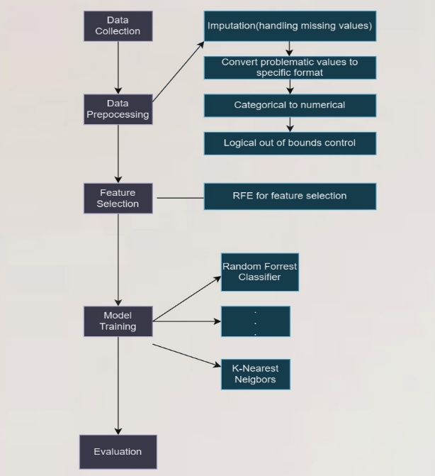
The primary objective of this study is to evaluate the performance of supervised machine learning algorithms in predicting GrainYield and to identify the most influential predictors affecting classification accuracy.[2] The study focuses on the following key variables:

SowingSchedule: Refers to the interval of dates during which wheat was sown, as reported by the farmer. This variable examines the impact of sowing timing on yield outcomes.

Figure 1. The data analytics flow chart
SoilType: Represents the type of soil as reported by the farmer, based on its texture. Soil quality and composition significantly influence nutrient availability and water retention, directly affecting crop yield.

LandType: Indicates the type of land as classified by the farmer, based on water-holding capacity. The physical characteristics of the land play a crucial role in determining productivity.

State: Refers to the name of the state where the experiment was conducted. This variable captures the geographical and climatic conditions impacting the trial outcomes.

PreviousCrop: Identifies the crop grown on the experimental plot before wheat. Crop rotation practices influence soil fertility and pest management, thereby impacting wheat yield.

CropEstablishment: Describes the method used for wheat seeding. Different seeding techniques can affect plant density, growth patterns, and overall productivity.

This project analyzes the contributions of these variables to classification models and compares classification results across different scenarios. By applying feature selection techniques, the interpretability of the results is enhanced, providing actionable insights for agricultural stakeholders.

1.3 Evaluation Metrics and Expected Outcomes
Metrics and Expected Outcomes:
The project evaluates the performance of ten machine learning algorithms using the following metrics:

Classification Accuracy (CA): Measures overall prediction correctness.
Area Under the Curve (AUC): Assesses the model's ability to distinguish between classes.
F1 Score: Evaluates the balance between Precision and Recall.
Precision and Recall: Measure the model's reliability in specific classes.
Matthews Correlation Coefficient (MCC): Evaluates classification performance across all classes.
These metrics provide a comprehensive evaluation of the algorithms' effectiveness and enable the identification of the best-performing models. The results are expected to offer insights in the following areas:

Optimizing Sowing Schedules: Identifying the most effective sowing windows.
Improving Land Management Strategies: Developing recommendations for soil and land usage.
Policy Recommendations: Informing agricultural decisions at regional and national levels.
- Methodology
The methodology adopted in this study is designed to systematically explore the factors affecting agricultural yields and optimize the classification of the GrainYield attribute. The workflow consists of several critical stages, each aimed at ensuring the quality and reliability of the analysis.

2.1 Data Collection and Preprocessing
The dataset originates from multi-year on-farm trials conducted across five regions, capturing key agricultural variables such as SowingSchedule, LandType, and SoilType. The data includes both numerical and categorical attributes, requiring preprocessing steps like:
- Missing Value Imputation: Missing numerical values were filled using KNN-based methods and medians, while categorical attributes were imputed using mode values.
- Normalization and Encoding: Numeric attributes were scaled using standardization techniques to ensure consistency across models.
- Class Imbalance Handling: The dataset exhibited significant class imbalance in the target variable, GrainYield. SMOTE[1] was applied to balance the dataset, ensuring equal representation of all yield classes ('A', 'B', and 'C').

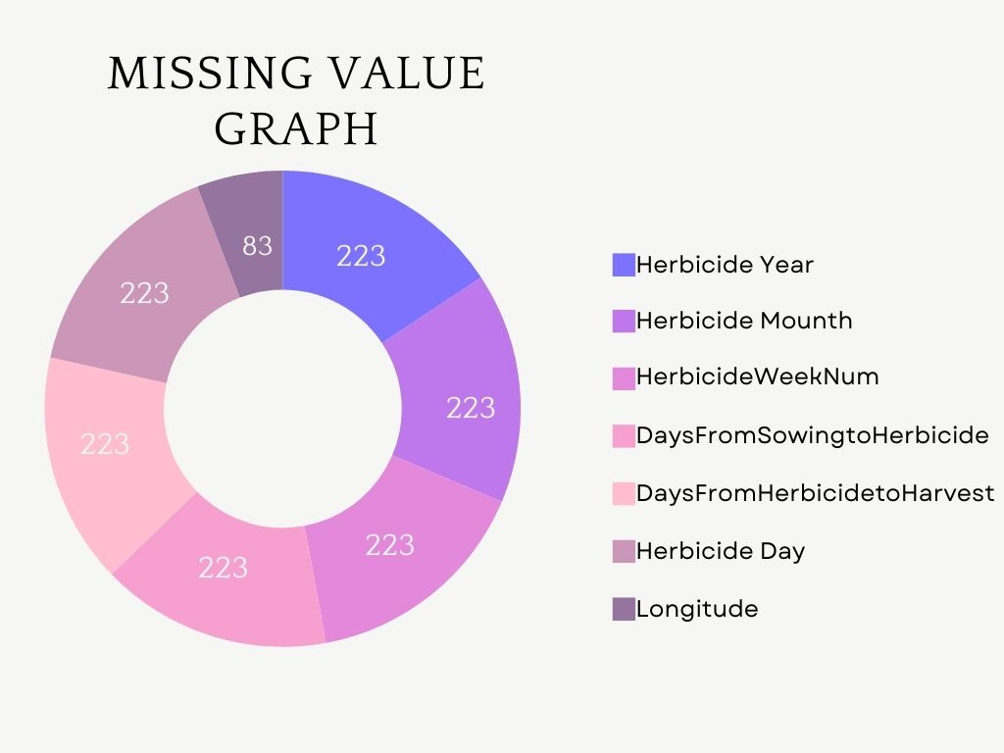
Figure 2. Missing Value Graph

2.2 Feature Selection
Feature selection techniques were applied to identify the most impactful variables for predicting GrainYield[5]. This process reduces data dimensionality, improves model performance, and enhances interpretability.[3] The top-ranked features, including CropEstablishment and LandType, were identified based on their contributions to classification accuracy.[2]

2.3 Model Implementation and Evaluation
Ten machine learning algorithms, such as RandomForest, GradientBoosting, and SVM, were employed to classify GrainYield. These models were evaluated using:
- 5-Fold Cross-Validation: Ensuring robustness and reliability of results by testing on multiple data splits.
- Performance Metrics: Metrics such as Classification Accuracy (CA), Area Under the Curve (AUC), F1 Score, Precision, Recall, and Matthews Correlation Coefficient (MCC) were used to assess model performance comprehensively.
- Data
The dataset utilized in this project originates from multi-year on-farm trials, capturing critical agricultural variables impacting GrainYield. The data includes 3,735 samples and 61 attributes collected over five years. These attributes cover soil characteristics, sowing schedules, temporal data, and crop management practices. The target variable, GrainYield, is a categorical attribute with three classes:
- A (High Yield): Optimal agricultural practices leading to high productivity.
- B (Moderate Yield): Average practices resulting in moderate yields.
- C (Low Yield): Suboptimal conditions causing lower yields.
Table 1. Data fields in the dataset.
Attribute Name | Description | Data Type
Longitude | Geographic location (longitude) | Numerical
Latitude | Geographic location (latitude) | Numerical
SowingSchedule | Timing of sowing operations | Numerical
SoilType | Soil composition and quality | Numerical
LandType | Land classification | Numerical
HerbicideYear | Year of herbicide application | Numerical
GrainYield (Target) | Yield classification | Categorical (A, B, C)
The dataset revealed an imbalance in the class distribution, with the majority of samples classified as C. This imbalance necessitated the application of SMOTE[1] to balance the classes.

B. Data Preparation
To ensure the dataset was suitable for analysis, several preprocessing steps were undertaken:
- Handling Missing Data:
  - Missing numerical values (e.g., Longitude, HerbicideYear) were filled using KNN imputation and median-based methods.
- Normalization and Encoding:
  - Numerical features were standardized to ensure uniform scales across algorithms.
  - Categorical attributes were encoded using one-hot encoding to prepare them for machine learning models.
- Balancing Class Distribution:
  - The target variable, GrainYield, exhibited class imbalance, with the majority of samples classified as C (Low Yield). To address this, SMOTE[1] (Synthetic Minority Over-sampling Technique) was applied, creating a balanced dataset for training and evaluation.
These preprocessing steps ensured that the dataset was ready for reliable and robust machine learning analysis, addressing common challenges such as missing data and class imbalance.
C. Classification Analysis
Ten machine learning algorithms were evaluated to predict GrainYield. Each model underwent 5-fold stratified cross-validation, and its performance was assessed using Classification Accuracy (CA) and Area Under Curve (AUC). The results are summarized in Table 2.
Table 2. Accuracy results for SoilType_Medium and SowingSchedule_T1 before Feature Selection Method
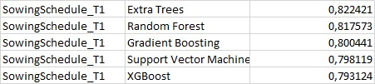
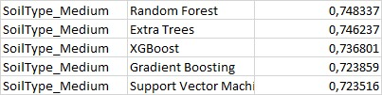
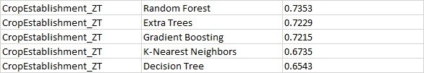
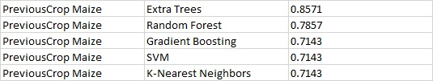
Table 3. Accuracy results for PreviousCrop Maize and CropEstablishment_ZT before Feature Selection Method

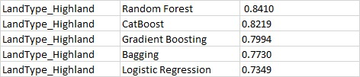
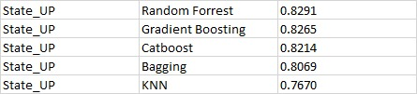
Table 4. Accuracy results for State_UP and LandType_Highland before Feature Selection Method

Table 5. Feature selection accuracy for sowingschedule and their selected features

Table 6. Top 10 accuracy changes before and after applying feature selection method
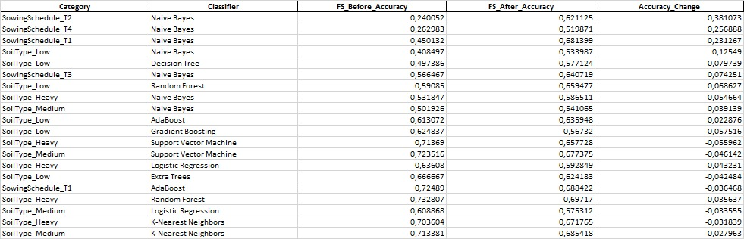

Key Insights:
- Different methods achieved highest CA and AUC scores for different features as you can see in Tables above.
- Mostly Random Forest and Extra Trees exhibited strong performances.

D. Visual Results

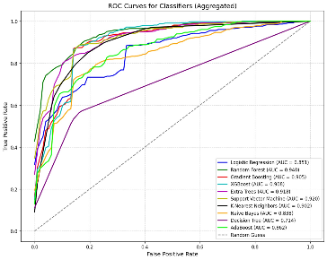
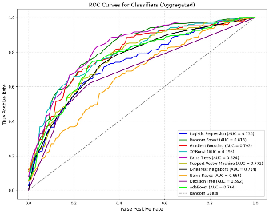
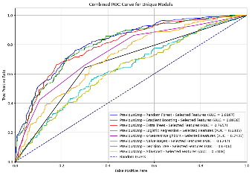

Figure 3.1 ROC (Receiving Operating Characteristic) curves for before applying feature selection
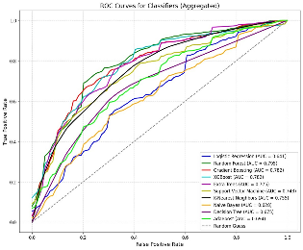
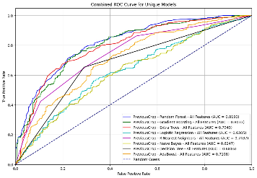
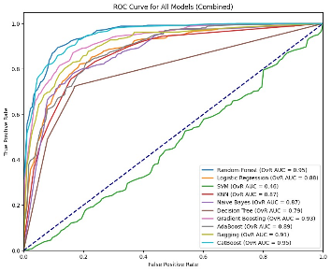

Figure 3.2 ROC (Receiving Operating Characteristic) curves for after applying feature selection
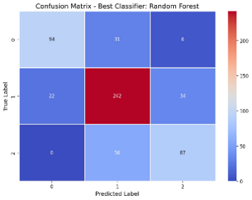
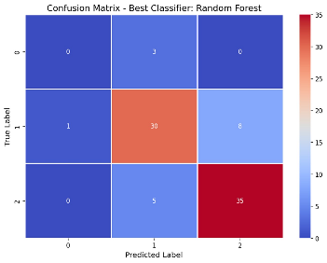

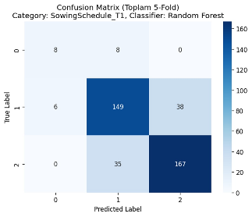
Figure 4.1 Confusion Matrix before applying Feature Selections
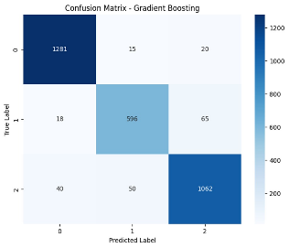
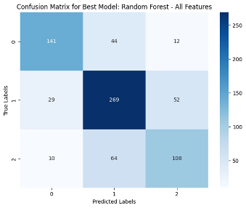
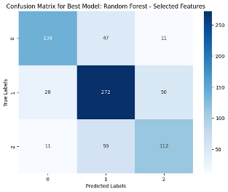

Figure 4.2 Confusion Matrix after applying Feature Selections
- Analysis and Results
A. Key Findings
This study comprehensively analyzed the performance of machine learning algorithms in predicting GrainYield and the impact of feature selection on their effectiveness. The primary findings are as follows:

Algorithm Performance: RandomForestClassifier achieved the highest performance both before and after feature selection. Post-feature selection, significant improvements were observed in CA (Classification Accuracy) and AUC (Area Under Curve) metrics.
GradientBoostingClassifier and Support Vector Machine (SVM) also showed strong performance, particularly in capturing non-linear relationships.
Impact of Feature Selection:

Feature selection significantly enhanced model performance. SowingSchedule, LandType, and SoilType emerged as the most influential predictors.[4]
As shown in Table 6, comparisons of CA values before and after feature selection reveal substantial improvements, particularly in algorithms like Naive Bayes and RandomForest.

B. Visual Results

ROC Curves: Figure 3.1 and Figure 3.2 present the ROC curves for all tested algorithms before and after feature selection. Post-feature selection, ensemble methods like RandomForest and GradientBoosting demonstrated noticeable improvements in AUC values.
Confusion Matrices: Figure 4.1 shows the confusion matrix for RandomForestClassifier before feature selection, highlighting classification challenges, particularly between classes B and C.
Figure 4.2 illustrates the confusion matrix after feature selection, with reduced misclassifications and improved overall accuracy.

C. Feature Selection Results

Table 5 summarizes the selected features for the SowingSchedule variable and their impact on model performance. Features such as Longitude, Latitude, and PrevCropResidue were critical in improving classification accuracy.

D. Interpretation of Analysis Results

The findings provide actionable insights for improving agricultural practices:

Optimization of Sowing Schedules: The prominence of SowingSchedule underscores the importance of data-driven decision-making in planning sowing operations.
Enhancement of Land Management:
Features like LandType and SoilType highlight the need for effective land classification and soil management strategies.
E. Recommendations for Future Research
Expanded Algorithm Variety: Incorporate additional algorithms (e.g., AutoML) to further compare performance.[6]
Segmentation-Based Analysis: Explore regional and crop-based segmentation to enable tailored agricultural strategies.[7]

- Conclusions
This study evaluated the application of supervised machine learning algorithms to predict GrainYield and identify the most influential agricultural variables. By leveraging multi-year agricultural datasets, this research demonstrated how data-driven approaches can be applied to optimize agricultural practices and yield prediction.

Future Directions

This study opens several avenues for future research:

Segmentation-Based Analysis: A two-dimensional or three-dimensional segmentation approach, such as analyzing combinations of LandType and SowingSchedule, could provide more granular insights. For example, Table 4 demonstrates how State_UP and LandType_Highland affect model performance. However, segmentation might result in smaller subsample sizes, requiring robust validation techniques.

Automated Machine Learning (AutoML): Future research could explore the use of AutoML frameworks to automate and optimize the selection of models and hyperparameters. As shown in Table 3, models such as Extra Trees and RandomForest performed well, and AutoML tools like AutoGluon or HuggingFace AutoTrain could further enhance these results.

Temporal and Regional Variations: Examining the temporal trends or regional variations in predictors (e.g., SoilType_Medium in Table 2) could refine the insights and inform location-specific agricultural strategies.

References
- Chawla, N. V., Bowyer, K. W., Hall, L. O., & Kegelmeyer, W. P. (2002). "SMOTE: Synthetic Minority Over-sampling Technique". Journal of Artificial Intelligence Research.Author, F., Author, S.: Title of a proceedings paper. In: Editor, F., Editor, S. (eds.) CONFERENCE 2016, LNCS, vol. 9999, pp. 1–13. Springer, Heidelberg (2016): .https://link.springer.com/chapter/10.1007/11538059_91
- Guyon, I., & Elisseeff, A. (2003). "An introduction to variable and feature selection". Journal of Machine Learning Research.Author, F.: Contribution title. In: 9th International Proceedings on Proceedings, pp. 1–2. Publisher, Location (2010): https://www.jmlr.org/papers/volume18/17-514/17-514.pdf
- Jian, Z., & Yang, X. (2019). "Feature selection methods in machine learning with applications to large-scale and high-dimensional data." International Journal of Data Science and Analytics.: .https://www.sciencedirect.com/science/article/pii/S2214860422000963
- Liu, H., & Motoda, H. (2007). "Computational Methods of Feature Selection." CRC Press.: 4. https://www.taylorfrancis.com/books/edit/10.1201/9781584888796/computational-methods-feature-selection-huan-liu-hiroshi-motoda
- Kohavi, R., & John, G. H. (1997). "Wrappers for feature subset selection." Artificial Intelligence.: https://www.researchgate.net/publication/223713209_Wrappers_for_Feature_Subset_Selection
- Optimal feature selection for Support Vector Machines" (geeksforgeeks.org).
- Soil Classification Using Machine Learning Methods and Crop Suggestion Based on Soil Series" (ieeexplore.ieee.org)

