Gender Classification from Speech

Chiu Ying Lay <g0203842@nus.edu.sg>
Ng Hian James <nghianja@comp.nus.edu.sg>

Abstract

This project uses MATLAB to devise a gender classifier from speech by analyzing the voice samples containing an arbitrary sentence. The speech signal is assumed to contain only 1 speaker, speaking in English, with no other background sounds. The classifier analyses the voice samples by using a pitch detection algorithm based on computing the short-time autocorrelation function of the speech signal.

Introduction

The ultimate goal in automatic speech recognition is to produce a system which can recognize continuous speech utterances from any speaker of a given language. One of the main application areas for speech recognition is voice input to computers for such tasks as document creation (word processing) and financial transaction processing (telephone-banking). Automatic speech recognition is done in parts with gender classification. The need for gender classification from speech also arises in several situations such as sorting telephone calls by gender (eg. gender sensitive surveys), as part of an automatic speech recognition system to enhance speaker adaptation and as part of automatic speaker recognition systems.

Speech sounds can be divided into three broad classes according to the mode of excitation. The three classes are voiced sounds, unvoiced sounds and plosive sounds. At a linguistic level, speech can be viewed as a sequence of basic sound units called phonemes. The same phoneme may give rise to many different sounds or allophones at the acoustic level, depending on the phonemes which surround it. Different speakers producing the same string of phonemes convey the same information yet sound different as a result of differences in dialect and vocal tract length and shape. Like most languages, English can be described in terms of a set of 40 or so phonemes or articulatory gestures [1].

Nearly all information in speech is in the range 200Hz to 8kHz. Humans discriminate voices between males and females according to the frequency. Females speak with higher fundamental frequencies than males. The adult male is from about 50Hz to 250Hz, with an average value of about 120Hz. For an adult female, the upper limit of the range is of much higher, perhaps as high as 500Hz. Therefore, by analyzing the average pitch of the speech samples, we can derive an algorithm for a gender classifier.

To process a voice signal, there are techniques that can be broadly classified as either time-domain or frequency-domain approaches. With a time-domain approach, information is extracted by performing measurements directly on the speech signal whereas with a frequency-domain approach, the frequency content of the signal is initially computed and information is extracted from the spectrum. Given such information, we can perform analysis on the differences in pitch, zero-crossing rate (ZCR) and formant positions for vowels between male and female.

This paper is organized as follows: section 2 gives a list of different feature extraction methods as well as classification techniques while section 3 is about our implementation of a gender classifier. Section 4 presents our evaluation of the implemented classifier and section 5 touches on some proposed idea for future enhancements.

Classification Techniques

The different features of a speech that can be extracted for analysis are basically formant frequency and pitch frequency. Based on our survey into the current literature, various implementations have been done using the above-mentioned features to classify voice samples according to gender. The following sub-sections highlight the various techniques of speech feature extraction.

2.1. Pitch Analysis
Pitch is defined as the fundamental frequency of the excitation source. Hence an efficient pitch extractor and an accurate pitch estimate calculated can be used in an algorithm for gender identification. The papers we surveyed provide multiple aspects in extracting and estimating pitch for gender classification.

Gold-Rabiner algorithm [2] illustrates pitch extraction based on the fact that locating the position of the maximum point of excitation is not always determinable from the time-waveform. Therefore it uses additional features of the time-waveform to obtain a number of parallel estimates of the pitch-period, as well as detecting the peak signal values.

Several works have implemented pitch extraction algorithms based on computing the short-time autocorrelation function of the speech signal. First, the speech is normally low-passed filtered at a frequency of about 1kHz, which is well above the maximum anticipated frequency range for pitch. Filtering helps to reduce the effects of the higher formats and any extraneous high-frequency noise. The signal is windowed using an appropriate soft window (such as Hamming) of duration 20 to 30 ms and a typical autocorrelation function is given by
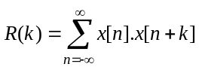

The autocorrelation function gives a measure of the correlation of a signal with a delayed copy of itself. In the case of voiced speech, the main peak in short-time autocorrelation function normally occurs at a lag equal to the pitch-period. This peak is therefore detected and its time position gives the pitch period of the input speech.

After extracting pitch information from speech files, pitch estimation algorithm is then usually applied. A version of the pitch estimation algorithm used for IMBE speech coding as described in [3] gives an average pitch estimate for the speaker by estimating the pitch for each frame of the speech. An initial estimate of the average pitch was calculated across the regions of interest identified by a pattern matcher. The estimate is refined by calculating a new average from pitch estimates within a percentage of the original average. Thus this removes the outliers produced by pitch doubling, tripling and error in region classification. This technique using pitch can be used in isolation for gender identification by comparing the average pitch estimate with preset threshold. Estimates below the threshold are identified as male and those above as female.

An alternative technique in pitch analysis is by looking at the zero-crossing rate (ZCR) and short-time energy function of a speech file [4]. ZCR is a measure of the number of times in a given time interval (frame) that the amplitude of the speech signal passes through the zero-axis. ZCR is an important parameter for voiced/unvoiced classification and end-point detection as well as gender classification as the ZCR for female voice is higher than that for male voice. The short-time energy function of speech is computed by splitting the speech signal into frames of N samples and computing the total squared values of the signal samples in each frame. Splitting the signal into frames can be achieved by multiplying the signal by a suitable window W[n], n=0, 1, 2…, N-1, which is zero for n outside the range (0, N-1). A simple function given to extract a measure related to energy can be defined as 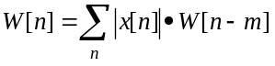
The energy of the voiced speech is generally greater than that of unvoiced speech.

Given in [4], the proposed variable to do gender classification is defined by a function comprising the mean of ZCR and the center of gravity of the acoustic vector. The logic is that the center of gravity for a male voice spectrum is closer to low frequencies and that of female is to higher frequencies.

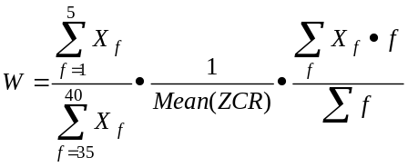
where Mean(ZCR) is the mean of ZCR in 1s and X_{f} is frequency coefficient of “f”. The W should be higher for male voices.

2.2. Formant Analysis
A formant is a distinguishing or meaningful frequency component of human speech. It is the characteristic harmonic that identifies vowels to the listener. This follows from the definition that the information humans require to distinguish between vowels can be represented purely quantitatively by the frequency content of the vowel sounds. Therefore, formant frequencies are extremely important features and formant extraction is thus an important aspect of speech processing.

Since male and female have different formant positions for vowels, therefore formant positions can be used to determine the gender of a speaker. Thus the distinction between male and female could be represented by the location in the frequency domain of the first 3 formants for vowels. Vergin et al. [5] presented that an automated male/female classification can be based on just the difference of the first and second formants between male and female voice samples. A robust but fast algorithm can then be developed to detect the gender of a speaker.

When talking about using formant analysis for doing gender classification, the problem is basically broken down to two parts. The first part is formant extraction which [5] uses a technique that performs a detection of energy concentration instead of the classic peak picking technique. The second part is the male/female detection based on the location of the first and second formant.

There are various ways proposed in the literature of speech processing for extracting formants, especially for the first two formants. Though vowels can be distinguished by the first three formants, the third does not play an important role as it does not increase the performance of any classifier significantly. Schafer and Rabiner [6] gave a peak picking technique that has become a classic but later studies evaluated it to be slow and inaccurate to a certain extent. They subsequently do have enhanced algorithms [7] but we did not study into them and hence not describe them here.

The modern forms of formant extraction studied make use of the concentration of spectral energy to track and estimate the first two formants, as shown by Vergin et al. and Chanwoo Kim et al. [8]. Vergin et al. first define a spectral energy vector obtained from fast Fourier transform. Then to estimate the first formant, an initial interval between two frequency positions valid for male and female is fixed. The interval chosen is between 125Hz and 875Hz. The lower bound is increased or the upper bound is decreased by a fixed amount in an algorithm until the difference reaches a predefined value. Finally, the mean position of the energy in the interval is estimated to get the first formant. The second formant is similarly found with a different initial interval that is between the maximum (first formant + 250Hz, 875Hz) and 2875Hz.

A list of the average formant frequencies for English vowels by male and female speakers has been obtained beforehand. For a voice sample, two scores, corresponding to the number of times the formant positions of a frame are assigned male and female values. To do this, the formant locations of the vowel frames are compared with the reference male/female formant locations of all vowels. The least difference provides the gender associated to this frame. The corresponding score is increased by 1. At the end of the computation, the greater score determines the estimated gender of the voice.

Implementation

The model that we have chosen for implementation is using pitch extraction via autocorrelation since human ears mainly differentiate by pitch. We have assumed a Gaussian distribution to compute the one-tailed confidence interval at 99% to assign weights to the results. By using one-tailed confidence interval, we also implied that only human speech samples without background noise are supplied for training and gender detection.

The model is implemented using MATLAB. There are basically two modules, Pitch (pitch.m) and Pitch Autocorrelation (pitchacorr.m) for pitch extraction and estimation [9].

The algorithm in Pitch (pitch.m) for pitch extraction is as follows:

- The speech is divided into 60ms frame segments. Each segment is extracted at every 50ms interval. This implies that the overlap between segments is 10ms.
- Each segment calls Pitch Autocorrelation to estimate the fundamental frequency for that segment.
- Median filtering is done for every 3 segments so that it is less affected by noise.
- Finally the average of all fundamental frequencies is returned.

The pitch estimated for each 60ms frame segment can be presented in a pitch contour diagram. It illustrates the pitch variation for the whole interval of 5s, as shown in Figure 1.
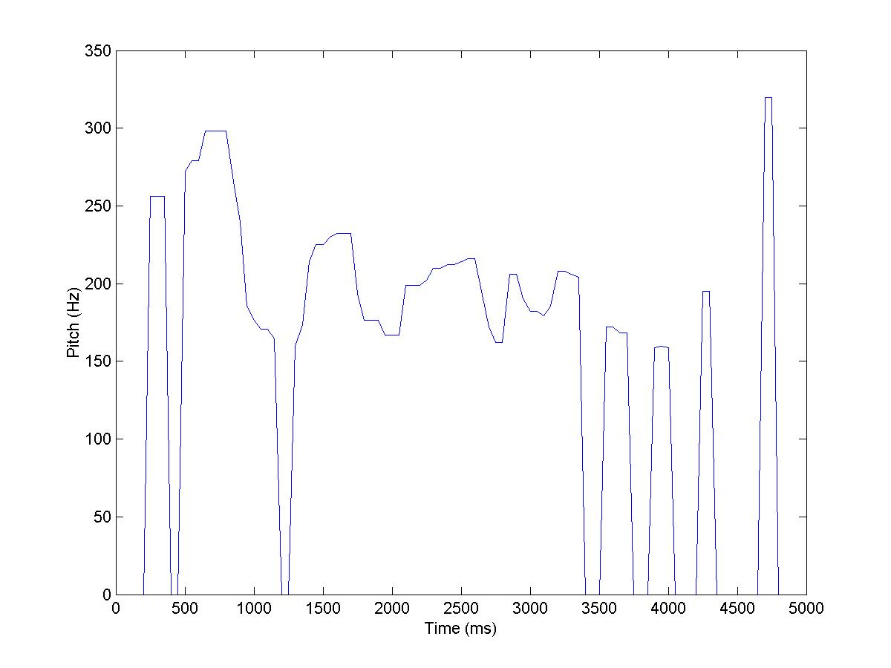
Figure 1: Pitch contour for F1.wav

The algorithm in Pitch Autocorrelation (pitchacorr.m) for pitch estimation using autocorrelation technique is as follows:

- The speech is normally low-pass filtered using a 4th order Butterworth low-pass filter at frequency of 900Hz which is well above the maximum anticipated frequency for pitch. The Butterworth filter is a reasonable choice to use as it is approximates an ideal low pass filter as the order increases.
- Due to the computational intensity of the many multiplications required for the computation of the autocorrelation function, centre-clipping technique is applied to eliminate the need for multiplication in autocorrelation-based algorithm. This involves suppressing values of the signal between two adjustable clipping thresholds. It is set at 0.68 of the maximum amplitude value. Centre-clipping removes most of the formant information, leaving substantial components due to the pitch periodicity which shows up more clearly in the autocorrelation function.
- After clipping, the short-time energy function is computed. We define silence if maximum autocorrelation is less than 40% of the short-time energy. The maximum autocorrelation is taken from the range of 60Hz to 320Hz. Hence if fundamental frequency found outside the range, it is treated as unvoiced segment.

Training

Eight pairs of voice samples (a pair consists of a male and a female) are collected for the training of the gender speech classifier. A voice sample is assumed to contain only 1 speaker speaking an arbitrary English sentence for 5s without background sounds. According Nyquist’s sampling theorem, if the highest frequency component present in the signal is f_{h} Hz, then the sampling frequency f_{s} must be at least twice this value, that is f_{s} ≥ 2f_{h}, in order to avoid aliasing. Each sample is recorded at 22.05 kHz which is well above the twice of 8 kHz (the highest frequency observed for speech).

The average fundamental frequencies (pitch) are computed for both male class and female class. A threshold is obtained by getting the mean of the 2 average fundamental frequencies. The standard deviation (SD) for each class is also computed. The values are used as parameters of the classifier as shown below.

Mean pitch for male | 146.5144 Hz
SD for male | 23.6838 Hz
Mean pitch for female | 212.3134 Hz
SD for female | 17.0531 Hz
Threshold | 179.4139 Hz

The threshold is the determinant for the gender class. If the pitch of a voice sample falls below the threshold, the classifier will assign it as male. Otherwise, it will assign as female.

A one-tailed 99% confidence level is computed to reflect the probability of misclassification. If it falls outside confidence interval (i.e. it belongs to the non-confident region), it is remarked as “Misclassification possible”.

Results

Six more voice samples are taken for testing of the gender speech classifier. Five of them (2 males and 3 females) are classified correctly into gender classes. However, one of the correctly classified samples falls outside the 99% confidence level.

One male voice sample is misclassified into female class due to the presence of high frequency noise component. The noise component gives rise to a higher fundamental frequency (pitch), hence it falls into the wrong gender class with high confidence. Therefore it is critical to record voice sample without background or static noise.

Future Enhancements

From our results given in the above section, our classifier based on pitch extraction using autocorrelation managed to perform satisfactorily. However, there are voice samples that failed to fall within the range of confidence level. Hence they cannot be classified with certainty. Extreme cases of males voice with higher pitch or female voices with lower pitch are classified into the wrong gender. This type of situations can hardly be improved as the threshold we derived has been crossed. We may fine-tune the threshold by training with a bigger sample set.

Other cases of inaccurate results involve voice samples that are being correctly classified but fall in the non-confident region. Improvements can be made to handle such cases by using “combo-classifier”. A “combo-classifier” is a classifier consists of multiple classifiers employing different methods of doing gender detection. A simple weight-scoring algorithm determines the gender of a voice sample by looking at the results returned from the group of classifiers.

It works in the following way:
- Each classifier assigns weight to the result based on how confident it is of the results. For example, our implementation will assign varying weights according to the distance away from the mean. If the result falls outside the confidence level, a further discounted weight may be given instead.
- The weights from the classifiers are summed up and the gender class that has the highest score is taken as the class. An arbitrary threshold for the total weight can also be defined so that there is still a grey area where the classification is deemed non-confident.

Conclusions

In this project, we have implemented a gender speech classifier based on pitch analysis. To show the sureness of our results, a 99% confidence level is used to demonstrate how confident the classifier is of the results. Based on our results, we can concluded that pitch differentiation is an excellent way of classifying speech into the gender classes.

We also proposed a “combo-classifier” that uses other techniques such as formant analysis to implement a weight-scoring system so that the gender speech classification is more robust. Confidence level computation can be used for assignment of weights.

References

[1] F. J. Owens, Signal Processing of Speech.

[2] Gold, B. and Rabiner, L.R, Parallel processing techniques for estimating pitch periods of speech in time-domain.

[3] E.S. Parris and M.J. Carey, Language Independent Gender Identification.

[4] H. Harb, L. Chen, J. Auloge, Speech/ Music/ Silence and Gender Detection Algorithm.

[5] R. Vergin, A. Farhat, D. O’Shaughnessy, Robust Gender-Dependent Acoustic-Phonetic Modelling in Continuous Speech Recognition Based On A New Automatic Male/Female Classification.

[6] R.W. Schafer and L.R. Rabiner, System for automatic formant analysis of voiced speech.

[7] L.R. Rabiner and R.W. Schafer, Digital Processing of Speech Signals.

[8] Chanwoo Kim and Wonyong Song, Vowel Pronunciation Accuracy Checking System Based on Phoneme Segmentation and Formants Extraction.

[9] E.D. Ellis, Design of a Speaker Recognition Code using MATLAB.

