The Mathematics, Implementation, and Future of RSA Cryptography
Boston Karymshakov
Penn State University

1. Introduction
Cryptography plays a major role in modern computing and cybersecurity. Every day, people send messages, make online purchases, access bank accounts, and store personal information online. Without cryptography, much of this communication would be vulnerable to interception or manipulation by attackers.
One of the main goals of cryptography is to protect the confidentiality, integrity, and availability of information, often referred to as the CIA Triad. Confidentiality ensures that information can only be read by authorized users, integrity ensures that data has not been modified unexpectedly, and availability ensures that systems and information remain accessible when needed.
Before public-key cryptography was introduced, most secure communication relied on symmetric encryption. In symmetric encryption, both parties use the same secret key to encrypt and decrypt information. While this method is efficient, it creates a major challenge known as the key distribution problem. If two people want to communicate securely, they first need a secure method of exchanging the secret key. This becomes increasingly difficult as the number of users grows.
Public-key cryptography was developed as a solution to this problem. Instead of using one shared secret key, each user has a public key and a private key. The public key can be shared openly, while the private key remains secret. A common analogy is a mailbox with a padlock attached to it. Anyone can place a letter into the mailbox because the padlock is publicly accessible, but only the owner possesses the key needed to open the mailbox and read its contents.
RSA is one of the most famous public-key cryptographic systems and remains an important topic in both computer science and cybersecurity. It was introduced in 1977 by Ron Rivest, Adi Shamir, and Leonard Adleman. RSA relies on mathematical concepts from number theory, particularly the difficulty of factoring very large integers. While multiplying two large prime numbers is relatively easy, determining the original prime factors from their product is computationally difficult. This asymmetry forms the foundation of RSA security.
The purpose of this project was to explore RSA from both a theoretical and practical perspective. In addition to studying the mathematical principles behind RSA, a complete implementation was developed in Python without using built-in cryptographic libraries. The project includes key generation, encryption, decryption, primality testing using the Miller–Rabin algorithm, modular exponentiation using the square-and-multiply method, benchmarking experiments, and an analysis of RSA security and future challenges such as quantum computing.

2. Background Knowledge
Before understanding how RSA works, it is important to review several mathematical and cryptographic concepts that form the foundation of the algorithm. RSA is heavily based on number theory and modular arithmetic, so understanding these topics makes it much easier to follow the key generation, encryption, and decryption processes.

2.1 Modular Arithmetic
Modular arithmetic is sometimes referred to as "clock arithmetic" because numbers wrap around after reaching a certain value. For example, on a 12-hour clock, adding 5 hours to 10 o'clock results in 3 o'clock rather than 15 o'clock. In mathematics, this is written using modulo notation.
For example:
15 mod 12 = 3
This means that when 15 is divided by 12, the remainder is 3. RSA relies heavily on modular arithmetic because it allows very large calculations to be performed while keeping the results within a manageable range. Both the encryption and decryption processes use modular exponentiation, which repeatedly applies exponentiation under a modulus.
Without modular arithmetic, the numbers involved in RSA would quickly become too large to handle efficiently.

2.2 Prime Numbers
Prime numbers are positive integers greater than 1 that have exactly two factors: 1 and themselves. Examples include 2, 3, 5, 7, 11, and 13.
Prime numbers are the backbone of RSA cryptography. During key generation, two large prime numbers are selected and multiplied together to create a value called the modulus. While multiplying two prime numbers is straightforward, determining the original prime factors from the resulting product is much more difficult. This property is what gives RSA its security.
Modern RSA systems use primes that are hundreds or even thousands of bits long, making factorization computationally expensive.

2.3 Greatest Common Divisor (GCD)
The Greatest Common Divisor (GCD) of two integers is the largest positive integer that divides both numbers without leaving a remainder.
For example:
GCD(48, 18) = 6
The Euclidean Algorithm is a fast method for finding the GCD of two numbers and is widely used in cryptography. RSA requires certain values to be relatively prime, meaning their GCD equals 1.
For example:
GCD(7, 40) = 1
Since the only common divisor is 1, the numbers are considered relatively prime. This concept becomes important when selecting the public exponent during RSA key generation.

2.4 Basic Number Theory
Number theory is the branch of mathematics that studies properties of integers. RSA relies on several important concepts from number theory, including divisibility, modular arithmetic, prime numbers, Euler's Totient Function, and modular inverses.
One important idea is Euler's Totient Function, which counts how many positive integers less than a given number are relatively prime to it. This value plays a critical role in generating RSA keys.
Another important concept is the modular inverse. In RSA, the private key is calculated by finding the modular inverse of the public exponent with respect to Euler's Totient Function. The Extended Euclidean Algorithm is commonly used to perform this calculation efficiently.
Although RSA may appear complicated at first, most of its operations are built upon these fundamental number theory concepts.

2.5 Symmetric vs Asymmetric Encryption
Encryption algorithms are generally divided into two categories: symmetric encryption and asymmetric encryption.
In symmetric encryption, the same key is used for both encryption and decryption. Popular examples include AES (Advanced Encryption Standard). Symmetric algorithms are very fast and efficient, making them suitable for encrypting large amounts of data. However, they introduce the key distribution problem because both parties must somehow share the secret key securely before communication can begin.
Asymmetric encryption, also known as public-key cryptography, solves this problem by using two different keys: a public key and a private key. The public key can be distributed openly and is used for encryption, while the private key is kept secret and is used for decryption.
RSA is an example of an asymmetric encryption algorithm. Although asymmetric algorithms are generally slower than symmetric algorithms, they provide a secure method for exchanging information without requiring a shared secret beforehand.
In practice, modern systems often combine both approaches. RSA is commonly used to exchange a symmetric key securely, and that symmetric key is then used by a faster algorithm such as AES to encrypt the actual data. This hybrid approach provides both security and efficiency.

3. History of RSA
The development of RSA marked one of the most significant milestones in the history of cryptography. Prior to the introduction of public-key cryptography, secure communication relied almost entirely on symmetric encryption systems. While these systems were effective, they suffered from the key distribution problem, which made it difficult to securely exchange secret keys between communicating parties.
RSA was introduced in 1977 by three researchers at the Massachusetts Institute of Technology (MIT): Ron Rivest, Adi Shamir, and Leonard Adleman. The algorithm takes its name from the first letters of their last names: Rivest, Shamir, and Adleman. Their work was published in a paper titled "A Method for Obtaining Digital Signatures and Public-Key Cryptosystems" and became the first practical implementation of public-key cryptography.
The story behind RSA is particularly interesting because the three researchers approached the problem from different perspectives. Ron Rivest was primarily responsible for developing the mathematical approach behind the algorithm, while Adi Shamir and Leonard Adleman contributed to its analysis, testing, and refinement. Together, they created a system that allowed secure communication without requiring a previously shared secret key.
What made RSA revolutionary was its use of two separate keys: a public key for encryption and a private key for decryption. This concept solved the key distribution problem that had challenged cryptographers for decades. Anyone could obtain a user's public key and use it to encrypt a message, but only the holder of the private key could decrypt it.
Interestingly, the idea behind public-key cryptography had actually been discovered several years earlier. In 1973, a British mathematician named Clifford Cocks, who worked for the Government Communications Headquarters (GCHQ) in the United Kingdom, independently developed a cryptographic system that was mathematically very similar to RSA. However, because his work was classified as a government secret, it was not publicly revealed until 1997, twenty years after RSA had already become widely known.
The publication of RSA in 1977 transformed the field of cryptography. For the first time, secure communication could be established over insecure networks without requiring a secure method of exchanging keys beforehand. This breakthrough laid the foundation for many of the technologies used today, including secure web browsing, online banking, encrypted email, digital signatures, and modern internet security protocols.
Even though newer cryptographic algorithms have been developed over the years, RSA remains one of the most influential cryptographic systems ever created. Its combination of elegant mathematics and practical security has made it a cornerstone of cybersecurity education and a fundamental topic in computer science.

4. RSA Mathematics
Formulas used:
Euler Totient
$$ϕ(n)=(p-1)(q-1)$$

Encryption
$$c≡m^{e}(modn)$$

Decryption
$$m≡c^{d}(modn)$$

Modular Inverse
$$d≡e^{-1}(modϕ(n))$$
4. RSA Mathematics
The security and functionality of RSA are based on several mathematical concepts from number theory. While the implementation of RSA may appear complicated at first, the algorithm itself can be broken down into a sequence of logical mathematical operations. The key idea behind RSA is that multiplying large prime numbers together is computationally easy, while reversing the process through factorization is extremely difficult.
This section explains the mathematical foundation of RSA, including key generation, encryption, decryption, and the role of modular inverses.

4.1 Euler's Totient Function
One of the most important mathematical concepts used in RSA is Euler's Totient Function, denoted by φ(n). The function counts how many positive integers less than n are relatively prime to n.
For RSA, two large prime numbers p and q are selected. The modulus n is computed as:
n = p × q
Since p and q are prime, Euler's Totient Function can be calculated using:
φ(n) = (p − 1)(q − 1)
This value is critical because it is used when generating the public and private keys.
For example, if:
p = 11
q = 13
Then:
n = 11 × 13 = 143
φ(n) = (11 − 1)(13 − 1)
φ(n) = 10 × 12
φ(n) = 120
The value φ(n) determines the mathematical relationship between the public and private keys.

4.2 RSA Key Generation
The first step in RSA is generating a pair of keys.
- Choose two large prime numbers p and q.
- Compute the modulus:
n = p × q
- Compute Euler's Totient Function:
φ(n) = (p − 1)(q − 1)
- Choose a public exponent e such that:
gcd(e, φ(n)) = 1
This means e and φ(n) must be relatively prime.
- Compute the private exponent d using the modular inverse:
d ≡ e⁻¹ (mod φ(n))
The public key becomes:
(e, n)
The private key becomes:
(d, n)
In this project, the modular inverse was calculated using the Extended Euclidean Algorithm, which efficiently finds d.

4.3 RSA Encryption
Once the public key has been generated, anyone can use it to encrypt a message.
Before encryption, the plaintext message is converted into an integer representation. RSA performs mathematical operations on numbers rather than text.
Encryption is performed using the formula:
c ≡ mᵉ (mod n)
where:
m = plaintext message
e = public exponent
n = modulus
c = ciphertext
The result is a seemingly random integer that cannot be easily converted back into the original message without the private key.
One important observation is that the exponentiation involved in RSA can become extremely large. To solve this problem efficiently, this project implemented the Square-and-Multiply algorithm for modular exponentiation rather than relying on naive exponent calculations.

4.4 RSA Decryption
The receiver uses the private key to recover the original message.
Decryption is performed using:
m ≡ cᵈ (mod n)
where:
c = ciphertext
d = private exponent
n = modulus
m = recovered plaintext
After the computation is complete, the resulting integer is converted back into its original text representation.
The remarkable property of RSA is that even though encryption and decryption use different keys, the original message is recovered exactly.

4.5 Modular Inverse
The modular inverse is one of the most important calculations in RSA because it establishes the mathematical relationship between the public and private keys.
The private exponent d is calculated as:
d ≡ e⁻¹ (mod φ(n))
This means that:
(d × e) mod φ(n) = 1
Finding d is only possible because e and φ(n) are chosen to be relatively prime.
In this project, the modular inverse was computed using the Extended Euclidean Algorithm rather than relying on external cryptographic libraries. This provided a deeper understanding of how RSA generates valid key pairs.

4.6 Why RSA Works
At first glance, the encryption and decryption formulas appear unrelated. However, RSA works because of Euler's Theorem and properties of modular arithmetic.
Euler's Theorem states that if two integers are relatively prime:
a^φ(n) ≡ 1 (mod n)
RSA chooses d such that:
ed ≡ 1 (mod φ(n))
This means there exists some integer k where:
ed = 1 + kφ(n)
During decryption:
m^(ed)
can be rewritten as:
m^(1 + kφ(n))
Applying Euler's Theorem simplifies the expression and ultimately reduces it back to:
m
which is the original plaintext message.
This mathematical relationship is what guarantees that decrypting an RSA ciphertext produces the original message.

4.7 Mathematical Security of RSA
The security of RSA does not depend on keeping the encryption algorithm secret. In fact, the entire algorithm is publicly known.
Instead, RSA relies on the difficulty of factoring very large integers.
An attacker who knows the public key can easily see:
n = p × q
However, determining the original prime numbers p and q from n becomes computationally difficult as the size of the primes increases.
This project explored that security assumption through benchmarking experiments and Pollard Rho factorization. The benchmarking results demonstrate an important asymmetry: generating large RSA keys can be performed in polynomial time, while factoring large semiprimes becomes significantly more expensive as key sizes grow.
This asymmetry is often referred to as the RSA trapdoor function. It is easy to move in one direction (multiplication and key generation) but extremely difficult to reverse through factorization. This property forms the foundation of RSA security and is one of the main reasons the algorithm has remained relevant for decades.

5. Python Implementation
The practical part of this project was implemented in Python. The main goal was to build a working version of textbook RSA from scratch without using built-in cryptographic libraries. This helped me understand not only what RSA does, but also how the math is actually translated into code.
The project was organized into separate Python files so that each part had a clear responsibility. This made the code easier to test, debug, and explain.

5.1 Project File Structure
The main implementation files were organized as follows:
src/
├── math_utils.py
├── primality.py
├── rsa_core.py
├── factorization.py
├── benchmarking.py
└── cli.py
Each file served a specific purpose:
math_utils.py Handles GCD, modular inverse, and modular exponentiation
primality.py Implements Miller-Rabin primality testing
rsa_core.py Handles RSA key generation, encryption, and decryption
factorization.py Implements Pollard Rho factorization
benchmarking.py Measures prime generation and key generation performance
cli.py Provides the command-line user interface
This structure made the project more modular. For example, the RSA core file does not need to know all the details of how Miller-Rabin works. It simply calls the prime generation function when it needs large primes.

5.2 Miller-Rabin Primality Test
RSA requires two large prime numbers, usually called p and q. Testing whether a very large number is prime using a basic trial division method would be too slow, so this project uses the Miller-Rabin probabilistic primality test.
Miller-Rabin works by checking whether a number behaves like a prime under modular exponentiation. It does not prove primality with absolute certainty in the same way as a deterministic proof, but with enough testing rounds, the probability of incorrectly identifying a composite number as prime becomes extremely small.
In my implementation, the function is_prime(n, k) performs multiple testing rounds, where k controls the accuracy. The generate_prime(bits) function repeatedly generates random odd numbers with the correct bit length until Miller-Rabin identifies one as probably prime.
A simplified version of the prime generation logic is:
def generate_prime(bits):
while True:
candidate = random.getrandbits(bits)

candidate |= (1 << bits - 1) | 1

if is_prime(candidate):
return candidate
The line that sets the highest bit ensures that the number has the correct bit length, and the | 1 part ensures that the candidate is odd. This is important because all even numbers greater than 2 are automatically not prime.

5.3 Modular Exponentiation
RSA encryption and decryption both involve exponentiation with very large numbers. For example, encryption uses:
c ≡ mᵉ mod n
A direct calculation such as m ** e would create extremely large intermediate values, which is inefficient and not realistic for RSA-sized numbers.
To solve this, I implemented modular exponentiation using the square-and-multiply method. This method repeatedly squares the base and reduces the result modulo n at each step. It avoids huge intermediate values and makes RSA practical.
The implementation was placed in math_utils.py:
def mod_exp(base, exponent, modulus):
result = 1
base = base % modulus

while exponent > 0:
if exponent % 2 == 1:
result = (result * base) % modulus

exponent = exponent >> 1
base = (base * base) % modulus

return result
This function is one of the most important helper functions in the whole project because it is used during encryption, decryption, primality testing, and factorization.

5.4 RSA Key Generation
The main RSA logic was implemented in rsa_core.py. The generate_keypair(bits) function creates both the public and private keys.
The key generation process follows the standard RSA steps:
- Generate two large prime numbers p and q.
- Compute the modulus n = p × q.
- Compute Euler's Totient Function φ(n) = (p − 1)(q − 1).
- Choose the public exponent e.
- Compute the private exponent d using the modular inverse.
In this project, I used 65537 as the public exponent because it is commonly used in real RSA systems. It is large enough to avoid some weaknesses of very small exponents but still efficient for computation.
A simplified version of the key generation function is:
def generate_keypair(bits):
p = generate_prime(bits)
q = generate_prime(bits)

while q == p:
q = generate_prime(bits)

n = p * q
phi = (p - 1) * (q - 1)

e = 65537

while gcd(e, phi) != 1:
e = random.randrange(2, phi)

d = mod_inverse(e, phi)

public_key = (e, n)
private_key = (d, n)

return public_key, private_key
The public key is used for encryption, while the private key is used for decryption.

5.5 Encryption and Decryption
RSA works with integers, not directly with text. Because of this, the plaintext message first has to be converted into bytes and then into an integer.
During encryption, the plaintext integer is raised to the public exponent e modulo n:
ciphertext = mod_exp(message_int, e, n)
During decryption, the ciphertext is raised to the private exponent d modulo n:
decrypted_int = mod_exp(ciphertext, d, n)
After decryption, the resulting integer is converted back into bytes and decoded into the original string.
The general flow is:
plaintext string → bytes → integer → RSA encryption → ciphertext integer
ciphertext integer → RSA decryption → integer → bytes → plaintext string
This conversion step was one of the parts that made the implementation feel more realistic, because RSA is mathematical, but users still expect to type and receive readable text.

5.6 Pollard Rho Factorization
To demonstrate why RSA is secure, I also implemented Pollard Rho factorization in factorization.py. This algorithm attempts to find a non-trivial factor of a composite number.
Pollard Rho is much faster than simple trial division in many cases, but it still becomes impractical as the number size grows. This makes it useful for demonstrating the factoring problem without needing advanced factorization algorithms like the General Number Field Sieve.
The main idea is to generate a pseudo-random sequence and look for a repeated cycle that reveals a factor through the GCD operation.
A simplified part of the implementation is:
while d == 1:
x = (mod_exp(x, 2, n) + c) % n
y = (mod_exp(y, 2, n) + c) % n
y = (mod_exp(y, 2, n) + c) % n

d = math.gcd(abs(x - y), n)
The algorithm is used in the benchmarking section to show how factorization time increases as the semiprime size grows. This connects directly to the security assumption behind RSA.

5.7 Benchmarking Implementation
The benchmarking part of the project was implemented in benchmarking.py and factorization.py.
The benchmark scripts measure:
Prime generation time
RSA key generation time
Factorization time
The timing was done using Python's time.perf_counter() function, which is useful for measuring short time intervals.
For prime and key generation, the project tests increasing bit sizes:
128-bit
256-bit
512-bit
1024-bit
For factorization, smaller semiprime sizes are used:
16-bit
24-bit
32-bit
40-bit
48-bit
64-bit
The factorization sizes are intentionally smaller because factoring large RSA moduli would take too long with classical algorithms. This was actually an important lesson from the project: RSA key generation is practical, but reversing the process by factoring n becomes much harder as the numbers grow.
The benchmark results are saved as graph images inside the graphs/ folder.

5.8 CLI Architecture
To make the project easier to use, I created a command-line interface in cli.py. The CLI allows users to interact with the RSA system without directly modifying the source code.
The menu includes:
1. Generate RSA Keys
2. Encrypt Message
3. Decrypt Message
4. Run Benchmark Tests
5. Run Factorization Benchmark
6. Exit
This makes the project easier to demonstrate because a user can generate keys, encrypt a message, decrypt it, and run benchmark tests from one place.
The CLI also includes basic error handling. For example, it checks whether keys have been generated before encryption or decryption, validates numeric input, and catches decryption errors if the ciphertext is invalid.
Overall, the CLI helped turn the project from just a collection of Python files into a complete working application.

5.9 Screenshots and Code Evidence
For the final version of the report, screenshots should be included to show the project working. The most useful screenshots are:
CLI main menu
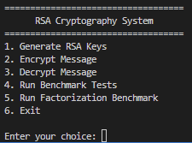
RSA key generation output
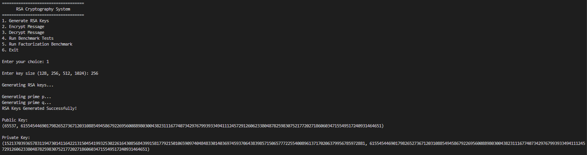
Encryption and decryption example
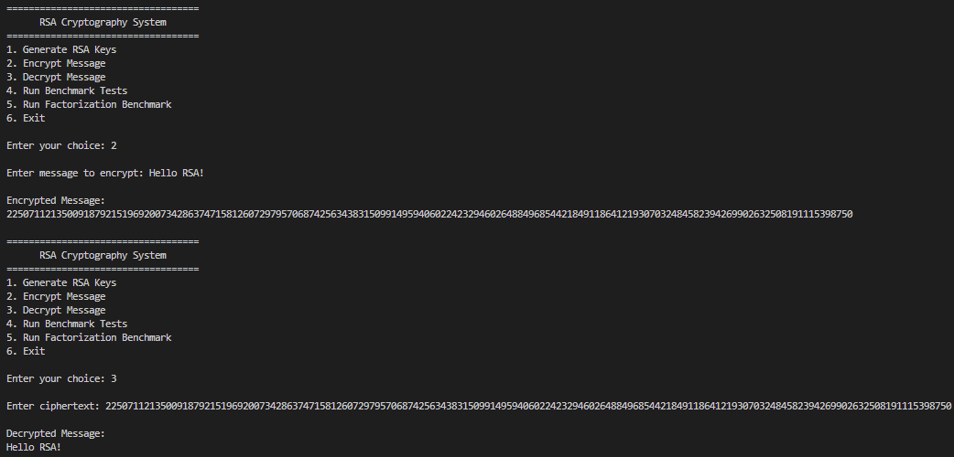
Prime/key generation benchmark graph
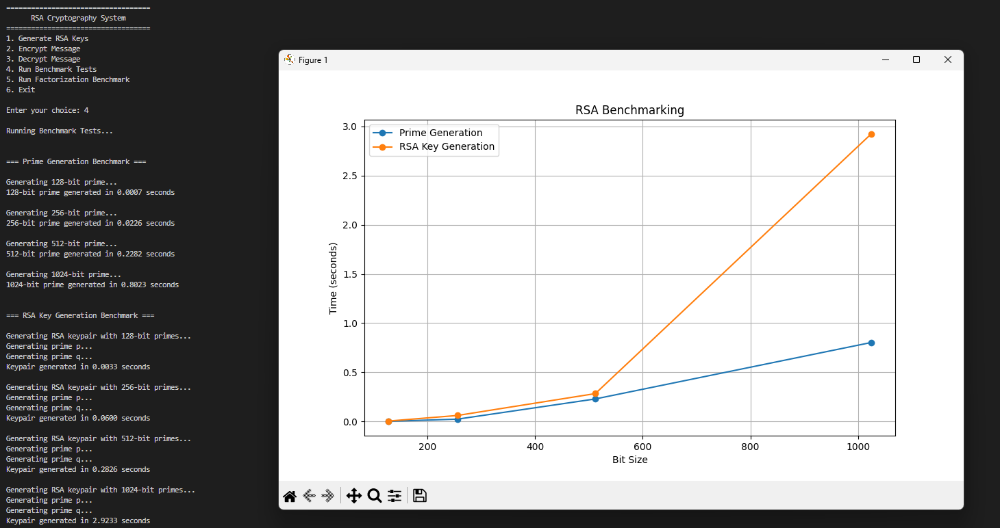
Factorization benchmark graph
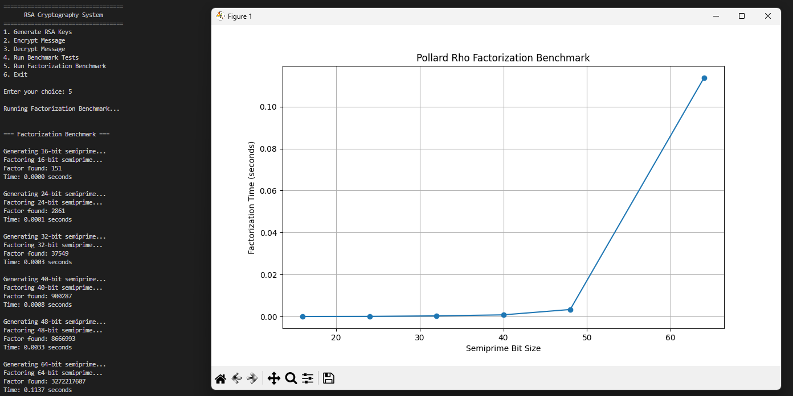
These screenshots help prove that the implementation is functional and make the report easier to follow visually.

6. Benchmarking and Analysis
One of the primary goals of this project was not only to implement RSA, but also to investigate why RSA remains secure despite its algorithm being publicly known. To explore this question, benchmarking experiments were performed on both RSA key generation and integer factorization.
The experiments focused on an important property known as computational asymmetry. In RSA, generating keys is relatively efficient, while reversing the process by factoring the modulus becomes significantly more difficult as the key size increases. This difference in computational difficulty is commonly referred to as the RSA trapdoor function.

6.1 Benchmarking Methodology
Two separate benchmarking experiments were conducted.
The first experiment measured the time required to generate large prime numbers and RSA key pairs. Since RSA relies on large prime numbers, this benchmark helps evaluate the practicality of key generation.
The second experiment measured the time required to factor semiprimes using the Pollard Rho algorithm. A semiprime is a number formed by multiplying two prime numbers together, which is exactly how RSA moduli are constructed.
Execution times were measured using Python's time.perf_counter() function to provide high-resolution timing data.
Prime Generation and Key Generation Tests
The following key sizes were tested:
128-bit
256-bit
512-bit
1024-bit
For each size, the benchmark measured:
- Prime generation time
- RSA key generation time
Factorization Tests
The following semiprime sizes were tested:
16-bit
24-bit
32-bit
40-bit
48-bit
64-bit
These smaller sizes were selected because factorization becomes increasingly expensive as the modulus grows. Attempting to factor realistic RSA key sizes would be impractical using classical algorithms on consumer hardware.

6.2 Prime Generation and Key Generation Results
Figure 1 shows the execution times recorded for prime generation and RSA key generation.
[Insert benchmark_results.png here]
Figure 1. Prime generation and RSA key generation benchmark results.
Several observations can be made from the graph.
First, prime generation time increases as the bit size grows. This behavior is expected because larger numbers require additional Miller-Rabin testing rounds and involve more expensive arithmetic operations.
Second, RSA key generation consistently takes longer than prime generation alone. This is because key generation includes multiple additional operations such as calculating Euler's Totient Function, verifying that the public exponent is relatively prime to φ(n), and computing the modular inverse to obtain the private key.
However, despite this increase, key generation remains practical even for larger key sizes. The growth rate appears relatively gradual rather than explosive.
This behavior is consistent with the theoretical complexity of the Miller-Rabin primality test, which operates in polynomial time. Although larger key sizes require more computation, the increase remains manageable and predictable.
In practical terms, this means that generating secure RSA keys is computationally feasible even for large key sizes commonly used in industry.
6.3 Factorization Results
The second experiment focused on the opposite side of the RSA problem: breaking the modulus through factorization.
Figure 2 shows the execution times recorded while factoring semiprimes using Pollard Rho.
[Insert factorization_results.png here]
Figure 2. Pollard Rho factorization benchmark results.
Unlike the key generation benchmark, the factorization graph shows a noticeably steeper increase in execution time as the semiprime size grows.
Even though the benchmark only tested relatively small numbers, the trend is already visible. Each increase in bit length requires significantly more computational effort to recover the original prime factors.
This result demonstrates the core assumption behind RSA security. Multiplying two prime numbers together is straightforward, but reversing the operation becomes increasingly difficult.
6.4 Computational Asymmetry
The most important conclusion from the benchmark results is the existence of computational asymmetry.
RSA relies on two mathematical operations:
Prime generation and multiplication
Factorization of the resulting modulus
The first operation is relatively efficient and can be completed in polynomial time.
The second operation becomes increasingly difficult as the modulus size grows. While Pollard Rho is significantly faster than naive trial division, it still struggles as the input size increases.
This asymmetry is what allows RSA to function securely.
A user can generate a public key and distribute it openly without concern that an attacker can easily derive the corresponding private key. The public modulus n is visible to everyone, but recovering the original prime factors p and q remains computationally expensive.

6.5 Relationship to Real-World RSA
The semiprime sizes used in this project are much smaller than those used in modern security systems.
Typical RSA implementations use key sizes such as:
2048-bit
3072-bit
4096-bit
While Pollard Rho can factor small semiprimes relatively quickly, modern RSA implementations would require significantly more advanced algorithms such as the General Number Field Sieve (GNFS).
Even with these advanced methods, factoring a properly generated 2048-bit RSA modulus remains computationally infeasible using current classical computers.
This helps explain why RSA has remained a widely used public-key cryptosystem for decades.

6.6 Analysis and Discussion
The benchmarking experiments confirmed the theoretical principles discussed earlier in this report.
The prime generation benchmark demonstrated that creating RSA keys is practical because the underlying algorithms operate in polynomial time. The Miller-Rabin primality test efficiently identifies large prime numbers, allowing key generation to remain relatively fast even as key sizes increase.
The factorization benchmark demonstrated the opposite behavior. Recovering the original prime factors becomes increasingly difficult as the modulus grows. Although the benchmark only tested smaller semiprimes, the upward trend clearly illustrates why factorization is considered a hard problem.
From a practical perspective, these results provide experimental evidence supporting RSA's security model. The system remains secure not because the algorithm is secret, but because the mathematics behind reversing the process is computationally expensive.
Overall, the benchmark results successfully demonstrated the central idea of RSA: generating keys is easy, but breaking them is hard.

7. Industry Usage
Although RSA is one of the most well-known cryptographic algorithms, modern systems rarely use RSA by itself. In practice, RSA is typically combined with other cryptographic techniques to provide both security and efficiency. This section explores how RSA is used in real-world applications, particularly in secure internet communication, key exchange, and digital signatures.

7.1 RSA in TLS and HTTPS
One of the most common places where RSA has historically been used is in TLS (Transport Layer Security), the protocol responsible for securing HTTPS connections.
Whenever a user visits a website that begins with "https://", TLS is used to establish a secure communication channel between the user's browser and the web server. This process protects sensitive information such as passwords, payment information, and personal data from being intercepted by attackers.
During the TLS handshake, the server presents a digital certificate containing its public key. The client verifies the certificate and uses the public key to establish secure communication.
A simplified TLS process is shown below:
Client → Requests secure connection

Server → Sends certificate and public key

Client → Establishes secure session key

Both parties → Use session key for encrypted communication
Historically, RSA was often used directly during this handshake process. Modern TLS versions increasingly rely on elliptic curve cryptography for key exchange, but RSA certificates and signatures remain widely used throughout the internet.
Without public-key cryptography such as RSA, secure online communication at a global scale would be much more difficult to implement.

7.2 Hybrid Encryption
One interesting discovery while studying RSA is that RSA itself is actually not very efficient for encrypting large amounts of data.
RSA operations involve modular exponentiation with very large numbers, making them significantly slower than symmetric encryption algorithms.
For this reason, modern systems use a technique called hybrid encryption.
In a hybrid encryption system:
- RSA is used to securely exchange a secret key.
- AES uses that secret key to encrypt the actual data.
The workflow looks like this:
Generate AES session key
↓
Encrypt AES key using RSA
↓
Send encrypted AES key
↓
Decrypt AES key using RSA private key
↓
Use AES for all data encryption
This approach combines the strengths of both cryptographic systems.
RSA provides secure key distribution.
AES provides fast and efficient encryption.
As a result, users get both security and performance.

7.3 AES Key Exchange
AES (Advanced Encryption Standard) is one of the most widely used symmetric encryption algorithms in the world. It is used in applications such as:
Online banking
Cloud storage
Messaging applications
Virtual private networks (VPNs)
Wi-Fi security
The challenge with AES is that both parties need the same secret key.
This creates the key distribution problem discussed earlier in the report.
RSA helps solve this problem by securely transporting the AES key between parties.
For example:
- A client generates a random AES key.
- The AES key is encrypted using the server's RSA public key.
- The encrypted AES key is sent across the network.
- The server decrypts it using its RSA private key.
- Both sides now possess the same AES key.
At this point, RSA has completed its job. All further communication is encrypted using AES because it is much faster.
This is one of the most important real-world uses of RSA today.

7.4 Digital Signatures
RSA is not only used for confidentiality. It can also be used to verify identity and protect data integrity through digital signatures.
In a normal RSA encryption process:
Public Key → Encrypt
Private Key → Decrypt
Digital signatures reverse this concept:
Private Key → Sign
Public Key → Verify
Instead of encrypting the entire message, a cryptographic hash of the message is created. The sender then encrypts the hash using their private key.
The recipient can verify the signature using the sender's public key.
The process looks like this:
Message
↓
Hash Function
↓
Message Digest
↓
Encrypt Digest with Private Key
↓
Digital Signature
When the recipient receives the message:
Message + Signature
↓
Verify using Public Key
↓
Compare Hash Values
If the hashes match, two important properties are confirmed:
- The message has not been modified.
- The sender possesses the corresponding private key.
Digital signatures are widely used in:
TLS certificates
Software distribution
Document signing
Email security
Blockchain systems

7.5 Why RSA Remains Important
Over the years, newer public-key cryptographic algorithms have been developed, including elliptic curve cryptography and several post-quantum candidates. Despite this, RSA remains one of the most important cryptographic systems ever created.
RSA introduced practical public-key cryptography to the world and solved the key distribution problem that had limited secure communication for decades. Even when newer technologies are used for certain operations, many systems still rely on RSA certificates, signatures, and key management processes.
The concepts explored throughout this project, including key generation, modular arithmetic, prime numbers, and factorization, continue to influence modern cybersecurity systems today.
For this reason, understanding RSA remains an important part of studying computer science, cybersecurity, and cryptography.

8. Vulnerabilities
While RSA remains one of the most influential cryptographic algorithms ever developed, the version implemented in this project is often referred to as Textbook RSA. This implementation is useful for understanding the mathematics and mechanics of RSA, but it lacks several security features required in modern cryptographic systems.
Over the years, researchers have discovered multiple attacks against improperly implemented RSA systems. As a result, real-world implementations include additional protections that are not present in basic educational versions.

8.1 Textbook RSA
Textbook RSA refers to the simplest form of RSA encryption based directly on the mathematical formulas:
Encryption:
c ≡ mᵉ (mod n)
Decryption:
m ≡ cᵈ (mod n)
The implementation developed in this project follows this approach because it clearly demonstrates how RSA works internally. However, modern cryptographic libraries do not use textbook RSA directly.
The reason is that textbook RSA provides only the mathematical operation itself. It does not include additional security mechanisms needed to protect against practical attacks.
Although the algorithm correctly encrypts and decrypts messages, it lacks randomness and therefore exposes information about the plaintext under certain circumstances.

8.2 Deterministic Encryption
One of the biggest weaknesses of textbook RSA is that it is deterministic.
A deterministic encryption scheme always produces the same ciphertext whenever the same plaintext is encrypted with the same public key.
For example, suppose the message:
Hello
is encrypted multiple times using the same RSA public key.
Each encryption will produce exactly the same ciphertext.
Message: Hello

Ciphertext:
938472938472938472...
Repeating the encryption produces:
Message: Hello

Ciphertext:
938472938472938472...
The ciphertext never changes.
This behavior creates a security problem because attackers can recognize repeated messages even if they cannot immediately decrypt them.
For example, if an attacker observes the same ciphertext appearing repeatedly on a network, they can infer that the same message is being transmitted multiple times.
Modern encryption systems avoid this problem by introducing randomness before encryption.

8.3 Chosen Plaintext Attacks
Deterministic encryption also makes textbook RSA vulnerable to chosen plaintext attacks.
In a chosen plaintext attack, an attacker can intentionally encrypt messages of their choice using the public key and compare the resulting ciphertexts against intercepted communications.
Consider a simple example.
An attacker suspects that a user is sending one of the following messages:
YES
NO
Because RSA encryption is deterministic, the attacker can encrypt both messages using the public key:
Encrypt("YES")
Encrypt("NO")
The attacker then compares the resulting ciphertexts with the intercepted ciphertext.
If a match is found, the attacker learns the original message without needing the private key.
Although this example is simplified, it demonstrates why deterministic encryption is considered insecure for practical use.
The problem becomes even more serious when the set of possible messages is small or predictable.

8.4 RSA-OAEP Padding
To address these weaknesses, modern RSA implementations use padding schemes that introduce randomness before encryption.
One of the most widely used standards is RSA-OAEP, which stands for Optimal Asymmetric Encryption Padding.
Instead of encrypting the plaintext directly, OAEP first combines the plaintext with randomly generated values.
The process looks roughly like this:
Plaintext
↓
Random Padding
↓
OAEP Encoding
↓
RSA Encryption
As a result, encrypting the same message multiple times produces completely different ciphertexts.
For example:
Message: Hello

Encryption 1:
48293847293847293

Encryption 2:
19834712983471293

Encryption 3:
76384726384726384
Even though the original message is identical, the ciphertext changes every time because new random padding is generated.
This randomness prevents attackers from building lookup tables or performing simple ciphertext comparisons.

8.5 Why Modern RSA Uses OAEP
RSA-OAEP provides several important security benefits:
Randomized encryption
Protection against chosen plaintext attacks
Improved semantic security
Reduced information leakage
For this reason, modern cryptographic standards such as PKCS #1 recommend OAEP instead of textbook RSA for encryption.
Most cryptographic libraries automatically apply OAEP and other security measures behind the scenes.
This means that developers rarely interact with raw RSA mathematics directly in production environments.

8.6 Lessons Learned
One of the most valuable lessons from this project was understanding the difference between learning cryptography and deploying cryptography.
The textbook RSA implementation developed in this project successfully demonstrates the mathematical foundations of public-key cryptography and provides insight into how RSA key generation, encryption, and decryption operate internally.
However, the project also highlights why real-world cryptographic systems require additional protections. Mathematical correctness alone does not guarantee security. Practical implementations must consider attack models, information leakage, and adversarial behavior.
This distinction between theory and practice is an important concept in cybersecurity. A system can be mathematically correct and still be vulnerable if it does not account for real-world threats.
For this reason, modern RSA implementations rely on techniques such as OAEP padding, secure key management, and carefully designed cryptographic standards to provide the level of security required for today's applications.

9. Quantum Threat
Throughout this report, RSA security has been shown to depend on one fundamental assumption: factoring very large semiprimes is computationally difficult. Modern RSA systems rely on the fact that while multiplying two large prime numbers together is easy, reversing the process through factorization is extremely expensive for classical computers.
Today, this assumption remains valid. However, the emergence of quantum computing introduces a potential challenge to RSA and many other widely used cryptographic systems.

9.1 Shor's Algorithm
In 1994, mathematician Peter Shor developed a quantum algorithm that could dramatically change the security landscape of public-key cryptography.
Shor's Algorithm is capable of factoring large integers in polynomial time on a sufficiently powerful quantum computer. This is significant because RSA's security is based on the belief that factorization is computationally difficult using classical computers.
Under classical computing, the time required to factor large RSA moduli grows extremely rapidly as key sizes increase. This was demonstrated earlier in the benchmarking section, where factorization became increasingly expensive even for relatively small semiprimes.
A sufficiently powerful quantum computer running Shor's Algorithm would approach the problem differently. Rather than gradually searching for factors, the algorithm uses quantum mechanical properties such as superposition and interference to solve parts of the factorization problem much more efficiently.
In theory, a large-scale quantum computer could derive the prime factors p and q from:
n = p × q
and then calculate:
φ(n)
which would allow an attacker to recover the private key.
This would effectively break RSA encryption, regardless of key size.

9.2 Current Limitations
Although Shor's Algorithm is mathematically proven, practical implementation remains a significant challenge.
Current quantum computers are still relatively small and prone to errors. Factoring small demonstration numbers has been achieved experimentally, but factoring real-world RSA keys would require far more stable and powerful quantum hardware than currently exists.
For perspective, modern internet security commonly uses:
2048-bit RSA
3072-bit RSA
4096-bit RSA
Breaking keys of this size would require thousands, and likely millions, of reliable error-corrected qubits depending on the specific architecture and implementation.
As of today, no publicly known quantum computer is capable of breaking properly implemented RSA-2048 encryption.
Therefore, RSA remains secure for current practical applications. However, researchers and governments are actively preparing for a future in which large-scale quantum computers may become viable.

9.3 Post-Quantum Cryptography
Because of the potential threat posed by quantum computing, researchers have been developing new cryptographic algorithms that are believed to be resistant to quantum attacks.
These algorithms are collectively known as post-quantum cryptography (PQC).
Unlike RSA, post-quantum cryptographic systems do not rely on integer factorization. Instead, they are based on mathematical problems that are currently believed to remain difficult even for quantum computers.
Some common post-quantum approaches include:
Lattice-based cryptography
Code-based cryptography
Hash-based cryptography
Multivariate cryptography
Among these approaches, lattice-based cryptography has emerged as one of the strongest candidates for widespread adoption.
The goal of post-quantum cryptography is not to replace current encryption immediately, but rather to ensure that secure communication remains possible even if quantum computers eventually become powerful enough to threaten existing public-key systems.

9.4 NIST Standardization Effort
Recognizing the importance of preparing for future quantum threats, the National Institute of Standards and Technology (NIST) launched a public competition in 2016 to evaluate and standardize post-quantum cryptographic algorithms.
The objective of the project was to identify replacement algorithms that could eventually succeed RSA and elliptic curve cryptography in environments where quantum-resistant security is required.
After several rounds of evaluation involving researchers from around the world, NIST selected a group of algorithms for standardization.
Some of the most notable selected algorithms include:
CRYSTALS-Kyber
CRYSTALS-Dilithium
SPHINCS+
FALCON
These algorithms are designed to resist attacks from both classical and quantum computers while remaining practical for real-world deployment.
Many organizations have already begun experimenting with post-quantum cryptography to prepare for future migration away from RSA-based systems.

9.5 Future Outlook
The future of RSA depends largely on the progress of quantum computing.
In the short term, RSA remains one of the most widely used public-key cryptosystems in the world. It continues to protect websites, digital certificates, software signatures, and secure communications across the internet.
In the long term, however, organizations may gradually transition toward post-quantum cryptographic systems as standards mature and adoption increases.
One interesting takeaway from this project is that the same mathematical property that makes RSA secure today—difficulty of factorization—is also the reason it could become vulnerable in a quantum future. This highlights how closely cryptography depends on available computational technology.
While it is impossible to predict exactly when large-scale quantum computers will become practical, the cryptographic community is already preparing for that possibility. The ongoing development of post-quantum cryptography demonstrates that cybersecurity is constantly evolving to address new challenges.
For now, RSA remains secure and highly relevant, but its long-term future will likely involve coexistence with, and eventually replacement by, quantum-resistant cryptographic algorithms.

10. Conclusion
RSA remains one of the most important cryptographic systems ever developed and continues to play a significant role in modern cybersecurity. Through this project, I explored RSA from both a theoretical and practical perspective by studying its mathematical foundations, implementing the algorithm from scratch in Python, benchmarking its performance, and examining its strengths and limitations.
One of the biggest strengths of RSA is its ability to solve the key distribution problem through public-key cryptography. Unlike symmetric encryption, which requires both parties to share a secret key beforehand, RSA allows secure communication using a public and private key pair. This innovation made secure communication over insecure networks practical and helped lay the foundation for technologies such as HTTPS, digital certificates, secure email, and digital signatures.
Another major strength of RSA is the mathematical difficulty of the factorization problem. The benchmarking results demonstrated the computational asymmetry that makes RSA secure. Generating large prime numbers and creating RSA key pairs can be performed relatively efficiently, while factoring the resulting modulus becomes significantly more difficult as key sizes increase. This asymmetry is the core security principle behind RSA and explains why the algorithm has remained effective for decades.
At the same time, this project also highlighted several weaknesses of textbook RSA. The implementation developed in this project successfully demonstrates the mathematics behind RSA, but it lacks the protections used in real-world cryptographic systems. Deterministic encryption can reveal patterns in encrypted data, making textbook RSA vulnerable to attacks such as chosen plaintext attacks. Modern implementations address these weaknesses through techniques such as OAEP padding and hybrid encryption schemes that combine RSA with symmetric algorithms like AES.
Another limitation is performance. While RSA is excellent for secure key exchange and digital signatures, it is not efficient for encrypting large amounts of data. This is why modern systems typically use RSA only to exchange symmetric keys, while algorithms such as AES perform the actual data encryption. Understanding this distinction was one of the more interesting lessons learned during the project because it demonstrated how theoretical cryptography is adapted for practical use.
The future of RSA is closely tied to developments in quantum computing. Current RSA implementations remain secure against classical computers, but a sufficiently powerful quantum computer running Shor's Algorithm could potentially break the factorization problem that RSA depends on. Although such quantum computers do not yet exist at the scale necessary to threaten modern RSA deployments, researchers and organizations are actively developing post-quantum cryptographic algorithms to prepare for future advancements in computing technology.
Overall, this project provided valuable insight into both the mathematics and practical applications of cryptography. Implementing RSA from scratch helped bridge the gap between theoretical concepts learned in computer science courses and real-world security systems. Beyond simply understanding how encryption works, this project demonstrated why cryptographic systems are designed the way they are, how security assumptions are tested through experimentation, and why cryptography continues to evolve as new technologies emerge.
In conclusion, RSA remains a remarkable example of how mathematical theory can be transformed into a practical tool that secures communication across the world. While future technologies may eventually replace it, the concepts introduced by RSA will continue to influence cryptography and cybersecurity for years to come.

