“Good Sheet” Site Plan

Spencer Santos

WDD 130

Overview

Purpose
Provide authentic, high quality sheet music. This should stand out, not being another generic music site.

Audience
Anyone who wants to find good arrangements consistently. This could be to any musician from any level.

Branding

Website Logo
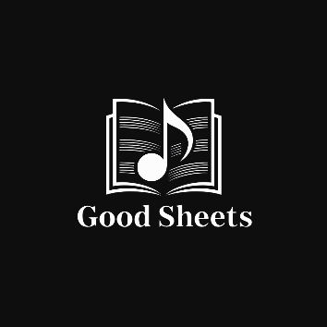

Style Guide

Color Palette
Primary | Secondary | Accent 1 | Accent 2
#DEE5E5 | #9DC5BB | #17B890 | #5E807F

Typography (Found in Google Fonts)

Heading Font: Bebas Neue

Paragraph Font: Montserrat

Navigation
Home Contact About

Content

[put all content for the pages here, including written text and images]
- Nav with Home, about, and contact
- Search bar for music
- About/intro to the page
- Testimonials
- Footer
Elevator pitch : My website is a dedicated platform for authentic, high-quality sheet music created by skilled composers and arrangers. It will feature licensed arrangements of popular songs, original compositions, composer profiles, performance resources, and flexible difficulty levels for musicians of all abilities. What makes this site unique is its commitment to musical integrity and craftsmanship—offering accurate, beautifully engraved scores that performers can trust, all in one centralized, reliable digital library for music lovers everywhere.

Wireframes (DOWNLOAD IT AND ZOOM IN)

Home
