[6 points] True or False (1 point each)

* 1. ababbaa is in a\*(ba)\* : FALSE
  2. (ab)\* = a(ba)\*b : FALSE (only true in some cases)
     1. Ab, abab, ababab … = ab, abab, ababab, abababab …
  3. a\*b\*a\*= (aba)\* : FALSE (only true in some cases)
     1. 0, aba, aaba, aabba, aabbaa … = 0, aba, abaaba, abaabaaba …
  4. (a | b)\* = a\*b\* : FALSE (only true in some cases)
     1. A, b, aa, bb, aaa, bbb … = a, aa, ab, aaab, aab, b, bb, abbb, abb
  5. bb is in a\*(ba)\* : FALSE
  6. (aa\*)(a | ɛ ) = a\* : FALSE (only true in some cases)
     1. Aa, aaa, aaaa, aaɛ, aaaɛ, aaaaɛ = a, aa, aaa, aaaa

1. [24 points] Given the language L=(a | b)\* bb\*a over the alphabet { a, b }
   1. Construct an FA for L (will be NDFA) [4 points]

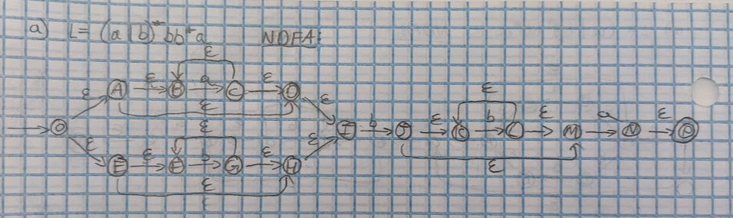

* 1. Convert the non-deterministic FA (NDFA) to a deterministic FA (DFA) [6 points]

* 1. Canvas Turn in

1. Canvas Turn in
2. Canvas Turn in