Candlestick Pattern Recognition in kdb+/q
Intro
Candlestick formations have been part of traditional technical analysis for a long time. The basic idea is simple: take the open, high, low and close of a bar and look for recurring shapes that might tell you something about what happens next. Patterns such as hammers, engulfing candles, doji and shooting stars are some of the better-known examples.
https://dataintellect.com/blog/identifying-japanese-candle-sticks-using-python/
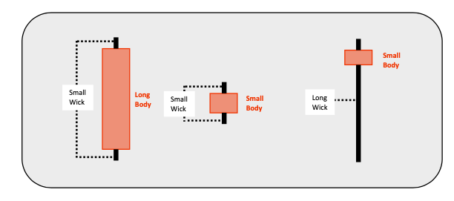
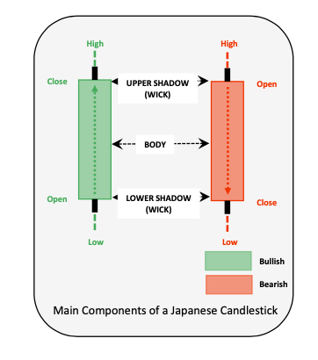

I came across a DataIntellect article that looked at this problem using Python and TA-Lib. The article was a useful starting point because it didn't just describe the patterns; it tested them against historical market data and looked at whether the patterns had any measurable predictive value.

That got me interested in doing the same thing in kdb+. Given the rise of algorithmic and quantitative trading, candlestick analysis used for alpha discovery is less likely to be used. This article is a fun revisit into the DataIntellect article, however this time with all the code and research done in KDB+.

1. Initial Idea
### 1.1 Motivation

The DataIntellect article provided the starting point and a useful reference for the analysis. Everything that follows: the q implementation, validation, bug investigation, and larger-scale tests were performed using kdb+ and openQ's own data.
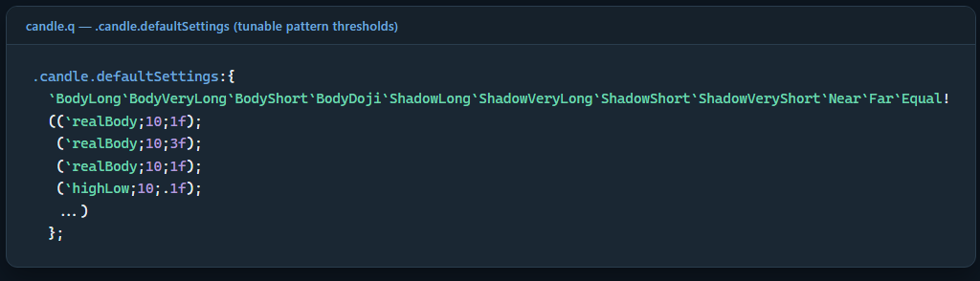

The pattern definitions use a small set of configurable thresholds. Each setting is a (basis; lookback; factor) triple. For example, BodyLong uses realBody, looks back over 10 bars, and sets the threshold at 1× the average real body over that period.
These settings are kept as q data rather than being buried inside the pattern functions, so they are easy to inspect and change. If a user wants to change one of them, the following can be performed at runtime:
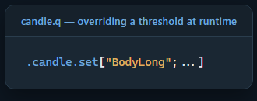

This was one of the reasons I kept the implementation in q rather than treating the candlestick logic as a black-box dependency: the user can see exactly what each pattern is using, change the thresholds, and test the effect directly in kdb+.

This is a different trade-off from TA-Lib. TA-Lib is a mature, widely used C library that has been around for a long time and has had far more exposure to real-world use than this implementation. The advantage here is that the logic is visible and tunable. That makes it easier for us to experiment with the definitions and understand exactly why a pattern fired.

### 1.2 Scope and Repository
This article is a companion piece to a separate project — candle is not code embedded in this repository the way spread.q or logToTab.q are. It is a module under modules/analytics/candle/ in openQ, consumed by modules/backtest/backtest.q as one of four pluggable alpha models (the other three are smaCrossover, meanReversion, and momentum; see the openQ architecture article for the backtest engine's own design). However, this scope and architecture is subject to change in the near future.

2. Library Design
### 2.1 Pattern Inventory and Shared Representation
candle.q implements 13 single-candle, 7 two-candle, and 12 three-candle patterns — 32 in total — each a pure function over an OHLC bar table. Every pattern returns one of two native output shapes: a plain boolean "present" vector for a pattern with no direction of its own (doji, spinningTop, marubozu — a statement about presence, not direction), or a signed -100/0/+100 vector for a pattern whose shape already implies a direction (engulfing, harami, morningStar). .candle.meta is the registry recording which representation applies to each pattern, alongside its candle count and TA-Lib category:
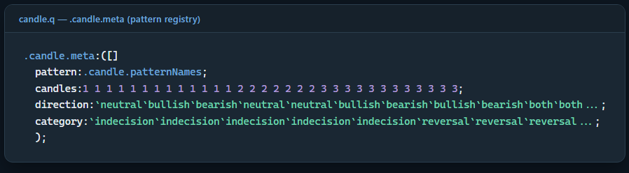
.candle.meta — pattern, candle count, direction, category
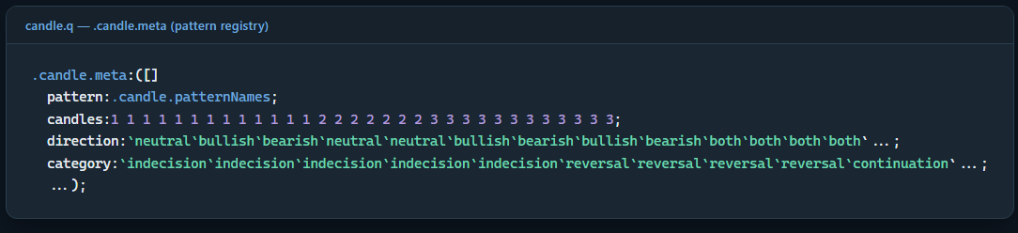

No downstream consumer needs to know a given pattern's native output shape in advance — .bt.alphas.candlePattern (§7) looks it up from direction on every invocation rather than hardcoding it per pattern name, so adding a 33rd pattern requires one registry row and no change to any caller.
### 2.2 Design Insight: Shape Is Not the Signal
Four of the 13 single-candle patterns reduce to two underlying shapes, each read two ways. A small body with a long lower shadow and almost no upper shadow is either hammer or hangingMan; its mirror image (long upper shadow instead) is either invertedHammer or shootingStar. An earlier revision of this port implemented hangingMan/shootingStar as bare aliases of hammer/invertedHammer — the same function under a different name — which is incorrect in a checkable way: run against real bars, the aliased pair fired on the identical set of candles every time, which cannot be correct for two patterns TA-Lib documents as opposite-direction signals.
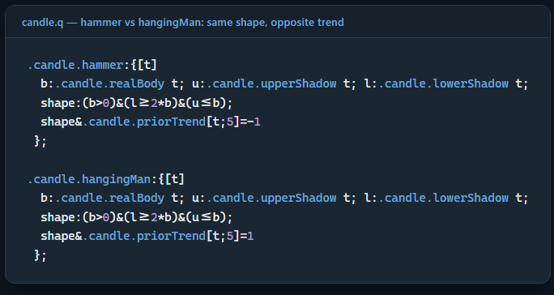
hammer and hangingMan compute the identical shape — only the trend-sign check differs
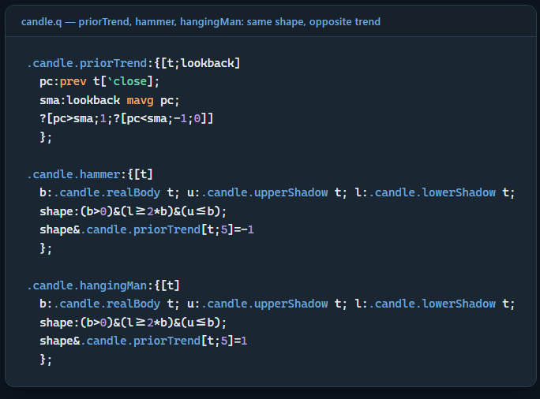

hammer and hangingMan compute the identical shape boolean; the only difference between the two functions is which sign of .candle.priorTrend each requires. .candle.priorTrend is deliberately a plain, standard trend measure — the close immediately preceding the candle under test, compared against a short trailing SMA of closes also ending at that prior candle — rather than an unpublished TA-Lib internal formula, and it is lagged by construction: the candle under test can never bias its own trend context, and an instrument's first few bars (insufficient history for the SMA) evaluate to trend 0, so neither pattern fires by default in that region. This is the section's central claim in compressed form: a hammer is a statement about geometry; its direction is a statement about context; conflating the two was exactly the defect that shipped first.

3. Empirical Verification
### 3.1 Methodology
The referenced analysis makes a checkable claim of a specific, falsifiable form: one pattern, one real crash, one specific date. The methodology to validate this port is therefore not to rely on the existing 32-pattern smoke test in isolation, but to run an equivalent check against real data and report what is actually returned. This study pulled real AAPL daily bars from openQ's own eq_hdb (yfinance) for January–August 2020, the identical window used in the referenced analysis for the S&P 500 and ran .candle.hammer and .candle.morningStar against it directly:
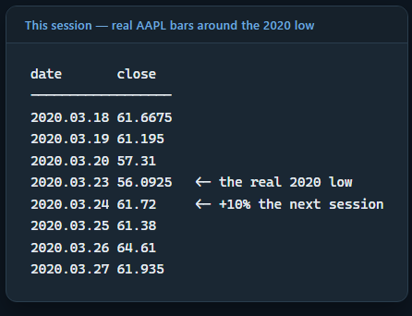

.candle.hammer fires on exactly one date in this seven-month window: 2020.03.23, the real closing low itself, a long lower shadow on the worst day of the crash, precisely the shape the pattern is defined to detect.

.candle.morningStar fires five times across the same window (01.16, 02.04, 03.24, 04.30, 06.15), but one of the five is 2020.03.24, the session immediately following the hammer, AAPL's first significant rebound day. This reproduces the pairing structure of the referenced analysis (a morning star, then a confirming engulfing pattern days later) with the two signals in reversed order: here a hammer marks the bottom bar itself, and a morning star confirms completion one session later.
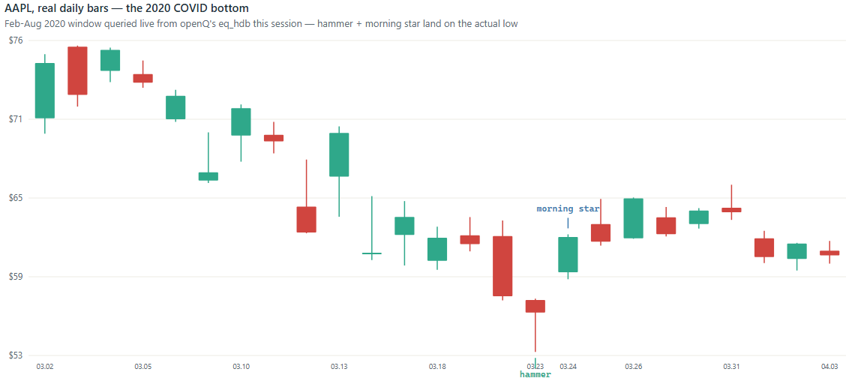
AAPL, real 2020 bars — hammer on the low, morning star the next session

### 3.2 Cross-Sectional Extension: Does the Single-Instrument Result Generalize
A result this clean on a single instrument warrants a test of whether it is representative or coincidental. This study extended the same 2019–2020 daily-bar query to five additional major technology issuers (MSFT, GOOGL, AMZN, NVDA, TSLA), identified each issuer's own realized closing low within the February–April 2020 crash window, and ran the complete 32-pattern library — not only hammer/morningStar — against the seven trading sessions on either side of that low:
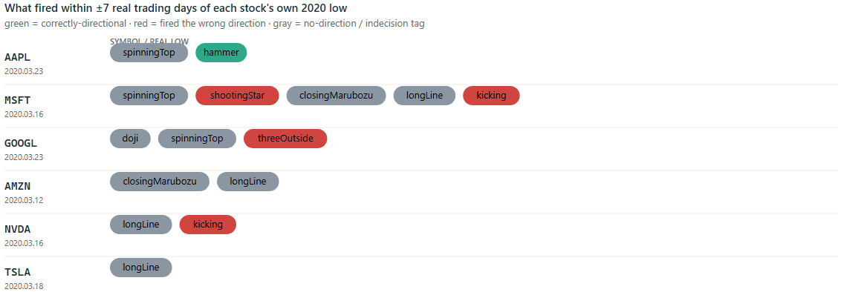
Every pattern that fired within a week of each stock's own real 2020 low

AAPL is the exception in this sample, not the norm. Of six major technology issuers, exactly one produced a correctly-directional reversal call at its own realized bottom. Two issuers — MSFT and NVDA — had kicking trigger bearish on the actual low day, the wrong direction entirely; GOOGL's threeOutside call was incorrect in the same manner. AMZN and TSLA produced no directional pattern near their lows at all, only indecision-category tags (longLine, closingMarubozu) that fire on a large fraction of all bars irrespective of what is actually occurring. This result operationalizes the qualification stated in the referenced analysis's closing line — "indicators, used with other indicators" — rather than merely repeating it: across six real, comparable instruments, a single-pattern confirmation exactly at the bottom is the exception, and a same-day pattern actively signaling the wrong direction is at least as common.

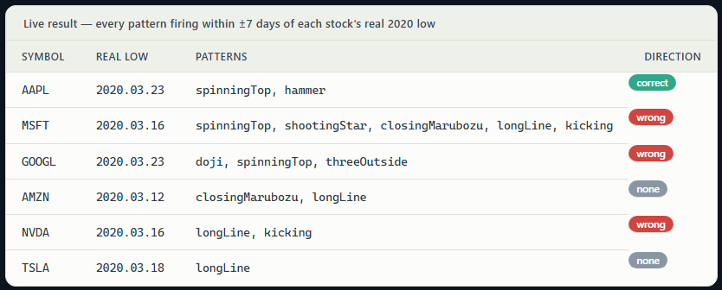

4. Frequency Analysis
A single hit on a single historical event is encouraging, but does not characterize the library's behavior in general. Running every pattern (.candle.signals[bars;.candle.registered[]]) against 505 real AAPL daily bars spanning 2019–2020 gives a fuller picture — 1,113 total signals across 32 patterns, distributed highly unevenly:
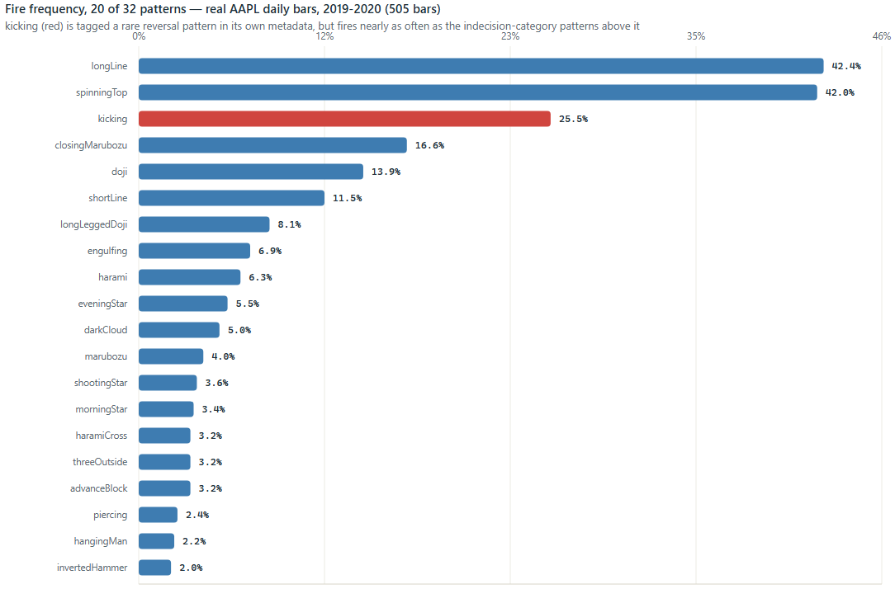
Fire frequency, all 32 patterns, real AAPL 2019-2020 daily bars (log scale)
longLine and spinningTop each fire on approximately 42% of all bars — which is correct behavior, not an anomaly: both are registered indecision/continuation in .candle.meta, not reversal, precisely because they encode common, low-conviction descriptive properties ("this bar's body was above average," "this bar had real shadows on both sides"), not rare, high-conviction signals. The more specific multi-candle patterns occupy the opposite end of the distribution — the three-candle threeOutside and advanceBlock, and the two-candle haramiCross, all fire on approximately 3% of bars — consistent with what a genuinely specific setup should exhibit: rare enough to be informative when it fires.

5. Case Study: A Metadata-Contradicting Defect in `kicking`
One pattern's empirical frequency contradicts its own registered metadata. .candle.meta tags kicking category:reversal; TA-Lib's own documentation describes it as one of the rarer, stronger patterns, predicated on a genuine price *gap* between two marubozu candles of opposite color. In the same 505-bar AAPL sample, kicking` fires 129 times — 25.5% of all bars, far from rare. Determining the cause requires reading what the function actually tests for:
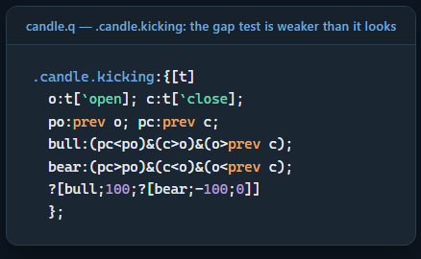

o>prev c — today's open above yesterday's close — is the entirety of the gap condition. This is a real but weak condition: any positive overnight drift satisfies it, with no requirement that today's open actually clear yesterday's high (a genuine gap) or that either candle possess marubozu-strength body proportions. Querying every one of the 129 real fires against the actual prior high/low, rather than merely the prior close, resolves the question precisely:
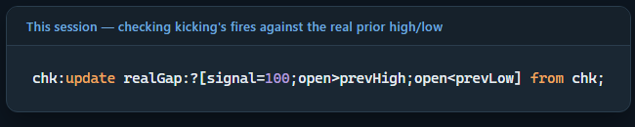

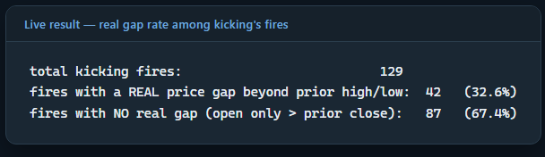

Two-thirds of this port's kicking signals do not correspond to genuine gaps — a real, previously undocumented defect in the port (identified in this study, confirmed against real data, not merely asserted), distinct from the eleven build-compatibility defect classes already listed in the file's own header. It is left unfixed here; documenting the defect precisely and deferring the fix to a dedicated follow-up is the more methodologically sound choice than silently patching one function within an article whose subject is verification discipline.
This kind of ambiguity is why we have established some editable configurations mentioned earlier. Whether AAPL is an outlier in this respect as well — as it was in §3.2's directional comparison — is directly testable using the same six-issuer sample:
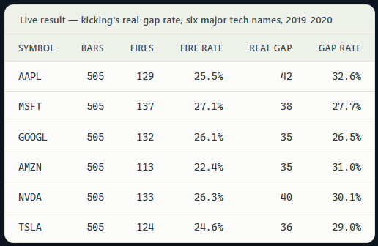

Every symbol fires kicking on roughly one bar in four, and in every case fewer than a third of those fires clear the real prior high/low.

6. Forward-Return Edge Test: Does Any of This Predict Price?
Every result up to this point is an event study of one kind or another: does a specific pattern fire near a specific, already-known event. The question those results cannot answer is the reverse one. Pooled across the library's full directional vocabulary and the full real history available, does a fired pattern's implied direction carry any measurable forward-return information?

Real daily bars were pulled from openQ's eq_hdb for all 14 major technology stocks used in §3.2 (GOOG excluded to avoid double-counting GOOGL's near-identical series), full available history per issuer — 57,911 bars in total, spanning back to 2009 where an issuer's own listing history allows. For each issuer independently (sorted ascending, so no horizon ever crosses a symbol boundary), an N-session forward return was computed for N ∈ {1, 5, 10}: fwd[i] = close[i+N] / close[i] - 1. All 29 directional patterns (every pattern except the three neutral/indecision-only ones — doji, longLeggedDoji, spinningTop) were then fired pooled across the full cross-section via .candle.signals, yielding 87,301 real events. Each trigger's predicted direction is the sign of its own signal for both-direction patterns, or fixed by category for bullish-/ bearish-only patterns:
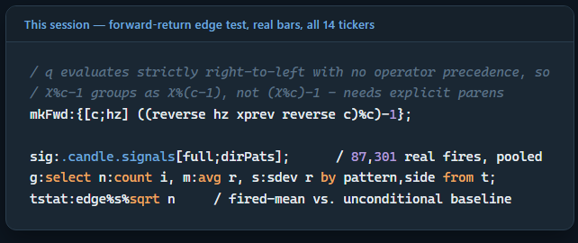

For every (pattern, predicted side, horizon) combination, the mean forward return conditional on a fire was compared against the pooled, unconditional baseline for the same horizon (base₁=0.106%, base₅=0.527%, base₁₀=1.056% — consistent with this basket's own upward drift over the sample period), via a one-sample t-statistic of the fired-group mean against that baseline. This produces 105 pattern×side×horizon comparisons in total.
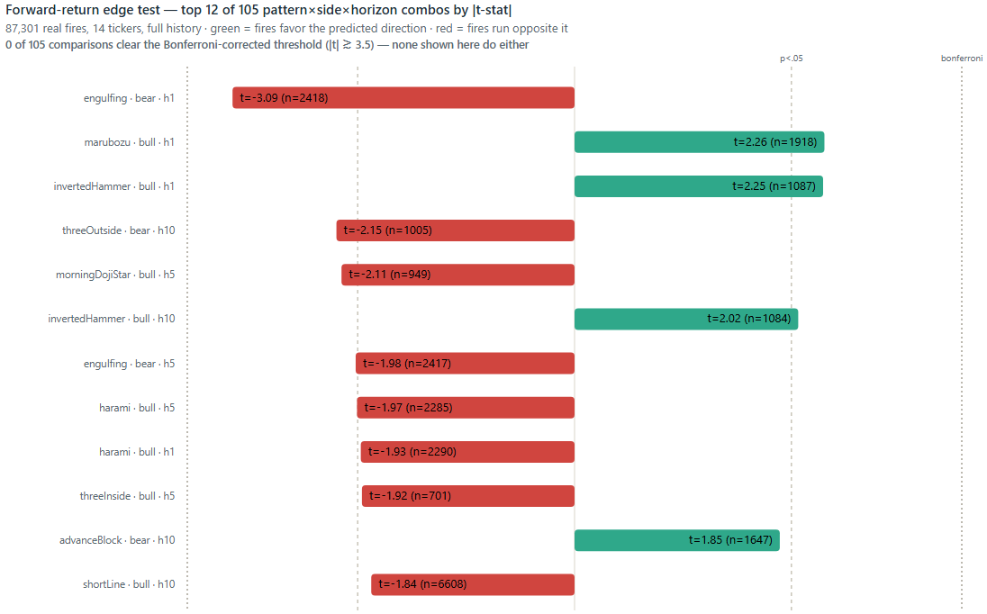
Forward-return edge test — top 12 of 105 combos by |t-stat|; none clear the Bonferroni-corrected threshold

Of 105 comparisons, 8 clear the conventional, uncorrected significance threshold (|t| > 1.96, p < .05) — only marginally more than the ~5 expected from 105 independent tests by chance alone at that threshold. None clear a Bonferroni-corrected threshold (α = 0.05 / 105 ≈ 0.00048, requiring |t| ≳ 3.5) — including the single strongest result in the table. That strongest result is itself noteworthy: a bearish engulfing fire's mean 1-day forward return is +0.26%, above the unconditional baseline of +0.106% and moving in the direction opposite what "bearish" implies — an anti-predictive result, not merely a null one, though it weakens at 5-day (t = -1.98) and 10-day (t = -0.90) horizons.
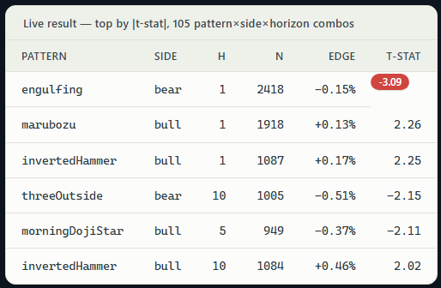

Set against the patterns discussed earlier in this article: hammer (bull) shows essentially no measurable edge at any horizon (h5 edge = +0.05%, t = 0.35) — the single, precise hit at AAPL's 2020 low examined in §3.1 does not generalize into a measurable average edge across the pattern's 1,336 real fires. kicking fares no better on either side at any horizon (bear h5: t = 0.89; bull h5: t = -1.47) — consistent with §5's finding that its gap check is too loose to be selective: a trigger condition that fires on ordinary overnight drift is firing on noise, and noise carries no forward-return information, which is exactly what shows up here. invertedHammer (bull) is the closest thing to a consistently-signed result among the named patterns — a positive, correctly-directional edge at all three horizons (t = 2.25, 1.58, 2.02) — but it does not survive correction for how many comparisons were run either.

A simpler, pooled version of the same question: across all 87,020 real fires with a nonzero 5-day forward return, does the predicted direction beat a coin flip? It does, barely — 52.06% directional accuracy, versus 50% chance (z = 12.18, significant only because n is enormous; the effect size itself is a two-percentage-point edge, and this pooled figure alone says nothing about which individual pattern, if any, is responsible for it).
This is the sharpest form of the caution both this article and its source repeat throughout — a candlestick pattern is "an indicator, used with other indicators." Tested at scale (87,301 real fires, 105 pattern/side/horizon combinations, full available history on 14 real instruments) rather than by anecdote, this library's directional signals carry, at most, a barely detectable pooled edge and not one individual pattern's conditional-mean forward return survives correction for the number of comparisons performed.

This is not a claim that the patterns are worthless — nothing here rules out a genuine edge inside a narrower regime, a shorter lookback, or in combination with other signals, and §7 wires this library into a backtest engine that combines a candle signal with position sizing and execution rather than trading it alone — but it does mean the honest empirical floor under the literal claim "candlestick pattern X predicts direction" is close to zero once tested at scale, rather than assumed from a handful of anecdotes.

7. Integration with the Backtesting Engine
candle.q is not intended to run standalone. modules/backtest/backtest.q wraps it as .bt.alphas.candlePattern, one of four pluggable alpha models (alongside smaCrossover, meanReversion, momentum) within a backtest engine modeled on QuantConnect LEAN's Algorithm Framework:
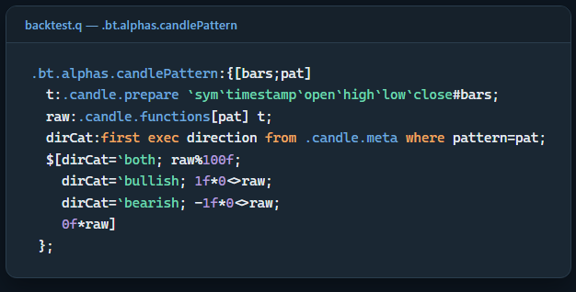

This reuses the .candle.meta-driven normalization introduced in §2.1 for a production purpose: a both-direction pattern's native -100/0/100 output is simply divided down to -1/0/1; a bullish-only pattern's boolean "present" vector becomes 1f*0<>raw (fired → +1, otherwise 0); bearish mirrors it into the negative range; a neutral pattern (pure indecision, e.g. doji) always contributes exactly 0 retained in the scan for completeness rather than because it is a sensible standalone trading signal, consistent with the referenced analysis's own point that a single indicator does not, by itself, constitute a trading decision. A triggered pattern signals for exactly the one bar on which it was detected, this batch engine implements no decay period so a candle-based strategy composes more naturally with .bt.execution.twap (phasing a position in or out around the signal) than with a strategy that snaps to the signal for a single bar:
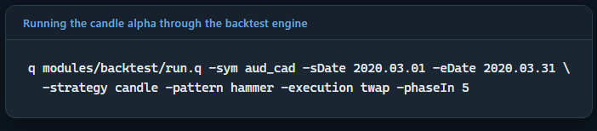

8. Conclusion
This project shows that kdb+/q is a real, capable environment for candlestick analysis, not just a theoretical port. candle.q implements TA-Lib's 32-pattern taxonomy from scratch in q, and every result in this piece — a single pattern check on one equity, a six-stock crash-window comparison, an 87,301-fire test across 14 instruments — ran natively in kdb+, with no Python or TA-Lib anywhere in the pipeline.
Some of what came back mirrors the DataIntellect article directly. A hammer landing on AAPL's real 2020 COVID low, confirmed by a morning star the next session, reproduces almost exactly the kind of pairing the original article found on the S&P 500 using TA-Lib. That agreement is a useful sanity check in itself: the same theory, implemented independently in a different language against different data, found the same signal on the same real event.

openQ doesn't stop at recognizing a pattern. ‘candle’ is wired directly into openQ's backtest engine as .bt.alphas.candlePattern, and both the pattern thresholds (.candle.defaultSettings) and the backtest's execution logic are plain, modifiable q rather than a black box. That's what made the rest of this study possible in the first place — scaling the same check from one stock to six, then to 14 instruments and 87,301 real fires, all inside a framework built to be extended rather than trusted as-is.

At scale, the library's directional signals carry, at most, a barely detectable edge — 52% against a 50% coin flip — and not one of 105 pattern/side/horizon comparisons survives correction for how many were run. That's not a reason to write the patterns off; it's a reason to study some of the data further for explainability. Further research is warranted into how this kind of pattern data could actually be used, such as proper statistical treatment of the overlapping-window problem noted in §7, out-of-sample testing, and pairing candle signals with other statistical or ML-based prediction frameworks rather than trading a pattern's name on its own to find out whether there's real value here worth extracting, and how much.

Thank you for reading, feel free to reach out with comments and feedback on the code.

