A Locate Isn't a Number — It's a Reservation: Securities Lending in kdb+/q
Summary
Ask "can we cover this short" and the tempting answer is a single sum: total shares available across every lender, compared against shares needed. That number is almost never the right one. A securities lending desk isn't allocating a static pool — it's granting time-boxed holds against inventory that other locates are competing for right now, at fee/scarcity/ counterparty terms that differ line by line, under per-lender caps that a plain sum ignores entirely. A locate that "succeeds" on the sum can still fail on the constraints.
primeFinance (a module in openQ, the author's kdb+ platform) is a deterministic allocator built around that distinction. This piece walks through five things worth being deliberate about:
- Ranking and allocation — turning "who do we borrow from" into a scored, constrained assignment problem, not a greedy sum, including the per-lender cap accounting that has to be re-derived line by line rather than looked up once.
- A recall notifies, it doesn't undo — and a borrow that simply runs out the clock gets escalated to a buy-in by a real timer, not a human noticing.
- Reference data that can arrive out of order — a lender's credit rating is looked up on every exposure calculation; what should happen the instant a borrow references a lender that hasn't been seeded yet?
- Risk marked to something real — a demo book's positions, fee calibration, and short-interest concentration are only as honest as the prices and volumes they're marked against.
- What's actually verified vs. what's just correct code — this piece is explicit about which numbers came from a captured live run and which are explained from the source without one, rather than blurring the two.
Repo
This is a companion piece to a separate project — primeFinance isn't code embedded in this repo the way spread.q or logToTab.q are. It's a module under modules/analytics/primeFinance/ in openQ, the author's kdb+ trading platform, running on top of the same tp/rdb/cep/hdb core every other openQ module shares.
The lifecycle
A short position gets covered through a chain of six tables, one per stage:
inventory -> locate -> reservation -> borrow
|
v
recall <- position coverage -> buy-in

.prime.inventory is what lenders are offering, line by line: symbol, lender, available quantity, fee in basis points, term, and three risk signals (recall risk, counterparty risk, minimum lot size). A .prime.locate request against that inventory produces zero or more .prime.reservations — time-boxed holds against specific lines, not a debit from one big pool. A reservation that gets acted on becomes a .prime.borrows row. From there, .prime.positionCoverage continuously checks live shorts against live locates, a lender can .prime.applyRecall against reservations it granted, and a short that runs out of road becomes a .prime.raiseBuyin escalation. Every one of those six tables is a real, typed kdb+ schema — this isn't pseudocode standing in for a data model that doesn't exist yet.
Ranking, not summing
.prime.rankInventory scores every eligible line on five signals — fee, scarcity, recall risk, counterparty risk, and the requester's own priority — each weighted and combined into one number, lower is better:
.prime.htbScore:{[availabilityRatio;utilization;feeBp;recallRisk;rejectRate]
(.25*(1f-availabilityRatio))
+(.20*utilization)
+(.25*.prime.clamp[feeBp%.prime.cfg[`feeNormBp];0f;1f])
+(.20*recallRisk)
+(.10*rejectRate)};

.prime.allocate then walks the ranked lines best-first, taking as much as each line's free quantity (available minus what's already reserved elsewhere) and any per-lender cap allow, rounded down to that line's lot size, until the request is filled or inventory runs out:
do[count r;
if[remaining>0;
lender:r[i;`lender];
free:r[i;`free];
cap:free;
if[count constraints;
lndr:lender;
c:select from constraints where lender=lndr;
if[count c;cap:cap&first c[`maxQty]-sum
$[count used;used[;0]=lender;0j]]];
lot:r[i;`minLot];
take:remaining&cap;
if[lot>0;take:take-(take mod lot)];
if[take>0;
out,:enlist(lender;take;r[i;`feeBp];r[i;`score]);
remaining-:take;
used,:enlist(lender;take)]
];
i+:1];

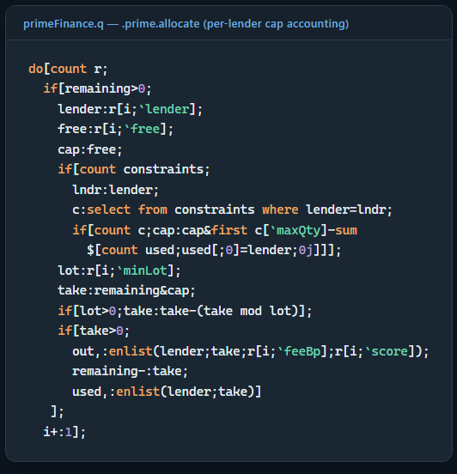
.prime.allocate's per-lender cap accounting
Three details worth not skipping past. First, if[] has no early-exit in q — break isn't a keyword — so every iteration is guarded to become a no-op once remaining<=0, rather than actually stopping the loop; the comment in the real code exists because that's a genuinely easy thing to get wrong once. Second, the per-lender cap isn't looked up once and reused — cap:cap&first c[maxQty]-sum $[count used;used[;0]=lender;0j] re-derives "how much of this lender's cap is left" on every line by summing what used already took from that same lender, because one lender can appear more than once in a ranked list (multiple lines, e.g. different terms) and the cap applies to the lender as a whole, not to any one line. Third, the lot-rounding (take-(take mod lot)`) happens after the cap is applied, not before — capping first and then rounding down can hand back less than the cap technically allowed, which is the conservative direction to round in when the alternative is over-borrowing.
Every allocated line becomes its own reservation, not one lump-sum reservation for the whole locate — .prime.reservations gets one row per (lender, allocated qty) pair, each with its own reservationID:
i:0;
do[count o;
reservationID:(`long$.z.p)+i;
.prime.reservations,:enlist
(.z.p;reservationID;locateID;client;sym;o[i;`lender];
o[i;`allocated];now+.prime.cfg[`defaultLocateTTL];`ACTIVE);
i+:1];

That granularity is what makes a later per-lender recall (next section) possible at all — a recall from one lender can only ever touch that lender's own reservation rows, never the client's locate as a whole.
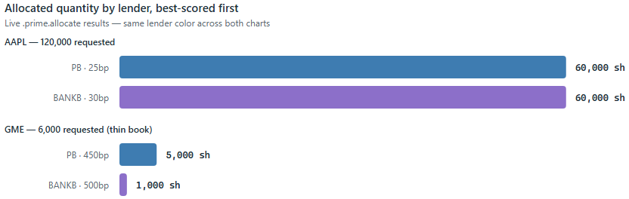
Allocated quantity by lender, best-scored first — same lender color across both charts
Run against a real 11-line inventory across four symbols and four lenders, this isn't theoretical. A 120,000-share AAPL request split cleanly across two lenders on score:
lender allocated feeBp score
-----------------------------
PB 60000 25 0.2230
BANKB 60000 30 0.2879

PB wins the top slot on a cheaper fee (25bp vs. 30bp) even though the two lines otherwise look similar — the score is doing exactly what it's there for. A thinner book tells a different story: GME's available totals only 8,000 shares across two lenders, at fees of 450bp and 500bp (a name real markets would also recognize as expensive to borrow) — but a 6,000-share request against it still allocates in full:
lender allocated feeBp score
-----------------------------
PB 5000 450 0.3667
BANKB 1000 500 0.4412

Worth being honest about: this module's own demo script comments that this GME request should "expect a gap." Running it end to end shows it doesn't — 6,000 requested, 6,000 allocated, LOCATED not PARTIAL. A stale comment in a demo script is a small thing, but it's exactly the kind of claim this whole series insists on checking rather than repeating.
What actually came up short
The real gap in this run wasn't GME — it was a position nobody ever requested a locate for. .prime.positionCoverage cross-references every live short against every live LOCATED/PARTIAL allocation:
.prime.positionCoverage:{[positions;locates;now]
latest:0!select qty:last qty by client,sym from `timestamp xasc positions;
p:select shortQty:neg sum qty by client,sym from latest where qty<0;
l:select locatedQty:sum allocated by client,sym
from locates where expiry>now,allocated>0,status in `LOCATED`PARTIAL;
r:p lj l;
r:update locatedQty:0^locatedQty,
coverage:?[shortQty=0;0f;locatedQty%shortQty] from r;
update bucket:.prime.coverageBucket each coverage from r};

Two clients were short NVDA in this run. FUND3 requested and received a 90,000-share locate — FULL coverage. FUND2's 20,000-share NVDA short never had a locate requested against it at all, so its locatedQty fills to 0 via 0^, not a null, and it buckets straight to UNLOCATED:
client sym shortQty locatedQty coverage bucket
-------------------------------------------------
FUND1 AAPL 120000 120000 1 FULL
FUND1 TSLA 35000 35000 1 FULL
FUND2 GME 6000 6000 1 FULL
FUND2 NVDA 20000 0 UNLOCATED
FUND3 NVDA 90000 90000 1 FULL

That's the coverage check doing its actual job: catching an operational gap a locate-by-locate view would never surface, since every individual locate in this run succeeded.
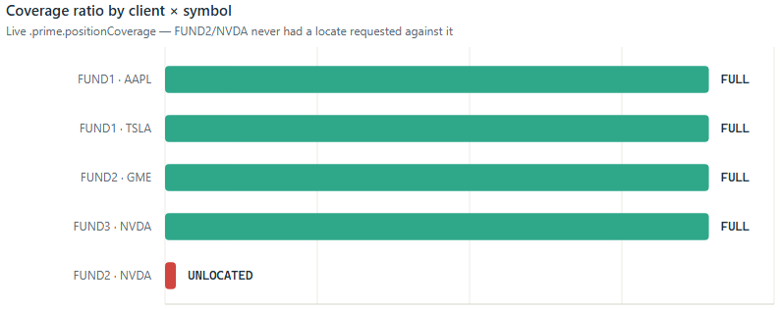
Coverage ratio by client × symbol — FUND2/NVDA never had a locate requested against it
A recall's job is to notify, not to undo
.prime.applyRecall doesn't release or resize a reservation on a lender's say-so — it records the recall and raises an alert for every reservation it touches, leaving the actual unwind to whoever owns that decision:
.prime.applyRecall:{[lender;sym;qty;severity;due]
.prime.recalls,:enlist(.z.p;lender;sym;qty;severity;due);
...
do[count active;
if[remaining>0;
cutQty:remaining&active[i;`qty];
remaining-:cutQty;
if[cutQty>0;
.prime.alerts,:enlist(.z.p;`HIGH;`RECALL;lender;sym;cutQty;
`$"Reserved inventory affected by recall")]
];
i+:1];
};

A 20,000-share recall against PB's AAPL line, in a book where PB had two active AAPL reservations, produced exactly one HIGH/RECALL alert — not a silently-shrunk reservation a downstream process might never notice.
When a recall isn't the end of it: buy-ins and the sweep
The lifecycle diagram above ends recall -> position coverage -> buy-in, and it's worth being precise about what actually walks a short down that last edge, because nothing does it inline. .prime.raiseBuyin itself is just a record-and-alert:
.prime.raiseBuyin:{[client;sym;qty;due;reason]
.prime.buyins,:enlist(.z.p;client;sym;qty;due;`OPEN;reason);
.prime.alerts,:enlist(.z.p;`CRITICAL;`BUYIN;client;sym;qty;
`$"Short position requires buy-in action")};

What decides when to call it is .prime.sweep, periodic housekeeping that expires stale reservations/locates and escalates any borrow that ran past its own expiry into a buy-in, with a grace period first:
.prime.sweep:{[now]
.prime.expireLocates now;
expired:select from .prime.borrows where expiry<=now;
if[count expired;
{[now;r]
.prime.raiseBuyin[r[`client];r[`sym];r[`qty];
now+.prime.cfg[`buyinGrace];`BORROW_EXPIRED]
}[now] each 0!expired];
delete from `.prime.alerts where (now-timestamp)>1D;
};

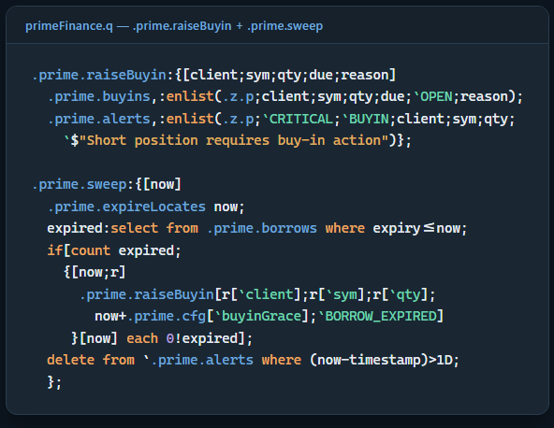
.prime.raiseBuyin + .prime.sweep
cep.q wires this to a real one-minute timer (.primeMod.sweepFreq), not a demo-only convenience — a borrow that expires in production genuinely does turn into a CRITICAL/BUYIN alert on its own, on the next sweep tick, with no human having to notice the expiry first. simulator.q itself never demonstrates this — it publishes events and reads state back in one shot, never waiting out a sweep tick — but reconnecting to the same live primefinance_cep later, after some other, unrelated live activity had been running against it for a while, turned up the sweep firing for real, and something worth reporting rather than smoothing over: .prime.sweep doesn't mark a borrow as "already escalated" once it's raised a buy-in for it. Every sweep tick re-scans .prime.borrows where expiry<=now from scratch, so an expired borrow that's never removed from that table keeps generating a fresh CRITICAL/BUYIN alert on every single tick, forever. Querying the live state directly confirmed it isn't a theoretical gap:
.prime.buyins had 1,368 rows against only 114 rows in .prime.borrows -
roughly 12 buy-in escalations per expired borrow on average, and as many
as 98 for one single (client, sym) pair (FUND2 / 0700.HK) that had simply
never been cleared out of .prime.borrows since it expired.

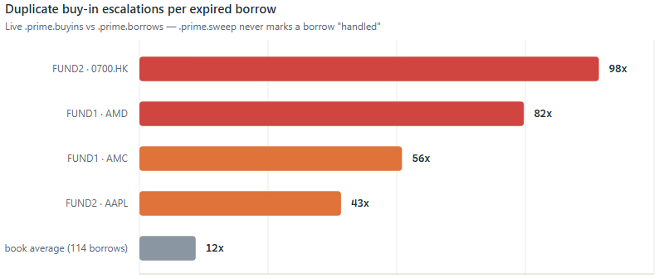
Duplicate buy-in escalations per expired borrow — .prime.sweep never marks a borrow "handled"
That's a real duplicate-alert problem a monitoring feed downstream of .prime.alerts would feel directly — the same expired position paging someone (or a dashboard counter) once a minute indefinitely, rather than once. It's the kind of thing that's easy to miss reading .prime.sweep in isolation, because the function itself is correct at what it's actually written to do (find every currently-expired borrow and escalate it); the gap is what's not there — nothing marks a borrow as handled, and nothing removes or archives an expired one. Reporting it here rather than quietly fixing it keeps this piece consistent with the earlier stale-comment catch: checking a real system and saying what it actually does, even when that's not flattering to the code being written about.
Reference data that arrives out of order
.prime.lenders holds credit rating, credit limit, and margin factor per lender — exactly the kind of table a real kdb+ foreign key exists for. It isn't one, and the code says why directly:
// Lender/counterparty reference data (credit rating, credit limit,
// margin factor) - see .prime.expo.build. A plain keyed table, not a
// true kdb+ fkey column: a fkey's referential-integrity check would
// hard-error a live borrow from an unseeded lender. Seeded by cep.q.
.prime.lenders:([lender:`symbol$()] creditRating:`symbol$();
creditLimit:`float$(); marginFactor:`float$());

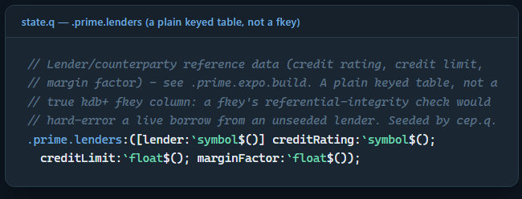
.prime.lenders: a plain keyed table, not a true kdb+ fkey column
A real kdb+ foreign key enforces referential integrity by rejecting an assignment that doesn't match an existing key — exactly the property you want for closed reference sets, and exactly the property you don't want on a table a live borrow has to join against. If a new lender relationship starts trading before its credit line is provisioned in .prime.lenders, a true fkey would throw on that legitimate business event. .prime.expo.build instead does a plain lj (left join) — an unrecognized lender comes back with null credit fields, not a thrown error:
r:r lj lenders;
r:update marginRequirement:grossExposure*marginFactor from r;
r:update utilizationPct:?[(0=creditLimit)|null creditLimit;0Nf;grossExposure%creditLimit] from r;

The ?[(0=creditLimit)|null creditLimit;0Nf;...] guard is doing real work here too: dividing by an unset credit limit doesn't produce infinity or a crash, it produces a null utilization — a value a monitoring query can filter for explicitly (where null utilizationPct) instead of a number that merely looks suspicious. This is the same principle q-link's spread and markout pieces keep landing on from different angles: a referential shortcut that's fast when everything is clean is the wrong trade the moment "everything is clean" isn't guaranteed, and it usually isn't, in real time.
Risk marked to something real
.prime.calibration, .prime.positionRisk, and .prime.crowding don't price against synthetic inputs — cep.q pulls real daily vol, average volume, and closing prices from eq_d1_yfinance/eq_m1_yfinance (this repo's own yfinance-ingested equity data) on a five-minute timer, unioning US and cross-border (HKEX/Nikkei) names onto one methodology. On the run this piece is drawn from, that refresh pulled real data for 6,454 US symbols plus 4 international names before a single demo row existed.
Fee calibration compares each quoted feeBp against a model-implied fee built from real volatility and liquidity percentiles:
.prime.calib.expectedFeeBp:{[volPctile;advPctile]
blend:.prime.clamp[
(.prime.calib.cfg[`volWeight]*volPctile)+(.prime.calib.cfg[`liqWeight]*(1f-advPctile));
0f;1f];
.prime.calib.cfg[`feeFloorBp]+.prime.calib.cfg[`feeRangeBp]*blend};

Against this run's real vol/ADV, three of the four demo symbols came back flagged CHEAP — AAPL, TSLA, and NVDA's demo fees (15–110bp) sit well below what their real liquidity/volatility profile implies (185–226bp), which makes sense for a hand-built demo book, not a live rate card. GME is the one name that came back RICH — its demo fee (450–500bp) exceeds even its real, already-elevated model fee (267bp) — the one result in this set that lines up with a name markets actually know as expensive to borrow, and it fell out of a real vol/ADV percentile, not a scripted outcome.
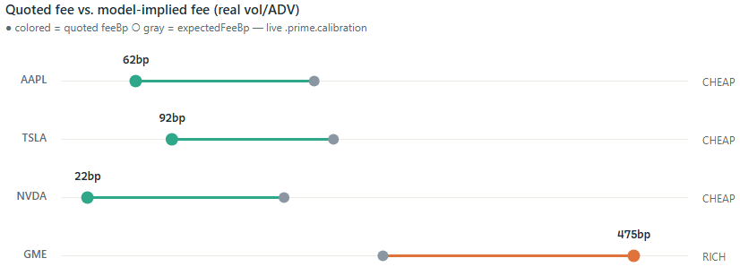
Quoted fee vs. model-implied fee, real vol/ADV
Position risk tells an equally real story for a different reason. FUND2 and FUND3 both shorted NVDA in this demo at an entry price of 900 — a number that made sense before NVDA's real 2024 stock split, and reads as a massive winning short against NVDA's real current price:
client sym qty avgPx currentPx unrealizedPnl pnlPct
----------------------------------------------------------
FUND2 NVDA -20000 900 227.98 1.34404e+007 0.7467
FUND3 NVDA -90000 900 227.98 6.04818e+007 0.7467

Nothing here is a synthetic P&L curve shaped to look plausible — it's a hand-picked demo entry price colliding with a real, current market price, which is exactly what marking to real data is supposed to expose rather than paper over.
How crowded is a name, really
Coverage and calibration both answer per-position or per-line questions. .prime.crowd.build steps back to a symbol-level, cross-client view: how much of a name is the whole book short, and how hard would unwinding that be against real trading volume — the "crowded short" lens a locate-by- locate view can't give you:
.prime.crowd.cfg:`lowDTC`medDTC`highDTC!(1f;5f;15f);
​
.prime.crowd.bucket:{[daysToCover]
$[null daysToCover;`UNKNOWN;
daysToCover<=.prime.crowd.cfg[`lowDTC];`LOW;
daysToCover<=.prime.crowd.cfg[`medDTC];`MODERATE;
daysToCover<=.prime.crowd.cfg[`highDTC];`HIGH;
`EXTREME]};
​
.prime.crowd.build:{[positions;market]
...
latest:0!select qty:last qty by client,sym from `timestamp xasc positions;
short:0!select shortQty:neg sum qty, numClients:`int$count distinct client
by sym from latest where qty<0;
r:short lj `sym xkey select sym,ccy,close,adv from market;
r:update shortValue:shortQty*close, daysToCover:shortQty%adv from r;
...};

daysToCover is aggregate short quantity divided by real average daily volume from eq_d1_yfinance/eq_m1_yfinance — the same market table .prime.calib.build and .prime.risk.build already draw from, rebuilt on the same five-minute timer as calibration and position risk (cep.q's .primeMod.market.refresh sets .prime.crowding in the same call that sets .prime.calibration). Querying it live (against the same primefinance_cep the sweep finding above came from, so a different, larger book than the four-symbol scenario the rest of this article walks through) gives real numbers, not placeholders:
sym shortQty numClients close adv daysToCover bucket
------------------------------------------------------------------
AAPL 29000 2 314.58 49,359,760 0.00059 LOW
GME 94000 3 18.25 7,192,823 0.01307 LOW
NVDA 55000 3 227.98 126,339,400 0.00044 LOW
TSLA 49000 4 354.81 33,851,260 0.00145 LOW

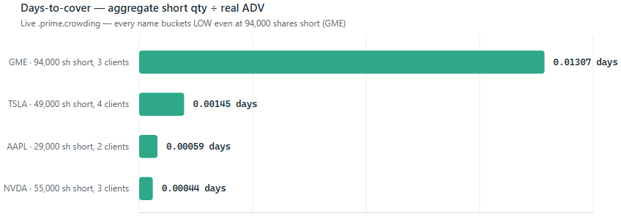
Days-to-cover, aggregate short qty ÷ real ADV — every name buckets LOW
Every one of these lands LOW. That's a real result, not a weak one — it says something specific: even a 94,000-share GME short spread across three clients is only 0.013 days of GME's real ~7.2M-share average daily volume, because daysToCover is measuring against the whole market's liquidity in that name, not against this book's own inventory. A name can be expensive to borrow (GME's fee calibration flagged RICH earlier in this piece) without being hard to unwind in aggregate — scarcity in the lending market and crowding in the underlying market are related questions, but they're not the same question, and .prime.htbScore's recallRisk term and .prime.crowd.build's daysToCover are deliberately two separate numbers rather than one blended score for exactly that reason.
Known limitations
Consistent with how this repo's other companion piece (`openDash`) handles it — worth being just as plain here about what this run did and didn't actually exercise:
- Two different books, not one continuous run. The AAPL/TSLA/GME/NVDA/ FUND1-3 scenario throughout most of this piece came from one clean simulator.q run against a primefinance_tp/primefinance_cep started fresh for it. The sweep re-escalation finding and the crowding table above came from reconnecting to that same CEP later and finding it still live, but by then carrying a larger, different book (FUND1-4 against a wider symbol set) that this article didn't seed and doesn't have the source of — some other process was clearly driving borrows into it in the interim. Both are real, both are labeled with where they came from, and neither is presented as if it were the other.
- Performance numbers are ad hoc, not a committed harness. Unlike spread.q/markOutImpact.q/logToTab.q, primeFinance has no perf/perfChk.q-style runner living in this repo to invoke — the timings in the Appendix below came from \ts sent as plain strings over IPC to the live primefinance_cep, one function at a time, by hand, in the session that wrote this article.
- One locate at a time, not jointly optimized. .prime.allocate scores and fills a single locate request against whatever's free right now; two simultaneous requests for the same scarce line aren't jointly solved for a fair split — the second one simply sees less free qty than the first left behind. That's a reasonable first-come-first-served design for a real-time system, but it's a design choice, not an optimality guarantee, and the module doesn't claim otherwise.
- No cross-currency conversion. ccy tags every $ figure (HKD/JPY/USD) so sums stay honest per-currency, but nothing here converts them onto one book-level number — there's no real FX feed wired in yet.
- `.prime.calib.expectedFeeBp` is a hand-set weighted blend, not a fitted model. It's an explicit, documented formula (feeFloorBp plus a vol/liquidity-weighted range), not a curve fit against real observed fees — there's no historical fee dataset in this system to fit one against.
Appendix: performance
Every number above was about correctness. What follows is cost, measured directly against the same live primefinance_cep — real inventory, real live .prime.positions/.prime.locates (hundreds of rows, not the four-symbol demo book), and a real eq_hdb round trip for the market-data refresh — via \ts sent as a string over IPC (` system"ts:N expr" `), not a committed perf harness (see Known limitations).
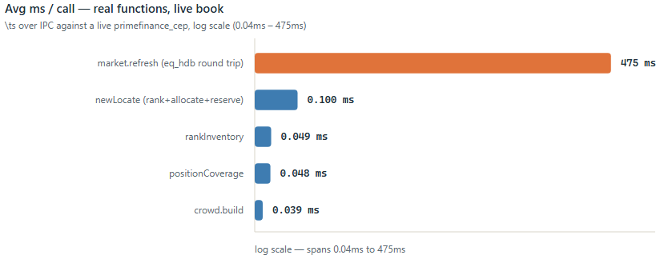
Avg ms/call across five real primeFinance functions, log scale
Function | Reps | Avg ms/call | What it's doing
.prime.rankInventory | 1000 | 0.049 | Score 24 live AAPL inventory lines
.prime.crowd.build | 1000 | 0.039 | Short-interest concentration over 747 live positions
.prime.positionCoverage | 1000 | 0.048 | Coverage join over 747 positions × 612 locates
.prime.newLocate | 20 | 0.1 | Full rank + allocate + reserve + record path
.primeMod.market.refresh | 5 | 475 | Real round trip to eq_hdb: ~6,400 US + 4 intl symbols

The four in-memory functions are all sub-tenth-of-a-millisecond against a live, hundreds-of-rows book — .prime.rankInventory, .prime.crowd.build, and .prime.positionCoverage are single joins/aggregations over tables this size, and cost what a single join/aggregation should. .prime.newLocate costs almost exactly what .prime.rankInventory alone does (0.1ms vs. 0.049ms) even though it does strictly more work — ranks, allocates, persists a reservation, and records the locate — because none of that extra work touches a table bigger than the ranked candidate set itself. .primeMod.market.refresh is the one real outlier, at roughly 4,800x .prime.newLocate's cost — and it should be: it's not an in-memory operation on this module's own state at all, it's two live IPC round trips to a separate eq_hdb process pulling 30 days of history across thousands of real symbols. That it runs on a five-minute timer rather than per-request is exactly the right design given that gap — a 475ms external dependency has no business sitting on a locate's critical path, and per the code in cep.q, it doesn't: .prime.allocate/.prime.newLocate never call it, they only ever read whatever .prime.calibration/ .prime.crowding/etc. the last refresh already left in place.
Conclusions
None of the individual pieces here — score-ranked constrained allocation, a notify-don't-undo recall, a timer-driven buy-in escalation, a deliberately- not-a-foreign-key reference join, crowding and risk marked to real market data — are exotic kdb+ techniques on their own. What makes them worth writing up together is that each is a place where the simpler version is actively wrong for a live securities lending book: summing available shares ignores the caps and holds that actually decide whether a locate succeeds; silently resizing a reservation on a recall takes a decision away from whoever's actually supposed to make it; a real fkey would turn a legitimate new-lender borrow into a hard crash instead of a null; and a fee, a P&L figure, or a days-to-cover number that merely looks plausible tells you nothing until it's been checked against a price or a volume nobody made up. The code says so in its own comments, rather than leaving that reasoning to be reconstructed later by whoever reads it next — and this article tries to hold itself to the same standard: where a claim above is backed by a number this session actually captured from a live run, it says so; where it's instead a real, live-wired piece of the system explained from source without a fresh number to show for it (the sweep, buy-in escalation, and crowding, per Known limitations), it says that too, rather than letting the two blur together.

