openDash: Bridging a Browser to kdb+ Over Async IPC

Summary
A browser cannot communicate directly with kdb+ over q IPC. The q IPC protocol is a binary TCP protocol and does not provide HTTP or WebSocket framing, so a React-based UI requires an intermediary service between the browser and the kdb+ platform.
That service is responsible for translating HTTP requests and WebSocket messages into q IPC calls, and for converting q results into a format that can be consumed by JavaScript applications, typically JSON.
At first glance, this looks like a relatively straightforward proxy. The more interesting part is how queries are handled by the kdb+ side of the platform.
In openQ, the gateway process (gw) does not necessarily return a query result as a conventional synchronous response. Instead, it sends an asynchronous message containing a query ID generated by the gateway itself. Once multiple queries are in flight, the problem is no longer simply:
request → response
The service must determine which response belongs to which original request.
A client that blocks on a single connection while waiting for a response cannot safely handle multiple concurrent queries. Responses may arrive asynchronously, potentially in a different order from the requests that produced them. The integration layer therefore needs to treat query handling as a correlation problem rather than a simple request-response cycle.
The openDash service addresses this problem while also providing two other important boundaries between a browser-based UI and the kdb+ platform:
- Correlation — Match asynchronous responses, identified by gateway-generated query IDs, to the original browser request without blocking other queries that may still be in flight.
- Trust — A browser should not be treated as a trusted q client. Requests from the UI must be constrained to a defined API rather than allowing user input to become arbitrary q code.
- Fan-out — A single upstream market-data or tick stream may need to support many connected browser clients, with each client subscribing to a different set of instruments, views, or analytics.
This separation provides a more suitable architecture for building JavaScript and React applications on top of kdb+. kdb+ remains responsible for storing, querying, and analysing high-volume data, while the integration layer handles protocol translation, request correlation, access boundaries, and real-time distribution to the browser.
Rather than exposing q IPC directly to the browser, openDash acts as an application-facing interface to the kdb+ platform. This allows a React UI to work with familiar web technologies while preserving the asynchronous and high-throughput characteristics of the underlying kdb+ processes.
Repo
This article accompanies a separate project, openDash. It is not code embedded within this repository in the same way as modules such as spread.q or logToTab.q. Instead, openDash sits in front of openQ, providing a browser-facing layer for the underlying kdb+ platform. It also exposes the repository's existing analytics/markOutImpact.q module directly, without reimplementing the analytics elsewhere, allowing its results to be served live through the dashboard.
The architecture is structured as follows:
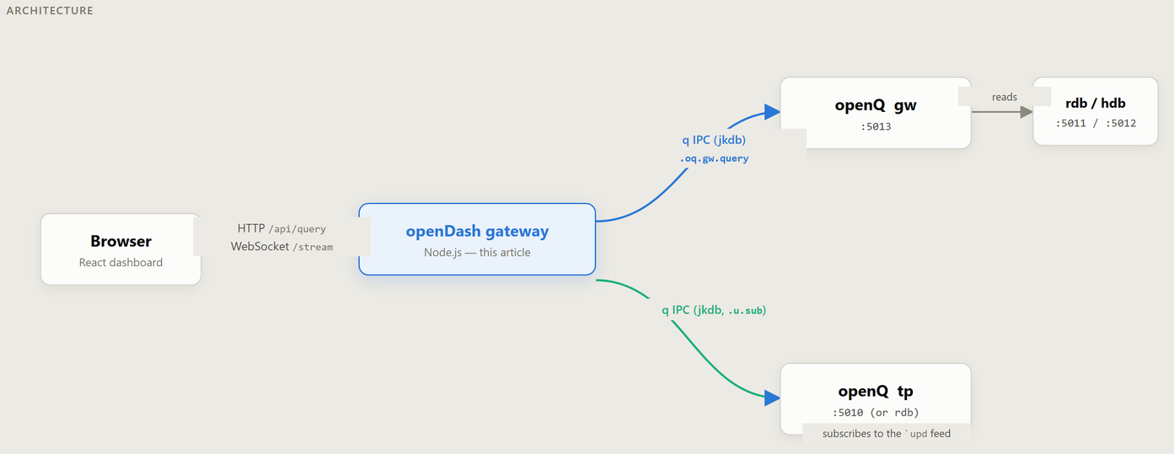
openDash gateway architecture: browser to gateway over HTTP/WebSocket, gateway to openQ's gw (query path) and tp (stream path) over q IPC
No q/kdb+ runs in the browser, and the gateway is a small, dependency-light Node.js service (ws and a patched jkdb for the q IPC leg — nothing else) rather than a general-purpose API framework.
Why a pool, not one shared connection
The most obvious approach is to use a single persistent q IPC connection: send a query and wait for the corresponding response. This works until multiple browser requests are active at the same time.
The openQ gateway (gw) returns results asynchronously in a message of the form `error`data`stack`queryID!. On a shared connection, replies are not delivered as conventional request-response pairs, so there is no mechanism to wait specifically for a particular queryID. Once queries overlap, the client must determine which asynchronous reply belongs to which request.
Rather than attempting to correlate multiple concurrent queries on a single connection, openDash avoids the ambiguity by using a pool of q connections. Each connection processes at most one query at a time.
As a result, when an asynchronous reply arrives on a particular connection, it can only belong to the query currently assigned to that connection. Additional requests are handled by other available connections in the pool or queued until a connection becomes available.
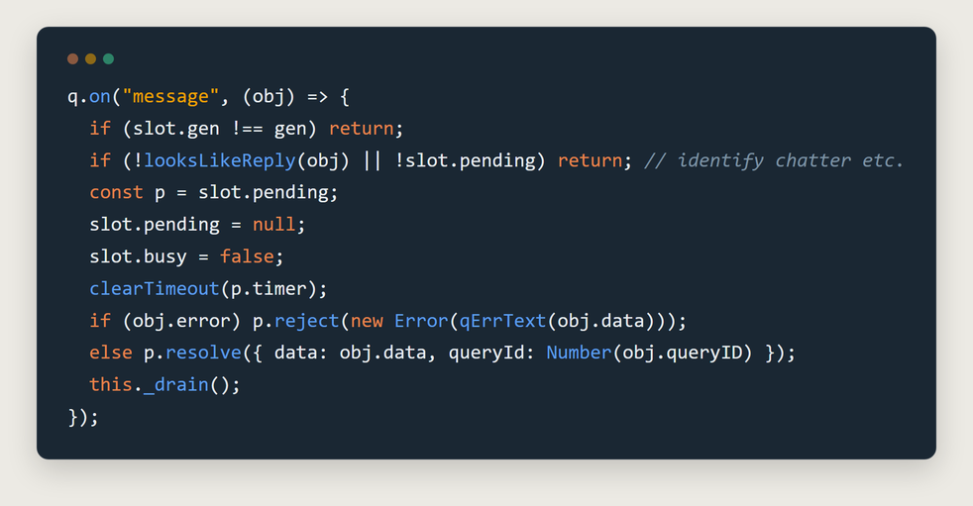
the message-reply handler: identifies a reply-shaped async payload, resolves or rejects whichever query this connection had pending, then drains the waiter queue
Each connection in the pool maintains a small amount of state, moving between ready, busy, and pending. If all connections are currently processing requests, new queries are placed in a queue rather than being sent to an already active connection. Each queued request maintains its own timeout, preventing a slow or unavailable connection from blocking requests indefinitely.
Each connection slot also maintains a generation counter (gen). This prevents a delayed response from a recycled connection from being associated with a newer request assigned to the same slot. When a connection is closed and re-established, the new connection belongs to a new generation, and any requests associated with the previous connection are no longer considered valid.
If a connection receives a malformed asynchronous message, the slot is recycled rather than attempting to recover from an uncertain state. The connection is closed, re-established, and any pending request is rejected. This ensures that a later response cannot be incorrectly matched to a different request after the connection has been reused.
Never trust a browser to write q for you
The dashboard may send parameters such as a table name, symbol, or time range, but those values are never used directly as q source code. A browser should be treated as an untrusted client, so allowing user-supplied values to be interpolated into a q expression would introduce an unnecessary injection risk.
Instead, each dynamic value is validated before being converted into the appropriate q literal. The resulting query is assembled from known, validated components rather than from arbitrary strings supplied by the browser:
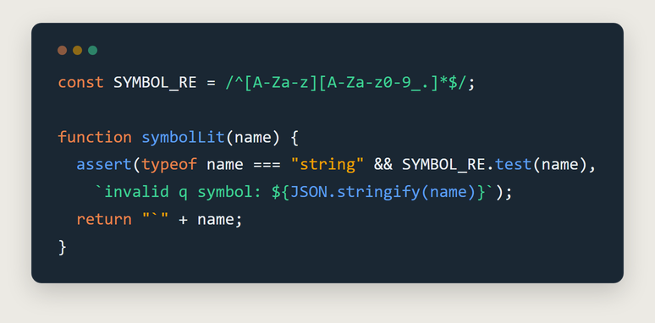
symbolLit: a table/symbol name is only ever accepted as a q literal after passing a regex, never interpolated as a raw string
buildGwQuery constructs the same q expression that a trusted client would send to the openQ gateway:
.oq.gw.query[table;sCols;sTime;eTime;symb;whereC] - Each component is validated before the query is assembled. Values such as table names and symbols must satisfy the expected format, while time values are parsed and normalised as valid JavaScript Date objects before being converted into q literals.
The whereC argument is treated differently. Because it represents an arbitrary q where clause, allowing it to be supplied through the HTTP API would effectively expose arbitrary query logic to the browser. Instead, whereC is always set to the null symbol and is not exposed as a request parameter. This keeps the API limited to the query operations required by the dashboard rather than attempting to safely support arbitrary q expressions.
This layer also handles an edge case in openQ's query implementation. .oq.query.root raises a `type error when only one time boundary is provided and the other is represented by the null-symbol sentinel. The HDB partition logic evaluates:
`date$(sTime;eTime)
and does not handle a mixed pair consisting of one timestamp and one null symbol.
Queries with both bounds defined, or with neither bound defined, work as expected. To avoid the mixed case, qlit.js supplies the missing boundary when only one is provided. It uses the lower or upper edge of the supported time range (2000.01.01 or 2999.01.01) rather than passing the mismatched pair through to the underlying query.
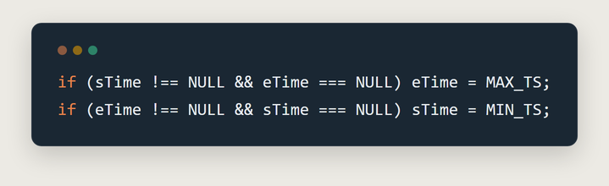
the openQ time-bound workaround: materialize the missing bound to the edge of the representable range rather than send a mismatched pair
One feed, many filters
The dashboard's live views communicate with clients over WebSocket, while the connection to openQ's tick feed is maintained through a single shared .u.sub subscription rather than creating a separate q connection for every browser tab.
This requires some care because openQ subscriptions are associated with a specific connection handle and are replaced rather than accumulated. If two subscriptions are issued on the same connection, the second subscription replaces the first rather than extending it. A separate upstream connection for every WebSocket client would avoid this issue, but it would also create unnecessary q connections as the number of browser sessions increases.
Instead, the bridge maintains a single subscription to the required table and manages it using reference counting as clients connect and disconnect. Symbol-level filtering is then performed in the Node.js layer for each individual WebSocket client.
As a result, openQ publishes the full stream once, while the gateway determines which rows should be forwarded to each connected client. This avoids conflicting upstream subscriptions and allows multiple browser sessions to consume different subsets of the same market-data feed without requiring a dedicated q IPC connection for every tab.
The jkdb patch
`jkdb` is a small, third-party, framework-free JavaScript q IPC client — not something written for this project, just the wire-protocol library the gateway is built on. Before this project needed it, jkdb only ever surfaced an async message shaped like `upd (the standard tick.q publish pattern) as a usable event; anything else async — including gw's `error`data`stack`queryID! reply — was silently dropped on the floor. That's fine for a feed handler, and exactly wrong for a gateway that needs to see every async reply regardless of its shape.
The fix was a small, additive patch to jkdb itself: a generic message event fires for every deserialized async payload, and a separate asyncError event fires for one that fails to parse. The existing upd event is untouched, so nothing that already depended on jkdb's original behavior changed — openDash just started listening for the event that was always arriving, previously invisible.
What's live today
Four dashboard pages are backed by real gateway endpoints rather than mock data — screenshots below are a live openQ platform (default pipeline + mon + markout modules) running behind this exact gateway and dashboard.
Logs — GET /api/logs tails and parses openQ's per-role log files (gw.log, rdb.log, …), folding stack-trace lines into the row they belong to, with level/process/text filters.
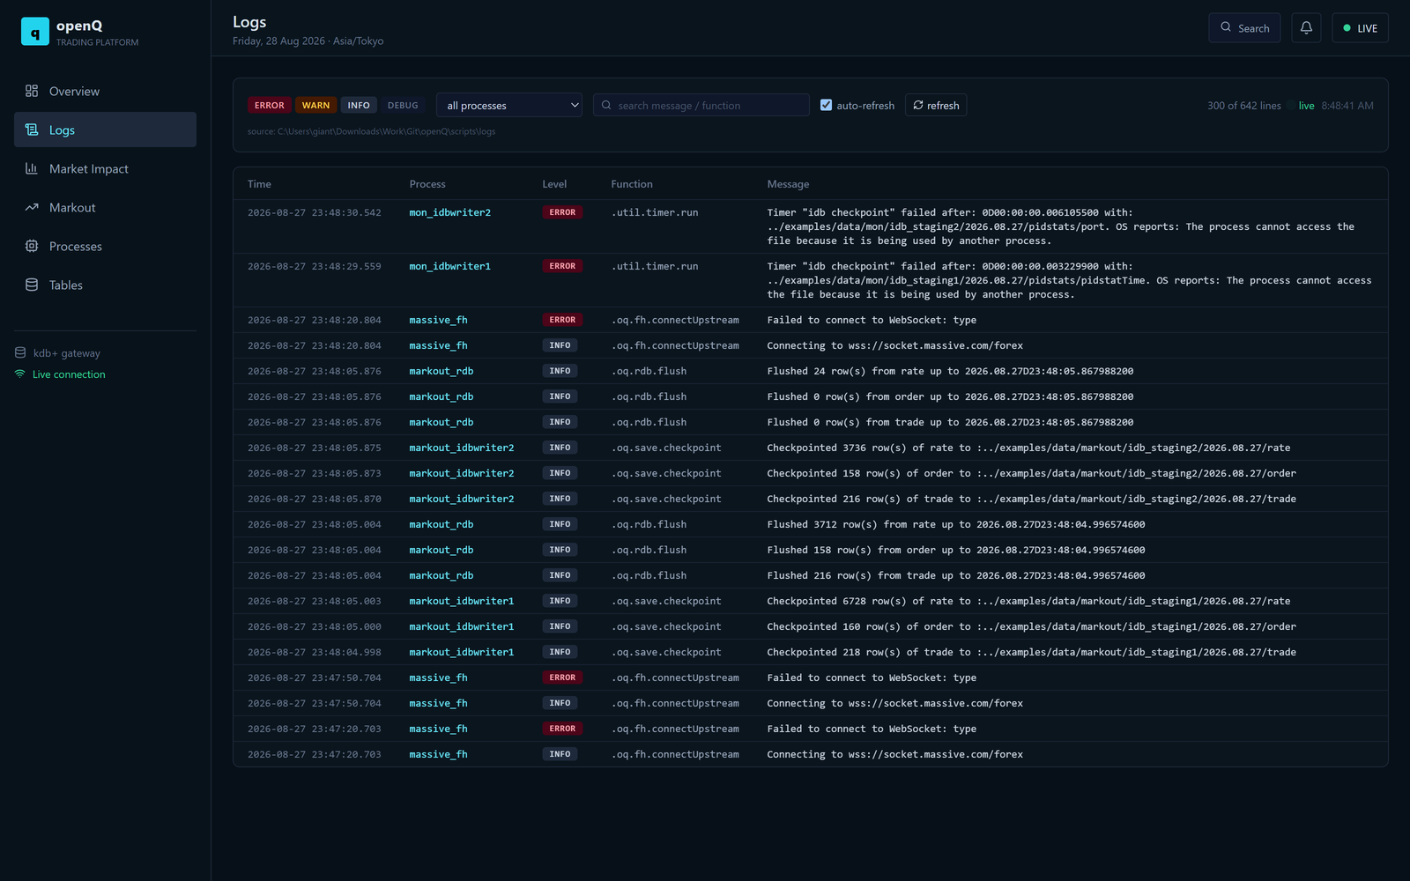
Logs page — level/process/text filters over openQ's live per-role log files
Processes — reads openQ's mon module (pidstats, per-process CPU/memory over time), fed on this Windows dev machine by a small stand-in for the platform's real Linux pidstat poller.
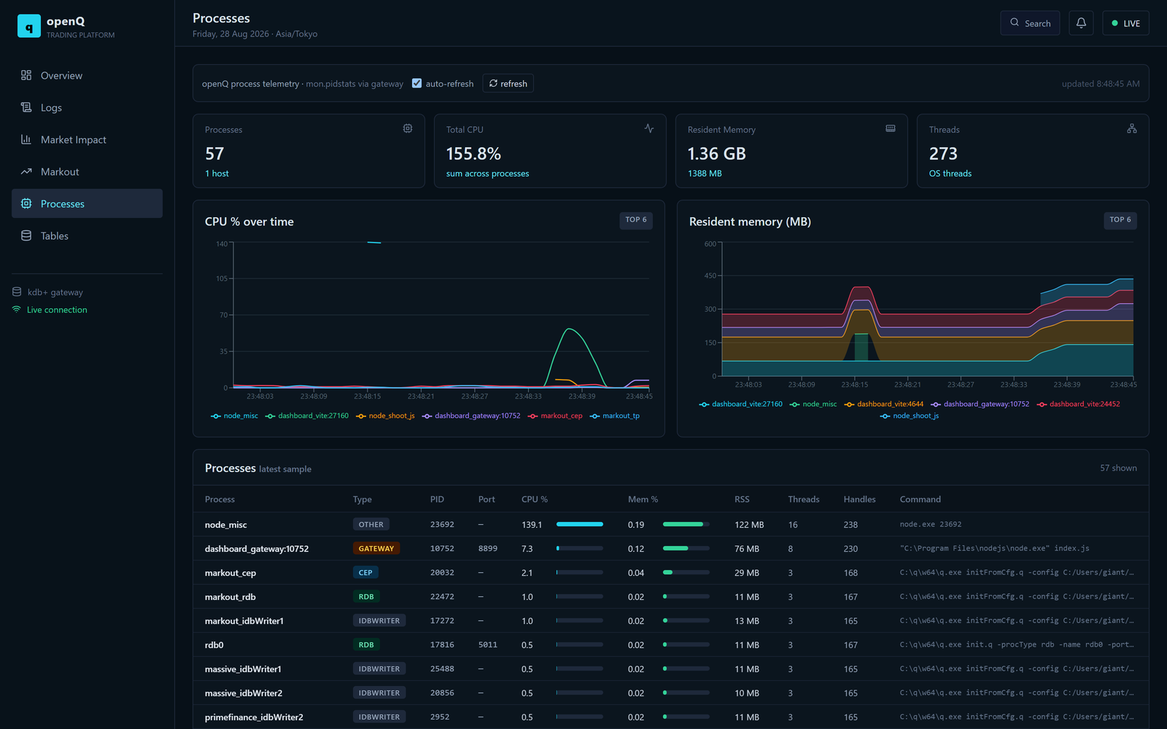
Processes page — CPU and resident-memory time series across every running openQ/gateway/dashboard process
Tables — a live inventory across every configured openQ pipeline: row counts, column counts, byte size, and freshness per table, so "is data actually flowing" is a glance instead of a query.
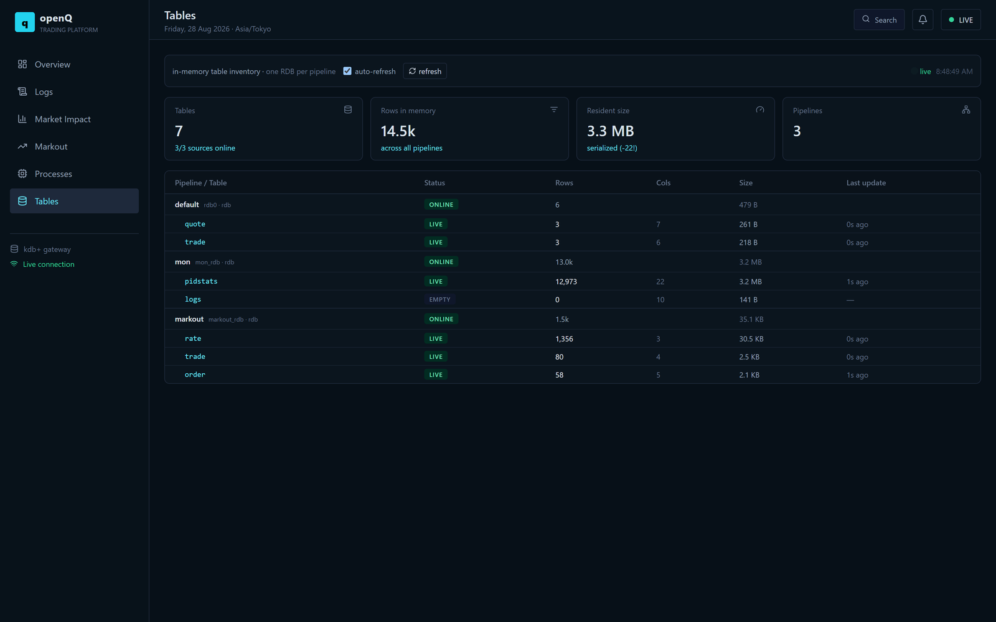
Tables page — per-pipeline row/column/byte counts and freshness, default + mon + markout
Markout — reads this repo's own analytics/markOutImpact.q state straight off openQ's markout-module CEP: the deal-markout decay curve, the order-impact decay curve, and the peak/permanent split, all live off the same in-memory keyed tables the batch functions compute from (.markout.completed, .impact.completed) — no separate reporting path, no re-derivation.
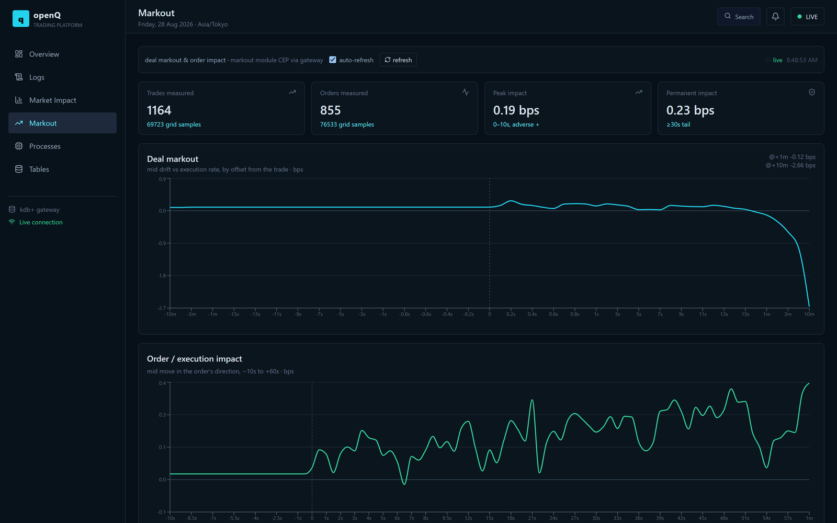
Markout page — live deal-markout and order-impact decay curves read straight off the CEP's in-memory state
Known limitations
- Time-bounded queries require a populated HDB. Queries that include a time range extending before the current trading day are routed to both the HDB and RDB. If the HDB contains no partitions, the associated date query will fail. Queries with no time bounds, or with bounds entirely within the current day, are unaffected.
- whereC is intentionally unavailable. Arbitrary where clauses are not exposed through the API. This is a deliberate design decision intended to prevent browser clients from submitting arbitrary q expressions.
- Publishing is outside the scope of the service. The gateway is responsible for querying data and managing subscriptions; it does not publish ticks into openQ. Data publication remains the responsibility of the appropriate feed handler or upstream process.
Conclusions
The goal is not simply to place a more polished dashboard in front of kdb+. The challenge is to expose an asynchronous, server-correlated binary protocol through familiar REST and WebSocket interfaces while preserving the constraints required to do so safely and reliably.
That means avoiding arbitrary where clauses from browser clients, preventing one slow query from blocking unrelated requests on a shared connection, and ensuring that one client's subscription cannot unintentionally replace another's.
The same principle underlies the three main parts of the integration:
- Connection pooling isolates concurrent queries so that asynchronous responses can be handled without blocking other requests.
- Literal-only query construction limits browser input to validated values rather than allowing arbitrary q expressions.
- Reference-counted subscriptions allow multiple clients to consume the same upstream feed without conflicting with one another.
Together, these components define a deliberately limited interface between the browser and the kdb+ platform. The browser is given access to the data and operations required by the application, while the underlying integration layer remains responsible for managing concurrency, protocol behaviour, and connection state when multiple clients are requesting different data at the same time.

