Explaining the Spread: Decomposing an FX Quote in kdb+/q

Summary
In production FX pricing systems, a quoted spread is rarely a single, atomic figure — it is the sum of several independently governed adjustments layered on top of a reference level: a base markup, a client-tier skew, a volatility buffer, quote-stability smoothing, a fallback component, and a directional-signal adjustment. That composition isn't a modeling detail; it's operationally load-bearing. Two quotes can land on the same total spread by entirely different routes, and treating the total as one opaque number makes margin attribution, risk review, and client-fairness questions impossible to answer with any precision — you can see that pricing moved, not why.
This piece is organized around three questions a pricing or risk team asks of any spread build-up, in increasing order of engineering difficulty:
- Composition — given the named components, what's the total quoted spread? Structurally trivial, a one-line row-wise sum; the risk is entirely in making sure every component is captured once and none is silently dropped or double-counted.
- Decomposition and aggregation — at production scale (thousands of quotes a day across symbols, aggression tiers, and market regimes), how much of the spread is attributable to which component, on average, and does that attribution survive being cut by time instead of by tag? This is the question with the most at stake: get the weighting wrong and every downstream rollup misattributes margin or risk to the wrong component, without ever raising an error.
- Reconciliation — is what the model actually quoted consistent with an independent reference — richer, cheaper, in line? This is what turns an internal pricing decomposition into an externally checkable claim, rather than a number the model is left grading on its own homework.
Framed this way, the problem has a different shape from markout / market impact. There, the components are unobserved: a trade produces one noisy price curve, and a temporary/permanent split has to be statistically inferred from it after the fact. Here, the reverse is true — every component is already a column in the row at the moment the quote is generated, so nothing needs to be estimated. The engineering burden moves entirely downstream: aggregating an additive decomposition without corrupting the weighting, and validating the result against a source outside the model itself.
Repo
- The code discussed in this article is at: https://github.com/SpencerFX/q-link
- To load the functions, synthetic data, and explore interactively:
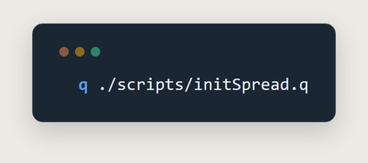
q ./scripts/initSpread.q
- To run the test suite (hard assertions, ground-truth checks included):
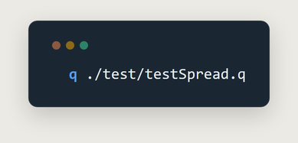
q ./test/testSpread.q
The component model
The starting assumption is that a quote's total spread decomposes losslessly into seven named, independently sourced components — the pricing engine's own build-up, not a statistical approximation of one reconstructed after the fact. .spread.componentCols fixes that vocabulary; .spread.compose implements the only claim this section makes: the total is the row-wise sum, nothing more.
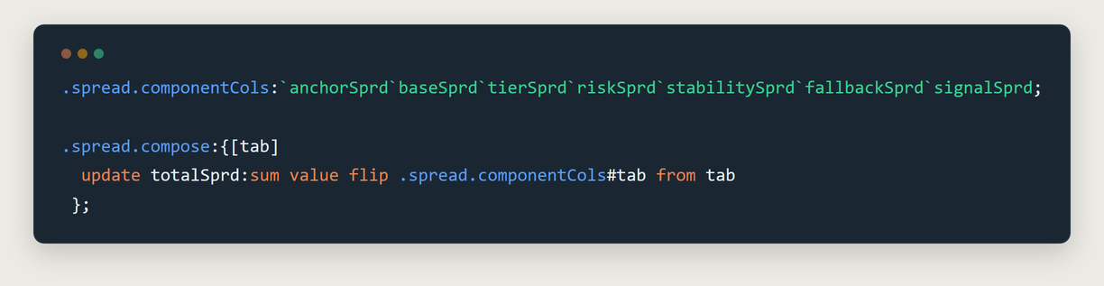
.spread.componentCols + .spread.compose
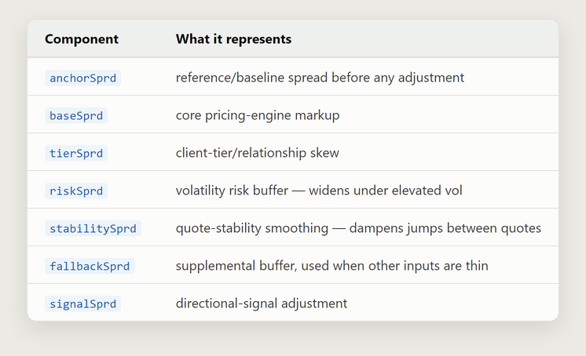
Component reference table
As an equation: totalSprd = anchorSprd + baseSprd + tierSprd + riskSprd + stabilitySprd + fallbackSprd + signalSprd — or more generally, totalSprd = Σ over componentCols.
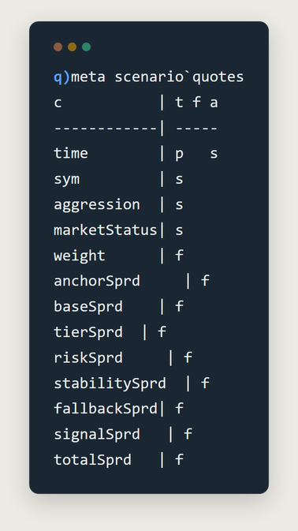
q)meta scenario`quotes
.spread.decompose and .spread.waterfall restate that same claim in the two shapes downstream analysis actually needs: decompose melts a wide row into one row per (quote, component) — the shape a stacked-bar or attribution view requires — and waterfall appends a running cumulative column per component, so cum_signalSprd == totalSprd holds on every row by construction. Neither is fitted: there is no residual and no goodness-of-fit statistic to report, because nothing here is being estimated — the exactness itself is the deliverable.
For each component, decompose computes contributionBps = 1e4 × componentValue, and pctOfTotal = 100 × componentValue ÷ totalSprd. waterfall's cumulative columns follow the same componentCols order: cum_anchorSprd = anchorSprd, and each subsequent cum_c = (previous cum_c) + c, so cum_signalSprd = totalSprd by construction — the invariant the test suite asserts directly, rather than trusting that it holds.
One weighting rule, three entry points
Aggregation is where a decomposition like this typically breaks in practice. A single quote's spread carries no information on its own — what a pricing or risk review actually needs is the size-weighted average across many quotes, and that weight has to be applied identically regardless of whether the rollup is by regime, by time, or by nothing at all. An inconsistency here doesn't raise an error; it just produces a number that's quietly wrong. The fix applied here is structural rather than procedural: one private helper builds the aggregate-column specification once, and every public rollup is required to route through it.
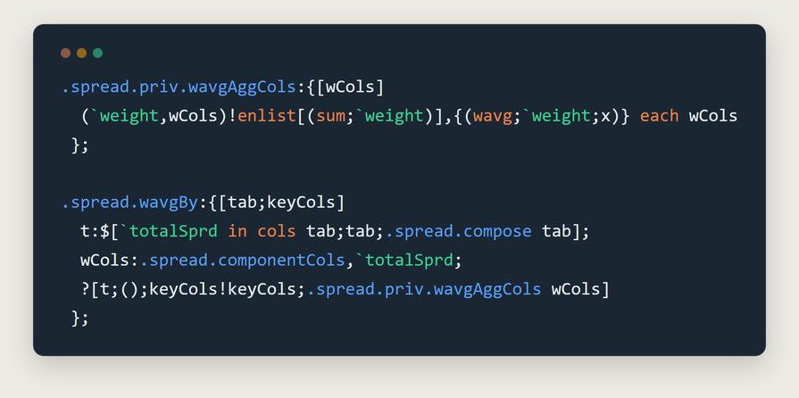
.spread.priv.wavgAggCols + .spread.wavgBy
The formula behind every one of those aggregates, for weights w and values x: wavg = Σ(w×x) ÷ Σw — exactly what q's built-in wavg computes, applied independently to totalSprd and each of the seven components rather than to a plain unweighted mean.
wavgAggCols builds the spec as a single key-vector/value-vector zip — `weight,wCols for keys, (sum;`weight) followed by one (wavg;`weight;col) tuple per column for values — rather than building a one-item dict per column and unioning them together. The result is identical; the cost isn't: one dict allocation instead of count[wCols]+1.
.spread.byTime and .spread.byRegime are both a handful of lines on top of the same helper: byTime swaps in a time-bucket parse-tree as the group-by key, byRegime calls wavgBy directly with whatever regime columns the caller supplies (e.g. `aggression`marketStatus) prepended to any extra keys. The result is one weighting convention enforced across three distinct entry points, rather than three independent chances to get it wrong.
On data
Validating an aggregation pipeline against real production data has an obvious failure mode: a plausible-looking number and a correct one are indistinguishable without a known answer to check against. data/spreadGenerator.q exists to remove that ambiguity — it builds a synthetic session with three effects injected in advance, each carrying a known ground-truth value the analytics functions are then required to recover:
- A market-status regime shift. The first half of the session is tagged normal, the second half stressed, and riskSprd is multiplied by a known factor (4.0x) for every stressed quote — nothing else is touched, isolating the effect to one component.
- An aggression tightening. baseSprd and tierSprd scale by a known per-aggression-level multiplier (low=1.0, medium=0.7, high=0.4), modeling the standard pricing behavior that more aggressive tiers get tighter spreads.
- An independent benchmark series, built from the model's own totalSprd minus a known constant offset (0.05 price units, i.e. 500 on the 1e4* bps convention .spread.vsReference uses) plus noise — standing in for a rate the model didn't produce itself, specifically to exercise the reconciliation path.
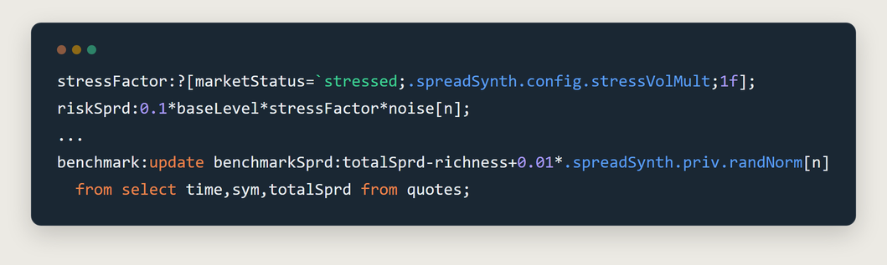
Injected stress/benchmark snippet
To be clear about what this buys and what it doesn't: this generator is not a model of how a real pricing engine sets a spread. It's a controlled way to know the correct answer in advance — the same role GBM plays in the markout/impact article's synthetic rate series — so that "the function ran without error" and "the function is correct" remain distinguishable claims.
Interpreting the results
scripts/initSpread.q runs the recovery check end to end: a 6,000-quote synthetic session (3 symbols, 3 aggression levels, two regimes) through .spread.wavgBy and .spread.vsReference, leaving recovery in the workspace as the result — the same assertion test/testSpread.q runs non-interactively as a pass/fail gate:
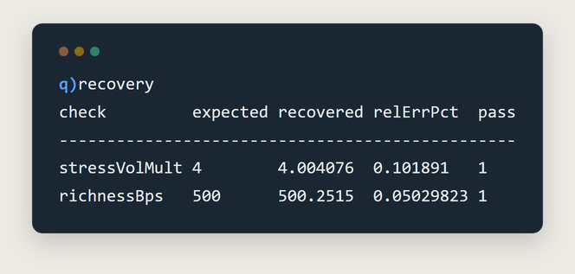
q)recovery
- stressVolMult — grouping all 6,000 quotes by marketStatus alone and taking the ratio of average riskSprd (stressed ÷ normal) recovers the injected 4.0x multiplier to within ~0.1%.
- richnessBps — joining the model's composed totalSprd against the independent benchmark series on `time`sym via .spread.vsReference and averaging the recovered richnessBps recovers the injected 500-unit richness to within ~0.05%.
The aggression effect isn't covered by the automated check above, but the same recovery is directly visible in .spread.byRegime's output — comparing low against high aggression within the same normal market status:
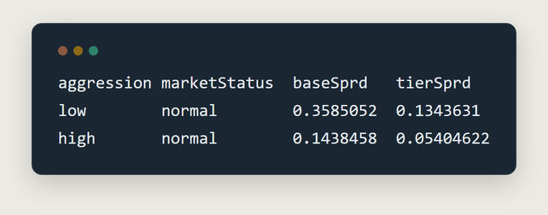
byRegime aggression comparison
0.1438458 / 0.3585052 ≈ 0.401 and 0.05404622 / 0.1343631 ≈ 0.402 — both independently converge on the injected aggressionMult[`high] of 0.4, recovered from two unrelated components without being asked to agree.
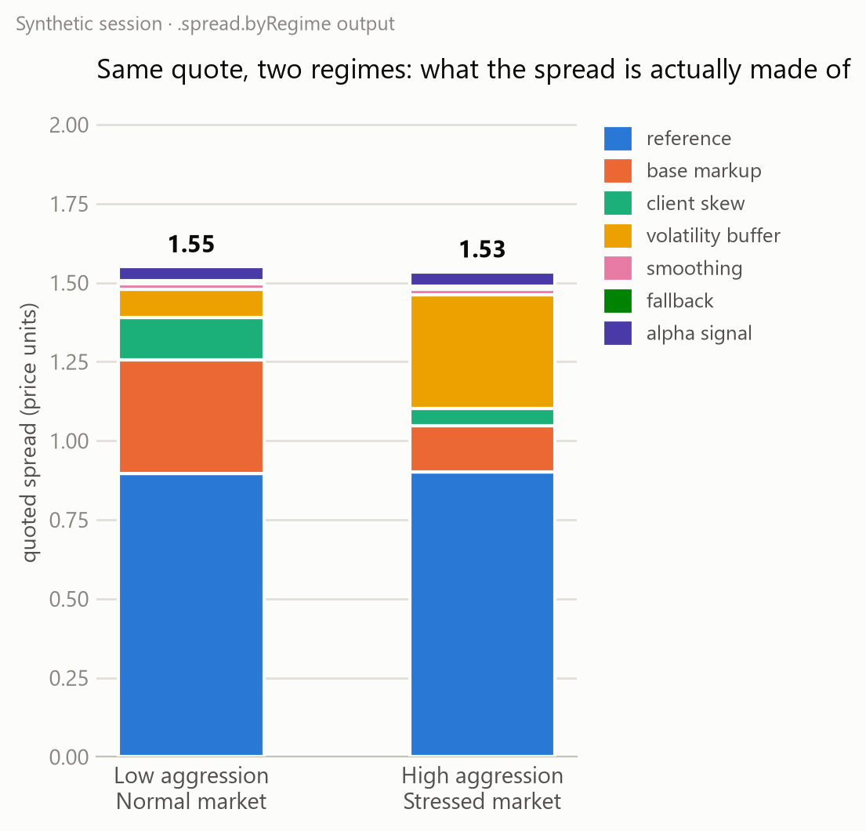
Same quote, priced two ways
That chart deliberately compares two realistic composite scenarios rather than isolating a single variable — a calm, low-aggression quote against an aggressive quote issued into a stressed market — and the result worth noting is what the totals do: 1.55 vs. 1.53, effectively unchanged. The tighter base markup and client skew from aggressive pricing nearly cancel the wider volatility buffer from the stress regime. A dashboard reporting only totalSprd would flag these two quotes as practically identical; the decomposition shows they arrived there by two entirely different routes. That gap — same total, different composition — is the operational case for keeping the components addressable, rather than collapsing them to one number at write time.
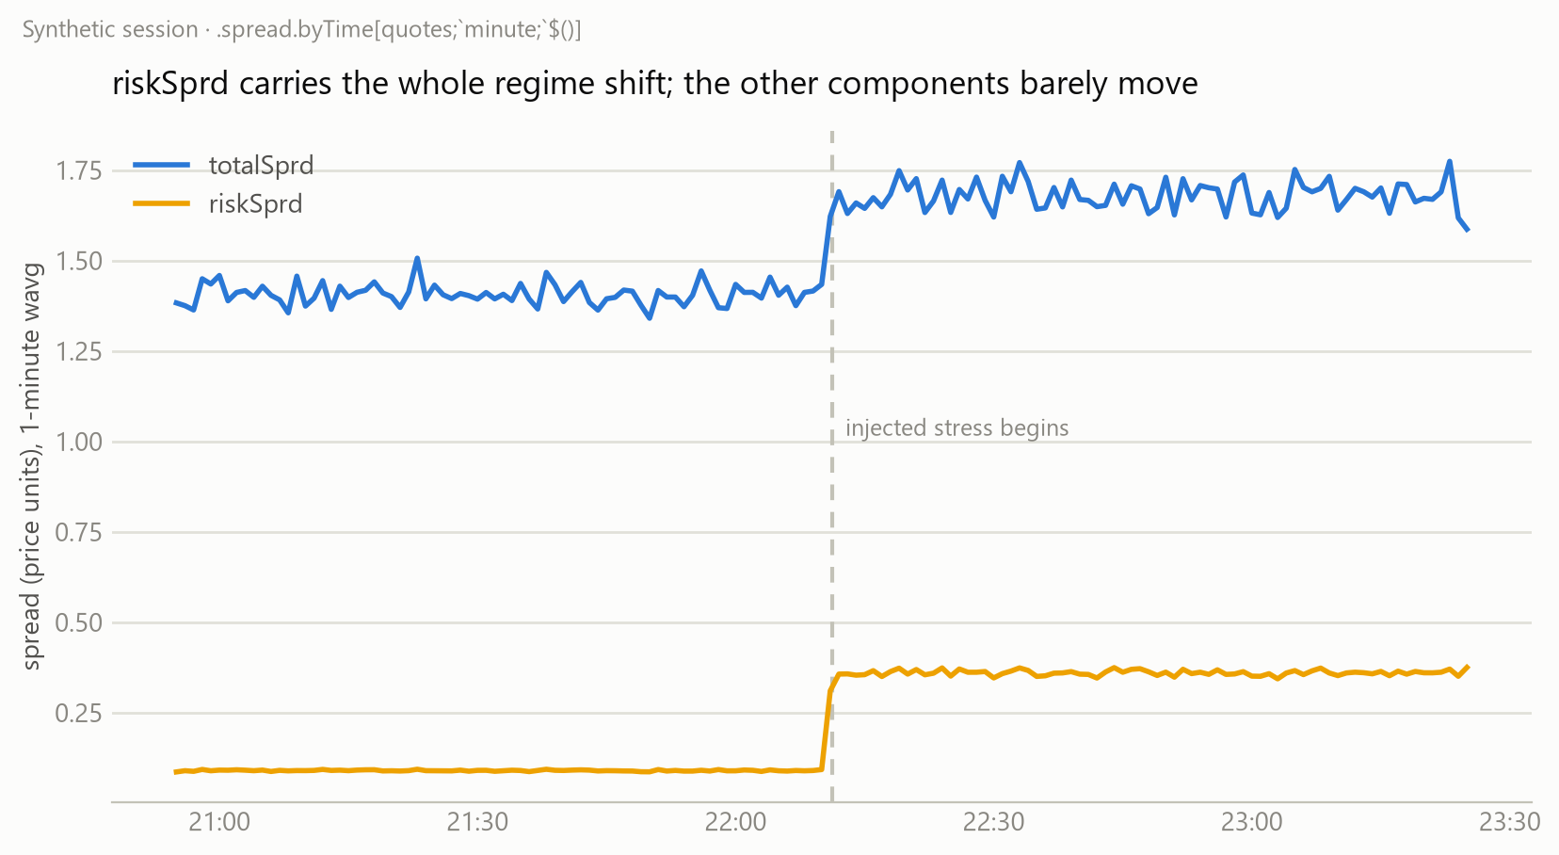
riskSprd carries the regime shift
The second chart rolls the same session up by .spread.byTime[quotes;`minute;`$()] instead of by regime tag — a fully independent aggregation path — and recovers the same signal: riskSprd jumps at the injected transition, totalSprd follows it, and every other component stays flat. Two unrelated rollups agreeing on the same result is itself a form of validation, distinct from either rollup being correct in isolation.
One more composition: share, not just level
byTime answers "what's the average level of riskSprd" — a related but distinct question is "what fraction of the spread is riskSprd responsible for, and does that change over the session." Level and share diverge whenever the other components are moving too, and a pricing review that only tracks level can miss a share shift entirely. Answering it required no new machinery: .spread.decompose already melts a wide row into one row per component with a pctOfTotal, and .spread.byTime's output is quote-shaped by construction (every component column plus totalSprd) — so decomposing a byTime result instead of raw quotes gives share-over-time as a direct consequence, not a separate feature:
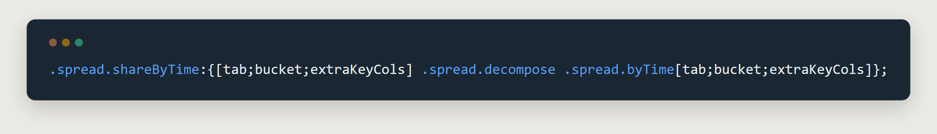
.spread.shareByTime
The order is not incidental. byTime has to run first: a component's share within a bucket is the ratio of its own weighted average to the bucket's weighted total — not an average of each quote's individual pctOfTotal, which produces the wrong answer as soon as weight varies within the bucket. In symbols, per bucket: pctOfTotal = 100 × wavg(component) ÷ wavg(totalSprd), not the mean of each quote's own componentValue ÷ totalSprd. Sequenced this way, pctOfTotal sums to exactly 100 within every bucket by construction — the same invariant .spread.waterfall's cum_signalSprd == totalSprd provides at the single-row level.
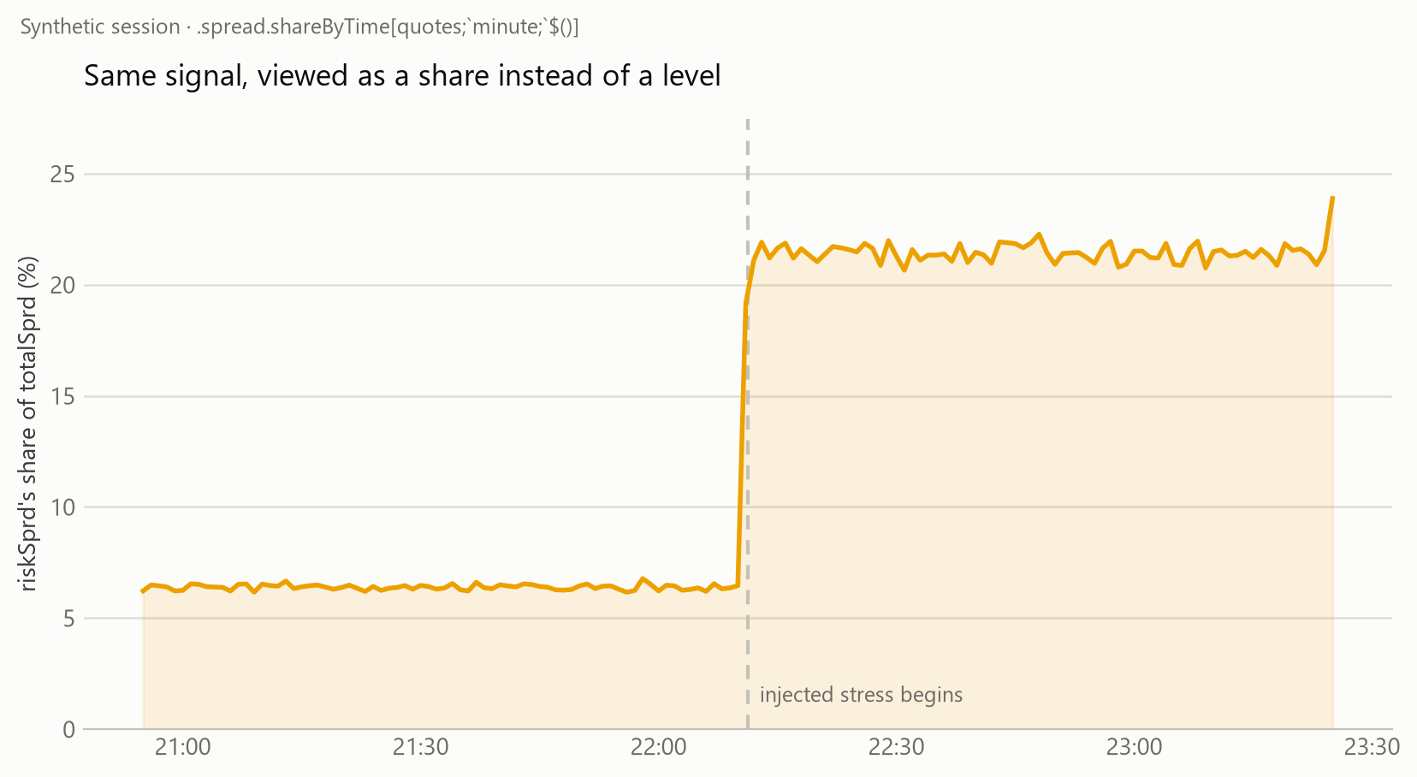
Same signal, viewed as a share instead of a level
Same session, same transition, same component — but the y-axis now reads "% of totalSprd" instead of price units. riskSprd moves from ~6% of the quoted spread to ~21% at the stress transition. That framing serves a different reader than the level chart does: a pricing manager asking "is the vol buffer eroding my margin today" needs the share, not the raw number, and the two don't always move together — a component can hold a constant share while the total moves, or the reverse.
Making .spread.decompose unkey its input defensively (0! before the column select) is what makes this composition possible at all. byTime's output is a keyed table — every ?[] group-by result is — and feeding a keyed table into code written against a plain one is exactly the kind of interface mismatch that looks fine in isolation and only surfaces once two functions are actually chained together.
The mean can hide the tail
Every rollup so far — wavgBy, byTime, byRegime, shareByTime — answers with a single weighted average, and an average can look stable while a meaningful part of the underlying distribution is not: three quotes at 1.30 and one at 4.00 average to 1.68, a figure that materially understates what happened on that fourth quote. The question a pricing or risk desk actually needs answered — "how bad does this get" — is a tail question, not a center-of-mass one, and a mean alone cannot answer it.
wavg is a q built-in; there's no equivalent built-in for a weighted percentile, so .spread.priv.wpctl implements the standard nearest-rank method — sort by value, walk cumulative weight in that order, and return the value at the point the cumulative weight fraction first reaches p:
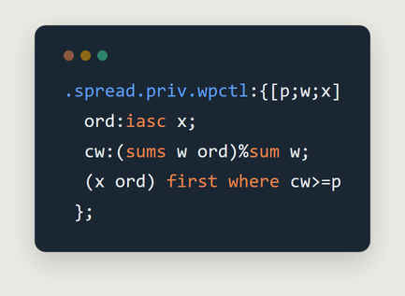
.spread.priv.wpctl
In symbols: sort x ascending to get order x(1) ≤ x(2) ≤ ... ≤ x(n), define the cumulative weight fraction CW(j) = (Σ w(i) for i ≤ j) ÷ Σw, and return x(j) for the smallest j where CW(j) ≥ p.
Nearest-rank rather than interpolated is a deliberate choice: the value returned is always an actual observed quote, consistent with how a "worst 1% of the time" figure is conventionally read in a risk context, rather than a smoothed statistical estimate that no single quote ever produced. Because wpctl takes the same (weight, value) -> number shape wavg does, it drops directly into the same aggregate-spec pattern .spread.priv.wavgAggCols already established — .spread.priv.pctlAggCols is that function's percentile counterpart, and .spread.pctlBy/.spread.pctlByTime are wavgBy/byTime with it substituted in:
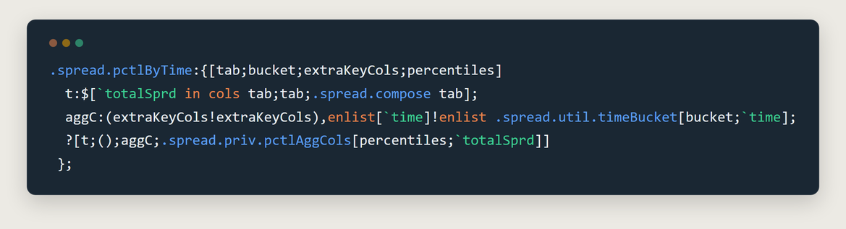
.spread.pctlByTime
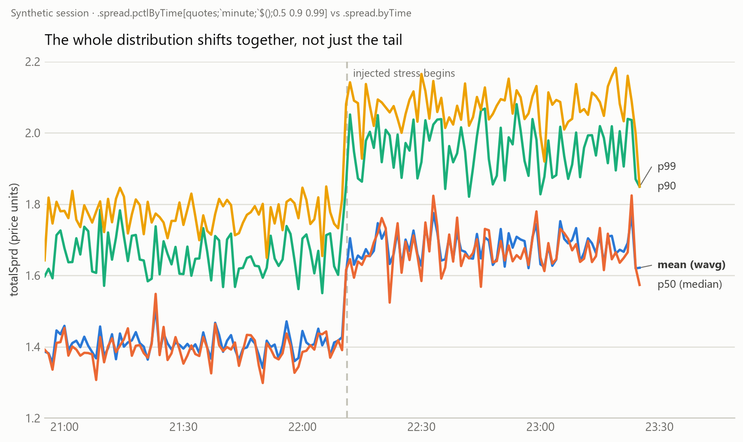
The whole distribution shifts together, not just the tail
Run against the same synthetic session as every other chart in this piece, p50/p90/p99 all move at the stress transition together with the mean — the gap between them doesn't widen the way it would if the stress were a tail-specific event (an occasional very-wide quote pulling p99 up while p50 held steady). That's not an inconclusive result: it confirms that the injected stress here is a uniform level-shift affecting every quote equally, exactly matching how data/spreadGenerator.q constructed it — riskSprd's multiplier applies to every stressed quote, not to a random subset. Distinguishing these two cases is precisely what percentile analysis is for; this session lands on the "uniform shift" side, and knowing that with certainty is worth more than assuming it from the mean alone.
Sorting isn't free: perf/perfSpread.q shows pctlByTime at roughly 3.4x byTime's cost (a full sort per bucket vs. one weighted sum) — the one rollup in this library where trading the mean for the distribution has a measurable, quantified price rather than a theoretical one.
Reconciliation vs. an outside reference
.spread.vsReference joins the model's composed total against any independently sourced spread series and reports richness in both bps and pct:
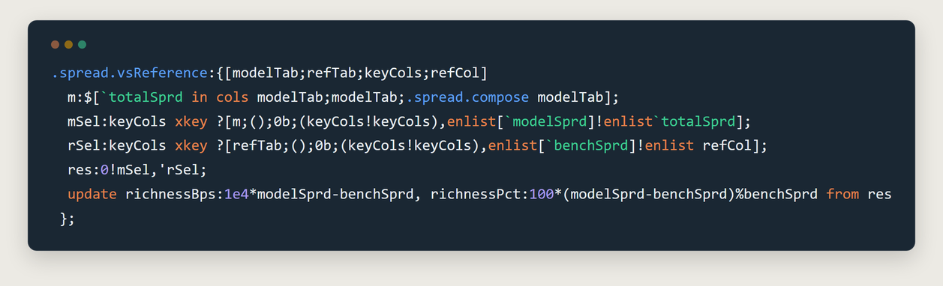
.spread.vsReference
In symbols: richnessBps = 1e4 × (modelSprd − benchSprd), and richnessPct = 100 × (modelSprd − benchSprd) ÷ benchSprd.
The immediate use case is a pricing-desk sanity check — is what's being quoted consistent with a competitor feed, a prior model version, or an internal benchmark rate — but the function makes no assumption about what refTab actually is. Any two independently produced spread series, reconciled on shared keys, fit the same shape: a required check, not a bespoke one built per comparison.
Conclusions
Spread decomposition and market impact sit under the same broad heading — pricing and post-trade analytics — while being close to opposite problems in shape. Market impact starts from one noisy observable (price after the fact) and has to recover a hidden temporary/permanent structure from it, which is why that analysis required a parametric fit and a goodness-of-fit statistic before its recovery could be trusted. Spread decomposition starts from the opposite position: the structure is already given, every component is a column the pricing engine already computed, and there is nothing left to estimate. The entire engineering problem is downstream of that — aggregating an additive decomposition without corrupting the weighting regardless of which dimension it's sliced by, and validating the result against something the model itself did not produce.
Both pieces are held to the same standard for knowing the code is correct rather than merely plausible: construct a synthetic scenario with a known answer built in, and require the functions to reproduce that specific number — not something in the right ballpark.
Appendix: performance
Correctness established, the remaining question is cost: what this decomposition- and-aggregation pipeline actually takes to run at production-representative volumes. perf/perfChk.q is a shared, functions-only timing harness; per-article runners load it and time every public function in their own analytics file against realistic-sized synthetic data, via kdb+'s built-in \ts time+space profiler (invoked programmatically as system"ts do[n;expr]", so the (ms;bytes) pair is captured and averaged over n reps rather than merely printed to console). The table below covers the .util.* and .spread.* subset — the shared offset-grid helpers plus every function discussed in this piece — run at 5x the session size used above: a 216,000-row rate series, 10,000 trades, 25 orders, and 30,000 quotes.
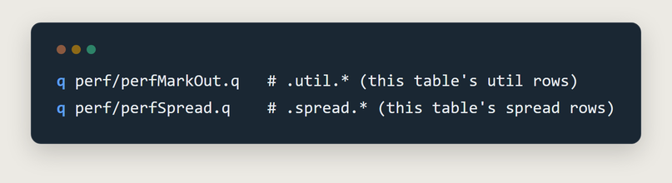
perf runner commands
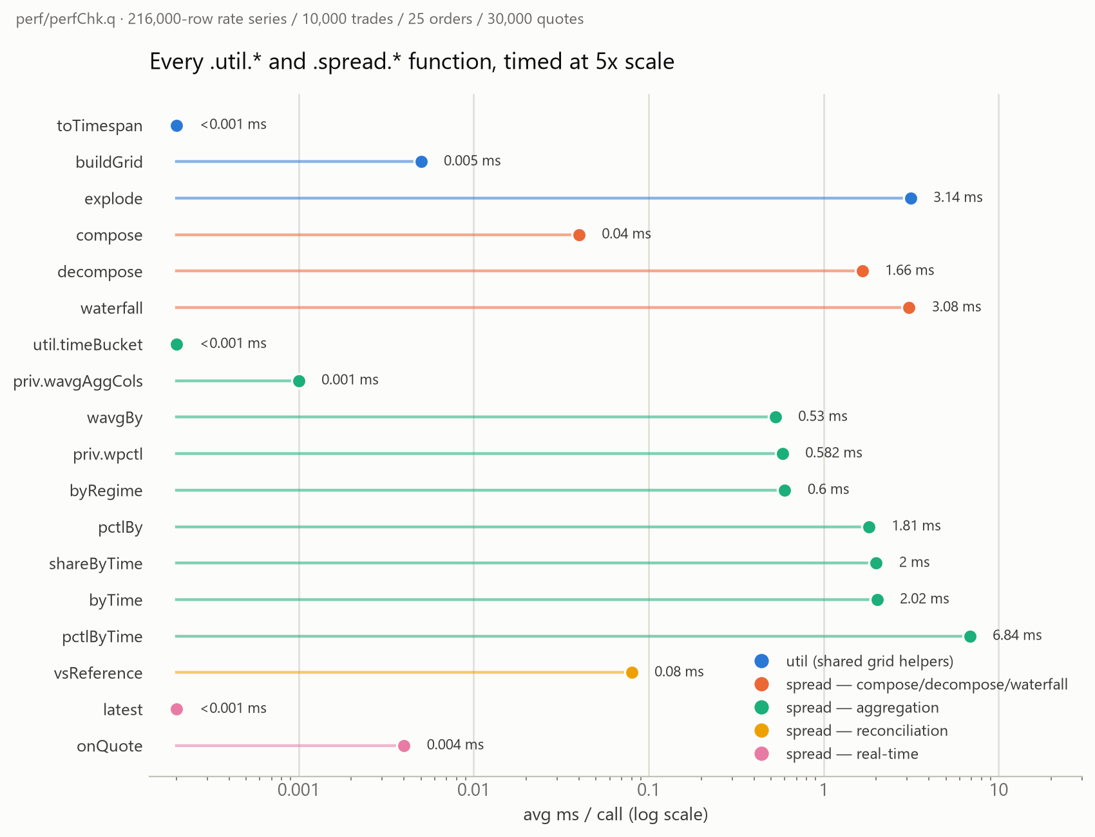
Every .util.* and .spread.* function, timed at 5x scale
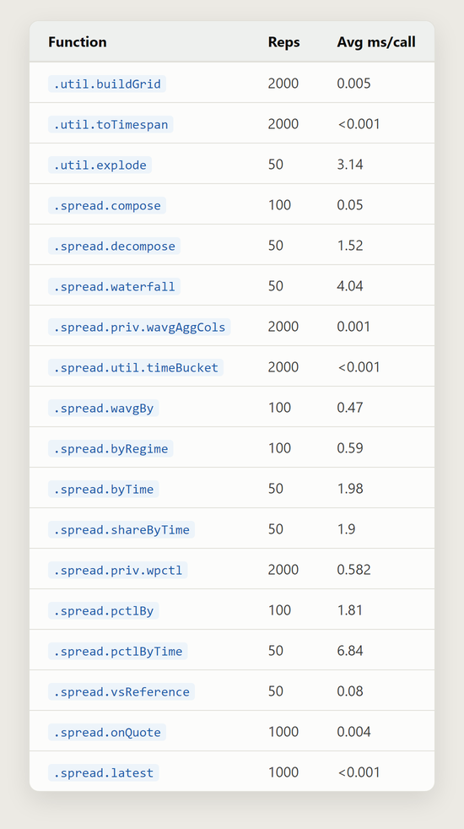
Performance results table
A few things stand out. The pure grid/dict helpers (buildGrid, toTimespan, priv.wavgAggCols, util.timeBucket) are all sub-microsecond to low-microsecond — they build small, fixed-size structures and never touch the quote table. .spread.compose is close to free (0.05ms for 30,000 rows), being a single row-wise sum; decompose and waterfall cost more (1.5–4ms) because each builds several full-sized intermediate tables — one per component, or one cumulative column per component — rather than a single pass. The aggregations (wavgBy, byRegime, byTime) stay under 2ms even while grouping and weight-averaging all 30,000 rows; byTime is the most expensive of the three because its time-bucket key produces more distinct groups than a coarse regime tag does. shareByTime costs almost exactly what byTime alone does (1.9ms vs. 1.98ms), since decompose only runs against the small, already-aggregated bucket table it produces rather than the original 30,000 rows — melting it into shares is close to free on top. The percentile rollups are the clear outliers: pctlBy costs roughly 3.8x wavgBy's (1.81ms vs. 0.53ms), and pctlByTime costs roughly 3.4x byTime's (6.84ms vs. 2.02ms) — the one place in this library where a full sort per group, rather than a running sum, materially shows up in the numbers. .spread.onQuote (the real-time path) is flat at 0.004ms regardless of session size, as required — it upserts one row into a table keyed by a small, bounded (sym, aggression, marketStatus) key space, never touching the historical quote volume.
The two <0.001 rows (toTimespan, latest) reported exactly 0 from the profiler — below \ts's millisecond resolution at this call cost, not a claim that the operation is literally free.

