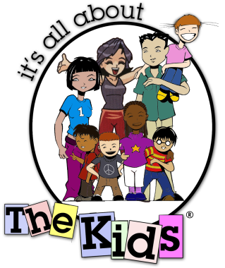

${date}

Dear ${name},

It’s All About the Kids® Foundation is a 501 c[3] non-profit organization that creates and provides new and innovative programs to benefit children’s charities and enhances the lives of less fortunate children. We help kids SUCCEED! We help over 1500 children that are impacted by HIV/AIDS, homelessness, neglect, abuse and crime in Southern California and Baja Mexico.

Thank you so much for your generous donation of ${item} for ${event}. With your donation, we will continue our programs and activities that make a difference in children’s lives. We are so grateful for your kindness!

We hope that you will continue to be a part of our adventure. Please visit [www.ItsAllAboutTheKids.org](http://www.ItsAllAboutTheKids.org) for upcoming events and programs.

Only the best,



Angela Brannon

President of the Board

It’s All About the Kids® Foundation

[www.ItsAllAboutTheKids.org](http://www.ItsAllAboutTheKids.org)

*It’s All About the Kids® is a 501c[3] non profit organization.*

*EIN; Tax Id #20-1114086.*

*This letter confirms that no goods or services were provided in exchange for this Donation. It’s the responsibility of the donor to assign a fair market value to this donation. For info on fair market values call the IRS or visit* [*www.irs.gov*](http://www.irs.gov)*. $_____ Value. Please keep this letter for tax purposes. There is no need to return it after assigning value.*