CS541 Project 1

Synopsis
Implement a modern micro-facet BRDF lighting model with interesting texture map.

Instructions for the BRDF part
A modern lighting model has a simple diffuse term and a micro-facet specular term. The input parameters are similar to Phong lighting:
- three unit vectors, , , and (light, viewing, and normal directions),
- two colors and (diffuse and specular color), and
- a roughness parameter (instead of the Phong exponent).
- halfway vector H calculated as L+V scaled to unit length

The full lighting equation is

where is the brightness of a single light. (Multiple lights would sum a number of such terms, and continuous light would integrate that calculation over a hemi-sphere of incoming directions.) The BRDF() portion is the sum of diffuse and specular terms

and the three functions , , and in the micro-facet specular term are:
- Fresnel term (Schlick approximation) :
- Distribution term: (among other possibilities)
- Shadowing term:
  - The original form
  - Or combined with part of the denominator
(cheaper than free, but darkens too fast), or
(an easy approximation to the original form)

This new equation interprets the parameters somewhat differently that the original Phong calculation:
- : The light needs to be much brighter than before (by a factor of ) to account for the fact that a reflected light beam is spread out over a full hemisphere.
- : Is now more properly refereed to as the albedo, and represents the portion of light reflected across the full outgoing hemisphere. It is still an RGB value with values in the range zero to one.
- : In most surfaces, is quite small, with RGB values of about 0.02 to 0.04. (That is, 2-4% of the incoming light is reflected specularly.)
- : The roughness parameter is exactly the old Phong exponent, but beware: As is increased for a narrower specular reflection it also becomes much brighter because of the other occurrence of in the distribution term. This matches the behavior of actual surfaces.

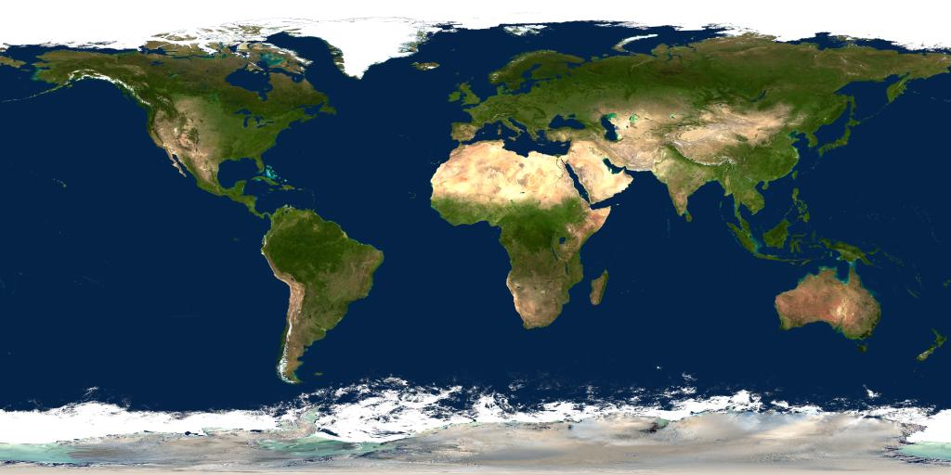
Instructions for the Texture mapping part
Replace the central model of the framework with a simple sphere, and produce a “nice” image of the earth using data from the two provided texture maps:
- earth.jpg: A 1024x512 RGB image of earth's surface
- effects.jpg: A 1024x512 RGB image containing 3 single-channel images (r=specular factor, g=night image, b=cloud image)
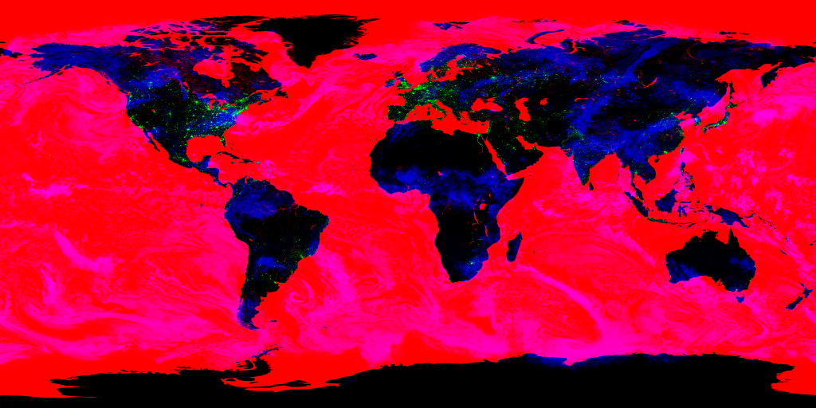
The framework defines texture coordinates on the sphere model which match these images. It also demonstrates how to read in textures (using glimg::loaders::stb::LoadFromFile) and pass them to a shader.

A “nice” image of the earth should include at least the following:
- Use your new BRDF lighting model, but restrict the specular reflection to watery regions using the effects.r channel. (This channel contains a 1.0 for watery regions, and a 0.0 for land regions.)
- Choose day-time colors (from earth image) when is positive, and night-time lights (from the effects.g channel) when is negative.
- Since the terminator (the line between night and day) is not a sharp line, due to the atmospheric scattering, implement a region of dawn/dusk between the two.
- Implement transparent clouds on the daytime side by using the cloud channel (effects.b) as a blending factor between ground color and cloud color (pure white).
- Be creative in using these these images to produce a nice earth image.

Project Report
Write a short project report describing your choices for the various BRDF factors, and any experimentation you did in setting the lighting parameters to produce a nice lighting effect. Also describe how you produced the various effects required of the production of a “nice” texture mapped earth image.

What/when/how to submit
Use Moodle to submit a single zip file of your project.
- Place your project report in a text file named report.txt (or report.doc or report.odt if you (unnecessarily) insist on producing a formated document).
- Create a zip file containing only your report, shaders, and source code (*.cpp, *.h) and .vcproj, and shaders (*.frag and *.vert)
Submit through the “CS541 Project1” link on the class Moodle web page.

