This has been incredibly difficult to map so I will freeform topics.

# SARS-CoV-2

**(1) Trauma**

My grandmother had this trait where she would never throw anything away. Her house was full of repurposed containers; she would wash everything and reuse it -- except that thing would be a paper towel.

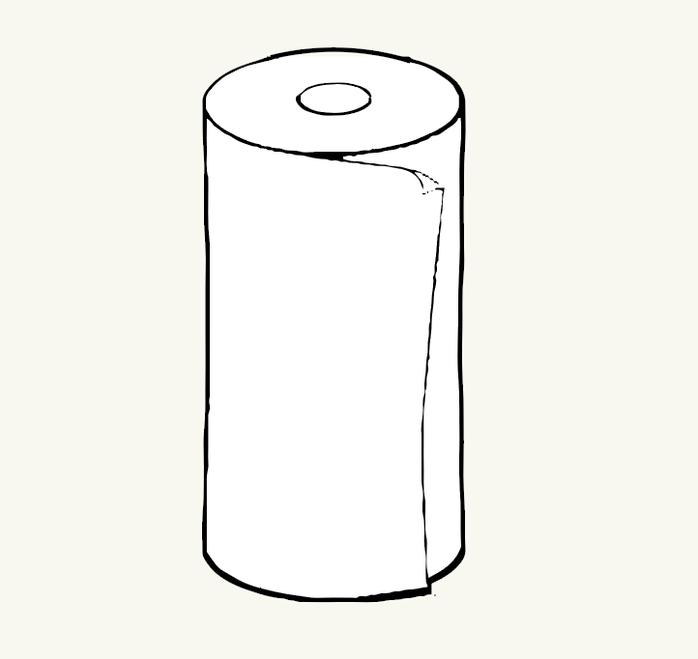

I’ve never confirmed with her but I presume it was from living through the Great Depression and growing up poor. She held onto this behavior for her entire life, long after it was necessary and our financial situations improved.

I believe this quarantine to be of similar quality in terms of significance in impacting individuals. I am not aware of anything particularly traumatic for myself as supply chains are still functional or any social behaviors but I'm not confident in saying the same for others.

**(2) Surreal**

It's surreal how large swaths of human behavior was changed overnight. This shared experience has made me feel very connected to others. I had a great conversation with my neighbor for the first time since I’ve moved here.

**(3) Social Distancing**

The terminology of ‘social distancing’ is fascinating and likely to stay embedded in the culture.

I'm interested in the term's origin and the rationale from the team who designed the phrase.

**(4) Quarantine**

A full quarantine is extremely unlikely to work in a democratic manner in our connected world.

There is utility in dissent and there is utility in obedience. The difficult wisdom is choosing which and when and to what degree. I can steel-man both sides: democratic and authoritarian. The difficulty increases given how frequently it is asymptomatic and the range in severity.

**(5) Negative Emotion**

It’s natural to feel depressed when there is nothing event-wise to look forward to and less human interaction.

I have not felt particularly poor socially or emotionally despite logistically it was a drastic U-turn for my life. Initially I was proud of my lack of negative emotion during this time -- my resiliency to this situation. Independence is waved around proudly however I am less convinced this is a healthy thing.

How can it be wrong to not feel negative emotion? While it’s great not to feel pain when holding your hand over the stove, the lack of pain is indicative of a *more severe* neurological problem than surface burns.

There is no shame in feeling the darker, less pleasant, less masculine emotions.

It is healthy to feel poorly in a negative circumstance.

**(6) Lasting Behavior Changes**

I am more conscious of washing my hands and aware of how easily germs can spread. Going forward I likely will wash my hands more frequently, push open doors differently, and perhaps I’ll be a fist bump only person.

Food delivery, video chats, and playing online games are more normalized.

These ‘wealthy’ friendship activities have become more normalized and ‘poor’ friendship activities are restricted.

**(7) Initial**

Early on the death rate of those without pre-existing conditions was low and I had more faith in America’s infrastructure and response than China’s. Not much to do besides hydration and rest and wait for your body to fight.

**(8) Severity**

With all news it comes off as numbers and otherly, however I’ve taken to reading biographical obituaries of individuals who have died as a result of this pandemic. It’s helpful to center myself and celebrate/mourn who they were; real full people with lives, history, hopes, dreams, etc.

**(9) Reopening**

[Everything has a tradeoff](http://todo). While scientifically it isn’t advisable to reopen, economically it’s a necessity for many people. While getting sick is a problem, there are also problems being in quarantine; the world keeps spinning and bills need to be paid.

Being poor is a critical issue where there is no luxury of choice. Unless individual’s needs are met it’s a clear argument that individuals should have the sovereignty to make their choices on priorities and necessities.

**(10) Politics**

Similar to (9), it isn’t always correct to say the most scientifically accurate thing. The game of politics is to produce the best results, and I’d posit that often includes not being an open book.

I am never envious of political decision making. It is not straightforward. Whether it’s discussing what we know about the virus or advocating against reopening.

**(11) China Virus**

Wuhan Virus != China’s Coronavirus != China Virus

Spanish Flu did not come from Spain or the Spanish people. West Nile Virus was named for a region in Uganda, it isn't called the Ugandan Virus. Ebola is specifically named for a river instead of the town that it was found in (it wasn't even the closest river to avoid stigma). Zika is from forest in Uganda. Lyme is the city but it isn't' named Connecticut or NA virus or US virus. None of these examples are analogous.

**(12) Risk**

The classic example of modeling risk is severity-frequency.

In contrast to this model, humans innately overweigh the immediate and underestimate the future. It’s always okay until it’s not.

**(13) Testing**

Bill Gates has stated the prerequisite to reopening is testing. Testing is the metric of determining whether we’re declining, stable, or recovering.

**(14) Future**

I’m sure things will develop and this will quickly become outdated. As all events move virtual (weddings, birthdays, work, etc) it’s fascinating to guess when the end date will be and plan for the future.

It is concerning comparing what we know now to what we knew in January - I’m unaware of many new discoveries. That is concerning, but perhaps I’m simply out of the loop.

Nothing is so healing as the human touch.

<https://www.youtube.com/watch?v=2ORsrbQa94M>

Lil Peep - Life Is Beautiful