s
Below is a senior-level end-to-end system architecture for an embeddable website chatbot that supports the features in your brief: landing-page popup, lead capture, AI answers, escalation to scheduling, email notifications, reminders, admin tooling, and client-specific question ingestion. The design is production-oriented and can be embedded into any website via a lightweight widget script
Functional scope
Your requirements map to seven core capabilities: embedded chatbot UI, lead capture before conversation, AI/LLM Q&A, fallback to scheduling after low confidence or 6–7 turns, email notifications, reminder automation, and an admin console for clients, leads, and question uploads. The uploaded file also implies client-specific knowledge handling, so the answer layer should be multi-tenant and isolated by client
System diagram
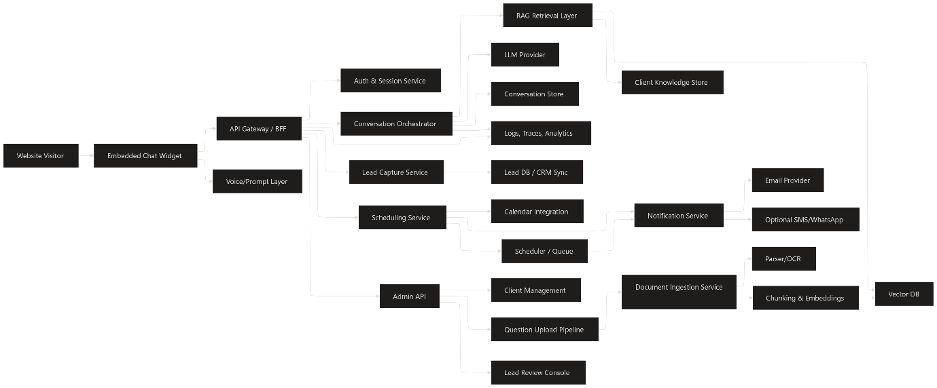
Frontend stack
The chatbot widget should be a self-contained JavaScript bundle or Web Component so it can be dropped into any website with one script tag. Use React or Vue for the widget UI, a lightweight state manager, and CSS isolation via Shadow DOM or CSS modules. For voice-over or greeting prompts, add browser text-to-speech or a small audio layer triggered on first open
Recommended frontend components:
- Widget shell, chat bubbles, quick replies, lead form, and schedule CTA.
- Session handling with anonymous visitor ID and optional authenticated user context.
- Typing indicators, file-safe markdown rendering, and rate-limit handling.
- Accessibility support with keyboard navigation, ARIA labels, and screen-reader-friendly announcements.
Backend services
A modular backend is the safest choice because your flows are not just chat; they include lead capture, scheduling, notifications, and admin actions. A typical setup is API Gateway/BFF, Conversation Orchestrator, Lead Service, Scheduling Service, Notification Service, Admin Service, and an Ingestion Pipeline for uploaded client questions. This separation makes it easier to scale parts independently and keeps the chatbot logic clean.
Suggested backend stack:
- API layer: Node.js/NestJS or Python/FastAPI.
- Auth: OAuth2/JWT for admins; session tokens for visitors.
- Database: PostgreSQL for tenants, leads, schedules, audit logs, and settings.
- Cache: Redis for session state, rate limits, and short-lived conversation context.
- Queue: RabbitMQ, Kafka, or SQS for reminders and email jobs.
- Search/vector: pgvector, Pinecone, Weaviate, or OpenSearch vector.
- Object storage: S3/GCS/Azure Blob for uploaded question files and docs.
AI answer pipeline
The AI layer should not call the LLM directly for everything. Use a retrieval-augmented generation flow: classify the user intent, retrieve client-specific FAQs/docs, apply conversation memory, then generate a response with guardrails. If retrieval confidence is low, the orchestrator should offer scheduling instead of hallucinating an answer.
Recommended AI components:
- Intent classifier for sales, support, schedule, lead, or admin-adjacent requests.
- Retriever over client-specific question sets and marketing content.
- Prompt builder with tenant context, tone rules, and fallback policy.
- LLM provider such as OpenAI, Anthropic, or Azure OpenAI.
- Response validator to block unsafe or irrelevant answers.
Lead and scheduling flow
Your lead capture should happen early, before the main conversation begins, using a short form for name, email, and phone. After 6–7 questions or when the model confidence drops below a threshold, the orchestrator should present a calendar link or embedded scheduler such as Calendly or a custom booking module. When the user schedules, trigger confirmation emails to the user and admin, and create reminder jobs for 3 days, 24 hours, and 1 hour before the call.
Scheduling stack:
- Calendar integration via Google Calendar, Outlook, or Calendly API.
- Event store in PostgreSQL.
- Reminder scheduler via cron plus queue, or a workflow engine like Temporal.
- Email service via SES, SendGrid, Mailgun, or Postmark.
- Optional SMS/WhatsApp via Twilio or similar.
Admin console
The admin side should be a separate secure web app. It needs client onboarding, lead review, question upload, scheduling visibility, and analytics on conversation outcomes. Since the chatbot is client-specific, each tenant should have isolated content, leads, and configs.
Admin modules:
- Create client / tenant.
- Upload FAQ files, campaign docs, and approved answers.
- Review and export leads.
- View conversations, fallback rates, and schedule conversion.
- Manage greeting copy, voice-over, business hours, and escalation policy.
Data model
A clean relational core works well here.
Entity | Purpose
Tenant | Client organization and config.
Visitor | Anonymous or known user profile.
Conversation | One chat session and metadata.
Message | Individual user/bot messages.
Lead | Captured contact details and qualification status.
KnowledgeDoc | Uploaded client content and source files.
QuestionSet | Client-centric questions and answers.
ScheduleEvent | Booking details and reminders.
NotificationJob | Email/SMS reminder tasks.
AuditLog | Admin actions and compliance trail.
Tech stack recommendation
If you want a practical, scalable default stack, I’d use:
- Frontend widget: React + TypeScript + Shadow DOM.
- Admin app: Next.js or React + TypeScript.
- Backend: NestJS or FastAPI.
- Database: PostgreSQL + pgvector.
- Cache/session: Redis.
- Queue/workflows: SQS + Lambda or RabbitMQ + worker service; Temporal if workflows grow complex.
- LLM: Hosted API with a model-agnostic abstraction layer.
- Storage: S3-compatible object storage.
- Auth: Auth0, Clerk, Cognito, or custom OIDC.
- Observability: OpenTelemetry, Prometheus/Grafana, Sentry, ELK.
- Deploy: Kubernetes for larger scale, or containerized services on ECS/Cloud Run for simpler ops.
Deployment pattern
For production, run the widget on a CDN, keep the API behind a gateway, and isolate each tenant at the data layer. Use environment-based configs for different websites, and sign widget initialization requests to prevent unauthorized embedding. Add rate limits, bot protection, PII masking, and audit logging from day one.
Operational guards
You should define clear fallback rules so the bot does not overpromise. For example, if retrieval confidence is low, if the user asks for pricing/legal details not in the approved content, or if the conversation exceeds the 6–7 question threshold, the bot should switch to scheduling. Also store explicit consent for contact capture and reminders, especially for email/phone-based follow-ups.[ppl-ai-file-upload.s3.amazonaws]
I can turn this into a clean PNG-style architecture diagram or a more detailed AWS/Azure/GCP reference architecture next.

