LIGADATA

# Fatafat 1.0 API Viewer Guide

# Overview

This guide will help you open and use the LigaDATA Fatafat Scala API documents

### To Install the API Documentation:

1. From GitHub, download the FatafatAPIDocs.zip to a local directory where the docs will reside.
2. Unzip FatafataAPIDocs.zip   
     
   You will see the .scala files. The first few folders are shown below:

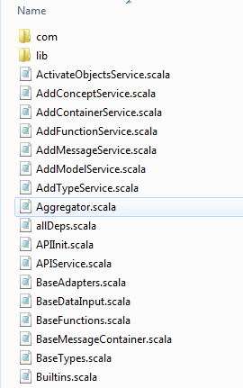

1. Viewing Objects and their components.
   1. Scroll down until you find Index.html

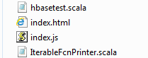

* 1. Double Click Index.html. You will see a UI like the one shown below:  
     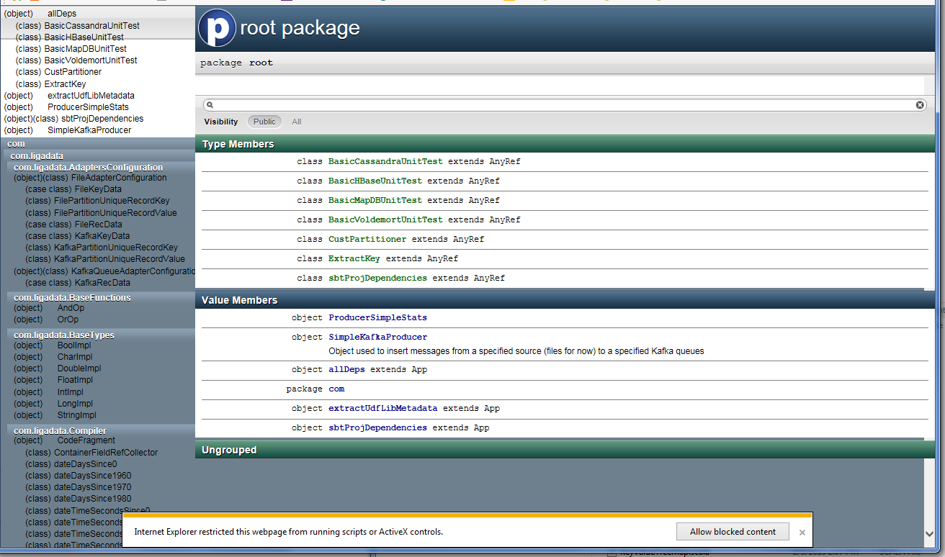
  2. Click “Allow Blocked Content” to view full API.

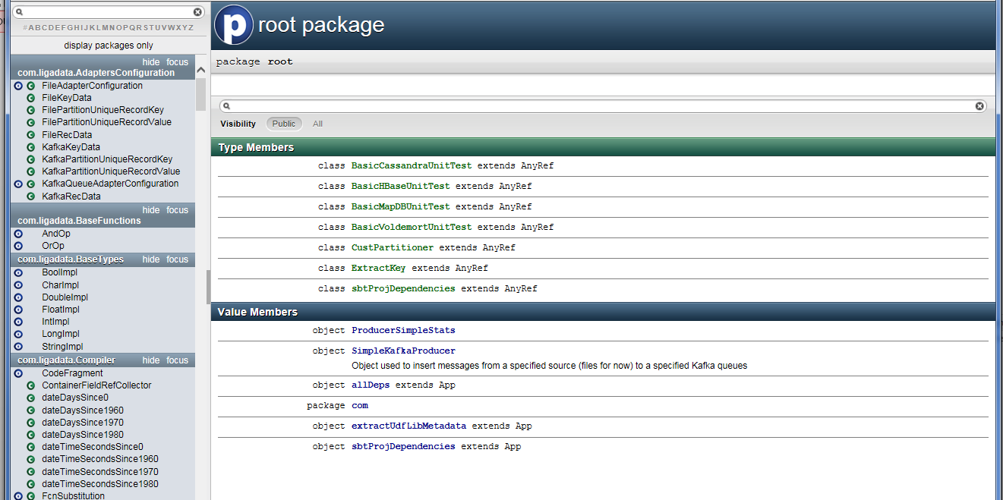

* 1. View the API for any code element on the left. For Instance, scroll down to “Learning Engine”, and click on it. You will see the following.

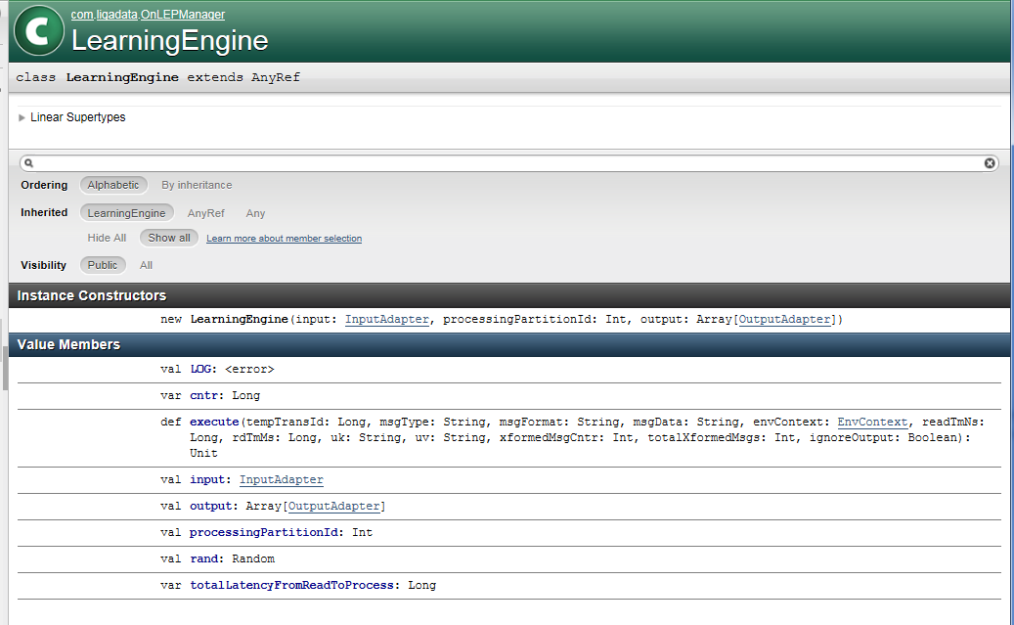

* 1. Click on the link to the InputAdapter trait to see its members. Note the order, inheritance, and visibility.

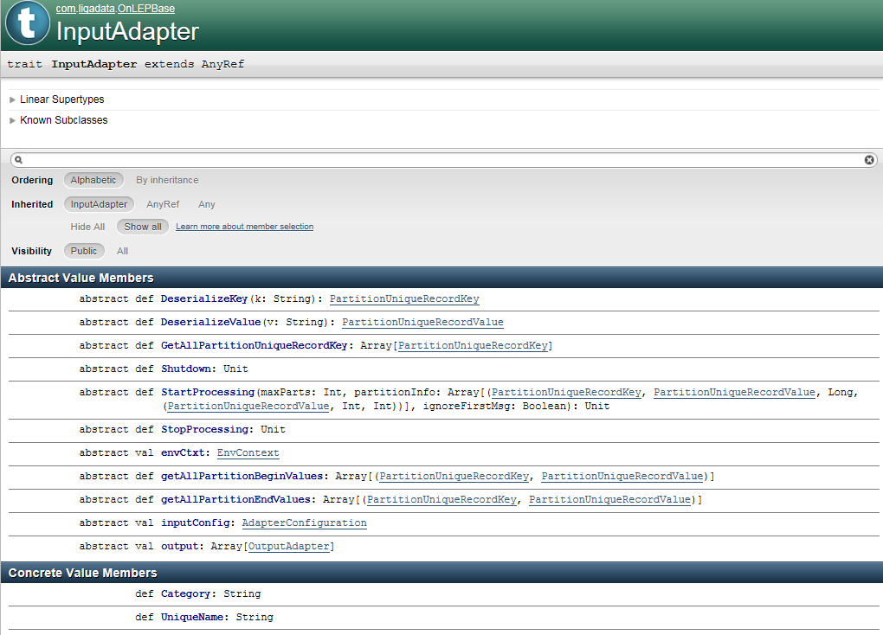

All the objects it the left nav can be explored in the same way.