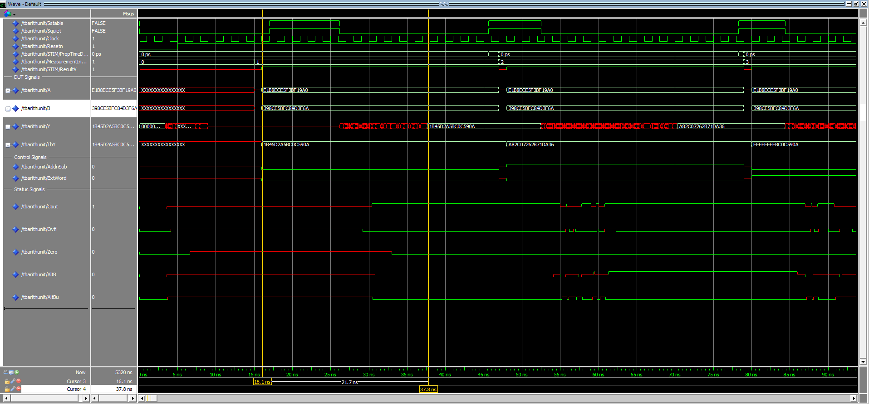

waveTAU1

Arithmetic unit – Timing simulation: This figure shows the simulation result of adding A and B, without sign extending. A is not less than B, and A is not less than B unsigned. No overflow occurred and the result does not equal to zero. Signal waves are correct since our output is identical to the output from the test bench. Measurement 1, the propagation delay of measurement 1 is tpd = 21.7 ns.

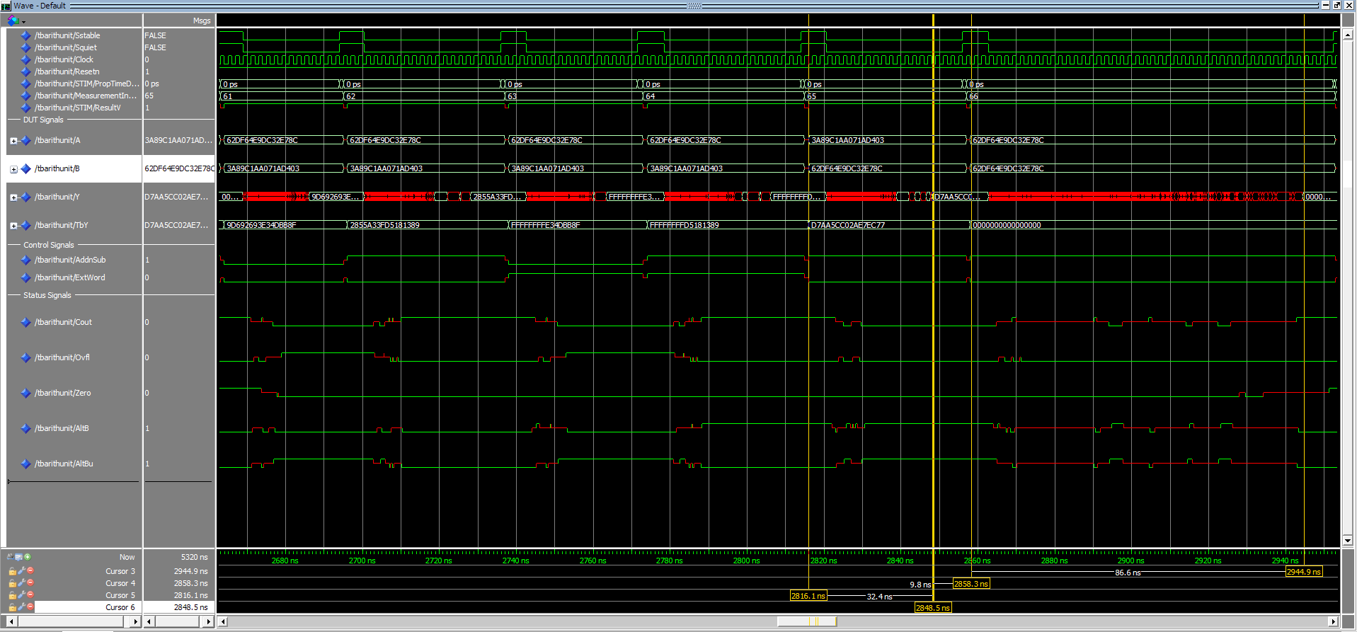

waveTAU1

Arithmetic unit – Timing simulation: This figure shows the simulation result of A subtracts B, without sign extending. A is less than B, and A is less than B unsigned. No overflow occurred and the result does not equal to zero. the propagation delay of measurement 66 is significant larger, because subtracting two same numbers will generate largest amount of carries. Measurement 65, tpd = 32.4 ns; Measurement 66, tpd = 86.6 ns.