# **FULLY EXPANDED SCHEMAS DIAGRAM**

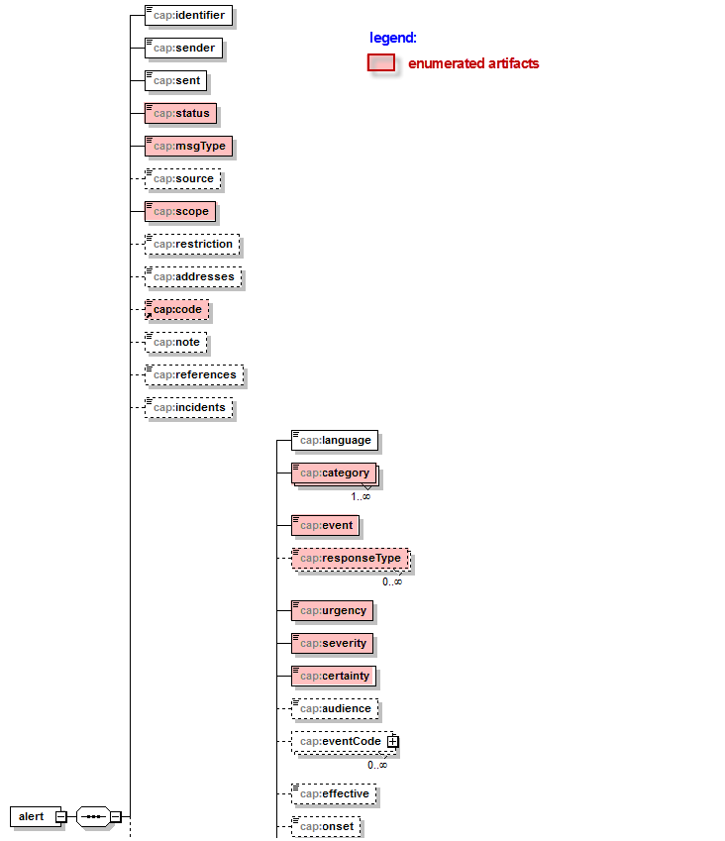

ref: https://data.gov.au/dataset/cap-au-std/resource/137e98ce-f069-48ca-a420-274afc4ad78c

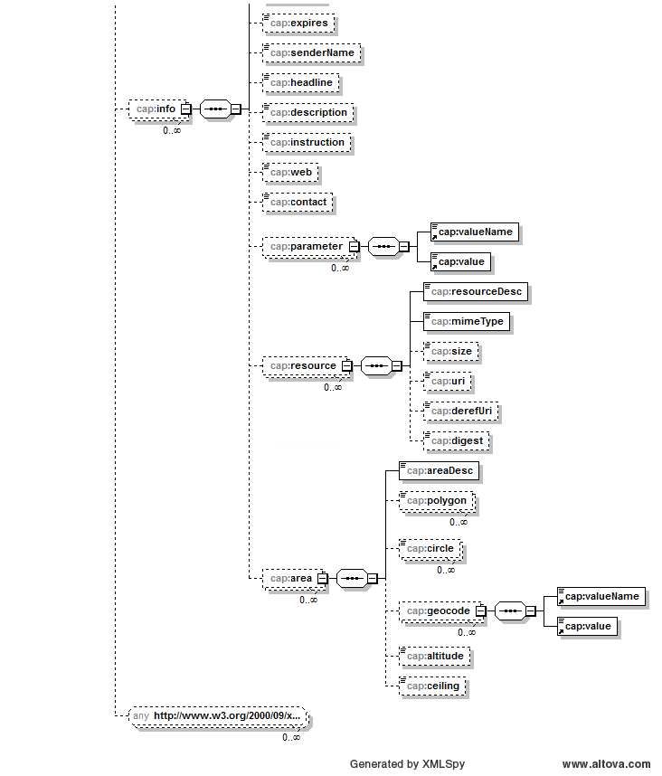

# **Enumerated ARTIFACTS**

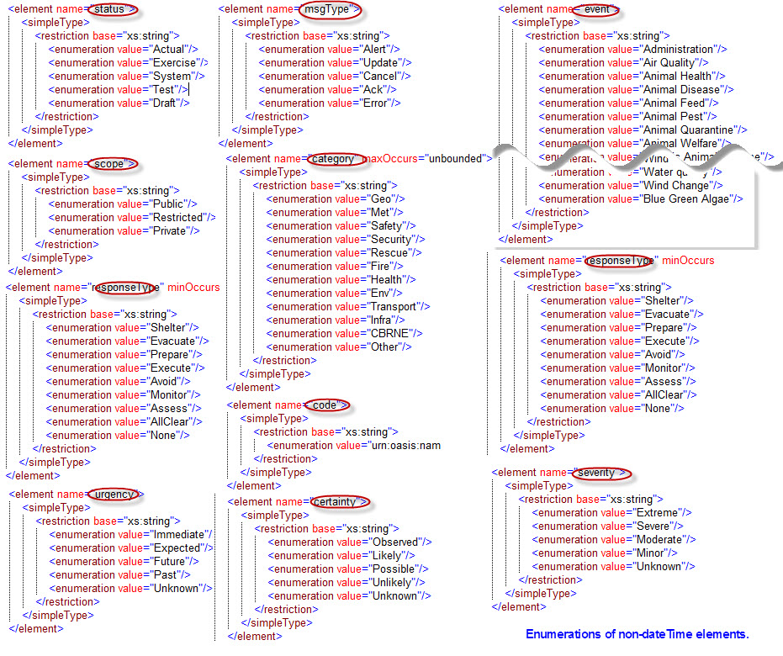

# **VERSION COMPATIBILITY MATRIX**

|  |  |  |  |
| --- | --- | --- | --- |
| **CAP-AU-STD version** | **XSD CAP-AU** | **CAP version** | **Backwards compatibility** |
| Pre-release | 1.0 | 1.2 |  |
| 1.0 | 2.0 | 1.2 | CAP-AU-STD (pre-release) |
| 2.0 | 2.0 | 1.2 | CAP-AU-STD 1.0 |
| 3.0 | 3.0 (this XSD) | 1.2 | CAP-AU-STD 2.0 |