ST10484340
PROG6212
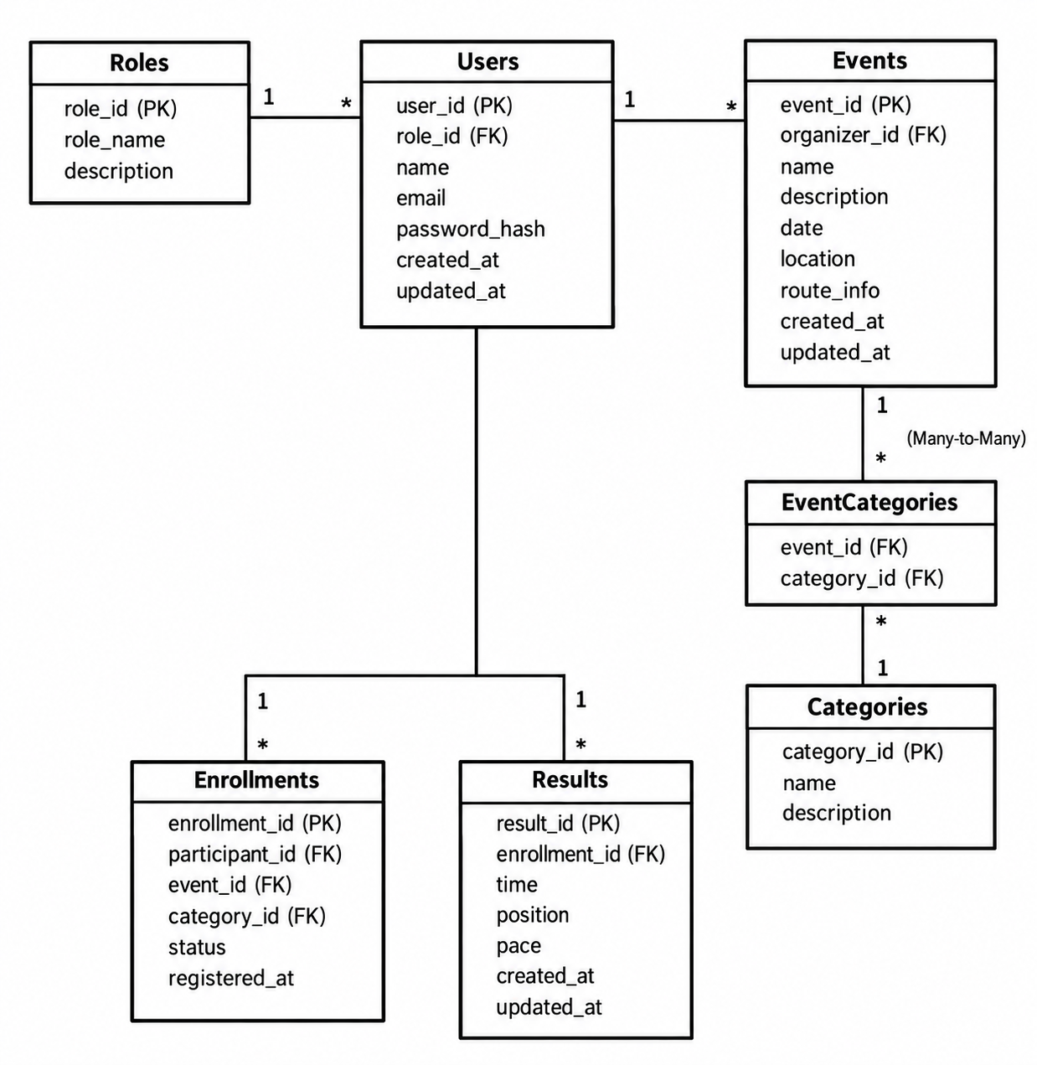

Github link
https://github.com/Sphelele20/RaceDay.git

youtube link
https://youtu.be/EP4sLVFkLBg

