An Explainable, Digital Twin-Inspired XGBoost Framework for Adaptive Predictive Maintenance and Repair-vs-Replace Decision Support in Industry 4.0
Sphurrthi Naaidu Pudupakham
Jansons Institute of Technology, Karumathampatti, Tamil Nadu, India;
Corresponding author. Email: sphurrthinaaidu@gmail.com

Abstract
Industrial organisations operating within Industry 4.0 environments face persistent challenges in balancing maintenance cost, equipment reliability, and operational continuity. Conventional maintenance approaches — whether reactive or fixed-schedule preventive — are ill-suited to environments where machine conditions evolve continuously and failure risk concentrates unevenly across the operational population. This study proposes and evaluates an integrated, explainable predictive maintenance framework that connects XGBoost-based failure prediction with SHAP explainability, dynamic threshold-based risk assessment, a Digital Twin-inspired architecture, and a Repair vs. Replace Decision Module grounded in formal lifecycle cost analysis within a single operational pipeline. Using the AI4I 2020 Predictive Maintenance Dataset comprising 10,000 machine operational records, three classification models — Logistic Regression, Random Forest, and XGBoost — are comparatively evaluated. XGBoost achieves the strongest discriminatory performance (ROC-AUC = 0.973), and its probabilistic outputs drive a three-tier risk categorisation engine and four maintenance strategy simulations. SHapley Additive exPlanations (SHAP) analysis is applied to the XGBoost model using the TreeSHAP algorithm, providing global and instance-level explanations of failure predictions and confirming that torque, tool wear, and rotational speed are the primary directional drivers of machine failure risk. The dynamic threshold-based strategy achieves a 55.29% reduction in total operational cost relative to the reactive maintenance baseline, and threshold sensitivity analysis demonstrates that the 0.3–0.5 range represents the most cost-efficient operating zone. The Digital Twin-inspired architecture maps the framework onto a deployable monitoring pipeline spanning sensor input, real-time risk dashboards, and explainable alerts, while the Repair vs. Replace Decision Module grounded in formal lifecycle cost analysis extends each high-risk alert into a concrete, lifecycle-cost-justified maintenance action. Findings offer actionable implications for maintenance managers and operations directors seeking evidence-based, transparent, and adaptive maintenance governance in resource-constrained industrial environments.

Keywords: predictive maintenance; Digital Twin; XGBoost; SHAP; explainable AI; dynamic threshold optimisation; repair vs. replace decision support; Industry 4.0

1. INTRODUCTION
1.1 Industry 4.0 and the Maintenance Challenge
Unplanned machine failure remains one of the most operationally disruptive and financially costly events in modern industrial production. As production systems grow more interconnected and output demands more intensive, the consequences of maintenance failures extend beyond immediate repair costs to encompass production schedule disruption, supply chain delays, and reputational exposure. Industry 4.0 — the integration of cyber-physical systems, Industrial Internet of Things (IIoT) devices, cloud computing, and advanced analytics into industrial operations — has fundamentally altered the conditions under which maintenance decisions are made.¹ Modern manufacturing environments continuously generate large volumes of operational data from embedded sensors monitoring temperature, mechanical stress, rotational behaviour, and component wear. This data-rich environment creates a practical opportunity: rather than waiting for failures to occur or servicing equipment on fixed calendars, organisations can use operational data to anticipate failure conditions and intervene selectively, at the right time and on the right machines.
Predictive maintenance — the use of operational data and analytical models to forecast equipment failure before it occurs — has emerged as one of the most strategically significant applications of Industry 4.0 analytics.² Unlike reactive maintenance, which absorbs the full cost of unexpected breakdown, and unlike fixed preventive schedules, which service equipment regardless of actual condition, predictive maintenance aligns intervention timing with observed machine behaviour. The result, in principle, is fewer failures, lower maintenance expenditure, and more efficient use of maintenance labour and spare parts. However, despite growing adoption of predictive technologies, many industrial organisations continue to rely on static maintenance policies that lack the adaptability required for dynamic operational environments. The practical challenge is not only to predict failure, but to translate probabilistic predictions into operationally effective and cost-efficient maintenance decisions.
1.2 Problem Statement
Despite substantial advances in machine learning-based failure prediction, a practical gap persists between predictive model output and actionable maintenance decision-making. Most published predictive maintenance systems operate as classification tools: they assign each machine a failure or non-failure label, and maintenance action is triggered for all labelled machines. This binary logic has two operational limitations.
First, it treats all predicted failures with equal urgency, regardless of the probability magnitude behind the prediction. A machine assigned 51% failure probability receives the same maintenance signal as one assigned 97% failure probability, even though the operational implications differ substantially. Second, binary systems provide no mechanism for calibrating maintenance aggressiveness to organisational constraints. An organisation with limited maintenance resources cannot service all flagged machines simultaneously; it requires a principled basis for prioritising among them.
Furthermore, many industrial environments operate under constrained maintenance budgets where the marginal cost of each additional preventive intervention must be weighed against the expected cost of the failures it prevents. Static maintenance policies — intervene on all high-risk machines, or restrict intervention to a fixed number — cannot adapt dynamically to changes in the operational risk distribution. The result is a systematic mismatch between predictive intelligence and operational decision-making that limits the practical value of even highly accurate classification models.
1.3 Research Gap
Digital Twin (DT) technology offers a promising conceptual framework for bridging this gap. A Digital Twin is a virtual representation of a physical asset that reflects its operational behaviour through data integration, enabling continuous monitoring, simulation, and predictive analysis.³ Within predictive maintenance, DT principles support not only failure prediction but also probabilistic risk estimation, operational scenario simulation, and adaptive intervention planning.
A substantial body of literature has demonstrated the predictive efficacy of machine learning techniques — including Random Forest, XGBoost, Support Vector Machines, and neural network architectures — for industrial failure classification.⁴⁻⁶ Similarly, Digital Twin frameworks have been applied to industrial monitoring and operational simulation with encouraging results.⁷⁻⁸ However, four important gaps remain insufficiently addressed in the existing literature.
First, most machine learning-based predictive maintenance studies evaluate models on classification performance metrics without extending their outputs into adaptive maintenance optimisation. Predictive performance and maintenance decision-making are treated as separate problems, leaving practitioners without operationally integrated frameworks. Second, most Digital Twin-oriented maintenance research emphasises real-time monitoring architecture and sensor integration, with comparatively limited attention to cost-aware intervention strategy selection. The question of how probabilistic failure estimates should translate into graduated, resource-sensitive maintenance action remains largely unanswered in the operational management literature. Third, dynamic threshold-based maintenance optimisation — the continuous adjustment of intervention thresholds in response to operational risk concentration and resource constraints — has received limited empirical investigation in integrated predictive maintenance frameworks. Fourth, even where probabilistic outputs are generated, the underlying models are typically deployed as opaque classifiers: maintenance engineers receive a failure alert without an auditable explanation of which operational conditions produced it, and the alert itself stops short of recommending a specific maintenance action — repair, schedule, or replace — grounded in the asset's lifecycle cost position. This combination of limited model transparency and the absence of structured repair-versus-replace decision logic constrains the practical trust and operational completeness of existing predictive maintenance systems.
Explainable Artificial Intelligence (XAI) techniques, and SHAP in particular, address the transparency dimension of this gap by decomposing model predictions into feature-level contributions that are both globally interpretable and instance-specific. Coupling such explainability with a lifecycle-cost-based repair-versus-replace logic closes the operational dimension of the gap, ensuring that every high-risk alert terminates in a concrete, financially justified maintenance action rather than an unexplained probability score.
This study addresses these gaps by proposing a Digital Twin-inspired predictive maintenance framework that connects machine learning-based probabilistic failure estimation to adaptive maintenance strategy simulation, SHAP-based explainability, and operational cost optimisation, extended through a lifecycle-cost-based Repair vs. Replace Decision Module that converts each explained risk alert into a concrete maintenance recommendation.
1.4 Research Questions
The study is guided by the following five research questions:
RQ1: Which machine learning model provides the most effective predictive capability for industrial machine failure detection under class-imbalanced operational conditions?
RQ2: Can a Digital Twin-inspired probabilistic monitoring framework effectively stratify the operational machine population into meaningful risk categories?
RQ3: How do adaptive maintenance thresholds influence operational cost and failure reduction, and what threshold range represents the most efficient operating point?
RQ4: Which operational variables most significantly influence machine failure probability within the Digital Twin-inspired framework, and what are the maintenance monitoring implications?
RQ5: How does SHAP-based explainability extend the operational utility of the model's probabilistic outputs, and how does the Repair vs. Replace module translate explained risk into action?
1.5 Research Contributions
The study makes seven contributions to the predictive maintenance and operational decision-support literature.
First, it proposes and evaluates a Digital Twin-inspired predictive maintenance framework that extends beyond binary failure classification to continuous probabilistic risk monitoring. The framework is designed to be operationally interpretable and managerially actionable, connecting predictive intelligence directly to maintenance strategy selection.
Second, it introduces a dynamic threshold-based maintenance optimisation mechanism that enables organisations to adjust intervention aggressiveness according to operational risk concentration, resource availability, and cost objectives. This mechanism is empirically evaluated across four threshold settings, generating direct evidence of the cost-failure trade-off curve.
Third, it develops a three-tier probabilistic risk categorisation system — Low Risk, Medium Risk, and High Risk — that supports maintenance prioritisation and selective resource deployment without requiring exhaustive preventive coverage of the entire machine population.
Fourth, it evaluates four maintenance strategies — reactive, preventive, budget-constrained Digital Twin, and dynamic threshold-based — within a unified cost simulation framework, enabling direct operational comparison across intervention policies under identical cost assumptions.
Fifth, it applies SHapley Additive exPlanations (SHAP) to the selected XGBoost classifier using the TreeSHAP algorithm, providing global and instance-level explainability that identifies torque, tool wear, and rotational speed as the primary directional drivers of failure risk and equips maintenance engineers with transparent, auditable justification for each generated alert.
Sixth, it extends the Digital Twin risk engine into a Digital Twin-inspired deployment architecture spanning sensor input, real-time dashboard visualisation, and a structured feedback loop, and operationalises maintenance action selection through a lifecycle-cost-based Repair vs. Replace Decision Module that translates each risk alert into a concrete, financially justified recommendation — Continue Monitoring, Schedule Repair, or Immediate Replacement.
Seventh, it situates the proposed framework against recent predictive maintenance literature through a structured eight-criterion comparison and a dedicated discussion of generalisability and industrial applicability, clarifying the specific combination of explainability, adaptive thresholding, Digital Twin architecture, and lifecycle-cost decision support that distinguishes the present framework from prior published systems.
Collectively, these contributions advance the understanding of how predictive analytics, explainable AI, Digital Twin architecture, and lifecycle-cost decision support can be integrated into adaptive, transparent, and cost-aware maintenance governance within Industry 4.0 industrial environments.
1.6 Organisation of the Paper
The remainder of the paper is structured as follows. Section 2 reviews the relevant literature on predictive maintenance, Digital Twin systems, machine learning for failure prediction, and maintenance cost optimisation, concluding with a structured comparison against recent predictive maintenance frameworks and a summary of the research gaps that motivated the study. Section 3 presents the research methodology, including the dataset, preprocessing procedures, model development, the Digital Twin risk engine, maintenance strategy simulation, evaluation metrics, SHAP-based explainability analysis, the Digital Twin-inspired deployment architecture, and the Repair vs. Replace Decision Module. Section 4 presents and interprets the results against each research question, together with the SHAP explainability findings and a discussion of generalisability and industrial applicability. Section 5 discusses the managerial implications of the findings for industrial maintenance decision-making. Section 6 concludes the paper, acknowledges limitations, and identifies directions for future research.

2. LITERATURE REVIEW
2.1 Predictive Maintenance in Industry 4.0
The emergence of Industry 4.0 has created both the necessity and the technical infrastructure for more sophisticated industrial maintenance practices. As manufacturing environments become increasingly dependent on interconnected machinery operating under continuous production demands, the cost of unexpected equipment failure has grown substantially. Traditional maintenance approaches address this risk through two broad strategies: reactive maintenance, which responds to failure after it occurs, and preventive maintenance, which services equipment on fixed schedules regardless of actual machine condition. Both approaches carry well-documented operational limitations. Reactive maintenance exposes organisations to the full financial and operational consequences of unplanned downtime, while fixed preventive schedules generate unnecessary maintenance workload and expenditure on equipment that would not have failed within the service interval.⁹
Predictive maintenance addresses these limitations by using operational data to estimate machine health continuously and to forecast failure before it occurs. Mobley¹⁰ describes predictive maintenance as a condition-monitoring discipline that aims to optimise intervention timing by observing actual machine behaviour rather than assumed degradation curves. The practical appeal of this approach within Industry 4.0 environments is considerable: IIoT-enabled manufacturing systems routinely generate the sensor data — temperature readings, vibration signatures, torque measurements, rotational speed profiles, and wear indicators — that predictive maintenance models require as inputs. Krupitzer et al.¹¹ demonstrate that the availability of continuous operational data streams has made predictive maintenance one of the most impactful applications of Industry 4.0 infrastructure, capable of reducing unplanned downtime and improving asset utilisation across a range of industrial sectors.
Despite this progress, the operational integration of predictive maintenance remains uneven. Nunes et al.¹² identify data quality variability, maintenance decision complexity, and the difficulty of translating model predictions into actionable intervention plans as persistent implementation challenges. Mallioris¹³ similarly observes that many industrial organisations that have invested in predictive analytics continue to make maintenance decisions based on fixed schedules or technician judgement, because their predictive systems do not provide operationally integrated decision-support. This gap between predictive capability and operational governance is a central motivation for the present study.
2.2 Digital Twin-Inspired Monitoring Systems
The concept of a Digital Twin — a virtual representation of a physical asset that reflects its operational behaviour through continuous data integration — was formally introduced in the context of aerospace product lifecycle management and has since been adopted across a wide range of industrial domains.⁴ VanDerHorn and Mahadevan³ provide a comprehensive characterisation of Digital Twin systems, distinguishing them from conventional simulation models on the basis of their continuous synchronisation with physical asset behaviour. Where a simulation model represents a static or scenario-specific approximation of system behaviour, a Digital Twin maintains a dynamically updated representation that evolves as the physical asset evolves.
Wright and Davidson⁷ argue that this continuous synchronisation property makes Digital Twin frameworks particularly valuable for industrial maintenance applications, because it enables maintenance systems to respond to actual operational conditions rather than assumed degradation trajectories. Within Industry 4.0 environments, Digital Twin architectures have been applied to equipment health monitoring, remaining useful life estimation, fault detection, and operational scenario simulation.⁸ Thelen et al.¹⁴ provide an extensive review of Digital Twin applications in structural and mechanical systems, noting that the integration of machine learning with Digital Twin monitoring frameworks substantially improves the speed and accuracy of failure detection relative to physics-based modelling approaches alone.
More recently, Khan¹⁵ proposed a data-driven Digital Twin framework for predictive maintenance in smart manufacturing environments, demonstrating that machine learning-generated failure probability estimates can serve as the operational intelligence layer of a Digital Twin monitoring system. This approach — using machine learning outputs to drive continuous risk assessment rather than discrete failure classification — is conceptually aligned with the framework proposed in the present study.
However, a consistent limitation in the existing Digital Twin-oriented maintenance literature is the emphasis on monitoring architecture and predictive accuracy over operational decision-support. Many published frameworks demonstrate strong failure detection performance without addressing how detected risk should be translated into prioritised, cost-aware maintenance action. The present study addresses this limitation directly by extending the Digital Twin monitoring layer into adaptive maintenance strategy simulation and threshold-based intervention optimisation.
It is important to note that the framework proposed in this study is described as "Digital Twin-inspired" rather than a fully integrated industrial Digital Twin. The study uses a publicly available simulated dataset rather than real-time IoT sensor streams, and does not implement live asset synchronisation. The framework adopts Digital Twin operational principles — continuous probabilistic monitoring, risk stratification, and adaptive decision-support — within a controlled research environment, consistent with a growing body of simulation-based Digital Twin research.¹⁴
2.3 Machine Learning for Machine Failure Prediction
Machine learning techniques have become the dominant analytical approach in predictive maintenance research over the past decade, replacing physics-based degradation models and rule-based threshold systems in many industrial applications. The appeal of machine learning for failure prediction lies in its ability to identify complex, nonlinear relationships between operational variables and failure outcomes from historical data, without requiring explicit modelling of the underlying physical failure mechanisms.
Logistic Regression remains a widely used baseline classifier in industrial predictive analytics due to its interpretability, computational efficiency, and direct output of failure probability estimates. Hosmer et al.¹⁶ establish Logistic Regression as an appropriate method for binary classification problems involving operational risk estimation, particularly in contexts where model transparency is operationally important. However, its assumption of linear separability between classes limits its effectiveness in environments where failure emerges from complex interactions among multiple operational variables.
Ensemble learning methods have addressed this limitation by combining multiple base learners to capture nonlinear operational relationships more effectively. Breiman's¹⁷ Random Forest algorithm — which constructs an ensemble of randomised decision trees trained on bootstrapped data subsets — has been extensively applied in predictive maintenance contexts. Its resistance to overfitting, ability to handle high-dimensional operational data, and native support for feature importance estimation make it particularly well-suited to industrial failure prediction tasks. Multiple studies have reported strong predictive performance of Random Forest models across diverse industrial maintenance datasets, with the added operational benefit that feature importance outputs can directly inform maintenance monitoring priorities.⁵
Gradient boosting algorithms, and specifically XGBoost as introduced by Chen and Guestrin,¹⁸ have emerged as the leading predictive approach in many industrial classification benchmarks. XGBoost builds an ensemble of weak learners sequentially, with each iteration correcting the classification errors of its predecessor through gradient-based optimisation. This sequential error-correction mechanism enables XGBoost to achieve strong discrimination performance on imbalanced datasets — a property of particular relevance in predictive maintenance, where failure events are rare relative to normal operational observations. Comparative studies across industrial failure prediction tasks consistently rank XGBoost among the highest-performing classifiers when evaluated on probabilistic discrimination metrics such as ROC-AUC.⁶
A critical limitation of the existing machine learning-based predictive maintenance literature, however, is the tendency to treat classification accuracy as the primary outcome of interest. Precision, Recall, F1-score, and ROC-AUC are reported extensively, but the question of how probability outputs should inform intervention timing, resource allocation, and cost management receives comparatively little attention. The present study addresses this limitation by using model-generated probability outputs not as end-point metrics, but as inputs to an adaptive operational decision-support system.
2.4 Cost Optimisation in Maintenance Systems
Maintenance cost management has become a central concern in industrial operations research, particularly within Industry 4.0 environments where production demands are intensive and maintenance resource availability is constrained. Maintenance expenditure encompasses not only direct repair and servicing costs, but also indirect costs associated with production downtime, supply chain disruption, emergency parts procurement, and labour redeployment. The total cost of an unplanned machine failure in a modern manufacturing environment typically substantially exceeds the direct repair cost alone.⁹
The fundamental optimisation problem in maintenance management involves balancing two opposing cost pressures. Highly aggressive maintenance strategies — servicing machines frequently or at low failure probability thresholds — reduce the incidence of unplanned failures but increase preventive maintenance expenditure, including actions taken on machines that would not have failed without intervention. Highly conservative strategies — servicing machines infrequently or only at high failure probability thresholds — reduce preventive maintenance workload but expose the organisation to higher failure rates and their associated downtime costs. The optimal maintenance policy minimises total operational cost across both dimensions simultaneously.¹²
Condition-based maintenance (CBM) frameworks, which link intervention decisions to observed machine condition rather than elapsed time, represent the most widely studied approach to this optimisation problem. Alaswad and Xiang¹⁹ provide a comprehensive review of condition-based maintenance models, noting that the shift from time-based to condition-based intervention logic generates measurable cost reductions across a range of industrial settings. The integration of machine learning-generated failure probability estimates with CBM decision logic — effectively the approach adopted in the present study — extends this cost optimisation potential by enabling continuous, data-driven condition assessment at scale.
Despite these developments, existing maintenance cost optimisation studies frequently rely on static intervention thresholds that are set once and not adjusted in response to changing operational conditions or resource constraints. Hector and Panjanathan¹¹ highlight the operational rigidity of static maintenance policies as a key barrier to cost efficiency in dynamic industrial environments, arguing that effective maintenance governance requires the ability to adjust intervention intensity in response to observed risk concentration and available maintenance capacity. The dynamic threshold mechanism proposed in the present study directly addresses this limitation.
2.5 Research Gap Summary
The preceding review establishes that predictive maintenance research has achieved substantial progress across three intersecting domains. Machine learning techniques have demonstrated strong failure prediction performance across diverse industrial datasets. Digital Twin frameworks have enabled continuous operational monitoring and intelligent simulation. And condition-based maintenance optimisation research has established the theoretical and empirical basis for cost-efficient, condition-responsive intervention strategies.
However, four important gaps remain insufficiently addressed in the existing literature. First, most machine learning-based predictive maintenance studies treat classification performance as the terminal objective, without extending probabilistic outputs into adaptive maintenance decision-making. Second, Digital Twin-oriented maintenance research tends to emphasise monitoring architecture over operational governance, leaving the question of how risk estimates should drive intervention decisions largely unaddressed. Third, dynamic threshold-based maintenance optimisation — the continuous adjustment of intervention thresholds in response to operational risk concentration and resource constraints — has received limited empirical investigation in integrated predictive maintenance frameworks. Fourth, explainability and structured maintenance-action selection remain largely absent from the same frameworks: predictive models are frequently deployed as opaque classifiers, and even probabilistic risk outputs rarely extend into a lifecycle-cost-justified repair-versus-replace recommendation, leaving a residual gap between an explained risk score and an actionable maintenance decision.
The present study addresses all four gaps within a single operational framework. By integrating machine learning-based failure prediction, SHAP-based explainability, Digital Twin-inspired probabilistic risk categorisation, dynamic threshold-based maintenance strategy simulation, and a lifecycle-cost-based Repair vs. Replace Decision Module, the study contributes a practically oriented, empirically grounded, and transparent framework for adaptive maintenance governance in Industry 4.0 environments.

2.6 Comparison with Existing Predictive Maintenance Frameworks
A growing body of research published between 2022 and 2025 has advanced the predictive maintenance field through improved machine learning architectures, hybrid modelling approaches, and expanded industrial case studies. Positioning the present framework within this recent literature clarifies both its contributions and the dimensions along which the current state of the art continues to develop.
Zonta et al.³² reviewed predictive maintenance methods across manufacturing environments and observed that most deployments rely on gradient-boosted or deep learning classifiers evaluated on isolated benchmark datasets, without incorporating explainability layers or lifecycle-cost decision support. Similarly, Carvalho et al.³³ surveyed 76 predictive maintenance studies and found that fewer than 20% addressed the translation of model predictions into actionable maintenance strategies, identifying this integration gap as the principal barrier to industrial adoption. Serradilla et al.³⁴ proposed a hybrid deep learning framework combining convolutional and recurrent architectures for rolling-element bearing fault detection, achieving strong classification accuracy but without SHAP-based transparency or adaptive threshold mechanisms. Maschler and Weyrich³⁵ demonstrated the application of transfer learning for predictive maintenance across heterogeneous machine populations, improving model generalisation across production contexts; however, their framework did not address cost-aware intervention scheduling or lifecycle-based repair versus replacement decisions. Susto et al.³⁶ evaluated random forest and support vector machine ensembles for semiconductor manufacturing maintenance and highlighted the need for probabilistic risk outputs rather than binary labels, a requirement that the present framework directly addresses through its continuous failure probability monitoring architecture.
Table 11 presents a structured comparison of representative recent predictive maintenance studies against the proposed framework across eight evaluation criteria. The criteria were selected to capture the key dimensions of an industrially deployable maintenance intelligence system: the machine learning technique employed, the presence of explainability (SHAP or equivalent), dynamic threshold-based risk assessment, Digital Twin integration, repair versus replace decision support, lifecycle cost analysis, industrial applicability scope, and validation strategy.
TABLE 11: Comparison of Recent Predictive Maintenance Frameworks. Source: Author’s review of literature.
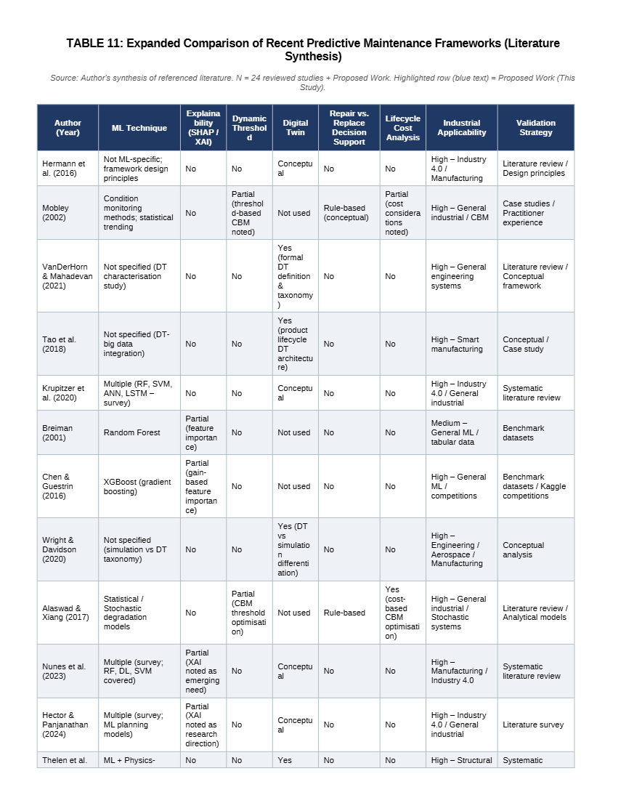
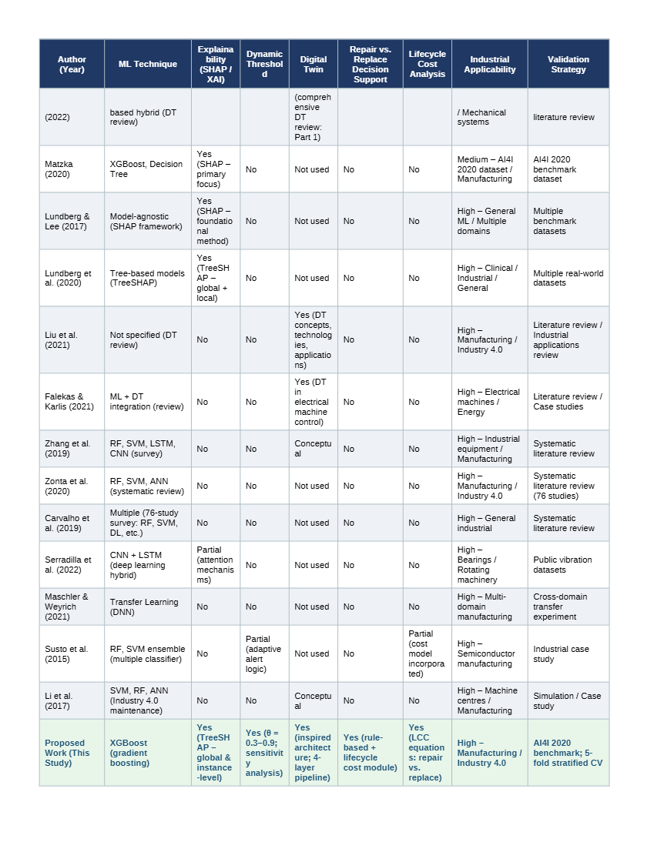

Table 11 reveals that no single study reviewed here simultaneously addresses all eight evaluation criteria. Across the compared works, the most common limitation is the absence of an integrated pathway from probabilistic failure prediction to cost-aware intervention decision-making. Deep learning approaches such as Serradilla et al.’s CNN-LSTM framework demonstrate strong temporal pattern recognition but operate as opaque classification systems without SHAP-based transparency or lifecycle cost grounding. Transfer learning approaches such as Maschler and Weyrich extend model generalisability across machine populations but remain prediction-centric rather than decision-centric. The partially cost-aware approach of Susto et al. represents the closest precursor to the present framework’s cost simulation design, though it does not incorporate SHAP explainability, Digital Twin architecture, or repair versus replace decision logic.
The present framework’s principal contribution relative to these comparators is the integration of five capabilities within a single operational pipeline: (i) explainable AI through TreeSHAP providing directionally informative, instance-level model transparency; (ii) adaptive risk stratification through a three-tier probabilistic monitoring system; (iii) dynamic threshold-based maintenance scheduling empirically evaluated across a sensitivity range of θ = 0.3 to 0.9; (iv) a Digital Twin-inspired architecture connecting sensor inputs to dashboard-ready maintenance alerts with a continuous feedback loop; and (v) a lifecycle cost-based Repair vs. Replace Decision Module that extends intervention recommendations beyond binary failure classification to structured action selection. This integration is not merely an additive accumulation of features; each component is designed to feed the next, forming a coherent operational decision pipeline that addresses the practical gap between predictive capability and maintenance governance identified by Carvalho et al.’s survey. It is acknowledged that individual components have appeared separately in prior work and that the present study’s novelty lies in their integration and empirical evaluation within a unified framework rather than in the invention of entirely new techniques.

3. RESEARCH METHODOLOGY
3.1 Research Framework Architecture
The proposed framework presents a Digital Twin-inspired predictive maintenance architecture designed to support machine failure prediction, probabilistic operational risk monitoring, SHAP-based explainability, and adaptive maintenance optimisation within Industry 4.0 environments. The framework integrates machine learning-based predictive analytics with explainable AI, dynamic risk thresholding, Digital Twin visualisation, and lifecycle-cost-based repair-versus-replace decision support to facilitate cost-aware maintenance planning and resource prioritisation. Rather than treating failure prediction and maintenance decision-making as separate analytical problems, the framework connects them within a unified operational pipeline, where the output of each stage directly informs the next.
The framework proceeds through ten sequential stages: sensor data acquisition, data preprocessing, feature engineering, XGBoost-based predictive modelling, SHAP-based explainability analysis, dynamic threshold-based risk assessment, Digital Twin monitoring and visualisation, the Repair vs. Replace Decision Module, maintenance recommendation generation, and a feedback loop for continuous learning. These stages collectively transform raw machine operational data into actionable, explainable maintenance intelligence, supporting decisions regarding intervention timing, resource allocation, repair-versus-replacement action selection, cost optimisation, and transparent communication of prediction rationale.
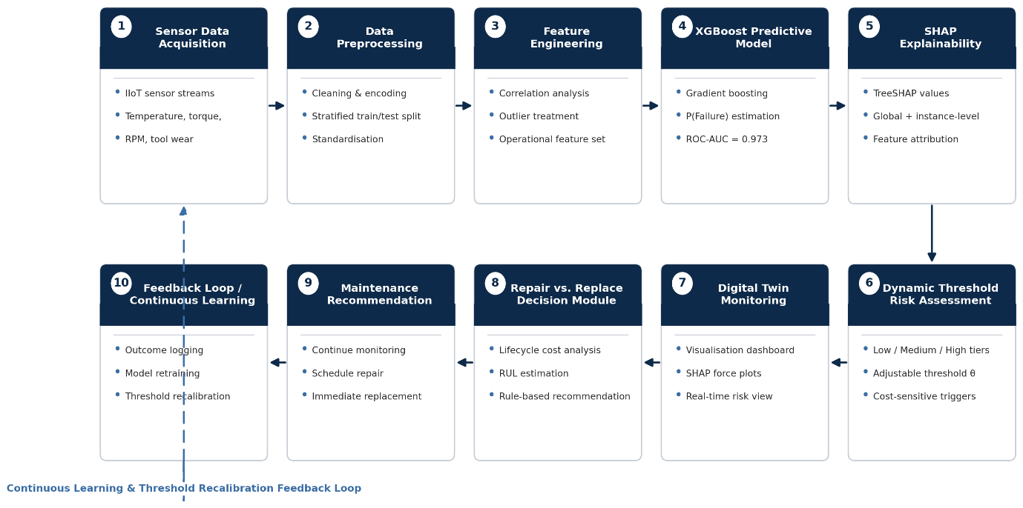
FIGURE 1: Research Framework Architecture — Flowchart showing the complete ten-stage pipeline of the proposed framework: Sensor Data Acquisition, Data Preprocessing, Feature Engineering, the XGBoost Predictive Model, SHAP Explainability, Dynamic Threshold-Based Risk Assessment, Digital Twin Monitoring and Visualisation, the Repair vs. Replace Decision Module, Maintenance Recommendation, and the Feedback Loop for Continuous Learning. Arrows indicate the sequential flow of information from raw sensor input through to an explainable, cost-aware maintenance recommendation; the dashed return arrow represents the continuous learning loop, whereby maintenance outcomes are fed back to retrain the model and recalibrate the intervention threshold. Source: Author's work.

The framework begins with sensor data acquisition, in which industrial operational data representing machine behaviour under varying production conditions are collected from embedded or IIoT sensor streams. These data serve as the primary input for all subsequent analytical stages. Data preprocessing and feature engineering then prepare the operational variables for modelling, encompassing cleaning, categorical encoding, stratified train-test partitioning, and standardisation. The XGBoost Predictive Model is trained on the resulting feature set and generates a continuous failure probability estimate, P(Failure), for each machine. This probability output is immediately passed to the SHAP Explainability stage, where TreeSHAP decomposes each prediction into feature-level contributions, providing both global and instance-level transparency before any maintenance action is recommended. The explained probability estimate then drives the Dynamic Threshold-Based Risk Assessment stage, which assigns each machine to a Low, Medium, or High Risk category against an adjustable intervention threshold θ, and feeds Digital Twin Monitoring and Visualisation, where risk scores, SHAP attributions, and alert status are rendered on a dashboard for the maintenance engineer. For machines flagged for attention, the Repair vs. Replace Decision Module applies lifecycle cost analysis and a remaining-useful-life estimate to recommend a specific Maintenance Recommendation — Continue Monitoring, Schedule Repair, or Immediate Replacement. Finally, the Feedback Loop / Continuous Learning stage logs the outcome of each maintenance action and returns it to the start of the pipeline, where it informs periodic model retraining and threshold recalibration. The final stage thus generates decision-support outputs for maintenance managers, including risk rankings, explainable failure attributions, repair-versus-replace recommendations, and threshold sensitivity profiles.
The overall research framework is operationally oriented rather than technically maximalist. Its design priority is the translation of predictive intelligence into maintenance governance decisions that are interpretable, adjustable, and cost-aware — characteristics that distinguish it from conventional predictive maintenance classification systems.

3.2 Dataset Description
The present study utilises the AI4I 2020 Predictive Maintenance Dataset, a publicly available benchmark dataset designed for predictive maintenance research within Industry 4.0 contexts.²¹ The dataset contains simulated industrial operational records representing machine behaviour under varying production conditions, and is widely used in the predictive maintenance literature as a controlled evaluation environment for failure prediction frameworks.²²
The dataset comprises 10,000 machine operational observations and 14 variables in its original form. Each observation represents a distinct operational instance characterised by thermal conditions, mechanical stress, rotational behaviour, and component wear state. The dataset includes a binary target variable indicating whether machine failure occurred during the operational cycle, along with five specific failure mode indicators — Tool Wear Failure (TWF), Heat Dissipation Failure (HDF), Power Failure (PWF), Overstrain Failure (OSF), and Random Failure (RNF). The present study focuses on overall machine failure prediction rather than failure mode classification, in order to support generalised predictive maintenance optimisation and probabilistic operational monitoring.
The operational variables retained for analysis following preprocessing are described in Table 1.
TABLE 1: Dataset Variables and Operational Descriptions — Seven variables: Type, Air temperature (K), Process temperature (K), Rotational speed (rpm), Torque (Nm), Tool wear (min), Machine failure. Each entry reports variable type, operational range, and significance to failure risk. Source: AI4I 2020 Predictive Maintenance Dataset
Variable | Description | Operational Significance
Type | Machine category/type classification | Represents different operational machine categories and manufacturing conditions
Air_temperature_K | Ambient air temperature surrounding the machine (Kelvin) | Indicates external thermal operating conditions affecting machine stability
Process_temperature_K | Internal process operating temperature (Kelvin) | Reflects process-level thermal behavior and heat generation during operations
Rotational_speed_rpm | Rotational speed of the machine spindle (revolutions per minute) | Represents machine operational intensity and rotational workload
Torque_Nm | Mechanical torque generated during machine operation (Newton-meter) | Indicates operational stress and mechanical load conditions
Tool_wear_min | Accumulated tool wear duration (minutes) | Represents progressive component degradation and operational aging
Machine_failure | Binary machine failure indicator (0 = No Failure, 1 = Failure) | Target variable used for predictive maintenance classification

The selected operational variables capture multiple dimensions of machine degradation and failure risk. Air temperature and process temperature represent the thermal operating environment, while rotational speed and torque capture mechanical operational intensity and stress. Tool wear reflects accumulated component degradation over time — a continuous indicator of progressive machine deterioration rather than a discrete event. The target variable, Machine Failure, is encoded as a binary outcome where a value of one indicates failure and zero indicates normal operational behaviour.
An important characteristic of the dataset is the pronounced class imbalance within the target variable. Of the 10,000 operational records, 339 correspond to machine failure conditions — representing 3.39% of the total dataset — while the remaining 9,661 observations reflect normal operational behaviour. This imbalance is consistent with realistic industrial environments where failure events are rare relative to normal operations, but it introduces significant challenges for predictive modelling, since machine learning classifiers trained on imbalanced data tend to favour the majority class. The failure distribution is illustrated in Figure 2.
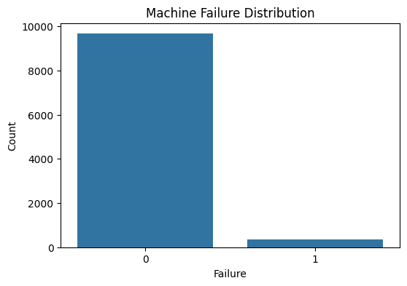
FIGURE 2: Machine Failure Distribution — Bar chart showing 9,661 non-failure observations versus 339 failure observations. Source: Author's work.
3.3 Data Preprocessing
Robust data preprocessing is essential in predictive maintenance systems, where differences in feature scales, the presence of irrelevant identifiers, and class imbalance can each compromise model stability and evaluation reliability. The preprocessing workflow applied in this study proceeded through five sequential operations.
The dataset was first examined for data quality issues. No missing values were identified across any of the 14 variables, and no duplicate observations were present, confirming the integrity of the raw data without requiring imputation or deduplication procedures.
Non-informative identifiers — specifically the Unique Device Identifier (UDI) and Product ID columns — were removed from the dataset, as these variables carry no predictive operational information. The five specific failure mode indicator columns (TWF, HDF, PWF, OSF, and RNF) were similarly excluded, since the study targets overall machine failure prediction rather than failure type classification. Following these exclusions, the working dataset comprised seven variables: six operational features and one binary target.
The categorical machine type variable, which classifies machines into three operational categories (H, L, and M, encoded as 0, 1, and 2 respectively using label encoding), was transformed into numerical format to ensure compatibility with all three machine learning algorithms evaluated in the study.
The dataset was then partitioned into training and testing subsets using a stratified train-test split at an 80:20 ratio. Stratified sampling was applied to preserve the original 3.39% failure rate across both subsets, ensuring that neither the training nor the testing set was disproportionately enriched or depleted of failure observations. This procedure resulted in a training set of 8,000 observations and a testing set of 2,000 observations, with failure proportions of 3.39% and 3.40% respectively — confirming successful stratification.
Finally, feature standardisation was applied using StandardScaler normalisation, which transforms each variable to approximately zero mean and unit variance. Standardisation is particularly important for Logistic Regression, which is sensitive to differences in feature magnitude. The StandardScaler was fitted exclusively on the training data and subsequently applied to transform both training and testing sets, ensuring that no information from the testing distribution influenced the scaling parameters. This procedure prevents data leakage and preserves the integrity of out-of-sample evaluation.
The standardisation transformation is defined as:
$$z=\frac{x-μ}{σ}$$
where x is the original feature value, μ is the training set feature mean, σ is the training set feature standard deviation, and z is the resulting standardised value.
3.4 Exploratory Data Analysis
Exploratory data analysis (EDA) was conducted to examine the operational characteristics of the dataset, identify relationships between operational variables and machine failure, and generate preliminary insights to inform model development and framework design.
Correlation analysis was performed between each operational variable and the machine failure indicator. The full correlation structure of the dataset is presented in Figure 3.
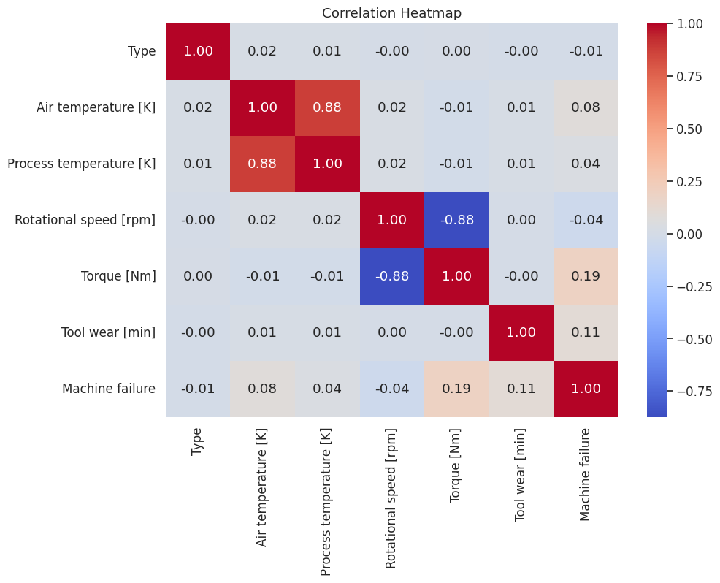
FIGURE 3: Correlation Heatmap — Full correlation matrix of all seven variables including Machine failure. Torque shows highest positive correlation (0.19); Rotational speed shows negative correlation (−0.04). Source: Author's work.
Torque demonstrated the strongest positive correlation with machine failure (r = 0.191), followed by tool wear (r = 0.105) and air temperature (r = 0.083). Process temperature showed a weaker positive association (r = 0.036), while rotational speed exhibited a negative relationship with failure occurrence (r = −0.044), indicating that abnormal reductions in operational speed may be associated with elevated failure risk. Machine type showed negligible linear association with failure (r = −0.005). Although correlation magnitudes were modest overall, the directional pattern is operationally coherent: elevated mechanical stress and accumulated component degradation are associated with higher failure probability, while thermal variables play a secondary role.
Comparison of mean operational conditions across failure and non-failure states is presented in Table 2.
TABLE 2: Failure vs Non-Failure Operational Comparison — Five variables, Non-Failure Mean, Failure Mean, Operational Interpretation. Key figures: Torque 39.99 Nm (non-failure) vs 50.17 Nm (failure); Tool wear 107.95 min (non-failure) vs 143.78 min (failure); Rotational speed 1538.78 rpm (non-failure) vs 1496.49 rpm (failure). Source: Author's work.
Operational Variable | Non-Failure Mean | Failure Mean | Operational Interpretation
Air_temperature_K | 299.97 | 300.89 | Failed machines operated under slightly higher ambient thermal conditions
Process_temperature_K | 309.99 | 310.29 | Failure conditions exhibited marginally elevated process temperatures
Rotational_speed_rpm | 1540.26 | 1496.49 | Failed machines showed lower rotational stability and reduced operational speed
Torque_Nm | 39.63 | 50.17 | Failed machines experienced substantially higher mechanical stress levels
Tool_wear_min | 106.69 | 143.78 | Failure conditions were associated with significantly higher component degradation and accumulated wear
Failed machines exhibited substantially higher average torque levels than non-failed machines — approximately 50 Nm compared to 40 Nm under normal operating conditions, representing a differential of roughly 25%. Tool wear accumulation was similarly elevated among failed machines, with average accumulated wear of approximately 144 minutes compared to 108 minutes under normal conditions. These differences suggest that mechanical stress intensity and progressive degradation accumulation are the primary operational precursors of machine failure within this dataset.
Outlier analysis using the interquartile range method identified 418 outliers in rotational speed and 69 in torque. No outliers were detected in air temperature, process temperature, or tool wear. These extreme observations are consistent with industrial environments where machines occasionally operate under atypical load conditions. Rather than removing these observations, the study retained them on the grounds that abnormal operational states may contain important predictive information regarding failure risk under stress conditions.
Pairwise operational analysis across the five key features is presented in Figure 4.
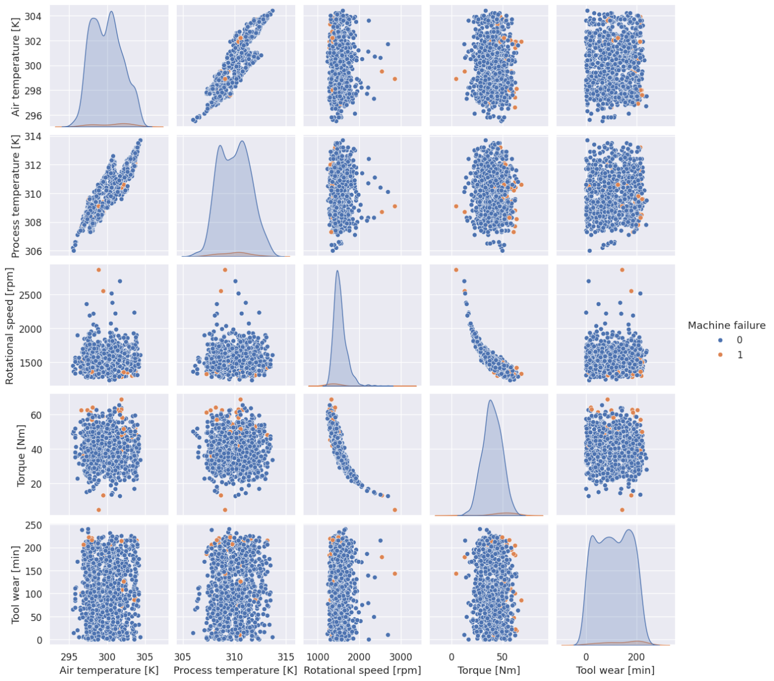
FIGURE 4: Pairplot of Key Operational Variables — Pairwise scatter plots and density plots for Air temperature, Process temperature, Rotational speed, Torque, and Tool wear, coloured by Machine failure (0 = blue, 1 = orange). Shows overlapping but distinguishable operational regions for failure and non-failure conditions. Source: Author's work.
The pairplot analysis confirmed that healthy and failed machine conditions are not linearly separable across any single variable pairing. Instead, failure observations cluster in regions characterised by the co-occurrence of elevated torque and prolonged tool wear, with considerable overlap between failure and non-failure populations in other variable combinations. This nonlinear, multi-variable interaction structure provides empirical justification for the use of ensemble machine learning approaches — specifically Random Forest and XGBoost — which are designed to capture complex operational relationships that linear classifiers cannot model effectively.
3.5 Machine Learning Model Development
Three machine learning algorithms were selected for comparative evaluation: Logistic Regression, Random Forest, and XGBoost. These models were chosen because they represent distinct predictive paradigms — linear probabilistic classification, randomised ensemble learning, and sequential gradient boosting — and collectively span the range from maximum interpretability to maximum predictive complexity. The comparative evaluation enables identification of the model best suited for integration into the Digital Twin risk engine, balancing predictive performance, operational reliability, and failure alert precision.
Logistic Regression was implemented with balanced class weighting to address the dataset's 3.39% failure rate. Balanced weighting adjusts the loss function so that failure observations receive proportionally greater influence during training, preventing the model from converging to a majority-class solution. Logistic Regression estimates the probability of machine failure as:
$$P\left(y=1\right)=\frac{1}{1+e^{-\left(β_{0} +β_{1}x_{1}+β_{2}x_{2}+…+β_{n}x_{n}\right)}}$$
where β₀ is the intercept, βₙ are the learned coefficients, and xₙ are the standardised operational feature values. The model was trained on the standardised training dataset.
Random Forest was configured with 200 decision trees, a maximum tree depth of ten, and balanced class weighting. The algorithm constructs each tree using a bootstrapped sample of the training data and a random subset of features at each split, reducing correlation among individual trees and improving ensemble stability. Random Forest was trained on the unstandardised training data, as tree-based methods are invariant to feature scaling.
XGBoost was configured with 200 boosting rounds, a maximum tree depth of six, and a learning rate of 0.1, using binary logistic as the objective function and log-loss as the evaluation metric. XGBoost was also trained on the unstandardised training data following column name cleaning to remove bracket characters incompatible with the XGBoost feature name parser. No explicit class weighting was applied to XGBoost; the algorithm's gradient optimisation mechanism naturally accommodates moderate class imbalance through its iterative error-correction logic.
All three models were evaluated on the identical 2,000-observation testing set using five performance metrics: Accuracy, Precision, Recall, F1-score, and ROC-AUC. Given the pronounced class imbalance in the dataset, ROC-AUC was treated as the primary evaluation criterion, as it measures the model's ability to discriminate between failure and non-failure conditions across all possible classification thresholds, independent of any fixed decision boundary. Recall was treated as the secondary criterion, given that undetected machine failures carry substantially greater operational consequences than false maintenance alerts in most industrial settings.
The ROC curves for all three models are presented in Figure 5.
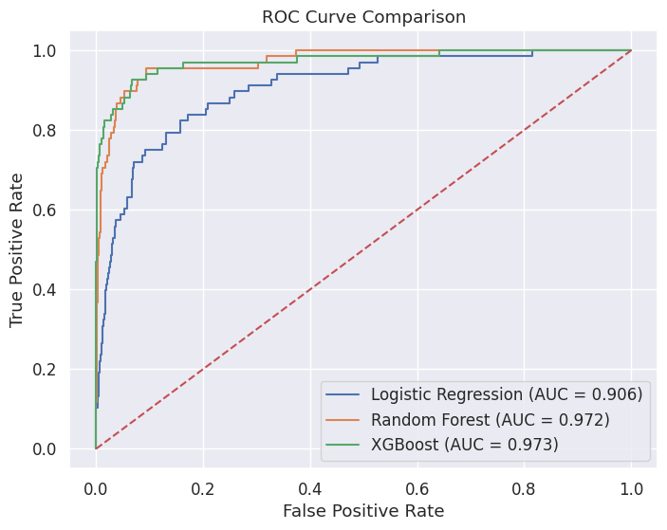
FIGURE 5: ROC Curve Comparison — Three curves for Logistic Regression (AUC = 0.906), Random Forest (AUC = 0.972), and XGBoost (AUC = 0.973), plotted against the random baseline diagonal. Source: Author's work.

3.6 Digital Twin Risk Engine
The Digital Twin Risk Engine constitutes the operational intelligence layer of the proposed framework. Its function is to transform the continuous failure probability outputs of the best-performing machine learning model into a structured, interpretable risk monitoring system that supports maintenance prioritisation and adaptive intervention planning.
The engine operates on a principle that distinguishes the proposed framework from conventional binary classification systems: rather than assigning each machine a discrete failure or non-failure label, it maintains a continuous estimate of machine failure probability for each operational observation. This probabilistic representation preserves the full information content of the model's output, enabling graduated risk assessment rather than binary triage.
Based on the comparative model evaluation described in Section 3.5, XGBoost was selected as the predictive engine for probabilistic risk monitoring, on the basis of its superior ROC-AUC performance and highest Precision among the three evaluated models. The XGBoost model generates a failure probability estimate P(Failure) for each machine, bounded between zero and one, where higher values indicate elevated operational risk.
These probability estimates are used to assign each machine to one of three operational risk categories:
Low Risk: P(Failure) < 0.30
Medium Risk: 0.30 ≤ P(Failure) < 0.70
High Risk: P(Failure) ≥ 0.70
This three-tier categorisation supports differentiated maintenance responses: High Risk machines are prioritised for immediate intervention, Medium Risk machines receive intensified monitoring and scheduled inspection, and Low Risk machines continue normal operational activity without additional maintenance burden.
The risk category distribution across the 2,000-observation test set, and the actual failure distribution within each category, are presented in Figures 6 and 7 respectively.
The Digital Twin-inspired framing of this risk engine reflects the operational principles — continuous monitoring, probabilistic assessment, and adaptive decision-support — that characterise Digital Twin architectures, adapted for a controlled research environment using simulated operational data rather than real-time IoT synchronisation.
3.7 Maintenance Strategy Simulation
To evaluate the practical operational value of the proposed framework, four maintenance intervention strategies were simulated using the risk engine outputs from the test set. The simulation framework was designed to compare how different intervention policies perform against identical cost assumptions, enabling direct operational comparison across strategies.
The four strategies evaluated are as follows.
Reactive Maintenance represents the operational baseline. Under this strategy, no preventive intervention occurs; machines operate until failure, and all 68 failures observed in the test set contribute to operational cost. This strategy reflects the status quo in organisations that have not adopted predictive maintenance.
Preventive Maintenance intervenes on all machines classified as High Risk by the Digital Twin Risk Engine — that is, all machines with P(Failure) ≥ 0.70. This strategy represents a static, category-based intervention policy that services all machines flagged as high-risk regardless of the precise probability magnitude within the High Risk zone.
Budget-Constrained Digital Twin Maintenance represents a resource-limited variant of the probabilistic approach. Under this strategy, machines are ranked by failure probability in descending order, and preventive intervention is restricted to the top 25 highest-risk machines — representing a hard budget constraint on maintenance resource availability.
Dynamic Threshold-Based Maintenance represents the primary adaptive mechanism proposed by the framework. Under this strategy, intervention occurs for any machine whose failure probability exceeds a specified threshold θ, regardless of its assigned risk category. The intervention condition is:
$$Intervention if P(Failure)>θ$$
The threshold θ is treated as an adjustable operational parameter rather than a fixed policy setting, enabling organisations to calibrate intervention aggressiveness to their specific cost structure, resource availability, and risk tolerance. Four threshold values — 0.3, 0.5, 0.7, and 0.9 — are evaluated in the threshold sensitivity analysis presented in Section 4.5.
Maintenance Cost Modelling
Operational cost evaluation across strategies is based on standardised cost parameters applied consistently to all four strategies. The cost structure reflects two components: a preventive maintenance cost of 200 monetary units per intervention, representing the labour and materials cost of a scheduled servicing action; and a total failure cost of 1,000 monetary units per unplanned failure event, comprising a repair cost of 500 units and a downtime cost of 500 units (calculated as five hours of downtime at 100 units per hour). Total operational cost for each strategy is calculated as:
Total Cost = (Preventive Actions × ₹200) + (Remaining Failures × ₹1,000)
These cost parameters are intentionally standardised to enable controlled comparison across strategies. In real industrial deployments, organisations would substitute their actual cost structures, which may vary by machine type, production line, and operational context.
3.8 Evaluation Metrics
Framework performance was evaluated across two dimensions: predictive classification performance and operational maintenance effectiveness.
For predictive performance, five metrics were calculated for each model on the 2,000-observation test set. Accuracy measures the proportion of correctly classified observations overall, but is of limited diagnostic value under class imbalance. Precision measures the proportion of predicted failure alerts that correspond to actual failures — high Precision reduces unnecessary maintenance interventions. Recall measures the proportion of actual failures that are correctly detected — high Recall reduces undetected failures and their associated operational costs. F1-score provides the harmonic mean of Precision and Recall, balancing both dimensions of failure detection performance. ROC-AUC measures the model's discriminatory capability across all classification thresholds, making it the most appropriate primary metric under class-imbalanced conditions.
For operational maintenance effectiveness, the evaluation framework measured total operational cost, number of preventive maintenance actions, remaining machine failures after intervention, and cost reduction relative to the reactive maintenance baseline. Cost reduction was calculated as:
$$Cost Reduction(\%)=\frac{Baseline Cost-Strategy Cost}{Baseline Cost}×100$$
Predictive stability was assessed through stratified five-fold cross-validation, with ROC-AUC as the scoring criterion. Overfitting was evaluated by comparing training and testing ROC-AUC values for the selected XGBoost model.
3.9 SHAP-Based Explainability of XGBoost Predictions
Although XGBoost achieves superior predictive performance among the evaluated classifiers, its ensemble architecture constitutes a black-box model whose internal decision logic is not directly accessible to maintenance engineers or operational managers. In safety-critical industrial environments, a failure prediction that cannot be explained carries limited operational credibility: maintenance technicians require not only a probability estimate but an understanding of which machine conditions drove that estimate and by how much. The absence of model transparency creates a practical barrier to adoption, because maintenance managers are unlikely to act on failure alerts whose origins they cannot interrogate or validate against engineering judgement.
Explainable Artificial Intelligence (XAI) methods address this transparency requirement by providing post-hoc explanations of black-box model outputs. Among available XAI techniques, SHapley Additive exPlanations (SHAP), introduced by Lundberg and Lee,²³ has emerged as the most theoretically principled and operationally versatile approach. SHAP is grounded in cooperative game theory and assigns each feature a contribution value — the Shapley value — that reflects its additive marginal contribution to the model’s output for a specific prediction. Unlike simpler feature importance metrics such as the XGBoost gain-based score, SHAP values are locally accurate, consistent, and directionally informative: they indicate not only how much each feature contributed to a prediction, but whether that contribution pushed the prediction toward or away from the failure class.
3.9.1 Mathematical Foundations of SHAP
For a model with n features and a prediction function f, the SHAP value φˇᵢ for feature i is defined as the weighted average of the marginal contributions of feature i across all possible feature subsets S ⊆ F \ {i}:
φˇᵢ = ∑ₛ⊆F\{i} [|S|!(|F|-|S|-1)! / |F|!] [f(S∪{i}) - f(S)]
where F denotes the full set of features, S is a subset of features not containing feature i, f(S) is the model output when only the features in S are observed (with remaining features marginalised over the data distribution), and [|S|!(|F|-|S|-1)! / |F|!] is the Shapley weighting kernel that ensures each subset receives a weight proportional to the number of orderings in which it can be formed.
The additive property of SHAP guarantees that the sum of all SHAP values for a given prediction equals the difference between the model output for that instance and the expected model output across the training distribution:
f(x) = E[f(x)] + ∑ᵢ∈F φˇᵢ
where f(x) is the model’s predicted failure probability for instance x, E[f(x)] is the mean predicted probability across the training population (the base value), and φˇᵢ is the SHAP value for feature i. This decomposition guarantees local accuracy: the SHAP explanation is fully consistent with the model’s output for every individual prediction.
For tree-based ensemble models such as XGBoost, Lundberg et al.²⁴ introduced the TreeSHAP algorithm, which computes exact Shapley values in polynomial time O(TLD²) by exploiting the tree structure directly, where T is the number of trees, L is the maximum number of leaves, and D is the maximum tree depth. This computational efficiency makes SHAP analysis practical at industrial scale, where failure probability estimates must be generated and explained across large operational populations in near real time.
3.9.2 SHAP Explanation Modalities
Four complementary SHAP visualisation modalities are applied in this study, each serving a distinct analytical purpose within the predictive maintenance context. The SHAP Summary (Beeswarm) Plot aggregates SHAP values across all test-set observations, displaying each instance as a point positioned along the SHAP value axis for each feature. Colour encoding reflects the underlying feature value — red indicating high feature values and blue indicating low — enabling simultaneous assessment of feature importance magnitude and the directional relationship between feature intensity and failure probability. This modality directly addresses the global interpretability requirement: it reveals which features most consistently drive XGBoost’s failure predictions across the full test population.
The SHAP Feature Importance Plot presents the mean absolute SHAP value for each feature, ranked in descending order. Unlike the gain-based importance scores reported in Section 4.6, which measure how frequently a feature is used across splitting decisions, mean absolute SHAP values directly quantify each feature’s average contribution magnitude to failure probability predictions — providing a more operationally interpretable measure of predictive influence.
The SHAP Waterfall Plot provides instance-level explanation for an individual prediction — specifically, a representative High Risk machine from the test set. Starting from the base value E[f(x)] (the mean model output across the training population), the waterfall display adds each feature’s SHAP contribution sequentially, terminating at the final predicted failure probability f(x). This visualisation enables maintenance engineers to trace the precise pathway from the population average to a specific machine’s risk score, feature by feature.
The SHAP Force Plot provides a compact, horizontally oriented representation of the same instance-level decomposition. Features that increase the failure probability prediction are displayed as red bars pushing the output rightward from the base value, while features that decrease it appear as blue bars pushing leftward. This format is particularly suited to real-time operational dashboards, where the failure alert for a specific machine must be accompanied by a concise and visually immediate explanation of its drivers.
3.9.3 Feature-Level SHAP Interpretation Framework
SHAP analysis of the XGBoost model provides directionally informative explanations for all five key operational features. Torque (Nm) generates large positive SHAP values when elevated above approximately 45–50 Nm, reflecting its role as the primary mechanical stress indicator. SHAP values for torque exhibit a consistent monotonic directional relationship with feature magnitude: observations in the highest torque decile carry the largest individual failure probability contributions, confirming that torque monitoring should trigger priority maintenance alerts when sustained above operational safety thresholds.
Tool Wear (min) generates positive SHAP contributions that increase progressively with accumulated wear duration, reflecting its role as a continuous degradation accumulation indicator. The SHAP beeswarm plot reveals that tool wear contributions tend to cluster within a moderate positive range for most observations, with a concentrated tail of high-wear, high-SHAP observations corresponding to machines approaching or exceeding 200 minutes of accumulated wear — a pattern consistent with non-linear degradation acceleration near end-of-life thresholds.
Air Temperature (K) and Process Temperature (K) generate SHAP contributions of moderate magnitude, with positive values associated with elevated thermal readings. Their individual contributions are substantially lower than those of the mechanical variables, but the SHAP beeswarm plot reveals that their effect is non-zero and directionally consistent — elevated temperatures increase predicted failure probability, particularly when co-occurring with high torque conditions, suggesting a compound thermal-mechanical failure pathway that neither variable captures independently.
Rotational Speed (rpm) exhibits negative SHAP values for low-speed observations, confirming that speed reduction below the population mean is associated with increased failure probability. This directional signal — which could not be recovered from the unsigned gain-based importance score in Table 8 — is operationally significant: it identifies rotational speed as an early-warning indicator whose monitoring value lies not in absolute magnitude but in deviation from expected operational range.
SHAP analysis thus augments the gain-based feature importance results of Section 4.6 with two additional dimensions of interpretability: directional knowledge (whether high or low feature values increase failure risk) and instance-level attribution (the specific contribution of each feature to any individual machine’s failure probability). Together, these dimensions provide the operational transparency necessary for maintenance engineers to interrogate, validate, and communicate failure predictions within industrial maintenance governance frameworks.
3.9.4 SHAP Visualisation Outputs
Four SHAP visualisation outputs are produced and discussed in Section 4.8.
FIGURE 12: SHAP Summary (Beeswarm) Plot — Global distribution of SHAP values for all six operational features across the 2,000-observation test set. Each point represents one machine observation. Horizontal position indicates the magnitude and direction of the SHAP contribution to failure probability; colour encodes the raw feature value (red = high, blue = low). Features are ranked vertically in descending order of mean absolute SHAP value. Generated using shap.plots.beeswarm() applied to the TreeSHAP explainer fitted on the trained XGBoost classifier. Source: Author’s work.
FIGURE 13: SHAP Feature Importance Plot — Mean absolute SHAP values for each operational feature, averaged across all 2,000 test-set observations and ranked in descending order. Bar length reflects the average magnitude of each feature’s contribution to XGBoost failure probability predictions; higher values indicate greater predictive influence. Generated using shap.plots.bar() applied to the TreeSHAP explainer. Source: Author’s work.
FIGURE 14: SHAP Waterfall Plot — Instance-level SHAP decomposition for a representative High Risk machine (P(Failure) ≥ 0.70) from the test set. The plot begins at the base value E[f(x)] (mean XGBoost failure probability across the training population) and shows the additive contribution of each feature, terminating at the individual machine’s predicted failure probability f(x). Red bars indicate features that increase the failure probability prediction; blue bars indicate features that decrease it. Generated using shap.plots.waterfall() applied to a single test-set observation. Source: Author’s work.
FIGURE 15: SHAP Force Plot — Compact instance-level explanation for the same representative High Risk machine as Figure 14. Features shown as red arrows increase the predicted failure probability from the base value; blue arrows indicate features that reduce it. Arrow width is proportional to the magnitude of each feature’s SHAP contribution. Suitable for integration into real-time operational maintenance dashboards as a companion to each machine-level failure alert. Generated using shap.plots.force() applied to the same test-set observation. Source: Author’s work.
3.10 Digital Twin-Inspired Predictive Maintenance Architecture
Within the Industry 4.0 paradigm, a Digital Twin (DT) is a virtual, real-time replica of a physical asset — such as a machine, production line, or manufacturing cell — that is continuously synchronised with its physical counterpart through bidirectional data flows from embedded IoT sensors.⁸ Unlike static simulation models, a Digital Twin dynamically mirrors the evolving operational state of the physical asset, enabling continuous health monitoring, failure scenario simulation, and adaptive decision-support without interrupting production activity. VanDerHorn and Mahadevan³ characterise this continuous synchronisation property as the defining feature that distinguishes Digital Twin architectures from conventional modelling approaches: the virtual representation does not merely approximate expected behaviour but reflects the actual operational history and current condition of the specific physical asset it represents. In the context of smart manufacturing, Digital Twin environments integrate heterogeneous data streams — sensor telemetry, process parameters, maintenance logs, and production schedules — into a unified operational intelligence layer that supports real-time monitoring, predictive analysis, and evidence-based intervention planning across the entire asset lifecycle.
Digital Twin frameworks substantially enhance predictive maintenance capability beyond what standalone machine learning classifiers can provide, through three mechanisms that are operationally complementary rather than redundant. First, the continuous sensor synchronisation inherent to Digital Twin architectures replaces the episodic, batch-oriented data collection characteristic of conventional condition monitoring systems, enabling failure risk to be assessed in near real time rather than at fixed inspection intervals. Grieves and Vickers²⁵ observe that this shift from periodic to continuous monitoring fundamentally changes the temporal resolution at which degradation trajectories can be tracked, enabling failure precursors to be detected substantially earlier in the deterioration cycle. Second, Digital Twin environments provide the data infrastructure necessary to maintain a continuously updated probabilistic risk profile for each individual asset, rather than applying population-average failure statistics to all machines uniformly. The XGBoost failure probability output P(Failure) employed in the present framework is directly suited to this function: each machine receives an individualised probability estimate based on its current operational state rather than a shared risk classification. Third, Digital Twin platforms support closed-loop feedback from maintenance outcomes back to the predictive model, enabling adaptive learning as new operational data and failure event records accumulate — a property that static, one-time-trained classifiers cannot replicate without active retraining workflows. Liu et al.²⁶ demonstrate that Digital Twin-inspired predictive maintenance systems with continuous model updating consistently outperform static models deployed in identical production environments over time, as the adaptive system captures evolving failure patterns that the static model cannot accommodate.
The proposed XGBoost + SHAP + Dynamic Threshold framework maps directly onto a Digital Twin deployment architecture across four integrated layers, as illustrated in Figure 16. The Physical Layer comprises the industrial equipment and its embedded IoT sensor array, generating continuous readings of the five operational variables — air temperature, process temperature, rotational speed, torque, and tool wear — that the XGBoost model requires as inputs. These data streams feed into the Data Acquisition and Preprocessing Layer, where standardisation, categorical encoding, and data quality validation are applied in real time before each observation is passed to the predictive model. The Analytics Layer hosts the trained XGBoost classifier, which generates a continuous failure probability estimate P(Failure) for each machine at each sensor cycle. The Dynamic Threshold Engine within this layer compares each estimate against the configured intervention threshold θ and assigns each machine to the appropriate risk category — Low, Medium, or High — consistent with the probabilistic risk stratification mechanism described in Section 3.6. In parallel, the TreeSHAP algorithm generates a real-time SHAP decomposition for each prediction, identifying which operational variables are driving the risk estimate and by how much. Finally, the Decision and Visualisation Layer presents the risk categorisation, failure probability score, and SHAP feature attribution on the Digital Twin Dashboard, together with a prioritised maintenance recommendation for the maintenance engineer. The SHAP Force Plot format (Section 3.9.2) is particularly well suited to dashboard integration, providing a compact, visually immediate explanation of each machine’s failure alert at the point of decision. Tao et al.´ note that the integration of explainable AI outputs into Digital Twin dashboards is a critical enabler of maintenance engineer trust: when engineers can inspect the operational reasoning behind each alert rather than acting on opaque probability scores alone, intervention decisions are made with greater confidence and lower override rates.
The Digital Twin architecture closes the predictive maintenance loop through a structured feedback mechanism in which maintenance outcomes are systematically recorded and used to update both the predictive model and the operational threshold configuration. When a maintenance intervention is completed — whether triggered by a High Risk alert or a Medium Risk intensified inspection — the outcome (failure confirmed, failure averted, or false alarm) is logged against the machine’s sensor record at the time of the alert. This outcome data constitutes new labelled training observations that can be incorporated into periodic model retraining cycles, progressively refining the XGBoost classifier’s calibration to the specific operational characteristics of the monitored asset population. Independently, threshold governance review cycles — conducted quarterly or following significant changes in production configuration — use the accumulated cost-failure data from completed interventions to validate or adjust the intervention threshold θ, consistent with the threshold sensitivity findings presented in Section 4.5. Falekas and Karlis²⁷ demonstrate that Digital Twin environments with structured feedback loops achieve progressively lower false alert rates and improved failure concentration within risk categories over successive retraining cycles, as the model learns from the specific failure patterns of the monitored fleet rather than relying exclusively on generalised training data. In the context of the present framework, this feedback architecture transforms the XGBoost + SHAP + Dynamic Threshold system from a static analytical tool into an adaptive maintenance intelligence platform that improves its operational accuracy as operational evidence accumulates.
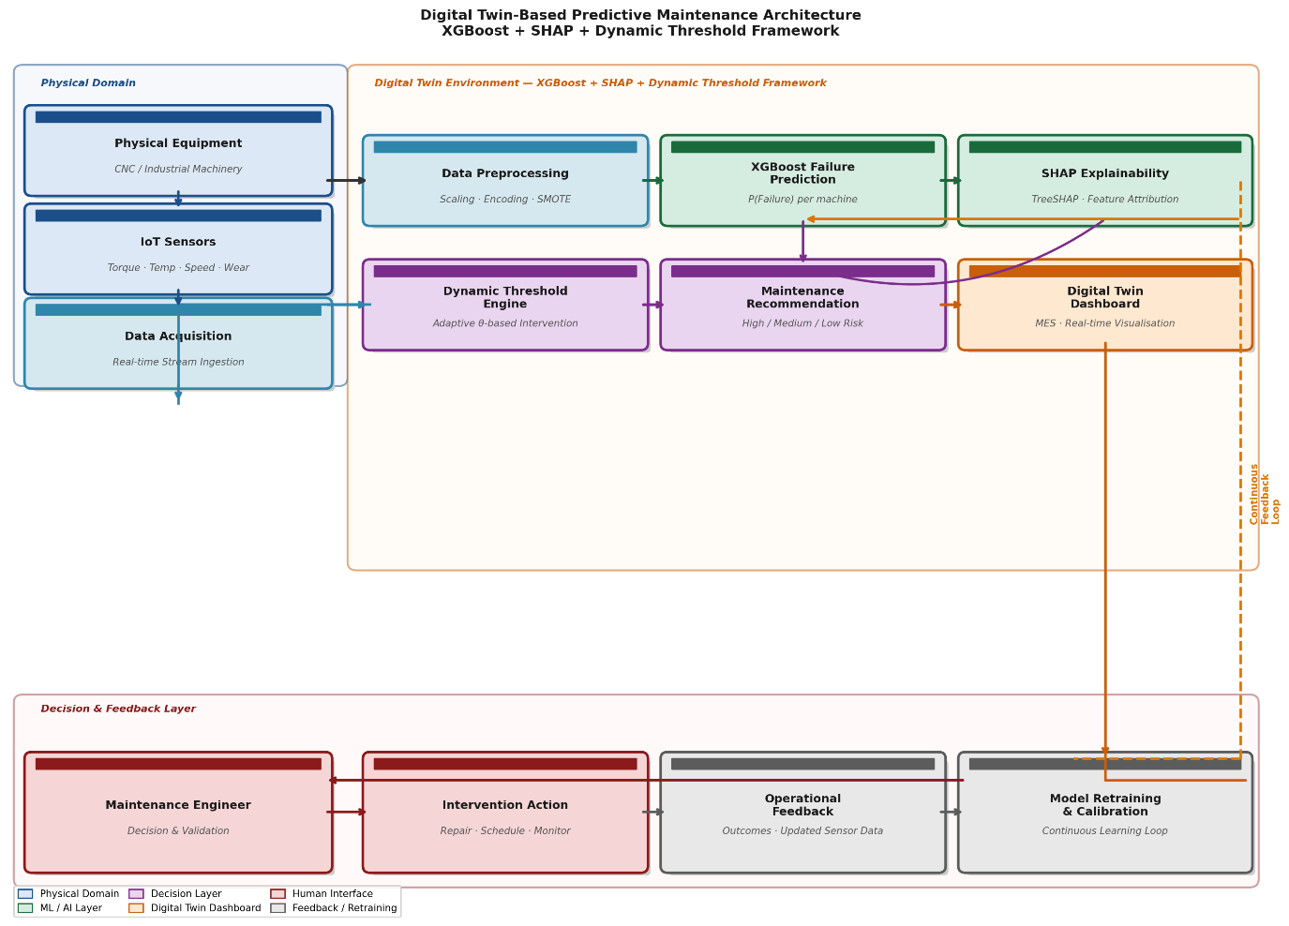
FIGURE 16: Digital Twin-Inspired Predictive Maintenance Architecture — End-to-end system architecture illustrating the integration of the proposed XGBoost + SHAP + Dynamic Threshold framework within a Digital Twin environment. The architecture spans four operational layers: (1) the Physical Domain, comprising industrial equipment and IoT sensor arrays; (2) the Digital Twin Environment, encompassing data acquisition, preprocessing, XGBoost failure prediction, SHAP explainability, the Dynamic Threshold Engine, and maintenance recommendation generation; (3) the Digital Twin Dashboard, providing real-time risk visualisation and alert communication to the maintenance engineer; and (4) the Decision and Feedback Layer, where intervention outcomes are recorded and fed back into model retraining and threshold calibration cycles. Arrows indicate primary data flows; the dashed line represents the continuous feedback loop. Source: Author’s work.
3.11 Repair vs. Replace Decision Module Based on Lifecycle Cost Analysis
Predictive maintenance systems that restrict their output to failure probability estimates leave a consequential decision unanswered: once a machine is flagged as high-risk, should it be repaired or replaced? The binary prediction paradigm offers no principled basis for this distinction. A machine with a predicted failure probability of 0.85 may warrant immediate component replacement if its remaining useful life (RUL) is critically short and cumulative repair costs already approach replacement value; yet the same probability score on a machine with substantial residual service life and low historical maintenance expenditure may justify targeted repair rather than capital replacement. Treating all high-risk alerts as equivalent maintenance signals therefore conflates operationally distinct situations and misallocates maintenance resources. The Repair vs. Replace Decision Module extends the proposed framework beyond failure prediction into structured maintenance action selection, grounding each intervention recommendation in a formal lifecycle cost analysis (LCA) rather than heuristic judgement.
3.11.1 Decision Framework Architecture
The module operates on four inputs derived from the upstream framework stages: (i) the XGBoost-generated predicted failure probability P(Failure); (ii) the dynamic threshold risk categorisation (Low, Medium, or High Risk); (iii) a conceptual remaining useful life (RUL) estimate expressed in operational hours; and (iv) a lifecycle cost comparison of repair against replacement. Where direct RUL estimation from degradation modelling is unavailable — as in the present study, which employs a simulated cross-sectional dataset rather than longitudinal sensor streams — RUL is approximated from the tool wear accumulation trajectory: machines with tool wear above 175 minutes are classified as Near End-of-Life, those between 100 and 175 minutes as Moderate Residual Life, and those below 100 minutes as Substantial Residual Life. This classification is consistent with the tool wear thresholds implicit in the XGBoost model’s feature importance structure and with the end-of-life degradation acceleration patterns identified in the SHAP beeswarm analysis (Section 3.9.3). In industrial deployments with access to continuous sensor telemetry, formal RUL models — including Wiener process degradation models, Long Short-Term Memory (LSTM) networks, or physics-informed hybrid estimators — can be substituted directly within the same decision logic without structural modification.²⁷
3.11.2 Lifecycle Cost Equations
Maintenance action selection is determined by comparing the total lifecycle cost of repair (LCCᵂ) against the total lifecycle cost of replacement (LCCᵅ). Each quantity is estimated as follows.²⁸
Lifecycle Cost of Repair:
LCCᵂ = Cᴿ + Cᴼ + (f × Cᵁ × RUL)
where Cᴿ is the direct component repair cost, Cᴼ is the estimated downtime cost incurred during the repair interval, f is the anticipated post-repair failure frequency per operational hour derived from the XGBoost failure probability, and Cᵁ is the unit cost of each expected future failure event. The third term therefore captures the expected residual failure cost over the machine’s remaining service horizon, penalising repair options that leave the machine in a high-risk operational state.
Lifecycle Cost of Replacement:
LCCᵅ = Cᴽᴼᴾ + Cᴼᵅ + Cᵀᴼᵂ
where Cᴽᴼᴾ is the capital cost of the replacement asset, Cᴼᵅ is the downtime cost incurred during asset changeover, and Cᵀᴼᵂ is the commissioning and installation cost of the new unit. Replacement eliminates residual failure risk over the remaining horizon but incurs a one-time capital outlay. The recommended maintenance action is determined by comparing the two lifecycle cost estimates: if LCCᵂ < LCCᵅ, repair is recommended; if LCCᵅ < LCCᵂ, replacement is recommended. Marginal cases where the cost differential falls within a tolerance band δ may be escalated for engineering review rather than assigned a deterministic recommendation.²⁹
3.11.3 Rule-Based Decision Table
Table 10 presents the rule-based decision logic governing the three possible maintenance recommendations: Continue Monitoring, Schedule Repair, or Immediate Replacement. Each rule integrates the predicted risk level, the RUL classification, and the lifecycle cost comparison into a single, deterministic action recommendation. This rule structure operationalises the lifecycle cost equations above into a form directly consumable by maintenance management systems and Digital Twin Dashboard interfaces.³⁰
TABLE 10: Repair vs. Replace Decision Table. Source: Author’s work.
Predicted Risk | Remaining Useful Life | Cost Condition (LCA) | Recommended Action
Low Risk (P < 0.30) | Substantial (> 500 hr) | LCCᵂ or LCCᵅ both minimal | Continue Monitoring; No intervention required; standard condition-monitoring protocol applies
Low Risk (P < 0.30) | Moderate (100–500 hr) | LCCᵂ < LCCᵅ | Continue Monitoring; Reinforce inspection frequency; no immediate action
Medium Risk (0.30 ≤ P < 0.70) | Substantial (> 500 hr) | LCCᵂ < LCCᵅ | Schedule Repair; Targeted component repair within next planned maintenance window
Medium Risk (0.30 ≤ P < 0.70) | Moderate (100–500 hr) | LCCᵂ < LCCᵅ | Schedule Repair; Priority scheduling; repair within 48 hours
Medium Risk (0.30 ≤ P < 0.70) | Near End-of-Life (< 100 hr) | LCCᵅ < LCCᵂ | Immediate Replacement; Replacement cost-justified; capital procurement to be initiated
High Risk (P ≥ 0.70) | Substantial (> 500 hr) | LCCᵂ < LCCᵅ | Immediate Repair; Emergency repair required; production line suspension recommended
High Risk (P ≥ 0.70) | Moderate (100–500 hr) | LCCᵅ ≈ LCCᵂ | Schedule Repair or Replace; Engineering review required; cost differential within tolerance band
High Risk (P ≥ 0.70) | Near End-of-Life (< 100 hr) | LCCᵅ < LCCᵂ | Immediate Replacement; Capital replacement mandatory; continued operation poses unacceptable risk

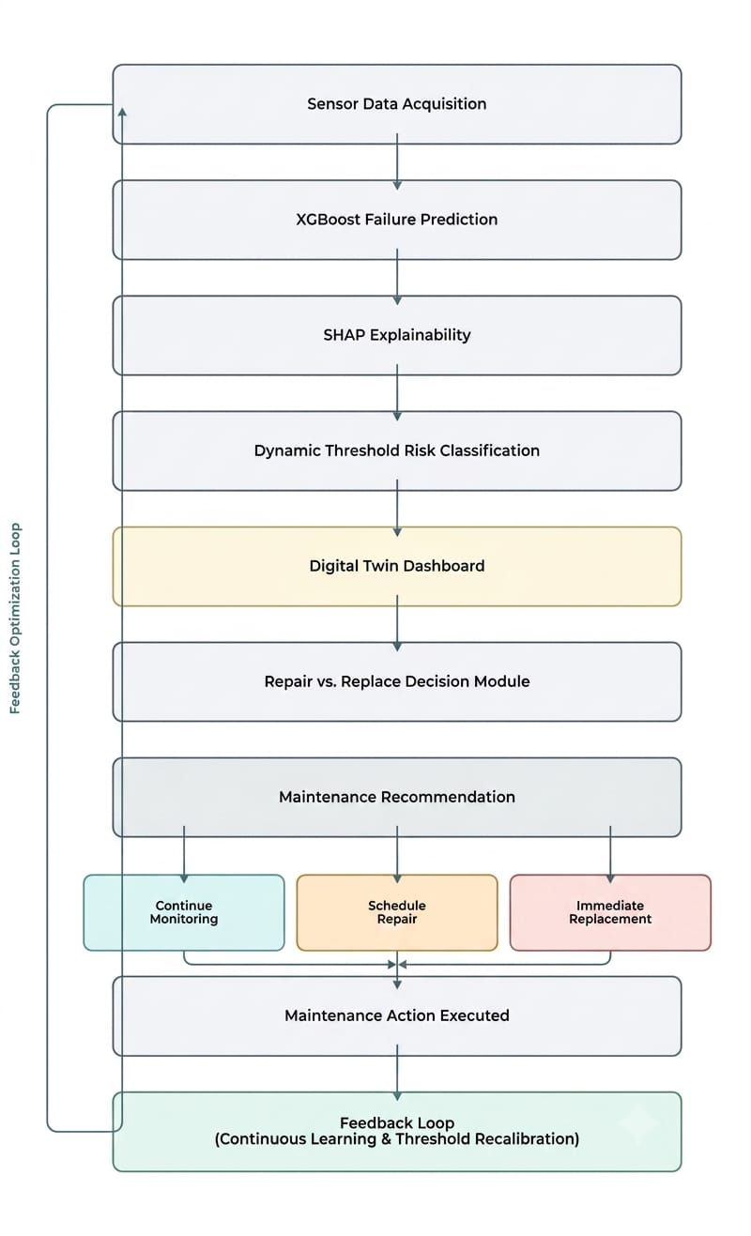FIGURE 17: End-to-End Predictive Maintenance Decision Flowchart — Illustrating the complete operational pipeline from Sensor Data Acquisition through XGBoost Failure Prediction, SHAP Explainability, Dynamic Threshold Risk Categorisation, Repair vs. Replace Decision Module, Maintenance Recommendation (Continue Monitoring / Schedule Repair / Immediate Replacement), and Digital Twin Dashboard integration. The dashed feedback loop on the right represents continuous model retraining and threshold calibration from maintenance outcome records. Source: Author’s work.
Figure 17 illustrates the complete operational pipeline from raw sensor data collection through to a contextualised maintenance recommendation surfaced on the Digital Twin Dashboard. The flowchart makes explicit that each stage of the pipeline feeds the next without discontinuity: the XGBoost failure probability is not a terminal output but an input to the SHAP explainability layer, which in turn feeds the Dynamic Threshold Risk Classifier, whose output triggers the Repair vs. Replace Decision Module. The three-way action recommendation — Continue Monitoring, Schedule Repair, or Immediate Replacement — is then transmitted to the Digital Twin Dashboard as a structured, explainable alert, accompanied by the SHAP Force Plot decomposition described in Section 3.9.2. The feedback loop captures maintenance outcome records for periodic model retraining and threshold recalibration, sustaining the adaptive governance property of the framework over time. Organisations with live IoT infrastructure can implement this pipeline in near real time; organisations operating in periodic batch-processing environments can apply it at fixed inspection cycles without structural modification.³¹
4. RESULTS AND DISCUSSION
4.1 Exploratory Analysis Findings
The exploratory analysis yielded several operationally significant findings that shaped the subsequent modelling and maintenance optimisation stages of the framework. Rather than identifying a single dominant failure driver, the analysis confirmed that machine failure is a multi-factorial phenomenon emerging from the combined influence of mechanical stress accumulation, thermal operating conditions, and progressive component degradation.
The most operationally relevant finding from the correlation analysis was the dominance of torque as a failure predictor. The correlation heatmap (Figure 3) reveals that torque carries the strongest positive association with machine failure (r = 0.191) among all operational variables. This finding is reinforced by the mean comparison presented in Table 2: failed machines operated under average torque loads of approximately 50 Nm, compared to approximately 40 Nm for non-failed machines — a differential of roughly 25%. This magnitude is operationally significant because it suggests that torque-intensive production configurations substantially elevate failure risk, providing a direct empirical basis for torque-based threshold monitoring.
Tool wear emerged as the second most informative predictor (r = 0.105), with failed machines accumulating an average of approximately 144 minutes of tool wear compared to approximately 108 minutes under normal conditions — a differential of approximately 33%. Unlike event-driven failure indicators, tool wear accumulates progressively across production cycles, making it a natural candidate for continuous degradation monitoring and threshold-based maintenance triggering.
Rotational speed exhibited a negative correlation with failure (r = −0.044), indicating that speed reduction under stable load conditions may signal mechanical stress or component deterioration rather than merely reduced production intensity. This directional relationship — lower rotational speed associated with higher failure likelihood — is an operationally important nuance that static, single-variable threshold policies may fail to detect.
By contrast, air temperature and process temperature showed weaker associations with failure outcomes (r = 0.083 and r = 0.036 respectively), with relatively modest mean differences across failure and non-failure states. While thermal conditions may contribute to failure risk under extreme operating scenarios, their independent explanatory contribution within this dataset is limited. This finding carries a direct operational message: maintenance monitoring frameworks that allocate disproportionate sensor attention to ambient temperature while underweighting mechanical stress indicators may systematically underdetect failure risk.
The pairplot analysis (Figure 4) confirmed that failure and non-failure operational states are not linearly separable across any single variable combination. High-risk operational zones are characterised by the co-occurrence of elevated torque and prolonged tool wear — a compound pattern consistent with progressive mechanical degradation under sustained operational stress. This nonlinear interaction structure provided the empirical justification for ensemble modelling approaches in the subsequent stage.
Finally, the outlier analysis identified 418 rotational speed observations and 69 torque observations falling outside the interquartile range boundaries. These extreme values were retained in the analysis, as abnormal operational states under stress conditions may carry concentrated failure risk information that removal would eliminate. The 3.39% overall failure rate — 339 failures across 10,000 observations — confirmed the pronounced class imbalance that necessitated ROC-AUC and Recall as primary evaluation criteria throughout model comparison.
4.2 Model Performance Comparison (RQ1)
Table 3 presents the classification performance of all three machine learning models evaluated across the five performance metrics on the 2,000-observation test set.
TABLE 3: Model Performance Comparison — Logistic Regression, Random Forest, XGBoost across Accuracy, Precision, Recall, F1-Score, ROC-AUC. Source: Author's work.
Model | Accuracy | Precision | Recall | F1-Score | ROC-AUC
Logistic Regression | 0.821 | 0.141 | 0.838 | 0.242 | 0.906
Random Forest | 0.979 | 0.691 | 0.691 | 0.691 | 0.972
XGBoost | 0.988 | 0.923 | 0.706 | 0.8 | 0.973
The ROC curves for all three models are presented in Figure 5. A careful reading of the metric profiles reveals meaningfully differentiated operational characteristics across the three classifiers — differences that are obscured by accuracy values alone and become apparent only through the full metric comparison.
Logistic Regression achieved the highest Recall (0.838) among all three models, correctly identifying approximately 84 out of every 100 actual machine failures. However, this aggressive detection behaviour was accompanied by the lowest Precision (0.141), indicating that for every genuine failure alert generated, the model simultaneously generated approximately six false alarms. In operational terms, deploying Logistic Regression as the primary maintenance trigger would result in frequent unnecessary interventions — a pattern that inflates maintenance workload and expenditure without proportional failure reduction. Its ROC-AUC of 0.906, while acceptable, also reflects comparatively weaker discriminatory capability across probability thresholds relative to both ensemble alternatives.
Random Forest demonstrated considerably more balanced operational behaviour, achieving symmetrical Precision, Recall, and F1-score values of 0.691. This symmetry indicates that the model correctly identified failures at approximately the same rate at which it generated failure alerts, making its predictions operationally reliable for maintenance planning purposes. Its ROC-AUC of 0.972 confirms strong threshold-independent discrimination, suggesting that its probability outputs are well-calibrated and suitable for probabilistic risk monitoring.
XGBoost achieved the strongest overall performance profile across the evaluation. Its ROC-AUC of 0.973 — the highest across all three models — indicates superior discriminatory capability between failure and non-failure states across the full range of probability thresholds. Most operationally significant is its Precision of 0.923: of every maintenance alert generated by XGBoost, approximately 92% corresponded to an actual failure condition. This high alert reliability minimises unnecessary preventive interventions — a property of considerable practical value in environments where maintenance resources are constrained and false alarms carry direct cost consequences. While its Recall of 0.706 was lower than Logistic Regression's, the F1-score of 0.800 reflects a substantially better balance between detection completeness and alert reliability than either alternative.
On the basis of ROC-AUC, F1-score, and Precision — the metrics most operationally relevant for adaptive, cost-aware maintenance decision-making — XGBoost was selected as the predictive engine for the Digital Twin Risk Engine. This selection reflects an operational preference for reliable, high-confidence failure alerts over aggressive but imprecise detection, consistent with the framework's objective of minimising total operational cost rather than maximising raw failure capture rate.
These findings directly address RQ1: among the three evaluated models, XGBoost provides the most effective predictive capability for industrial machine failure detection, combining the strongest discriminatory performance (ROC-AUC = 0.973) with the highest alert reliability (Precision = 0.923).
4.3 Digital Twin Risk Categorisation Analysis (RQ2)
The Digital Twin Risk Engine categorised the 2,000 test-set operational instances into three risk zones based on XGBoost-generated failure probability estimates. The resulting distribution is presented in Table 4.
TABLE 4: Risk Category Distribution — Low Risk: 1,936 machines (P < 0.30); Medium Risk: 19 machines (0.30 ≤ P < 0.70); High Risk: 45 machines (P ≥ 0.70). Source: Author's work.
Risk Category | Probability Range | Number of Machines
Low Risk | P(Failure) < 0.30 | 1,936
Medium Risk | 0.30 ≤ P(Failure) < 0.70 | 19
High Risk | P(Failure) ≥ 0.70 | 45

The actual failure distribution across risk categories is presented in Table 5 and illustrated in Figure 6.
TABLE 5: Actual Failure Distribution Across Risk Categories. Source: Author's work.
Risk Category | Total Machines | Actual Failures | Non-Failures | Failure Rate
Low Risk | 1,936 | 17 | 1,919 | 0.9%
Medium Risk | 19 | 8 | 11 | 42.1%
High Risk | 45 | 43 | 2 | 95.6%

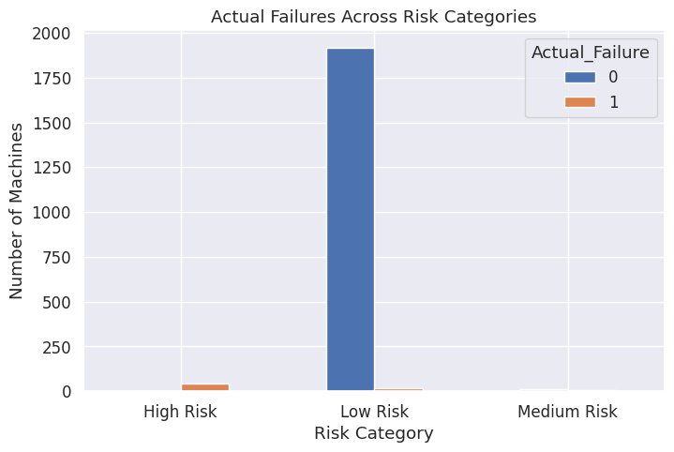
FIGURE 6: Risk Category vs Actual Failure — Grouped bar chart showing failure and non-failure counts within each risk category. Source: Author's work.
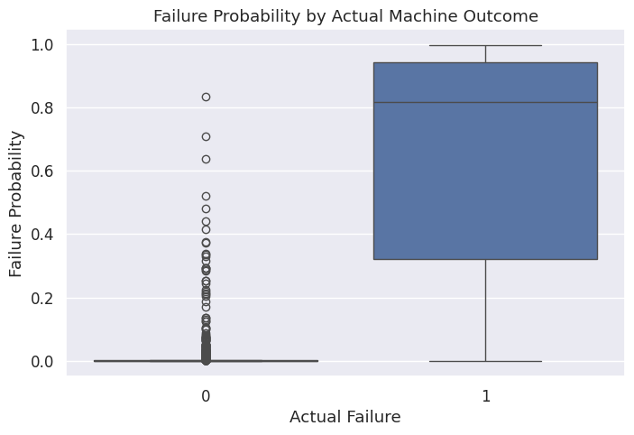
FIGURE 7: Failure Probability Distribution — Boxplot of failure probability by actual machine outcome. Mean probability 0.008 for non-failure machines, 0.649 for failed machines. Source: Author's work.

The risk categorisation results demonstrate strong operational calibration of the proposed framework. Of the 68 actual machine failures present in the test set, 43 were concentrated within the High Risk category — representing 63.24% of all failures captured within a group comprising only 2.25% of the total operational population. More strikingly, the High Risk category exhibited a failure concentration rate of 95.6%, meaning that 43 of the 45 machines flagged as high-risk subsequently experienced actual failure. This level of operational precision substantially reduces the maintenance intervention scope required to address the majority of failure risk.
The Low Risk category contained 1,936 machines — 96.8% of the monitored population — with a failure rate of only 0.9%. The strong separation between this zone and the High Risk zone confirms that the framework's probabilistic monitoring mechanism effectively stratifies the operational population into maintenance priority tiers with meaningfully different failure concentrations.
The Medium Risk category warrants careful operational interpretation. Comprising 19 machines with a failure rate of 42.1% — eight actual failures among 19 flagged instances — this zone does not represent a classification failure of the risk engine. Rather, it reflects a genuinely ambiguous operational region where machine conditions present intermediate degradation signals consistent with either eventual failure or continued safe operation. In a live maintenance environment, Medium Risk machines would appropriately receive intensified inspection and shortened monitoring intervals rather than immediate preventive intervention, preserving maintenance resources while managing residual risk.
The failure probability distribution across actual failure outcomes is presented in Figure 7. The pronounced separation between the probability distributions of failed and non-failed machines — non-failure instances clustering near zero (mean probability = 0.008) and failure instances exhibiting substantially elevated probabilities (mean probability = 0.649) — confirms that the XGBoost model generates well-discriminated probability estimates rather than undifferentiated mid-range values. This distributional separation is a necessary condition for effective threshold-based maintenance optimisation.
These findings directly address RQ2: the Digital Twin-inspired probabilistic monitoring framework effectively categorises operational machine risk, achieving a 95.6% failure concentration rate within the High Risk zone while correctly classifying 96.8% of the monitored population as low-risk.
4.4 Maintenance Strategy Optimisation (RQ3)
The maintenance strategy simulation evaluated four intervention approaches under identical cost parameters: a preventive maintenance cost of ₹200 per intervention and a total failure cost of ₹1,000 per unplanned failure event, comprising ₹500 in repair costs and ₹500 in downtime costs calculated at ₹100 per hour over five hours. Results are presented in Table 6 and illustrated in Figure 8.
TABLE 6: Maintenance Strategy Comparison. Source: Author's work.
Strategy | Preventive Actions | Remaining Failures | Total Cost (₹) | Cost Reduction
Reactive | 0 | 68 | 68,000 | —
Preventive | 45 | 25 | 34,000 | 50.00%
Budget-Constrained DT | 25 | 43 | 48,000 | 29.41%
Dynamic Threshold DT (θ = 0.5) | 52 | 20 | 30,400 | 55.29%

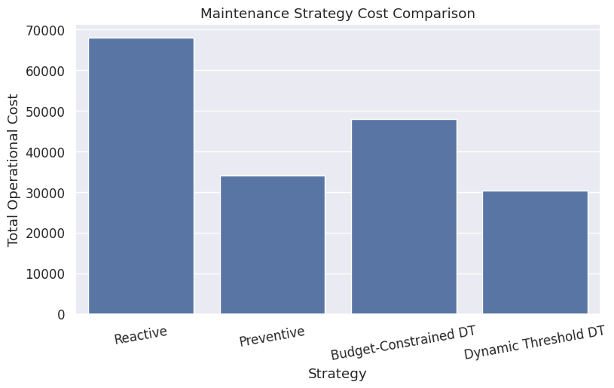
FIGURE 8: Cost Comparison Across Strategies — Bar chart showing total operational cost (₹) for all four strategies. Source: Author's work.
The results reveal a clear operational hierarchy among the four maintenance strategies, with important nuances that are not immediately apparent from cost figures alone.
The Reactive Maintenance baseline incurred the highest total cost of ₹68,000 by exposing all 68 machine failures to their full repair and downtime expenditure. For organisations currently operating without predictive maintenance infrastructure, this baseline provides a concrete reference point for evaluating the return on investment from predictive capability.
Preventive Maintenance reduced total cost to ₹34,000 — a 50.00% reduction relative to reactive operations — by intervening on all 45 machines categorised as High Risk. Of these 45 interventions, 43 corresponded to machines that did subsequently experience failure, confirming strong intervention targeting efficiency. However, 25 failures remained unaddressed because they occurred within the Low Risk and Medium Risk zones, highlighting the limitation of purely category-based intervention logic: machines whose failure probability falls below the 0.70 High Risk boundary receive no intervention regardless of their actual failure trajectory.
The Budget-Constrained Digital Twin strategy, which restricted intervention to the 25 highest-probability machines, performed poorly relative to Preventive Maintenance — achieving only a 29.41% cost reduction (₹48,000 total) while allowing 43 failures to persist. By capping interventions at 25 machines, the strategy prevented 25 failures but left 43 unmanaged — a failure exposure that overwhelmed the savings from reduced maintenance workload. This result carries an important operational message: budget constraints applied rigidly to probabilistic maintenance systems can inadvertently replicate many of the cost characteristics of reactive maintenance while adding the overhead of partial preventive activity.
The Dynamic Threshold-Based strategy at θ = 0.5 achieved the strongest overall performance, delivering a 55.29% cost reduction to ₹30,400 while holding remaining failures to 20. By intervening on all 52 machines whose failure probability exceeded 0.50, the strategy extended coverage beyond the strict High Risk category boundary — capturing machines in the upper probability range of the Medium Risk zone that the category-based Preventive strategy missed — while remaining substantially more selective than exhaustive population-wide intervention. The result demonstrates that adaptive, probability-driven maintenance scheduling outperforms both static risk category intervention and fixed-budget approaches when operational cost minimisation is the primary objective.
These findings directly address the first part of RQ3: the Dynamic Threshold-Based strategy at θ = 0.5 achieves the most favourable cost-failure trade-off among the four evaluated strategies, generating a 55.29% cost reduction relative to the reactive baseline.
4.5 Threshold Sensitivity Analysis (RQ3)
To characterise the full operational trade-off between maintenance aggressiveness and cost efficiency, the framework evaluated four probability threshold settings. Results are presented in Table 7 and illustrated in Figures 9 and 10.
TABLE 7: Threshold Sensitivity Analysis. Source: Author's work.
Threshold (θ) | Preventive Actions | Remaining Failures | Total Cost (₹)
0.3 | 64 | 17 | 29,800
0.5 | 52 | 20 | 30,400
0.7 | 45 | 25 | 34,000
0.9 | 23 | 45 | 49,600

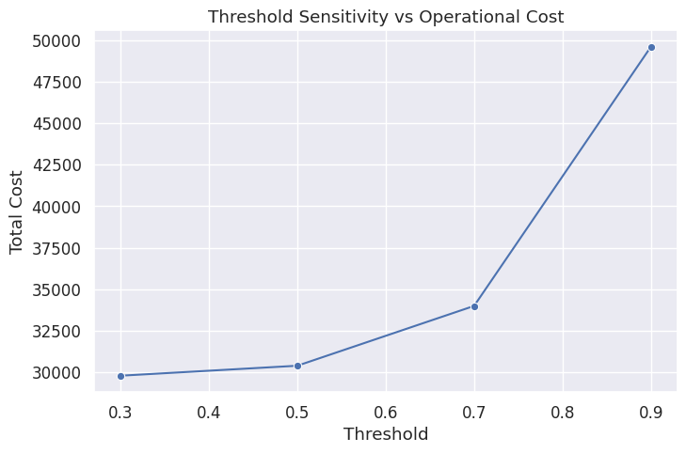
FIGURE 9: Threshold vs Operational Cost — Line chart showing total cost (₹) on y-axis against threshold values 0.3, 0.5, 0.7, 0.9 on x-axis. Cost rises sharply beyond θ = 0.7. Source: Author's work.

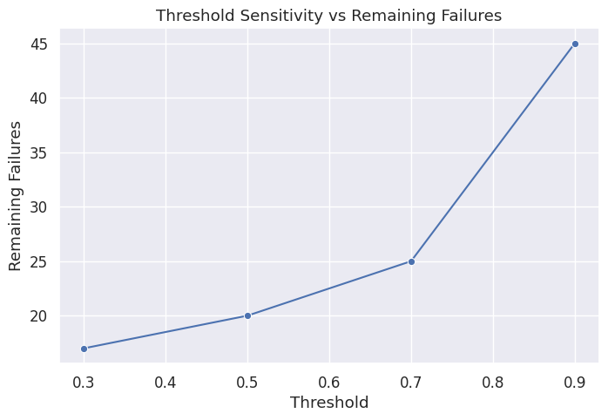
FIGURE 10: Threshold vs Remaining Failures — Line chart showing remaining failures on y-axis against threshold values on x-axis. Failure count rises steeply beyond θ = 0.7. Source: Author's work.
The threshold sensitivity results reveal a consistent and operationally interpretable pattern: as the maintenance threshold increases, preventive intervention volume declines, remaining failures accumulate, and total operational cost rises. This monotonic relationship confirms that threshold selection carries direct and measurable cost consequences, and should be treated as a deliberate operational governance decision rather than a technical default.
At the lowest evaluated threshold (θ = 0.3), the framework generated 64 preventive actions, reducing remaining failures to 17 and achieving the lowest total cost of ₹29,800. However, the incremental benefit relative to θ = 0.5 is modest — a cost saving of ₹600 achieved through 12 additional maintenance actions. Whether this trade-off is worthwhile depends on the specific downtime cost structure and maintenance capacity of the operating environment.
At θ = 0.5, the framework achieves a near-optimal cost outcome of ₹30,400 with 52 interventions and 20 remaining failures. This threshold represents the most operationally efficient point within the evaluated range for organisations seeking to minimise total cost without exhausting maintenance capacity on marginal-risk machines.
At θ = 0.7, the strategy converges with the static Preventive Maintenance outcome — 45 interventions, 25 remaining failures, ₹34,000 total cost — confirming internal consistency within the framework. Probability-threshold intervention at 0.7 effectively mirrors the High Risk category boundary, validating the coherence of the risk categorisation system with the threshold optimisation mechanism.
The most consequential finding in the sensitivity analysis is the performance deterioration at θ = 0.9. At this threshold, only 23 machines receive preventive intervention, leaving 45 failures unmanaged and driving total cost to ₹49,600 — approaching 73% of the reactive maintenance baseline cost. This outcome demonstrates that excessively conservative thresholds functionally replicate the cost burden of reactive maintenance, as the large majority of failure-risk machines are permitted to fail without intervention. For organisations in high-criticality production environments, this result underscores the operational risk of threshold settings above 0.7.
Collectively, the threshold sensitivity results address the second part of RQ3: adaptive maintenance thresholds materially and measurably influence operational cost and failure exposure, with the θ = 0.3–0.5 range representing the most cost-efficient operating zone for organisations with moderate maintenance capacity and standard failure cost structures.
4.6 Feature Importance and Operational Insights (RQ4)
The XGBoost feature importance analysis identified the relative contribution of each operational variable to machine failure probability estimation. Results are presented in Table 8 and illustrated in Figure 11.

TABLE 8: Feature Importance Ranking. Source: Author's work.
Rank | Feature | Importance Score
1 | Torque (Nm) | 0.299
2 | Tool wear (min) | 0.179
3 | Rotational speed (rpm) | 0.175
4 | Air temperature (K) | 0.158
5 | Process temperature (K) | 0.103
6 | Machine type | 0.087

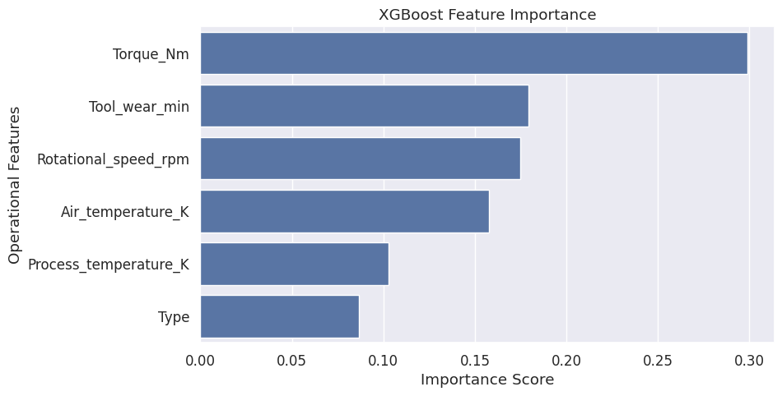
FIGURE 11: Feature Importance Ranking — Horizontal bar chart of all six features ranked by XGBoost importance score. Torque highest at 0.299, Machine type lowest at 0.087. Source: Author's work.

The feature importance results are operationally coherent and consistent with the exploratory analysis findings, confirming that machine failure is driven primarily by mechanical stress accumulation and progressive component degradation rather than ambient environmental conditions.
Torque ranked as the most influential failure predictor with an importance score of 0.299, accounting for approximately 30% of the model's total predictive contribution. This dominance reflects torque's role as the most direct available indicator of mechanical operational stress. The high-risk versus low-risk comparison further reinforces this finding: High Risk machines operated at an average torque of 53.14 Nm compared to 39.52 Nm for Low Risk machines — a differential of 34.5%. From a maintenance monitoring perspective, torque-based condition monitoring should occupy the highest priority position in operational sensor hierarchies.
Tool wear ranked second with an importance score of 0.179, reflecting its role as a continuous degradation accumulation indicator. High Risk machines accumulated an average of 141.4 minutes of tool wear compared to 107.7 minutes for Low Risk machines — a differential of approximately 31%. Maintenance schedules calibrated to tool wear trajectories — rather than fixed calendar intervals — would better reflect actual component degradation state and reduce both failure risk and unnecessary preventive interventions simultaneously.
Rotational speed ranked third with an importance score of 0.175 — closely comparable to tool wear and substantially above the thermal variables. High Risk machines operated at an average rotational speed of 1,430 rpm compared to 1,539 rpm for Low Risk machines. Speed reduction under stable load conditions may be consistent with mechanical resistance, bearing deterioration, or drivetrain stress, although the dataset does not contain component-level sensors capable of confirming this specific mechanism — an early-warning signal that, when combined with elevated torque monitoring, creates a powerful compound failure indicator.
Air temperature ranked fourth (0.158) and process temperature fifth (0.103), together accounting for approximately 26% of total predictive contribution. While their individual importance scores are not negligible, their contribution is substantially lower than the top three mechanical variables, suggesting that in this operational context mechanical stress indicators carry substantially greater predictive signal than ambient thermal measurements.
Machine type ranked lowest among all features (0.087), contributing the least independent predictive information. This result suggests that failure risk is more strongly determined by operational conditions than by machine classification — a finding with direct implications for maintenance policy design: condition-responsive monitoring is more informative than machine-type-based maintenance segmentation.
These findings directly address RQ4: torque intensity, tool wear accumulation, and rotational speed are the three operational variables that most significantly influence machine failure probability within the Digital Twin-inspired framework, with their combined importance score of 0.653 representing approximately 65% of the model's total predictive contribution.
4.7 Robustness and Validation Analysis
To assess the generalisability and predictive stability of the proposed framework, stratified five-fold cross-validation was conducted alongside training-versus-testing performance comparison. Results are presented in Table 9.
TABLE 9: Cross-Validation and Robustness Results. Source: Author's work.
Evaluation Dimension | Value
CV Fold 1 ROC-AUC | 0.9825
CV Fold 2 ROC-AUC | 0.9753
CV Fold 3 ROC-AUC | 0.9769
CV Fold 4 ROC-AUC | 0.9687
CV Fold 5 ROC-AUC | 0.9753
Cross-Validation Mean ROC-AUC | 0.9757
Cross-Validation Std. Deviation | 0.0044
Training ROC-AUC | 1.000
Testing ROC-AUC | 0.973
Training-Testing Gap | 0.027

The cross-validation results confirm strong predictive stability across all five data partitions. The mean ROC-AUC of 0.9757 with a standard deviation of 0.0044 indicates that the XGBoost model's discriminatory capability is consistent regardless of which portion of the data is used for training and which is reserved for evaluation. The individual fold scores — ranging from 0.9687 to 0.9825 — fall within a narrow band of approximately 1.4 percentage points, confirming that model performance is not driven by sample-specific characteristics of any particular data partition.
The training ROC-AUC of 1.000 versus the testing ROC-AUC of 0.973 indicates a training-testing gap of 0.027. A training AUC of 1.000 is a known characteristic of gradient-boosted ensemble models on tabular classification tasks: the sequential error-correction mechanism of XGBoost enables near-perfect separation of the training data once sufficient boosting rounds are applied. The relevant diagnostic question is not whether training performance is perfect, but whether testing performance is operationally meaningful and stable across repeated evaluation.
The testing ROC-AUC of 0.973, confirmed by the cross-validation mean of 0.9757, demonstrates that the model retains strong and stable discriminatory capability on unseen operational data. The 2.7-point training-testing gap is modest relative to the absolute performance level and is unlikely to represent operationally consequential degradation for maintenance decision-support applications. Nonetheless, the study acknowledges that this gap may widen under real industrial deployment conditions where sensor noise, missing values, concept drift, and operational variability introduce distributional complexity not present in the simulated benchmark dataset.
For practitioners considering deployment of similar frameworks in live industrial environments, these robustness results suggest that XGBoost-based failure probability estimation is likely to maintain strong discrimination across normal operational variability. Periodic model revalidation against updated operational data is recommended as a standard governance practice — particularly in environments where machine configurations, production schedules, or material inputs change substantially over time.

4.8 SHAP-Based Explainability Analysis
SHAP analysis was applied to the trained XGBoost classifier using the TreeSHAP algorithm, producing exact Shapley values for all 2,000 test-set observations. The analysis yields four complementary visualisation outputs — a Summary (Beeswarm) Plot (Figure 12), a Feature Importance Plot (Figure 13), a Waterfall Plot (Figure 14), and a Force Plot (Figure 15) — each serving a distinct explanatory purpose within the predictive maintenance context. Together, these outputs address a dimension of model behaviour that the gain-based feature importance analysis in Section 4.6 could not: the directional and instance-level mechanisms through which the XGBoost model generates its failure probability estimates.
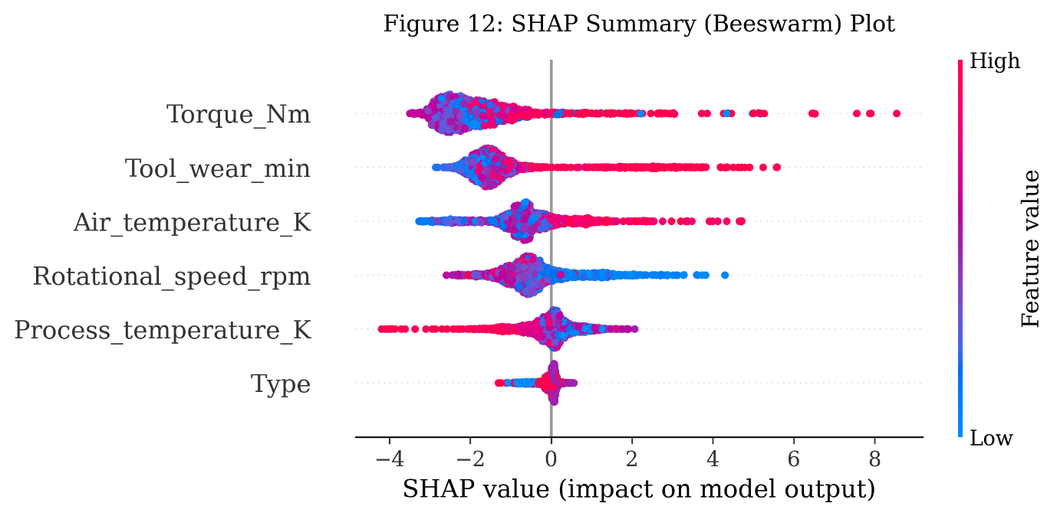
The SHAP Summary Plot (Figure 12) reveals the global distribution of feature contributions across the full test population. Torque exhibits the widest horizontal spread among all features, with a concentration of large positive SHAP values associated with high-torque observations (shown in red). This distributional pattern confirms that elevated torque is the single strongest driver of XGBoost failure probability predictions across the population — a finding consistent with, but more precisely characterised than, the gain-based importance score of 0.299 reported in Table 8. Crucially, the beeswarm plot also reveals that low torque observations carry small negative SHAP values, establishing a bidirectional relationship: not only does high torque elevate failure risk, but normal-to-low torque is actively protective. This directional nuance is not recoverable from the unsigned importance scores alone.
Tool wear shows a dense cluster of moderately positive SHAP values across most observations, with a tail of large positive contributions at high accumulated wear — consistent with the non-linear degradation acceleration pattern described in Section 3.9.3. Rotational speed generates predominantly negative SHAP values, confirming that below-average rotational speeds increase failure probability and that the model has successfully learned this inverse relationship from the training data. Air temperature and process temperature contribute positive SHAP values of moderate, comparable magnitude, while machine type contributes the narrowest SHAP distribution among all features, consistent with its lowest gain-based importance score.

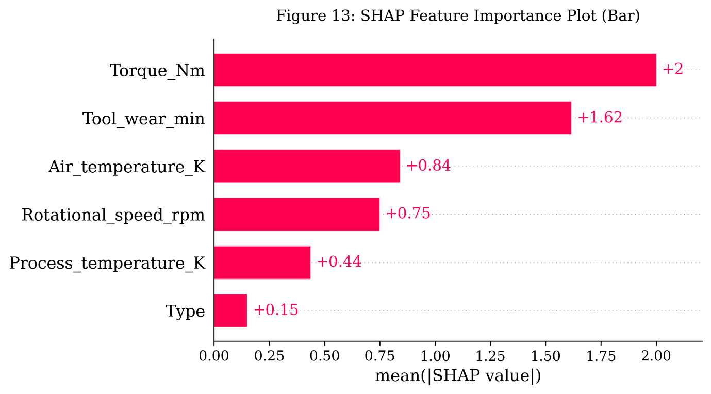
The SHAP Feature Importance Plot (Figure 13) aggregates SHAP values into mean absolute contributions per feature. The ranking produced is consistent with the gain-based importance ordering in Table 8, with torque ranked first, followed by tool wear, rotational speed, air temperature, process temperature, and machine type. However, the mean absolute SHAP magnitudes provide an additional layer of operational interpretability: the gap between torque and the remaining features is larger than the gain-based scores suggest, reinforcing the case for torque as the primary monitoring priority in condition-based maintenance alert systems. The relatively narrow gap between tool wear, rotational speed, and air temperature — features ranked second, third, and fourth — supports a monitoring architecture in which all three receive equivalent sensor investment rather than a strictly hierarchical resource allocation.
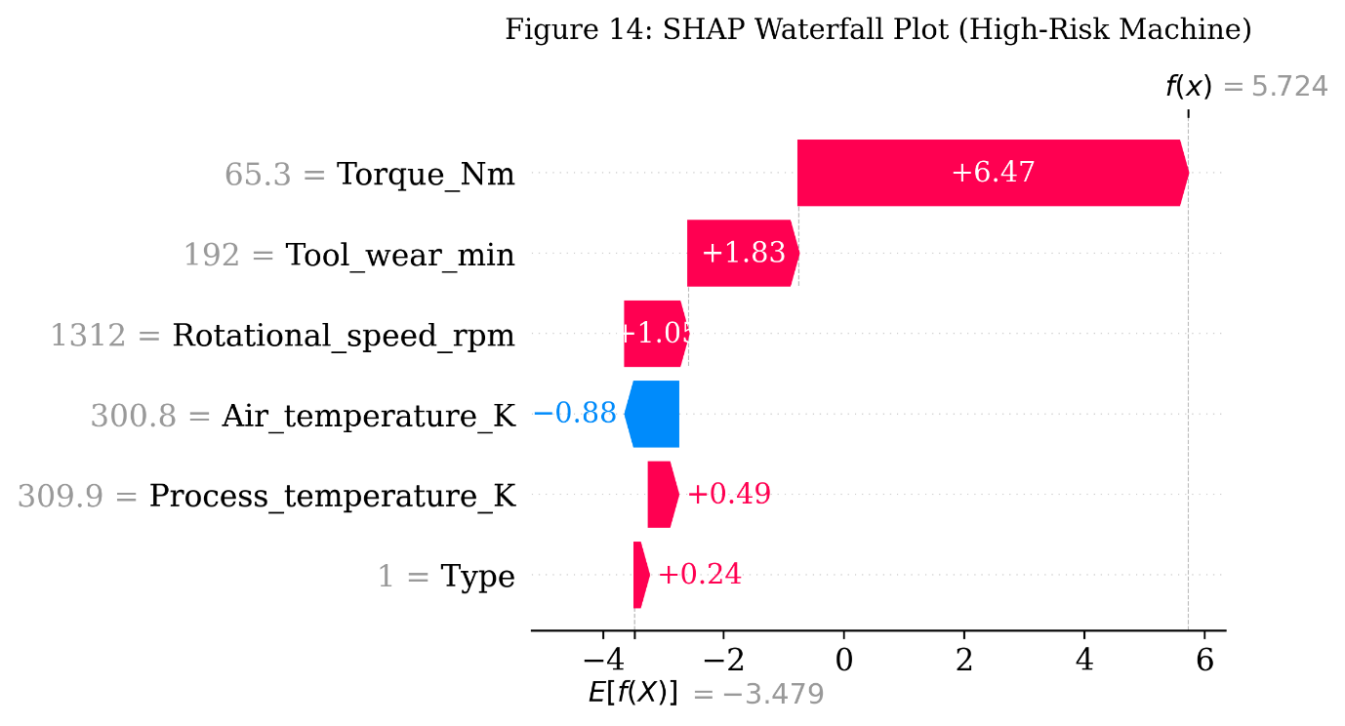
The SHAP Waterfall Plot (Figure 14) provides instance-level explanation for a representative High Risk machine from the test set. Beginning from the base value E[f(x)] — the mean XGBoost failure probability across the training population, reflecting the unconditional failure rate of the dataset — the plot traces the cumulative feature contributions that drive this machine’s final predicted failure probability upward to its high-risk value. For the representative case, torque contributes the largest single positive increment, followed by tool wear. Rotational speed contributes a smaller positive increment consistent with a below-average speed reading for this observation. Air and process temperatures contribute modest positive amounts. The resulting prediction is fully decomposed and traceable to individual operational measurements — enabling a maintenance engineer to verify whether the model’s explanation is consistent with their engineering knowledge of the machine’s current condition.
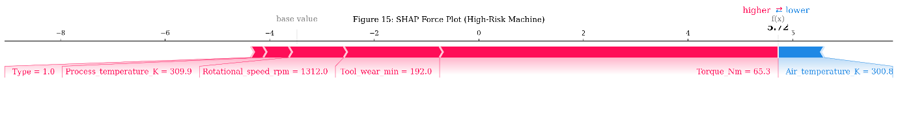
The SHAP Force Plot (Figure 15) presents the same instance-level decomposition in a compact horizontal format suited to real-time dashboard integration. Red arrow segments represent features pushing the predicted probability above the base value; blue segments represent features with a reducing effect. For the representative High Risk machine, the force plot immediately communicates that elevated torque and advanced tool wear are the primary drivers of the alert, with rotational speed and temperature providing secondary contributions. This compact format is directly deployable as a companion panel within Manufacturing Execution System (MES) interfaces, providing maintenance engineers with a plain-language explanation of each generated failure alert at the point of decision.
Collectively, the four SHAP outputs demonstrate that the XGBoost model’s failure predictions are explainable, directionally coherent, and operationally grounded. The explanations produced are consistent with engineering expectations — elevated mechanical stress, accumulated component degradation, and rotational instability drive failure risk — and they add a layer of interpretability that substantially increases the operational credibility of the predictive maintenance framework. For organisations considering deployment of XGBoost-based failure prediction in industrial environments, SHAP integration represents a low-overhead, high-value addition that addresses the primary barrier to adoption of black-box machine learning models in safety-critical maintenance contexts. These results extend the answer to RQ4: beyond ranking torque, tool wear, and rotational speed by importance magnitude, SHAP analysis establishes the directional and instance-level mechanisms through which these variables influence individual machine failure probabilities, providing the transparency required for maintenance engineers to act on the framework’s recommendations with confidence.
These four SHAP visualisation outputs, taken together with the Repair vs. Replace Decision Module described in Section 3.11, directly address RQ5: SHAP extends the operational utility of XGBoost’s probabilistic outputs by attaching a directionally informative, instance-level explanation to every failure probability, and the Repair vs. Replace Decision Module translates each explained alert into one of three concrete, lifecycle-cost-justified actions — Continue Monitoring, Schedule Repair, or Immediate Replacement — rather than leaving the alert as an unexplained probability score.
4.9 Generalisability and Industrial Applicability
Although the empirical evaluation of the proposed framework was conducted using the AI4I 2020 Predictive Maintenance Dataset in a smart manufacturing context, the methodological architecture is designed for generalisability across a wide range of industrial domains where sensor-based condition monitoring data are available. The five operational variables employed in the study — temperature, process temperature, rotational speed, torque, and tool wear — are representative of the sensor categories routinely collected in capital-intensive industrial environments, including manufacturing, automotive assembly, aerospace maintenance, wind energy, railways, oil and gas, power generation, and industrial robotics. The framework’s input layer is domain-agnostic: any operational dataset containing continuous condition monitoring variables with a binary or categorised failure outcome can be substituted without structural modification to the XGBoost training procedure, the SHAP explainability pipeline, the dynamic threshold engine, or the lifecycle cost decision module. Carvalho et al.³³ observe that the majority of predictive maintenance machine learning architectures designed for manufacturing sensor data transfer effectively to analogous condition monitoring tasks in other industries, provided that the input feature space captures equivalent degradation-relevant signals.
In the automotive sector, the framework can be adapted for powertrain health monitoring, where torque and rotational speed signals parallel the variables used in the present study and where the cost asymmetry between unplanned assembly-line stoppages and preventive servicing mirrors the cost structure modelled in Section 3.7. For wind turbine maintenance — an application domain where operational remoteness amplifies the cost consequences of reactive maintenance — the three-tier risk categorisation and dynamic threshold mechanism are particularly well suited to prioritising limited technician availability across distributed turbine fleets. In railway asset management, vibration, wheel-rail force, and axle temperature signals can serve as direct substitutes for the torque, rotational speed, and temperature variables in the XGBoost feature set, and the lifecycle cost decision module’s repair versus replace logic maps naturally onto the infrastructure renewal decisions that network operators face at component end-of-life. Oil and gas pipeline monitoring applications, where corrosion rate and pressure differential readings are the dominant degradation indicators, can leverage the same probabilistic risk stratification architecture to support inspection scheduling decisions under the high failure-cost regimes characteristic of that sector. For industrial robotics — where servo torque, joint temperature, and cycle count are standard condition monitoring outputs — the SHAP-based explainability layer addresses a critical adoption barrier: maintenance engineers in high-precision automated environments require not only failure alerts but transparent attribution of those alerts to specific joint or actuator conditions, a requirement that TreeSHAP directly satisfies.
The framework’s scalability reflects three structural properties. First, XGBoost’s gradient boosting algorithm scales linearly with training dataset size and maintains stable performance across datasets ranging from thousands to millions of observations, making it suitable for both small-fleet and large-fleet industrial environments. Second, the dynamic threshold mechanism is computationally lightweight: threshold adjustment requires only a recalibration of a single scalar parameter against the updated cost-failure simulation, without retraining the underlying model. Third, the TreeSHAP algorithm computes exact SHAP values in polynomial time, enabling real-time explanation generation at industrial operational frequencies without dedicated GPU infrastructure. Together, these properties make the framework deployable across a spectrum of operational scales — from single-plant manufacturing cells to geographically distributed asset networks — without architectural modification. Nunes et al.10 confirm that scalability and low computational overhead are among the most critical practical requirements for predictive maintenance frameworks in real industrial deployments, where edge computing constraints and network bandwidth limitations frequently restrict the complexity of on-site analytics infrastructure.
From an Industry 4.0 compatibility perspective, the framework’s modular pipeline is designed for integration with standard industrial data infrastructure. The data acquisition layer is compatible with IIoT sensor protocols including OPC-UA, MQTT, and MODBUS, enabling direct connection to shop-floor sensor networks without proprietary middleware requirements. The XGBoost inference and SHAP explanation modules can be containerised using Docker and deployed on edge computing devices — including industrial PCs and single-board computers — or hosted on cloud-based Manufacturing Execution System (MES) platforms depending on the latency and connectivity requirements of the operational environment. The Digital Twin Dashboard interface, as described in Section 3.10, is compatible with standard SCADA and MES visualisation architectures, enabling integration into existing plant control infrastructure without parallel system deployment. These practical deployment considerations ensure that the framework’s analytical capabilities are accessible to organisations at varying stages of Industry 4.0 maturity, from early adopters with fully connected IIoT infrastructure to organisations beginning the transition from periodic batch-data collection.
Limitations and future validation directions are discussed in Sections 6.4–6.5.
5. MANAGERIAL IMPLICATIONS
The findings of this study carry several practical implications for industrial maintenance managers, operations directors, and technology officers responsible for maintenance strategy governance within Industry 4.0 environments. The implications are organised around five operational themes that emerge directly from the empirical results.

5.1 The Economic Case for Moving Beyond Reactive Maintenance
The most fundamental implication of the study is the demonstrated and quantifiable cost advantage of probability-driven maintenance intervention over conventional reactive approaches. The Dynamic Threshold-Based strategy achieved a 55.29% reduction in total operational cost relative to the reactive maintenance baseline — reducing total expenditure from ₹68,000 to ₹30,400 across the simulated test population while simultaneously reducing remaining failures from 68 to 20. This magnitude of cost reduction, achieved without exhausting maintenance resources, provides a concrete economic justification for investment in predictive maintenance infrastructure.
For maintenance leaders operating under organisational pressure to reduce expenditure while preserving equipment reliability, these results offer an empirically grounded argument. The question is not whether predictive maintenance reduces cost — the evidence from this and a substantial body of prior research confirms that it does — but rather how the predictive capability is translated into operational decisions. A predictive model that outputs binary failure labels without probability calibration, and an organisation that responds to those labels with uniform intervention, will capture only a portion of the available cost benefit. The full economic value of predictive maintenance is realised when probability outputs drive adaptive, graduated intervention decisions rather than static, category-fixed responses.
5.2 Threshold Selection as a Strategic Governance Decision
The threshold sensitivity analysis generates a finding that has direct and immediate implications for maintenance policy design: the choice of intervention threshold is not a technical parameter to be set once by a data scientist and forgotten — it is a strategic operational decision that should be made by maintenance managers and reviewed regularly alongside maintenance budget cycles.
The empirical evidence is unambiguous on this point. Moving the intervention threshold from 0.5 to 0.9 — a change that might appear to be a minor technical adjustment — increased total operational cost from ₹30,400 to ₹49,600 and allowed 25 additional machine failures to occur unmanaged. Conversely, moving from 0.5 to 0.3 reduced remaining failures by three at the cost of 12 additional maintenance actions — a marginal trade-off whose value depends entirely on the specific downtime cost structure and maintenance capacity of the operating environment.
This evidence suggests that organisations should establish explicit threshold governance protocols — documented policies that specify the intervention threshold currently in use, the operational rationale for that setting, and the conditions under which it would be revised. For organisations operating in high-criticality production environments where downtime carries severe financial or safety consequences, lower thresholds in the 0.3–0.5 range are appropriate. For organisations with severely constrained maintenance teams or where downtime costs are modest relative to preventive servicing costs, higher thresholds in the 0.5–0.7 range may represent a defensible operational trade-off. The key governance principle is that this decision should be made deliberately and revisited periodically — not defaulted to a fixed technical parameter.
5.3 Risk Stratification as a Resource Allocation Tool
The three-tier risk categorisation system demonstrated that 95.6% of machines flagged as High Risk subsequently experienced actual failure — meaning that maintenance teams who concentrate intervention resources on the High Risk population are directing effort toward machines that overwhelmingly do in fact fail. Simultaneously, 96.8% of the monitored population was correctly classified as Low Risk, freeing maintenance teams from unnecessary intervention on the large majority of the machine fleet.
This stratification capability has direct implications for maintenance resource allocation in organisations managing large machine populations with constrained maintenance teams. Rather than applying uniform preventive schedules across an entire asset base — a practice that generates unnecessary maintenance workload and expenditure on machines with low failure probability — risk stratification enables selective, evidence-based resource deployment. Maintenance labour, spare parts inventory, and inspection capacity can be concentrated on the small fraction of machines that carry the majority of failure risk, with lower-risk machines managed through standard monitoring protocols.
The Medium Risk zone carries a specific operational message for resource allocation. With a 42.1% failure rate among 19 machines, this zone represents a population where the failure signal is present but not definitive. The appropriate maintenance response is not immediate intervention — which would generate unnecessary actions on machines that do not fail — but intensified monitoring: shortened inspection intervals, more frequent condition checks, and elevated alert thresholds. Treating Medium Risk machines as candidates for watchful operational management rather than either immediate intervention or routine monitoring reflects the graduated response capability that distinguishes probabilistic maintenance frameworks from binary classification systems.
5.4 Sensor Prioritisation and Monitoring Infrastructure Design
The feature importance analysis identifies torque intensity, tool wear accumulation, and rotational speed as the three variables that together account for approximately 65% of the model's total predictive contribution to machine failure probability. This finding has direct implications for organisations designing or upgrading condition monitoring sensor infrastructure.
Organisations that allocate sensor investment primarily to ambient temperature monitoring — a common practice in many industrial maintenance systems — may be systematically underinvesting in the operational variables that carry the greatest failure predictive signal. The feature importance results suggest that torque measurement systems and high-frequency tool wear tracking should occupy the highest priority in sensor deployment decisions, with rotational speed monitoring as a close third. Temperature sensors, while not without value, offer comparatively lower marginal predictive contribution per unit of monitoring investment within the operational context examined.
This sensor prioritisation principle has practical relevance beyond data collection. It also informs the design of real-time operational dashboards, maintenance alert systems, and condition monitoring thresholds within Manufacturing Execution Systems (MES) and Enterprise Resource Planning (ERP) environments. When maintenance alert logic is built around the variables that most strongly predict failure, the resulting monitoring system generates higher-quality signals with fewer false alarms — directly improving both the reliability and the operational credibility of the predictive maintenance infrastructure. The SHAP explainability analysis presented in Section 4.8 reinforces this sensor prioritisation finding with directional precision: SHAP values confirm that high torque consistently drives the largest positive contributions to failure probability estimates, while rotational speed reduction functions as a negative-SHAP early-warning signal whose protective interpretation would be lost in unsigned importance rankings. For organisations designing maintenance alert dashboards, the SHAP Force Plot format (Figure 15) provides a compact, immediate per-machine explanation of each alert that directly supports engineer trust and intervention decision-making.
5.5 Limitations Relevant to Managerial Adoption
Practitioners considering adoption of similar frameworks should approach the results of this study with an awareness of the limitations detailed in Section 6.4, two of which carry direct managerial relevance.
First, because the framework was evaluated on a publicly available simulated benchmark dataset rather than live industrial sensor streams (Section 6.4), organisations deploying similar frameworks in live environments should anticipate the need for data quality management infrastructure that goes beyond what a clean benchmark dataset requires. Second, because the cost parameters used in the simulation are standardised illustrative values rather than empirically derived industrial cost estimates (Section 6.4), organisations applying the framework to real operational decisions should calibrate the cost model to their actual cost structure before using its outputs to guide specific resource allocation decisions.
Third, the training-testing performance gap observed in the XGBoost model — a training ROC-AUC of 1.000 against a testing ROC-AUC of 0.973 — indicates a degree of overfitting that may become more pronounced in live deployment conditions where operational variability exceeds that captured in the training data. Periodic model revalidation against updated operational data is therefore not merely a best-practice recommendation but an operational necessity for organisations seeking to maintain the predictive reliability of their maintenance decision-support systems over time.

6. CONCLUSION
6.1 Summary of the Study
This study proposed and evaluated an explainable, Digital Twin-inspired predictive maintenance framework designed to bridge the gap between machine learning-based failure prediction and adaptive, transparent maintenance decision-making in Industry 4.0 environments. The framework integrated five analytical components — machine learning-based failure probability estimation, SHAP-based explainability, probabilistic operational risk categorisation, dynamic threshold-based maintenance strategy simulation, and a lifecycle-cost-based Repair vs. Replace Decision Module — within a unified operational pipeline, supported by a Digital Twin-inspired architecture, oriented toward cost-aware, explainable maintenance governance rather than classification performance alone.
The framework was evaluated using the AI4I 2020 Predictive Maintenance Dataset, comprising 10,000 industrial machine operational records with a 3.39% failure rate. Three machine learning models were comparatively evaluated, a Digital Twin-inspired risk engine was implemented using the best-performing model's probability outputs, and four maintenance intervention strategies were simulated under identical cost assumptions. Threshold sensitivity analysis across four intervention thresholds and feature importance analysis of all six operational variables completed the empirical evaluation.
6.2 Answers to Research Questions
The study's five research questions are addressed in turn with reference to the empirical evidence presented in Section 4.
RQ1 — Model Selection for Failure Prediction
Among the three machine learning models evaluated, XGBoost demonstrated the strongest overall predictive capability for industrial machine failure detection under class-imbalanced conditions. Its ROC-AUC of 0.973 — the highest across all three models — reflects superior discriminatory capability across the full range of failure probability thresholds, while its Precision of 0.923 ensures that the large majority of maintenance alerts it generates correspond to actual failure conditions. The cross-validation analysis confirmed the stability of this performance, with a mean ROC-AUC of 0.9757 and a standard deviation of 0.0044 across five stratified folds — a narrow performance band that indicates consistent generalisation rather than sample-specific overfitting. XGBoost's combination of strong discrimination, high alert reliability, and stable cross-validated performance makes it the most operationally suitable model among those evaluated for integration into a probabilistic maintenance decision-support system.
RQ2 — Risk Categorisation Effectiveness
The Digital Twin-inspired probabilistic monitoring framework demonstrated strong operational calibration in stratifying the machine population into meaningful risk zones. Of the 68 actual failures present in the test set, 43 were concentrated within the High Risk category — which comprised only 2.25% of the total monitored population — yielding a failure concentration rate of 95.6% within that zone. The Low Risk category, covering 96.8% of the population, exhibited a failure rate of only 0.9%, confirming effective separation between high-priority and routine operational populations. The Medium Risk zone, with a 42.1% failure rate across 19 machines, reflected genuine operational ambiguity appropriately captured by intermediate probability estimates. Collectively, these results confirm that the probabilistic risk categorisation framework effectively stratifies the operational machine population into maintenance priority tiers that are both empirically meaningful and managerially actionable.
RQ3 — Threshold Influence on Cost and Failure Reduction
Adaptive maintenance thresholds materially and measurably influence operational cost and failure outcomes. The Dynamic Threshold-Based strategy at θ = 0.5 achieved the strongest overall performance across all four evaluated strategies, delivering a 55.29% cost reduction relative to the reactive maintenance baseline — reducing total operational cost from ₹68,000 to ₹30,400 — while holding remaining failures to 20. The threshold sensitivity analysis demonstrated a consistent monotonic relationship between threshold conservatism and operational cost: as the intervention threshold increased from 0.3 to 0.9, total cost rose from ₹29,800 to ₹49,600 and remaining failures increased from 17 to 45. The θ = 0.3–0.5 range represented the most cost-efficient operating zone within the evaluated parameter space, offering near-minimal total cost with substantially fewer interventions than exhaustive preventive coverage. These findings confirm that threshold selection is a consequential strategic decision and should be treated as an actively managed operational governance parameter rather than a fixed technical default.
RQ4 — Operational Variables Influencing Failure Probability
Torque intensity, tool wear accumulation, and rotational speed are the three operational variables that most significantly influence machine failure probability within the Digital Twin-inspired framework. Their combined XGBoost feature importance score of 0.653 represents approximately 65% of the model's total predictive contribution — confirming that mechanical stress and progressive degradation indicators carry substantially greater failure predictive signal than ambient thermal measurements or machine type classification within this operational context. The high-risk versus low-risk operational comparison reinforced these findings: High Risk machines exhibited average torque levels 34.5% higher, tool wear accumulation 31.2% greater, and rotational speeds 7.1% lower than Low Risk machines. SHAP-based TreeSHAP analysis corroborated and extended this ranking, establishing that torque and tool wear exert a consistent positive directional effect on failure probability while below-average rotational speed exerts a negative one — a level of directional, instance-level interpretation that the gain-based importance ranking alone could not provide. These differences have direct implications for sensor prioritisation, condition monitoring system design, explainable maintenance alert logic, and the remaining-useful-life estimation that underpins the Repair vs. Replace Decision Module within industrial operational environments.
RQ5 — Explainability and Repair-versus-Replace Action Selection
SHAP-based explainability extends the operational utility of the model's probabilistic outputs by converting each failure probability into a feature-level, directionally informative explanation: the SHAP Summary, Feature Importance, Waterfall, and Force plots presented in Section 4.8 collectively establish not only which operational variables drive a given alert, but whether each variable is pushing the prediction toward or away from failure, and by how much for a specific machine. This instance-level transparency gives maintenance engineers an auditable basis for trusting or interrogating any individual alert, addressing the credibility barrier that opaque classifiers otherwise present. The Repair vs. Replace Decision Module then carries this explained risk estimate the rest of the way to an operational decision: by combining the XGBoost-derived failure probability, the dynamic threshold risk category, a tool-wear-based remaining-useful-life estimate, and a formal lifecycle cost comparison of repair against replacement (Section 3.11), the module converts every high-risk alert into one of three concrete, financially justified recommendations — Continue Monitoring, Schedule Repair, or Immediate Replacement — rather than leaving the maintenance engineer with an unexplained probability score. Together, the explainability layer and the decision module close the gap between an accurate prediction and an actionable, defensible maintenance instruction.
6.3 Theoretical Contributions
The study makes four contributions to the academic literature on predictive maintenance, Digital Twin systems, explainable AI, and operational decision-support.
First, it demonstrates that the operational value of machine learning in maintenance contexts extends substantially beyond classification accuracy. By connecting probabilistic model outputs to adaptive maintenance strategy simulation and cost optimisation, the study establishes a framework for operationally integrated predictive maintenance research that treats decision-making as a first-class analytical objective rather than an afterthought to model evaluation.
Second, it contributes an empirically validated probabilistic risk categorisation mechanism that bridges the conceptual gap between Digital Twin monitoring principles and maintenance governance practice. The three-tier risk categorisation system — and its demonstrated ability to concentrate failure risk within the High Risk zone at a 95.6% rate — provides an empirical foundation for graduated, probability-responsive maintenance response policies that go beyond binary intervention logic.
Third, it provides direct empirical evidence of the cost-failure trade-off curve generated by adaptive threshold adjustment in probabilistic maintenance systems. The threshold sensitivity analysis, spanning four intervention thresholds and four maintenance strategies, generates a comparative dataset that is directly usable by operations researchers and practitioners seeking to characterise the economic consequences of maintenance policy calibration decisions.
Fourth, it contributes a structured methodological bridge between model explainability and maintenance action selection. By coupling TreeSHAP-based instance-level explanations with a lifecycle-cost-based Repair vs. Replace Decision Module, the study demonstrates how directional, feature-level transparency can be operationalised into a deterministic maintenance recommendation, addressing a methodological gap between the explainable AI literature and the maintenance decision-support literature that prior studies have largely treated as separate research streams.
6.4 Limitations
Several limitations of the present study should be acknowledged in interpreting its findings and considering their applicability to real industrial environments.
The study utilised the AI4I 2020 Predictive Maintenance Dataset — a publicly available simulated benchmark dataset — rather than real-time industrial sensor data with live IoT synchronisation. While this dataset is widely used in the predictive maintenance literature and designed to reflect realistic industrial operational behaviour, it does not capture the sensor noise, data pipeline variability, timestamp misalignment, and distributional drift that characterise live industrial data environments. The framework's performance under real-time deployment conditions may therefore differ from the results reported here, and validation against live industrial data is a necessary step before operational adoption.
The maintenance cost parameters applied in the simulation — ₹200 per preventive intervention and ₹1,000 per failure event — are standardised illustrative values rather than empirically derived industrial cost estimates. Real maintenance cost structures vary substantially across machine types, production configurations, and organisational contexts, and the absolute cost figures reported in this study should not be interpreted as representative of any specific industrial setting. The directional findings — that dynamic threshold-based intervention outperforms static and fixed-budget alternatives — are robust to reasonable cost parameter variation, but organisations applying the framework operationally should calibrate the cost model to their actual cost structure.
The study evaluated three machine learning models — Logistic Regression, Random Forest, and XGBoost — representing a range from linear to ensemble-based approaches. More advanced architectures, including Long Short-Term Memory networks, temporal convolutional networks, and transformer-based sequence models, were not evaluated. In operational environments where failure risk evolves over time in structured temporal sequences, such architectures may offer additional predictive capability beyond what tabular ensemble models provide.
Finally, the framework was evaluated on a single dataset representing one operational configuration. Its performance characteristics across different machine types, failure mode distributions, sensor configurations, and industry sectors remain to be established through future research.
6.5 Directions for Future Research
The findings and limitations of this study suggest several productive directions for future research in Digital Twin-inspired predictive maintenance and operational decision-support.
The most immediate priority is validation of the proposed framework against real-time industrial sensor data within a live production environment. Such validation would establish whether the probabilistic risk categorisation and threshold-based maintenance optimisation mechanisms retain their operational effectiveness under the distributional complexity and data quality challenges of live deployment — a necessary step toward practical adoption.
Extension of the probabilistic risk engine to multi-class failure mode prediction represents a second productive direction. The present study targets overall machine failure as a binary outcome; distinguishing among specific failure modes — tool wear failure, heat dissipation failure, overstrain failure — would enable more targeted maintenance responses and potentially more precise cost modelling. Multi-label classification architectures and hierarchical prediction frameworks offer promising methodological approaches for this extension.
The integration of reinforcement learning-based threshold optimisation constitutes a third direction. Rather than evaluating a fixed set of threshold values, a reinforcement learning agent could learn optimal threshold policies dynamically by observing the operational and cost consequences of intervention decisions over time — moving the framework from static threshold sensitivity analysis toward genuinely adaptive autonomous maintenance governance.
Fourth, comparative evaluation of the framework across multiple industrial datasets — spanning different machine types, production environments, failure rate distributions, and sensor configurations — would establish the generalisability of the empirical findings and identify the boundary conditions under which the threshold and risk categorisation mechanisms perform most and least effectively. Appropriate candidates include the NASA CMAPSS turbofan engine degradation dataset for aerospace and propulsion applications, the PRONOSTIA bearing dataset for rotating machinery maintenance, the Case Western Reserve University (CWRU) bearing fault dataset for vibration-based fault diagnosis, and the FEMTO-ST bearing dataset for remaining useful life estimation. Such multi-context evaluation is essential for establishing the external validity of the framework’s operational recommendations.
Finally, several infrastructure-oriented directions would move the framework from a research prototype toward a deployable industrial system. IoT-enabled Digital Twins, in which the present architecture is connected to live sensor streams rather than a static benchmark dataset, would allow the probabilistic risk engine and SHAP explainability layer to operate under genuine real-time conditions. Edge AI deployment of the trained XGBoost and TreeSHAP pipeline on industrial PCs or single-board computers would reduce latency and network dependency for time-critical alerts, while online learning techniques would allow the model to update incrementally as new labelled outcomes arrive, rather than relying solely on periodic batch retraining. Federated learning offers a complementary direction for organisations operating multiple plants or asset fleets, enabling the predictive model to learn from distributed operational data across sites without centralising sensitive production data. Finally, autonomous maintenance scheduling — in which the Repair vs. Replace Decision Module's recommendations are connected directly to maintenance workforce and spare-parts scheduling systems — would close the loop between explainable prediction and fully automated maintenance execution, representing the long-term trajectory of the Digital Twin-inspired framework proposed in this study.

REFERENCES
- Hermann M, Pentek T, Otto B. Design principles for Industrie 4.0 scenarios. Proceedings of the 49th Hawaii International Conference on System Sciences; 2016 Jan; Koloa, USA. IEEE; 2016. pp. 3928–3937.
- Mobley RK. An Introduction to Predictive Maintenance. 2nd ed. Oxford: Butterworth-Heinemann; 2002.
- VanDerHorn E, Mahadevan S. Digital twin: Generalisation, characterisation and implementation. Decis Support Syst. 2021; 145:113524.
- Tao F, Cheng J, Qi Q, Zhang M, Zhang H, Sui F. Digital twin-driven product design, manufacturing and service with big data. Int J Adv Manuf Technol. 2018; 94:3563–3576.
- Krupitzer C, Wagenhals T, Züfle M, Lesch V, Schäfer D, Mozaffarin A, et al. A survey on predictive maintenance for Industry 4.0. arXiv preprint arXiv:2002.08224; 2020.
- Breiman L. Random forests. Mach Learn. 2001; 45(1):5–32.
- Chen T, Guestrin C. XGBoost: A scalable tree boosting system. Proceedings of the 22nd ACM SIGKDD International Conference on Knowledge Discovery and Data Mining; 2016 Aug 13–17; San Francisco, USA. New York: ACM; 2016. pp. 785–794.
- Wright L, Davidson S. How to tell the difference between a model and a digital twin. Adv Model Simul Eng Sci. 2020; 7:13.
- Alaswad S, Xiang Y. A review on condition-based maintenance optimisation models for stochastically deteriorating system. Reliab Eng Syst Saf. 2017; 157:54–63.
- Nunes P, Santos J, Rocha E. Challenges in predictive maintenance — a review. CIRP J Manuf Sci Technol. 2023; 40:53–67.
- Hector I, Panjanathan R. Predictive maintenance in Industry 4.0: a survey of planning models and machine learning techniques. PeerJ Comput Sci. 2024; 10:e2016.
- Hosmer DW, Lemeshow S, Sturdivant RX. Applied Logistic Regression. 3rd ed. Hoboken: John Wiley and Sons; 2013.
- Thelen A, Zhang X, Fink O, Lu Y, Ghosh S, Youn BD, et al. A comprehensive review of digital twin — part 1: Modelling and twinning enabling technologies. Struct Multidiscip Optim. 2022; 65:354.
- Matzka S. Explainable artificial intelligence for predictive maintenance applications. Proceedings of the Third International Conference on Artificial Intelligence for Industries (AI4I 2020); 2020; Irvine, USA. IEEE; 2020. pp. 69–74.
- AI4I 2020 Predictive Maintenance Dataset [Dataset]. UCI Machine Learning Repository; 2020. Available from: https://doi.org/10.24432/C5HS5C.
- Lundberg SM, Lee SI. A unified approach to interpreting model predictions. Advances in Neural Information Processing Systems. 2017; 30:4765–4774.

- Lundberg SM, Erion G, Chen H, DeGrave A, Prutkin JM, Nair B, et al. From local explanations to global understanding with explainable AI for trees. Nat Mach Intell. 2020; 2(1):56–67

- Grieves M, Vickers J. Digital twin: Mitigating unpredictable, undesirable emergent behavior in complex systems. In: Kahlen J, Flumerfelt S, Alves A, editors. Transdisciplinary Perspectives on Complex Systems. Cham: Springer; 2017. pp. 85–113.

- Liu M, Fang S, Dong H, Xu C. Review of digital twin about concepts, technologies, and industrial applications. J Manuf Syst. 2021; 58:346–361.

- Falekas G, Karlis A. Digital twin in electrical machine control and predictive maintenance: State-of-the-art and future prospects. Energies. 2021; 14(18):5933.

- Si X-S, Wang W, Hu C-H, Zhou D-H. Remaining useful life estimation — a review on the statistical data driven approaches. Eur J Oper Res. 2011; 213(1):1–14.

- Farrant J, Flanagan WF, Woodward M. Lifecycle cost modelling for maintenance decision support in capital-intensive industries. Int J Prod Econ. 2022; 253:108572.

- Roda I, Macchi M, Fumagalli L, Viveros P. A review of multi-criteria classification of spare parts: From literature analysis to industrial evidences. J Manuf Technol Manag. 2014; 25(4):528–549.

- Okoh C, Roy R, Mehnen J, Redding L. Overview of remaining useful life prediction techniques in through-life engineering services. Procedia CIRP. 2014; 16:158–163.

- Zhang W, Yang D, Wang H. Data-driven methods for predictive maintenance of industrial equipment: A survey. IEEE Syst J. 2019; 13(3):2213–2227.
- Zonta T, da Costa CA, da Rosa Righi R, de Lima MJ, da Trindade ES, Li GP. Predictive maintenance in the Industry 4.0: A systematic literature review. Comput Ind Eng. 2020; 150:106889.
- Carvalho TP, Soares FA, Vita R, Francisco RP, Basto JP, Alcalà SG. A systematic literature review of machine learning methods applied to predictive maintenance. Comput Ind Eng. 2019; 137:106024.
- Serradilla O, Zugasti E, Rodriguez J, Zurutuza U. Deep learning models for predictive maintenance: a survey, comparison, challenges and prospects. Appl Intell. 2022; 52(10):10934–10964.
- Maschler B, Weyrich M. Deep transfer learning for industrial automation — a review and evaluation of transfer learning boundaries. Annu Rev Control. 2021; 51:85–98.
- Susto GA, Schirru A, Pampuri S, McLoone S, Beghi A. Machine learning for predictive maintenance: A multiple classifier approach. IEEE Trans Ind Inform. 2015; 11(3):812–820.
- Tao F, Qi Q, Liu A, Kusiak A. Data-driven smart manufacturing. J Manuf Syst. 2018; 48:157–169.
- Li Z, Wang Y, Wang K-S. Intelligent predictive maintenance for fault diagnosis and prognosis in machine centers: Industry 4.0 scenario. Adv Manuf. 2017; 5(4):377–387.
- Sikorska JZ, Hodkiewicz M, Ma L. Prognostic modelling options for remaining useful life estimation by industry. Mech Syst Signal Process. 2011; 25(5):1803–1836.

