DIPLOMA THESIS
Documentation

Author(s) | Philip Fenk  Emilio Zottel  Marco Molnár  Adrián Kalapis
Form  Academic year | 5AHIF 2023/24
Topic | Utilization of LiDAR in Autonomous Driving
Co-operation partners | HTBLuVA St. Pölten

Assignment of tasks | Attain optimal performance for an autonomous vehicle operating within the CARLA simulation environment.

Realisation | To achieve the goal, the programming language Python was predominantly utilized. Additionally, the Deep Learning framework Tensorflow was employed to implement the AI agent.  For the utilization of the LiDAR sensor and visualization of its data, C++ as well as Processing 4.3 (Java) were used  As a simulation environment that facilitated efficient agent training, CARLA was employed.  Furthermore, the Python library NetworkX was used to pass certain nodes along a path to the agent, which represent the shortest path to the goal.  The data was cleaned in Python and passed to the agent for training. The libraries matplotlib and seaborn were used for visualizations.

Results | - Visualization and analysis of LiDAR data  - Implementation of an SAC-Agent in CARLA  - Utilization of pathfinding in the simulation environment  - Exploration of various Reinforcement Learning approaches  - Optimization of the environment for the agent

Illustrative graph, photo  (incl. explanation) | 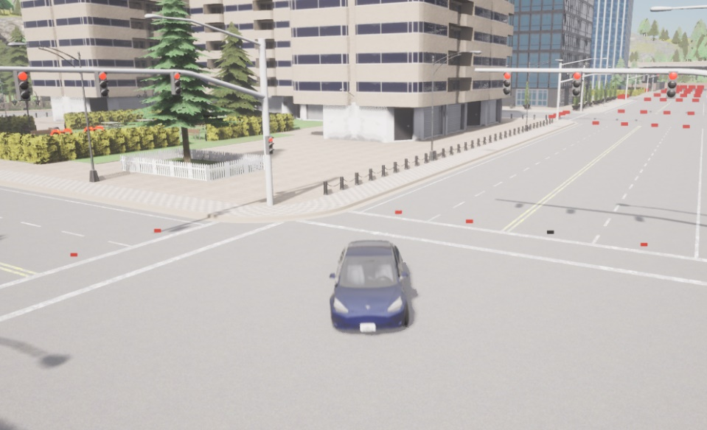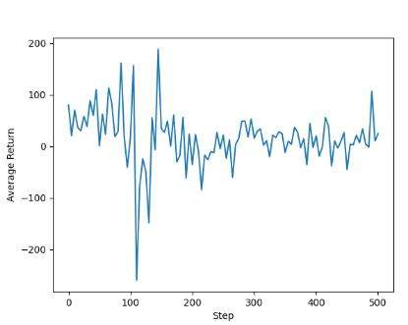  The first image shows the training simulation of the car in CARLA. The nodes of the graph on which the car navigates are visualized as colored rectangles. Black represents nodes that are part of the path it should follow. The path is calculated using the Dijkstra algorithm from the Python library NetworkX.  In the second image, the average reward over the 500 episodes is displayed. An episode lasts until the car collides.

Participation in competitions
Awards

Accessibility of  diploma thesis | The work is available at the HTBLuVA St. Pölten / Department of Computer Science (Waldstraße 3, 3100 St. Pölten).

Approval  (date / signature) | Examiner | Head of College / Department

