Háskólinn í Reykjavík

Design report



Höskuldur Ágústsson

Janus Þór Kristjánsson

Kristinn Guðmundsson

Skúli Þór Árnason

Steinn Elliði Pétursson

Sveinbjörn Guðjohnsen

Tómas Darri Þorsteinsson

Hugbúnaðarfræði

Kennari: Hannes Pétursson

Haustönn 2015

1. **Introduction**
2. **Coding conventions**
3. **Class diagram**
4. **Introduction**

This report will cover everything related to the design of the TicTacToe system. An overview of coding conventions used in the development of this system will be listed below. A class diagram showing all the classes that will be used and how they interact with each other is included. The system will be a website where a user can play tictactoe with an opponent on a single computer.

1. **Coding conventions**

We will follow java conventions to the best of our ability and use pmd to ensure there are no critical coding errors in the system.

1. **Class diagram**

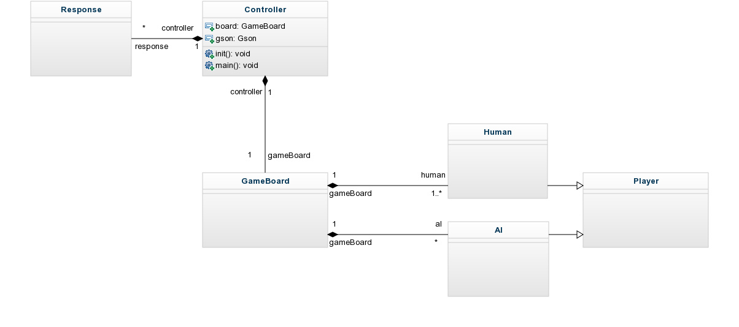

**Details:**

Because of the TDD cycle we cannot conclusively decide what methods and variables each class should have but this is how it will look like. GameBoard will have methods that perform all of the game logic and it will save the board state among other things. It will also keep a track of the players which can be either AI or Human. Both AI and Human inherit from the Player class which is a purely abstract class. Response is used to move information to the html view.

The controller creates a GameBoard which the game is played on and manages the UI.