Initialization 1
Inverse Filtering 1
Wiener Filtering 3

Initialization
close all
clear clc
im = imread('../data/jingjing.jpg');
imGray = rgb2gray(im);
[rows, cols] = size(imGray);

Inverse Filtering
figure
subplot(2,4,1)
imshow(imGray)
title('Original Image')
% gaussian low-pass
imBlurred = imgaussfilt(imGray, 2);
subplot(2,4,2)
imshow(imBlurred, [])
title('Gaussian Blurred Image')
imNoise = imnoise(imBlurred, 'salt & pepper', 0.02);
subplot(2,4,3)
imshow(imNoise, [])
title('Salt & Pepper Noise Image')
Y = fft2(imNoise);
subplot(2,4,4)
imshow(10.*log10(abs(fftshift(Y))+1), [])
title('Y(u,v)')
H = fft2(imBlurred)./fft2(imGray);
subplot(2,4,5)
imshow(10.*log10(abs(fftshift(H))+1), [])
title('H(u,v)')
N = fft2(imNoise - imBlurred);
subplot(2,4,6)
imshow(10.*log10(abs(fftshift(N))+1), [])
title('N(u,v)')
X = fft2(imGray);
subplot(2,4,7)
imshow(10.*log10(abs(fftshift(X))+1), [])
title('X(u,v)')
x = ifft2( X - N./(H+1) );
subplot(2,4,8)
imshow(abs(x), [])
title('Inverse Filtering Result')
fprintf('PSNR without noise: \n\t%f, \nwith noise: \n\t%f\n',...
psnr(imBlurred, imGray), psnr(imNoise, imGray))
fprintf('Inverse Filter PSNR without noise: \n\t%f, \nwith noise: \n\t%f\n',...
psnr(uint8(ifft2(fft2(imBlurred)./H)), imGray), psnr(uint8(x), imGray))
PSNR without noise:
26.555532,
with noise:
20.665432
Inverse Filter PSNR without noise:
Inf,
with noise:
29.955409
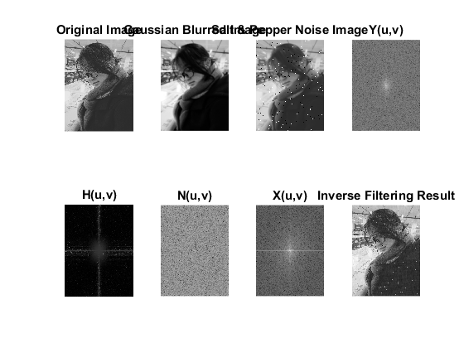

Wiener Filtering
from snr funciton, we could know that --------------------------------- % function re = signalPower(in) re = rssq(in(:))^2; end --------------------------------- %
Sn = signalPower(imGray);
Sf = signalPower(imNoise - imBlurred);
F = (1./H .* ( abs(H).^2./( abs(H).^2 + 0.11 ) )) .* Y;
% F = (1./H .* ( abs(H).^2./( abs(H).^2 + Sn/Sf ) )) .* Y;
f = ifft2(F);
figure
subplot(2,2,1)
imshow(imGray, [])
title('Original Image')
subplot(2,2,2)
imshow(imNoise, [])
title('Noise Image')
subplot(2,2,3)
imshow(10.*log10(abs(fftshift(F))+1), [])
title('Wiener Filter F-Frequency Domain')
subplot(2,2,4)
imshow(f, [])
title('Wiener Filter Re-construction')
fprintf('PSNR without noise: \n\t%f, \nwith noise: \n\t%f\n',...
psnr(imBlurred, imGray), psnr(imNoise, imGray))
fprintf('Wiener Filter PSNR without noise: \n\t%f, \nwith noise: \n\t%f\n',...
psnr(uint8(ifft2(fft2(imBlurred)./H)), imGray), psnr(uint8(f), imGray))
PSNR without noise:
26.555532,
with noise:
20.665432
Wiener Filter PSNR without noise:
Inf,
with noise:
21.072115
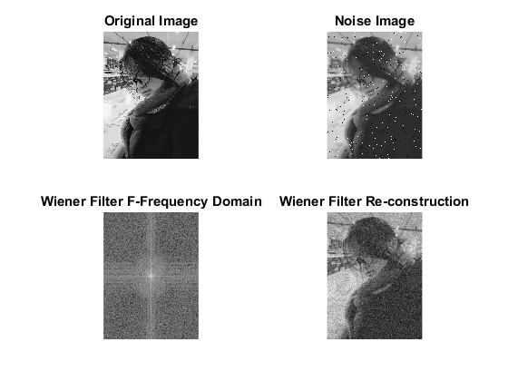
Published with MATLAB® R2016b

