MLV Resolve FS
v2.8 User Guide
Magic Lantern MLV footage in DaVinci Resolve without a full CinemaDNG export

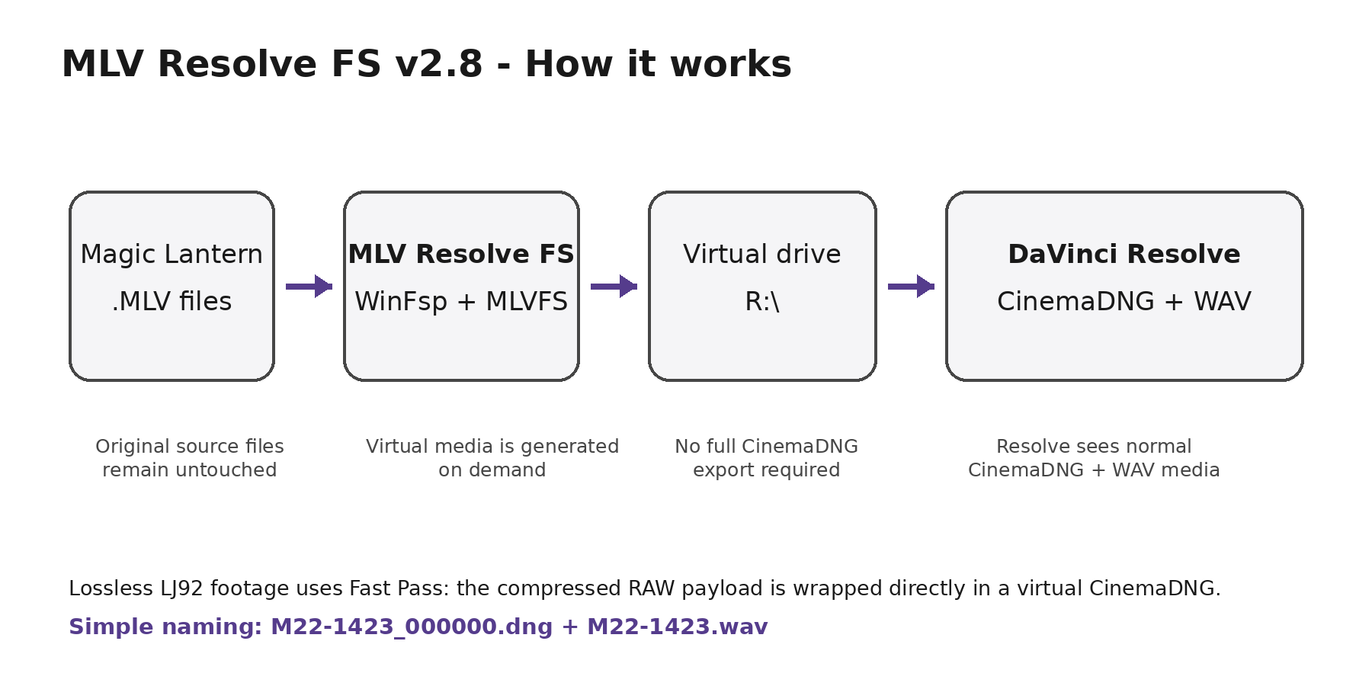
Windows 10/11 • DaVinci Resolve Free or Studio • WinFsp/FUSE + MLVFS
Documentation for MLVResolveFS-v2.8-OneClick • 22 September 2026

Quick start
What it does: MLV Resolve FS mounts a folder of Magic Lantern .MLV recordings as a virtual Windows drive. Resolve sees cleanly named CinemaDNG sequences and matching WAV audio, while the original MLV files remain untouched.

1. Close DaVinci Resolve and unmount any older MLV Resolve FS drive before installing or updating.
2. Extract MLVResolveFS-v2.8-OneClick.zip and run INSTALL-MLV-RESOLVE-FS.cmd normally. Approve UAC when Windows asks.
3. When installation finishes, close the Administrator installer. Launch MLV Resolve FS from the Desktop or Start Menu normally — not as Administrator.
4. Choose the folder containing the MLV footage, select a free virtual drive letter such as R:, leave Simple Resolve naming enabled, and click Mount for Resolve.
5. Open DaVinci Resolve and browse to the virtual drive. Import the clip using the clean folder/sequence names.
6. Keep the virtual drive mounted while Resolve is using the media. When finished, close the project/Resolve and click Unmount.
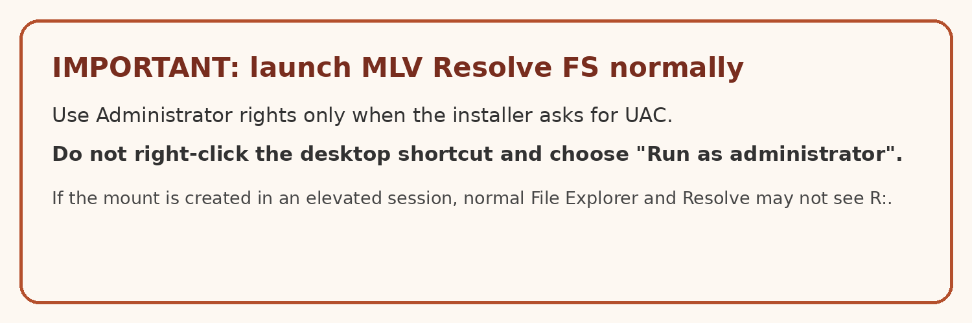

1. What MLV Resolve FS is
MLV Resolve FS is a Windows bridge for Magic Lantern RAW video. It does not add native .MLV decoding to DaVinci Resolve. Instead, it uses a userspace filesystem so Resolve can access each MLV recording as virtual CinemaDNG media.
- The original .MLV, .M00, .M01 and other split recording files stay where they are.
- The virtual DNG files are created on demand; a second full CinemaDNG copy of the shoot is not required.
- Lossless LJ92 recordings use a Fast Pass path that places the original compressed RAW payload inside the virtual DNG wrapper.
- A matching virtual WAV is exposed alongside each DNG sequence.
- Simple filenames allow Resolve to recognise the image sequence naturally without the helper scripts used in earlier development versions.

2. Requirements
- Windows 10 or Windows 11, 64-bit.
- DaVinci Resolve Free or DaVinci Resolve Studio.
- Administrator permission during installation only.
- A source drive containing Magic Lantern MLV recordings.
- Enough source-drive performance for the resolution and frame rate being edited. The virtual workflow avoids a full DNG export, but it still has to read the MLV data in real time.
Installed automatically: The full installer installs or repairs the WinFsp/Cygwin/MLVFS backend as required. You do not need to manually set up WinFsp, Cygwin, Git or the compiler toolchain.

3. Installation
1. Extract the ZIP to a normal folder. Do not run it directly from inside the compressed ZIP.
2. Double-click INSTALL-MLV-RESOLVE-FS.cmd.
3. Approve the Windows UAC prompt when it appears. The installer uses elevated rights for the backend installation.
4. Wait for the installer to report that the backend is ready. Installer logs are written to C:\ProgramData\MLVResolveFS\logs\.
5. Close the elevated installer window.
6. Launch MLV Resolve FS from the Desktop or Start Menu normally.
INSTALL-MLV-RESOLVE-FS.cmd
Do not run the launcher as Administrator. An elevated mount can be visible only to the Administrator security session. File Explorer and Resolve running normally may then report that R: is unavailable.

Updating from v2.7
If the v2.7 backend is already working and you only want the streamlined v2.8 launcher/installer, use:
UPDATE-TO-V2.8-NO-BACKEND-REBUILD.cmd
A full install is still available at any time if the backend needs to be rebuilt or repaired.

4. The MLV Resolve FS launcher
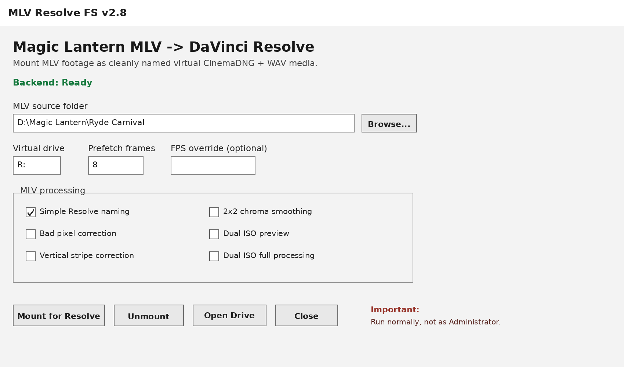
MLV source folder: Choose the folder containing the .MLV recordings. Split .M00/.M01/etc. files stay with the recording.
Virtual drive: Choose the drive letter Resolve will see. R: is a convenient default; any unused letter is fine.
Prefetch frames: 8 is a sensible starting point for preparing upcoming frames.
FPS override: Leave blank unless you deliberately need to override the clip frame rate.
Simple Resolve naming: Keep enabled. This is the working Resolve-friendly layout.
Processing options: Bad pixel, stripes, chroma smoothing and Dual ISO are ignored for lossless Fast Pass clips.
Mount / Unmount / Open Drive: Mount creates the virtual drive; Unmount stops it after Resolve has finished; Open Drive opens the mounted location in Explorer.
Install / Repair Backend: Use this when the backend status is not Ready.

5. Simple Resolve naming
The final working change was to expose each recording with a short shared basename. This allows Resolve to recognise the DNG sequence cleanly and avoids the long timestamp-heavy names used during development.
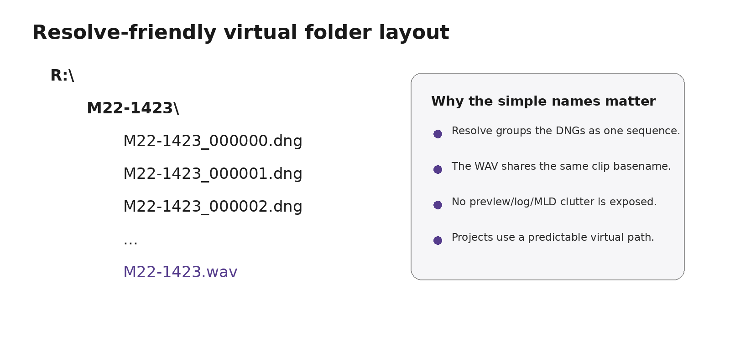
For a source recording named M22-1423.MLV, the mounted media looks like:
R:\M22-1423\
M22-1423_000000.dng
M22-1423_000001.dng
M22-1423_000002.dng
...
M22-1423.wav
The folder, the DNG image sequence and the WAV all share the same basename. Preview GIFs, logs, MLD sidecars and other MLVFS clutter are not exposed in the clean Resolve view.

Real mounted result
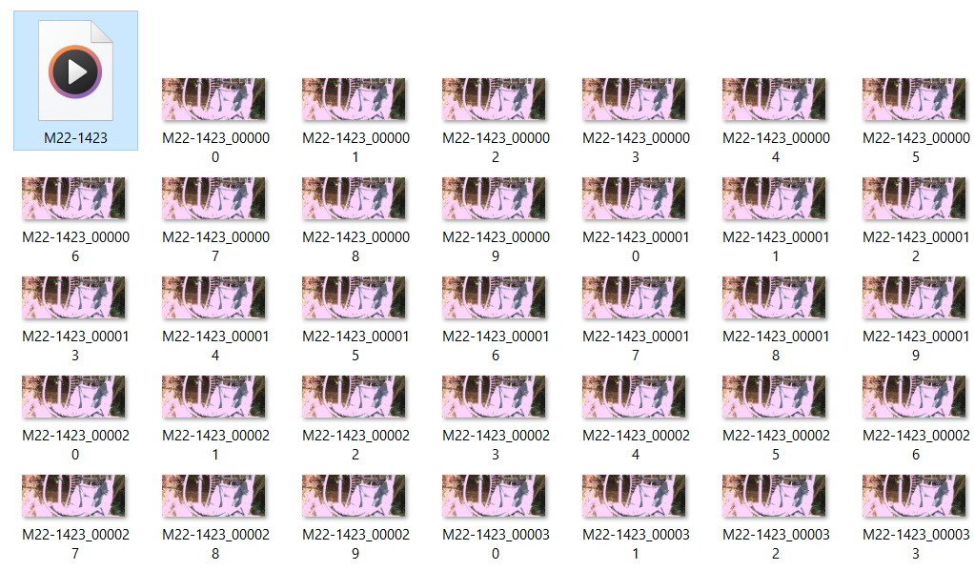
Example of the simplified virtual frame naming in Windows.

6. Editing in DaVinci Resolve
1. Mount the source folder before importing or relinking the media in Resolve.
2. Open Resolve and go to the Media page.
3. Browse to the selected virtual drive, for example R:.
4. Open the clip folder. Resolve should recognise the numbered DNG files as a CinemaDNG image sequence rather than hundreds of unrelated stills.
5. Import the clip into the Media Pool. The matching WAV is exposed with the same basename.
6. Edit and grade the CinemaDNG media normally. Keep MLV Resolve FS running and the source drive connected for the whole session.
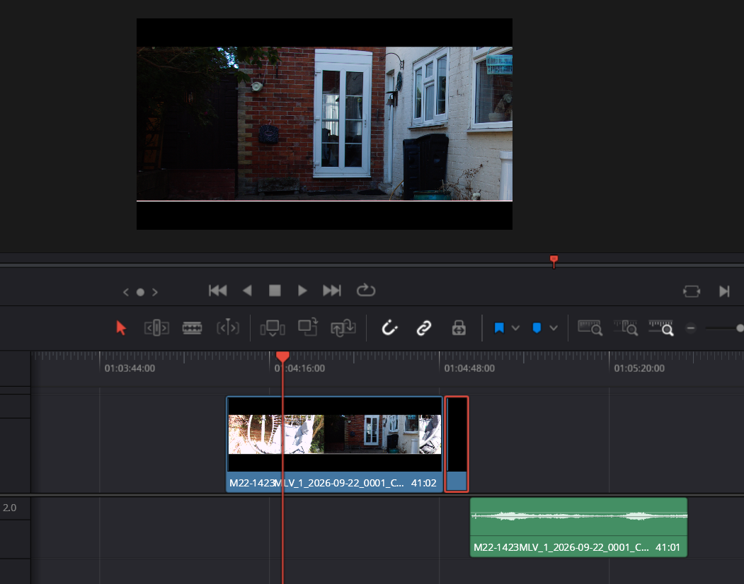
Working virtual MLV media in Resolve after the per-frame sizing and trailing-frame fixes.
Reopening a project later: Mount the same source folder to the same virtual drive letter before opening the project. Resolve stores media paths, so changing R: to another drive letter can make previously imported clips appear offline.

7. Finishing a session
1. Save the Resolve project.
2. Close the project or quit Resolve so it is no longer reading the virtual files.
3. Return to MLV Resolve FS and click Unmount.
4. Only then disconnect or eject the source drive if required.
The virtual DNGs are temporary. They disappear when the filesystem is unmounted. Your MLV source files are not deleted or modified.

8. Troubleshooting

R: is unavailable in File Explorer
- Close MLV Resolve FS completely.
- Make sure you are not launching the Desktop/Start Menu shortcut with Run as administrator.
- Launch it normally and mount again.
- Choose another unused drive letter if R: is already occupied.

Backend: Not installed / incomplete
- Click Install / Repair Backend.
- Approve UAC and allow the build/repair process to finish.
- Check the newest installer log if the repair stops.
C:\ProgramData\MLVResolveFS\logs\

Resolve shows Media Offline
- Confirm the virtual drive is mounted and accessible in normal File Explorer.
- Confirm Simple Resolve naming is enabled.
- If the clip was imported using an older MLV Resolve FS build, remove it from the Media Pool and re-import after mounting v2.8.
- When reopening an existing project, mount the same source to the same drive letter first.
- Restart Resolve if it has cached thumbnails/media information from an older mount layout.

Audio is missing
- Open the virtual clip folder and confirm a matching WAV exists, for example M22-1423.wav.
- Use v2.8 simple naming so the DNG sequence and WAV have the same basename.
- If Resolve was already open during a mount/layout change, remove and re-import the clip so it rescans the mounted media.

Mount logs
%LOCALAPPDATA%\MLVResolveFS\mount-stderr.log
%LOCALAPPDATA%\MLVResolveFS\mount-stdout.log

Old helper scripts still appear in Resolve
v2.8 no longer uses Resolve Lua/Python helper scripts. The v2.8 installer/update removes helper scripts left by earlier development versions. If Resolve was open during the update, restart Resolve.

9. Technical notes
- MLV Resolve FS is a userspace filesystem bridge built around WinFsp/FUSE and a modified MLVFS backend.
- It is not a native DaVinci Resolve codec plugin. Resolve sees standard virtual CinemaDNG/WAV media.
- Lossless LJ92 Fast Pass avoids the obsolete MLVFS decompression path and preserves the original compressed RAW payload inside the DNG wrapper.
- Virtual DNG file sizes are calculated per frame. This is essential because lossless JPEG frame sizes vary from frame to frame.
- Trailing invalid/extra items are suppressed in the clean Resolve view.
- The simple basename layout is deliberately conservative because Resolve image-sequence grouping is most reliable with a stable prefix plus zero-padded frame number.

10. Known limitations and good practice
- The project depends on the virtual path. Remount to the same drive letter when continuing an edit.
- Do not rename or move source MLV files while a project is using the mounted media.
- Do not unmount while Resolve is playing, caching, conforming or rendering the virtual media.
- Fast Pass is designed for compatible lossless MLV footage. Pixel-domain correction checkboxes are not applied to compressed Fast Pass frames.
- Performance depends on the source disk, recording resolution, CPU and Resolve cache settings.
- Keep the original MLV files as the camera masters. The virtual DNGs are a working view, not a replacement archive.

11. Package commands
File | Purpose
INSTALL-MLV-RESOLVE-FS.cmd | Full install/update including backend repair/build.
MLV-RESOLVE-FS.cmd | Launch the application.
REPAIR-OR-UPDATE.cmd | Repair/update an installed backend.
UPDATE-TO-V2.8-NO-BACKEND-REBUILD.cmd | Update a working v2.7 install to the streamlined v2.8 app without rebuilding the backend.
FIX-LAUNCHER-ONLY.cmd | Repair the installed launcher only.
UNINSTALL-MLV-RESOLVE-FS.cmd | Remove MLV Resolve FS.

Project status: v2.8 is the streamlined build that retains the working Fast Pass backend and simple Resolve naming while removing the experimental Resolve scripting layer used during development.

