Home Page wireframe, mock up and prototype

Page Title: Home Page

Text Box containing a brief introduction to all the elements on the website and how the page runs.

Text Box containing general text about me and what there is to expect on the website.

Sticky Nav Bar:

Home Page Project Page CV Page Contact Me

Text Box with external hyperlink

(Use is still to be decided)

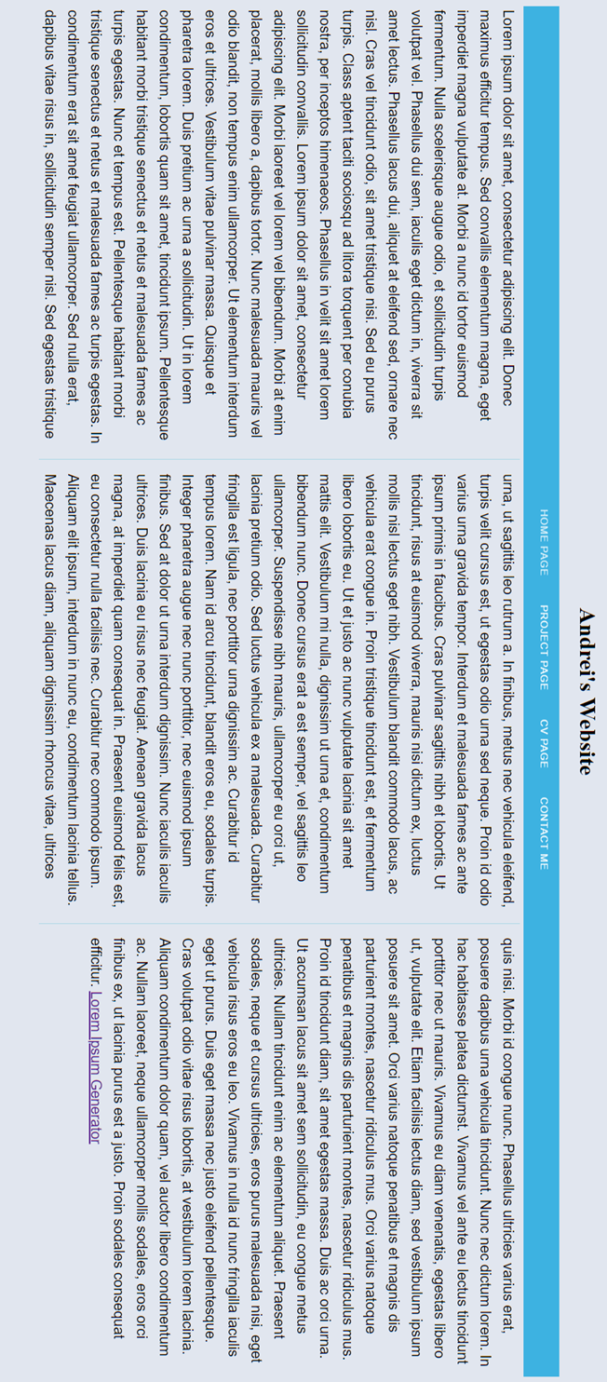

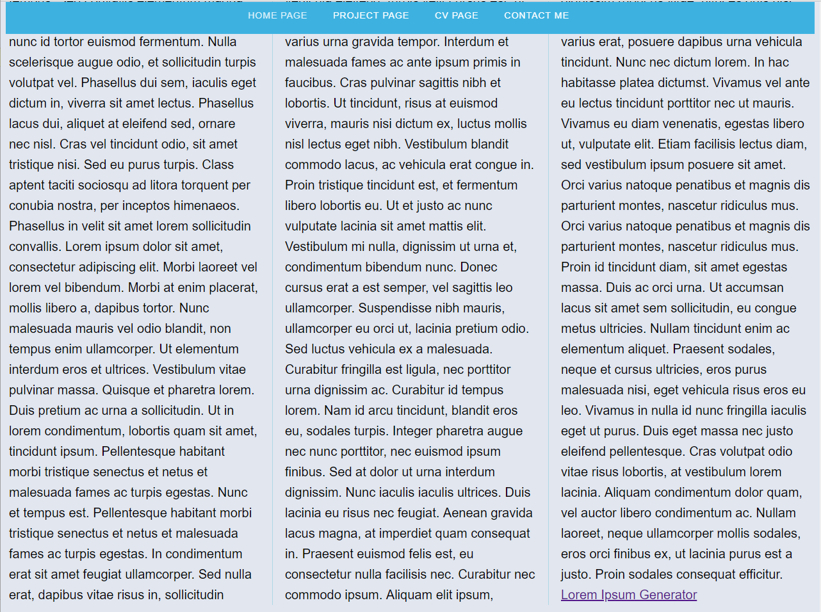

Project Page wireframe mock up and prototype

Page Title: Project Page

Text Box containing text relevant to past projects

Sticky Nav Bar:

Home Page Project Page CV Page Contact Me

YouTube player showing a project I have done

Text Box containing text relevant to future projects

Text Box containing text relevant to current projects

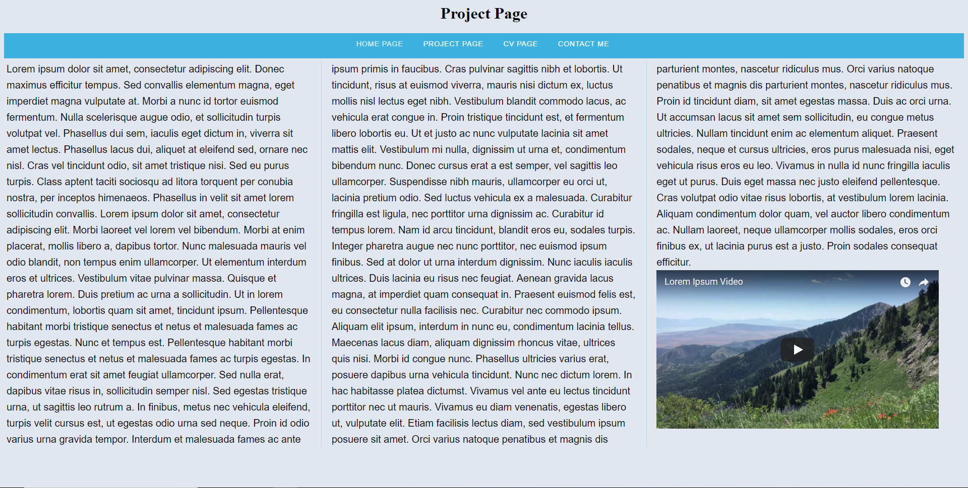

CV page wireframe mock up and prototype

Page Title: CV Page

Text Box containing text relevant to my finalised CV

Text Box containing text relevant to how I constructed my CV

Text Box containing text relevant to CV with external hyperlink at the bottom to an external page where the CV can be read (or a download link like a PDF)

Sticky Nav Bar

Home Page Project Page CV Page Contact Me

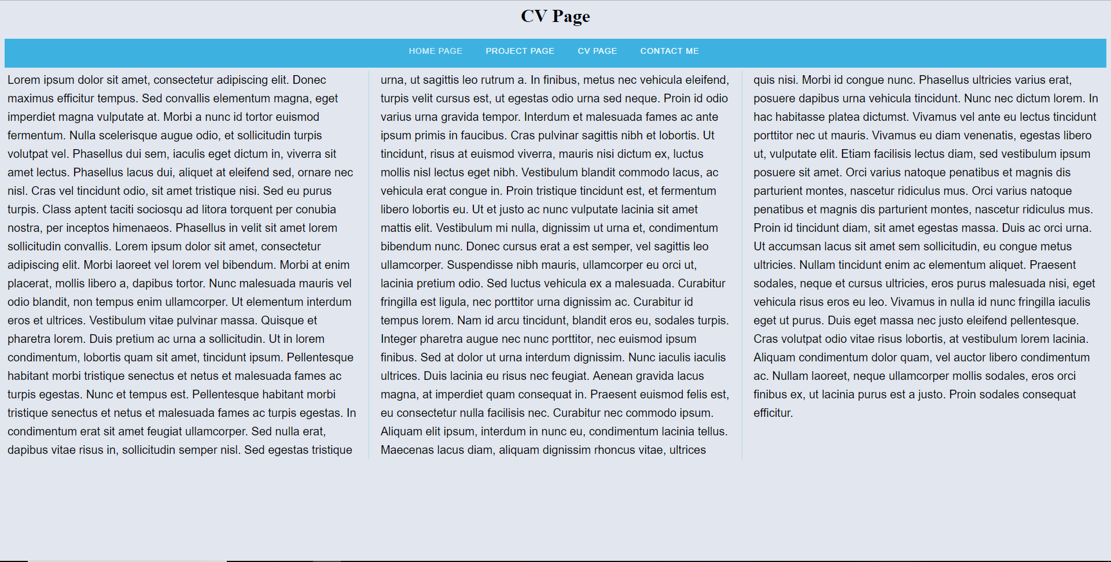

Contact me page wireframe mock up and prototype

Page Title: Contact Me

#

Sticky Nav Bar:

Home Page Project Page CV Page Contact Me

Form

Name:

Email:

Query:

Table displaying content submitted in form

Name: Email: Query:

Image

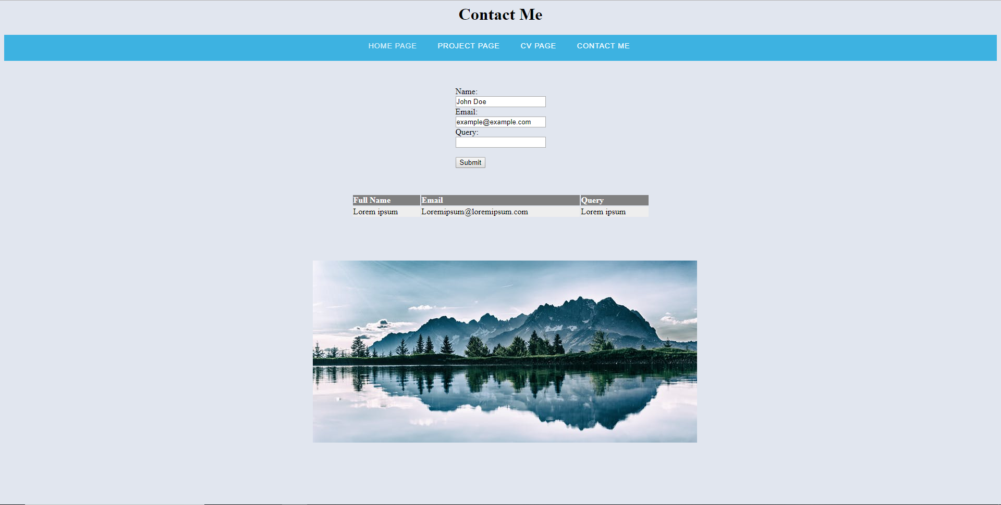

***Homepage:***

The Homepage has a very simple but effective design. I have minimised the use of elements and split the text up in 3 columns as I believe that it makes the web page easier to read. I have also included a hyper link at the end as a small extra feature. I have not yet decided what it’s use will be, but I will do so in the coded version of the website. I also plan on implementing a sticky navigation bar to make it easier for a user to move across pages. I have chosen a neutral grey background as I think it gives the web page a more professional look. The Nav Bar is blue so that it transitions smoothly from the grey background. I have left title slightly bigger than to font to make sure it stands out clearly above the nav bar and attracts the user’s attention to it before looking at other elements. I am unsure whether to align the text to justify or to keep it as it is. I believe that it might be difficult to implement as I am unsure if alignment works on columns.

***Project Page:***

The overall design of my project page is somewhat similar to my Homepage. I have kept the same navigation bar, title font and font size, background and text colour. I have yet again added a 3 column text split design but I have included a YouTube player at the bottom of the third column. This currently only plays a filler video, but I plan on replacing it to a relevant video that complements my past projects. Additionally, I plan on using external hyperlinks to show off the other projects I have created or a picture gallery as an extra feature.

***CV Page:***

I have left the CV page similar to the home page as I do not believe that I can implement anything interesting without breaking the flow of text unnecessarily. I have thought about implementing external links or snapshots of my CV but I am not sure that there is a need to do this. I have also thought about removing the columns and keeping the CV as a continuous flowing piece of text. I am unsure on whether I should align the text to centre or the left If I do remove the columns, but I will create iterations of code that has these options when I build the website.

***Contact Me:***

The contact me page is quite different from the other 3. For a start I have 3 cantered elements, this is not present anywhere else in my website. Additionally, I also have a form so that the user can directly contact me through the website. I plan on having the table below display the information they have sent me until the page is refreshed. There is also a stock photo of scenery, this is currently only a filler picture, but I will change that to a relevant picture in the coded version. There are also no columns on this page as I do not believe there is any need for them. Furthermore I am considering adding some external hyperlinks such as Facebook, Twitter and google button as well as a phone number to offer the user various different methods of contacting if they do not have access to an email.

***Design Report***

To aid with visual accessibility, I have changed the background colour from a bright white to a medium/light grey. I have done this to avoid a sharp contrast between the black and white and risk straining user’s vision, especially during at night. I have spread the text across three different columns to help it flow and break up massive paragraphs. I have also used a slightly bigger than normal font so that users with poor vision can read all the text easily. In addition, I have used a simple and easy to read font to further aid with sight issues.

I have not implemented any sort of Text to Speech services as those are already supplied by the browsers.

In terms of communication and cognitive accessibility, for the time being I have standard filler text, but I plan on implementing an easy to understand vocabulary within the website and eliminate any words that are too long are have multiple meanings.

I have taken care of the Physical Accessibility by having big buttons on my navigation bar to make it easier for people with bad motor skills to access the different parts of the page. I plan on making the boxes rotate, to show the user that they have their mouse over the internal link. I have also used a grey form on the Contact Me page. I have left it that colour so that it complements the background and doesn’t cause a sharp contrast or mismatch of colours, making the website unappealing. In addition, I have cantered most of my elements to avoid eye strain on big monitors. I have also implemented a YouTube player to a random video (I will change that in the final copy) and an external hyper link to a filler text generator. I have a random picture (Will be changed in the final) that I plan to centre in the final copy. The image also contains an alt tag to aid the understanding of people with stages of blindness.

To deal with cognitive accessibility on my form I have implemented example inputs to make it easier for the user to understand what they are required to fill in.

In addition to all of this, I will make my navbar sticky for quick access to a different page and to avoid implementing a “To Top” button or link which might be harder to click on for some users. Overall, I have taken extra care in the implementation of accessibility for people with various disabilities and I am looking to add extra features in the final coded version of the website, such as a search bar, that may or may not be implementable in a reasonable amount of time. There are also a few extra features that I plan to add but they might be useless, so I have not listed them here as more research needs to be done into the technicality of these elements.