TETRAD PROTOCOL | QUANTITATIVE RESEARCH

A Risk-Adjusted Deep-Learning Meta-Allocator for a Multi-Strategy Crypto Trading Stack
Coordinating Praxis, Satoshi, Arrow, and Hedge through structured temporal memory and feature selection
Tetrad Protocol — Quantitative Research
Working Paper TPR-2026-04 | April 2026 | Version 1.0
JEL Classification: C45, C53, G11, G17 | Keywords: deep learning, portfolio construction, regime detection, risk-adjusted optimization, cryptocurrency markets
Abstract
We propose a meta-allocation framework that supervises a heterogeneous suite of systematic crypto trading strategies — Praxis (mean reversion), Satoshi (trend), Arrow v1 and v2 (market structure), and Hedge (drawdown compression) — using a deep neural architecture trained directly on a risk-adjusted objective. The framework adapts the design principles established by Saly-Kaufmann, Wood, Calliess and Zohren (Oxford, 2026), whose large-scale benchmark of sixteen architectures demonstrates that hybrid models combining a Variable Selection Network with recurrent temporal memory (VLSTM) deliver the highest annualized Sharpe ratio (2.39) over a fifteen-year cross-asset futures sample, alongside a HAC-adjusted t-statistic of 8.81 and an information ratio of 0.85 against a passive benchmark. Rather than constructing a single price predictor, we treat the existing strategy stack as a collection of conditionally specialised experts and learn a state-dependent allocation policy over them, governed by a Variable Selection Network, an LSTM/xLSTM temporal encoder, and multiple output heads for regime classification, directional permission, capital weighting, and risk estimation. The system is bounded by a Risk Governor that enforces hard constraints on drawdown, value-at-risk, and turnover. The architecture is designed to improve portfolio-level Sharpe, Sortino, Calmar, conditional value-at-risk, and seed stability, while maintaining transaction-cost robustness in a market microstructure characterised by elevated frictions. We outline the data construction, training objective, walk-forward validation protocol, and a phased deployment roadmap. All performance claims are framed as testable hypotheses, not promises.

1. Introduction
Cryptocurrency markets exhibit several stylised facts familiar from the broader asset-pricing literature — heavy-tailed return distributions, volatility clustering, regime persistence with abrupt transitions, and pronounced deviations from Gaussianity — but in compressed time and at amplified magnitudes. The combination of continuous trading, retail-dominated flow, embedded leverage through perpetual swaps, and the absence of a circuit-breaker infrastructure produces a return-generating process that is simultaneously more predictable in its behavioural patterns and more punishing in its tail realisations than equity or commodity futures markets.
Tetrad Protocol's existing infrastructure already contains the building blocks of a multi-regime trading framework. Five distinct alpha and defence engines — Praxis (mean reversion), Satoshi (trend continuation), Arrow v1 and Arrow v2 (market-structure detection in the Wyckoff tradition), and Hedge (adverse-excursion compression) — operate alongside a Risk Governor enforcing exposure constraints and a Machine-Learning Trend Timing / Risk-On-Risk-Off (MLTT/RORO) layer providing a directional bias. The challenge addressed in this paper is not the construction of additional signals but rather the coordination of those that already exist. Specifically, we ask: given a portfolio of conditionally specialised strategies, can a deep learning meta-allocator improve aggregate risk-adjusted performance by learning when to allocate capital to which strategy under which market state?
The motivating evidence comes from the Oxford / Oxford-Man Institute benchmark by Saly-Kaufmann, Wood, Calliess and Zohren (2026), hereafter SWCZ, which evaluates sixteen deep learning architectures on a daily futures dataset spanning commodities, equity indices, bonds, and foreign exchange from 2010 through 2025. Three findings from that work shape our design. First, prediction accuracy and risk-adjusted trading performance are not equivalent objectives, and direct optimisation of the negative annualised Sharpe ratio produces materially different solutions than mean-squared-error minimisation. Second, architectural inductive bias — specifically the combination of dynamic feature selection with structured temporal memory — matters more than raw parameter count or attention complexity. Third, robustness across multiple dimensions (downside risk, breakeven transaction cost, seed stability) is at least as economically meaningful as headline Sharpe.
The remainder of this paper is organised as follows. Section 2 summarises the SWCZ benchmark results that we treat as design priors. Section 3 formalises the meta-allocation problem and presents the proposed architecture. Section 4 describes the strategy roles and the regime-conditional allocation logic. Section 5 specifies the training objective, dataset construction, and label-generation procedure. Section 6 details the walk-forward validation protocol and evaluation metrics. Section 7 outlines the phased deployment roadmap. Section 8 discusses limitations and concludes.

2. Evidence from the Oxford Benchmark
SWCZ (2026) benchmark sixteen architectures spanning four design families: linear baselines (AR1x, ARnnx, DLinear, NLinear), recurrent networks (LSTM, xLSTM, PsLSTM), transformer-based models (iTransformer, PatchTST), state-space models (Mamba, Mamba2), and hybrid architectures combining feature-selection and temporal-memory components (VLSTM, VxLSTM, VSN+Mamba2, LPatchTST, TFT). All models share a common training pipeline: a sequence encoder produces a hidden state which is projected through a tanh activation to a position in [−1, +1], multiplied by an EWMA-based volatility scaling factor targeting 10% annualised portfolio volatility, and trained end-to-end against the negative annualised Sharpe ratio computed on pooled portfolio returns.
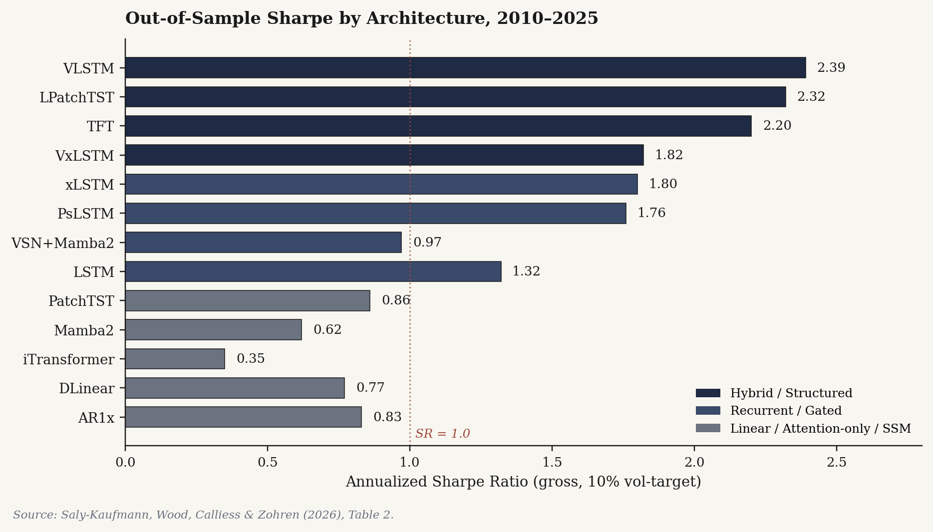
Figure 1. Out-of-sample Sharpe ratio by architecture, 2010–2025. Hybrid models that combine feature selection with structured temporal memory occupy the top of the ranking, with VLSTM at 2.39 and LPatchTST at 2.32. Linear baselines and attention-only architectures cluster below the SR = 1.0 threshold. Reproduced from SWCZ (2026), Table 2.

2.1 Risk-adjusted performance
Table 1 reports the headline performance metrics from SWCZ (2026), Table 2, for the full 2010–2025 evaluation window under the 10% volatility-targeting constraint. The hybrid VLSTM architecture delivers the strongest aggregate result — 23.9% annualised return at a Sharpe ratio of 2.39 with a HAC-adjusted t-statistic of 8.81, an information ratio of 0.85 against the passive long-only benchmark, and a directional hit rate of 58.8%. LPatchTST and TFT follow closely, with Sharpe ratios of 2.32 and 2.20 respectively. The xLSTM architecture is notable for achieving 1.80 Sharpe at substantially lower turnover (483 versus 967 for VLSTM), producing the highest information ratio per unit of trading intensity in the benchmark.
Table 1. Aggregate out-of-sample performance, 2010–2025 (10% vol-target). Source: SWCZ (2026), Table 2.
Model | CAGR | Ann. Ret. | Sharpe | t (HAC) | Hit | Info. Ratio | Corr. v Passive
Passive | 0.044 | 0.048 | 0.48 | 1.65 | 0.531 | — | —
AR1x | 0.081 | 0.083 | 0.83 | 3.12 | 0.539 | −0.009 | 0.353
DLinear | 0.075 | 0.077 | 0.77 | 2.87 | 0.539 | 0.014 | 0.261
iTransformer | 0.031 | 0.035 | 0.35 | 1.26 | 0.529 | −0.154 | 0.486
Mamba2 | 0.059 | 0.062 | 0.62 | 2.31 | 0.546 | −0.090 | 0.222
PatchTST | 0.085 | 0.086 | 0.86 | 3.29 | 0.541 | −0.215 | 0.553
LSTM | 0.135 | 0.132 | 1.32 | 4.56 | 0.554 | −0.064 | 0.282
VSN+Mamba2 | 0.097 | 0.097 | 0.97 | 3.65 | 0.555 | 0.109 | 0.282
PsLSTM | 0.187 | 0.176 | 1.76 | 6.83 | 0.563 | 0.398 | 0.486
xLSTM | 0.194 | 0.180 | 1.80 | 6.85 | 0.568 | 0.798 | 0.627
VxLSTM | 0.194 | 0.182 | 1.82 | 6.89 | 0.574 | 0.467 | 0.507
TFT | 0.240 | 0.220 | 2.20 | 8.13 | 0.584 | 0.667 | 0.389
LPatchTST | 0.255 | 0.232 | 2.32 | 8.81 | 0.577 | 0.707 | 0.347
VLSTM | 0.263 | 0.239 | 2.39 | 8.81 | 0.588 | 0.854 | 0.404
Notes. CAGR and annualised return reported as decimals. HAC t-statistics computed under Newey–West heteroskedasticity- and autocorrelation-consistent inference. Information ratio and correlation are measured against a passive long-only benchmark. The two strongest hybrid models, VLSTM and LPatchTST, are highlighted in bold.

2.2 Stability across regimes
Aggregate Sharpe ratios can mask substantial intertemporal heterogeneity. Figure 3 reports sub-period Sharpe ratios across three five-year windows, isolating the post-GFC trend regime (2010–2015), the low-volatility expansion (2015–2020), and the high-uncertainty regime initiated by the 2020 pandemic shock. Three patterns emerge. First, the linear AR1x and iTransformer baselines exhibit near-zero or weakly negative Sharpe ratios in the 2015–2020 window, consistent with the documented difficulty of linear and attention-only architectures in low-signal regimes. Second, classical LSTM degrades materially in the post-2020 window (1.07 versus 1.83 in 2010–2015), suggesting a regime-specific decay. Third, the hybrid VLSTM, LPatchTST, and TFT architectures maintain Sharpe ratios above 2.0 in two of three windows and never fall below 1.88, indicating that the structural inductive biases of feature selection and gated recurrence translate into intertemporal robustness.
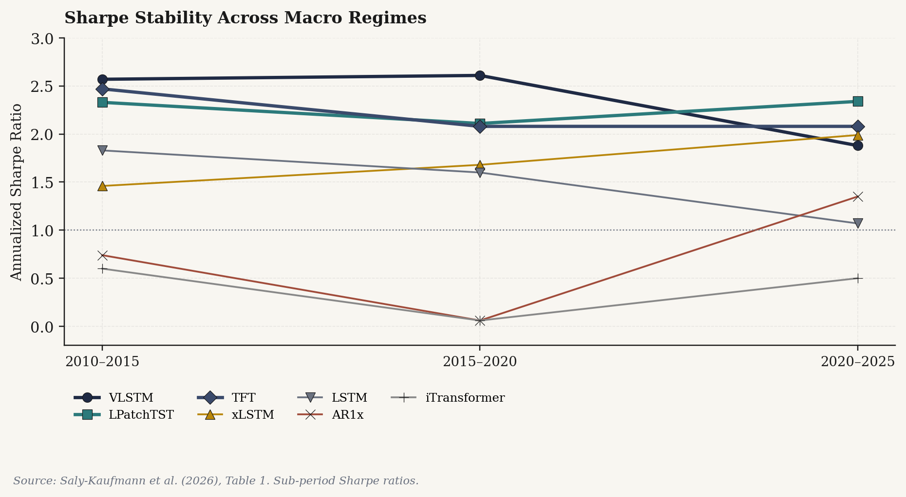
Figure 2. Sharpe ratio stability across five-year sub-periods. Hybrid architectures (VLSTM, LPatchTST, TFT) maintain risk-adjusted performance above 1.88 across all three windows; linear and attention-only baselines collapse during the low-signal 2015–2020 regime. Source: SWCZ (2026), Table 1.

2.3 Downside risk and tail behaviour
From an institutional perspective, average risk-adjusted return is necessary but not sufficient. Capital allocators must also evaluate behaviour in adverse market states. Table 2 reports the downside metrics from SWCZ (2026), Table 3, including maximum drawdown, the Calmar ratio (annualised return divided by maximum drawdown), the worst three-month rolling Sharpe ratio, the minimum annual Sharpe ratio, and the 5% conditional value-at-risk (CVaR). VxLSTM exhibits the smallest maximum drawdown at 11.8% and the highest Calmar at 1.64, although its mean Sharpe is below VLSTM. LPatchTST achieves the only positive minimum annual Sharpe (+0.51), an unusual property in this sample. The classical LSTM, despite its respectable mean Sharpe of 1.32, draws down 34.2% in the worst episode — more than twice the drawdown of VxLSTM and substantially worse than the passive benchmark on a Calmar basis.
Table 2. Downside risk and tail behaviour, gross returns. Source: SWCZ (2026), Table 3.
Model | Max DD | Calmar | Worst 3m Sharpe | Min Ann. Sharpe | CVaR 5%
Passive | −0.308 | 0.14 | −6.11 | −1.53 | 0.0144
AR1x | −0.167 | 0.49 | −3.92 | −0.59 | 0.0147
DLinear | −0.180 | 0.42 | −4.93 | −0.94 | 0.0149
iTransformer | −0.264 | 0.12 | −3.93 | −1.16 | 0.0154
Mamba2 | −0.263 | 0.22 | −4.06 | −0.71 | 0.0149
PatchTST | −0.176 | 0.48 | −5.58 | −1.21 | 0.0151
LSTM | −0.342 | 0.40 | −5.15 | −1.51 | 0.0143
VSN+Mamba2 | −0.163 | 0.59 | −4.00 | −0.63 | 0.0148
PsLSTM | −0.131 | 1.43 | −3.80 | −0.40 | 0.0143
xLSTM | −0.141 | 1.35 | −3.57 | −0.28 | 0.0141
VxLSTM | −0.118 | 1.64 | −3.70 | −1.31 | 0.0139
TFT | −0.232 | 1.03 | −3.87 | −0.14 | 0.0141
LPatchTST | −0.174 | 1.47 | −3.91 | +0.51 | 0.0136
VLSTM | −0.229 | 1.15 | −3.68 | −0.10 | 0.0137
Notes. Maximum drawdown reported as negative decimal. Calmar ratio computed as annualised return divided by absolute maximum drawdown. CVaR 5% is the conditional expectation of daily losses in the worst 5% of the return distribution.
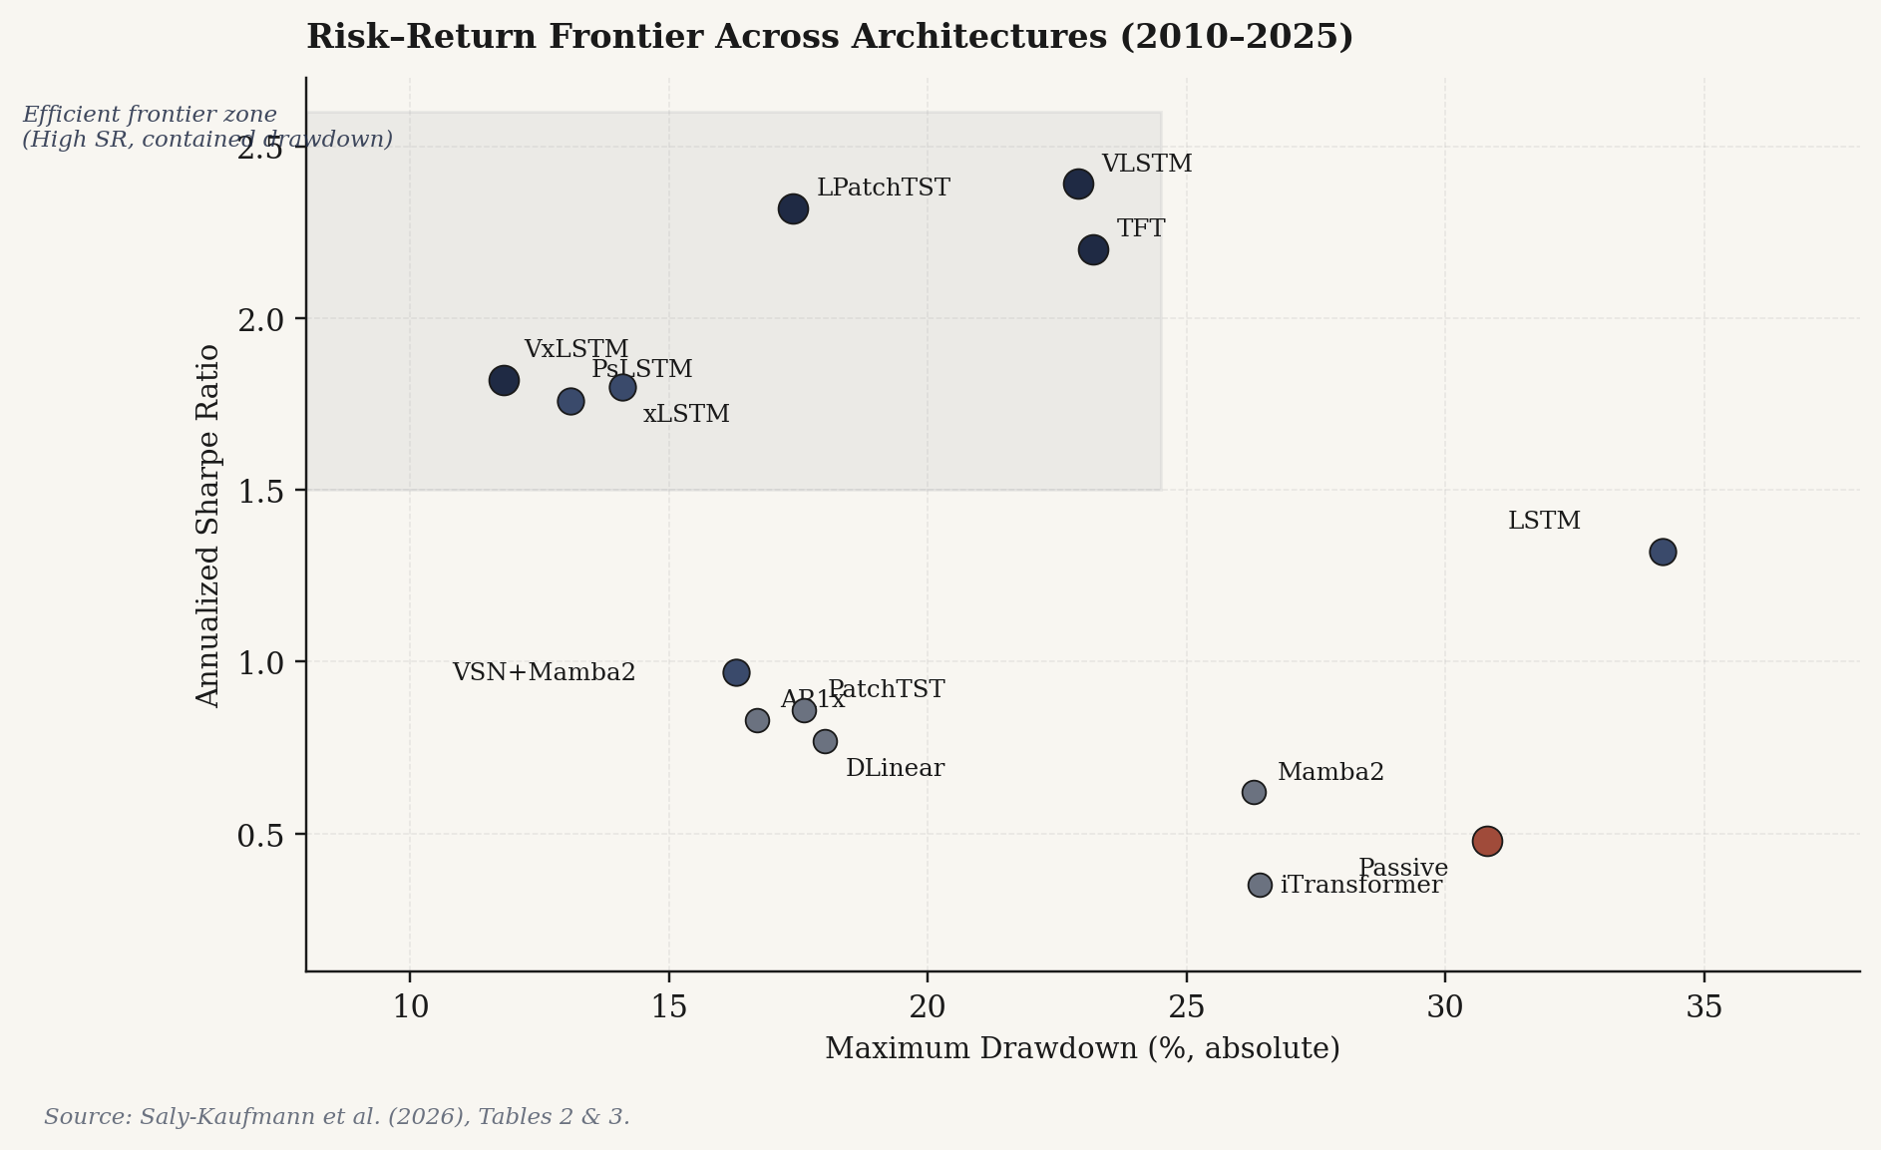
Figure 3. Risk–return frontier across architectures, 2010–2025. The shaded region delineates the high-Sharpe / contained-drawdown zone. Hybrid architectures (VLSTM, LPatchTST, TFT, VxLSTM) dominate the frontier; the passive benchmark and attention-only iTransformer cluster in the inefficient region. Source: SWCZ (2026), Tables 2 & 3.

2.4 Transaction cost robustness
SWCZ (2026) report a per-asset breakeven transaction cost analysis, defined as the maximum constant proportional friction (in basis points) at which the cumulative profit-and-loss path remains non-negative. The xLSTM architecture demonstrates the highest portfolio-level breakeven buffer in their analysis, exceeding VLSTM despite a lower mean Sharpe ratio. The mechanism is straightforward: xLSTM achieves comparable signal extraction at roughly half the turnover, raising the cost barrier at which the strategy ceases to be economically viable. Figure 4 plots Sharpe ratio against annualised turnover and highlights this efficiency.
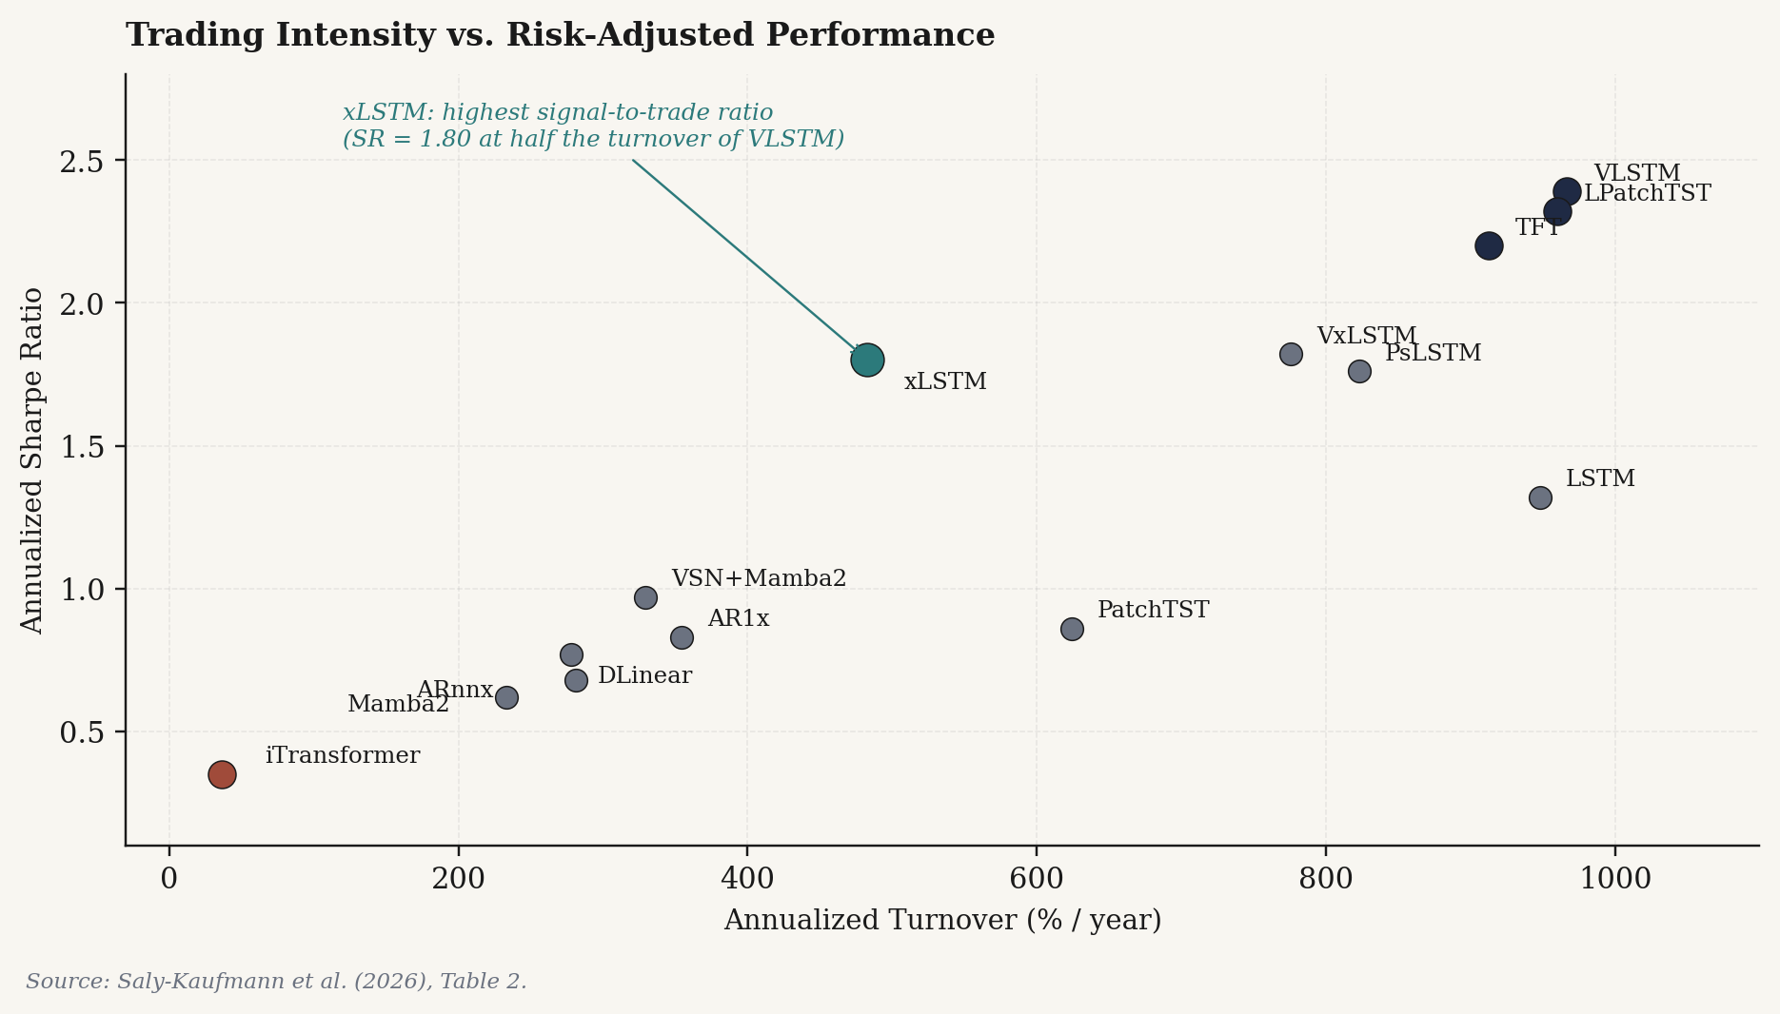
Figure 4. Trading intensity versus risk-adjusted performance. xLSTM delivers Sharpe of 1.80 at half the turnover of VLSTM, producing the strongest signal-to-trade efficiency in the benchmark. iTransformer's extreme turnover compression (36 per year) coincides with the lowest Sharpe (0.35), suggesting under-reactivity rather than discipline. Source: SWCZ (2026), Table 2.
The cross-sectional implication is that the highest Sharpe architecture (VLSTM) and the most cost-efficient architecture (xLSTM) are not the same model. For deployment in markets with material frictions — and crypto markets, despite their nominal liquidity, exhibit non-trivial slippage in size — this suggests an ensemble approach in which signal-quality and cost-efficiency are simultaneously optimised, rather than a single-architecture choice.

2.5 Seed stability
A persistent concern with deep learning in finance is that reported performance reflects favourable initialisation rather than structural edge. SWCZ (2026) address this directly by re-running their main analysis under a reduced experimental budget — 25 random seeds with averaging over the top 5 by validation loss, rather than 50 seeds with top 10 — and report that the rankings and economic magnitudes are largely preserved. The VLSTM Sharpe ratio under reduced budget is 2.40 (versus 2.39 under full budget) with HAC t-statistic of 8.86; the VxLSTM Calmar ratio improves marginally from 1.64 to 1.88. This stability strengthens the inference that the observed performance differentials are properties of the architectural inductive bias rather than artefacts of seed selection.
Design priors imported from SWCZ (2026)
(i) Optimise risk-adjusted performance directly; do not use mean-squared-error proxies. (ii) Combine dynamic feature selection (VSN) with structured temporal memory (LSTM or xLSTM) — this combination dominates pure attention, pure state-space, and pure linear architectures across return, downside, and stability dimensions. (iii) Evaluate models multi-dimensionally: mean Sharpe, Calmar, worst-period Sharpe, breakeven transaction cost, and seed stability are non-redundant. (iv) Do not assume that the highest-Sharpe model is the best deployment choice; cost efficiency and tail behaviour matter independently.

3. Problem Formalisation

3.1 Strategy stack as a basis of conditional experts
Let the existing Tetrad strategy stack be denoted by the set S = {Praxis, Satoshi, Arrow_v1, Arrow_v2, Hedge}, with each strategy s ∈ S producing at time t a base directional signal σₛ,ₜ ∈ {−1, 0, +1} and a base size βₛ,ₜ ∈ [0, 1]. Define the realised single-strategy return as rₛ,ₜ₊₁ = σₛ,ₜ · βₛ,ₜ · Δpₜ₊₁ − fₛ,ₜ, where Δpₜ₊₁ is the underlying asset return and fₛ,ₜ is the per-strategy fee and slippage drag.
The portfolio return at t + 1 under a meta-allocation policy π is:
R_{t+1}^{π} = Σ_{s∈S} w_{s,t}^{π} · r_{s,t+1} − τ(w_{t}^{π}, w_{t-1}^{π}) (1)
where wₛ,ₜπ is the policy-determined capital weight on strategy s at time t, subject to Σₛ wₛ,ₜ ≤ 1, wₛ,ₜ ≥ 0, and τ(·) is a turnover-induced cost function.

3.2 The meta-allocation objective
Following SWCZ (2026), we optimise the policy parameters θ of π against a differentiable approximation of the negative annualised Sharpe ratio computed on pooled portfolio returns:
L(θ) = − [ Ê[R^π] / √(V̂ar[R^π] + ε) ] · √252 (2)
This single-term objective captures the central insight from SWCZ (2026): predictive accuracy and economic performance diverge in low signal-to-noise environments, and direct optimisation of the deployment objective yields materially different solutions than mean-squared-error minimisation. We extend this objective with a small set of auxiliary regularisers, weighted to encode investor preferences over the mean–tail trade-off:
L_total(θ) = L(θ) + λ_DD · MaxDD + λ_CVaR · CVaR_5% + λ_TO · Turnover + λ_stab · σ_seed (3)
where the regulariser weights λ are determined by validation-set tuning and reflect institutional risk preferences. The seed-stability term σ_seed penalises high cross-seed dispersion of the realised Sharpe and is computed across an ensemble of independently-trained models, in line with the seed robustness diagnostic of SWCZ (2026, §3.6).

3.3 Architecture
The proposed architecture is summarised in Figure 5. The encoder receives a multivariate time series X_t = [x_{t−L+1}, …, x_t] ∈ ℝ^(L × d) of market, macro, derivatives, strategy-state, portfolio-state, and execution-state features (specified in Section 5). A Variable Selection Network (VSN) produces dynamically-weighted feature embeddings, suppressing covariates that are uninformative in the prevailing regime. The selected representation is processed by an LSTM or xLSTM temporal encoder over a lookback window of L = 60 to 180 trading days, yielding a hidden state h_t ∈ ℝ^H. This shared representation feeds six output heads:
Output Head | Function
Regime Head | Categorical classifier over {trend, range, volatility expansion, liquidation cascade, recovery, late-cycle distribution}.
RORO Head | Categorical classifier over {long-only, short-only, market-neutral, flat}; gates the allocation head.
Allocation Head | Softmax over {Praxis, Satoshi, Arrow v1, Arrow v2, Hedge, Cash} producing target capital weights.
Sizing Head | Continuous multiplier in [0, 1.5] applied to the base strategy size; expresses model conviction.
Hedge Head | Categorical classifier over {off, level 1, level 2, level 3} controlling hedge intensity.
Risk Head | Continuous predictor of one-month-ahead expected drawdown, CVaR, and volatility stress.
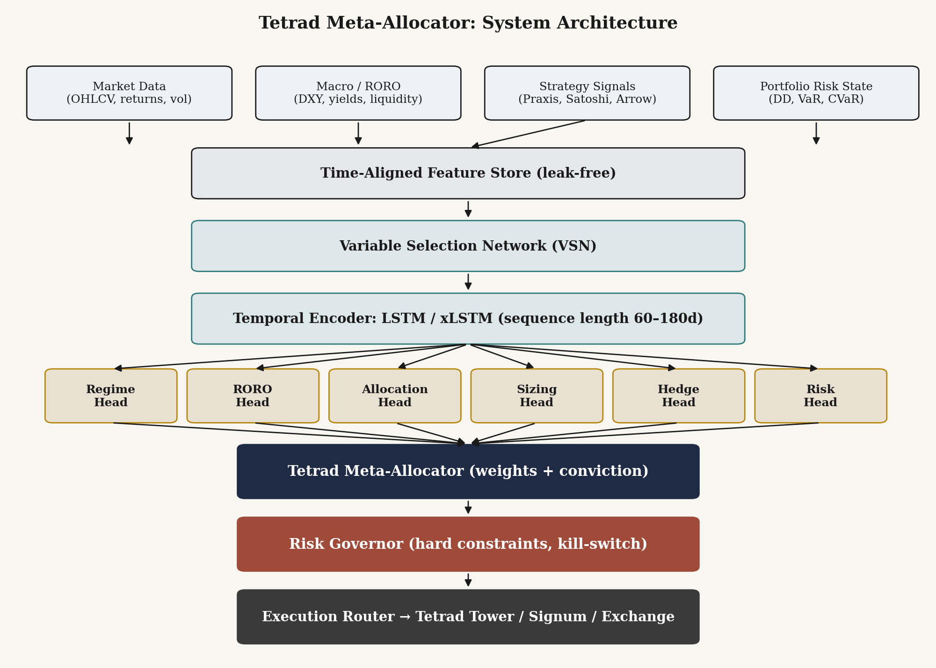
Figure 5. Tetrad Meta-Allocator architecture. Heterogeneous inputs flow through a leak-free feature store into a Variable Selection Network and an LSTM/xLSTM temporal encoder. Six output heads produce regime, directional, allocation, sizing, hedge, and risk estimates. Outputs are aggregated by the meta-allocator and constrained by the Risk Governor before reaching the execution router.
The final position size for each strategy is the product of the base signal, the meta-allocator output, and a sequence of constraint multipliers:
size_{s,t} = β_{s,t} · w_{s,t}^{π} · ψ_{conv,t} · I_{RORO} · κ_{RG,t} · I_{fee} · κ_{ens,t} (4)
where ψ_conv is the conviction multiplier from the sizing head, I_RORO ∈ {0, 0.25, 0.5, 1.0} is the directional permission from the RORO head, κ_RG ∈ [0, 1] is the Risk Governor's exposure multiplier, I_fee ∈ {0, 1} is the fee-breakeven gate, and κ_ens ∈ [0, 1] is the ensemble-stability multiplier derived from cross-seed agreement. The Risk Governor never receives an override authority from the model: equation (4) is a multiplicative chain in which any constraint can independently force size = 0.

4. Strategy Roles and Regime Conditioning
Each strategy in the Tetrad stack possesses a distinct conditional return profile. The meta-allocator's task is to learn the mapping from the encoded market state to the convex combination of strategy weights that maximises the objective in equation (3). Figure 6 illustrates a stylised version of this mapping across six market regimes, showing the qualitative direction of capital flow under each regime; the production model produces continuous weights from the allocation head.
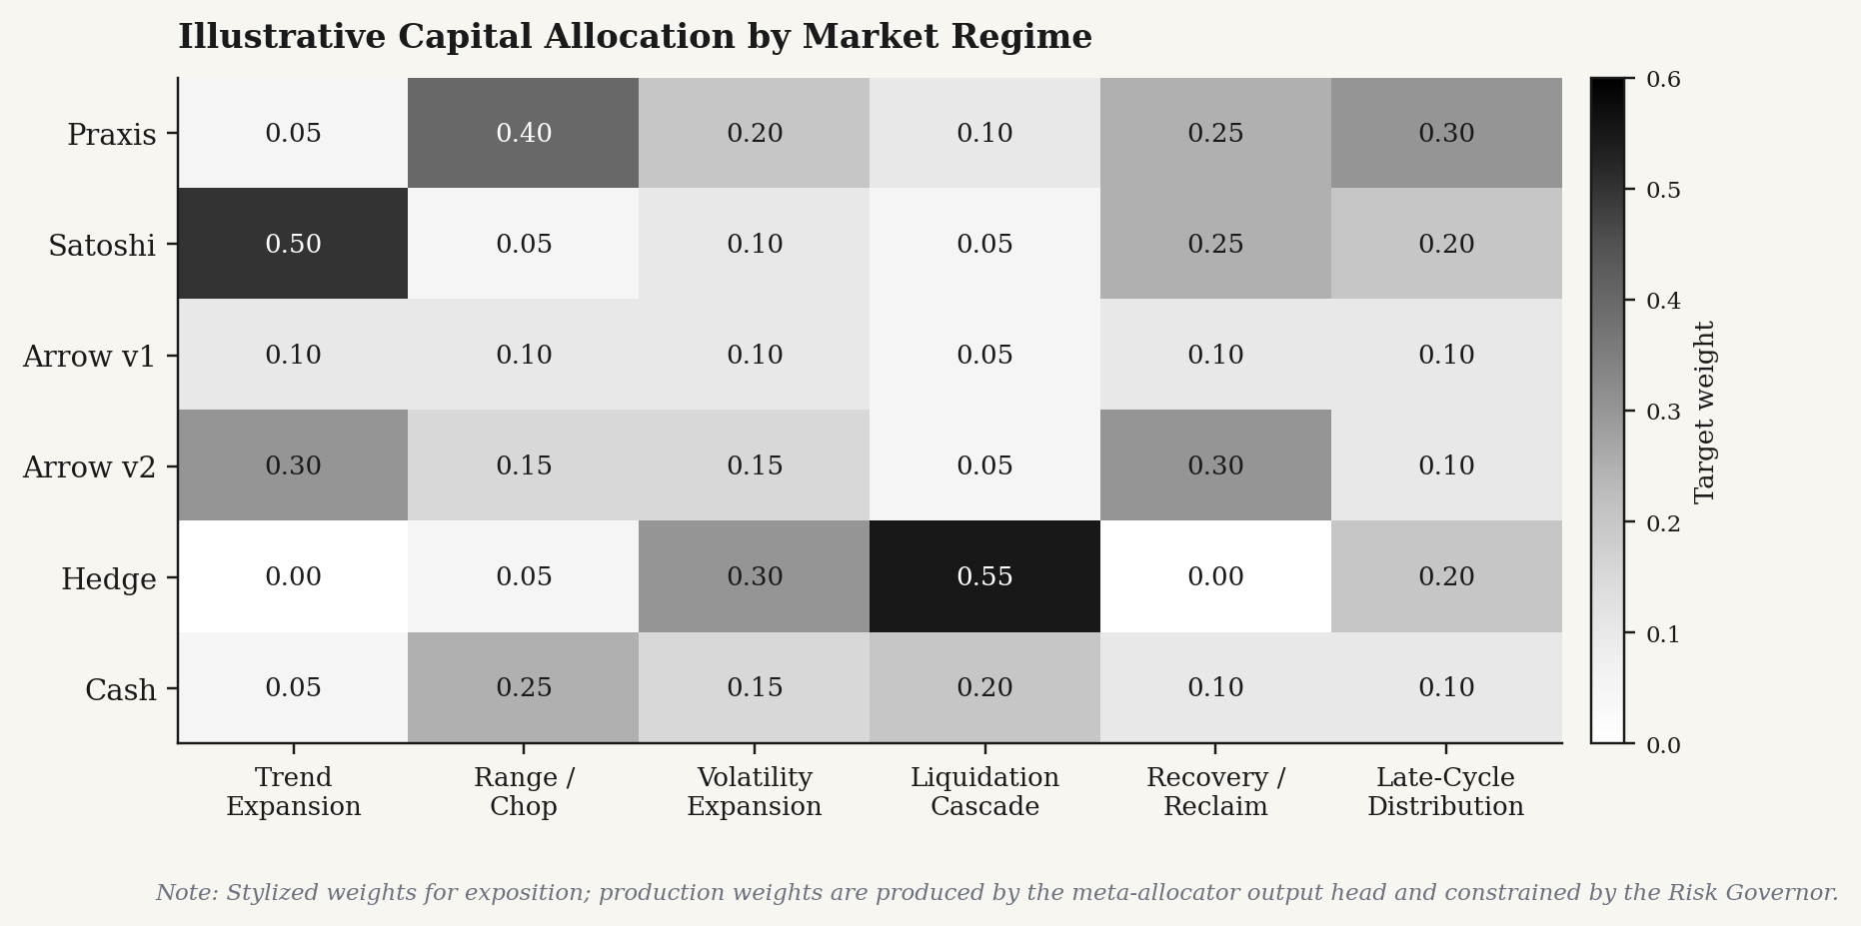
Figure 6. Stylised regime-conditional capital allocation across the Tetrad strategy stack. Production weights are produced by the meta-allocator's allocation head and constrained by the Risk Governor. Hedge weight rises sharply during volatility expansion and liquidation cascade regimes; Satoshi dominates trend expansions; Praxis takes the lead during range and chop conditions.

4.1 Praxis (mean reversion)
Praxis receives elevated allocation when trend strength is decaying, price is statistically extended from a moving-average reference, the Bollinger z-score reaches an extreme, realised volatility is elevated but not in cascade, and the Praxis rolling Sharpe ratio is improving. Allocation is suppressed when a confirmed directional trend persists, when breakouts are holding, or when the Risk Governor detects clustering of adverse excursions.

4.2 Satoshi (trend following)
Satoshi receives elevated allocation under positive trend slope, confirmed breakout structure, shallow pullbacks, RORO alignment with the trend direction, positive momentum persistence, and supportive volatility. Allocation is suppressed when trend signals whipsaw, in chop regimes, under volatility compression that produces false starts, or when the Risk Governor detects late-cycle drawdown convexity.

4.3 Arrow v1 and Arrow v2 (market structure)
Arrow v2 receives the primary structural allocation when reclaim and rejection zones are clean, breakout and volume behaviour align, and Wyckoff-style accumulation or distribution events confirm the broader regime. Arrow v1 functions as a comparative signal source rather than a primary allocator: it provides ensemble diversity, detects early-warning behaviour that v2 may filter out, and serves as a feature input to v2's confirmation logic. The meta-allocator can opportunistically route capital to Arrow v1 if it remains profitable out-of-sample within a particular regime.

4.4 Hedge (defensive trader)
The Hedge module is evaluated against a different objective than the alpha strategies. Its mandate is the reduction of maximum drawdown, conditional value-at-risk, tail loss, margin stress, and the implicit psychological pressure that drives strategy abandonment. Hedge is activated when portfolio drawdown exceeds predefined bands, when an open position moves into adverse excursion, when volatility expands against existing exposure, when the RORO state flips against the base position, when the CVaR estimate rises above threshold, or when ensemble disagreement increases. It is reduced when the original trade reclaims drawdown zones, volatility compresses, the RORO state realigns with the base exposure, or the expected hedge value falls below fee drag.

4.5 The Risk Governor as final authority
The Risk Governor enforces hard constraints that the model cannot override. These include drawdown throttles, value-at-risk budgets, conditional value-at-risk thresholds, turnover caps tied to fee-efficient ranges, liquidity-conditional sizing, ensemble-disagreement throttles, and a directional block when the RORO state is flat. The Risk Governor's exposure multiplier κ_RG enters equation (4) multiplicatively, ensuring that no model output can produce a position when the Governor's constraints would set κ_RG = 0.

5. Data Construction and Training Protocol

5.1 Feature space
The unified dataset combines eleven feature groups, each time-aligned at the daily frequency and constructed under a strict no-look-ahead constraint. The full feature space comprises approximately 90 covariates across the following groups:
Feature group | Representative covariates
Price action | 1d, 3d, 7d, 14d, 30d returns; high–low range; gap statistics.
Trend | Moving-average slopes (20d, 50d, 200d); ADX; breakout distance; market-structure markers.
Mean reversion | RSI(14), Bollinger z-score, VWAP deviation, liquidation wick magnitude.
Volatility | ATR(14), realized volatility (7d, 30d), volatility compression and expansion indicators.
Macro | DXY, US 2Y/10Y yields, stablecoin supply growth, composite risk-on score, liquidity score.
Cycle | Halving-relative timing, Nakamoto calendar phase, four-year cycle position.
Derivatives | Funding rates (perpetuals), open interest changes, liquidation cluster proximity.
Strategy state | Current Praxis, Satoshi, Arrow v1, Arrow v2, and Hedge signal states and positions.
Portfolio state | Drawdown from high, VaR (1d, 95%), CVaR (1d, 5%), margin utilisation, gross exposure.
Performance state | Rolling 30d Sharpe, Sortino, win rate, profit factor per strategy; Hedge effectiveness.
Execution state | Spread, slippage estimate, fee rate, realised turnover, liquidity score.

5.2 Label construction
Each row in the training set represents a decision point at time t. The supervised target is the optimal allocation over a forward window of length N, computed as the weight vector that would have maximised the realised risk-adjusted portfolio return:
y_t* = arg max_{w ∈ Δ} { Σ_{s∈S} w_s · SR_{s,t→t+N} − λ · MaxDD(w; t→t+N) } (5)
where Δ is the simplex of feasible allocations, SR_{s,t→t+N} is the realised Sharpe ratio of strategy s over the forward window, and λ is a drawdown penalty calibrated to the deployment objective. We construct labels at four horizons — N ∈ {7, 14, 30, 90} — and train multi-horizon heads simultaneously. The 7-day target captures tactical allocation; the 90-day target captures strategic regime allocation.

5.3 Training and validation
Models are trained under the end-to-end Sharpe-optimisation protocol of SWCZ (2026), with the loss in equation (3) computed on pooled portfolio returns concatenated across batch sequences. Hyperparameters are selected via grid search on a rolling validation window. We follow the SWCZ ensembling convention: each architecture is trained under 25 to 50 random seeds, with the top 5 to 10 seeds (by validation Sharpe) ensembled for inference. The seed-stability multiplier κ_ens in equation (4) is the normalised cross-seed agreement on the allocation vector, computed as one minus the Jensen–Shannon divergence between the seed-specific softmax outputs and the ensemble mean.

5.4 Baseline hierarchy
Following SWCZ's emphasis on linear baselines as a credibility check, the deep meta-allocator must clear a sequence of progressively more challenging baselines before deployment: (i) equal-weight strategy portfolio; (ii) static mean–variance optimised allocation on in-sample strategy returns; (iii) rule-based RORO allocator with manual regime triggers; (iv) ridge regression and gradient-boosted tree (XGBoost / LightGBM) allocators on the same feature space; (v) the deep model with VSN + LSTM; (vi) the deep model with VSN + xLSTM and full ensembling. Improvement against each baseline must be statistically significant under a HAC-adjusted t-test, in line with the inference protocol of SWCZ (2026).

6. Walk-Forward Validation Protocol
All evaluation is conducted under expanding-window walk-forward validation. The training window begins in 2018 (the earliest period of reliable cross-exchange crypto data with derivative coverage) and expands by one calendar year per fold, with the immediately following year used for validation and the year after that used for out-of-sample testing:
Fold | Training window | Validation | Test (out-of-sample)
Fold 1 | 2018 – 2020 | 2021 | 2022
Fold 2 | 2018 – 2021 | 2022 | 2023
Fold 3 | 2018 – 2022 | 2023 | 2024
Fold 4 | 2018 – 2023 | 2024 | 2025
Fold 5 | 2018 – 2024 | 2025 | 2026 YTD

6.1 Evaluation metrics
Aggregate test-window performance is reported across eleven metrics, mirroring the multi-dimensional evaluation framework of SWCZ (2026): annualised Sharpe ratio, Sortino ratio, Calmar ratio, maximum drawdown, worst three-month rolling Sharpe ratio, minimum annual Sharpe ratio, 5% conditional value-at-risk, annualised turnover, breakeven transaction cost, cross-seed Sharpe dispersion, and the Newey–West HAC-adjusted t-statistic against both a passive long-BTC benchmark and the equal-weight Tetrad baseline. No single metric is treated as decisive: a model that improves Sharpe but doubles maximum drawdown is not considered an improvement. The deployment criterion is a Pareto-improving performance surface.

6.2 Stress diagnostics
Beyond the standard walk-forward analysis, we conduct four stress diagnostics: (i) asset hold-out tests, in which BTC, ETH, SOL, and high-beta altcoins are individually withheld from training; (ii) regime hold-out tests, in which the 2022 deleveraging cycle and the 2024 ETF launch periods are masked; (iii) fee stress tests under doubled and quadrupled assumed transaction costs; and (iv) Monte Carlo trade resampling, in which strategy-level fills are bootstrapped to produce confidence intervals on the realised performance metrics. The seed stability diagnostic of SWCZ (2026, §3.6) is replicated by reducing the seed budget from 50 to 25 and verifying that rankings persist.

7. Phased Deployment Roadmap
Production deployment proceeds through seven phases, each gated on quantitative criteria from the prior phase. No phase advances on the basis of model performance alone; each requires an explicit sign-off on the Risk Governor's behaviour under the relevant data regime.
# | Phase | Scope | Advance criterion
1 | Research dataset | Unified historical store of strategy signals, returns, fills, fees, slippage, macro alerts, Risk Governor states, and MLTT/RORO states. | Reproducibility audit; leak-free feature regeneration on a held-out month.
2 | Baseline allocator | Equal-weight, static optimised, rule-based RORO, and gradient-boosted tree allocators. | Statistically significant improvement over equal-weight at 95% HAC.
3 | Risk Governor integration | Drawdown throttle, VaR budget, CVaR estimate, turnover throttle, fee-breakeven filter. | Maximum drawdown reduction ≥ 25% versus Phase 2 with non-negative Sharpe impact.
4 | VSN + LSTM/xLSTM model | Deep sequence allocator with multi-head outputs. | Pareto-improving performance surface against Phase 3 across the eleven metrics.
5 | Walk-forward backtest | Five-fold expanding-window backtest with stress diagnostics. | Minimum annual Sharpe ≥ 0 in all five folds; Calmar ≥ 1.0 in aggregate.
6 | Paper trading (shadow) | Model recommendations logged but not executed; daily reconciliation with live system. | 30-day shadow-versus-live tracking error within tolerance; recommendation latency under threshold.
7 | Limited capital live | Small-allocation deployment with hard caps on size, daily loss, turnover, drawdown, with manual override. | 60-day live performance consistent with shadow projections within statistical tolerance.

8. Limitations
Several limitations should be made explicit. First, the SWCZ (2026) benchmark is constructed on traditional futures markets rather than crypto; the inductive-bias evidence we import is suggestive rather than directly transferable. Crypto markets exhibit substantially heavier tails, weaker macro factor structure, and greater sensitivity to retail flow and on-chain liquidity events, all of which may alter the relative ranking of architectures. Second, the proposed framework's training labels (equation 5) are themselves derived from a backtest, and label quality is bounded by the realism of strategy-level fill simulation. Third, deep models can exhibit instability across hyperparameters and seeds; the ensemble approach mitigates but does not eliminate this. Fourth, the regime taxonomy used for the Regime Head is a modelling choice rather than a property of the data, and may misclassify novel regimes. Fifth, all walk-forward results, however carefully constructed, remain conditional on the historical sample; future regimes may not resemble historical ones. Sixth, the system as proposed is supervised by historical labels and therefore inherits any structural biases present in the historical strategy returns.
These limitations argue for the conservative deployment protocol of Section 7, the multi-dimensional evaluation framework of Section 6, and the absolute authority of the Risk Governor encoded in equation (4).

9. Conclusion
The Oxford / Oxford-Man Institute benchmark of Saly-Kaufmann, Wood, Calliess and Zohren (2026) provides a credible empirical foundation for the next stage of Tetrad Protocol's research agenda. Its central methodological contribution — that financial deep learning should optimise risk-adjusted economic performance directly, and that hybrid architectures combining feature selection with structured temporal memory dominate alternatives across return, downside, and stability dimensions — translates naturally to the meta-allocation problem confronting a multi-strategy systematic operation.
The proposed Tetrad Meta-Allocator is not a replacement for Praxis, Satoshi, Arrow v1, Arrow v2, Hedge, or the Risk Governor. It is a coordination layer that learns the regime-conditional capital-allocation policy that the existing components cannot learn individually. The expected outcome is an adaptive, risk-aware portfolio engine designed to improve Sharpe, Sortino, Calmar, drawdown control, conditional value-at-risk, turnover discipline, and out-of-sample robustness, while remaining bounded by the hard constraints of the Risk Governor.
Crypto market structure rewards rule-based, regime-aware, risk-bounded systems and punishes discretionary conviction at scale. The framework proposed here is a step toward operationalising that asymmetry.

References
Saly-Kaufmann, A., Wood, K., Calliess, J.-P., & Zohren, S. (2026). Deep Learning for Financial Time Series: A Large-Scale Benchmark of Risk-Adjusted Performance. arXiv:2603.01820 [q-fin.TR]. Machine Learning Research Group, Department of Engineering Science, University of Oxford, and Oxford-Man Institute of Quantitative Finance.
Beck, M., Pöppel, K., Spanring, M., Auer, A., Prudnikova, O., Kopp, M., Klambauer, G., Brandstetter, J., & Hochreiter, S. (2024). xLSTM: Extended Long Short-Term Memory. arXiv:2405.04517.
Lim, B., Arık, S. Ö., Loeff, N., & Pfister, T. (2021). Temporal Fusion Transformers for Interpretable Multi-Horizon Time Series Forecasting. International Journal of Forecasting, 37(4), 1748–1764.
Hochreiter, S., & Schmidhuber, J. (1997). Long Short-Term Memory. Neural Computation, 9(8), 1735–1780.
Newey, W. K., & West, K. D. (1987). A Simple, Positive Semi-Definite, Heteroskedasticity and Autocorrelation Consistent Covariance Matrix. Econometrica, 55(3), 703–708.
Nie, Y., Nguyen, N. H., Sinthong, P., & Kalagnanam, J. (2023). A Time Series is Worth 64 Words: Long-term Forecasting with Transformers. International Conference on Learning Representations.
Gu, A., & Dao, T. (2024). Mamba: Linear-Time Sequence Modeling with Selective State Spaces. arXiv:2312.00752.
Zeng, A., Chen, M., Zhang, L., & Xu, Q. (2023). Are Transformers Effective for Time Series Forecasting? Proceedings of the AAAI Conference on Artificial Intelligence, 37(9), 11121–11128.
Wood, K., Roberts, S. J., & Zohren, S. (2022). Slow Momentum with Fast Reversion: A Trading Strategy Using Deep Learning and Changepoint Detection. Journal of Financial Data Science, 4(1), 111–129.
Lim, B., Zohren, S., & Roberts, S. (2019). Enhancing Time-Series Momentum Strategies Using Deep Neural Networks. Journal of Financial Data Science, 1(4), 19–38.

Disclosure
This document is a research proposal prepared for internal use at Tetrad Protocol. Performance metrics cited from Saly-Kaufmann et al. (2026) refer to gross simulated returns on a futures dataset (commodities, equity indices, bonds, energy, foreign exchange) under a 10% annualised volatility-targeting framework, and are not directly representative of expected performance in cryptocurrency markets. All forward-looking statements regarding the proposed Tetrad Meta-Allocator describe testable hypotheses; no return, Sharpe ratio, or drawdown outcome is forecast or guaranteed. Past performance, simulated or realised, is not indicative of future results. Cryptocurrency trading involves substantial risk of loss including the loss of entire principal.

Saly-Kaufmann, A., Wood, K., Calliess, J.-P., & Zohren, S. (2026). Deep Learning for Financial Time Series: A Large-Scale Benchmark of Risk-Adjusted Performance. arXiv:2603.01820 [q-fin.TR], 2 March 2026.

