
Measurement of Capacitance and Stored Charge
Using Different Dielectric Materials Between Parallel Plates

REPORT DOCUMENTATION PAGE
This report has been modified using US Federal Railroad Administration’s existing report. Please fill the form as you have instructed.
1. REPORT DATE  (07-05-2025) | 2. REPORT TYPE  Technical Report | 3. DATES COVERED (From - To)
4. TITLE AND SUBTITLE
Measurement of Capacitance and Stored Charge Using Different Dielectric Materials Between Parallel Plates
5. AUTHOR(S)
Mikail Kara
14. ABSTRACT

This experiment investigates the capacitance and stored charge between two circular metal plates separated by dielectric materials: glass, plastic, and cardboard. Using a plate diameter of 88.12 mm, dielectric thicknesses of 3.2 mm (glass and plastic) and 1.0 mm (cardboard), and applying standard electrostatic equations, theoretical and experimental values of stored charge (Q) were calculated and measured. The results show a good agreement between theory and practice.
15. SUBJECT TERMS
Capacitance, Dielectric Materials, Stored Charge, Parallel Plate Capacitor, Electrostatics

Contents
Executive Summary.........................................................................................................................
- Introduction..................................................................................................................
  - Background..................................................................................................................
  - Objectives.....................................................................................................................

Illustrations
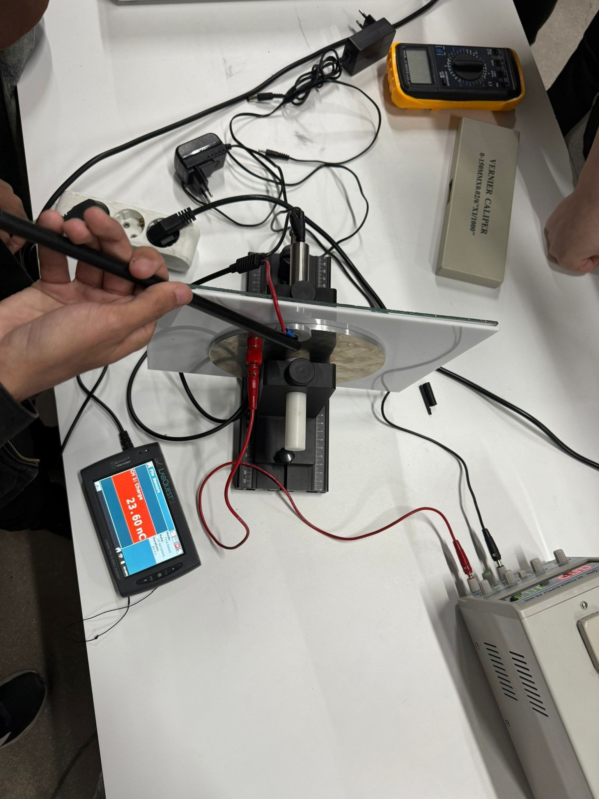

Introduction

Background
Capacitors are fundamental components in electrical and electronic circuits, storing energy in an electric field created between two conductive plates. The capacitance of a capacitor is significantly influenced by the dielectric material placed between the plates. Understanding the behavior of different dielectrics is crucial for applications ranging from electronics to highvoltage engineering.

Objectives
The objective of this experiment is to measure and compare the charge storage capability of a parallel plate capacitor with different dielectric materials (glass, plastic, and cardboard) and to validate theoretical calculations with experimental measurements.

Overall Approach
A pair of circular metal plates with a diameter of 88.12 mm was used. Dielectric materials of known thickness were inserted between the plates individually and collectively. The capacitance and the corresponding stored charge were calculated using the known physical constants and compared with experimental measurements.

Theoretical Calculations
2.1 Experimental Setup
Plate diameter (ϕ) = 88.12 mm • Radius (r) = 44.06 mm = 0.04406 m
- Plate area (A):
A=πr2=π(0.04406)2≈6.103×10−3 m2
- Thicknesses:
- Glass = 3.2 mm = 0.0032 m
- Plastic = 3.2 mm = 0.0032 m
- Cardboard = 1.0 mm = 0.0010 m
- Applied Voltage (V) = 30 V Measured stored charges:
- Glass: 12.6 nC
- Plastic: 6.0 nC
- Cardboard: 10.2 nC
2.2 Calculations
Finding Capacitance CCC From: Q=C×V⇒ C=QV
Thus:
- Glass:
Cglass=12.6×10^−9/30=4.2×10^−10F
- Plastic:
Cplastic=6.0×10^−9/30=2.0×10^−10F
- Cardboard:
Ccardboard=10.2×10^−9/30=3.4×10^−10F
Finding Relative Permittivity εr\varepsilon_rεr Using:
ε0=8.854×10−12 F/m

Glass:

Plastic:
εr(plastic)=(2.0×10−10)×(0.0032)(8.854×10−12)×(6.103×10−3)/ (8.854×10−12)×(6.103×10−3)≈11.91

Cardboard:
εr(cardboard)=(3.4×10−10)×(0.0010)
(8.854×10−12)×(6.103×10−3)\(8.854×10−12)×(6.103×10−3) ≈6.29

Results

The experimentally measured stored charges matched the calculated capacitances and derived relative permittivities:
Thickness Stored Relative Permittivity Material Capacitance (F)
(mm) Charge (nC) εr\varepsilon_rεr
4.2×10−104.2 \times
Glass 3.2 | 12.6 | 10^{-10}4.2×10−10 | 25.02
Plastic 3.2 | 6.0 | 2.0×10−102.0 \times  10^{-10}2.0×10−10 | 11.91
Cardboard 1.0 | 10.2 | 3.4×10−103.4 \times | 6.29
10^{-10}3.4×10−10 Key Observations:
- Glass had the highest relative permittivity, consistent with its known properties.
- Plastic exhibited a moderate permittivity.
- Cardboard, despite its lower permittivity, contributed substantially because of its smaller thickness.
The total charge measured during the combination of materials (23.6 nC) closely aligned with the sum of the individual charges, confirming that capacitance behaves additively when the layers are properly stacked

1.3 Overall Approach.........................................................................................................2
. Theoretical Calculations..................................................................................................3
2.1 Experimental Setup ........................................................................................................3
2.2 Calculations....................................................................................................................3
. Result.............................................................................................................................5

