GWAS Collaboration
End-to-End Workflow Timeline
Initiator • Collaboration Server • Collaborator
Collaborative Study Web Application
Project documentation — prepared for review

How to read this document
Each section below is a single point in time (T0, T1, T2, …) in the end-to-end GWAS collaboration workflow — from the very first account registration through the final AI-generated summary report.
Every time point shows three columns in parallel: what the Initiator is doing, what the Collaboration Server is doing, and what the Collaborator is doing. This makes it easy to see who is active when, and who is just waiting.
Cells that show a purple ▸ RUNS ON LOCAL MACHINE banner are doing real computation on that party's own computer. Raw genotype data NEVER leaves the local machine — only the aggregated survivor lists and case/control counts are returned to the Collaboration Server.
Below each swimlane is a set of screenshot placeholders — usually 3 to 5 per phase.

Legend
 | Initiator | The researcher who creates the collaboration, invites partners, and triggers GWAS + AI report.
 | Collaboration Server | Backend (Flask + MongoDB) handling auth, datasets, QC orchestration, chi-square, and LLM calls.
 | Collaborator | An invited researcher who contributes their cohort + summary stats.
 | Screenshot box | A dashed box showing the actual UI.
 | ▸ Runs locally banner | Indicates this party's work happens on their own machine. Raw data never leaves.

Timeline at a glance
Time | Phase | What happens
T0 | Account Registration | First-time setup
T1 | Login & Authentication | Returning session
T2 | Metadata / Dataset Upload | Each party registers their cohort
T3 | Open Start Collaboration (Step 1: Details) | Initiator launches the 3-step wizard
T4 | Wizard Step 2 — Quality Control (with thresholds) | Choose QC methods + dataset
T5 | Wizard Step 3 — Find Collaborators & Submit | Search by phenotype + sample, invite, submit the wizard
T6 | Review & Accept Invitation | Collaborator agrees to participate
T7 | Automatic Chained Quality Control | Server orchestrates — QC runs locally on each party's machine
T8 | Review QC, Set Thresholds | Initiator confirms filtered cohort
T9 | Build & Upload GWAS Summary Stats | Each party generates aggregated counts LOCALLY
T10 | Run GWAS Chi-Square | Initiator triggers aggregation
T11 | View GWAS Results | Per-SNP statistics
T12 | Generate AI Summary Report | LLM-written, privacy-preserving
T13 | Read & Share AI Report | End of the workflow

T0 • Account Registration
First-time setup
TIME | INITIATOR | COLLABORATION SERVER | COLLABORATOR
T0  First-time setup | - Opens the web app at the public URL.  - Clicks Register New Account on the login screen.  - Fills in name, email, password, institution, phenotype interests.  - Submits the form (POST /api/register).  - Receives a confirmation and a JWT token in localStorage. | - Receives request.  - Validates email uniqueness and password strength.  - Hashes password and creates a record in the users collection.  - Issues a JWT and returns it to the client. | - Independently visits the web app.  - Clicks Register New Account and fills the same form.  - Receives a JWT and is redirected to Home.

Login / Register screen
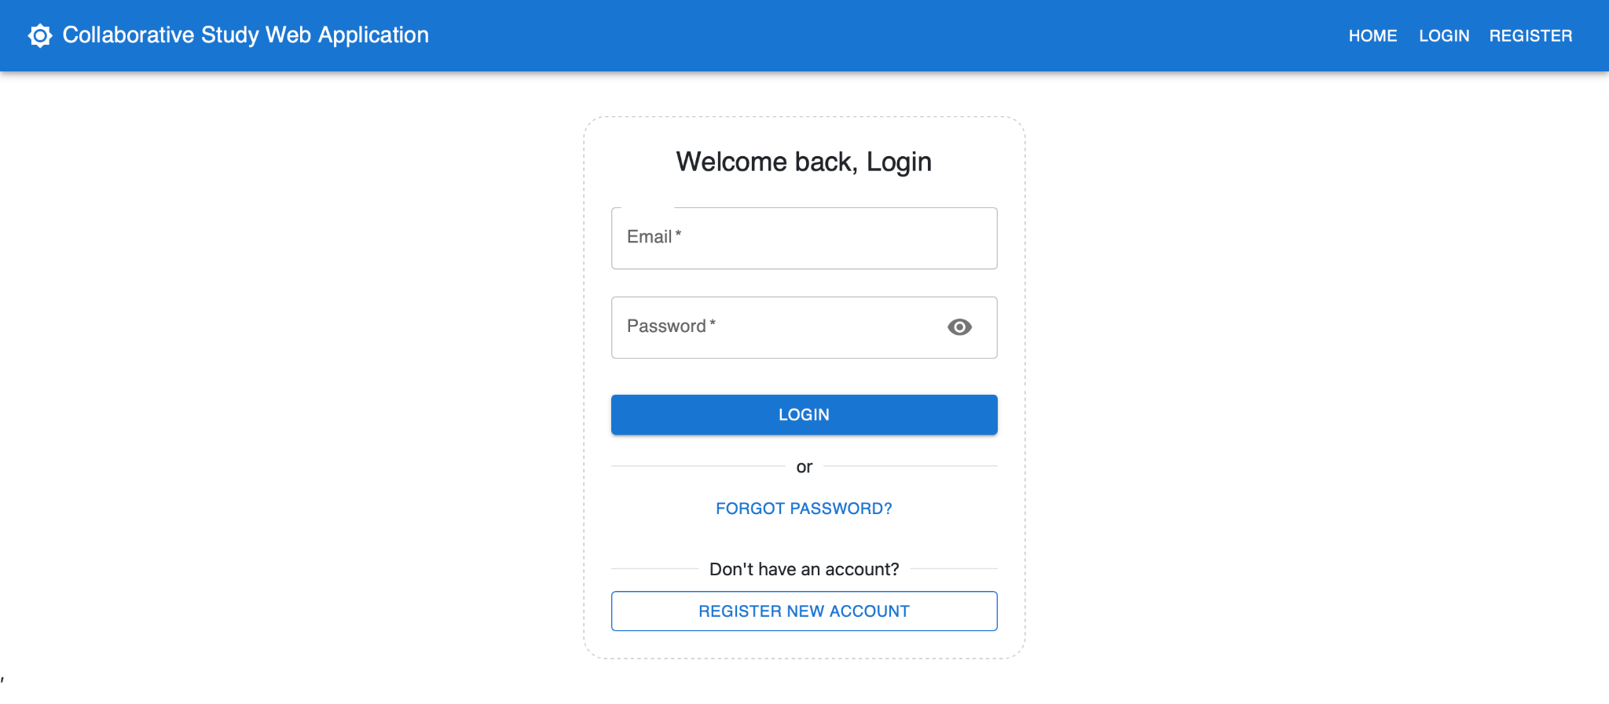
Welcome back, Login + Register New Account button.

Registration form (Initiator)
name, email, password.
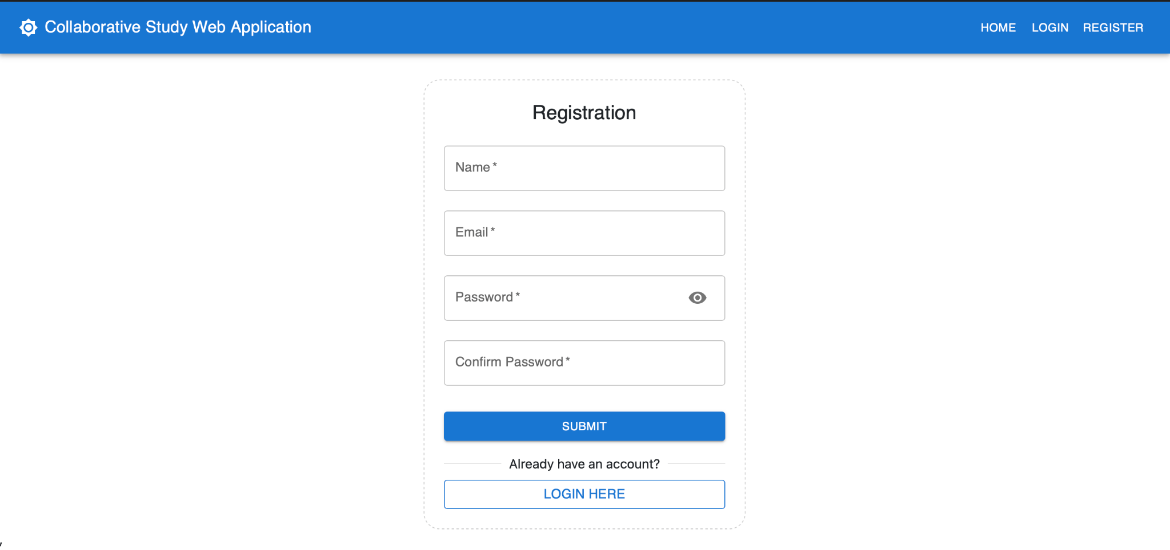ste).

Registration form (Collaborator)
Same form, captured on the collaborator's machine to show both accounts.


T1 • Login & Authentication
Returning session
TIME | INITIATOR | COLLABORATION SERVER | COLLABORATOR
T1  Returning session | - Enter email + password on the login screen.  - Token is stored client-side; UI switches to the LoggedIn navbar.  - Lands on Home with quick links: Upload, Search, Collaborations. | - validates credentials against the users collection.  - Returns { message: 'Login successful', token: <JWT> }.  - All subsequent calls are authenticated via token. | - Logs in the same way from their own institution.  - Sees their own Home dashboard.

Login screen (filled in)
Email + password entered, just before clicking Login.
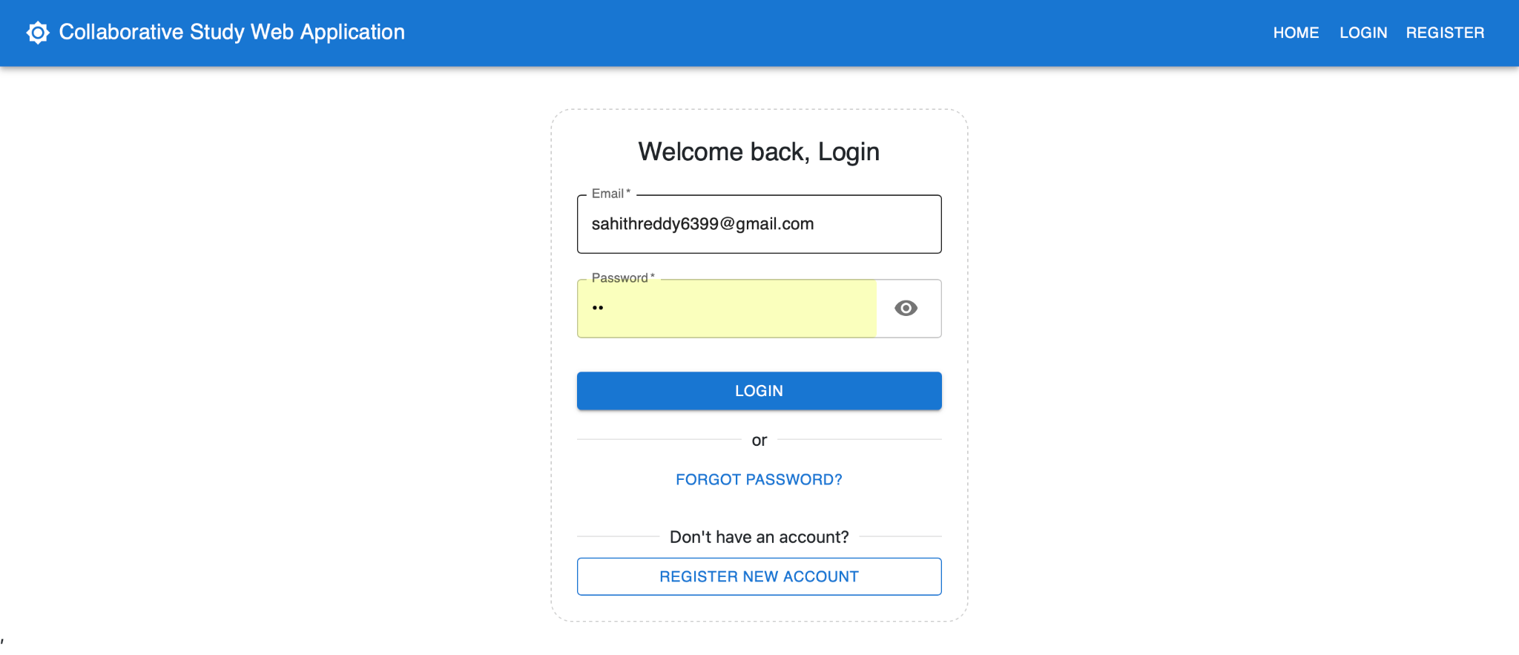

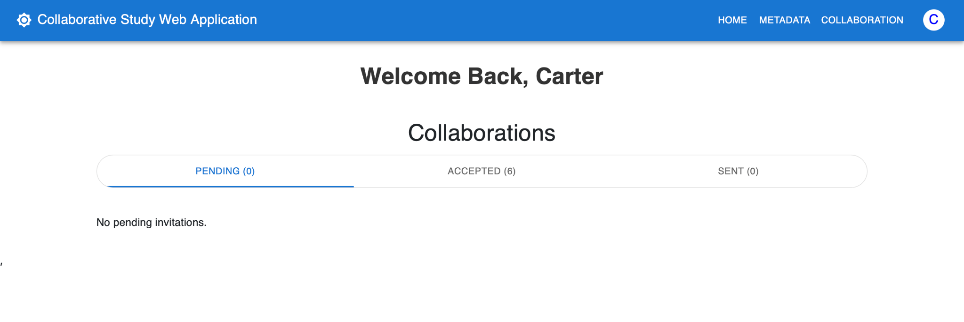
Logged-in Home dashboard (Initiator)

Logged-in Home dashboard (Collaborator)
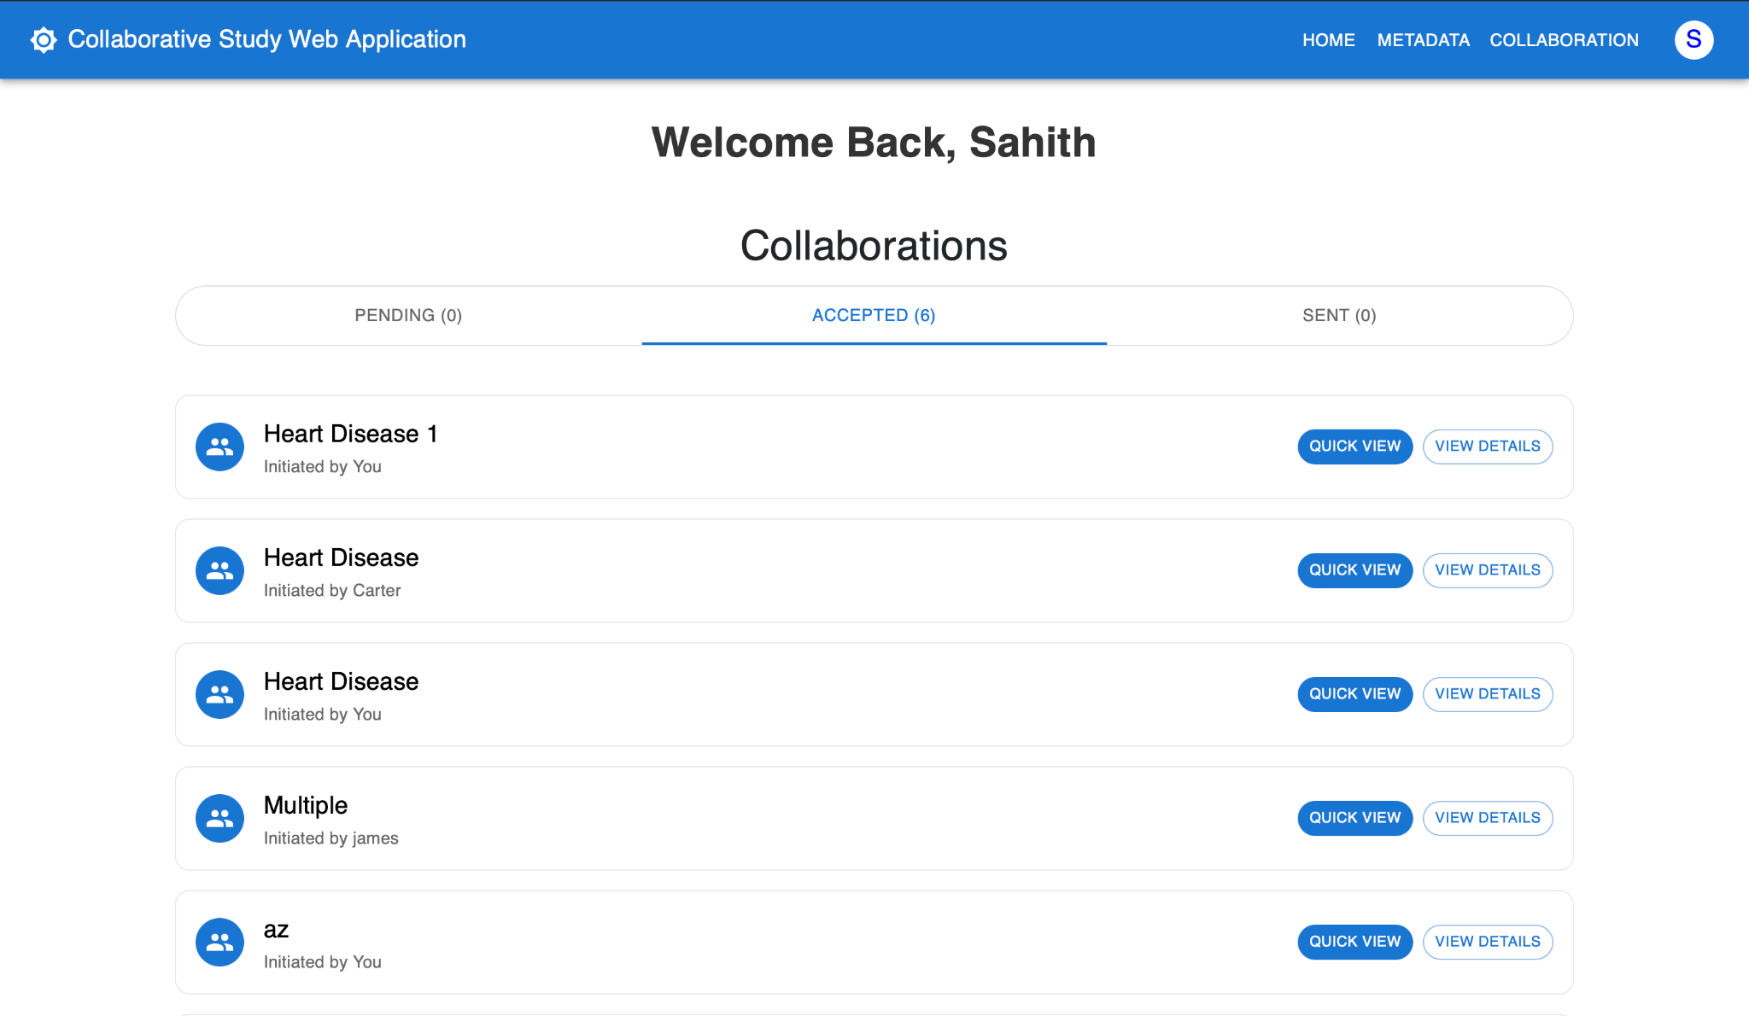
Same view captured on the collaborator's machine — confirms both are signed in.

T2 • Metadata / Dataset Upload
Each party registers their cohort
TIME | INITIATOR | COLLABORATION SERVER | COLLABORATOR
T2  Each party registers their cohort | ▸ RUNS ON INITIATOR'S LOCAL MACHINE  - Clicks MetaData in the navbar (from home page)  - Enters phenotype (e.g. eye_color) and number of samples.  - Submits with multipart form data.  - Sees 'Metadata uploaded successfully' alert. | - Receives request, ties it to the specific user.  - Stores metadata in the datasets collection.  - Indexes by phenotype so other users can find it later in Search. | ▸ RUNS ON COLLABORATOR'S LOCAL MACHINE  - Performs the same upload from their own login.  - Their dataset metadata is now discoverable under the same phenotype.

Metadata upload form (Initiator)
Phenotype, # of Samples fields and Submit button.
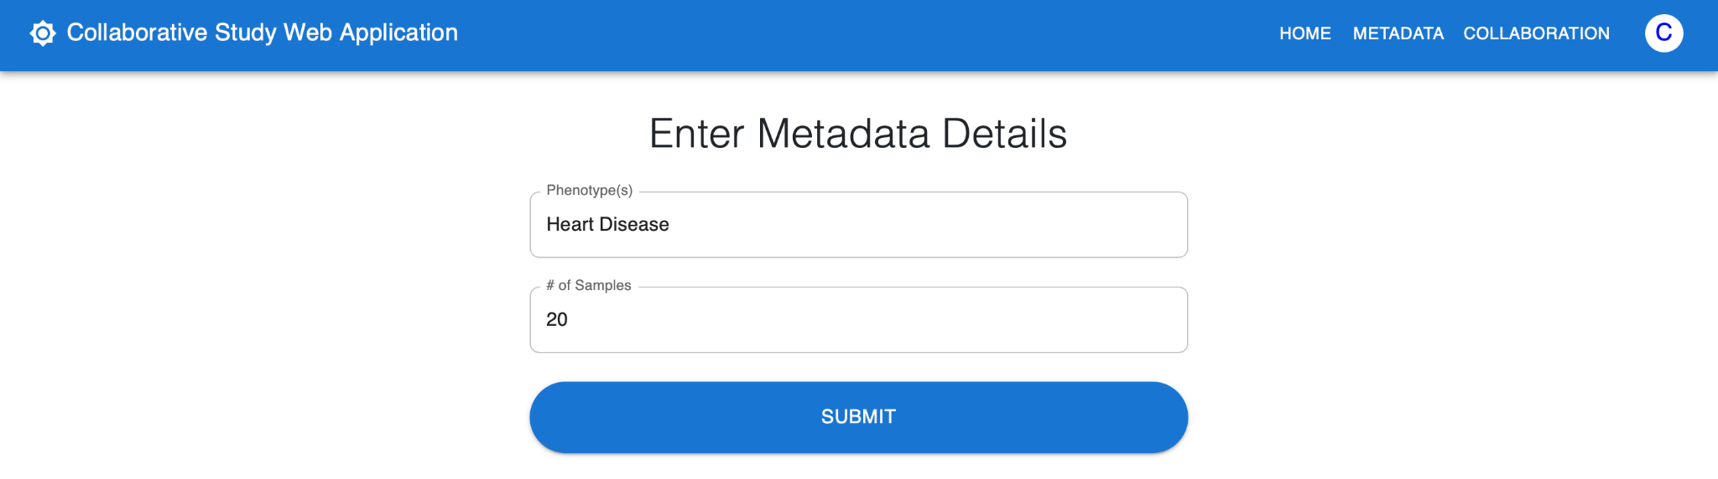

Upload success toast (Initiator)
alert/snackbar after a successful upload on the initiator's machine.
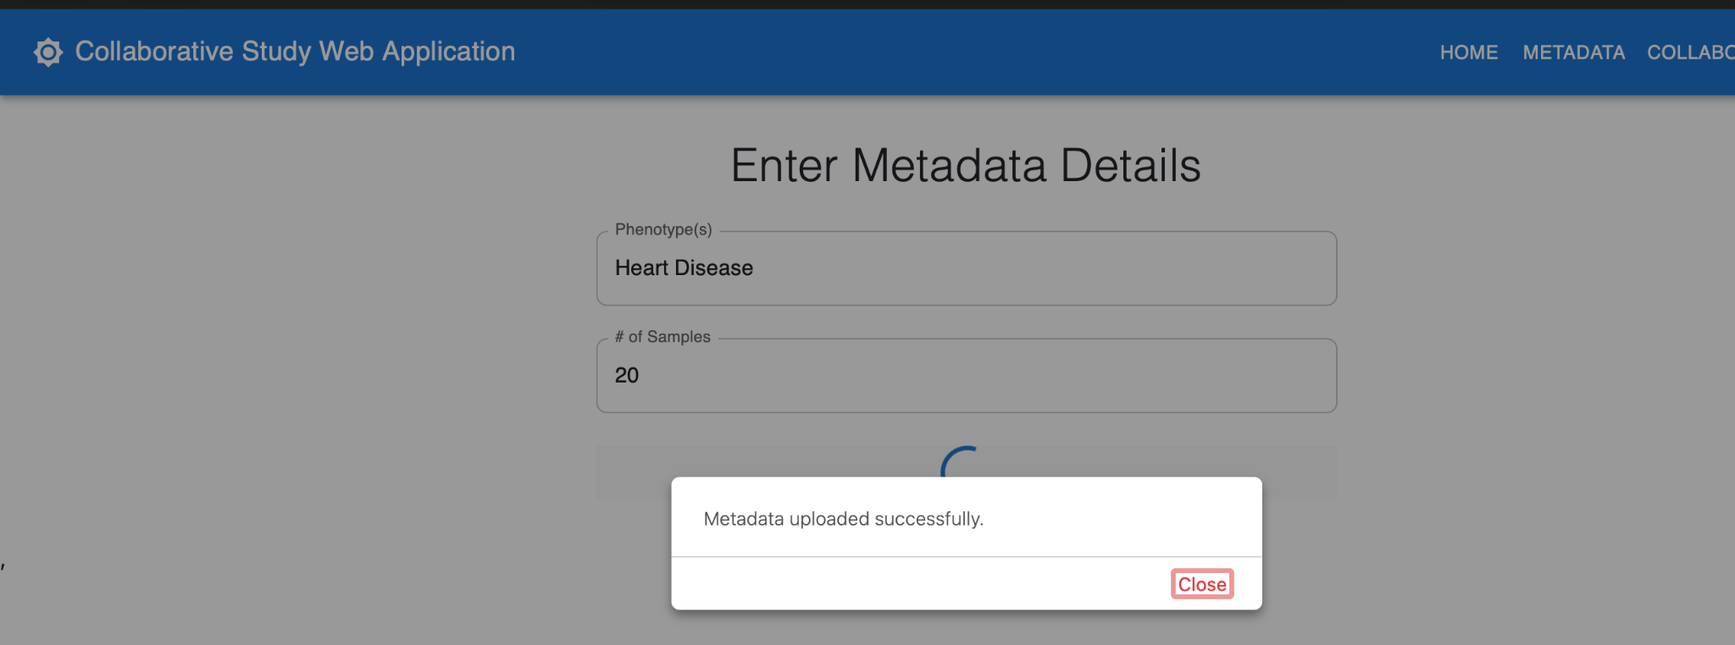

Metadata upload form (Collaborator)

Same form on the collaborator's end.

T3 • Open Start Collaboration (Step 1: Details)
Initiator launches the 3-step wizard
TIME | INITIATOR | COLLABORATION SERVER | COLLABORATOR
T3  Initiator launches the 3-step wizard | - Clicks Collaborations in the navbar to open the Collaborations page.  - Clicks Start a Collaboration to open the 3-step wizard (StartCollaboration.jsx).  - STEP 1 — Collaboration Details: types a Collaboration Name into the first field.  - Selects the Experiment Type from the dropdown (e.g. GWAS). | - No backend call yet — Step 1 is purely client-side.  - The full submit happens only after Steps 2 + 3 (see T5). | - Not active yet — has not been invited.  - Nothing to do on their side until T5.

[ SCREENSHOT PLACEHOLDER ]
Collaborations page (entry point)
Components/Collabrations/CollabrationsPage.jsx — the Collaborations page just before clicking Start a Collaboration.
Replace this box with your screenshot (right-click → Insert Picture, or paste).

[ SCREENSHOT PLACEHOLDER ]
Wizard Step 1 — Collaboration Details (Name field)
StartCollaboration.jsx Step 1: Collaboration Name input and Experiment Type closed dropdown.
Replace this box with your screenshot (right-click → Insert Picture, or paste).

[ SCREENSHOT PLACEHOLDER ]
Experiment Type dropdown opened
Experiment Type dropdown expanded showing GWAS / Federated Learning options.
Replace this box with your screenshot (right-click → Insert Picture, or paste).

T4 • Wizard Step 2 — Quality Control (with thresholds)
Choose QC methods + dataset
TIME | INITIATOR | COLLABORATION SERVER | COLLABORATOR
T4  Choose QC methods + dataset | - STEP 2 — Quality Control: under “Choose QC Scheme (select multiple to chain)” picks one or more methods.  - Available methods: Sample Relatedness, Population Stratification, Minor Allele Frequency (MAF), Hardy-Weinberg Equilibrium (HWE), Missing Data QC.  - Multiple methods can be chained — they will run in sequence on each party's local machine (see T7).  - Methods with thresholds (MAF cutoff, HWE p-value, missingness %) reveal a threshold input — initiator enters the cutoff values.  - Picks an existing Dataset from the “Select Dataset” dropdown (the metadata uploaded at T2).  - Or clicks Upload Dataset File to add a new dataset inline before continuing. | - Still no server call — wizard remains client-side until Submit at T5.  - Selections (methods + thresholds + chosen dataset) are buffered in the wizard state.  - When the initiator uploads inline, the file is staged for /api/upload_csv_qc (same endpoint as T2). | - Not active yet.

[ SCREENSHOT PLACEHOLDER ]
Wizard Step 2 — QC scheme cards (None selected)
Quality Control panel showing the row of selectable method chips with the default “None” selected.
Replace this box with your screenshot (right-click → Insert Picture, or paste).

[ SCREENSHOT PLACEHOLDER ]
Multiple QC methods selected to chain
Several method chips selected together (e.g. MAF + HWE + Sample Relatedness) to show the chained-QC behaviour.
Replace this box with your screenshot (right-click → Insert Picture, or paste).

[ SCREENSHOT PLACEHOLDER ]
Threshold input for MAF / HWE / Missing-Data
Threshold fields that appear when MAF / HWE / Missing-Data are selected — capture with values typed in.
Replace this box with your screenshot (right-click → Insert Picture, or paste).

[ SCREENSHOT PLACEHOLDER ]
Select Dataset dropdown + Upload Dataset File area
Select Dataset dropdown opened (or with a value chosen) + the Upload Dataset File cloud icon below it.
Replace this box with your screenshot (right-click → Insert Picture, or paste).

T5 • Wizard Step 3 — Find Collaborators & Submit
Search by phenotype + sample, invite, submit the wizard
TIME | INITIATOR | COLLABORATION SERVER | COLLABORATOR
T5  Search by phenotype + sample, invite, submit the wizard | - STEP 3 — Find Collaborators: searches for partners by Phenotype + Sample Size from within the wizard.  - Clicks Invite on each chosen researcher — they appear in the Invited list with status “pending”.  - Clicks Submit / Create — POST /api/start_collaboration creates the collab AND POST /api/sendinvitation fires for each invitee. | - Receives /api/start_collaboration; creates the collaboration document (status = pending, stores creator_id, name, experiment, QC schemes + thresholds, dataset, UUID).  - For each invitee, writes to the invitations collection, appends to collaborations.invited_users[], and emits a notification. | - A notification badge appears on their navbar.  - Sees the new pending invitation on their Collaborations page.

[ SCREENSHOT PLACEHOLDER ]
Wizard Step 3 — Find Collaborators search inputs
Step 3 of StartCollaboration.jsx — Phenotype + Sample Size search inputs visible.
Replace this box with your screenshot (right-click → Insert Picture, or paste).

[ SCREENSHOT PLACEHOLDER ]
Search results inside the wizard
Search result cards (researcher name + phenotype + sample count) inside the wizard.
Replace this box with your screenshot (right-click → Insert Picture, or paste).

[ SCREENSHOT PLACEHOLDER ]
Invited list with pending status
Invited list at the bottom of the wizard or on the new collaboration page, with each invitee showing pending.
Replace this box with your screenshot (right-click → Insert Picture, or paste).

[ SCREENSHOT PLACEHOLDER ]
Collaborator's notification + pending invite card
Collaborator's machine: notification badge in the navbar + the new pending invite card on the Collaborations page.
Replace this box with your screenshot (right-click → Insert Picture, or paste).

T6 • Review & Accept Invitation
Collaborator agrees to participate
TIME | INITIATOR | COLLABORATION SERVER | COLLABORATOR
T6  Collaborator agrees to participate | - Refreshes the collaboration detail page and watches the invited list.  - Sees the collaborator's status change from pending → accepted. | - Receives POST /api/acceptinvitation { uuid, receiver_id }.  - Updates invited_users[].status = 'accepted' on the collaboration document.  - When the last invitee has responded, internally calls _maybe_trigger_auto_chained_qc(uuid). | - Opens CollaborationDetails.jsx for the pending invite.  - Reviews initiator name, QC scheme, phenotype, expected dataset.  - Clicks Accept (or Reject).

[ SCREENSHOT PLACEHOLDER ]
Collaboration details — invite preview (Collaborator)
Components/Collabrations/CollaborationDetails.jsx (collaborator view).
Replace this box with your screenshot (right-click → Insert Picture, or paste).

[ SCREENSHOT PLACEHOLDER ]
Accept / Reject buttons (Collaborator)
Buttons + confirmation modal on the collaborator's machine.
Replace this box with your screenshot (right-click → Insert Picture, or paste).

[ SCREENSHOT PLACEHOLDER ]
Status flips to accepted (Initiator's view)
Initiator refreshes their detail page — the row shows 'accepted'.
Replace this box with your screenshot (right-click → Insert Picture, or paste).

T7 • Automatic Chained Quality Control
Server orchestrates — QC runs locally on each party's machine
TIME | INITIATOR | COLLABORATION SERVER | COLLABORATOR
T7  Server orchestrates — QC runs locally on each party's machine | ▸ RUNS ON INITIATOR'S LOCAL MACHINE  - Initiator's local QC controller (qc_controller.py at localhost:5001) is running in the background on their machine.  - When the server pings it, the controller reads the initiator's RAW genotype data locally — raw data NEVER leaves this machine.  - Runs MAF → HWE → Missing-Data → Sample Relatedness → Population Stratification in sequence.  - Returns ONLY surviving sample IDs and SNP IDs back to the orchestrator (no genotypes).  - On the browser UI, the initiator sees the QC Calculation panel update to 'In progress' then 'Done'. | - Orchestrator (Flask app) detects all invitees have accepted and triggers _maybe_trigger_auto_chained_qc(uuid).  - Filter-only methods (MAF / HWE / Missing-Data) are dispatched first, then pairwise methods (Relatedness / Population Stratification).  - For each step, the server POSTs to each party's local QC controller at {QC_CONTROLLER_URL}/api/qc with { username, phenotype, method }.  - Polls each controller for completion; on done, writes surviving_samples and surviving_snps per user into the collaborations document.  - Server never sees raw genotypes — only survivor lists. | ▸ RUNS ON COLLABORATOR'S LOCAL MACHINE  - Collaborator's local QC controller (qc_controller.py at localhost:5001) is also running in the background on their machine.  - Receives the same QC requests from the orchestrator and runs them against the collaborator's OWN raw data — locally.  - Raw data never leaves the collaborator's machine; only survivor lists are returned.  - On the browser UI, the collaborator sees the same live QC panel.

[ SCREENSHOT PLACEHOLDER ]
Local QC controller terminal/logs (Initiator)
Terminal window where qc_controller.py is running on the initiator's machine — capture the log lines that print as each method runs.
Replace this box with your screenshot (right-click → Insert Picture, or paste).

[ SCREENSHOT PLACEHOLDER ]
Local QC controller terminal/logs (Collaborator)
Same terminal window on the collaborator's machine.
Replace this box with your screenshot (right-click → Insert Picture, or paste).

[ SCREENSHOT PLACEHOLDER ]
QC Calculation panel — running
Browser UI: progress bar + per-method status chips (Initiator).
Replace this box with your screenshot (right-click → Insert Picture, or paste).

[ SCREENSHOT PLACEHOLDER ]
QC Calculation panel — running (Collaborator)
Same browser panel viewed on the collaborator's machine.
Replace this box with your screenshot (right-click → Insert Picture, or paste).

[ SCREENSHOT PLACEHOLDER ]
QC results — surviving samples / SNPs
Final per-party counts table once QC completes.
Replace this box with your screenshot (right-click → Insert Picture, or paste).

T8 • Review QC, Set Thresholds
Initiator confirms filtered cohort
TIME | INITIATOR | COLLABORATION SERVER | COLLABORATOR
T8  Initiator confirms filtered cohort | - Inspects survivor counts and per-method drop-off charts.  - Optionally adjusts thresholds (e.g. MAF cutoff) and re-runs.  - Confirms — locks the surviving sample / SNP lists for the GWAS step. | - GET/POST /api/datasets/<uuid>/qc-results to fetch or update thresholds.  - Re-runs affected QC methods if thresholds change.  - Marks QC as finalized when initiator confirms. | - Read-only view of the same QC results.  - Can be informed via the collaboration timeline that QC is finalized.

[ SCREENSHOT PLACEHOLDER ]
QC results review screen — top
Survivor counts per party + Confirm button.
Replace this box with your screenshot (right-click → Insert Picture, or paste).

[ SCREENSHOT PLACEHOLDER ]
QC results review screen — drop-off chart
Per-method bar chart / histogram if your UI renders one.
Replace this box with your screenshot (right-click → Insert Picture, or paste).

[ SCREENSHOT PLACEHOLDER ]
Threshold adjustment dialog (optional)
Re-run flow if the initiator changes a cutoff.
Replace this box with your screenshot (right-click → Insert Picture, or paste).

T9 • Build & Upload GWAS Summary Stats
Each party generates aggregated counts LOCALLY
TIME | INITIATOR | COLLABORATION SERVER | COLLABORATOR
T9  Each party generates aggregated counts LOCALLY | ▸ RUNS ON INITIATOR'S LOCAL MACHINE  - Initiator clicks Create GWAS Dataset in the browser UI.  - The browser POSTs /api/create_gwas_dataset to the server, which in turn asks the initiator's LOCAL controller to compute case/control counts per SNP using the QC-filtered sample list — this read happens on the initiator's machine, against the initiator's raw genotypes.  - Only the aggregated counts (SNP_id → {case_count, control_count}) leave the local machine.  - Alternatively, the initiator can manually upload a pre-computed stats CSV via POST /api/upload_csv_stats.  - Upload flag flips to true on their row. | - Coordinates the request — triggers each party's local controller to generate stats.  - Receives aggregated case/control counts only (never raw genotypes).  - Stores stats in the datasets collection (is_qc_data = False, with case/control counts per SNP).  - When all expected users have uploaded, sets collaboration.stat_uploaded = true. | ▸ RUNS ON COLLABORATOR'S LOCAL MACHINE  - Collaborator clicks the same Create GWAS Dataset button in their browser UI.  - Their LOCAL controller computes case/control counts from their own QC-filtered samples — again, raw data stays local.  - Only aggregated counts are returned to the server.  - Or: collaborator uploads a stats CSV manually.  - Their row in the upload-status table flips to 'uploaded'.

[ SCREENSHOT PLACEHOLDER ]
Stat Data Upload panel (Initiator)
CollaborationDetails.jsx — Create GWAS Dataset + Upload CSV options.
Replace this box with your screenshot (right-click → Insert Picture, or paste).

[ SCREENSHOT PLACEHOLDER ]
Create GWAS Dataset — confirmation dialog
The modal/loading state when the initiator triggers stat generation.
Replace this box with your screenshot (right-click → Insert Picture, or paste).

[ SCREENSHOT PLACEHOLDER ]
Local controller logs generating stats (Initiator)
Terminal window on the initiator's machine showing case/control counts being computed.
Replace this box with your screenshot (right-click → Insert Picture, or paste).

[ SCREENSHOT PLACEHOLDER ]
Local controller logs generating stats (Collaborator)
Same terminal capture on the collaborator's machine.
Replace this box with your screenshot (right-click → Insert Picture, or paste).

[ SCREENSHOT PLACEHOLDER ]
Stat upload status per party
Table showing initiator + each collaborator with Uploaded / Pending badges.
Replace this box with your screenshot (right-click → Insert Picture, or paste).

T10 • Run GWAS Chi-Square
Initiator triggers aggregation
TIME | INITIATOR | COLLABORATION SERVER | COLLABORATOR
T10  Initiator triggers aggregation | - Goes to the Experiment Results section.  - Clicks Initiate GWAS Calculation (enabled only once stat_uploaded = true).  - POST /api/calculate_chi_square { uuid }.  - UI shows 'computing' spinner. | - Aggregates case/control counts across initiator + all accepted collaborators.  - Builds contingency tables per SNP and computes chi-square + p-value.  - Stores per-user and aggregated results in collaborations.chi_square_results. | - Read-only — watches the same spinner / progress indicator.

[ SCREENSHOT PLACEHOLDER ]
Experiment Results panel — pre-compute
Initiate GWAS Calculation button.
Replace this box with your screenshot (right-click → Insert Picture, or paste).

[ SCREENSHOT PLACEHOLDER ]
Confirmation dialog
Optional modal asking the initiator to confirm before computing.
Replace this box with your screenshot (right-click → Insert Picture, or paste).

[ SCREENSHOT PLACEHOLDER ]
Compute in progress
Spinner + status text while chi-square runs.
Replace this box with your screenshot (right-click → Insert Picture, or paste).

T11 • View GWAS Results
Per-SNP statistics
TIME | INITIATOR | COLLABORATION SERVER | COLLABORATOR
T11  Per-SNP statistics | - GET /api/calculate_chi_square_results/<uuid> populates a results table.  - Sees SNPs ranked by p-value with chi-square, OR, and per-site contribution.  - Can download the results as CSV. | - Serves cached chi-square results from the collaboration document.  - Computes any derived stats requested by the UI (sorting, filtering). | - Sees the same results table from their CollaborationDetails view.  - Has the same export options as the initiator.

[ SCREENSHOT PLACEHOLDER ]
GWAS results table — top SNPs (Initiator)
Sortable table of chi-square / p-value.
Replace this box with your screenshot (right-click → Insert Picture, or paste).

[ SCREENSHOT PLACEHOLDER ]
GWAS results table (Collaborator)
Same results table viewed on the collaborator's machine.
Replace this box with your screenshot (right-click → Insert Picture, or paste).

[ SCREENSHOT PLACEHOLDER ]
Manhattan-style or bar chart of -log10(p)
If your UI renders a chart for results, snapshot it here.
Replace this box with your screenshot (right-click → Insert Picture, or paste).

[ SCREENSHOT PLACEHOLDER ]
Export / Download CSV button
Wherever the user can save the results locally.
Replace this box with your screenshot (right-click → Insert Picture, or paste).

T12 • Generate AI Summary Report
LLM-written, privacy-preserving
TIME | INITIATOR | COLLABORATION SERVER | COLLABORATOR
T12  LLM-written, privacy-preserving | - Opens GwasSummaryCard inside CollaborationDetails.  - Clicks Generate Summary — POST /api/collaboration/<uuid>/gwas-summary.  - While it runs, the UI shows a 'generating' state. | - Builds a privacy-preserving digest from chi_square_results: anonymises collaborators as 'Site A', 'Site B', etc. — no raw genotypes, no participant IDs.  - Calls the LLM (gpt-4o-mini) with the digest and a structured system prompt.  - Parses the structured JSON: { overview, top_snps, per_collaborator, recommendation: continue | continue_with_caveats | reconsider }.  - Stores in collaborations.ai_summary with generated_at and site_label_map. | - Read-only — can view the summary once it's generated.  - Sees themselves only under their anonymised site label.

[ SCREENSHOT PLACEHOLDER ]
Generate Summary button (idle)
GwasSummaryCard before clicking.
Replace this box with your screenshot (right-click → Insert Picture, or paste).

[ SCREENSHOT PLACEHOLDER ]
Loading state
Spinner / 'Generating...' state while the LLM runs.
Replace this box with your screenshot (right-click → Insert Picture, or paste).

[ SCREENSHOT PLACEHOLDER ]
Server log of outbound LLM call (optional)
Flask app terminal showing the POST to OpenAI being made — proves only aggregated digest is sent.
Replace this box with your screenshot (right-click → Insert Picture, or paste).

T13 • Read & Share AI Report
End of the workflow
TIME | INITIATOR | COLLABORATION SERVER | COLLABORATOR
T13  End of the workflow | - Reads the final report: overview paragraph, ranked top SNPs, per-site contribution, recommendation callout.  - GET /api/collaboration/<uuid>/gwas-summary returns the cached summary on later visits.  - Can copy / export the report and discuss next steps with collaborators. | - Caches the report in collaborations.ai_summary; subsequent GETs are read-only.  - Closes the workflow — no more compute is required unless the initiator regenerates. | - Opens CollaborationDetails and sees the same final report.  - Identified only by site label (privacy preserved).  - Can use the recommendation to decide on follow-up work.

[ SCREENSHOT PLACEHOLDER ]
Final AI Summary Card — top of report
Overview + Top SNPs section.
Replace this box with your screenshot (right-click → Insert Picture, or paste).

[ SCREENSHOT PLACEHOLDER ]
Final AI Summary Card — per-site analysis
The middle block of the summary card.
Replace this box with your screenshot (right-click → Insert Picture, or paste).

[ SCREENSHOT PLACEHOLDER ]
Recommendation banner (continue / caveats / reconsider)
The colored callout at the bottom of the card.
Replace this box with your screenshot (right-click → Insert Picture, or paste).

[ SCREENSHOT PLACEHOLDER ]
Same report on Collaborator's screen
Confirms collaborators see only site labels, not real names.
Replace this box with your screenshot (right-click → Insert Picture, or paste).

How to capture local-machine screenshots
Some steps (T2, T7, T9) run on each party's own computer — the local QC controller at localhost:5001 does the actual data crunching. Here is how to capture evidence of that local activity so the placeholders in those sections can show real screenshots.
1. Terminal running qc_controller.py
On the machine that's playing the role (Initiator or Collaborator), start the controller with `python qc_controller.py` from Collaborator_Server/. Leave the Terminal window visible. Trigger the QC from the web UI and screenshot the Terminal as the log lines scroll by: 'Running MAF...', 'Surviving samples: N', etc. macOS: Cmd+Shift+4 + Space to capture just the window. Windows: Snip & Sketch (Win+Shift+S).
2. Browser DevTools → Network tab
Open the web app, hit F12 / Cmd+Option+I, switch to the Network tab, filter by '/api/qc' or '/api/create_gwas_dataset'. Trigger the action. Screenshot the network panel showing the request being POSTed to localhost:5001 — this proves the orchestrator is talking to the local controller, not pulling raw data into the cloud.
3. Raw data file in Finder / Explorer
Open the folder where the party's raw genotype CSV lives (e.g. ~/data/eye_color.csv). Screenshot the Finder/Explorer window showing the file timestamp before and after the QC run is unchanged — emphasises that QC reads it but doesn't move it.
4. Flask app server log
On whichever machine the Collaboration Server is running, screenshot the Flask log lines showing the orchestrator firing requests to each party's QC controller URL. This is what proves the server is coordinating, not computing on raw data itself.
5. Side-by-side composite
For the most impressive figure, take two screenshots at the same moment — one of the Initiator's local Terminal and one of the Collaborator's local Terminal — and place them side by side in the doc. This visually demonstrates that both parties are crunching their own data in parallel.
How to drop multiple screenshots into one section
Each phase already has several dashed placeholder boxes. Click inside a box, delete the placeholder text, and use Insert → Pictures → This Device. If you need more boxes, copy any existing dashed box (click its border, Cmd/Ctrl+C, Cmd/Ctrl+V) and paste it below — Word preserves the formatting.

Notes on privacy and data handling
• Raw genotype data never leaves a party's local environment. Only QC survivor lists and per-site case/control counts are shared with the Collaboration Server.
• The chi-square aggregation uses contingency tables only — there is no row-level genotype exchange between Initiator and Collaborator.
• The AI summary is built from an already-aggregated digest. Collaborators are anonymised as Site A / Site B / … in both the prompt and the rendered report; participant IDs are never sent to the LLM.
• The generated summary is cached server-side so that subsequent reads (GET /api/collaboration/<uuid>/gwas-summary) do not re-call the LLM.

