GWAS Collaboration
Workflow at a Glance
Initiator • Collaboration Server • Collaborator
Short version — 7 key steps
Companion to the full timeline. Login/authentication and backend internals are omitted.

How to read this document
Each numbered step below is one stage of a GWAS collaboration, from registering cohorts to reading the final AI-generated summary report.
Every step shows three columns: what the Initiator (study lead) is doing, what the Collaboration Server is doing, and what the Collaborator is doing — at the same point in time.
A purple ▸ ON MACHINE banner means that step's work happens on that party's own computer. Raw genotype data never leaves it — only counts, survivor lists, and summary statistics are returned.
Each step has 1–3 screenshot placeholders below the swimlane — drop in a screenshot of the actual UI for that stage.

The 7 steps
Step | Stage | What happens
1 | Register the cohort | Each party tells the platform about its data
2 | Set up the collaboration | Initiator configures the study and invites partners
3 | Accept the invitation | Collaborator agrees to participate
4 | Quality Control | Filter samples and SNPs — privately on each machine
5 | Generate summary statistics | Turn QC-filtered samples into per-SNP counts
6 | Run GWAS analysis | Combine counts across parties and view results
7 | AI summary report | Plain-English, privacy-preserving overview

Step 1 • Register the cohort
Each party tells the platform about its data
STEP | INITIATOR | COLLABORATION SERVER | COLLABORATOR
1  Each party tells the platform about its data | ▸ ON INITIATOR'S MACHINE  - Logs in and adds a record describing their cohort: phenotype (e.g. eye colour, heart disease) and sample count.  - Their raw genotype file stays on their own computer. | - Stores only the cohort description so other researchers can discover it later.  - Never receives the underlying genotype data. | ▸ ON COLLABORATOR'S MACHINE  - Does the same on their own computer — registers their cohort with phenotype + sample count.  - Their raw data also stays local.

Cohort registration form
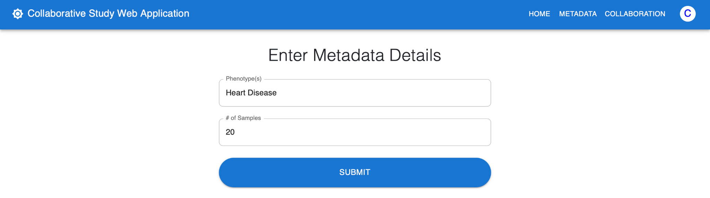

Step 2 • Set up the collaboration
Initiator configures the study and invites partners
STEP | INITIATOR | COLLABORATION SERVER | COLLABORATOR
2  Initiator configures the study and invites partners | - Opens the Collaborations page and clicks Start a Collaboration.  - STEP 1: gives the collaboration a name and picks Experiment Type = GWAS.  - STEP 2: picks one or more Quality Control methods (and sets threshold values for methods that need them).  - Selects which dataset to use for the study.  - STEP 3: searches for partners by phenotype and sample size, then sends invitations and submits. | - Creates the collaboration record with all the chosen settings.  - Sends invitations to each selected researcher. | - Receives a notification that they have been invited.

Wizard Step 1 — Name + Experiment Type
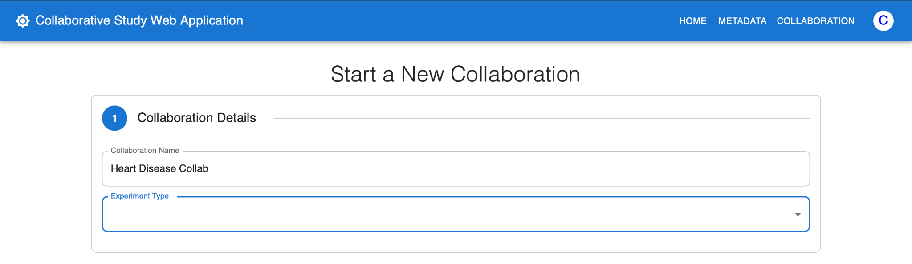

Wizard Step 2 — QC methods + thresholds
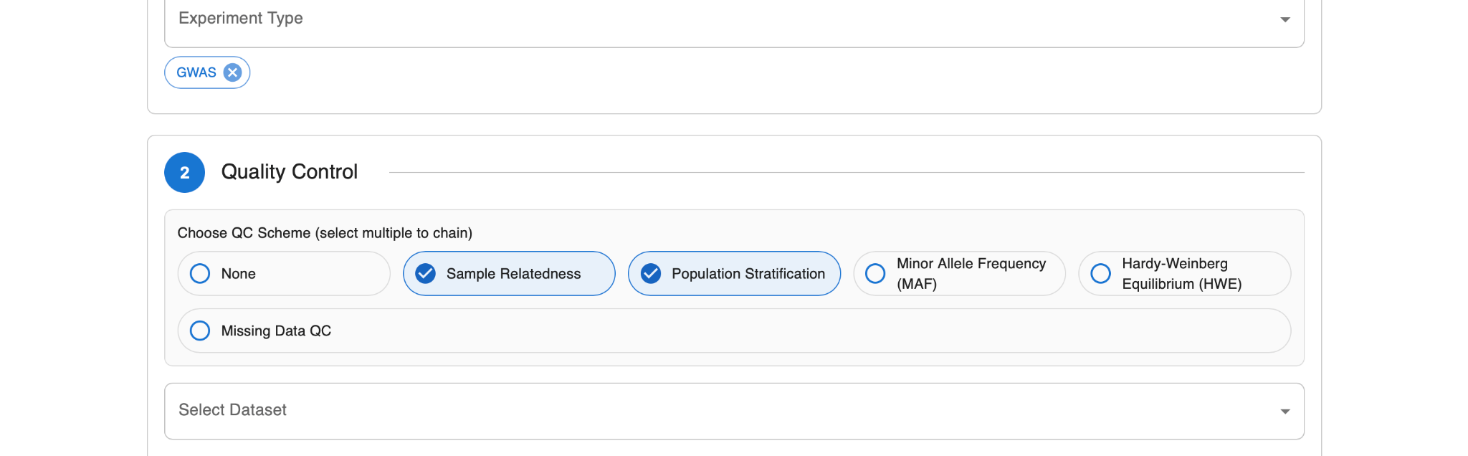

Wizard Step 3 — Find Collaborators + Submit
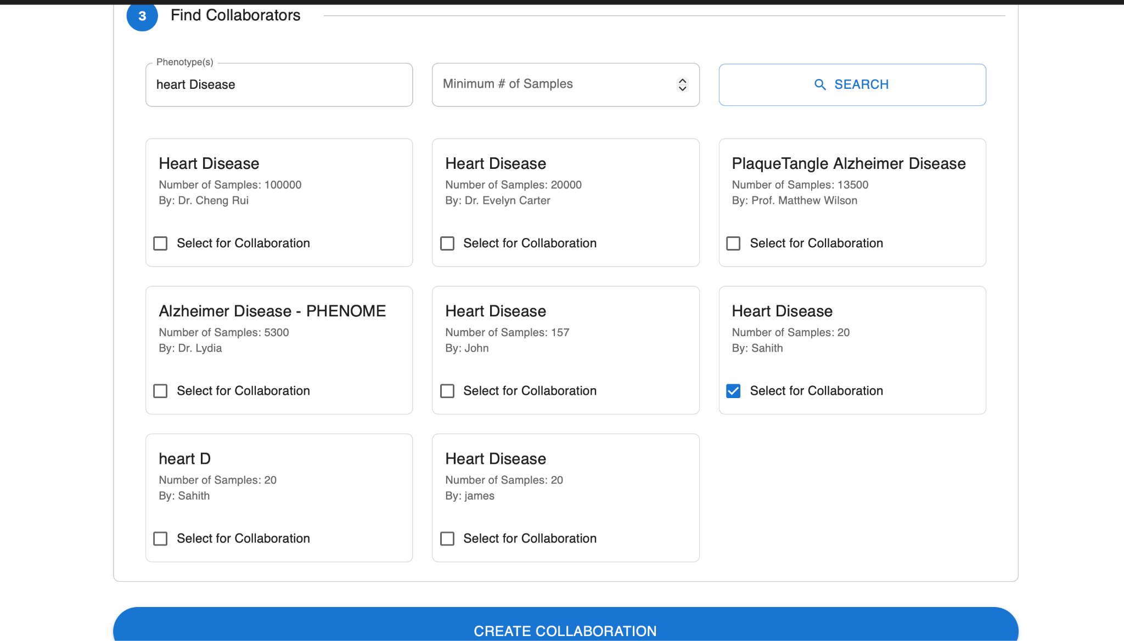

Step 3 • Accept the invitation
Collaborator agrees to participate
STEP | INITIATOR | COLLABORATION SERVER | COLLABORATOR
3  Collaborator agrees to participate | - Watches the collaboration page — the invited researcher's status changes from pending to accepted. | - Records the acceptance and is ready to start Quality Control. | - Reviews the invitation (study name, QC plan, phenotype) and clicks Accept.

Collaborator's invitation card with Accept / Reject
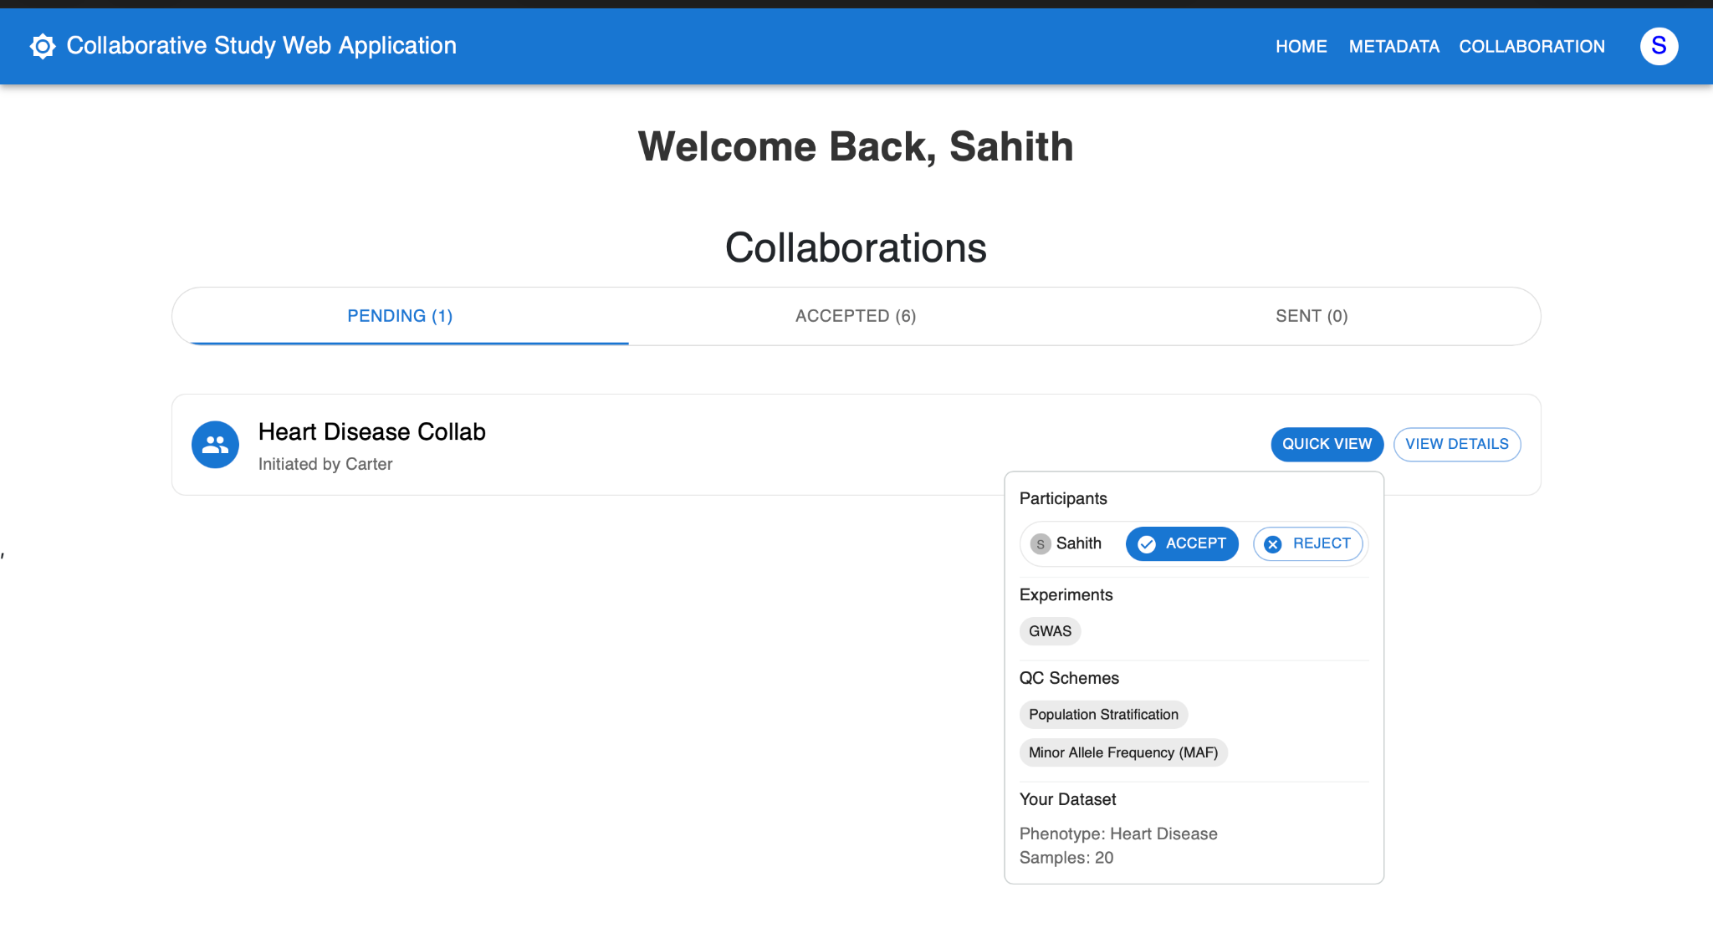

Step 4 • Quality Control
Filter samples and SNPs — privately on each machine
STEP | INITIATOR | COLLABORATION SERVER | COLLABORATOR
4  Filter samples and SNPs — privately on each machine | ▸ ON INITIATOR'S MACHINE  - Filter-only QC (MAF / HWE / Missing Data) runs automatically — survivor counts show up on its own.  - For pairwise methods (Sample Relatedness, Population Stratification) clicks Initiate QC Calculation.  - Drags a Threshold slider — the per-party sample counts update LIVE as the slider moves.  - Clicks Confirm Threshold to lock in the surviving samples and reveal the per-party preview list. | - Orchestrates QC across all parties.  - Receives only the survivor lists — never sees raw genotype data. | ▸ ON COLLABORATOR'S MACHINE  - QC runs on their own machine against their raw data. Raw data never leaves their computer.  - Sees the same live counts and the same preview list once the initiator confirms.

QC running on each party's machine (per-method progress)
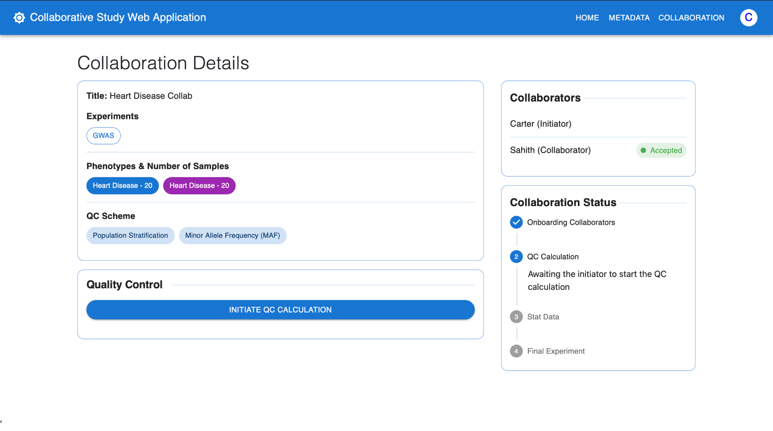

[ SCREENSHOT ]
Initiate QC Calculation + threshold slider + preview list
For pairwise methods: Initiate button, slider with live per-party counts, Confirm Threshold, preview list.

Step 5 • Generate summary statistics
Turn QC-filtered samples into per-SNP counts
STEP | INITIATOR | COLLABORATION SERVER | COLLABORATOR
5  Turn QC-filtered samples into per-SNP counts | ▸ ON INITIATOR'S MACHINE  - Clicks Create GWAS Dataset.  - Per-SNP case/control counts are computed on their own machine and only those counts are sent to the server. | - Collects each party's aggregated counts.  - Marks the collaboration as ready for analysis once everyone has uploaded. | ▸ ON COLLABORATOR'S MACHINE  - Does the same on their machine — counts only, never raw data.

[ SCREENSHOT ]
Stat upload status — each party Uploaded
Per-party checklist showing all rows flipped to Uploaded.

Step 6 • Run GWAS analysis
Combine counts across parties and view results
STEP | INITIATOR | COLLABORATION SERVER | COLLABORATOR
6  Combine counts across parties and view results | - Clicks Initiate GWAS Calculation.  - Sees a ranked table of SNPs with chi-square and p-value, sorted by significance.  - Can export the results. | - Combines the per-SNP counts from all parties.  - Computes the chi-square test for each SNP and stores the results. | - Sees the same results table — identified only by site label, not by name.

[ SCREENSHOT ]
GWAS results table (top SNPs)
Table sorted by p-value / chi-square.

Step 7 • AI summary report
Plain-English, privacy-preserving overview
STEP | INITIATOR | COLLABORATION SERVER | COLLABORATOR
7  Plain-English, privacy-preserving overview | - Clicks Generate Summary.  - Reads the AI-written report: overview, top SNPs, per-site contribution, and a recommendation (continue / continue with caveats / reconsider). | - Builds an anonymised digest (collaborators shown as Site A, Site B, …) and sends it to the AI model.  - Stores the generated report so subsequent reads are instant. | - Opens the collaboration and reads the same report.  - Identified only by site label — never by real name or institution.

[ SCREENSHOT ]
Final AI Summary card with recommendation banner
Overview + top SNPs + per-site analysis + recommendation callout.

Privacy at a glance
• Raw genotype data never leaves the machine it sits on. Quality Control runs locally on each party's computer; only survivor lists are returned to the Collaboration Server.
• The GWAS step uses aggregated case/control counts — there is no row-level genotype exchange between parties.
• The AI summary is built from an already-aggregated, anonymised digest. Collaborators are shown as Site A / Site B / … in the report.

