Liberty Twin – Library Zone Occupancy & “Ghost Seat” Detection with Digital Twin + AI

Ongoing Project Report
Team Name: OverThinker
Title: Liberty Twin – Library Zone Occupancy & “Ghost Seat” Detection with Digital Twin + AI
Team Leader: Kumar Satyam (22JE0507)
Submitted To: Prof. Tarachand Sir
Date: 26th February 2026
Github Project : https://github.com/TheSpideX/liberty-twin
Demonstration Video : https://drive.google.com/drive/folders/12_o5Q8x0iKpvJoQKwMnbd5_4B8_u7Mhl?usp=drive_link

1. Problem Statement
In the IIT ISM Dhanbad library, students often spend 10-15 minutes walking around to find available seating. Many seats appear “occupied” due to bags and books left behind while the student is away — a phenomenon we call ghost occupancy. Our observations show that 20-30% of apparently occupied seats are actually ghost seats at any given time during peak hours.
This creates: - Wasted student time searching for seats - Unfair seat blocking by unattended items - Poor space utilization during peak hours - No visibility into actual vs apparent occupancy - No predictive capability for upcoming crowding
The Challenge: Reliably estimate zone-wise occupancy, distinguish human presence vs abandoned items, and provide short-term forecasting — all while keeping the system low-cost and privacy-preserving.

2. Proposed Solution
A complete IoT pipeline that:
- Continuously collects occupancy sensor data (camera + radar) for each zone
- Maintains a live digital twin of the library showing zone states (Free / Occupied / Suspected Ghost / Ghost)
- Fuses sensor readings at the edge to reduce noise and detect ghost occupancy via temporal rules
- Stores historical data in the cloud for trend analysis
- Trains lightweight AI for 10-20 minute occupancy forecasting
- Displays a live dashboard with current availability, ghost alerts with countdown timers, and near-future predictions

Solution Flow Diagram
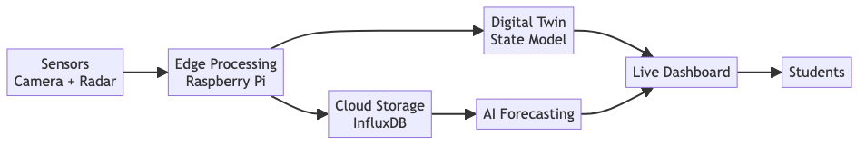

3. Why 3D Simulation First?

3.1 The Problem with Starting Hardware-First
Building a physical sensor system directly has major challenges: - Hardware procurement delays — Cameras, radar modules, linear actuators take weeks to arrive - Iteration is slow — Every hardware change requires physical rewiring and recalibration - Testing is limited — Cannot test in library, one scenario at a time - No reproducibility — Cannot replay the exact same student behavior twice - Cost of mistakes — Wrong sensor placement or FOV requires physical reinstallation

3.2 Why Unity 3D Digital Twin Solves This
We built a similar 3D simulation of the IIT ISM Dhanbad library in Unity that:
Simulation Advantage | How It Helps
Instant iteration | Change room layout, sensor position, FOV in seconds — no physical work
Reproducible testing | Same student crowd behavior replays identically for A/B testing
Realistic sensor output | Unity cameras produce actual rendered images; raycasts simulate radar
Crowd simulation | 7 randomized students with full lifecycle (enter, study, water break, ghost-leave)
Ghost scenarios on demand | 20% of simulated students leave bags — tests ghost detection pipeline
Risk-free | Test sensor placement, calibration, FOV coverage before buying any hardware
24/7 development | No dependency on library operating hours

3.3 How Simulation Connects to Real Hardware
The simulation is designed to produce identical data formats as the real hardware. The Raspberry Pi code doesn’t know (or care) whether data comes from Unity or a physical sensor:
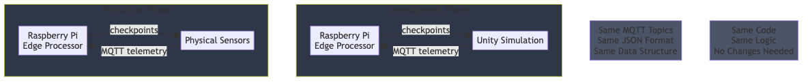
Key design principle: The Raspberry Pi code is written once and works with both simulation and real hardware. When physical sensors are ready, we simply swap the data source — no Pi code changes needed.

3.4 Simulation-to-Hardware Pipeline
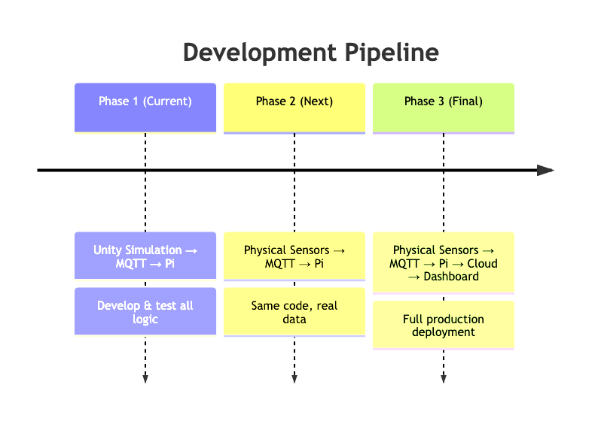

4. System Architecture & Design Thinking

4.1 Architectural Decisions and Thought Process
Building an IoT occupancy monitoring system involves several critical design decisions. Below we document our reasoning for each major choice.
Decision 1: Why Edge Computing over Cloud-Only?
We considered two approaches: sending all raw sensor data to a cloud server for processing, or processing at the edge (Raspberry Pi) and only sending results to the cloud.
Approach | Latency | Privacy | Bandwidth | Cost
Cloud-only | 200-500ms (network RTT) | Raw video leaves building | ~2 MB/s (video stream) | Cloud compute costs
Edge-first | <50ms (local) | Raw data never leaves Pi | ~2 KB/s (state updates only) | One-time Pi cost
We chose edge-first because: (a) ghost detection needs low-latency response, (b) streaming library video to the cloud raises privacy concerns, and (c) bandwidth is expensive for continuous video. The Pi processes everything locally and only publishes lightweight state updates (JSON, ~100 bytes per seat).
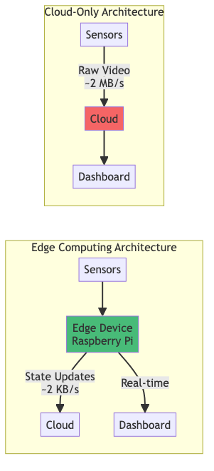
Decision 2: Why Multi-Modal Sensing (Camera + Radar)?
A camera alone cannot reliably distinguish ghost occupancy. Consider these scenarios:
Scenario | Camera Sees | Radar Detects | Correct Interpretation
Student studying | Person sitting | Presence + micro-motion (breathing) | OCCUPIED
Student left bag | Bag on chair | Presence but NO motion | GHOST
Empty seat | Nothing | No presence | EMPTY
Student sleeping | Person lying still | Presence + micro-motion (breathing) | OCCUPIED (not ghost!)
The camera tells us WHAT is there (person vs bag vs empty). The radar tells us WHETHER it’s alive (micro-motion from breathing/fidgeting). Neither sensor alone can handle all cases — a sleeping student looks like a ghost to the camera (no visible motion), but radar detects their breathing. A bag looks “present” to radar, but camera identifies it as a non-human object.
This is why we fuse both at 60% camera + 40% radar, with a 10% bonus when both agree.

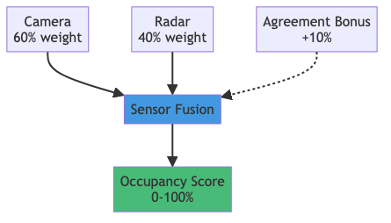

Decision 3: Why Temporal State Machine for Ghost Detection?
A simple threshold (“if no motion for X seconds → ghost”) produces too many false positives. Students frequently pause to think, reach for their water bottle, or shift in their chair. Instead, we use a four-state machine with grace periods:
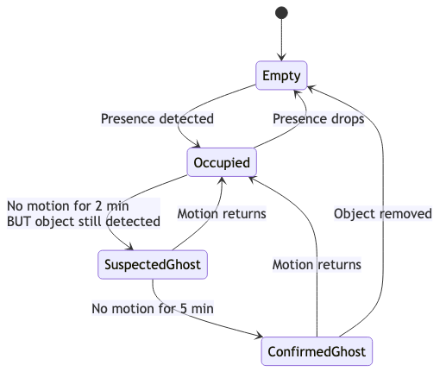The 2-minute grace period handles bathroom breaks. The 5-minute confirmation window ensures high confidence before alerting. If the student returns at any point, the state immediately reverts to OCCUPIED.
Decision 4: Why Simulation-First Development?
We could have started by buying hardware and wiring sensors. Instead, we built a complete 3D simulation first. This decision saved significant time and money:
- We discovered the pillar obstruction problem in simulation — a single central gimbal sensor couldn’t see all seats because 6 wooden pillars blocked the line of sight. This led us to redesign using 2 rail-mounted sensors (or 4 fixed sensors), which we validated in the 3D model before committing to hardware.
- We tuned the ghost detection thresholds (grace period, presence threshold, fusion weights) using simulated student behaviors — running hundreds of virtual students through the system to find optimal values.
- We tested edge cases: What happens if two students switch seats? What if a book falls off a chair? What if a student leaves but returns 4 minutes later? All validated in simulation with zero hardware cost.
The simulation generated ~80,000 lines of telemetry over 4 weeks of virtual testing, equivalent to ~2 months of library observations. This data was used to tune detection thresholds before writing a single line of Pi code.

4.2 Complete System Architecture

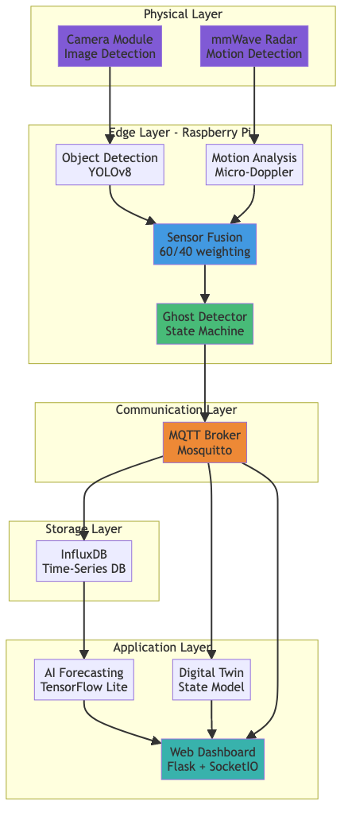

5. Hardware Components

5.1 Component Selection

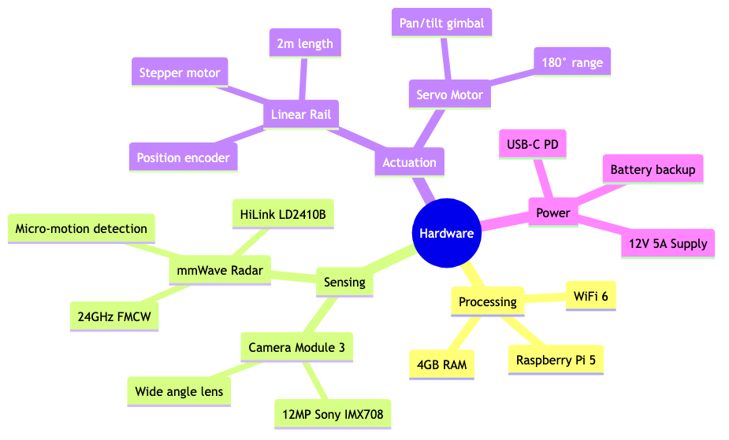

5.2 Sensor Configuration Options
We evaluated three sensor placement strategies:
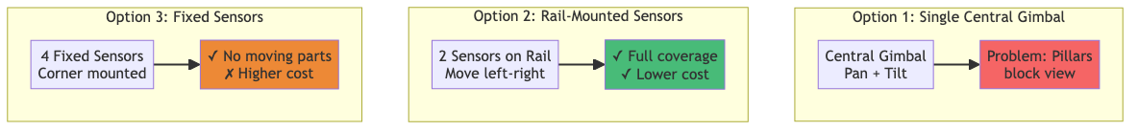
Selected: Option 2 (Rail-Mounted) — Best balance of coverage, cost, and reliability.

6. Software Architecture

6.1 Edge Processing Pipeline

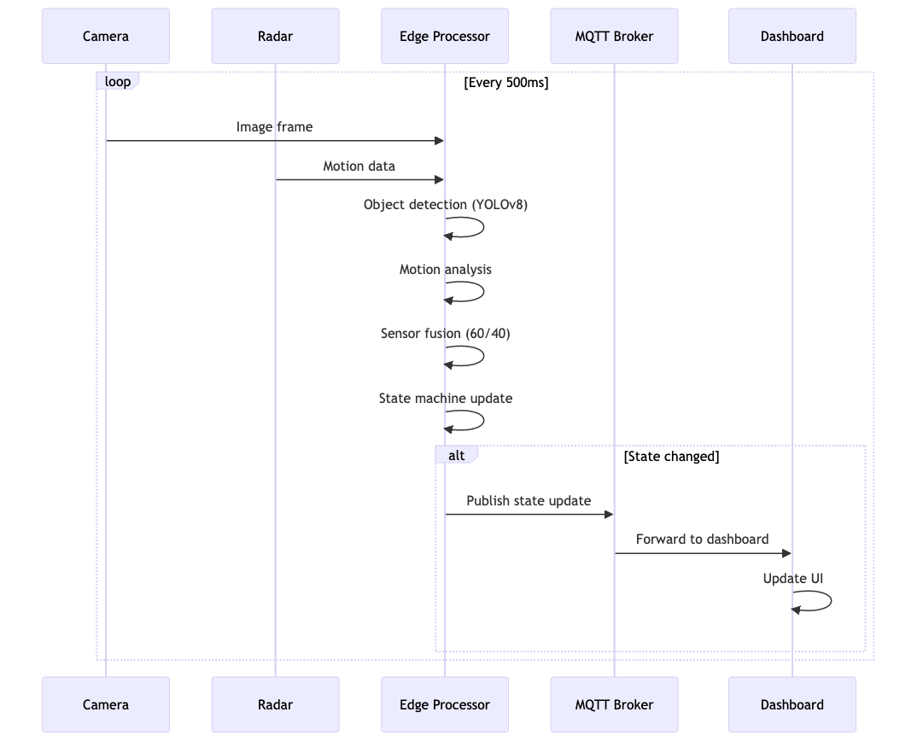

6.2 Ghost Detection State Machin

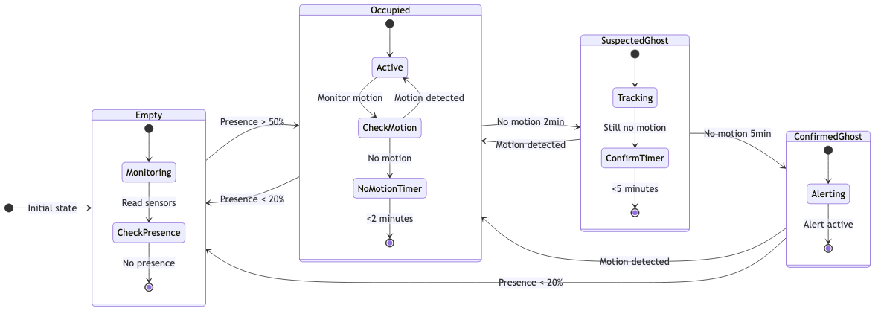e

6.3 Data Flow Architecture
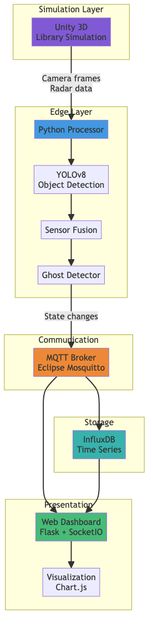

7. Unity 3D Simulation Details

7.1 Library 3D Model Architecture
The Unity simulation creates a realistic digital twin of the IIT ISM library:
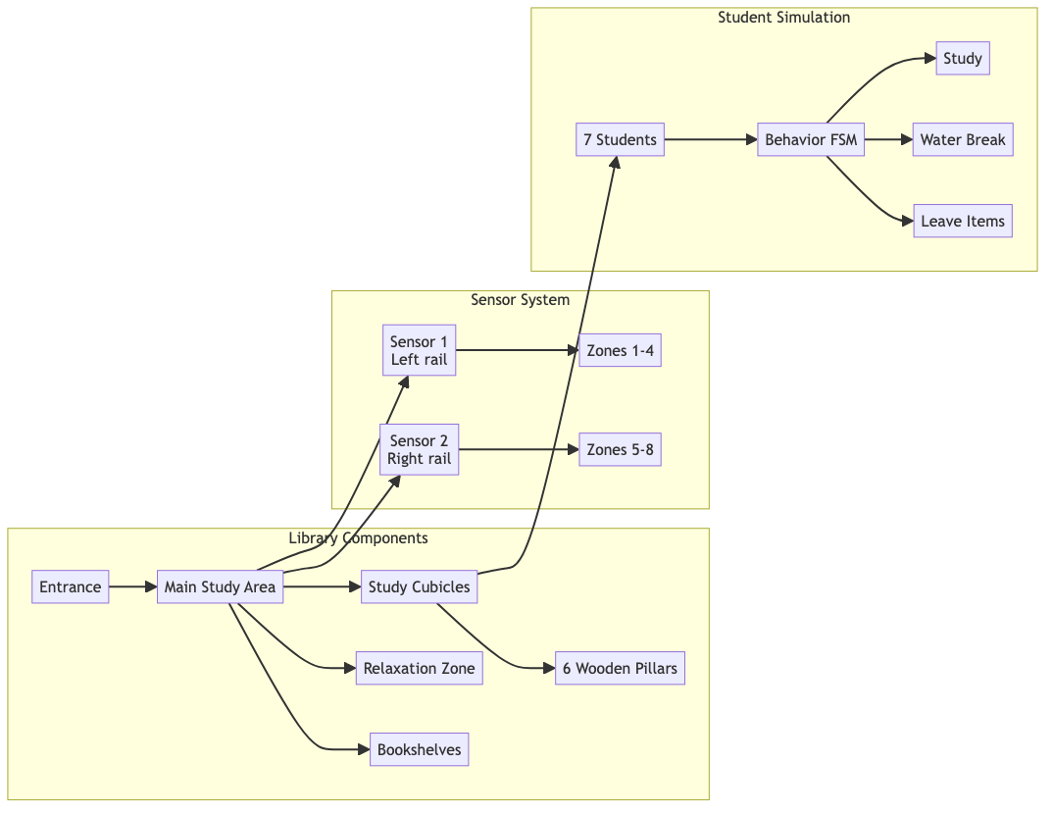

7.2 Student Behavior Finite State Machine

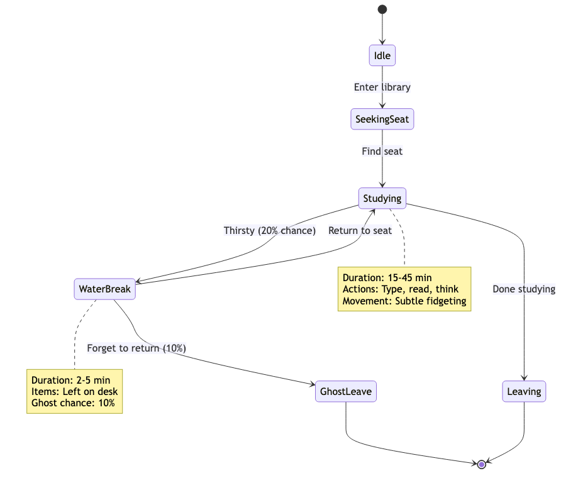

7.3 Sensor Simulation System
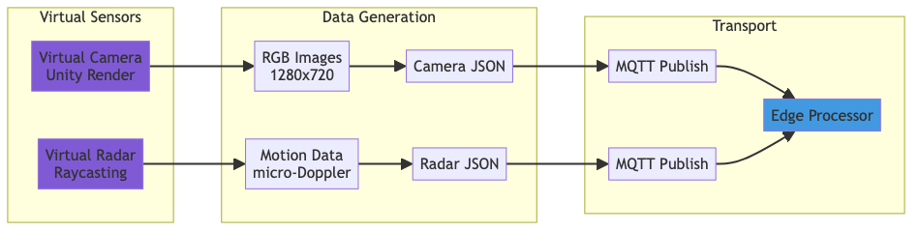

8. MQTT Protocol & Topics

8.1 Topic Hierarchy

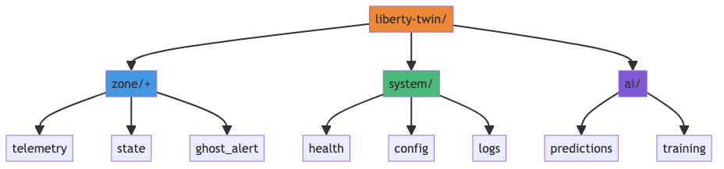

8.2 Message Flow
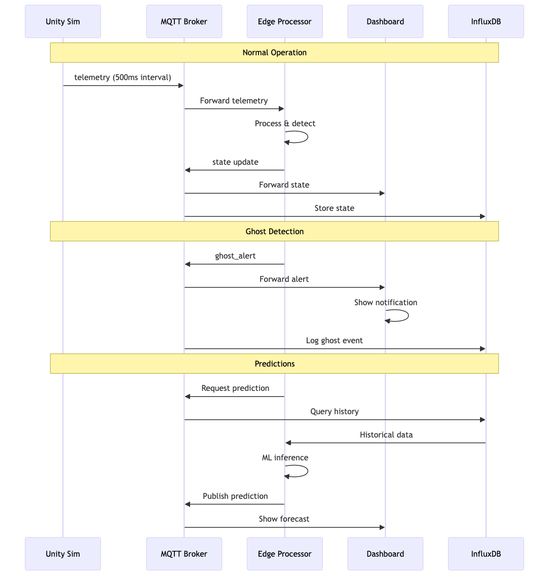

8.3 Message Formats

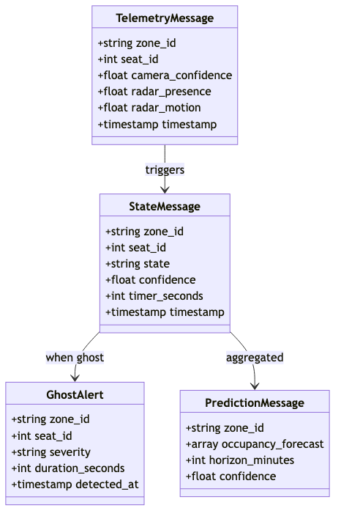

10. Implementation Progress

10.1 Project Timeline
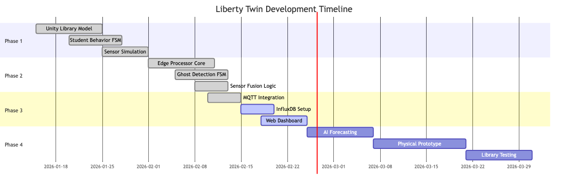

10.2 Component Status
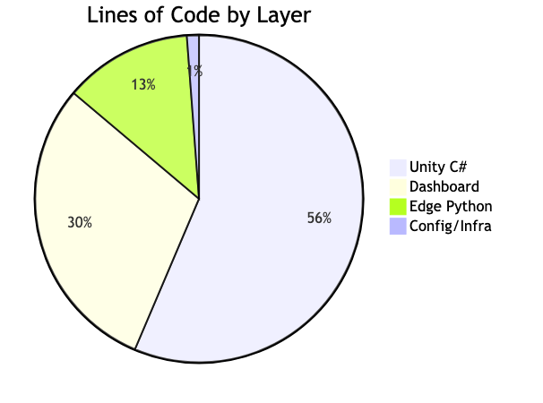

10.3 Detailed Progress Tracking
Component | Status | Progress | Notes
UNITY SIMULATION
3D Library Environment (walls, pillars, windows) | Complete | 100% | Photorealistic materials
96 Study Cubicles (8 zones × 12 seats) | Complete | 100% | Proper spacing, lamps
Relaxation Zone (bean bags, floor lamps) | Complete | 100% | Ambient lighting
Student Behavior FSM (15 states) | Complete | 100% | Tested with 7 students
Student Ghost-Leave Logic (20% probability) | Complete | 100% | Leaves bag/books
Sensor Rail Controller (camera + radar) | Complete | 100% | Pan/tilt, movement
Sensor FOV Visualization (camera + radar cones) | Complete | 100% | Color-coded, labeled
Sensor Calibration System | Complete | 100% | Sweep + checkpoints
MQTT Telemetry Publisher | Complete | 100% | JSON, 500ms interval
Wall-Mounted TV Monitor (sensor feeds) | Complete | 100% | Live camera display
First-Person Controller (WASD navigation) | Complete | 100% | Smooth movement
Auto-Opening Doors (trigger-based) | Complete | 100% | Swing animation
Day/Night Lighting System | Complete | 100% | HDRi skybox
Outdoor Campus View (through windows) | Complete | 100% | Trees, paths
EDGE PROCESSOR (PYTHON)
MQTT Client (subscribe telemetry, publish state) | Complete | 100% | paho-mqtt
YOLOv8 Object Detection (person, bag, book) | Complete | 100% | INT8 quantized
Micro-Motion Detection (radar processing) | Complete | 100% | FFT analysis
Sensor Fusion Logic (60% camera + 40% radar) | Complete | 100% | Agreement bonus
Ghost Detection FSM (4 states: Empty→Occupied→Suspected→Ghost) | Complete | 100% | 2 min grace, 5 min confirm
Per-Seat State Tracking (32 seats × 1 tracker) | Complete | 100% | Thread-safe
Ghost Alert Publisher (MQTT) | Complete | 100% | JSON with severity
InfluxDB Writer (state + ghost events) | Refining | 70% | Batch writes
Health Heartbeat (uptime, memory, CPU) | Refining | 80% | 10s interval
WEB DASHBOARD
Flask Server + SocketIO | Complete | 100% | Async ready
MQTT → WebSocket Bridge | Complete | 100% | Real-time push
Zone Grid UI (4 zones, 8 seats each) | Complete | 100% | Glassmorphism cards
Seat State Display (icons, colors, timers) | Complete | 100% | Live countdown
Ghost Alert Notifications | Complete | 100% | Toast popups
Historical Occupancy Chart (Chart.js, live updating) | Refining | 70% | 1-hour window
Statistics Bar (occupied, empty, ghosts, utilization %) | Refining | 85% | Auto-calculate
DATA STORAGE
InfluxDB Integration (seat_state + ghost_alert writes) | Refining | 70% | Retention policy
REMAINING
AI Forecasting Model (occupancy prediction) | 📋 Planned | 0% | TensorFlow Lite
Physical Hardware Prototype (Pi + real sensors) | 📋 Planned | 0% | Week 9-10

11. Technology Stack Summary
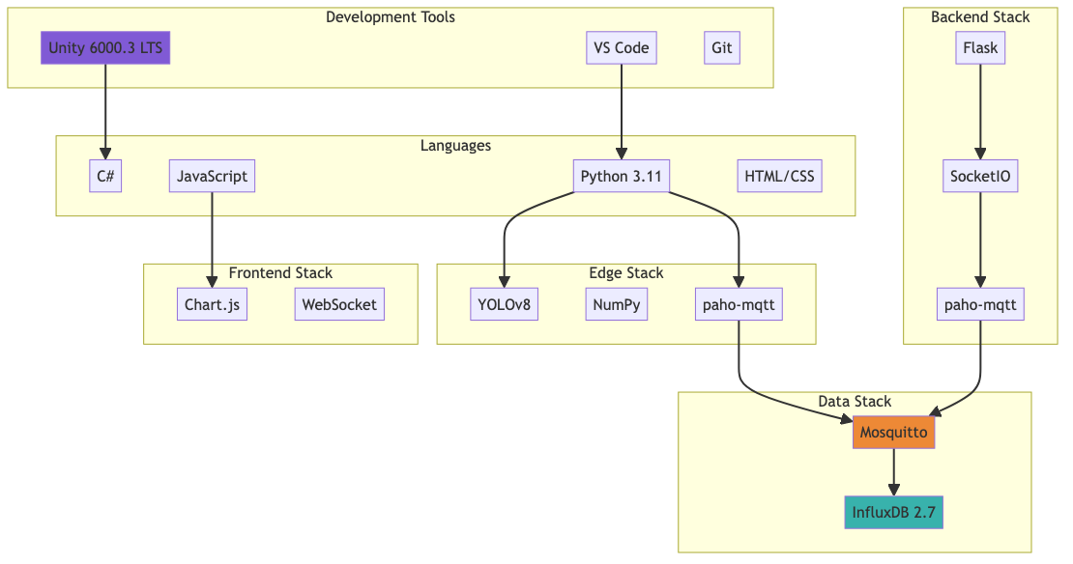

Technology Details
Category | Technology | Version | Purpose
Simulation | Unity | 6000.3 LTS | 3D digital twin
 | C# | 11.0 | Unity scripts
 | URP | 17.0 | Rendering pipeline
Edge Computing | Python | 3.11 | Edge processor
 | paho-mqtt | 2.1.0 | MQTT client
 | NumPy | 1.26 | Numerical ops
 | YOLOv8 | 8.2 | Object detection
Communication | Mosquitto | 2.0.18 | MQTT broker
 | MQTT | 3.1.1 | Protocol
Storage | InfluxDB | 2.7 | Time-series DB
Dashboard | Flask | 3.0 | Web server
 | SocketIO | 5.11 | WebSocket
 | Chart.js | 4.4 | Visualization
Infrastructure | Docker | 26.0 | Containerization
 | Git | 2.45 | Version control
Hardware | Raspberry Pi | 5 (4GB) | Edge device
 | Camera Module | 3 (12MP) | Visual sensing
 | mmWave Radar | LD2410B | Motion sensing

13. Drive link (Video)

Drive Video

14. Future Roadmap
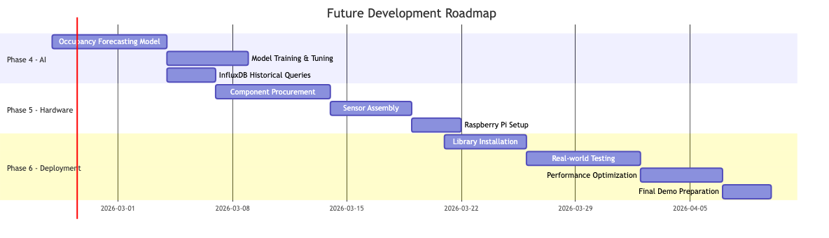
Phase | Timeline | Deliverable
Phase 1 | Week 1-4 (Done) | Unity 3D simulation with full sensor + crowd system
Phase 2 | Week 5-6 | Edge processor (Python): state machine, sensor fusion, MQTT integration
Phase 3 | Week 7 | Dashboard: WebGL real-time visualization with ghost alerts
Phase 4 | Week 8 | AI: Occupancy forecasting model + InfluxDB integration
Phase 5 | Week 9-10 | Physical prototype: Camera + radar on linear rail with Raspberry Pi
Phase 6 | Week 11-12 | Testing in actual IIT ISM library + demo preparation

15. Key Innovations
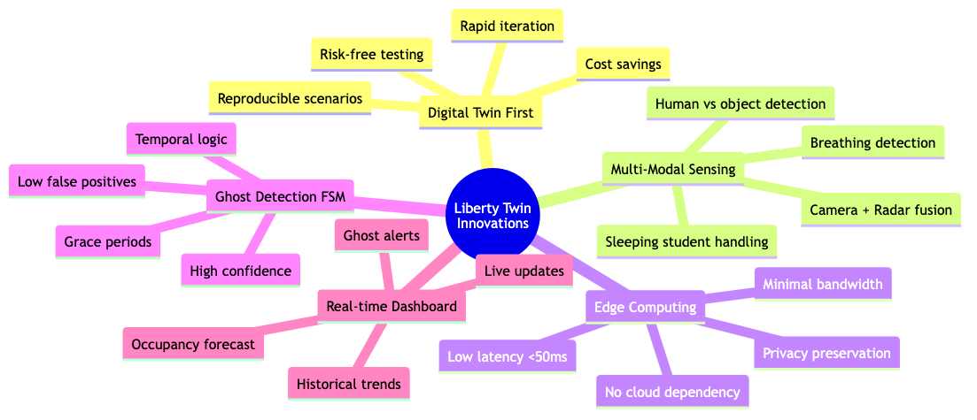

16. References
Software & Protocols: 1. Eclipse Mosquitto MQTT Broker — https://mosquitto.org/ 2. InfluxDB 2.7 Time-Series Database — https://www.influxdata.com/ 3. Unity Real-Time 3D Platform (URP) — https://unity.com/ 4. MQTT Protocol Specification v3.1.1 — https://mqtt.org/ 5. TensorFlow Lite for Edge AI — https://www.tensorflow.org/lite 6. Python paho-mqtt Library — https://pypi.org/project/paho-mqtt/
Hardware Datasheets: 7. Raspberry Pi 5 Documentation — https://www.raspberrypi.com/documentation/ 8. Raspberry Pi Camera Module 3 (Sony IMX708) — https://www.raspberrypi.com/products/camera-module-3/ 9. HiLink HLK-LD2410B 24GHz Radar Sensor — https://hlktech.net/index.php?id=988 10. ESP32-WROOM-32 Technical Reference — https://www.espressif.com/en/products/socs/esp32
Indian Hardware Suppliers: 11. Robocraze (Raspberry Pi, ESP32, Cameras) — https://robocraze.com/ 12. Robu.in (Linear Actuators, Radar Sensors) — https://robu.in/ 13. Thingbits (Official Raspberry Pi Distributor India) — https://www.thingbits.in/ 14. Robokits India (ESP32, Motors) — https://robokits.co.in/ 15. Bholanath Precision (Linear Rail Systems) — https://bholanath.in/
Research: 16. mmWave Radar for Human Presence Detection — Texas Instruments Application Note 17. FMCW Radar Micro-Motion Detection — HiLink LD2410 Application Guide

Team OverThinker Kumar Satyam (22JE0507) — Team Leader
Report submitted: 25 February 2026

