ECS

云计算基础服务 -> 云服务器 ECS -> 实例 （choose area at top bar：杭州、上海...）

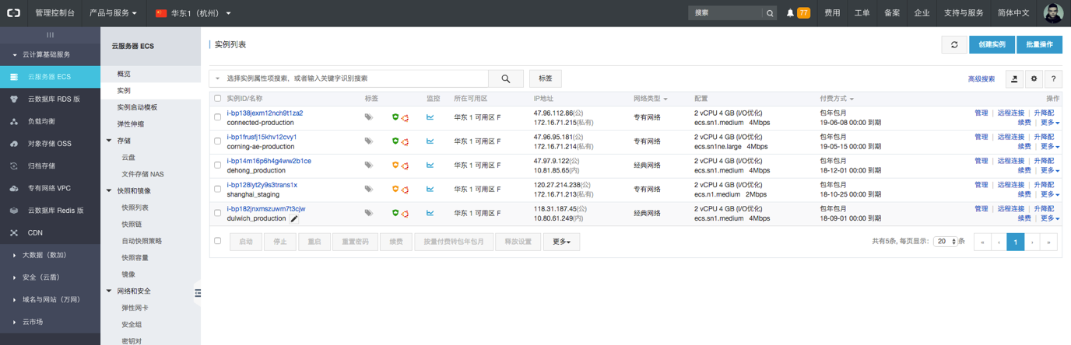

click “实例名称” or “管理” on the right control panel to go into instance details page

There is a “创建实例” button on the top right of “实例列表”, which can create new ECS instance, can check configuration of existed ones, normally we don’t have big changes. Area normally should be either杭州（华东一）or上海（华东二）, there is no big difference between them but the only one need to careful with is, the area of ECS instance is bound with OSS bucket, for example, ECS in Shanghai can only access to OSS bucket in Shanghai.

OS Image normally should be public images of Ali such as Ubuntu 16.04, also, custom image make by snapshot of existed ECS instance is available to use, the key is after the new ECS starts up the password of user maximum has to be changed.

In addition, Ali will send emails time to time to report some out dated patches or unusual logins of ECS, there is link in email which will take to details page.

To those instances near to expired, Ali will also send email to notify, there is “续费” button at the right control panel of “实例列表” page which can be clicked to extend the service.

Snapshot

The ECS instance detail page has information of disk and snapshot, we can click numbers in below pic to go the list of snapshots of current instance.

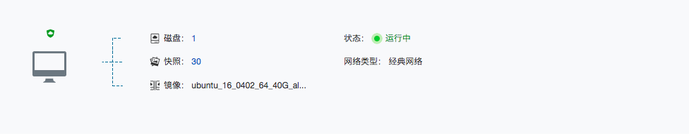

On the left menu under “快照和镜像” topic, we have below:

快照列表: list of all snapshots, “创建自定义镜像” on the right is used to create custom OS image

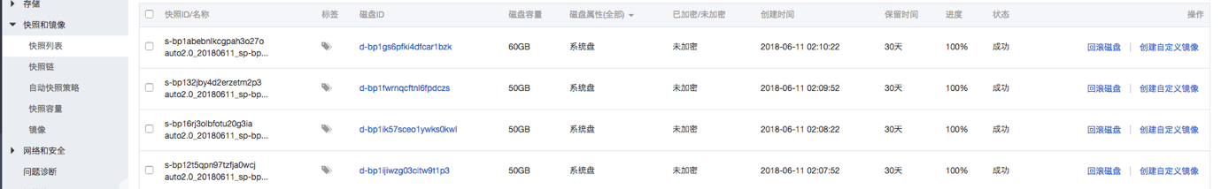

快照链: list of all disks which have snapshots

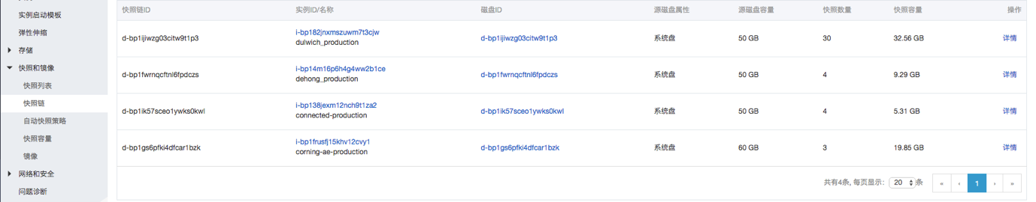

自动快照策略: manage the strategy of snapshot

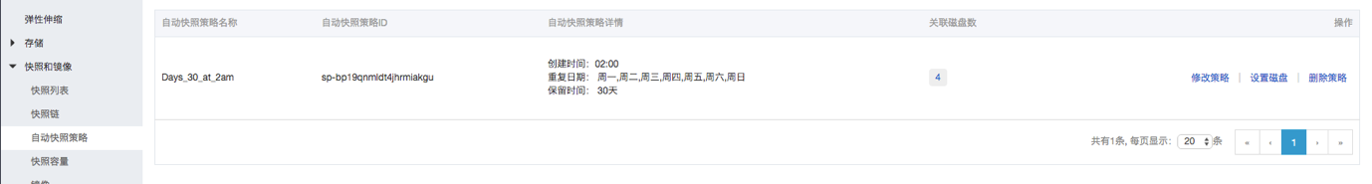

快照容量: the total volume usage of all snapshots, based on what we buy the storage package

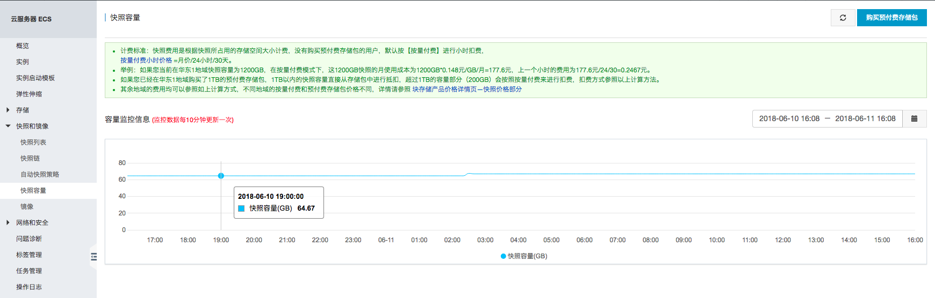

镜像: list of OS images created based on existed snapshots, which can be used during ECS creation

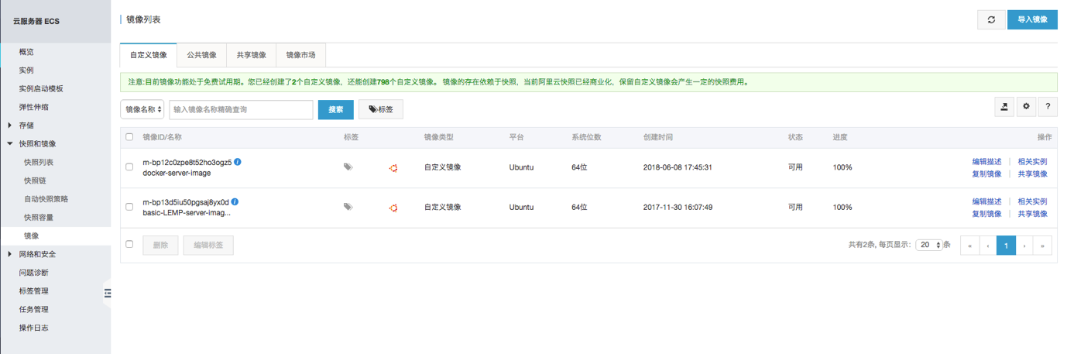

Cost Calculation

Charge together with OSS, so refer to OSS cost calculation.

OSS

云计算基础服务 -> 对象存储 OSS

create bucket：

input custom bucket name which becomes the sub-domain of this bucket, select area (the same as the ECS instance we want to use), “标准存储” for “存储类型” and “公共读” for “读写权限”

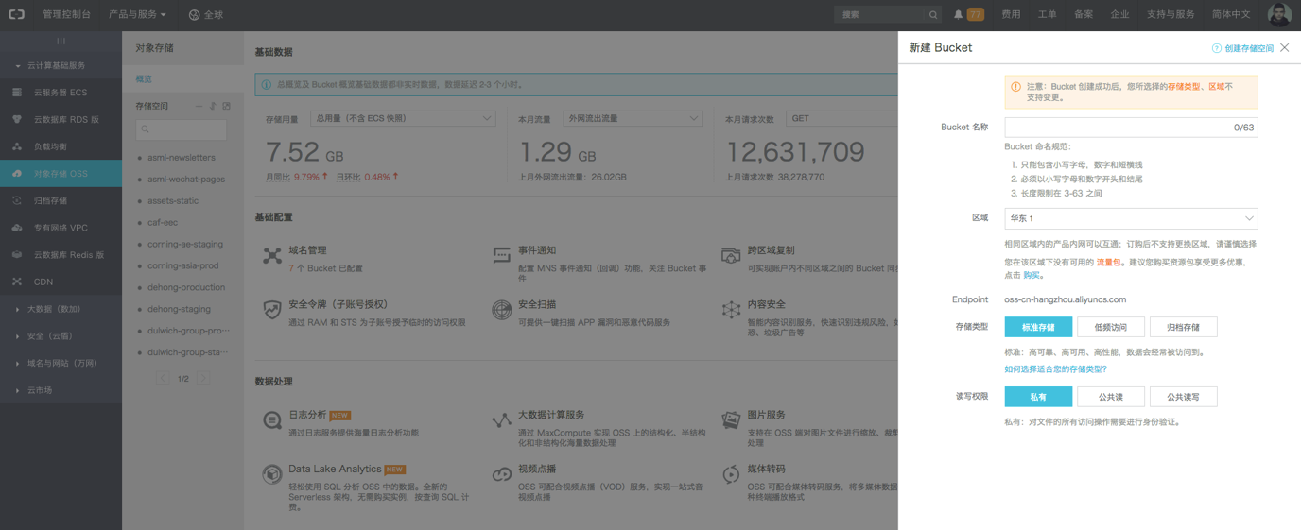

In bucket details page, we can check the traffic usage, upload and download files in “文件管理”, set CORS header in “基础设置” -> “跨域设置”

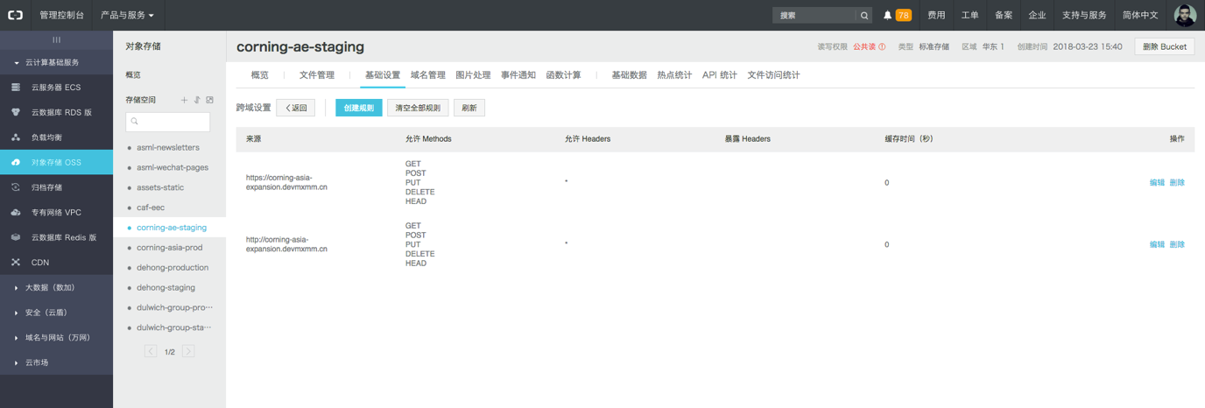

Account credentials can be checked by the “Access Key” button on the top right control panel of “概览” page,

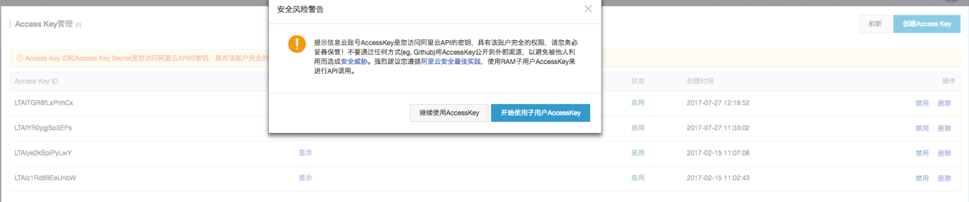

choose “继续使用AccessKey”

credentials are used in code to set the connection between Laravel and OSS, we are using <https://github.com/jacobcyl/Aliyun-oss-storage> as third-party bundle, but it has a bug with custom domain name, so Jonas changed it a bit. As a result, below lines need to be add in composer.json file:

"repositories": [

{

"type": "vcs",

"url": "https://github.com/jonasva/Aliyun-oss-storage.git"

}

],

Cost Calculation

Doc: <https://cn.aliyun.com/price/product?spm=5176.doc27271.2.4.6MFEZS#/oss/detail>

存储总量: Check in OSS “概览” page, need to plus snapshot usage because they charge together

外网流出流量: Check in OSS “概览” page

CDN 回源流量: Check in CDN “监控” page

请求: Check in OSS “概览” page

|  |  |  |  |  |  |
| --- | --- | --- | --- | --- | --- |
|  | 存储总量 | 外网流出流量 | CDN回源流量 | 请求 | 汇总 |
| 单价 | 0.148 元／GB／月 | 0.5 元／GB | 0.15元／GB | 0.01 元／万次 | ／ |
| 流量 | 2.55 GB | 114 MB／天 | 2.72 GB／天 | 353.4 万次 | ／ |
| 总计 | 0.38 元／月 | 0.057 元／天 | 0.41 元／天 | 3.534 元／天 | ／ |
| 年费 | 5 元 | 21 元 | 150 元 | 1290 元 | 1466 元 |

DNS

DNS information:

域名与网站（万网） -> 域名 -> 域名列表

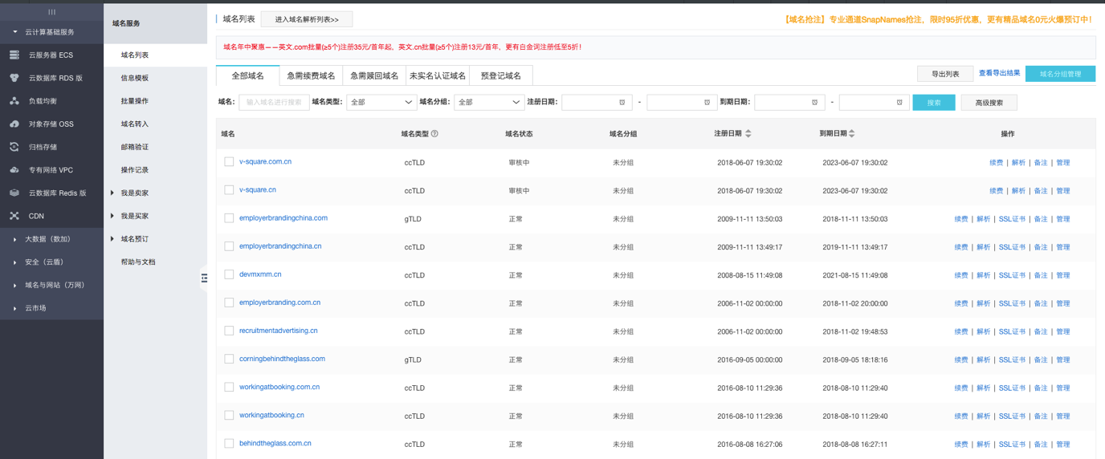

Go to “域名控制台” by clicking domain name, where we can find detail information about this domain, including DNS server. If it’s “万网” server then this domain name can be directly managed in Ali DNS, otherwise have to config in corresponding DNS server. However, if you want to change the DNS sever back to Ali “万网” server, just click “修改DNS”.

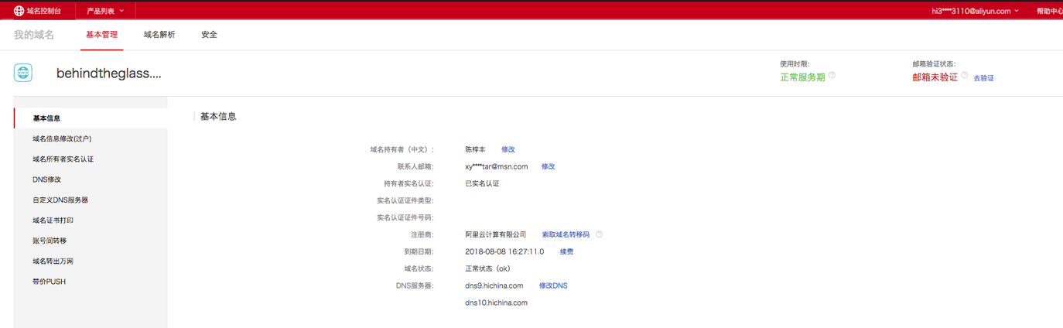

DNS management:

域名与网站（万网） -> 云解析 DNS -> 域名解析 -> 域名解析列表

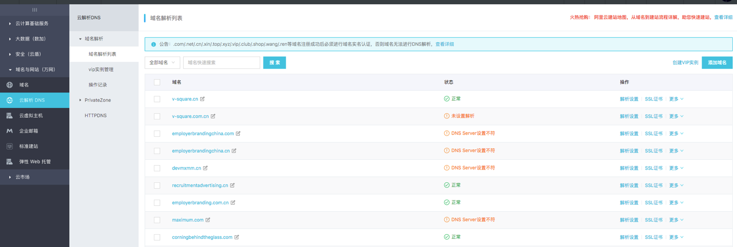

Go to DNS management panel by clicking domain name, click “添加记录” button on the right top to create new item

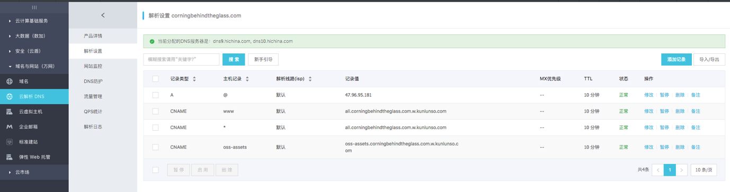

记录类型 A: point to server ip

记录类型 CNAME: point to another domain name

主机记录 @: for naked domain

主机记录 *: for wildcard domain, but doesn’t include deeper level domain

After we activate CDN, we create a CNAME record to point to CDN CNAME domain name

CDN

云计算基础服务 -> CDN -> 域名管理

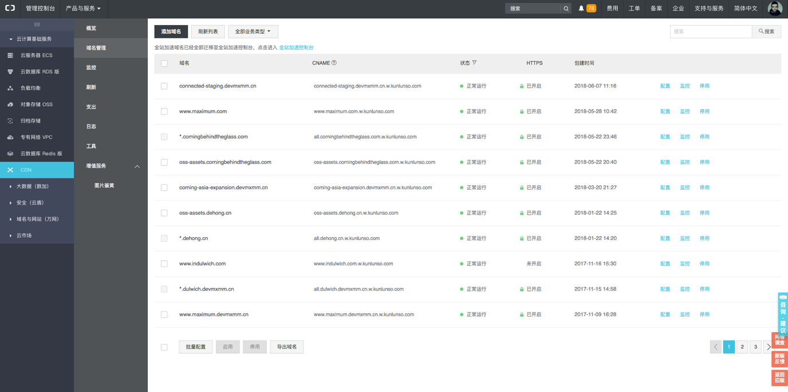

Create new CDN record by clicking “添加域名” on the top

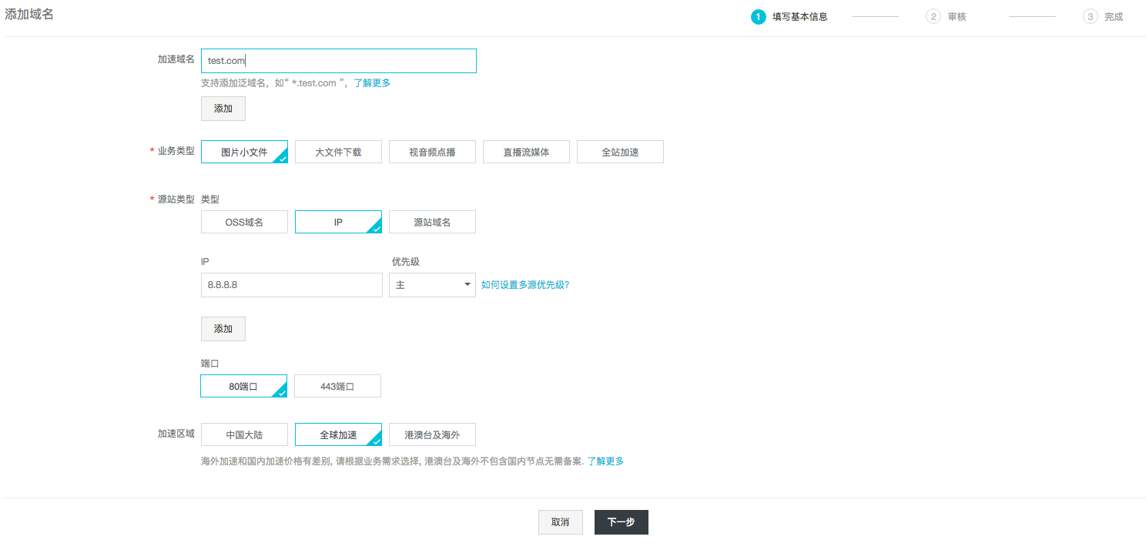

Fill in with domain name(wildcard domain name acceptable), “图片小文件” for “业务类型”.

For “源站类型”, “IP” is for server IP, “源站域名” is for those projects you already have a domain, then current CDN domain is used to point to specific origin domain

“OSS域名” is for OSS bucket as below

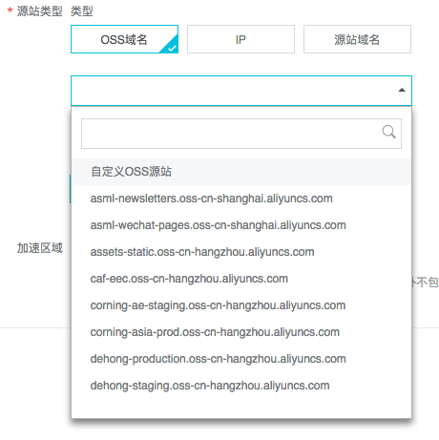

“端口” PORT is selected according to actual situation, 443 for https configured, it can be changed after creation anyway.

“加速区域” need to be careful because it cannot be changed after creation, the only way to change is delete the old one and create a new.

Click “下一步” to finish, it will take around 5 minutes to configure CDN, then the CNAME record is shown on top of the details page, then create the CNAME record in DNS.

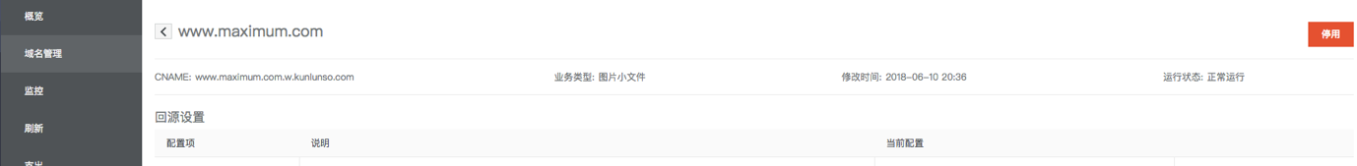

In CDN details page:

回源设置: “协议跟随回源” is only used when you don’t want mandatory redirection from http to https, then you open it and choose “跟随”. In the mean time, you need to change HTTPS configuration accordingly, which will be mentioned in HTTPS part below.

缓存设置: There are 9 (actually 10, Ali has bug in hint message lol) available headers can be set, such as Access-Control-Allow-Origin.

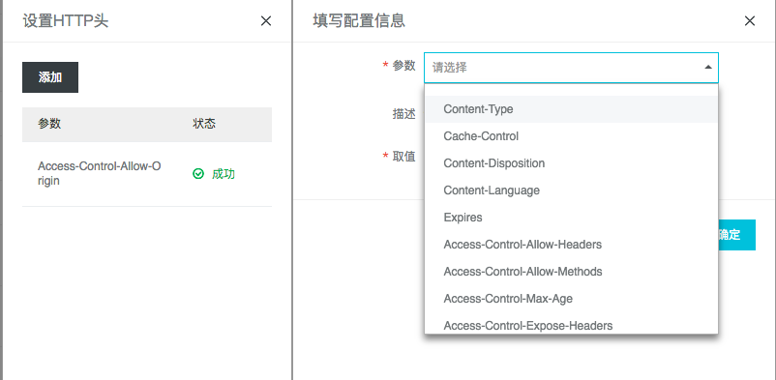

HTTPS 设置:

自有证书: upload existing cert, such as cert generated by letsencrypt, copy paste pem and key file and insert custom cert name

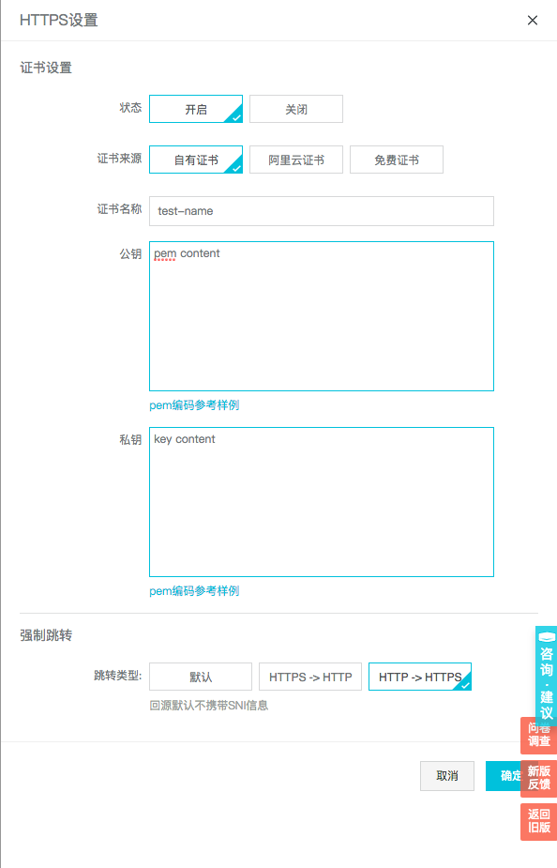

阿里云证书:

Directly select an existing cert issued by Ali (The first for Ali cert configuration is done by pushing the cert to CDN from “云盾服务”, which will be mentioned below in “云盾” part)

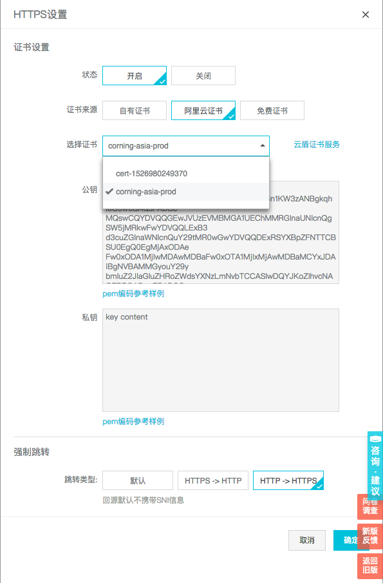

免费证书: I haven’t tried before, looks efficient and simple to use, Ali will automatically issue a 1-year free cert for this CDN domain and refresh it when near expire.

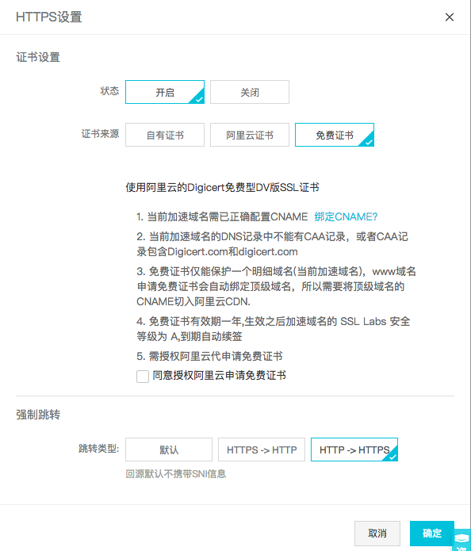

强制跳转: Mandatory redirection, widely used for “HTTP -> HTTPS”. But need to be careful that “默认” doesn’t means no redirection, it will still redirect from HTTP to HTTPS. If you want to disable the redirection, you need to setup the “协议跟随回源” to “跟随” too as I have mentioned before In CDN details page.



|  |  |  |  |  |  |
| --- | --- | --- | --- | --- | --- |
|  | 总流量（国内） | 总流量（国外） | 回源流量 | HTTPS | 汇总 |
| 单价 | 0.24 元／GB | 0.46 元／GB | 不计费（OSS） | 0.05 元／万次 | ／ |
| 流量 | 2.79 GB／天 | 7.8 GB／天 | ／ | 11.86 万次 | ／ |
| 总计 | 11.6 元／天 | | ／ | 0.6 元／天 | ／ |
| 年费 | 1570 元 | | ／ | 220 元 | 1790 元 |

Traffic Cost Calculation

Doc: <https://cn.aliyun.com/price/product?spm=5176.doc27271.2.4.6MFEZS#/cdn/detail>

SSL

安全（云盾） -> CA证书服务（数据安全）

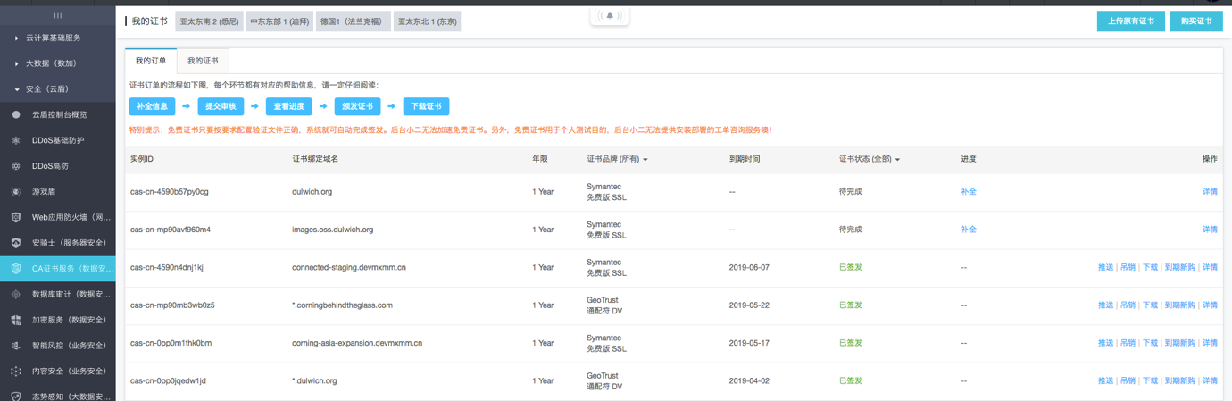

To buy 1-year free cert:

Click “购买证书” on top right, then select one by one “1个域名” – “Symantec” – “免费型DV SSL”, Click “立即购买”

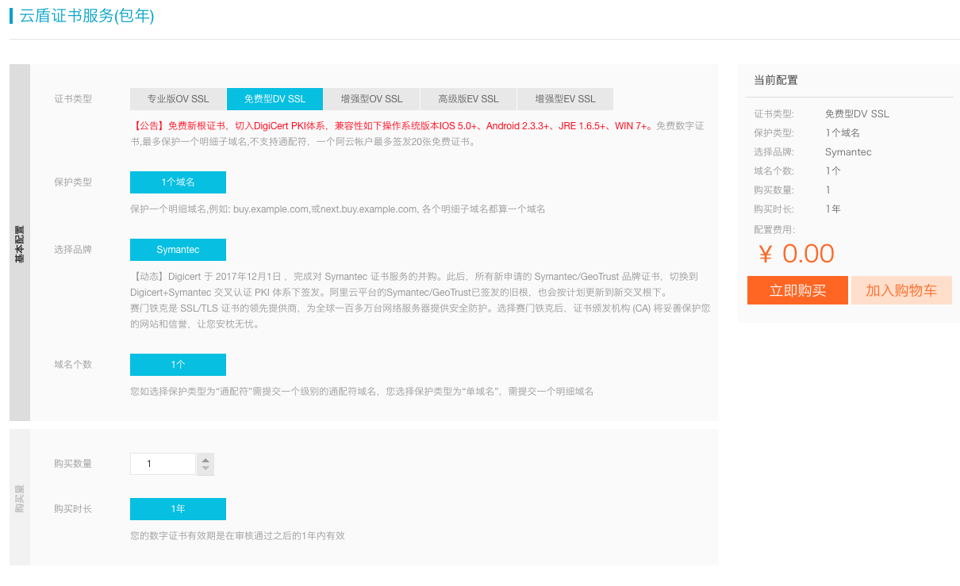

To buy 1-year wildcard domain cert:

“通配符域名” – “GeoTrust／Symantec”

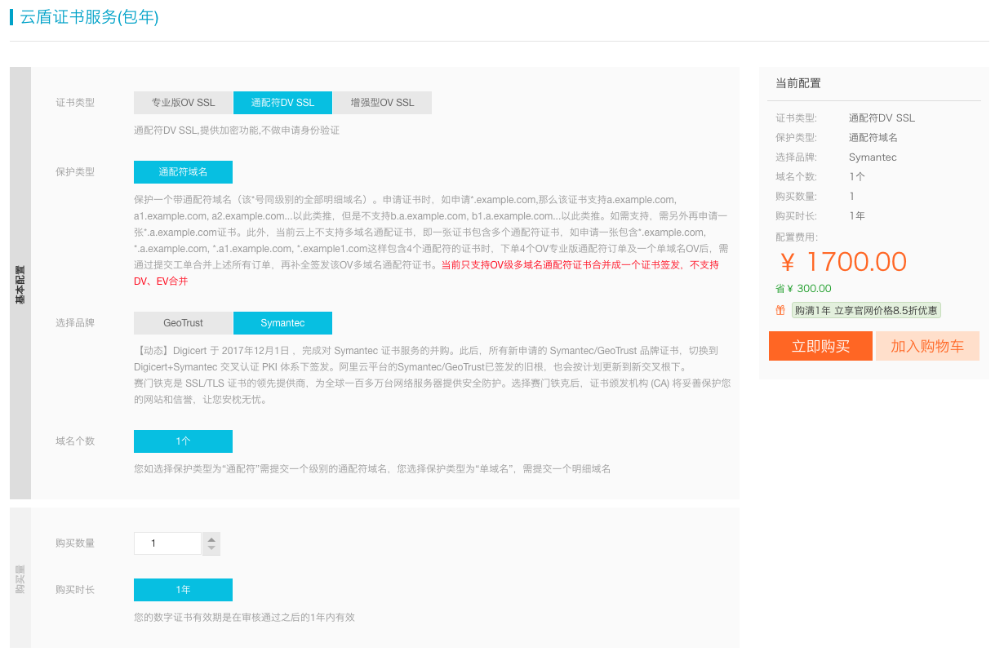

After purchased, we can see the new cert record in “我的订单” list, click “补全” and fill in with certain information, then Ali will need to validate the domain, the description of how to validate will show accordingly, basically there are 2 ways to verify:

1. DNS

If DNS server of this domain is hosted in Ali, then just choose “DNS” and Ali will finish verification automatically and issue the cert.

2. 文件

If DNS server is not hosted in Ali, then we have to choose this way which is more complicated. We need to download the fileauth.txt file provided by Ali and upload it to the specific folder under project according to description, then click “检查配置” to test ourselves. If the configuration is correct, we can see the 200 response, and the only thing left is waiting for around 30 minutes.

Push to CDN

Finally we got the cert issued from Ali, then click the “推送” button on the right side of “我的订单” page, click “推送” again on CDN item then you will be asked to confirm the CDN domain, and finally the cert is successfully used on CDN.

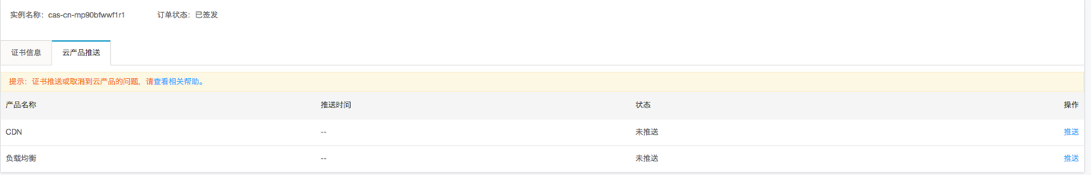

Support

Click “工单” button on the top menu bar to access to ticket system

Screen%20Shot%202018-06-11%20at%2017.49.21.png

We can see the list of all history tickets.

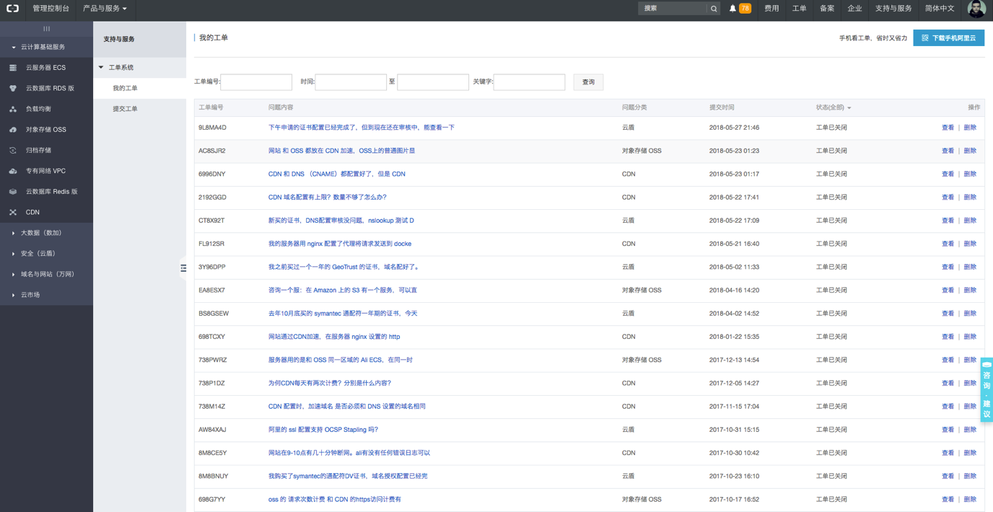

Click “提交工单” button on the submenu bar to submit a new ticket

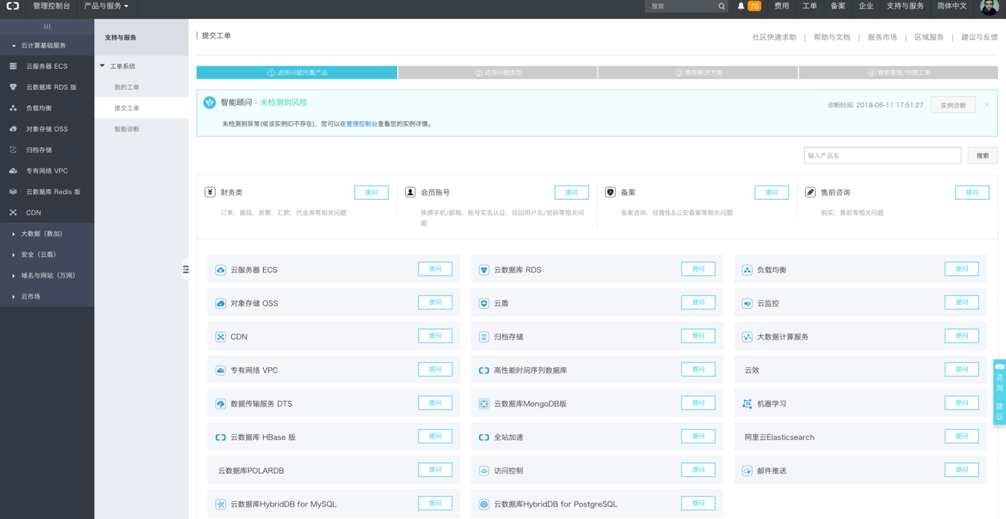

Select the topic of your question, look up the docs, if no answer, then click “创建工单”

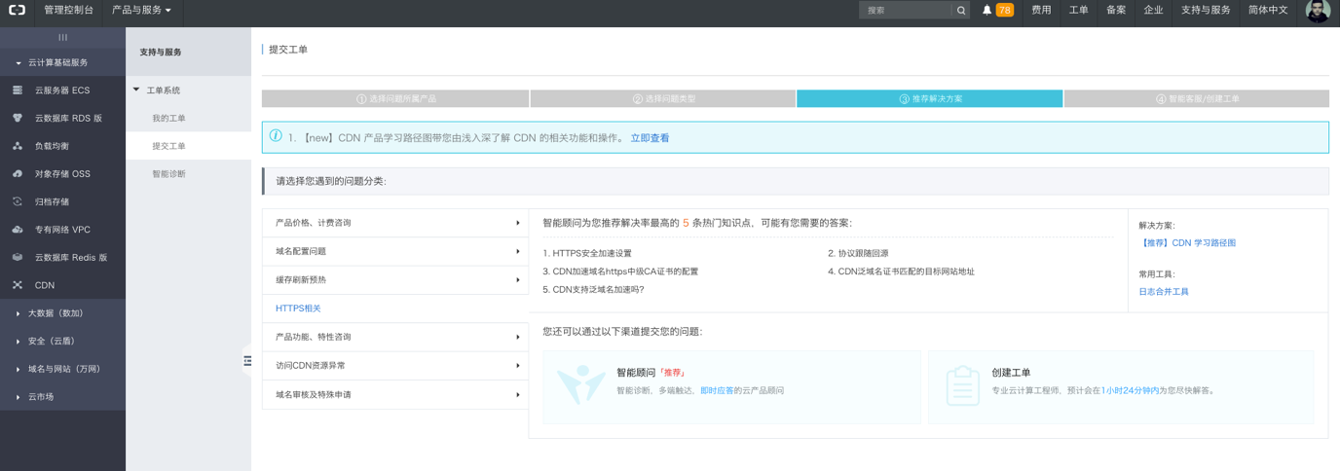

Fill in the form according to your question and click “提交”, I suggest to change “手机号” and “邮箱” to your own because it’s easier for you to communicate with Ali support, and if with any emergency issue you can ask them to call you directly.

