ABHINEET BHATTACHARYA 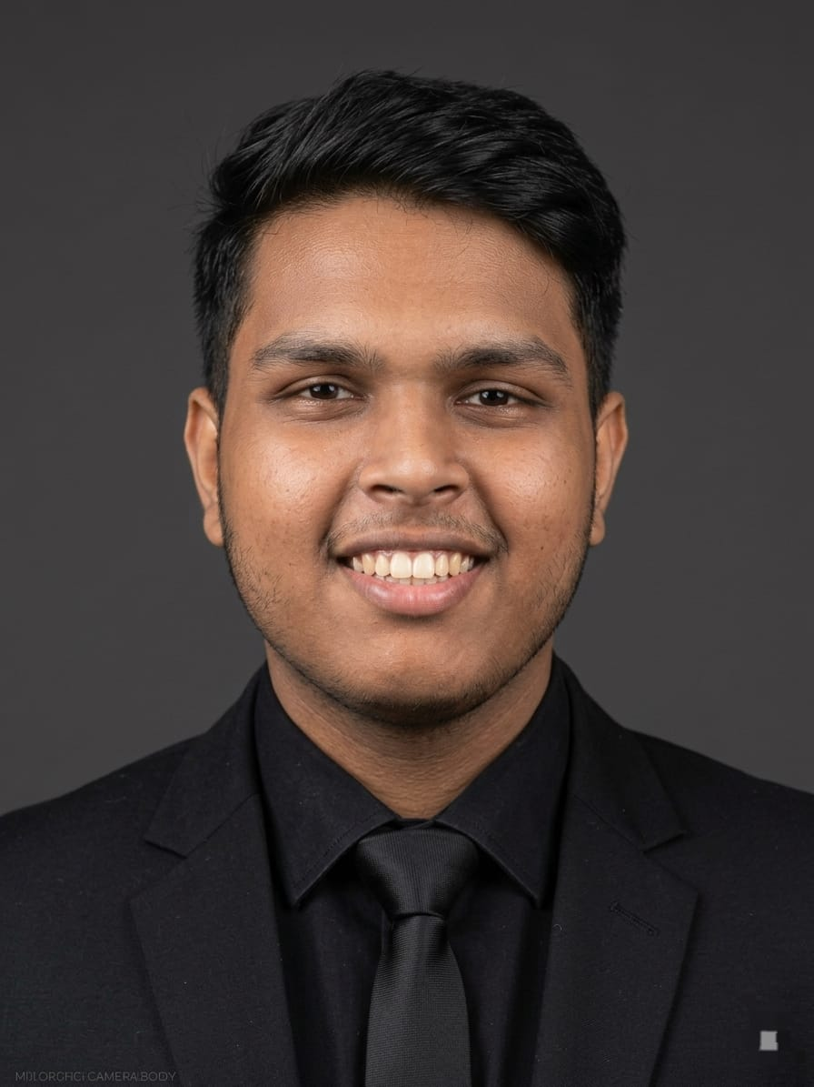
BTech CSE (AI & ML) Student | Aspiring AI Developer
Email: abhineetbhattacharya17@gmail.com | Phone: +91-7905596862
LinkedIn: linkedin.com/in/abhineet-bhattacharya | GitHub: github.com/Spiderdynamo
Location: Diamond Harbour, West Bengal, India

Professional Summary
Motivated BTech Computer Science Engineering student specializing in Artificial Intelligence and Machine Learning at The Neotia University. Passionate about developing AI-driven applications, solving real-world problems with technology, and building innovative digital solutions. Interested in AI systems, software development, and intelligent health-tech platforms.

Education
BTech in Computer Science Engineering (Artificial Intelligence & Machine Learning)
The Neotia University, West Bengal
Expected Graduation: 2028
Current Semester: 4th Semester

Technical Skills
Programming: Python, C, Java, SQL
AI & Data: Machine Learning Basics, Data Analysis
Web Development: HTML
Tools: Git, GitHub, VS Code, Vercel
Other: Problem Solving, Algorithmic Thinking

Projects
NeuraSync – AI Health Ecosystem
• Designed concept of an AI-driven health ecosystem including a mobile application and smartwatch.
• Features include real-time calorie tracking, food scanner, injury scanner, and emergency medicine suggestions.
• Smartwatch integration provides AI-powered diet programs, mental exercises, and emergency ambulance calling.
AI Content Creation Channel (Concept Project)
• Planning a YouTube channel based on AI-generated videos without personal recording.
• Focus on automated storytelling, AI visuals, and unique digital content.
Cyber Security for IoTs
• Planning different ways for securing the everyday devices and IoTs.
• Focus on automated alerts, AI visuals, easy handling and unique GUI.

Achievements & Activities
• Participated in academic and technical events at university.
• Contributed to organizing university programs and competitions.
• Active in creative and technical ideation projects.

Creative Skills
• Full time anchor and event manager.
• Poetry writer in Hindi and English focusing on emotional and natural themes.

Interests
Artificial Intelligence, Technology Innovation, Creative Writing, Digital Content Creation, Gaming, Editing, Audio Editing

Declaration
I hereby declare that the information provided above is true and correct to the best of my knowledge.
Abhineet Bhattacharya
Date: 13th March 2026

