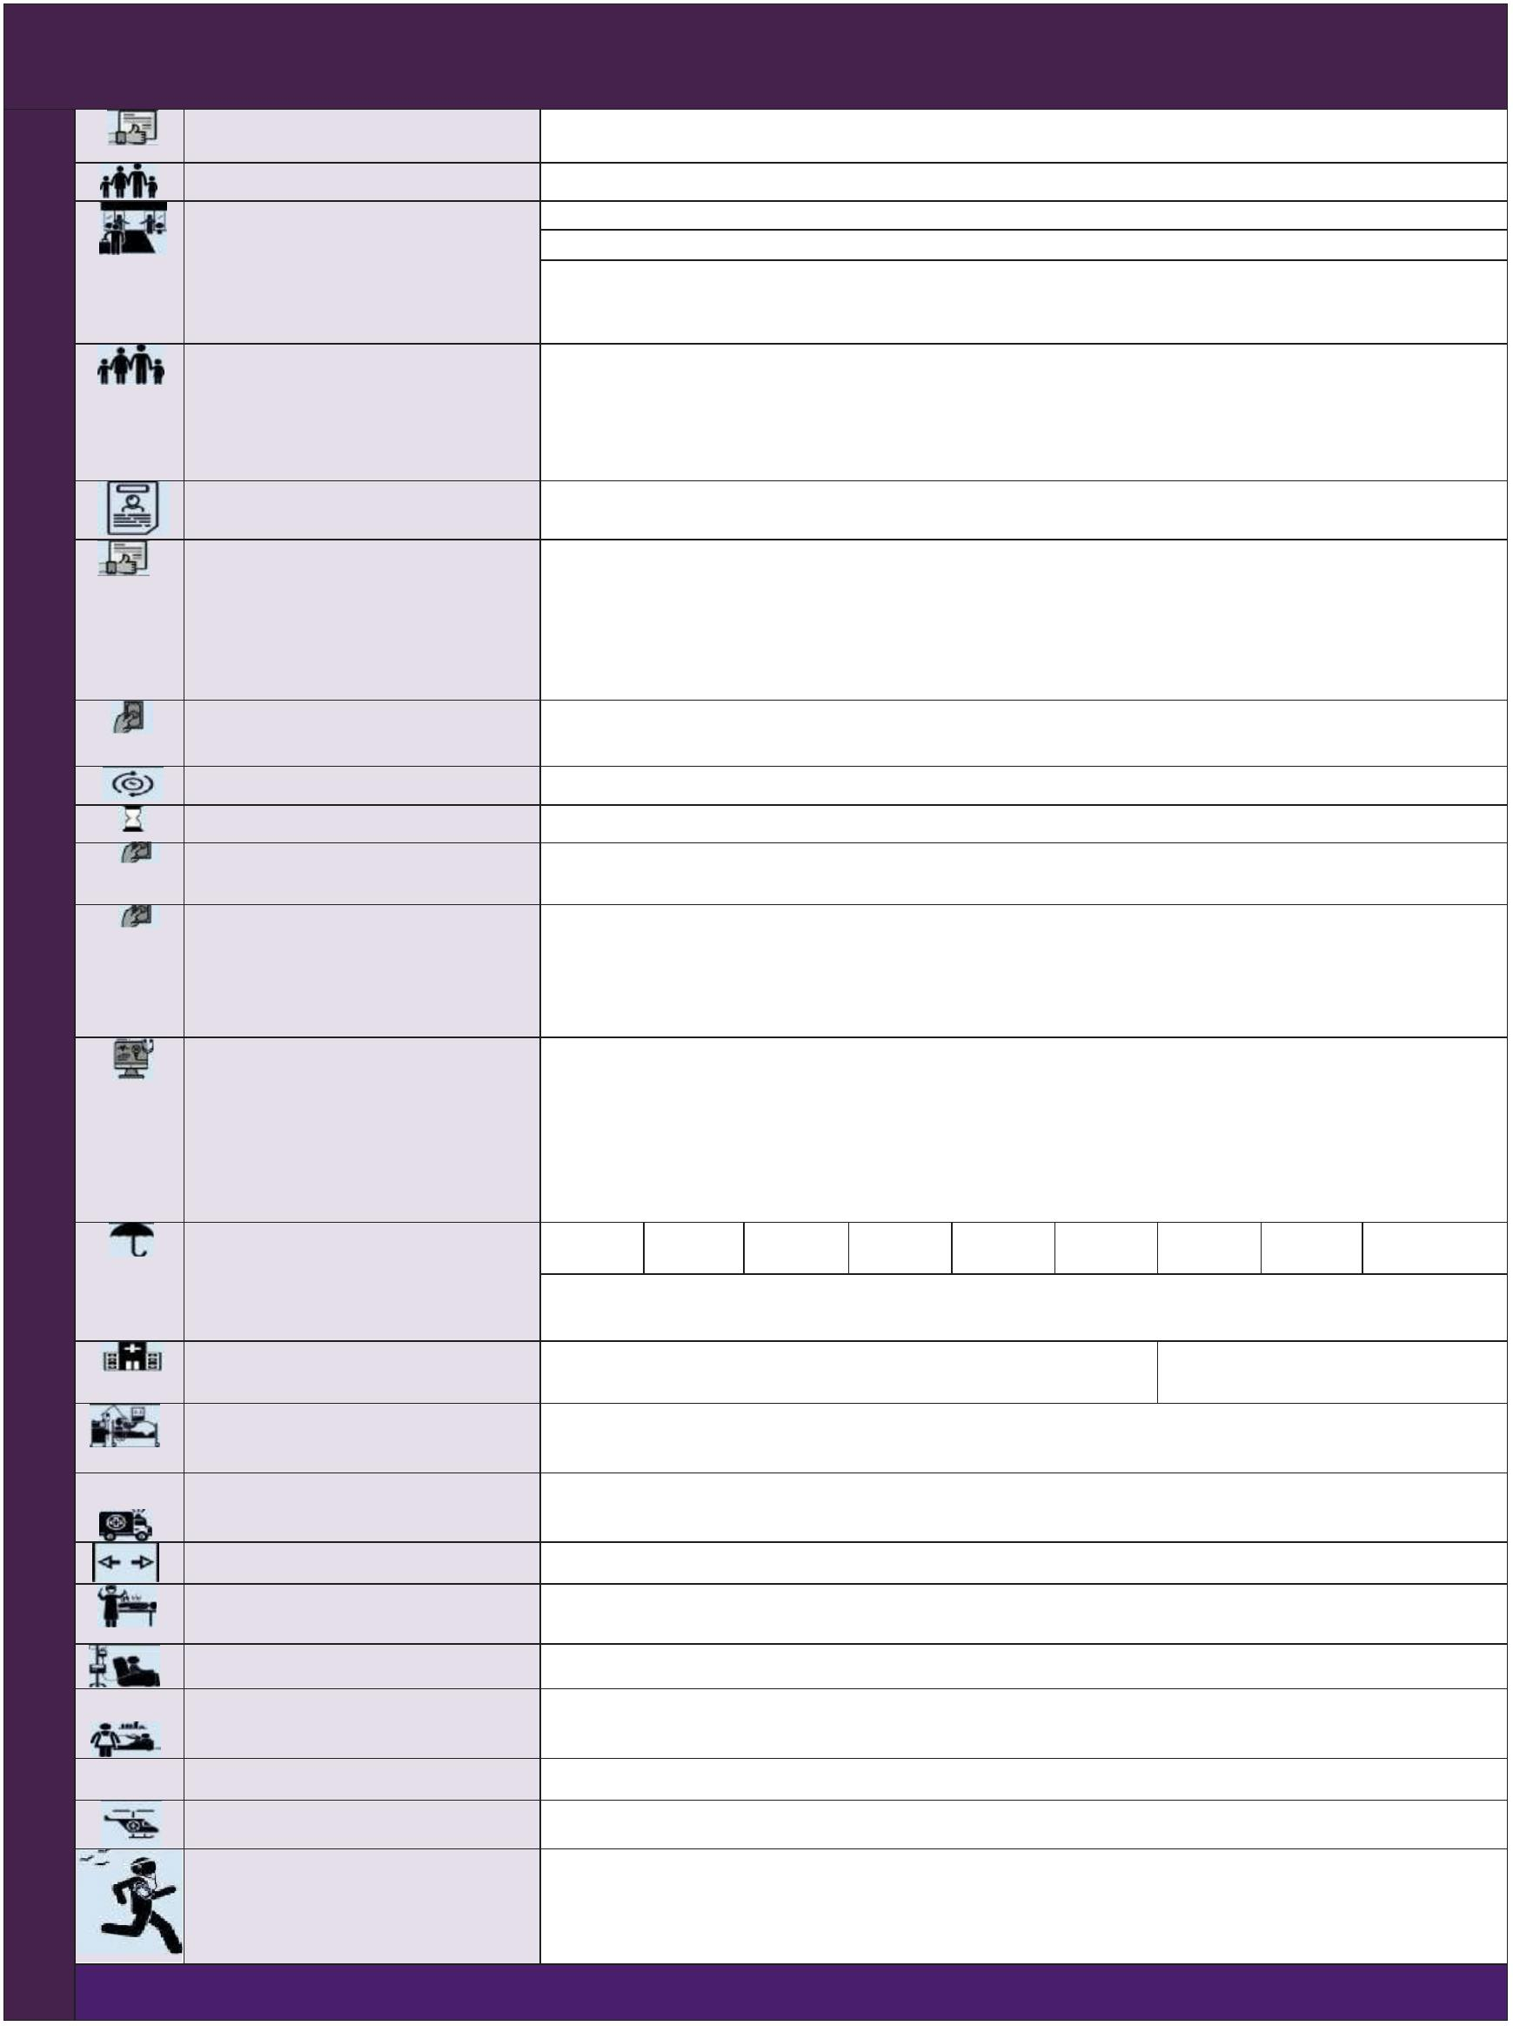Version_1.0_SP Parameters Star Health Assure Insurance Policy
UIN: SHAHLIP23017V012223
About the policy Covers hospitalization expenses incurred as a result of illness and/or accidental injuries
Type of Cover Individual and Floater
Individual : Min 18 Years to Max 75 Years, Dependent Children: Min 91 Days to Max17 Years Entry Age
Floater : Min 18 Years to Max 75 Years, Dependent Children: Min 16 Days to Max17 Years
Note: In case of dependent children, at the time of renewal when they become 18 years of age, such
 | Maximum Family Size |  | children will be considered as Adult and he/she can continue under floater sum insured till he/she gets  married  Maximum family size is 2A+3C+4P. Self, Spouse , Dependent children, Parents and Parents in law.  (or)  6 Adults + 3 Children (6 Adults = Self + Spouse + Parents + Parents-in-law).  If Dependent parents and parents in-laws alone wants to cover under this policy separately, the same is possible under 2A family scheme.
 | Midterm Inclusion |  |  |  | Available for Newly Wedded spouse, New born baby and Legally adopted child. Intimation should be given within 45 days from the date of marriage or date of birth
Zone based pricing ZoneA: Delhi including Faridabad, Gurgaon, Ghaziabad and Noida, Mumbai including Thane, Ahmedabad,
Surat and Vadodara
Zone B: Pune including Nashik, Trivandrum, Ernakulam, Chennai, Bengaluru, Hyderabad, Secunderabad and Rest of Gujarat
Zone C: Rest of India
Co-payment 10% of each and every claim amount for fresh as well as renewal policies for insured person whose age at
the time of entry is 61 years an above.
Renewal Lifelong
Policy Term One Year, Two years & Three Years
Long Term Discount Two year policy: 10 % discount on 2 ^{nd} year premium
Three year policy: 10% discount is available on 2 ^{nd} and 3rd year premium
Floater Discount For Child : 40% discount is available from 1A premium when he/she becomes 18 years at the time of
renewal in floater policy
For Parent/Parent in law - 10% discount is available from 1Apremium for each parent when they come under floater policy
Pre Medical Screening For those who declare adverse medicalhistory, company may subject them to undergo pre-policy medical
check-up. 100% cost of such medical examination is borne by the company
Note : For children whose age is less than 12 years, Paediatrician letter, Vaccination report or Health Report should be submitted and the proposal will be routed to our CMU Team for medical opinion.
Sum Insured Options (Rs. in Lakhs) 5 10 15 20 25 50 75 100 200
Note: Rs 75 Lakhs, Rs 100 Lakhs and Rs 200Lakhs sum insured willbe available for persons aged up to 65 years only. This is applicable only at thetime of inception of this policy
 |  | Room Rent Upto1% of Sum Insured or upto Rs.20,000/- per day whichever is  less |  |  |  | No limit (Any room)
 | Coverage for Non Medical Items (Consumables) |  |  | If there is an admissible claim under inpatient / day care the policy, then Items as per List I will become payable
 |  | Emergency Road Ambulance |  | Covered upto sum insured  (i) for transportation to hospital (ii) from one hospital to other hospital (iii) from hospital to residence
Pre & Post Hospitalization 60 days & 180 days. Covered upto sum insured
 | Organ Donor Expenses |  | Coveredupto sum insured. Additional SI up to Basic SI for theComplications(if any) that necessitate a Redo Surgery/ICU admission
Day Care Treatments All day care treatments are covered upto sum insured
Covered upto sum insured.Treatment taken at home for the period exceeding three days Domiciliary hospitalization
Home Care Treatment Payable up to 10% of the sum insured subject to maximum of Rs 5 Lakhs in a policy year Air Ambulance Covered up to 10% of sum insured per policy year
Wellness platform is available both in our mobile app “Star Power” & Customer Portal (Retail) The Star Wellness Program Insured can earn reward points and avail premium discount up to 20% on the renewal premium by Available for Insured aged => 18 yrs enrolling and achieving the wellness goals. For details please refer the policy wording / prospectus.

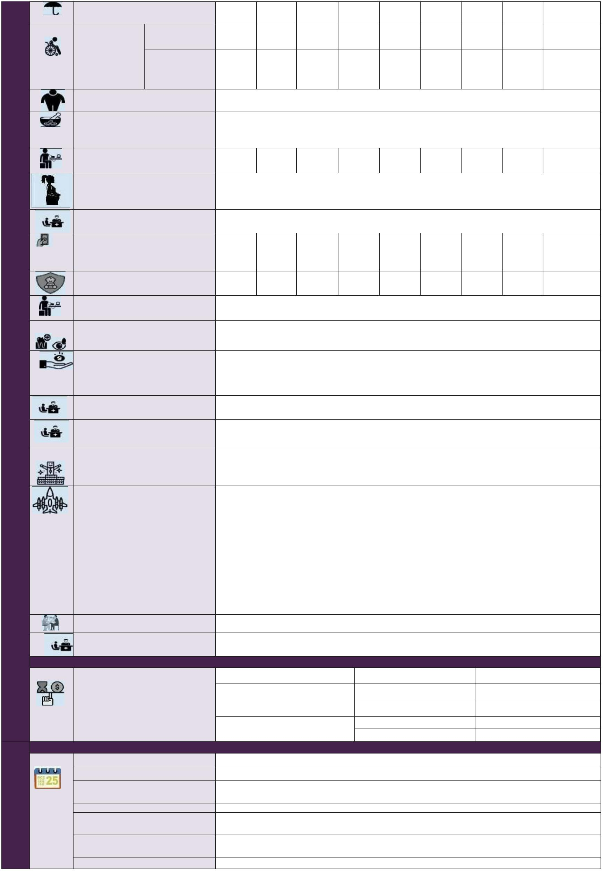Sum Insured Options (Rs. in Lakhs) 5 10 15 20 25 50 75 100 200
 |  | Health Check up  Assure |  | Individual (Rs) 1500 2000 4000 5000 5000 5000 8000 8000 8000
 | Each policy year (Irrespective of  claim)  Cumulative Bonus |  |  |  |  | Floater (Rs) 2500 5000 8000 10000 10000 10000 15000 15000 15000  25% of sum insured for each claim free and maximum up to 100% of the sum insured
Ayush Treatment
Covered up to sum insured
(For Ayurveda, Unani, Sidha & Homepathy)
Assisted Reproduction Treatment 1 Lakh 2 Lakhs 2 Lakhs 2 Lakhs 2 Lakhs 4 Lakhs 4 Lakhs 4 Lakhs 4 Lakhs (Limit of Liability in a policy year)
DeliveryExpenses(Per Policy Year) Covered up-to 10% of the Sum Insured.
Both self and spouse are covered under this policy for a continuous period of 2 years under Individual or floater sum insured
In Utero Fetal surgery/Intervention Covered up to sum insured, Waiting period: 2 years from the date of inception of this policy
Sum Insured 5 10 15 20 25 50 75 100 200
Options (Rs. in Lakhs)
 | Hospitalization Expenses for Treatment of New Born Cover |  | 2 Lakhs 2 Lakhs 2 Lakhs 2 Lakhs 2 Lakhs 4 Lakhs 4 Lakhs 4 Lakhs 4 Lakhs
 | Treatment for Chronic Severe Refractory Asthma |  |  |  | Payable up to 10% of sum insured not exceeding Rs.5 Lakhs per policy period
Compassionate Travel Company will reimburse the transportation expenses by air incurred up to Rs.10,000/- for one immediate
family member (other than the travel companion)
Repatriation of mortal remains
Company shall reimburse up to Rs.15,000/- in a policy year
Payable towards the cost of repatriation of mortal remains of the insured person (including the cost of embalming and coffin charges) to the residence of the Insured as recorded in the policy
Treatment in Valuable
Service Providers Network 1% of Sum Insured subject to a maximum of Rs.5,000/- per policy period is payable as lump sum
 | Shared Accommodation |  | Payable for in-patient hospitalization, then amount of Rs.1,000/- per day will be payable for each continuous and completed period of 24 hours of stay in such shared accommodation
Second Medical Opinion Can obtain a Second Medical Opinion from a Doctor in the Company’s network of Medical Practitioners.
All medical records should be forwarded to the mail-id e_medicalopinion@starhealth.in.or through Post/Courier.
Sum Insured will be restored unlimited number of times and maximum up to 100% each time, which can be utilized for a subsequent hospitalization.
Restoration will trigger immediately upon partial/ full utilization of the sum insured, which can be utilized for a subsequent hospitalization.
Automatic Restoration
On partial utilization of the Sum Insured, it will be restored up to extent of utilization. On full utilization of the Sum Insured, it will be restored to 100%
Used for all claims including for modern treatment, but for a subsequent hospitalization
Maximum payable amount for a single claim under restoration benefit shall not more than the sum insured Modern treatments Covered up to sum insured
 | Rehabilitation and Pain Management |  | Covered up to the sub-limit (or) maximum up to 20% of the sum insured whichever is less, per policy year  Optional Cover  Sum Insured Aggregate Deductible Option Discount Offered
 | Optional Cover to choose deductible  This deductible is applicable for every policy year (onAggregate basis) |  |  |  | Upto Rs 20 Lakhs Rs 50,000 45%  Rs 1 Lakh 55%  Above Rs 20 Lakhs Rs 50,000 35%  Rs 1,00,000 50%  Waiting Period
Initial waiting period 30 days for all illnesses (except accident)
For Speciﬁc diseases 2 years
For Pre-existing diseases Applicable for 3 year policy term: 2.5 years.
Applicable for 1 year and 2 year policy term :3 years Delivery Expenses Cover 2 years
2 years In Utero Fetal Surgery /
Intervention
2 years Assisted Reproduction
Treatment
New Born Baby Cover 1 year
* The information provided in this document is only indicative. For more details on the terms and conditions, please read the policy wordings before concluding a sale.

