Star Health Assure Insurance Policy
Version_1.0_SP
Parameters
UIN: SHAHLIP23017V012223
About the policy
Covers hospitalization expenses incurred as a result of illness and/or accidental injuries
Individual and Floater
Type of Cover Entry Age
Individual : Min 18 Years to Max 75 Years, Dependent Children: Min 91 Days to Max17 Years Floater : Min 18 Years to Max 75 Years, Dependent Children: Min 16 Days to Max17 Years
Note: In case of dependent children, at the time of renewal when they become 18 years of age, such
children will be considered as Adult and he/she can continue under floater sum insured till he/she gets
married
Maximum family size is 2A+3C+4P. Self, Spouse , Dependent children, Parents and Parents in law.
(or)
Maximum Family Size
6
Adults + 3 Children (6 Adults = Self + Spouse + Parents + Parents-in-law).
If Dependent parents and parents in-laws alone wants to cover under this policy separately, the same is possible under 2A family scheme.
Available for Newly Wedded spouse, New born baby and Legally adopted child. Intimation should be given within 45 days from the date of marriage or date of birth
ZoneA: Delhi including Faridabad, Gurgaon, Ghaziabad and Noida, Mumbai including Thane, Ahmedabad, Surat and Vadodara
Midterm Inclusion Zone based pricing
Zone B: Pune including Nashik, Trivandrum, Ernakulam, Chennai, Bengaluru, Hyderabad, Secunderabad and Rest of Gujarat
Zone C: Rest of India
Co-payment
10% of each and every claim amount for fresh as well as renewal policies for insured person whose age at the time of entry is 61 years an above.
Renewal
Lifelong
Policy Term
One Year, Two years & Three Years
Long Term Discount
Two year policy: 10 % discount on 2 ^{nd} year premium
Three year policy: 10% discount is available on 2 ^{nd} and 3rd year premium
Floater Discount
For Child : 40% discount is available from 1A premium when he/she becomes 18 years at the time of renewal in floater policy
For Parent/Parent in law - 10% discount is available from 1Apremium for each parent when they come under floater policy
Pre Medical Screening
For those who declare adverse medicalhistory, company may subject them to undergo pre-policy medical check-up. 100% cost of such medical examination is borne by the company
Note : For children whose age is less than 12 years, Paediatrician letter, Vaccination report or Health Report should be submitted and the proposal will be routed to our CMU Team for medical opinion.
Sum Insured Options (Rs. in Lakhs) Room Rent
5
10
15
20
25
50
75
100
200
Note: Rs 75 Lakhs, Rs 100 Lakhs and Rs 200Lakhs sum insured willbe available for persons aged up to
5 years only. This is applicable only at thetime of inception of this policy
Upto1% of Sum Insured or upto Rs.20,000/- per day whichever is No limit (Any room)
less
6
Coverage for Non Medical Items If there is an admissible claim under inpatient / day care the policy, then Items as per List I will become
(Consumables)
payable
Covered upto sum insured
(i) for transportation to hospital (ii) from one hospital to other hospital (iii) from hospital to residence
Emergency Road Ambulance
Pre & Post Hospitalization Organ Donor Expenses
60 days & 180 days. Covered upto sum insured
Coveredupto sum insured. Additional SI up to Basic SI for theComplications(if any) that necessitate a Redo Surgery/ICU admission
Day Care Treatments
All day care treatments are covered upto sum insured
Covered upto sum insured.Treatment taken at home for the period exceeding three days
Domiciliary hospitalization
Payable up to 10% of the sum insured subject to maximum of Rs 5 Lakhs in a policy year Covered up to 10% of sum insured per policy year
Home Care Treatment Air Ambulance
Wellness platform is available both in our mobile app “Star Power” & Customer Portal (Retail) The Insured can earn reward points and avail premium discount up to 20% on the renewal premium by
Star Wellness Program
Available for Insured aged => 18 yrs enrolling and achieving the wellness goals. For details please refer the policy wording / prospectus.
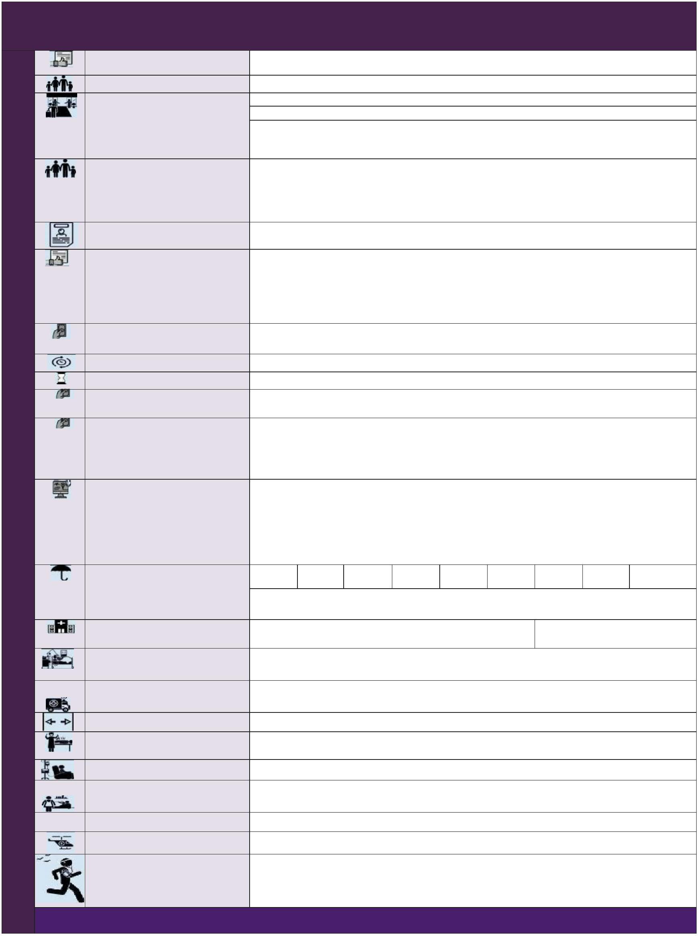

5 500
10 2000
15 4000
20 5000
25 5000
50 5000
75 8000
100 8000
200 8000
Sum Insured Options (Rs. in Lakhs)
Individual (Rs) Health Check up
Assure
1
Floater (Rs)
2500
5000
8000
10000 10000 10000 15000 15000
15000
Each policy year (Irrespective of
claim)
Cumulative Bonus
25% of sum insured for each claim free and maximum up to 100% of the sum insured
Ayush Treatment
Covered up to sum insured
(For Ayurveda, Unani, Sidha & Homepathy)
Assisted Reproduction Treatment 1 Lakh 2 Lakhs 2 Lakhs 2 Lakhs 2 Lakhs 4 Lakhs 4 Lakhs 4 Lakhs 4 Lakhs
(Limit of Liability in a policy year)
DeliveryExpenses(Per Policy Year)
Covered up-to 10% of the Sum Insured.
Both self and spouse are covered under this policy for a continuous period of 2 years under Individual or
floater sum insured
In Utero Fetal surgery/Intervention Covered up to sum insured, Waiting period: 2 years from the date of inception of this policy
Sum Insured Options (Rs. in Lakhs)
5
10
15
20
25
50
75
100
200
Hospitalization Expenses for Treatment of New Born Cover Treatment for Chronic Severe Refractory Asthma
2 Lakhs 2 Lakhs 2 Lakhs 2 Lakhs 2 Lakhs 4 Lakhs 4 Lakhs 4 Lakhs 4 Lakhs Payable up to 10% of sum insured not exceeding Rs.5 Lakhs per policy period
Compassionate Travel
Company will reimburse the transportation expenses by air incurred up to Rs.10,000/- for one immediate family member (other than the travel companion)
Repatriation of mortal remains
Company shall reimburse up to Rs.15,000/- in a policy year
Payable towards the cost of repatriation of mortal remains of the insured person (including the cost of embalming and coffin charges) to the residence of the Insured as recorded in the policy
Treatment in Valuable Service Providers Network
1% of Sum Insured subject to a maximum of Rs.5,000/- per policy period is payable as lump sum
Shared Accommodation
Payable for in-patient hospitalization, then amount of Rs.1,000/- per day will be payable for each continuous and completed period of 24 hours of stay in such shared accommodation
Can obtain a Second Medical Opinion from a Doctor in the Company’s network of Medical Practitioners. All medical records should be forwarded to the mail-id e_medicalopinion@starhealth.in.or through Post/Courier.
Second Medical Opinion
Sum Insured will be restored unlimited number of times and maximum up to 100% each time, which
can be utilized for a subsequent hospitalization.
Restoration will trigger immediately upon partial/ full utilization of the sum insured, which can be utilized for a subsequent hospitalization.
On partial utilization of the Sum Insured, it will be restored up to extent of utilization.
On full utilization of the Sum Insured, it will be restored to 100%
Used for all claims including for modern treatment, but for a subsequent hospitalization
Automatic Restoration
Maximum payable amount for a single claim under restoration benefit shall not more than the sum insured Covered up to sum insured
Modern treatments
Rehabilitation and Pain Management
Covered up to the sub-limit (or) maximum up to 20% of the sum insured whichever is less, per policy year
Optional Cover
Sum Insured Upto Rs 20 Lakhs
Aggregate Deductible Option
Rs 50,000
Discount Offered
Optional Cover to choose deductible
45% 55%
This deductible is applicable for every policy year (onAggregate basis)
Rs 1 Lakh
Above Rs 20 Lakhs
Waiting Period
Rs 50,000 Rs 1,00,000
35% 50%
Initial waiting period
30 days for all illnesses (except accident)
For Speciﬁc diseases
2 years
For Pre-existing diseases
Applicable for 3 year policy term: 2.5 years. Applicable for 1 year and 2 year policy term :3 years 2 years
Delivery Expenses Cover In Utero Fetal Surgery / Intervention
2
years
2
years
Assisted Reproduction Treatment
New Born Baby Cover
1 year
*
The information provided in this document is only indicative. For more details on the terms and conditions, please read the policy wordings before concluding a sale.
