Download: Download Laragon – Fast & Modern Dev Environment
Download: phpMyAdmin

Extract laragon to C:\Users\your_user
Extract phpMyAdmin to C:\ your_user \laragon\etc\apps
Change name to phpMyAdmin

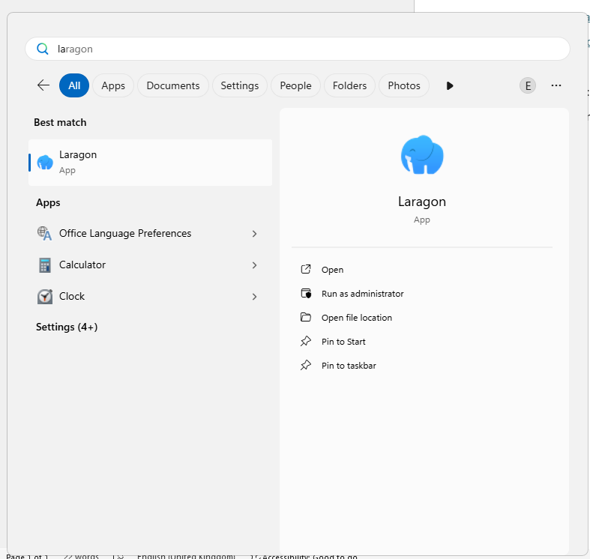

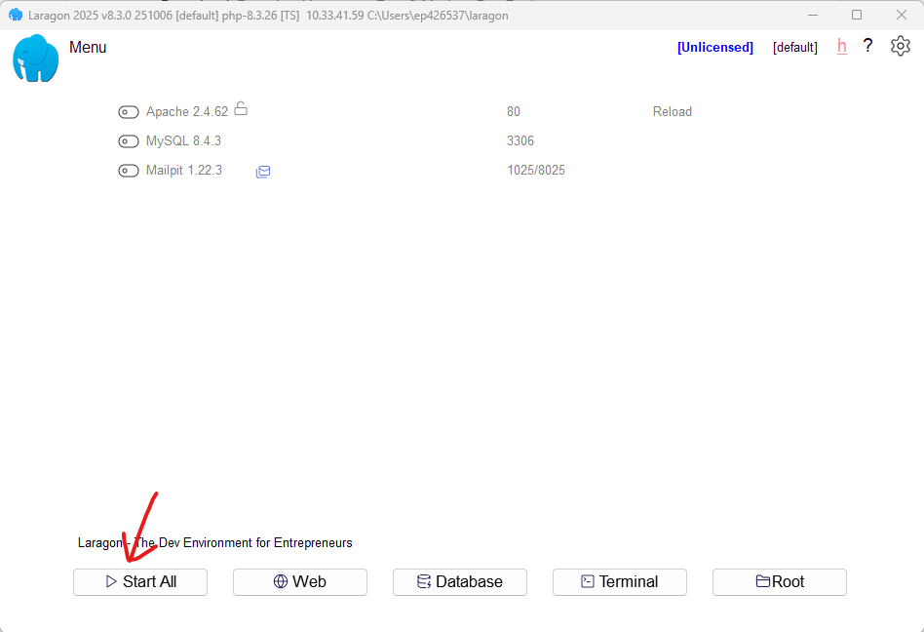

To run projects store them in C:\Users\your_user\laragon\www

Or if you want to save it one drive to access it on any machine and back it up

Change C:\Users\your_user7\laragon\bin\apache\httpd-2.4.62-240904-win64-VS17\conf
Then select httpd.conf
then change this two lines
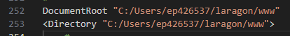
To Something else like

