Comparative Fashion Trend Forecasting Across Indian and International Markets Using LSTM Networks: Evaluating Seasonal Effects
Bedaanntica Paul
[Institutional affiliation — edit here]
Code, data and results: github.com/Spideykook/LSTM-DL

Abstract
This study asks whether explicit seasonal features improve forecasts of fashion search interest. Using monthly Google Trends indices (January 2016 – September 2026) for four keywords (streetwear, oversized clothing, sustainable fashion, traditional clothing) in India and France, we compare a seasonal naive baseline, a standard LSTM, and an LSTM that receives sine/cosine encodings of the calendar month. Each of the eight series is evaluated separately on an identical chronological test period (February 2025 – September 2026) with one-step walk-forward forecasts, scalers fitted on training data only, and five random seeds per LSTM. Averaged over series, MAE was 12.82 (seasonal naive), 11.00 (standard LSTM) and 10.80 (seasonality-aware LSTM) index points. Both LSTMs outperformed the naive baseline in seven of eight series, but the 0.2-point advantage of the seasonal features over the standard LSTM is smaller than seed-to-seed variation and inconsistent across series, so we do not claim a reliable seasonal benefit. The test period contains an unexplained simultaneous peak in all eight series (February 2026), which we report with and without. Results concern independently normalized search-interest indices, not sales.
Keywords: fashion trend forecasting; Google Trends; LSTM; seasonality; seasonal naive baseline; India; France.

1. Introduction and Research Motivation
Search-engine query data are a widely used, low-cost signal of public interest and behaviour [2], [3]. For fashion, anticipating shifts in attention to styles such as streetwear or sustainable fashion could inform assortment and marketing decisions. Fashion attention is also seasonal and culturally specific: festival and wedding seasons plausibly shape interest in traditional clothing in India, whereas climate and retail calendars shape European interest. Long short-term memory (LSTM) networks [1] are a standard neural approach to sequence forecasting, yet it is unclear whether they need explicit seasonal inputs or can infer seasonality from lagged values alone.

2. Research Gap and Objectives
Prior fashion-forecasting work has concentrated on visual style, for example forecasting the popularity of styles discovered in product images [8], while the forecasting literature on neural networks gives mixed guidance on seasonality and on whether neural models beat simple benchmarks [4]–[6]. Within the sources we reviewed (the review is not exhaustive), we found no controlled comparison of seasonality-aware and standard LSTMs on search-interest series from an Indian and a European market. The objectives are therefore to answer three questions: (RQ1) do LSTMs beat a seasonal naive benchmark on fashion search interest? (RQ2) do sine/cosine month features improve a standard LSTM? (RQ3) do conclusions differ between India and France? A further objective is to document data quality and the limits of Google Trends data transparently.

3. Literature Review
Choi and Varian showed that search indices can help “predict the present”, i.e. nowcast contemporaneous economic indicators, while explicitly not claiming to predict the future [2]; Ginsberg et al. used Google query data to estimate current influenza activity with a reporting lag of about one day [3]. Google documents that Trends data are a sample, that low-volume terms appear as zero, and that unusual spikes can occur [9]. LSTMs [1] were introduced to overcome vanishing error flow in recurrent networks. Hewamalage et al. found recurrent networks to be competitive but not silver bullets relative to ETS and ARIMA, noted that individual series are often too short for complex models, and concluded that RNNs can model seasonality directly when series share homogeneous seasonal patterns, otherwise recommending deseasonalization [4]. Zhang and Qi reported that neural networks did not capture seasonal or trend variation effectively from raw data, and that detrending or deseasonalization reduced forecasting errors substantially [5]. Makridakis et al. found that popular machine-learning methods were dominated by eight statistical methods on 1,045 monthly M3 series across accuracy measures and horizons [6]. Hyndman and Athanasopoulos present the seasonal naive method as a standard benchmark [7]. This literature motivates (i) a seasonal naive baseline, (ii) treating explicit seasonal inputs as an empirical question, and (iii) caution about short series.

4. Dataset and Methodology

4.1 Data and verification
Eight monthly series (4 keywords × India, France) were collected on 20 October 2026 with the unofficial pytrends library, one query per keyword–country pair, from January 2016 to September 2026 (129 observations each). Google Trends reports a sampled, normalized index in which each series’ own peak equals 100; it is neither absolute search volume nor sales [9]. We re-checked the data: no missing values, no duplicate dates, a complete monthly index, and values within 0–100. Provenance rests on the collection metadata; we could not re-query Google Trends from the analysis environment. Three issues were found and left unaltered (Section 9): a simultaneous peak in February 2026, a common upward shift in November 2025, and an almost entirely zero series (France, oversized clothing: 126 of 129 months, including the whole training period).

4.2 Split, leakage control and protocol
Each series is split chronologically (70/15/15): training January 2016 – June 2023 (90 months), validation July 2023 – January 2025 (19) and test February 2025 – September 2026 (20). Test months are identical for all models. Min–max scalers are fitted on training data only; 12-month input windows look strictly backward; validation data are used only for early stopping. Forecasts are one-step-ahead walk-forward: at each test month every model sees actual history up to the previous month. No hyperparameters were tuned.

5. Models
Seasonal naive: the forecast for month t is the observed value at t−12.
Standard LSTM: input of 12 lagged scaled values; one LSTM layer (50 units) and a dense output; Adam optimizer, MSE loss, batch size 16, up to 100 epochs with early stopping on validation loss (patience 10).
Seasonality-aware LSTM: identical, but each input step also carries sin(2πm/12) and cos(2πm/12), where m is the month being predicted (the calendar is known in advance), giving three features per step.

6. Experimental Setup and Evaluation Metrics
Each LSTM was trained with five seeds (42–46) and the five forecasts were averaged; per-seed variability is reported separately. Accuracy is measured by mean absolute error (MAE) and root mean squared error (RMSE) over the 20 test months for each keyword–country series, in each series’ own index points. Because the February 2026 observation dominates squared error, all scoring is repeated with that month excluded from evaluation only (model inputs unchanged). As a diagnostic outside the three pre-specified models, we also score last-value persistence, y(t−1). With eight short series and a single split we do not perform significance tests.

7. Results
All three models ran on all eight series. Table 1 reports per-series results, Table 2 aggregates, Table 3 the sensitivity analysis, and Figs. 1–2 show forecasts and errors.
Table 1. Test-period MAE and RMSE per series (index points; full 20-month test set).
Keyword | Country | Naive MAE | Naive RMSE | Std LSTM MAE | Std LSTM RMSE | Seas. LSTM MAE | Seas. LSTM RMSE
Oversized clothing | France | 7.40 | 23.67 | 7.45 | 23.63 | 7.46 | 23.63
Oversized clothing | India | 11.05 | 20.06 | 8.32 | 18.17 | 8.51 | 18.40
Streetwear | France | 10.90 | 19.07 | 10.15 | 17.81 | 9.54 | 17.15
Streetwear | India | 13.25 | 23.09 | 8.53 | 18.70 | 9.51 | 20.59
Sustainable fashion | France | 13.15 | 24.33 | 11.62 | 23.39 | 11.21 | 23.19
Sustainable fashion | India | 15.65 | 29.18 | 13.81 | 26.08 | 13.90 | 26.09
Traditional clothing | France | 16.20 | 26.69 | 13.34 | 22.85 | 13.78 | 23.79
Traditional clothing | India | 14.95 | 21.45 | 14.77 | 19.08 | 12.45 | 18.05

Table 2. Mean over the 8 series (and by country, MAE only); “excl.” = February 2026 not scored.
Model | MAE | RMSE | MAE excl. | RMSE excl. | Series won (MAE) | MAE: India / France
Seasonal naive | 12.82 | 23.44 | 9.12 | 14.01 | 1 | 13.73 / 11.91
Standard LSTM | 11.00 | 21.21 | 7.50 | 11.74 | 4 | 11.36 / 10.64
Seasonality-aware LSTM | 10.80 | 21.36 | 7.20 | 11.58 | 3 | 11.09 / 10.50

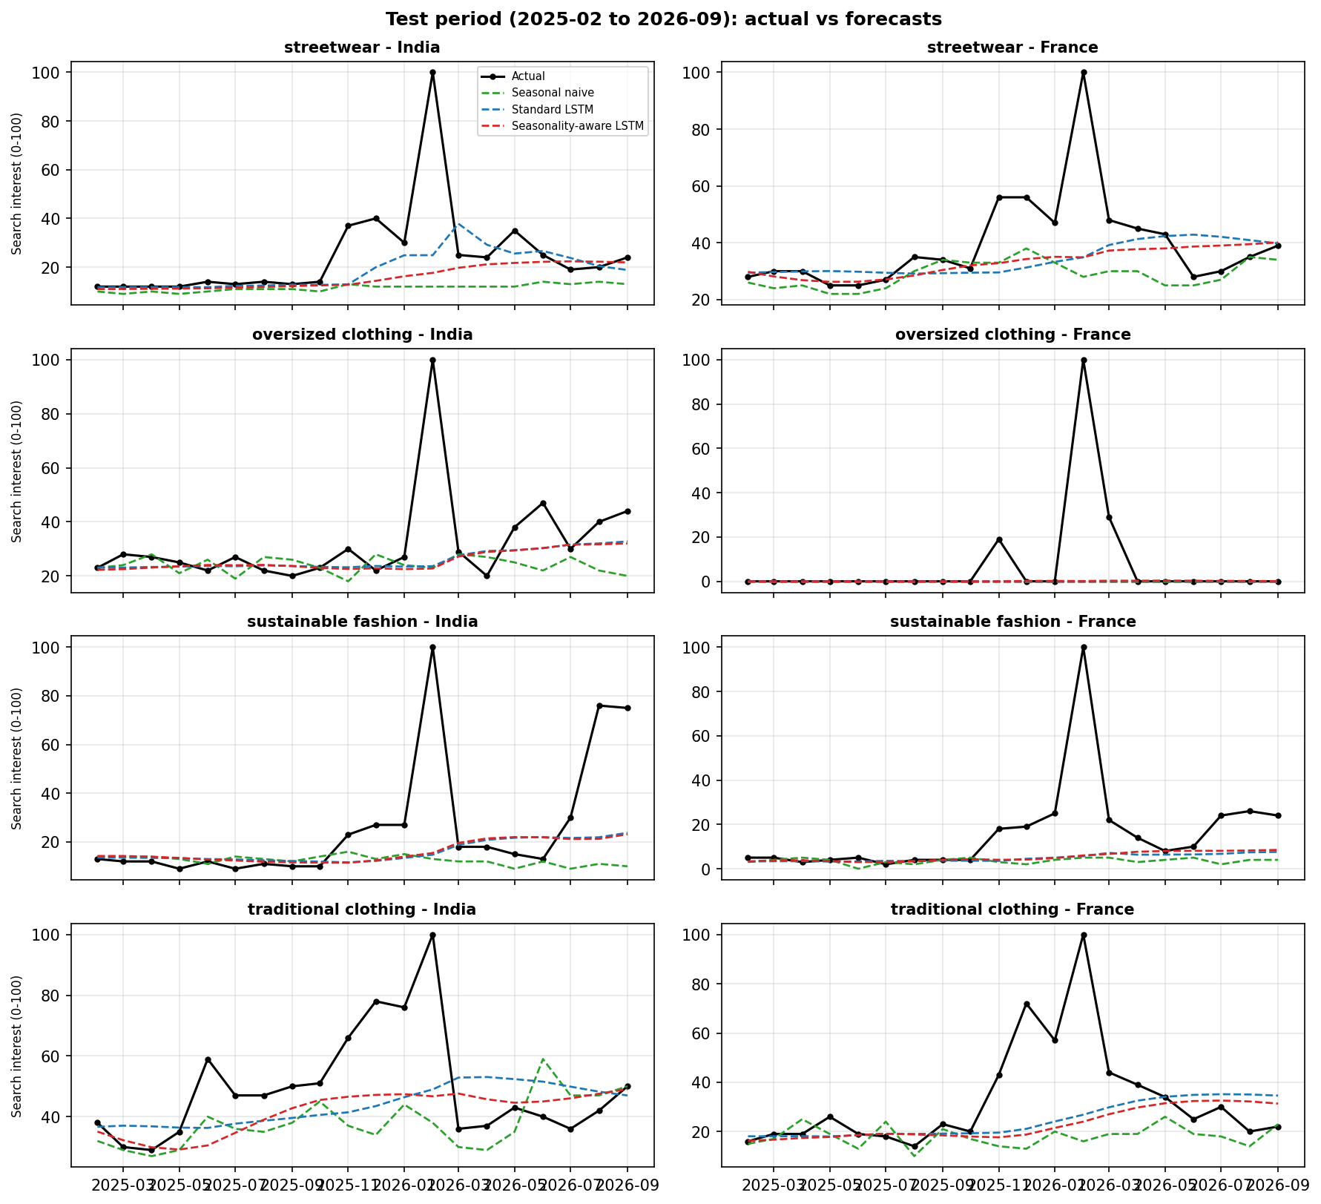
Fig. 1. Test-period forecasts for all eight series (Feb 2025 – Sep 2026). Index values are normalized per series.
Table 3. Sensitivity: MAE and RMSE per series with February 2026 excluded from scoring (19 test months).
Keyword | Country | Naive MAE | Std LSTM MAE | Seas. LSTM MAE | Naive RMSE | Std LSTM RMSE | Seas. LSTM RMSE
Oversized clothing | France | 2.53 | 2.59 | 2.59 | 7.95 | 7.92 | 7.92
Oversized clothing | India | 7.58 | 4.74 | 4.90 | 10.55 | 6.35 | 6.51
Streetwear | France | 7.68 | 7.26 | 6.62 | 10.48 | 10.53 | 9.28
Streetwear | India | 9.32 | 5.02 | 5.67 | 12.39 | 8.43 | 9.44
Sustainable fashion | France | 8.84 | 7.26 | 6.85 | 12.17 | 10.36 | 10.06
Sustainable fashion | India | 11.89 | 10.05 | 10.18 | 22.32 | 18.26 | 18.45
Traditional clothing | France | 12.63 | 10.19 | 10.51 | 19.45 | 16.37 | 17.08
Traditional clothing | India | 12.47 | 12.87 | 10.30 | 16.79 | 15.69 | 13.90

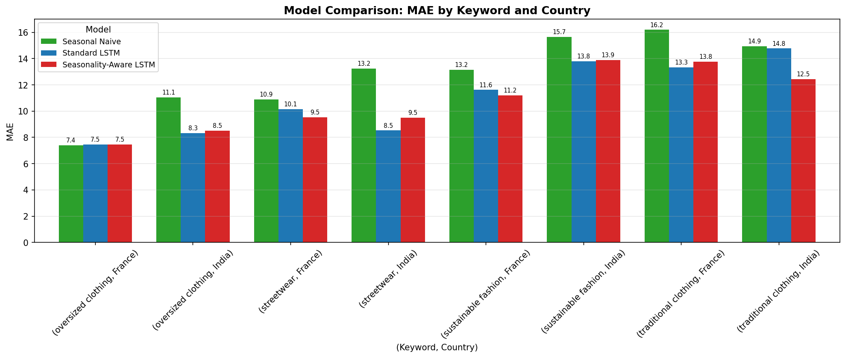
Fig. 2. Test MAE by series and model (full test set).
Both LSTMs had lower mean MAE than the seasonal naive baseline (11.00 and 10.80 versus 12.82) and lower mean RMSE (21.2–21.4 versus 23.4); each beat the baseline by MAE in seven of eight series, the exception being the degenerate France oversized series where all three models are within 0.1 point. The seasonality-aware LSTM had slightly lower mean MAE than the standard LSTM (10.80 vs 11.00; 7.20 vs 7.50 excluding February 2026) but slightly higher mean RMSE on the full test set (21.36 vs 21.21). It had the lower MAE in three of eight series (France streetwear, France sustainable fashion, India traditional clothing), the standard LSTM in the other five. Seed-to-seed standard deviations of MAE averaged about 0.5 points (up to 1.3 for individual series). Persistence scored MAE 11.45 (8.69 excluding February 2026).

8. Discussion and Critical Interpretation

8.1 LSTMs versus the seasonal naive baseline (RQ1)
The LSTMs’ advantage should not be read as proof that learned models capture fashion seasonality better. The naive baseline forecasts each month from the same month a year earlier, so it cannot follow the level shift of late 2025, whereas walk-forward LSTMs adapt to recent values. The persistence diagnostic supports this reading: its MAE of 11.45 (8.69 excluding February 2026) is close to the LSTMs’ 10.80–11.00 (7.20–7.50), so a large part of the LSTM gain over seasonal naive reflects level adaptation, and the margin over persistence is small. This is consistent with cautions that neural forecasters must be judged against simple benchmarks [4], [6].

8.2 Effect of seasonal features (RQ2)
The mean MAE difference of −0.20 in favour of the seasonal model is driven mostly by one series, India traditional clothing (−2.32); excluding it, the mean difference is +0.10 in favour of the standard model. Because the gap is smaller than the typical seed-to-seed spread, we conclude that explicit sine/cosine month features gave no reliable improvement in these data. Plausible reasons, which we did not test, are that a 12-month window already contains the seasonal phase, that seasonality in the training period is moderate (lag-12 autocorrelation from 0.09 to 0.88 across the seven non-degenerate series), and that the test period is dominated by a level shift and a one-month spike that no calendar feature can anticipate. India traditional clothing, where seasonal features helped most, is the series for which a festival-related annual cycle is most plausible; this is consistent with, but does not demonstrate, a seasonal benefit. The result also differs from the emphasis of Zhang and Qi [5] on explicit seasonal handling, but their setting (raw inputs, different data) is not directly comparable.

8.3 India versus France (RQ3)
The LSTMs reduced MAE relative to the seasonal naive baseline by about 17–19% in India (13.73 to 11.09–11.36) and 11–12% in France (11.91 to 10.50–10.64). However, the France mean includes the uninformative oversized series, the series are normalized independently, and eight series cannot support a statistical claim of a country difference. The ranking of the two LSTMs was not consistent within either country (France: seasonal better in 2 of 4 series; India: 1 of 4). We regard the cross-country comparison as descriptive only.

9. Limitations
Google Trends normalization. Values are sampled, relative indices scaled so that each series’ own maximum is 100 [9]; they are not search volumes or sales. Each keyword–country series is normalized independently, so levels and absolute errors are not comparable across series or countries, and averaged MAE/RMSE are descriptive summaries rather than pooled errors. A single extreme value rescales the whole series. Low-volume terms are reported as zero [9].
February 2026 anomaly. All eight series equal exactly 100 in February 2026, and all rise sharply in November 2025, both inside the test period. This coincidence across unrelated keywords and two countries is unusual; its cause is unknown and it may be a data artifact or a common event. We could not re-query Google Trends to check provenance, left the data unaltered, and report results with and without that month. Because the spike is the series maximum, it also compresses earlier values and dominates squared error, so conclusions about accuracy in this window may not generalize.
Other limitations. “Oversized clothing” in France is 98% zeros and its results are uninformative. There is one chronological split, 20 test months and 8 series, so no significance tests were run. Only one-step forecasts were evaluated; ETS, SARIMA and multi-step horizons were not tested, and persistence was only a diagnostic. No tuning was performed. Queries are four English-language keywords and may not represent fashion demand, sales or Hindi/French searches.

10. Conclusion and Future Work
On eight Google Trends fashion series, LSTMs achieved lower average error than a seasonal naive baseline under a leakage-controlled walk-forward protocol, but the gain is largely explained by adaptation to a recent level shift, and adding sine/cosine month features did not yield a reliable improvement over a standard LSTM (mean MAE 10.80 vs 11.00, with seed noise of similar size). No single best model can be established beyond “either LSTM variant over seasonal naive”. Future work should re-collect the data and investigate the 2025–2026 anomalies, average repeated Google queries to reduce sampling noise, add persistence, ETS and SARIMA baselines, use rolling-origin and multi-step evaluation, test contemporaneous-month features and pooled (global) LSTMs across series, and add statistical tests on a larger set of keywords and markets, including Hindi and French queries.

References
[1] S. Hochreiter and J. Schmidhuber, “Long short-term memory,” Neural Computation, vol. 9, no. 8, pp. 1735–1780, 1997. doi:10.1162/neco.1997.9.8.1735
[2] H. Choi and H. Varian, “Predicting the present with Google Trends,” The Economic Record, vol. 88, no. s1, pp. 2–9, 2012. doi:10.1111/j.1475-4932.2012.00809.x
[3] J. Ginsberg, M. H. Mohebbi, R. S. Patel, L. Brammer, M. S. Smolinski and L. Brilliant, “Detecting influenza epidemics using search engine query data,” Nature, vol. 457, no. 7232, pp. 1012–1014, 2009. doi:10.1038/nature07634
[4] H. Hewamalage, C. Bergmeir and K. Bandara, “Recurrent neural networks for time series forecasting: Current status and future directions,” International Journal of Forecasting, vol. 37, no. 1, pp. 388–427, 2021. doi:10.1016/j.ijforecast.2020.06.008
[5] G. P. Zhang and M. Qi, “Neural network forecasting for seasonal and trend time series,” European Journal of Operational Research, vol. 160, no. 2, pp. 501–514, 2005. doi:10.1016/j.ejor.2003.08.037
[6] S. Makridakis, E. Spiliotis and V. Assimakopoulos, “Statistical and machine learning forecasting methods: Concerns and ways forward,” PLoS ONE, vol. 13, no. 3, e0194889, 2018. doi:10.1371/journal.pone.0194889
[7] R. J. Hyndman and G. Athanasopoulos, Forecasting: Principles and Practice, 3rd ed. Melbourne, Australia: OTexts, 2021. [Online]. Available: https://otexts.com/fpp3/
[8] Z. Al-Halah, R. Stiefelhagen and K. Grauman, “Fashion Forward: Forecasting visual style in fashion,” in Proc. IEEE Int. Conf. Computer Vision (ICCV), 2017, pp. 388–397. doi:10.1109/ICCV.2017.50
[9] Google, “FAQ about Google Trends data,” Google Trends Help. [Online]. Available: https://support.google.com/trends/answer/4365533 (accessed Nov. 2, 2026).

