Comparative Fashion Trend Forecasting Across Indian and French Markets Using LSTM Networks: Evaluating Seasonal Effects
Bedaanntica Paul
School of Computer Engineering, KIIT Deemed to be University, Bhubaneswar, India.
Code, data and results: github.com/Spideykook/LSTM-DL

Abstract
Fashion interest is seasonal, but it is not obvious that a forecasting model needs to be told so. This study asks whether cyclical calendar features improve forecasts of fashion search interest in India and France. The data are monthly Google Trends indices (January 2016 – September 2026) for four keywords (streetwear, oversized clothing, sustainable fashion and traditional clothing), giving eight series. A seasonal naive baseline, a standard LSTM and an LSTM with sine/cosine month features are compared on an identical chronological test period (February 2025 – September 2026), using one-step walk-forward forecasts, training-only scaling and five seeds per LSTM. Mean MAE was 12.82, 11.00 and 10.80 index points, respectively. Both LSTMs beat the naive baseline in seven of eight series, but the 0.2-point advantage of the seasonal features over the standard LSTM is smaller than seed-to-seed variation and inconsistent across series, so we do not claim a reliable seasonal benefit. All eight series peak at 100 in February 2026, an unexplained coincidence inside the test period; leaving that month out of scoring lowers every model’s MAE by roughly 30% but does not change the MAE ranking. The results describe independently normalized search-interest indices, not sales.
Keywords: fashion trend forecasting; Google Trends; LSTM; seasonality; seasonal naive baseline; India; France.

1. Introduction and Research Motivation
Search-query data are a cheap signal of public interest [2], [3], and in fashion they could inform assortment and marketing decisions. Interest in fashion is also seasonal and market-specific: festival and wedding seasons plausibly shape searches for traditional clothing in India, while climate and retail calendars shape them in France. Long short-term memory (LSTM) networks [1] are a standard choice for sequence forecasting, but it is unclear whether they benefit from explicit calendar inputs or can infer seasonality from lagged values alone.
Applying an LSTM to fashion data is not in itself a contribution, and this paper proposes no new architecture. Its contribution is a controlled comparison, organised around four points: (i) a comparative analysis of Indian and French fashion search-interest series and of how forecasting models behave on each; (ii) an evaluation of cyclical sine/cosine calendar features in LSTM forecasting; (iii) a comparison against a seasonal naive baseline under one walk-forward protocol; and (iv) an investigation of how data anomalies, chiefly a simultaneous February 2026 peak, affect measured forecasting performance.

2. Research Gap and Objectives
Earlier fashion-forecasting work has focused largely on visual style, for example forecasting the popularity of styles found in product images [8]. The neural-forecasting literature gives mixed guidance on seasonality and on whether neural models beat simple benchmarks [4]–[6]. Among the sources we reviewed (the review is not exhaustive), we did not find a controlled comparison of seasonality-aware and standard LSTMs on search-interest series from an Indian and a European market. We therefore ask: (RQ1) do LSTMs beat a seasonal naive benchmark on fashion search interest? (RQ2) do sine/cosine month features improve a standard LSTM? (RQ3) do the conclusions differ between India and France? We also document data quality and the limits of Google Trends data throughout.

3. Literature Review
Choi and Varian showed that search indices can help “predict the present”, that is, nowcast current economic indicators, without claiming to predict the future [2]. Ginsberg et al. used Google query data to estimate current influenza activity with a reporting lag of about one day [3]. Google notes that Trends data are a sample, that low-volume terms appear as zero, and that unusual spikes can occur [9]. LSTMs [1] were designed to overcome vanishing error flow in recurrent networks. Hewamalage et al. found recurrent networks competitive with ETS and ARIMA but not a silver bullet, observed that individual series are often too short for complex models, and concluded that RNNs can model seasonality directly when series share homogeneous seasonal patterns, and that otherwise deseasonalization is advisable [4]. Zhang and Qi reported that neural networks struggled to capture seasonal and trend variation from raw data, and that detrending or deseasonalization reduced errors substantially [5]. Makridakis et al. found that popular machine-learning methods were dominated by eight statistical methods on 1,045 monthly M3 series [6], and Hyndman and Athanasopoulos present seasonal naive as a standard benchmark [7]. Together these works motivate a seasonal naive baseline, an empirical test of explicit seasonal inputs, and caution about short series.

4. Dataset and Methodology

4.1 Data and verification
We use eight monthly series (four keywords in India and France), collected on 20 October 2026 with the unofficial pytrends library, one query per keyword–country pair, covering January 2016 to September 2026 (129 observations each). Google Trends reports a sampled, normalized index in which each series’ own peak equals 100; it is neither absolute search volume nor sales [9]. We re-checked the data and found no missing values, no duplicate dates, a complete monthly index and values within 0–100. Provenance rests on the collection metadata, because we could not re-query Google Trends from the analysis environment. Three issues were found and left unaltered (Section 9): a simultaneous peak in February 2026, a common upward shift in November 2025, and an almost entirely zero series (France, oversized clothing: 126 of 129 months, including the whole training period).

4.2 Split, leakage control and protocol
Each series is split chronologically 70/15/15: training January 2016 – June 2023 (90 months), validation July 2023 – January 2025 (19) and test February 2025 – September 2026 (20). All models are tested on the same months. Min–max scalers are fitted on training data only, 12-month input windows look strictly backward, and validation data serve only for early stopping. Forecasts are one-step-ahead and walk-forward: at each test month, every model sees the actual history up to the previous month. No hyperparameters were tuned.

5. Models
Seasonal naive: the forecast for month t is the observed value at t−12.
Standard LSTM: the input is 12 lagged scaled values, followed by one LSTM layer (50 units) and a dense output. Training used Adam, MSE loss, batch size 16 and up to 100 epochs, with early stopping on validation loss (patience 10).
Seasonality-aware LSTM: the same network, with each input step also carrying sin(2πm/12) and cos(2πm/12), where m is the month being predicted (the calendar is known in advance). This gives three features per step.

6. Experimental Setup and Evaluation Metrics
Each LSTM was trained with five seeds (42–46), and the five forecasts were averaged; per-seed variability is reported separately. Accuracy is measured by mean absolute error (MAE) and root mean squared error (RMSE) over the 20 test months of each series, in that series’ own index points. Because the February 2026 observation dominates squared error, all scoring is repeated with that month excluded from evaluation only; model inputs are unchanged. As a diagnostic outside the three pre-specified models, we also score last-value persistence, y(t−1). With eight short series and a single split, we run no significance tests.

7. Results
All three models ran on all eight series. Table 1 gives per-series results, Table 2 the aggregates and Table 3 the sensitivity analysis; Figs. 1 and 2 show the forecasts and errors.
Table 1. Test-period MAE and RMSE per series (index points; full 20-month test set).
Keyword | Country | Naive MAE | Naive RMSE | Std LSTM MAE | Std LSTM RMSE | Seas. LSTM MAE | Seas. LSTM RMSE
Oversized clothing | France | 7.40 | 23.67 | 7.45 | 23.63 | 7.46 | 23.63
Oversized clothing | India | 11.05 | 20.06 | 8.32 | 18.17 | 8.51 | 18.40
Streetwear | France | 10.90 | 19.07 | 10.15 | 17.81 | 9.54 | 17.15
Streetwear | India | 13.25 | 23.09 | 8.53 | 18.70 | 9.51 | 20.59
Sustainable fashion | France | 13.15 | 24.33 | 11.62 | 23.39 | 11.21 | 23.19
Sustainable fashion | India | 15.65 | 29.18 | 13.81 | 26.08 | 13.90 | 26.09
Traditional clothing | France | 16.20 | 26.69 | 13.34 | 22.85 | 13.78 | 23.79
Traditional clothing | India | 14.95 | 21.45 | 14.77 | 19.08 | 12.45 | 18.05

Table 2. Mean over the 8 series (and by country, MAE only); “excl.” = February 2026 not scored.
Model | MAE | RMSE | MAE excl. | RMSE excl. | Series won (MAE) | MAE: India / France
Seasonal naive | 12.82 | 23.44 | 9.12 | 14.01 | 1 | 13.72 / 11.91
Standard LSTM | 11.00 | 21.21 | 7.50 | 11.74 | 4 | 11.36 / 10.64
Seasonality-aware LSTM | 10.80 | 21.36 | 7.20 | 11.58 | 3 | 11.09 / 10.50

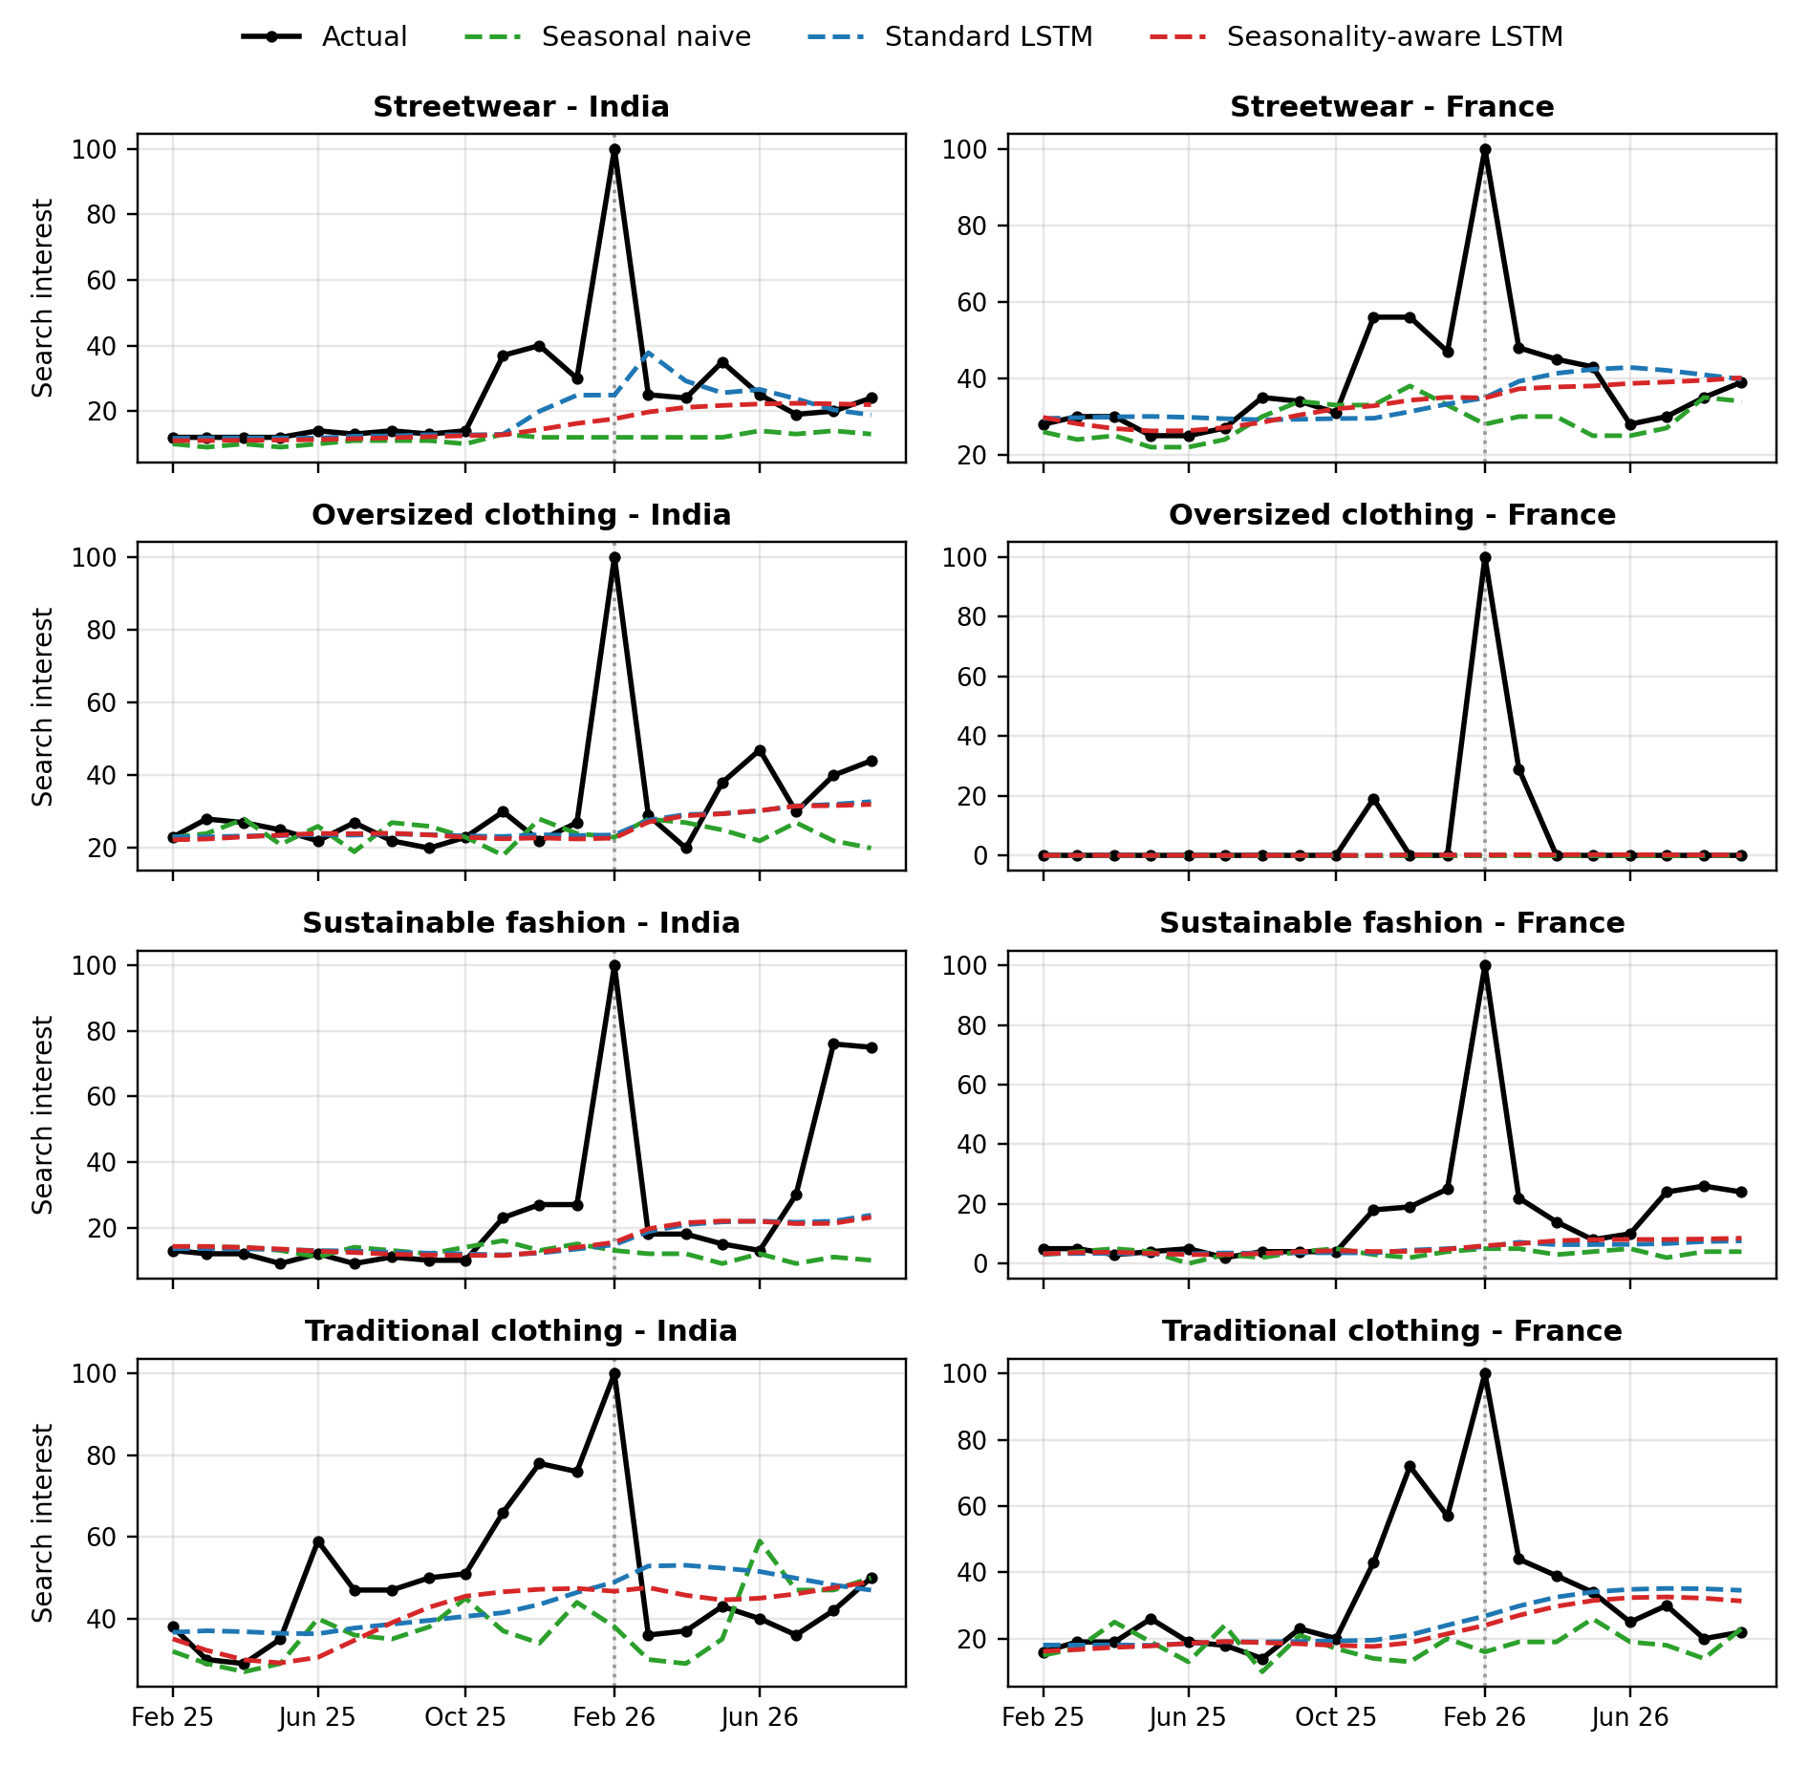
Fig. 1. Test-period forecasts for the eight series (Feb 2025 – Sep 2026). Index values are normalized per series; the dotted vertical line marks February 2026.
Table 3. Sensitivity: MAE and RMSE per series with February 2026 excluded from scoring (19 test months).
Keyword | Country | Naive MAE | Std LSTM MAE | Seas. LSTM MAE | Naive RMSE | Std LSTM RMSE | Seas. LSTM RMSE
Oversized clothing | France | 2.53 | 2.59 | 2.59 | 7.95 | 7.92 | 7.92
Oversized clothing | India | 7.58 | 4.74 | 4.90 | 10.55 | 6.35 | 6.51
Streetwear | France | 7.68 | 7.26 | 6.62 | 10.48 | 10.53 | 9.28
Streetwear | India | 9.32 | 5.02 | 5.67 | 12.39 | 8.43 | 9.44
Sustainable fashion | France | 8.84 | 7.26 | 6.85 | 12.17 | 10.36 | 10.06
Sustainable fashion | India | 11.89 | 10.05 | 10.18 | 22.32 | 18.26 | 18.45
Traditional clothing | France | 12.63 | 10.19 | 10.51 | 19.45 | 16.37 | 17.08
Traditional clothing | India | 12.47 | 12.87 | 10.30 | 16.79 | 15.69 | 13.90

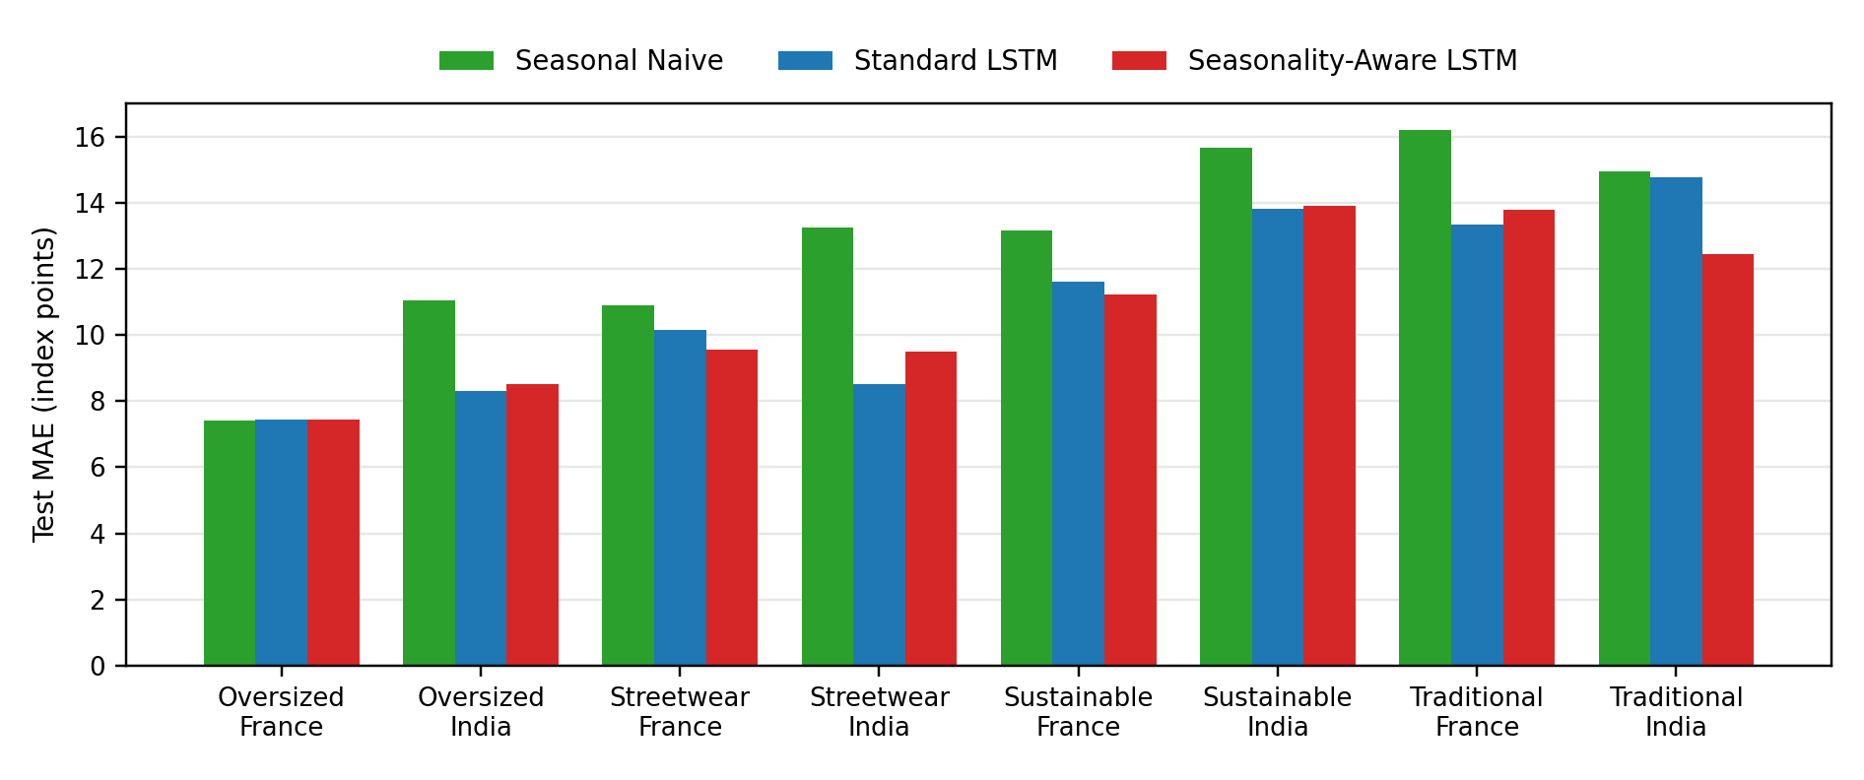
Fig. 2. Test MAE by series and model (full test set).
Both LSTMs had lower mean MAE than the seasonal naive baseline (11.00 and 10.80 versus 12.82) and lower mean RMSE (21.2–21.4 versus 23.4). Each beat the baseline by MAE in seven of eight series; the exception was the degenerate France oversized series, where all three models are within 0.1 point. The seasonality-aware LSTM had slightly lower mean MAE than the standard LSTM (10.80 vs 11.00; 7.20 vs 7.50 excluding February 2026), but slightly higher mean RMSE on the full test set (21.36 vs 21.21). It had the lower MAE in three of eight series (France streetwear, France sustainable fashion and India traditional clothing) and the standard LSTM in the other five. Seed-to-seed standard deviations of MAE averaged about 0.5 points (up to 1.3 for individual series). Persistence scored MAE 11.45 (8.69 excluding February 2026).

8. Discussion and Critical Interpretation

8.1 LSTMs versus the seasonal naive baseline (RQ1)
The LSTMs’ advantage should not be read as evidence that learned models capture fashion seasonality better. The naive baseline copies the same month of the previous year, so it cannot follow the level shift of late 2025, whereas walk-forward LSTMs adapt to recent values. The persistence diagnostic points the same way: its MAE of 11.45 (8.69 excluding February 2026) is close to the LSTMs’ 10.80–11.00 (7.20–7.50), so much of the gain over seasonal naive reflects level adaptation, and the margin over persistence is small. This agrees with the advice to judge neural forecasters against simple benchmarks [4], [6].

8.2 Effect of seasonal features (RQ2)
The mean MAE difference of −0.20 in favour of the seasonal model comes mostly from one series, India traditional clothing (−2.32); without it, the mean difference is +0.10 in favour of the standard model. Because the gap is smaller than the typical seed-to-seed spread, we conclude that explicit sine/cosine month features did not demonstrate a reliable improvement here. We did not test why, but three explanations are plausible: a 12-month window already contains the seasonal phase; seasonality in the training period is moderate (lag-12 autocorrelation of 0.09 to 0.88 across the seven non-degenerate series); and the test period is dominated by a level shift and a one-month spike that no calendar feature can anticipate. India traditional clothing, where the seasonal features helped most, is the series for which a festival-related annual cycle is most plausible. That fits a seasonal benefit but does not demonstrate one. Our result also sits alongside the emphasis of Zhang and Qi on explicit seasonal handling [5], although their setting (raw inputs, different data) is not directly comparable.

8.3 India versus France (RQ3)
Relative to the seasonal naive baseline, the LSTMs reduced MAE by about 17–19% in India (13.72 to 11.09–11.36) and 11–12% in France (11.91 to 10.50–10.64). The France mean includes the uninformative oversized series, the series are normalized independently, and eight series cannot support a statistical claim about a country difference. The ranking of the two LSTMs was not consistent within either country (France: seasonal better in 2 of 4 series; India: 1 of 4). We treat the cross-country comparison as descriptive.

8.4 What the comparison contributes
The contribution of this study is the comparative investigation, not the use of LSTMs for fashion data. Three results follow from it. First, a seasonal naive benchmark is not the hardest baseline when the level shifts, so conclusions about LSTM accuracy depend on which benchmark is used. Second, explicit cyclical features gave no reliable gain over a standard LSTM on these short series, which is still an informative result. Third, the anomalies matter for evaluation: leaving February 2026 out of scoring lowered MAE by roughly 29–33% for every model (naive 12.82 to 9.12, standard LSTM 11.00 to 7.50, seasonality-aware LSTM 10.80 to 7.20; Table 2), left the MAE ranking and the series-win counts unchanged, but reversed the RMSE order of the two LSTMs (standard lower on the full test set, seasonal lower without February 2026). A model ranking that flips on a single month is a further sign that the gap between the LSTM variants is within noise.

9. Limitations
Google Trends normalization. Values are sampled, relative indices scaled so that each series’ own maximum is 100 [9]; they are not search volumes or sales. Each keyword–country series is normalized independently, so levels and absolute errors cannot be compared across series or countries, and averaged MAE/RMSE are descriptive summaries rather than pooled errors. A single extreme value rescales a whole series, and low-volume terms are reported as zero [9].
February 2026 anomaly and November 2025 shift. All eight series equal exactly 100 in February 2026, and all rise sharply in November 2025, both inside the test period. This coincidence across unrelated keywords and two countries is unusual. Its cause is unknown: it may be a data artifact or a common event. We could not re-query Google Trends to check provenance, so we left the data unaltered and report results with and without that month. Because the spike is each series’ maximum, it also compresses earlier values and dominates squared error, so conclusions about accuracy in this window may not generalize.
Other limitations. “Oversized clothing” in France is 98% zeros and its results are uninformative. There is a single chronological split, 20 test months and 8 series, so no significance tests were run. Only one-step forecasts were evaluated; ETS, SARIMA and multi-step horizons were not tested, and persistence was only a diagnostic. No tuning was performed. The queries are four English-language keywords and may not represent fashion demand, sales, or Hindi and French searches.

10. Conclusion and Future Work
On eight Google Trends fashion series, LSTMs had lower average error than a seasonal naive baseline under a leakage-controlled walk-forward protocol, but the gain is largely explained by adaptation to a recent level shift. Adding sine/cosine month features did not show a reliable improvement over a standard LSTM (mean MAE 10.80 vs 11.00, with seed noise of similar size), so no best model can be named beyond “either LSTM variant over seasonal naive”. Future work should re-collect the data and investigate the 2025–2026 anomalies; average repeated Google queries to reduce sampling noise; add persistence, ETS and SARIMA baselines; use rolling-origin and multi-step evaluation; test contemporaneous-month features and pooled LSTMs across series; and extend to more keywords and markets, including Hindi and French queries, with statistical tests.

References
[1] S. Hochreiter and J. Schmidhuber, “Long short-term memory,” Neural Computation, vol. 9, no. 8, pp. 1735–1780, 1997. doi:10.1162/neco.1997.9.8.1735
[2] H. Choi and H. Varian, “Predicting the present with Google Trends,” The Economic Record, vol. 88, no. s1, pp. 2–9, 2012. doi:10.1111/j.1475-4932.2012.00809.x
[3] J. Ginsberg, M. H. Mohebbi, R. S. Patel, L. Brammer, M. S. Smolinski and L. Brilliant, “Detecting influenza epidemics using search engine query data,” Nature, vol. 457, no. 7232, pp. 1012–1014, 2009. doi:10.1038/nature07634
[4] H. Hewamalage, C. Bergmeir and K. Bandara, “Recurrent neural networks for time series forecasting: Current status and future directions,” International Journal of Forecasting, vol. 37, no. 1, pp. 388–427, 2021. doi:10.1016/j.ijforecast.2020.06.008
[5] G. P. Zhang and M. Qi, “Neural network forecasting for seasonal and trend time series,” European Journal of Operational Research, vol. 160, no. 2, pp. 501–514, 2005. doi:10.1016/j.ejor.2003.08.037
[6] S. Makridakis, E. Spiliotis and V. Assimakopoulos, “Statistical and machine learning forecasting methods: Concerns and ways forward,” PLoS ONE, vol. 13, no. 3, e0194889, 2018. doi:10.1371/journal.pone.0194889
[7] R. J. Hyndman and G. Athanasopoulos, Forecasting: Principles and Practice, 3rd ed. Melbourne, Australia: OTexts, 2021. [Online]. Available: https://otexts.com/fpp3/
[8] Z. Al-Halah, R. Stiefelhagen and K. Grauman, “Fashion Forward: Forecasting visual style in fashion,” in Proc. IEEE Int. Conf. Computer Vision (ICCV), 2017, pp. 388–397. doi:10.1109/ICCV.2017.50
[9] Google, “FAQ about Google Trends data,” Google Trends Help. [Online]. Available: https://support.google.com/trends/answer/4365533 (accessed Nov. 2, 2026).

