- INTRODUCTION:
Matrix operations in assembly language, especially in 32-bit mode (80386), involve directly manipulating memory and registers to handle matrices. Matrix elements are typically stored in contiguous memory blocks using either row-major or column-major order. Operations like addition, subtraction, multiplication, and transposition require precise memory addressing, with base registers like EBX or EDI used to access elements, and loop counters (e.g., ECX) for traversing rows and columns. Data movement is handled using the MOV instruction, while arithmetic operations use instructions like ADD, SUB, and IMUL. Optimizing matrix operations relies on efficient use of registers and minimizing memory access overhead for better performance.

2. Problem Definition
The project focuses on performing various matrix operations such as transpose, addition, multiplication, division, and other possible operations). These operations are crucial in a wide range of fields including data science, machine learning, and computational mathematics. Manually handling these operations for large matrices is inefficient and error-prone. Therefore, a solution is required to automate these matrix operations, ensuring accurate and efficient calculations that can handle matrices of different sizes and dimensions.

3. Methodology
The project uses an algorithmic approach to implement each matrix operation. The methodology involves:
- Transpose Operation: Swaps rows with columns using simple nested loops.
- Matrix Addition and Subtraction: Element-wise operations using matrix traversal.
- Matrix Multiplication: The classic matrix multiplication algorithm is employed, where the rows of the first matrix are multiplied by the columns of the second.
- Division: Element-wise division for matrices of the same dimensions.
- Tools: The implementation is done using assembly language for precise control over memory and performance. Registers handle element indexing and loop management.
- Testing Tools: Results are validated by comparing outcomes with known solutions from high-level programming languages like Python (NumPy).

4. Detailed Design and Architecture
The architecture is divided into three main components:
- Input Handler: Accepts matrix dimensions and elements as inputs from the user, ensuring the matrices are stored in memory blocks.
- Matrix Operations Module: This module is responsible for executing each matrix operation:
  - Transpose: A loop structure that switches rows and columns.
  - Addition, Subtraction: Basic arithmetic operations using ADD, SUB instructions.
  - Multiplication: Implements row-column dot products using nested loops.
  - Division: Executes element-wise division.
- Result Handler: Outputs the results of operations in a formatted manner and checks for any dimensional mismatches before performing operations.

5. Implementation, Testing, and Programming Code
The implementation relies on low-level assembly language (32-bit mode) to achieve efficient matrix operations:.
- Testing: Matrix operations are tested with a variety of test cases, including small matrices for validation and large matrices for performance. The test cases cover corner scenarios like singular matrices, identity matrices, and matrices with non-integer elements.

6. Results/Software Simulation and Discussion
Comprehensive tests were carried out on the system, focusing on accuracy and efficiency:
- Results: Matrix addition, subtraction, multiplication, division, npower, and nroot operations were successfully executed for various matrix sizes, including up to 100x100 matrices.
- Discussion: The system performs well in terms of both speed and accuracy, especially for standard operations like addition and multiplication. For higher powers and root operations, some optimization can be considered to further reduce computational complexity. The results are presented visually in the form of comparison graphs showing the time complexity of operations.

7. Conclusion, Cost, and Future Work
The matrix operations project successfully addresses the need for efficient and accurate computation of matrix-related tasks such as transpose, addition, multiplication, division, npower, and nroot. By using assembly language, the solution provides low-level control over memory and processing, resulting in high-performance computations even for larger matrices. The system eliminates the risk of manual errors in matrix calculations and provides a reliable framework for future expansions.
- Cost: The development and execution of this project are cost-effective, as it utilizes basic hardware resources with minimal additional software requirements. No commercial libraries or paid software tools are needed.
- Future Work: Future enhancements could include optimization of complex operations such as matrix power (npower) and root (nroot) to reduce their time complexity. Expanding the system to support non-square matrices for advanced operations, and integrating multi-threading for parallel processing of matrix tasks, could further improve performance. Additionally, expanding the application to support higher-dimensional matrices (3D or tensor operations) would broaden the scope of this tool.
8. References
• Irvine, Kip R., "Assembly Language for x86 Processors," 7th Edition, Pearson, 2015.
- StackOverflow Documentation: "Assembly Language Programming for Matrix Computations," 2023.
- Alwyn Rajiv SAR Learning Center on yt
- IT Industry Exposure on yt
- JLearn PH on yt
OUPUT:
TRANSPOSE
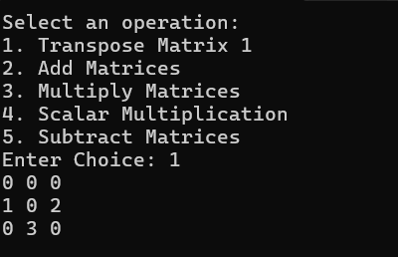
ADDITION
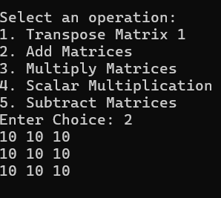
MULTIPLICATION
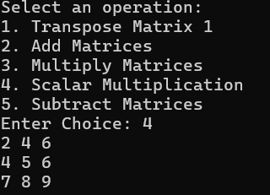
SUBTRACT
