Web Storage

Overview
In this lab, you'll implement shopping cart functionality using Web storage at the client.

Source folders
- <LAB_HOME>/labs/WebStorage
- <LAB_HOME>/solutions/WebStorage

Roadmap
There are 3 exercises in this lab, of which the last exercise is "if time permits". Here is a brief summary of the tasks you will perform in each exercise; more detailed instructions follow later:
- Implementing basic Web storage
- Enhancing the application functionality
- Additional suggestions (if time permits)

Exercise 1: Implementing basic Web storage
In the Student folder, open ShoppingBasket.html in the browser. The Web page appears as follows:

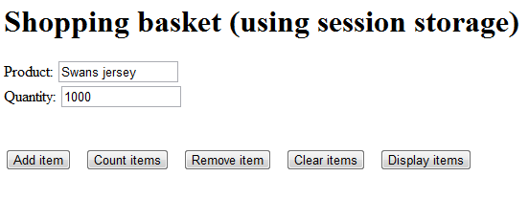

Open the Web page in an editor and implement the Add item button. This will allow the user to add a specified product and quantity to the shopping cart (use the product name as a key in session storage, and use the quantity as the corresponding value).

Exercise 2: Enhancing the application functionality
Add the following features to the Web page:
- Display a count of items in the shopping cart
- Remove a particular item from the shopping cart
- Clear all items from the shopping cart
- Display all items in the shopping cart

Exercise 3 (if time permits): Additional suggestions
Add a "checkout" feature that posts all the local shopping cart data to an Ajax-enabled server. The server should return some useful status information, such as the total quantity of all the items in the shopping cart.

